

**A Project Report on**

**“Content Management System”**

Submitted in Partial fulfillment of the Requirements for the VI Semester of the Degree of

**Bachelor of Engineering In**

**Computer Science & Engineering**

By

MB ASHISH – 1CR17CS66

NEERAJ KUMAR –1CR17CS080

NITIN KUMAR – 1CR17CS088

PRATYUSH SINHA-1CR17CS096

**Under the Guidance of Mr. KIRAN BABU**

**Assistant Professor, Dept. of CSE**

**MRS POONAM TIJARE**

**Assistant professor, Dept. of CSE**

**DEPARTMENT OF COMPUTER SCIENCE AND ENGINEERING**

# **CMR INSTITUTE OF TECHNOLOGY**

#132, AECS LAYOUT, IT PARK ROAD, KUNDALAHALLI, BANGALORE-560037



**CERTIFICATE**

This is to certify that the Project work entitled **“ CONTENT MANAGEMENT SYSTEM”** has been carried out by **MB ASHISH(1CR17CS066), NEERAJ KUMAR(1CR17CS080), NITIN KUMAR(1CR17CS088**) and **PRATYUSH SINHA(1CR17CS096)** bonafide students of CMR Institute of Technology in partial fulfillment for the award of **Bachelor of Engineering** in **Computer Science and Engineering** of the Visvesvaraya Technological University, Belgaum during the year **2019-2020**.

### ----------------------- ----------------------

Signature of Guide Signature of HOD

Mrs Poonam Tijare Dr. Prem Kumar Ramesh

Assistant Professor Professor, Head

Dept. of CSE, CMRIT Dept. of CSE, CMRIT

External Viva

Name of the examiners Signature with date

1.

2.

**INDEX**

INTRODUCTION…………………………………………………….4

REQUIREMENTS…………………………………………………….5

IMPLEMENTATION…………………………………………………6

CONCLUSION……………………………………………………….10

**INTRODUCTION**

**REQUIREMENTS**

HARDWARE REQUIREMENTS

Hard disk capacity : 8GB or more

Ram : 256MB or more

SOFTWARE REQUIREMENTS

Database : my sql

Application server :XAMPP server

Browser : Google chrome

Operating system: Windows 2010

Language : PHP,HTML

**IMPLEMENTATION**

In this system, there are mainly two types of users:

* Admin
* User

Login page:

This page is used by the admin and the user to go their respective login pages



ADMIN:

The admin can be anyone we have made the teacher the admin here in this project

ADMIN SIGN IN:

This page is the login page for the admin it’s a simple login page.

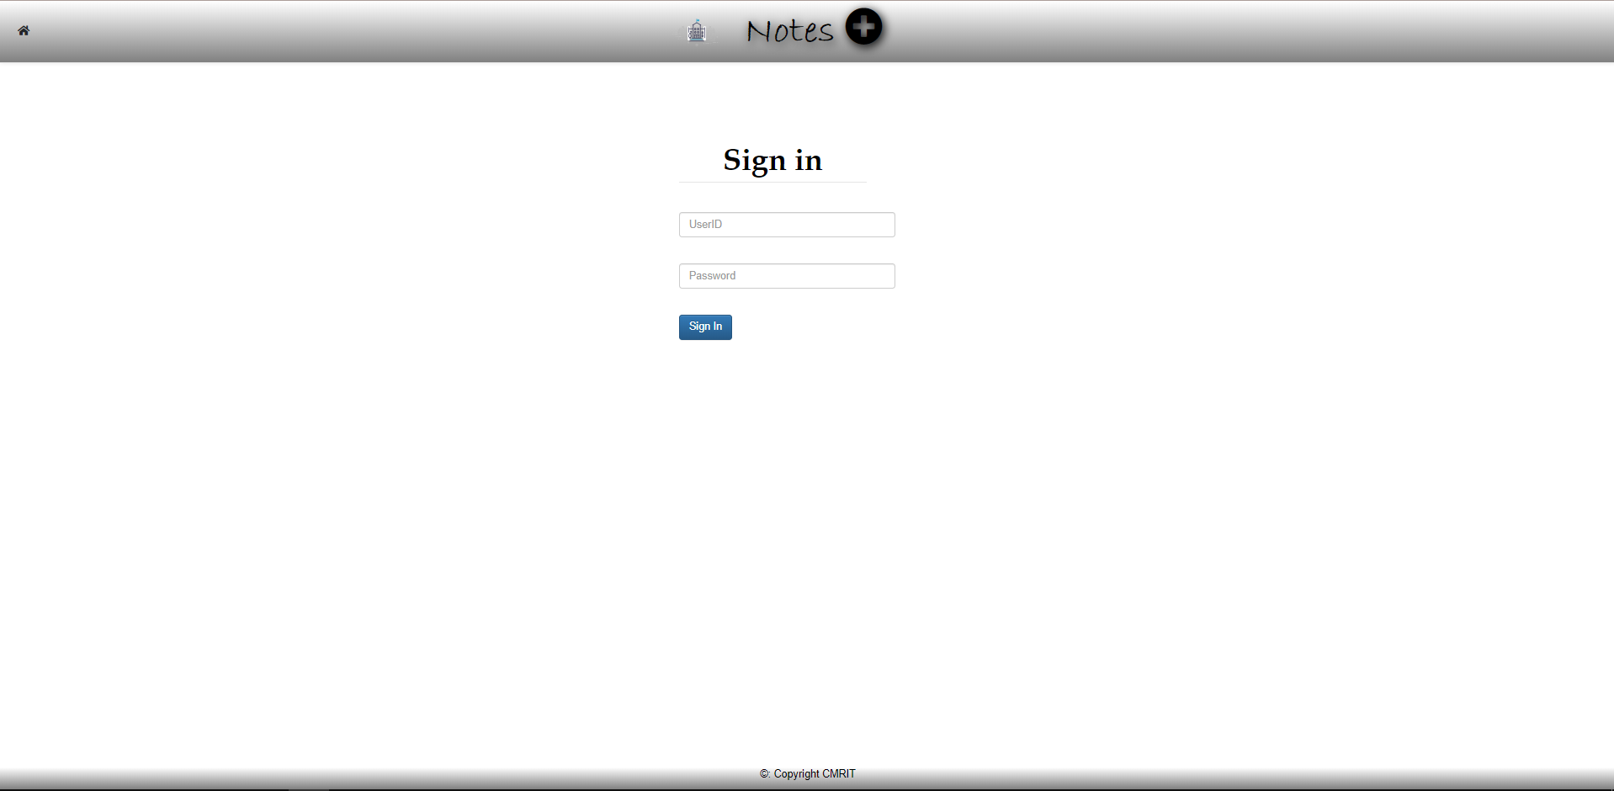

ADMIN VIEW PAGE:

This page is used by the admin to upload the content notes providing the details of the semester branch and the subject.

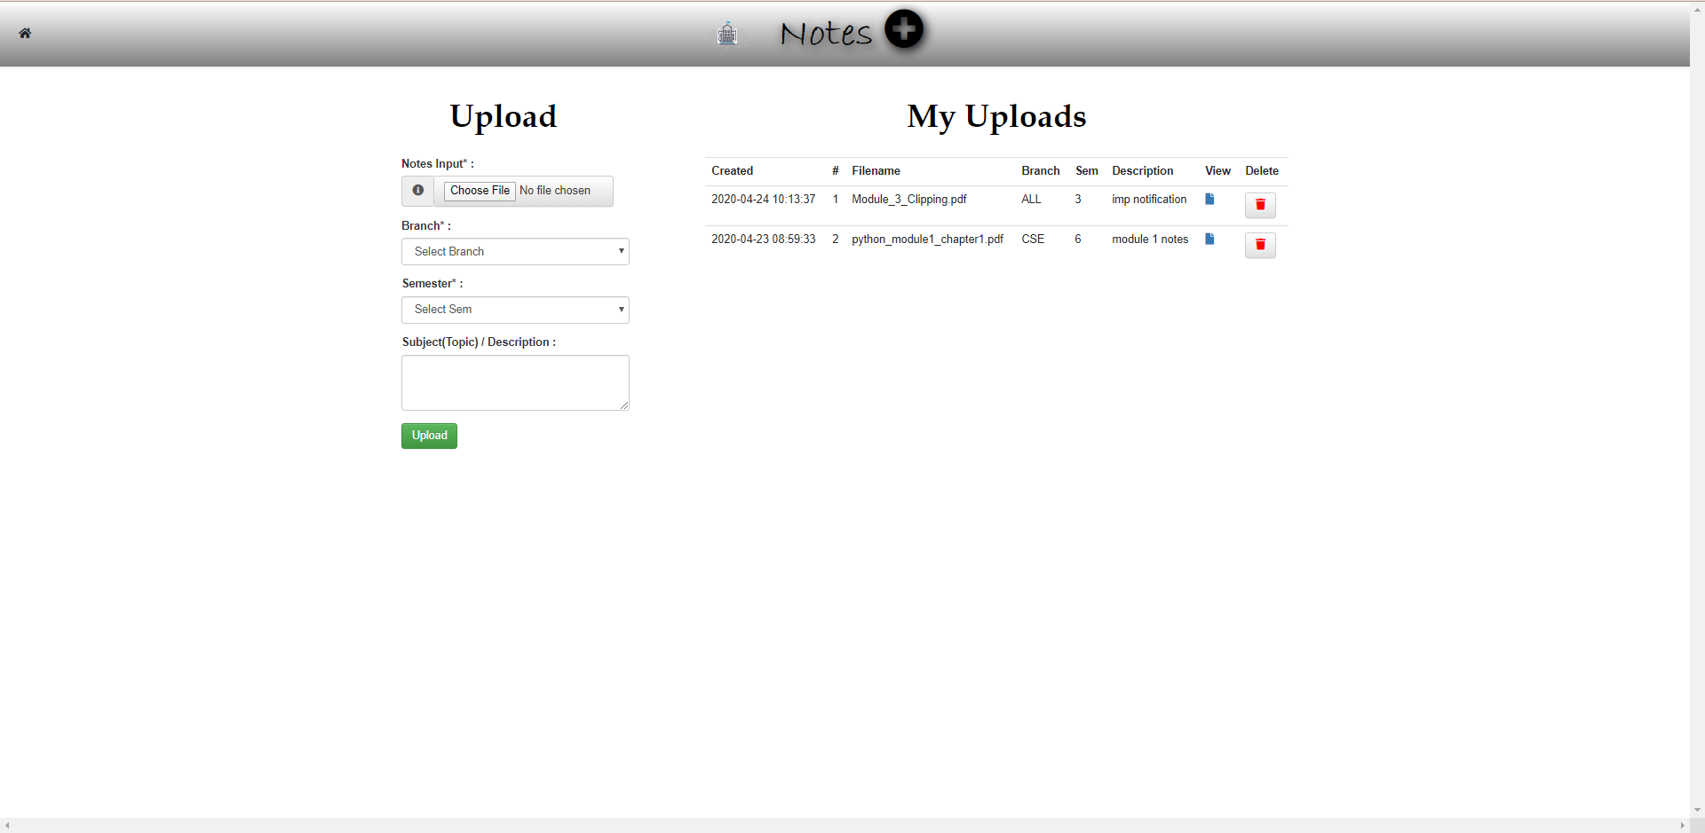

USER:

Users are the students or the people looking for notes or content. But since it is an open source website even user can upload notes on it.

USER SIGN UP PAGE:

This page is the Login page for the User it’s a simple login page if the person does not have an existing account they have the option for a sign in.

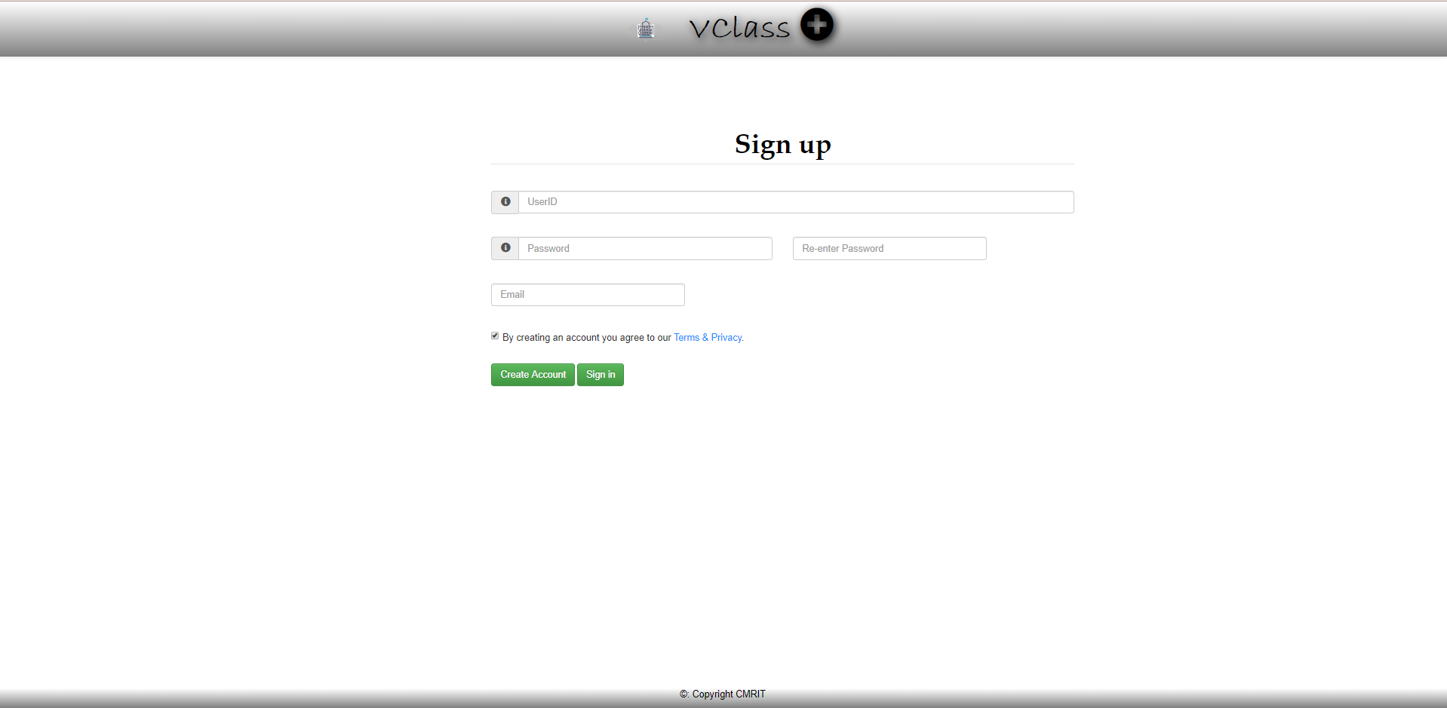

USER PROFILE SETTINGS:

This page is used for a Sign in option for new users and even editing the details of the user”s profile if needed.

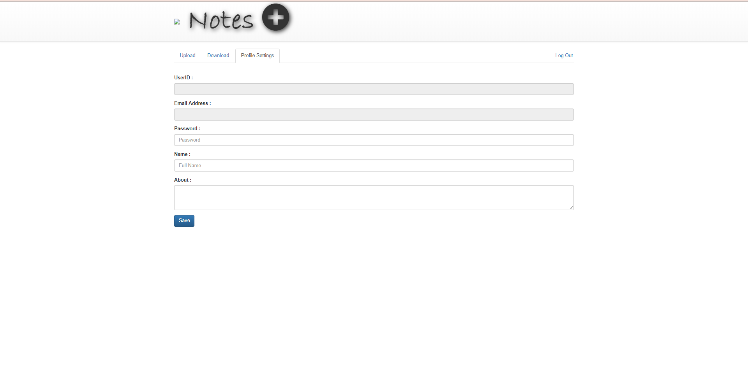

USER UPLOAD PAGE:

This page is used to upload the content or notes by the user providing the details of the subject semester and branch.

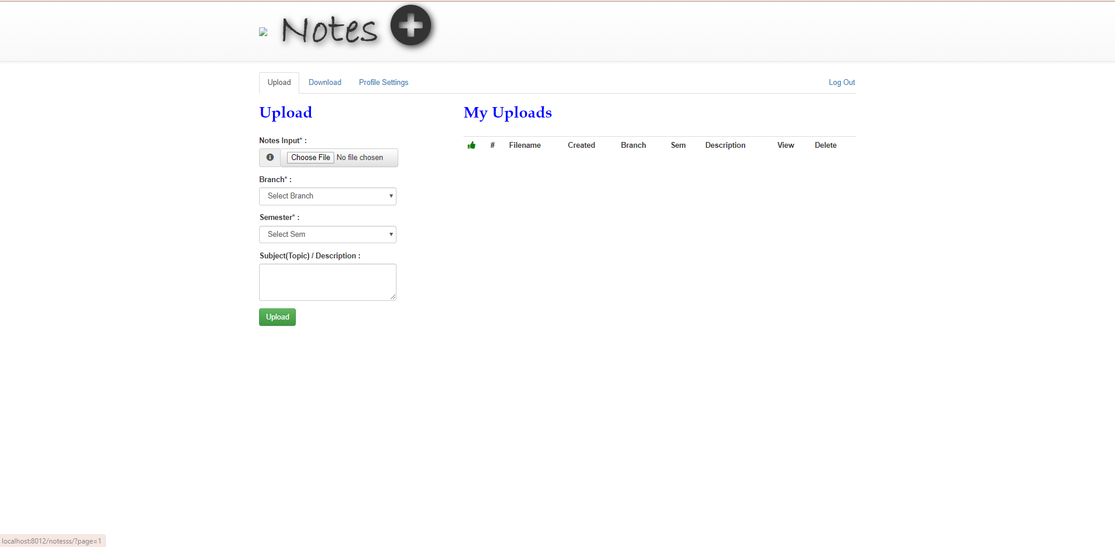

USER DOWNLOAD PAGE:

This page is used by the user to download the Contents or notes provided by the details of the content and uploader.

**CONCLUSION**