1. **Profile Creation**

**Step1 : Right click on Profiles tab in Tests Explorer and click on Execution profile.**

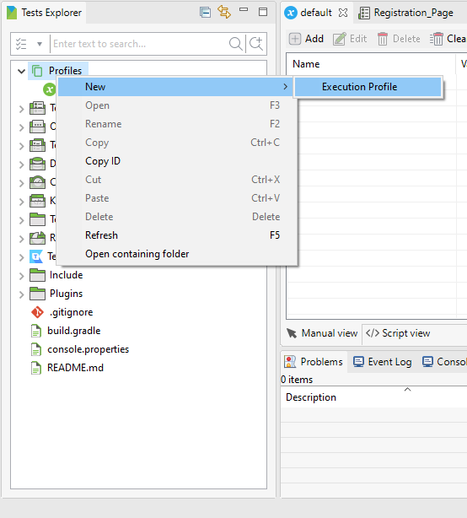

**Step 2 : Enter Name of Profile**

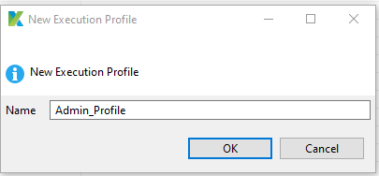

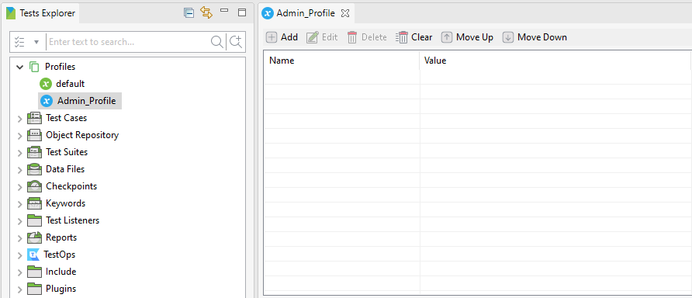

**Step 3 : Click on Add button to Enter Global Variables and Values.**

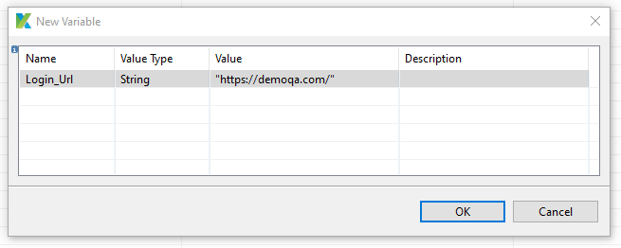

**Step 4 : Save the Execution profile.**

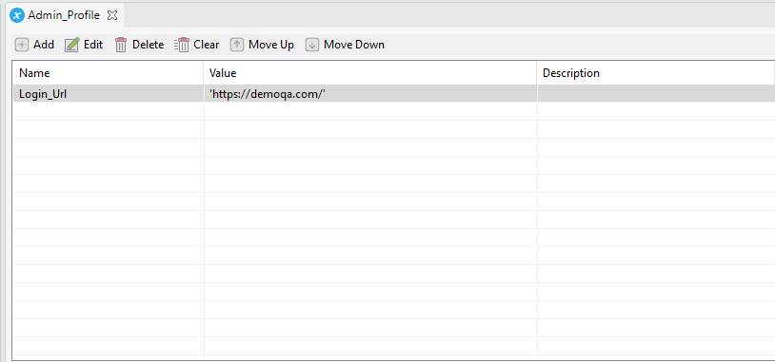

1. **Use Global Variables**

**Step 1 : Open Registration Page**

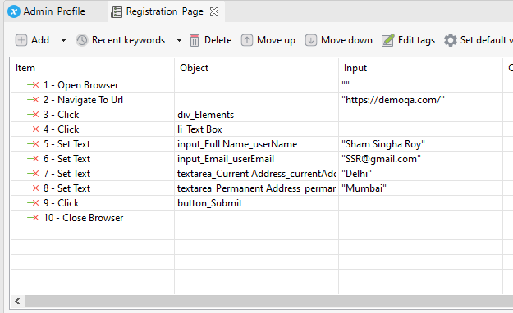

**Step 2 : Double click on URL input.**

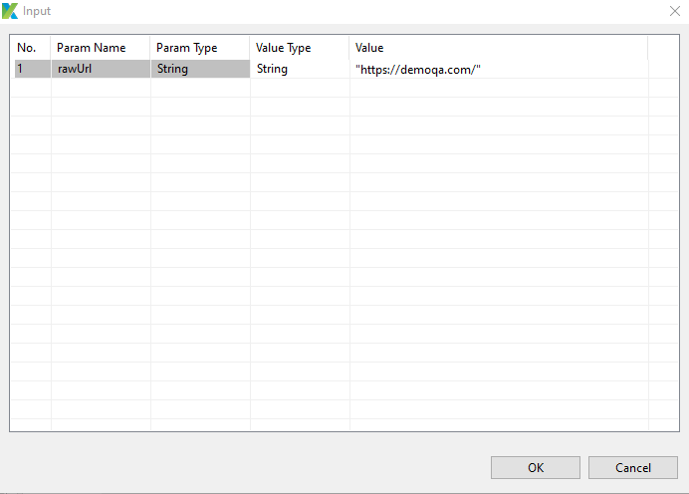

**Step 3 : Change Value Type to Global Variable.**

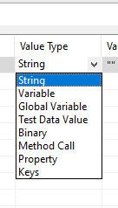

**Step 4 : Select Login_Url in Value column.**

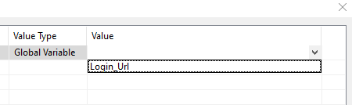

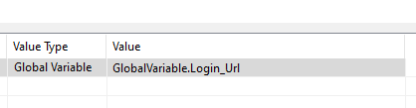

**Step 5 : Verify if Url input changes to Global variable value.**

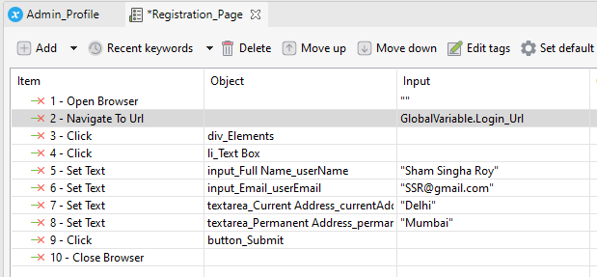

**Step 6 : Change Profile to Admin_Profile.**

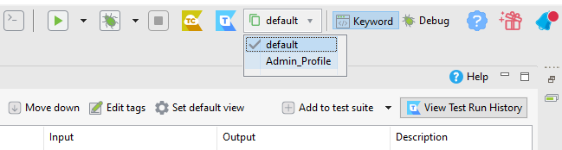

**Step 7 : Run test Case**

1. **Create Data Files.**

**Step 1 : Right click on Data Files folder and click New>>Test Data.**

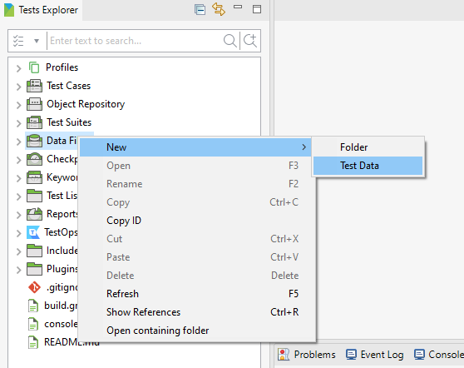

**Step 2 : Enter Name and select internal data for Data Type**

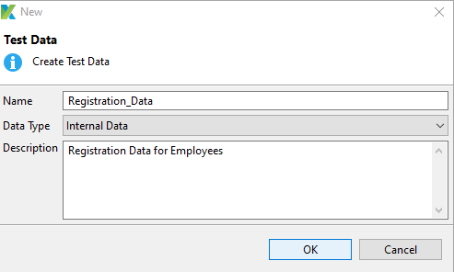

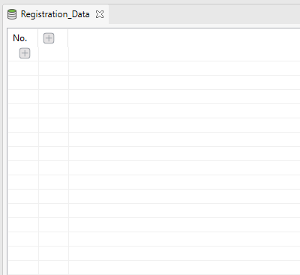

**Step 3 : Click on + button to Add columns.**

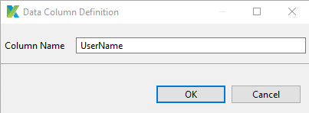

**Step 4 : Add all other Data columns.**

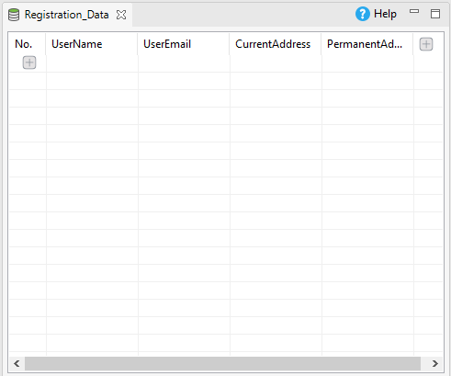

**Step 5 : Enter All the Employee Records and their details.**

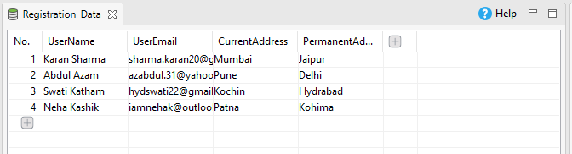

**Step 6 : Click on Variables Tab near manual and script.**

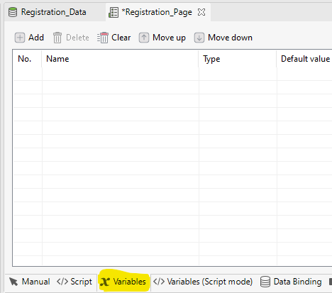

**Step 7: Add Variables for each Data Column.**

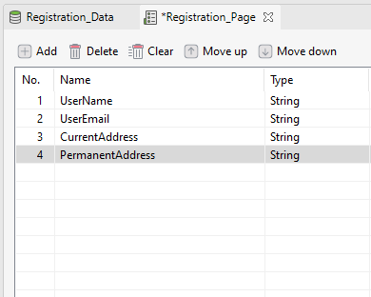

**Step 8 : Right Click on Test Suites and select New>>Test Suite**

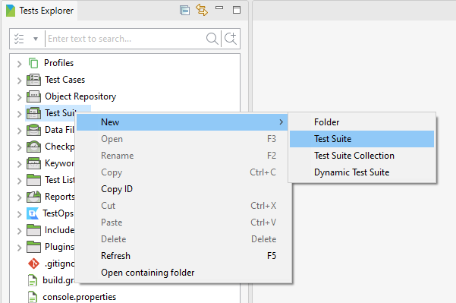

**Step 9: Enter Name and Add Test Suite.**

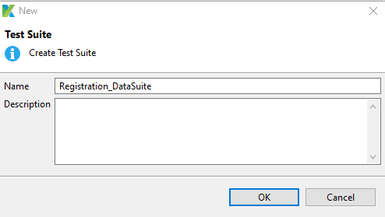

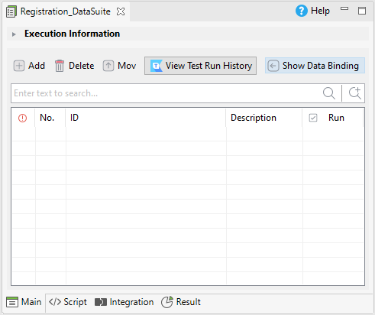

**Step 10: Drag and Drop Registration_Page Test Case in Test Suite.**

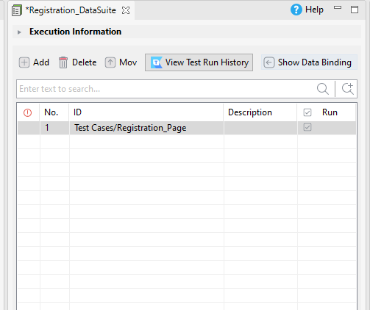

**Step 11: Click on Show Data Binding tab.**

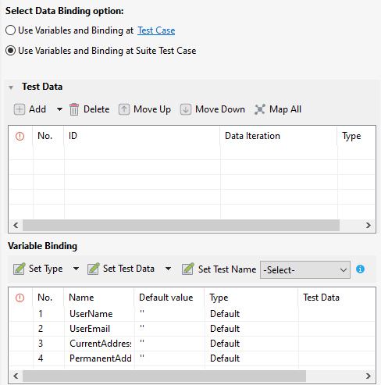

**Step 12: Select Registration_Data and click on Ok button.**

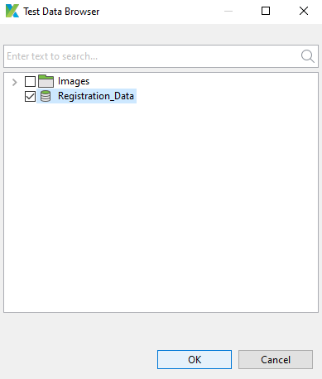

**Step 13: Data File get Added.**

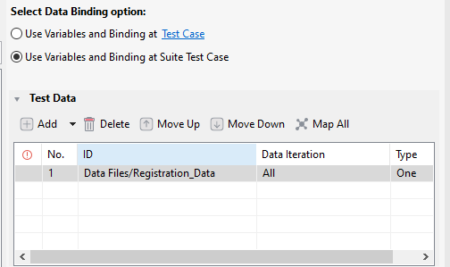

**Step 14: In Variable Binding select Type as Data Column for all the variable.**

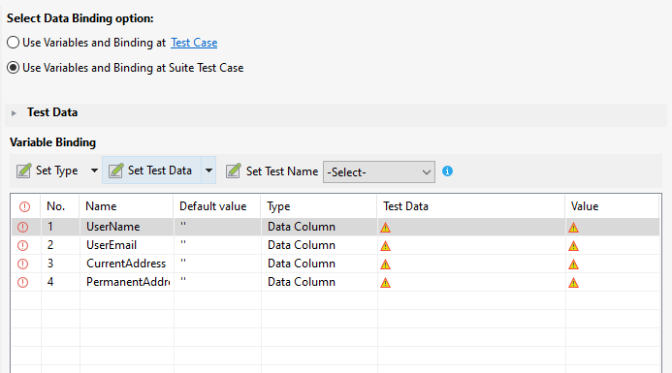

**Step 15: Click on Test Data and click on ok Button.**

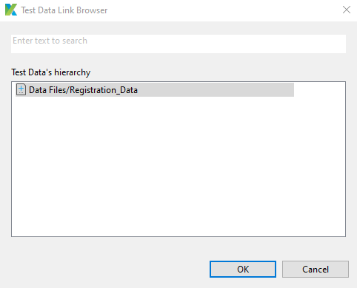

Note : add Test Data to all the Variables.

**Step 16: choose Column to fetch value and click on ok.**

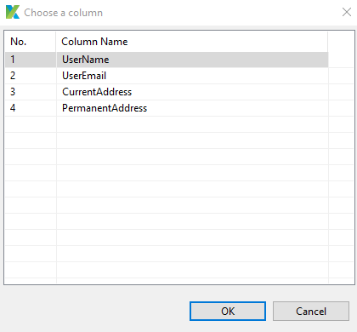

Note : Repeat the process for all the column values.

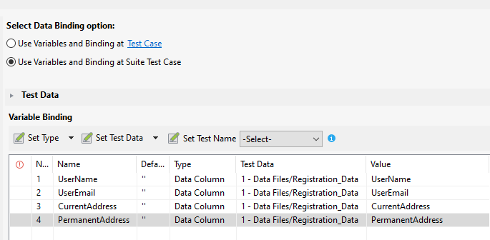

**Step 17: Go to Registration_Page Test Case.**

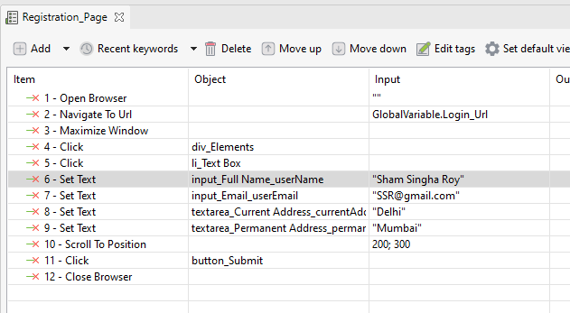

**Step 18: Click on UserName input.**

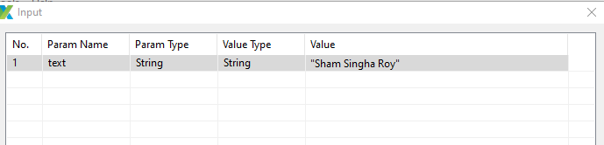

**Step 19 : Select Variable Value type.**

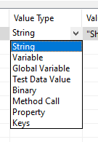

**Step 20: Select UserName as value .**

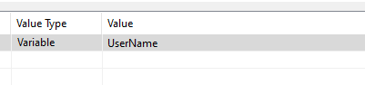

**Step 21: complete same process to all the inputs.**

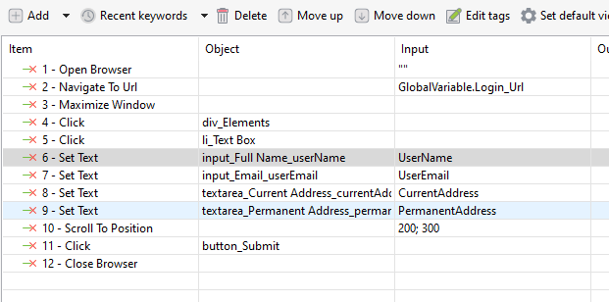

**Step 22: Go to Registration_DataSuite and Run.**