1. **Spy Web**

**Step 1**: Click on Spy Web Button.

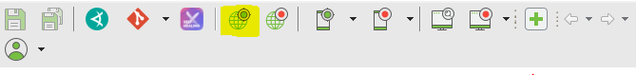

note: Object Spy window will be displayed.

**Step 2:** Enter URL and Select browser

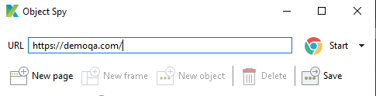

note: New browser window will be opened with entered URL.

**Step 3:** Move your mouse over the element which Xpath you want to capture.

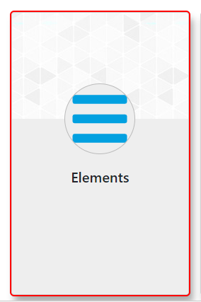

Note: Red outline will be display on the element which is selected.

**Step 4:** Click on ( Alt + ` ) to capture Xpath of Element.

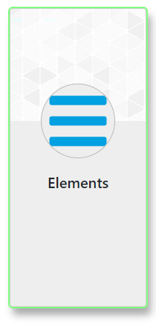

Note: Green outline will be start blinking once xpath is captured.

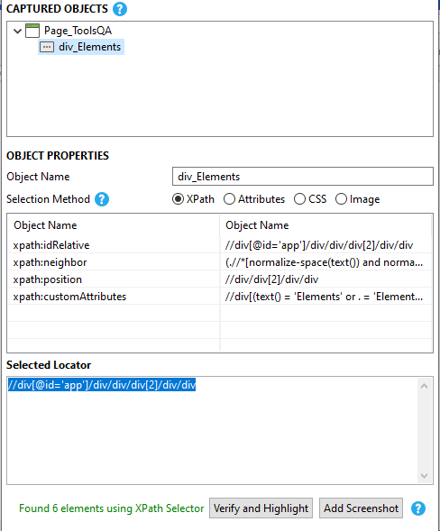

note: In object spy window we can see the element name, Selected locator, number elements match with given Xpath.

you create your own xpath using this window and you can verify and highlight the element.

**Step 5:** Click on Save button.

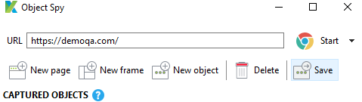

Note: Add Element to Object Repository window will be opened.

**Step 6:** Select Object Repository option and click on OK button.

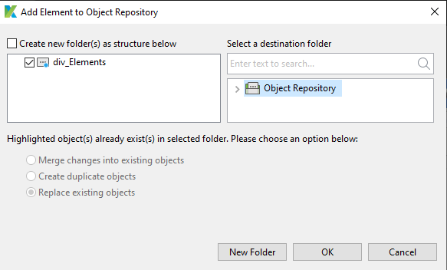

Note: Element will be saved in Object Repository.

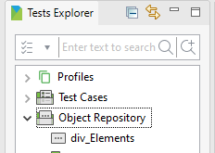

**2. Record Web**

**Step 1:** Click on Record Web Button.

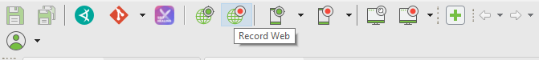

Note: Web Recorder Window will be displayed.

**Step 2:** Enter URL and Select browser.

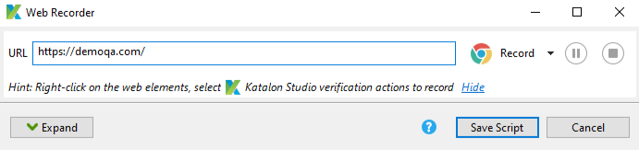

Note: New browser window will be opened with entered URL.

**Step 3:** Start with testing site with random values.

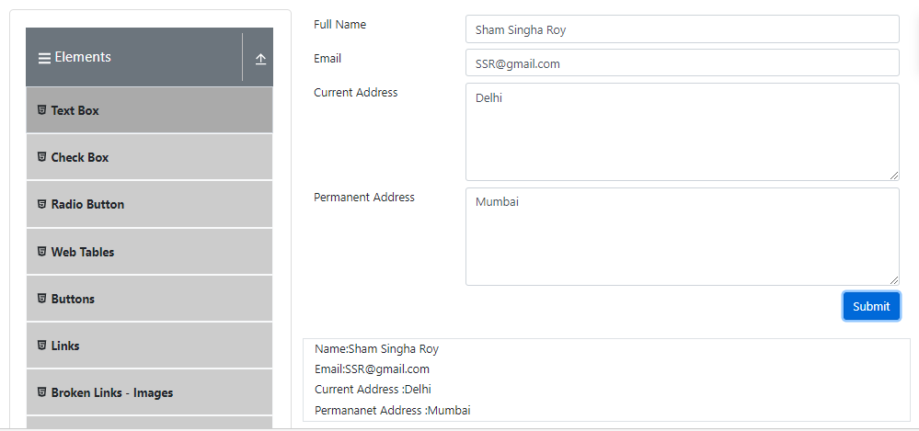

Note: Record web will capture all the action done by you and capture the xpath of element with which you interact in process.

**Step 4:** Click on Expand button to see all the captured Elements.

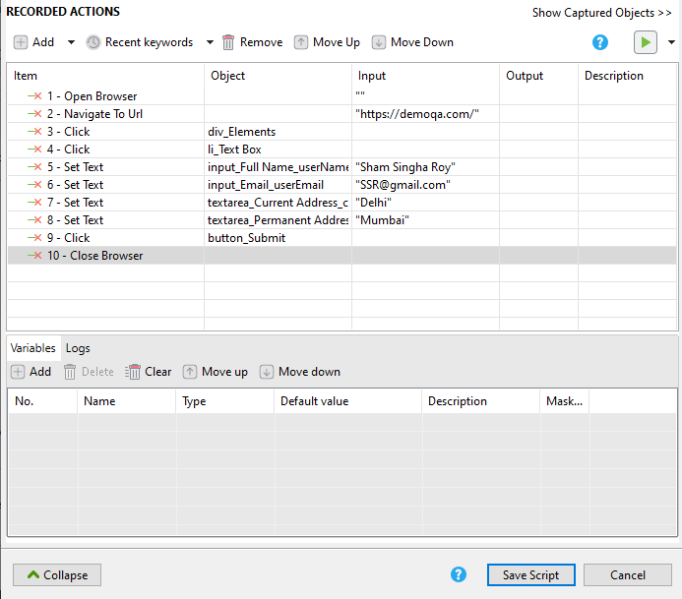

Note: Record web will capture all the inputs and click.

**Step 5**: Click on Save Script button.

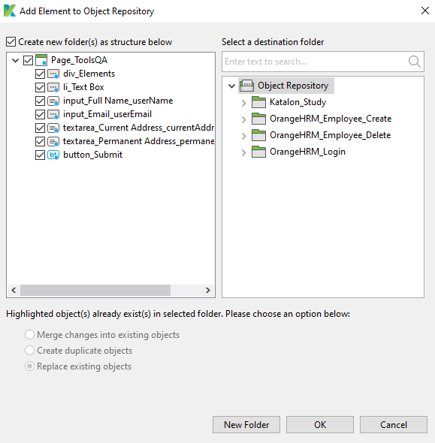

**Step 6:** Click on Ok button.

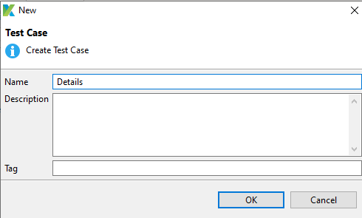

Note: New window will be opened for Test case creation. Enter name and click on Ok Button.

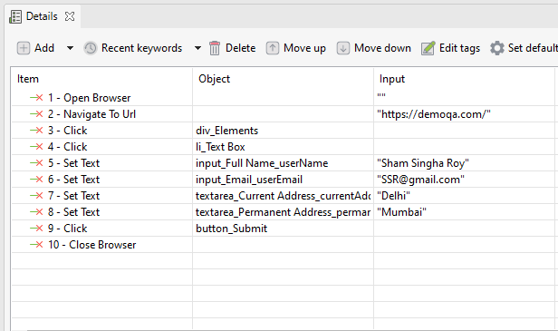

Note: Test case will be opened with all the elements.

**Step 7:** Click on Run Test case button

Note: new browser will be opened and form process will be repeated.