**Assignment-1**

**Analog Communication Lab**

% 1. Pulse waveform of width 2ms

% ------------------------------

%

% -by Subhajit Sahu, 110EC0181

%

clc;

clear all;

close all;

t = linspace(0,0.02,1000);

d = 0 : 0.02/5 : 0.02;

y = pulstran(t,d,'rectpuls',0.002);

subplot(2,1,1);

plot(t,y, 'LineWidth', 2);

title('Pulse Waveform of width 2ms');

xlabel('Time (s)');

ylabel('Amplitude');

ylim([-0.5 1.5]);

fs = linspace(-25000,25000,1000);

y1 = abs(fftshift(fft(y)));

subplot(2,1,2);

plot(fs,y1);

title('Frequency domain plot');

xlabel('Frequency (Hz)');

ylabel('Amplitude');

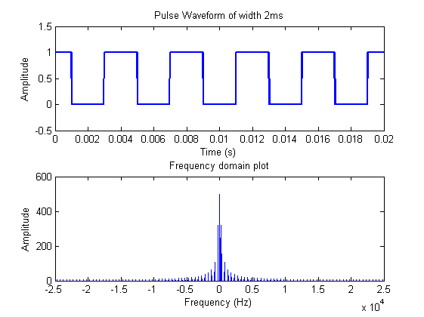

% 2. Triangular Wave of width 2ms

% -------------------------------

%

% -by Subhajit Sahu, 110EC0181

%

clc;

clear all;

close all;

t = linspace(-0.005,0.005,1000);

w = 0.002;

y = tripuls(t,w);

subplot(2,1,1);

plot(t,y);

title('Triangular wave of width 2ms');

xlabel('Time (s)');

ylabel('Amplitude');

fs = linspace(-5000,5000,1000);

y1 = abs(fftshift(fft(y)));

subplot(2,1,2);

plot(fs,y1)

title('Frequency Domain Plot');

xlabel('Frequency (Hz)');

ylabel('Amplitude');

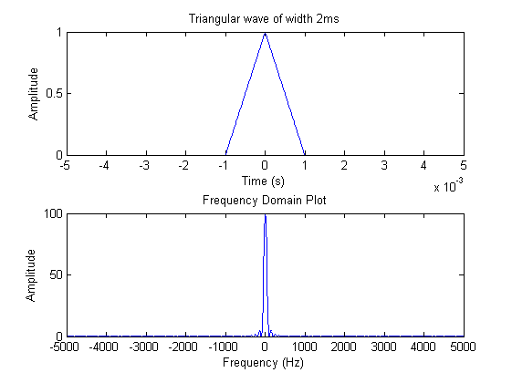

% 3. Square Wave of different amplitude and period

% ------------------------------------------------

%

% -by Subhajit Sahu, 110EC0181

%

clc;

clear all;

close all;

t = linspace(0,0.005,10000);

x = 2*square(t/(0.000025*2*pi));

subplot(3,2,1);

plot(t,x)

title('Square Wave of Period 1ms & Amplitude 2V');

xlabel('Time (s)');

ylabel('Amplitude');

fs = linspace(-1000000,1000000,10000);

y1 = abs(fftshift(fft(x)));

subplot(3,2,2);

plot(fs,y1);

title('Frequency Domain plot');

xlabel('Frequency (Hz)');

ylabel('Amplitude');

t = linspace(0,0.05,10000);

x = 4*square(t/(0.00025*2*pi));

subplot(3,2,3);

plot(t,x)

title('Square Wave of Period 10ms & Amplitude 4V');

xlabel('Time (s)');

ylabel('Amplitude');

fs = linspace(-100000,100000,10000);

y1 = abs(fftshift(fft(x)));

subplot(3,2,4);

plot(fs,y1);

title('Frequency Domain plot');

xlabel('Frequency');

ylabel('Amplitude');

t = linspace(0,0.05,10000);

x = 6*square(t/(0.00025*2*pi));

subplot(3,2,5);

plot(t,x)

title('Square Wave of Period 10ms & Amplitude 6V');

xlabel('Time (s)');

ylabel('Amplitude');

fs = linspace(-100000,100000,10000);

y1 = abs(fftshift(fft(x)));

subplot(3,2,6);

plot(fs,y1);

title('Frequency Domain plot');

xlabel('Frequency (Hz)');

ylabel('Amplitude');

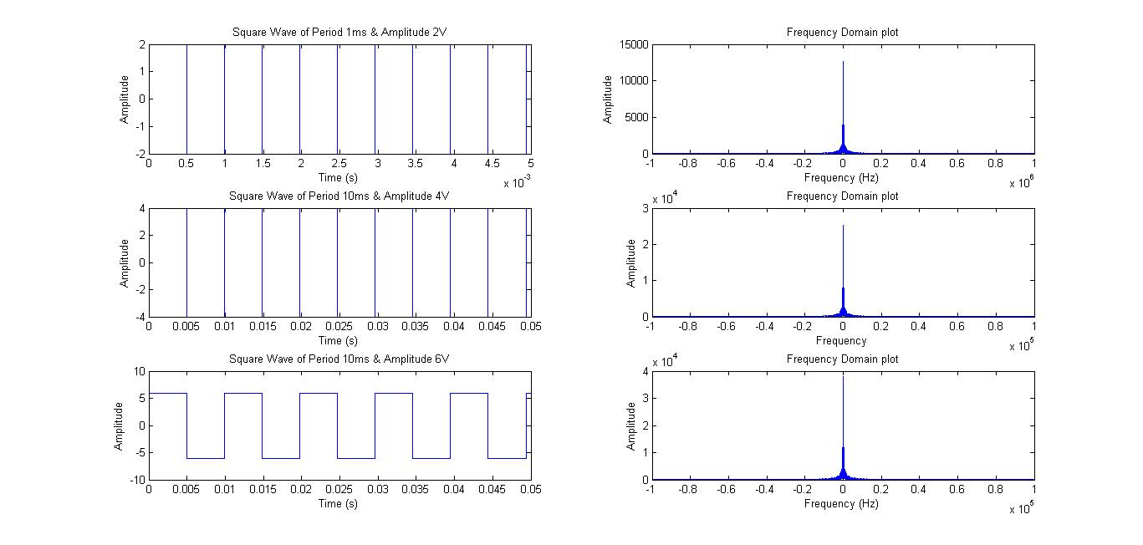

% 4. Sine wave of frequency 1kHz and sampling frequency 10kHz

% -----------------------------------------------------------

%

% -by Subhajit Sahu, 110EC0181

%

clc;

clear all;

close all;

t = linspace(0,0.04,400);

x = sin(2*pi*t*(1000));

subplot(2,1,1);

plot(t,x);

title('Sine Wave of Frequency 1kHz');

xlabel('Time (s)');

ylabel('Amplitude');

fs = linspace(-5000,5000,400);

y1 = abs(fftshift(fft(x)));

subplot(2,1,2);

plot(fs,y1);

title('Frequency Domain plot');

xlabel('Frequency (Hz)');

ylabel('Amplitude');

