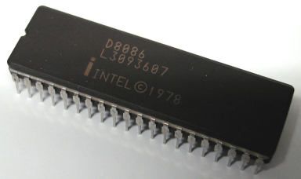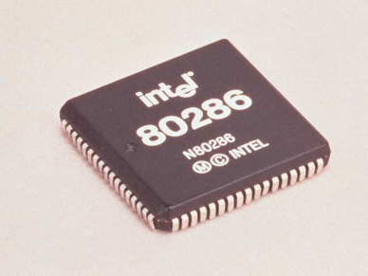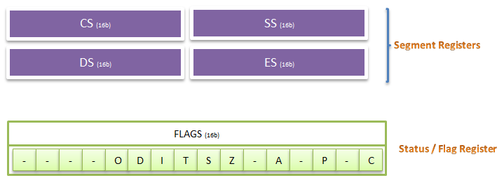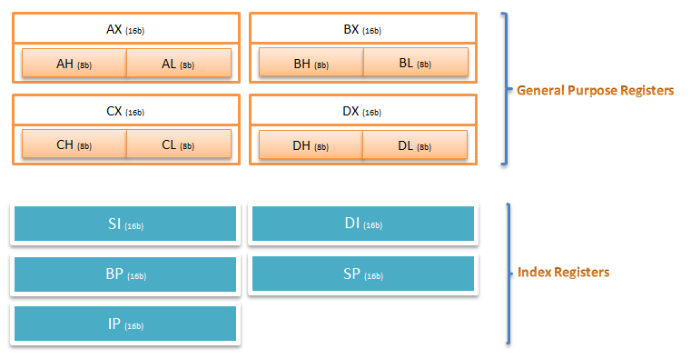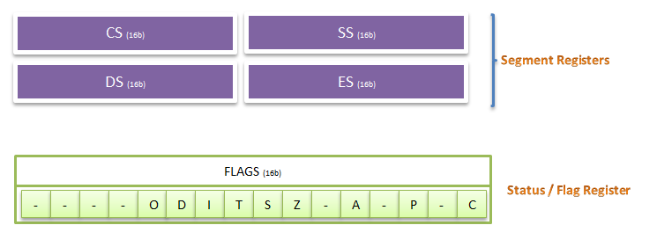

**AUTHORS**

**OMBENI KANZE KENNEDY (110EC0648)**

**KIRTIDIPAN BEHERA (110EC0159)**

**SUBHAJIT SAHU (110EC0181)**

**Register Comparison of Intel® 8086 and Intel® 80286**

**The general registers of the 80286 are the 16-bit registers AX, BX, CX, DX, SP, BP, SI, and DI. These registers are used interchangeably to contain the operands of logical and arithmetic operations.**

**Some instructions and addressing modes (see section 2.4), however, dedicate certain general registers to specific uses. BX and BP are often used to contain the base address of data structures in memory (for example, the starting address of an array); for this reason, they are often referred to as the base registers. Similarly, SI and DI are often used to contain an index value that will be incremented to step through a data structure; these two registers are called the index registers. Finally, SP and BP are used for stack manipulation. Both SP and BP normally contain offsets into the current stack. SP generally contains the offset of the top of the stack and BP contains the offset or base address of the current stack frame.**

**As shown in figure, eight byte registers overlap four of the 16-bit general registers. These registers are named AH, BH, CH, and DH (high bytes); and AL, BL, CL, and DL (low bytes); they overlap AX, BX, CX, and DX. These registers can be used either in their entirety or as individual 8-bit registers. This dual interpretation simplifies the handling of both 8- and 16-bit data elements.**

**The general registers of the 8086 are the 16-bit registers AX, BX, CX, DX, SP, BP, SI, and DI. These registers are used interchangeably to contain the operands of logical and arithmetic operations.**

**Some instructions and addressing modes, however, dedicate certain general registers to specific uses. BX and BP are often used to contain the base address of data structures in memory (for example, the starting address of an array); for this reason, they are often referred to as the base registers. Similarly, SI and DI are often used to contain an index value that will be incremented to step through a data structure; these two registers are called the index registers. Finally, SP and BP are used for stack manipulation. Both SP and BP normally contain offsets into the current stack. SP generally contains the offset of the top of the stack and BP contains the offset or base address of the current stack frame.**

**As shown in figure, eight byte registers overlap four of the 16-bit general registers. These registers are named AH, BH, CH, and DH (high bytes); and AL, BL, CL, and DL (low bytes); they overlap AX, BX, CX, and DX. These registers can be used either in their entirety or as individual 8-bit registers. This dual interpretation simplifies the handling of both 8- and 16-bit data elements.**

**Introduction**

**Late 1978: Just a short while later, Intel released the 8088. This processor also came in 4.77 8MHz flavors, and was used in many of the early IBM PC computers as it was cheap(er) to produce and of course, featured the stunning 16-bit internal design. The 8088 used an 8-bit external bus, however, because 16-bit hardware was expensive (just everything had been realized by 8-bit technology), and IBM didn't want the PC being faster than its mainframe systems. An 8-bit external bus also allowed IBM to use off-the-shelf components to make the system, resulting in higher market priority. The decision of using 8088 in IBM's PC's was a major business success for Intel, which led the company to dominance over the chip market in the following years, setting them into the place of ruling the multi-billion industry as we know it today**

**In 1985 and the years following, the 80286 was being hugely used in the next generation of IMB PC’s, the PC-AT. During the reign of the 80286, the first "chipsets" were introduced. The computer chipset was nothing more than a set of chips that replaced dozens of other peripheral chips, while maintaining identical functionality. Note that even though these processors were Intel's brainchild as for the design, there were many rip-off companies ,some useful - such as AMD, NEC, Harris, which were pushing the technology ahead and added their ideas into it; there were also some useless - such as the Soviet union.**