**Traffic Light Controller**



**PROJECT REPORT FOR THE MICROPROCESSOR LAB**

By

GROUP-1

Subhajit Sahu 110EC0181

Debashish Shanti 110EC0182

Kirtidipan Behera 110EC0159

**Under the Supervision of:**

**Prof. S. K. Patra**

**Professor-in –charge of Microprocessor Lab**

**INTRODUCTION**

A Traffic Controller is an electronic device which is used to control the operation of traffic lights primarily, the one ones that are used on the road. The techniques used to implement a traffic controller vary as per the requirement. Simple applications make use of timer based control of traffic lights, while complex traffic controllers exist which make use of CCTV cameras across the roads to monitor the traffic (as well as guess the future traffic) and accordingly switch the traffic lights ensuring as minimum congestion problems as possible, which would have been the case unless such systems had been installed.

In this project, the problem statement was to implement a traffic controller for the zebra-crossing near the Indira Gandhi Park, Rourkela. Shown below is the entrance to the IG Park obtained from the site: <http://rourkela.com/2010/07/i-g-park/>.

*Old IG Park Entrance*

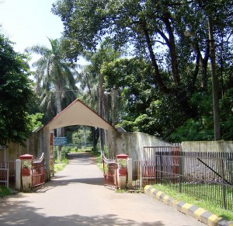

**Traffic Light arrangement at the Zebra-crossing near the IG Park**

At the Zebra-crossing near the IG Park, there is a two-lane road connected perpendicularly to a single lane road to the left (considering that you are coming from the Railway station to the NIT Rourkela). This requires the use of three traffic lights (with red, yellow and green lights) for the road traffic control for full automation. Keeping this image in mind, the modal logic has been devised and accordingly further steps of design and implementation were carried out.

*Traffic Light Arrangement at the Zebra-crossing near the IG Park*

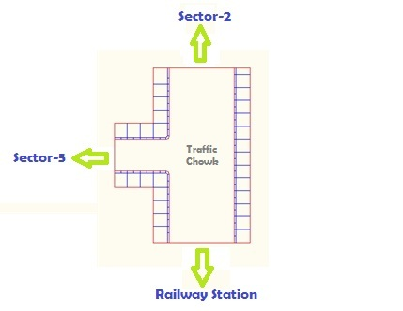

**Modality**

Let Traffic Light be represented by TL. Let the TL on Sector-5 side be known as S5, the one on Sector-2 side be known as S2, and the one on Railway station side be known as RS. Let the traffic on S5 side be known as TS5, the one on S2 side be known as TS2, and the one on RS side be known as TRS.

Cases:

1. When TS5 want to cross, TS2 and TRS need to be stopped.
2. When TS2 want to cross, TS5 and TRS need to be stopped.
3. When TRS want to cross, TS2 and TS5 need to be stopped.

*Case Table*

|  |  |  |  |
| --- | --- | --- | --- |
| Case | S5 State | S2 State | RS State |
| TS5 to cross | Go | Stop | Stop |
| TS2 to cross | Stop | Go | Stop |
| TRS to cross | Stop | Stop | Go |

**TIMING**

The Traffic light controller being implemented in this project is a timing-based traffic light controller. The detailed timing table of the traffic lights has been shown below which provides the entire logic to write the program for implementation of the traffic light controller.

*Timing table for implementation on Traffic light controller*

|  |  |  |  |  |  |  |  |  |  |
| --- | --- | --- | --- | --- | --- | --- | --- | --- | --- |
| *Time* | Traffic Light – S5 | | | Traffic Light – S2 | | | Traffic Light – RS | | |
| Red | Yellow | Green | Red | Yellow | Green | Red | Yellow | Green |
| *0 sec.* | Off | On | Off | On | Off | Off | On | Off | Off |
| *5 sec.* | Off | Off | On | On | Off | Off | On | Off | Off |
| *50 sec.* | On | Off | Off | Off | On | Off | On | Off | Off |
| *55 sec.* | On | Off | Off | Off | Off | On | On | Off | Off |
| *100 sec.* | On | Off | Off | On | Off | Off | Off | On | Off |
| *105 sec.* | On | Off | Off | On | Off | Off | Off | Off | On |
| *150 sec.* | repeat | repeat | repeat | repeat | repeat | repeat | repeat | repeat | repeat |

**Design Methodology**

The Circuit has been designed as an I/O device for the 8086 microprocessor to be connected to the 3 ports of the 8255 programmable peripheral interface. It was specifically designed for the purpose of simulating the working of traffic lights, similar to the one that is installed near the Indira Gandhi Park Rourkela.

A special program would be assembled into an 8086 microprocessor kit, which would send control bits to the designed I/O device through the 8085 programmable peripheral interface in I/O mode. The program would be simply a delay-based program to implement the timing table shown above.

*8255 I/O Register usage*

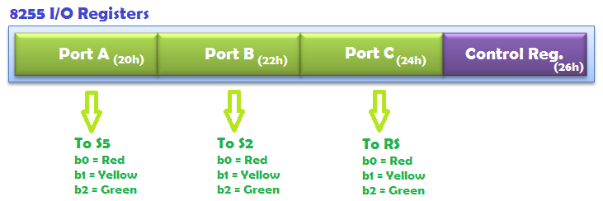

*Block diagram of proposed hardware*

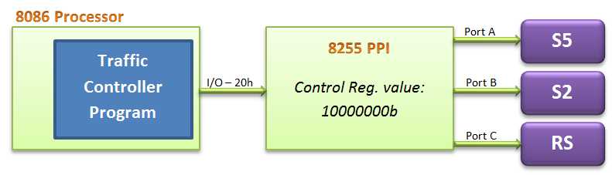

**COMPONENTS USED**

1. Red LED x 3
2. White LED x 3
3. Blue LED x 3
4. BC547 NPN BJT x 9
5. Resistor 4.7kΩ x 9
6. 3-pin 90° Berg Strip x 3
7. Prototyping PCB Board x 1

**TRAFFIC LIGHT CONTROLLER PROGRAM FOR 8086 Microprocessor**

Given below is the program assembled for the 8086 microprocessor kit by VI Micro. The program is assembled into the kit using the assemble command “**A**” at start address **1000h**. The program is then executed by using “**GO 1000**” once the output pins of the 8255 PPI at base address 20h is connected to the Traffic light hardware implemented by us.

*; Initialize the 8255 PPI at 20h to I/O mode, Mode 0, Port A, B, C = Output*

mov al, 80h

out 26h, al

*; Allow TS5 to cross*

start:

mov al, 2

out 20h, al

mov al, 1

out 22h, al

out 24h, al

call delay5

mov al, 4

out 20h, al

call delay45

*; Allow TS2 to cross*

mov al, 2

out 22h, al

mov al, 1

out 20h, al

out 24h, al

call delay5

mov al, 4

out 22h, al

call delay45

*; Allow TRS to cross*

mov al, 2

out 24h, al

mov al, 1

out 20h, al

out 22h, al

call delay5

mov al, 4

out 24h, al

call delay45

jmp start

*; Subroutine to perform a delay of 45 sec*

delay45:

mov cx, 9

delay45_loop:

call delay5

dec cx

jnz delay45_loop

ret

*; Subroutine to perform a delay of 5 sec*

delay5:

mov bx, 2800h

delay5_loop1:

mov dx, 0

delay5_loop2:

dec dx

jnz delay5_loop2

dec bx

jnz delay5_loop1

ret

**RESULT**

The Traffic controller was successfully implemented and tested using the 8086 microprocessor kit by VI Micro. To assemble the program, labels were replaced by requisite offset values. The output timing was close to the desired timing values. Given below is the hardware developed for the project.

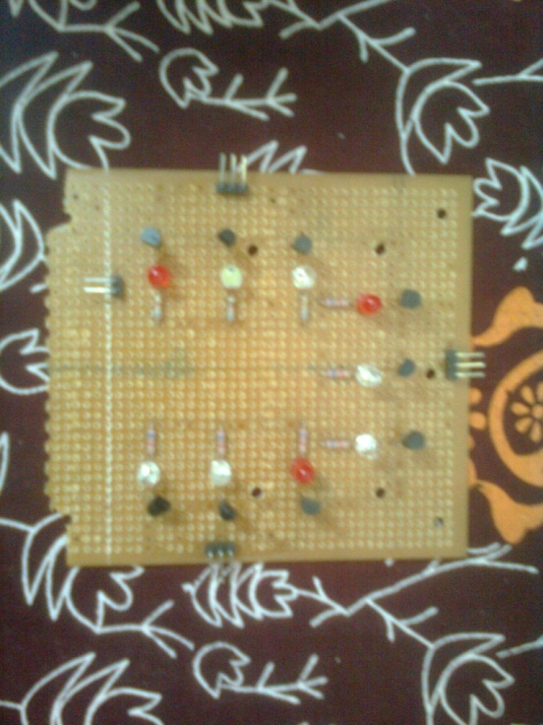

**HARWARE DESIGN NOTE**

The circuit essentially consists of 9 LEDs in groups of 3, each group representing a traffic light. Each group of LEDs has LEDs of 3 different colours – (Red, White, Blue) representing the colours of a traffic light. Each LED can be controlled by the 8086 microprocessor by the 9 pins provided on the circuit. Additionally, there are two power pins which need to be provided for the circuit to work. The circuit uses 9 NPN transistors to control the output of LEDs.

**CONCLUSION**

A Timer-based traffic light controller is not difficult to implement for a 3rd year B. Tech. student in terms of knowledge, but requires a great deal of time and effort to be put in, to be able to complete the project.

*Spectacular monument at the end of IG Park*

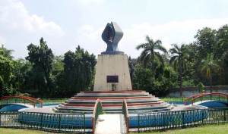

*Note: National Institute of Technology, Rourkela Logo Credit –* [*http://nitrkl.ac.in*](http://nitrkl.ac.in)

*Note: Cartoon Traffic Light Image Credit –* [*http://blog.scooterunderground.ca/*](http://blog.scooterunderground.ca/)

*Note: IG Park, Rourkela Images Credit –* [*http://rourkela.com/2010/07/i-g-park/*](http://rourkela.com/2010/07/i-g-park/)