915 MHz QPSK signal – Channel power

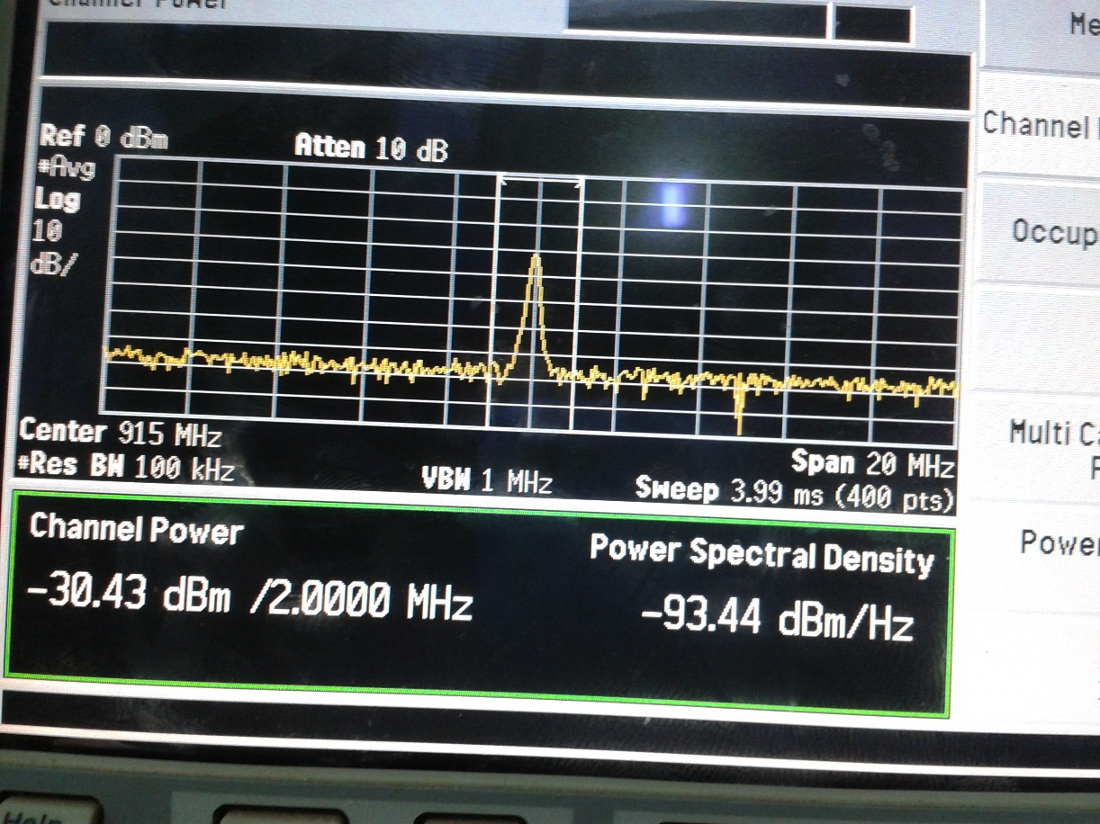

915 MHz QPSK signal – Output power

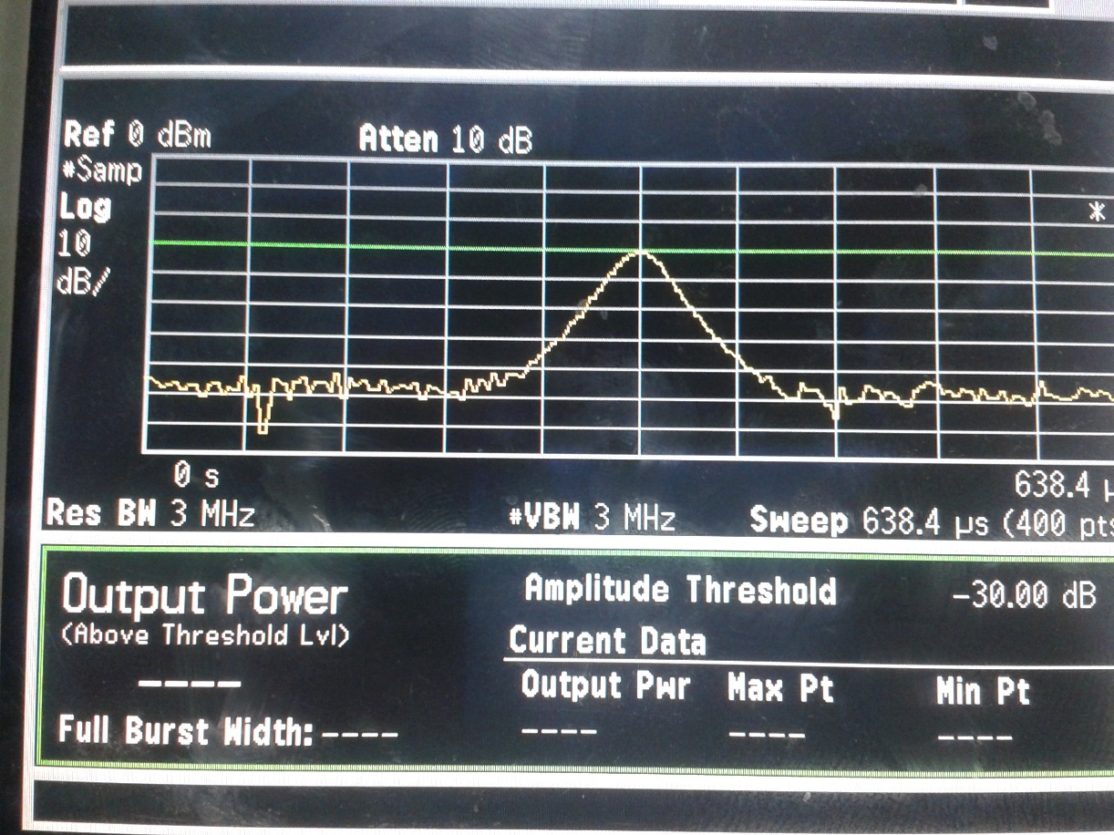

915 MHz QPSK signal – Occupied Bandwidth

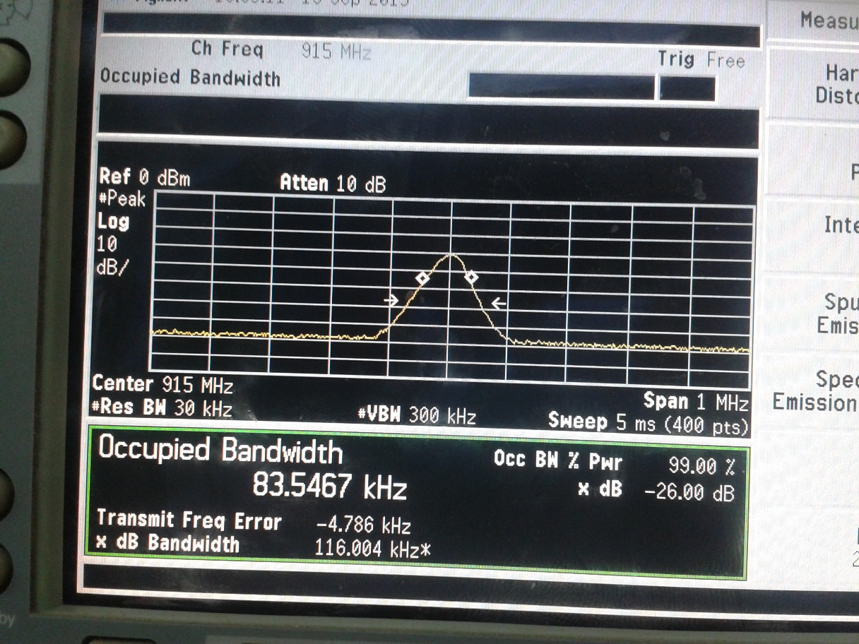

10MHz QPSK Signal – IQ diagram

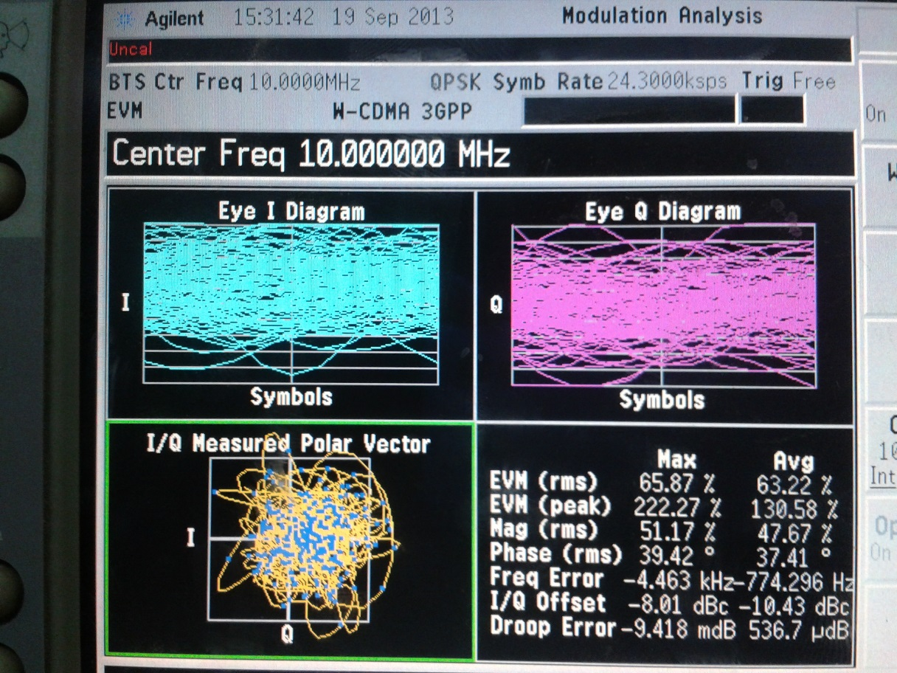

10MHz QPSK Signal – Power Stat CCDF

