913 MHz QPSK signal – Channel power

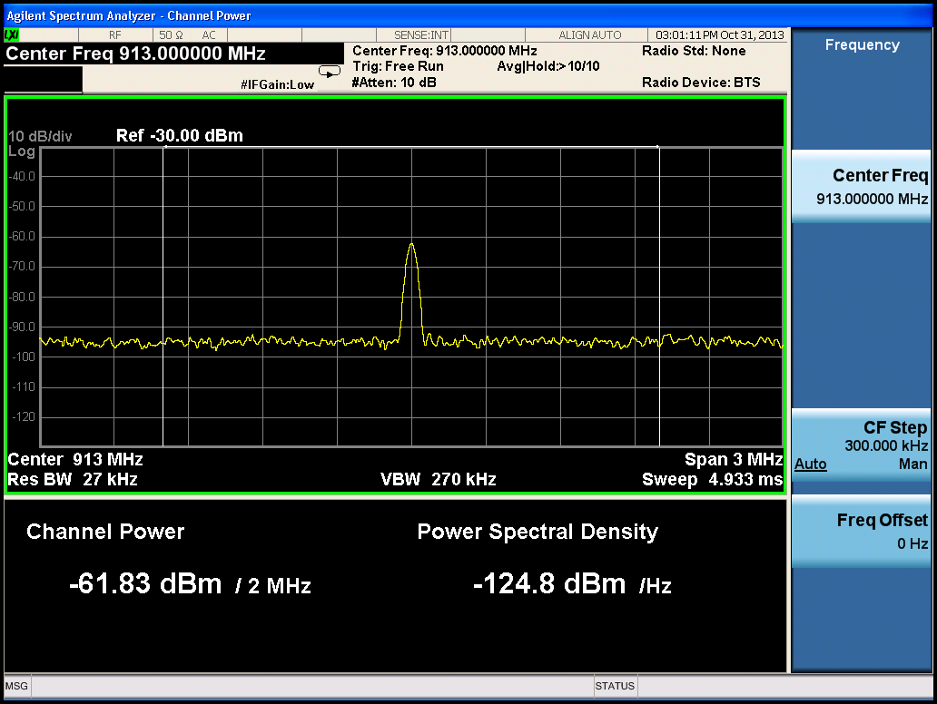

913 MHz QPSK signal – Occupied Bandwidth

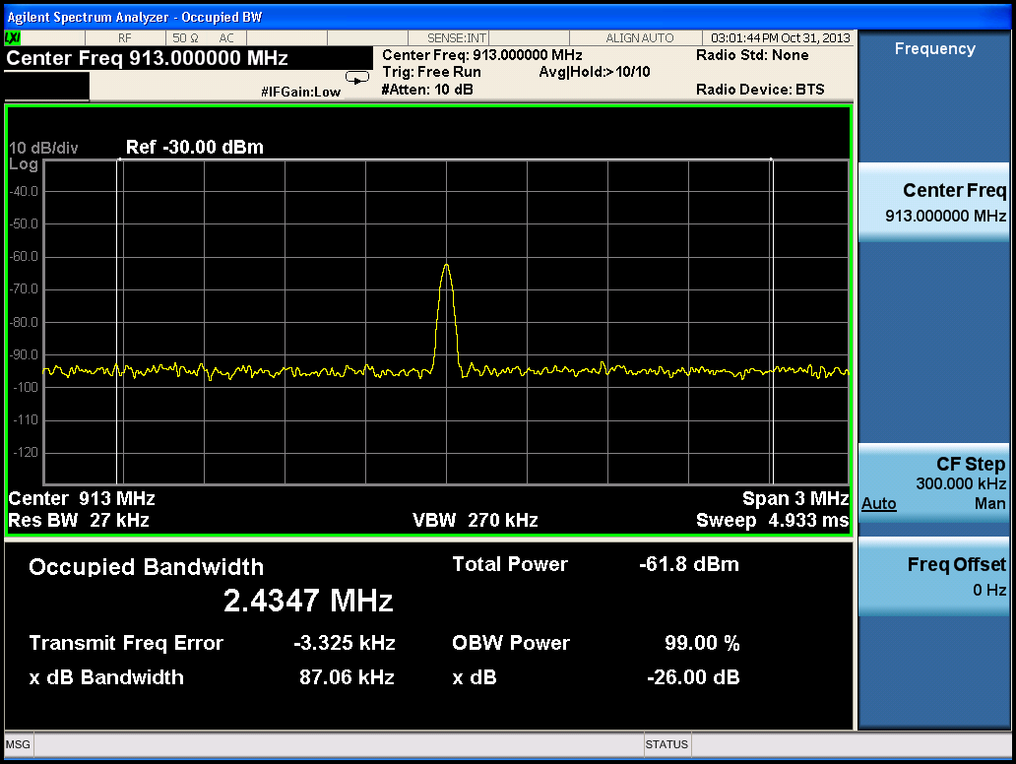

913 MHz QPSK signal – Spurious Emissions

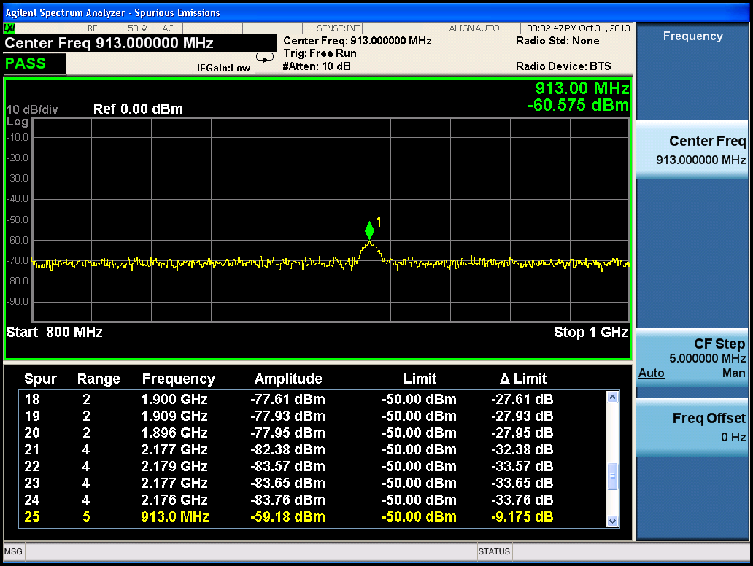

913MHz QPSK Signal – Complex Spectrum

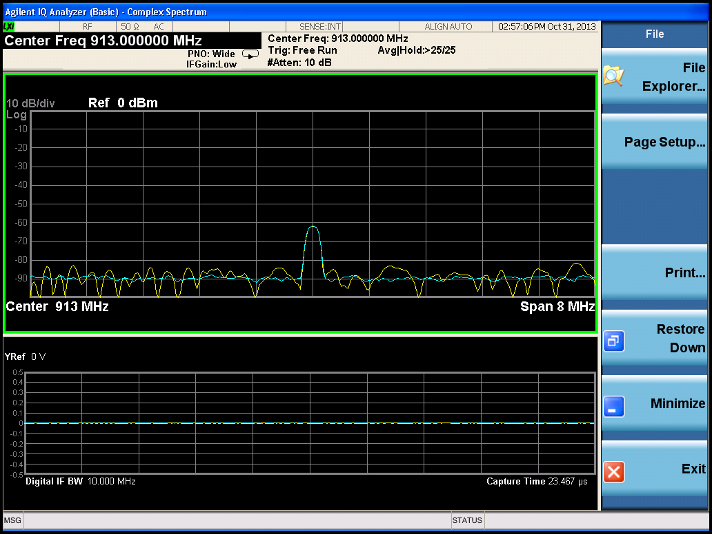

913MHz QPSK Signal – Swept SA

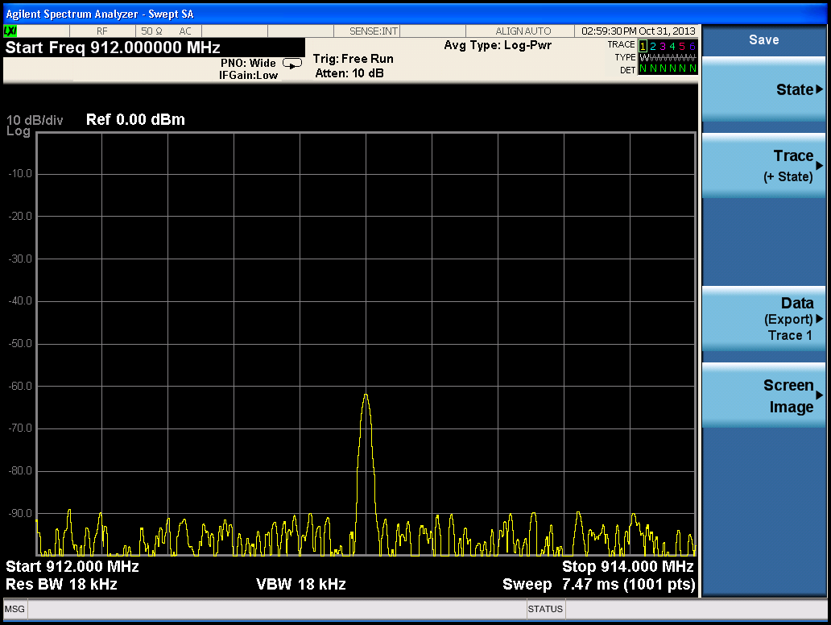

913 MHz QPSK signal – ACP

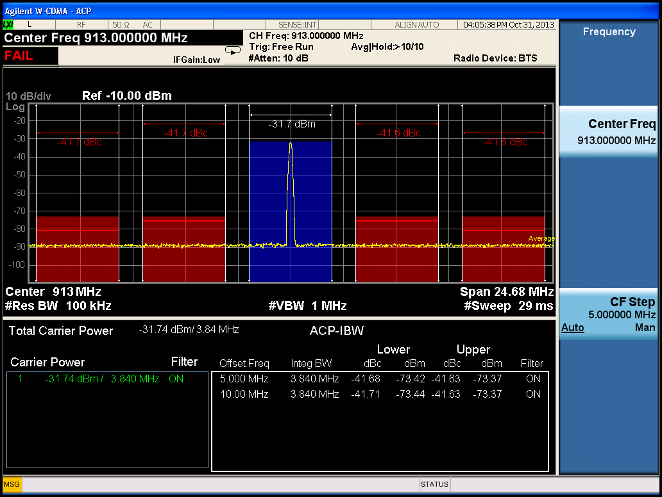

913 MHz QPSK signal – IQ Constellation Diagram with EVM

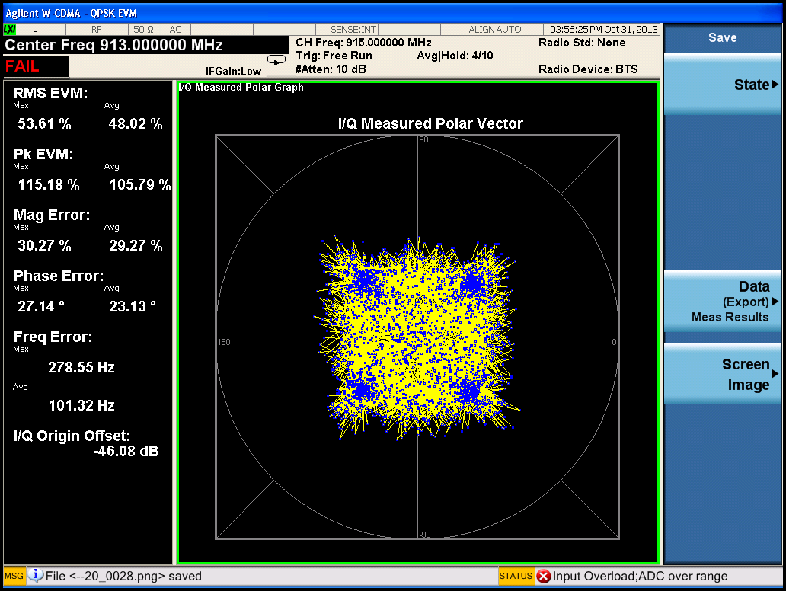

913 MHz QPSK signal – Power Stat CCDF

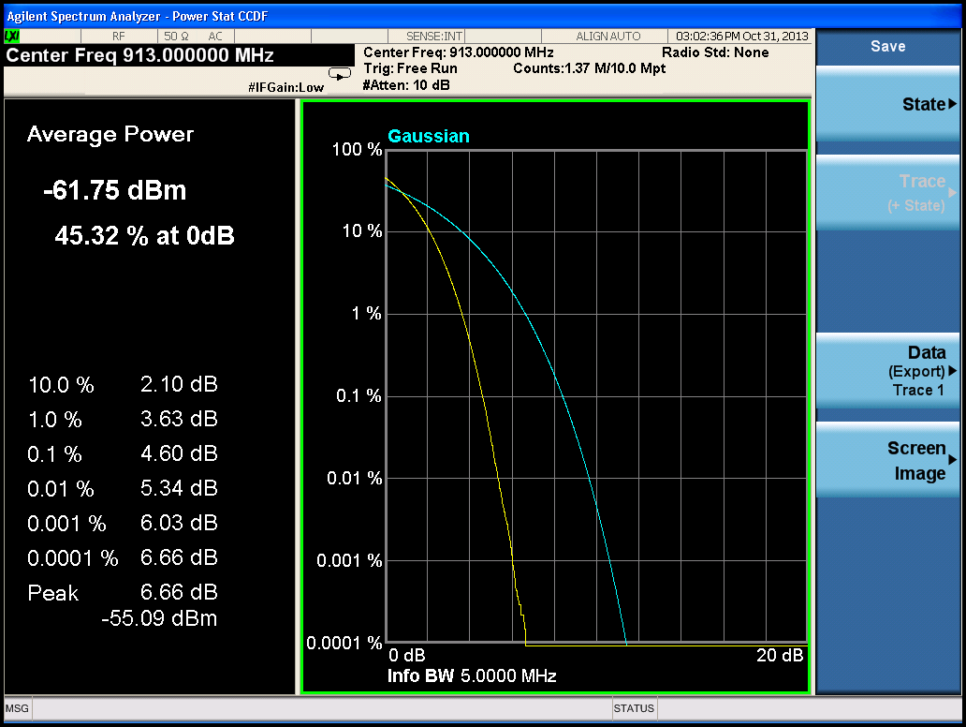

915 MHz 16QAM signal – Channel power

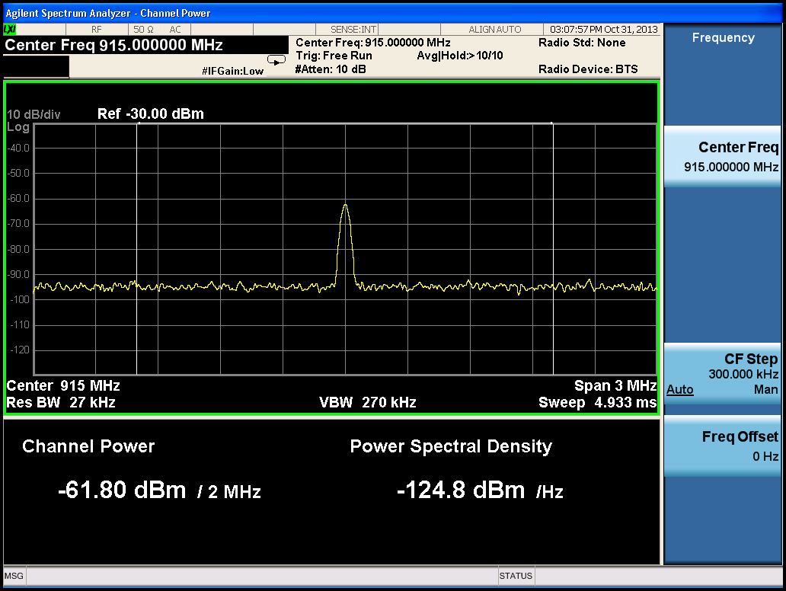

915 MHz 16QAM signal – Occupied Bandwidth

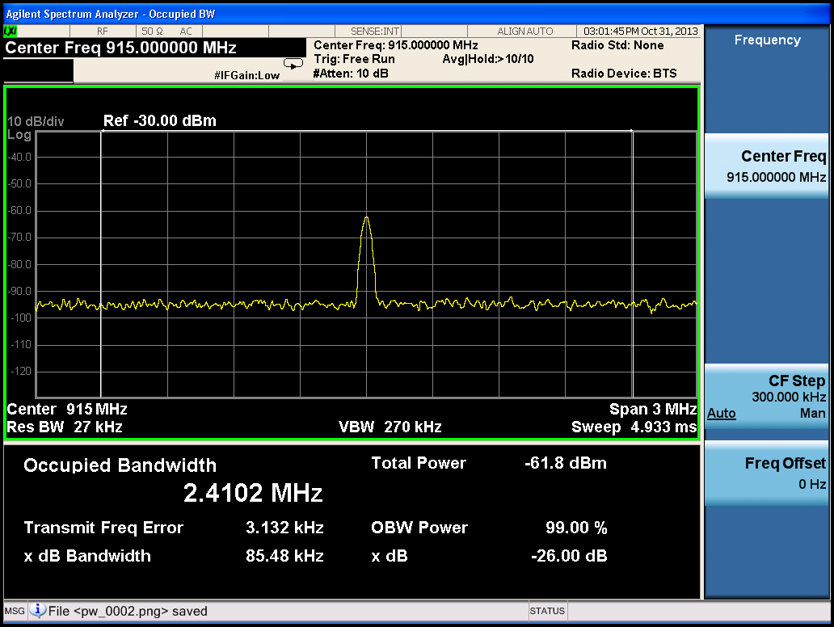

915 MHz 16QAM signal – Spurious Emissions

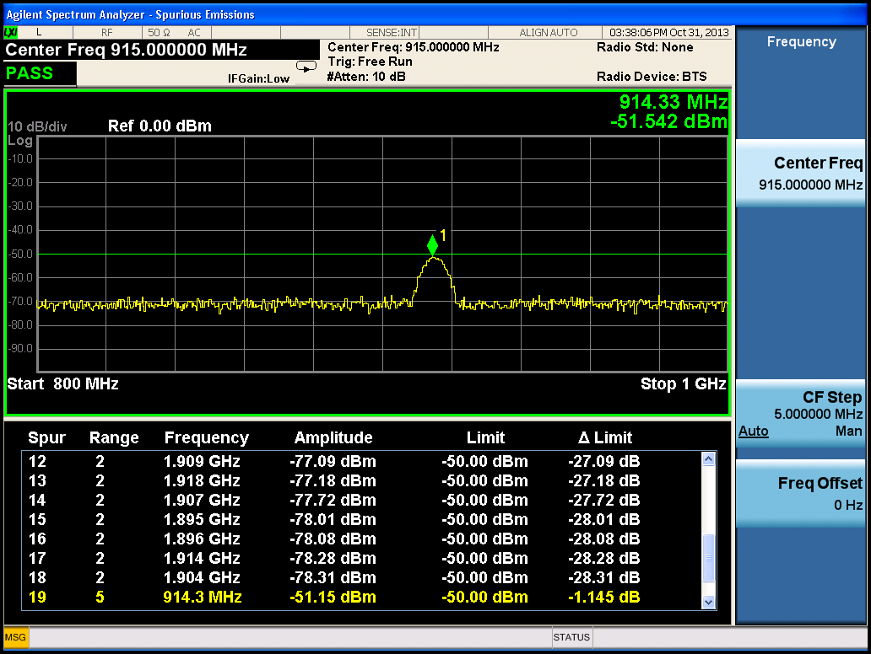

915MHz 16QAM Signal – Complex Spectrum

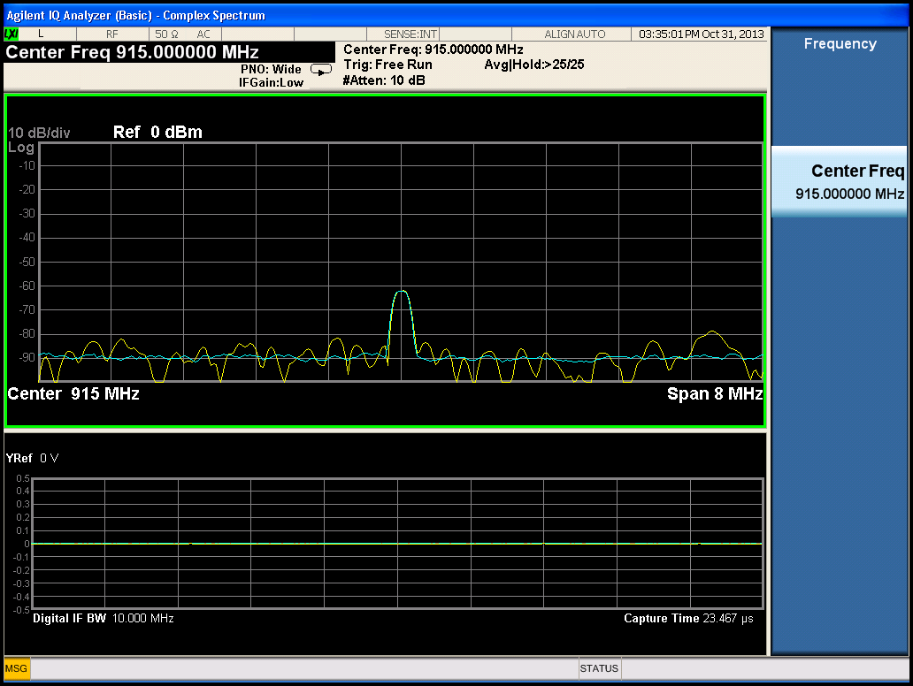

915MHz 16QAM Signal – Swept SA

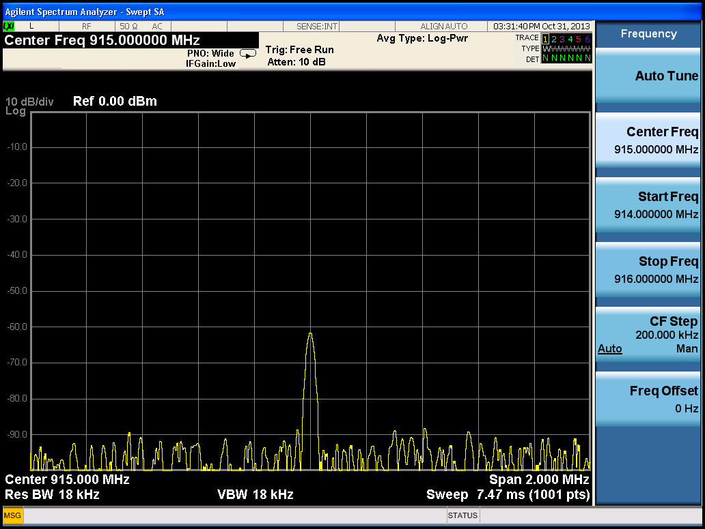

915 MHz 16QAM signal – ACP

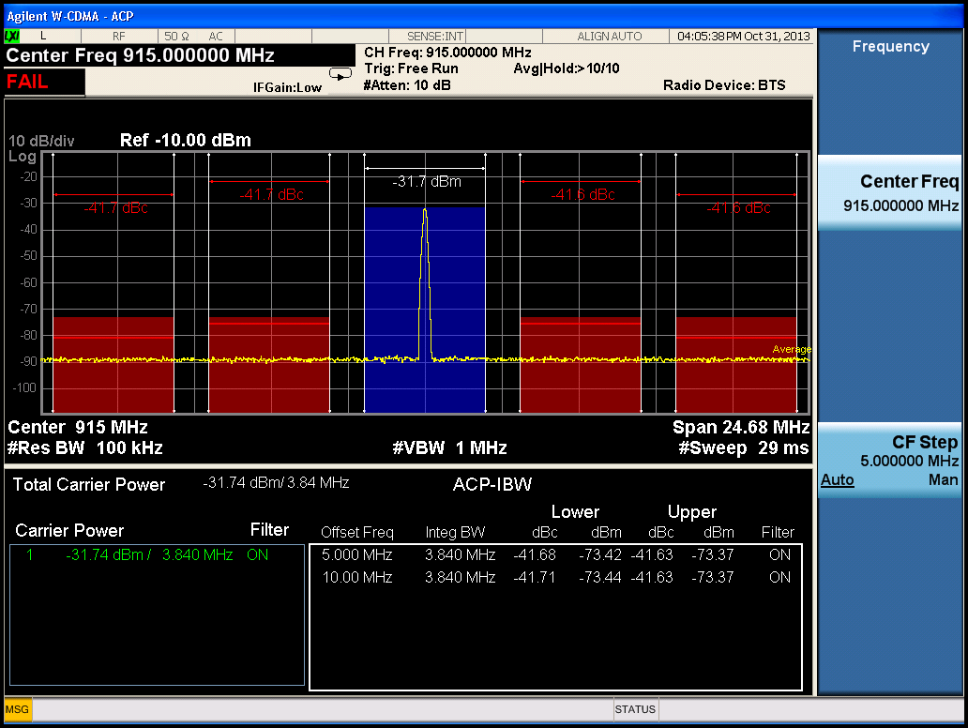

915 MHz 16QAM signal – IQ Constellation Diagram with EVM

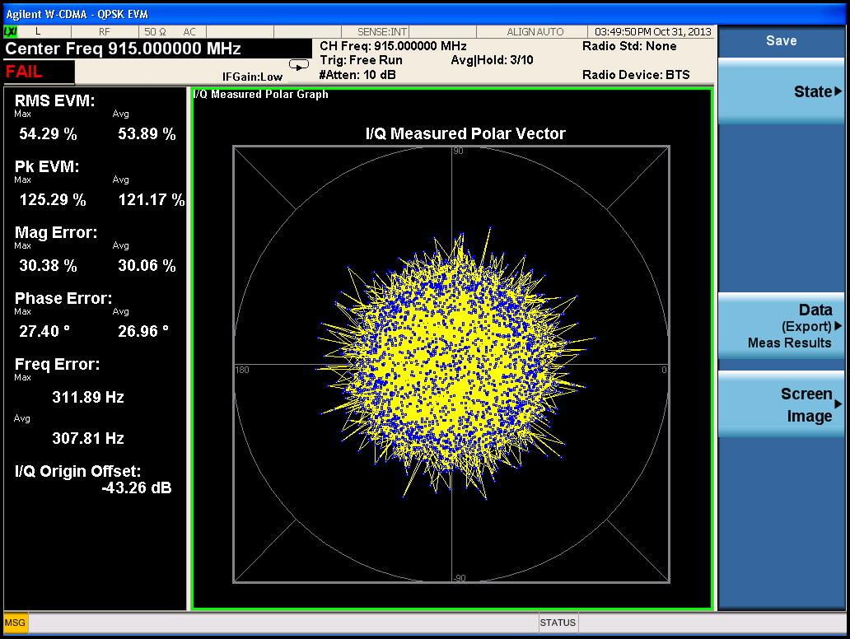

915 MHz 16QAM signal – Power Stat CCDF

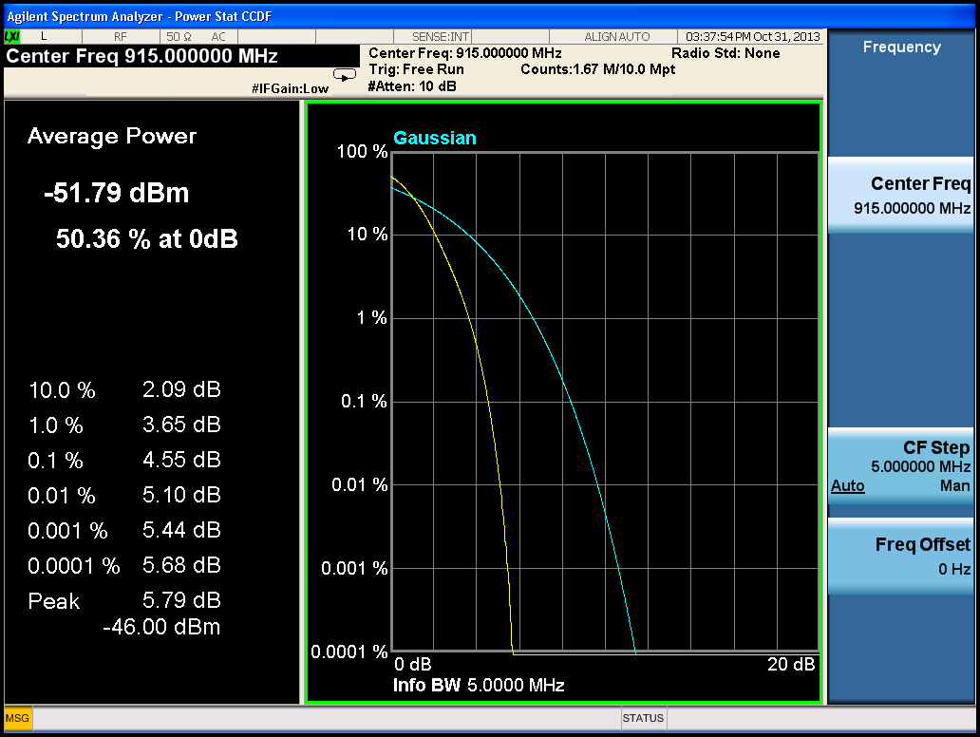

917 MHz 64QAM signal – Channel power

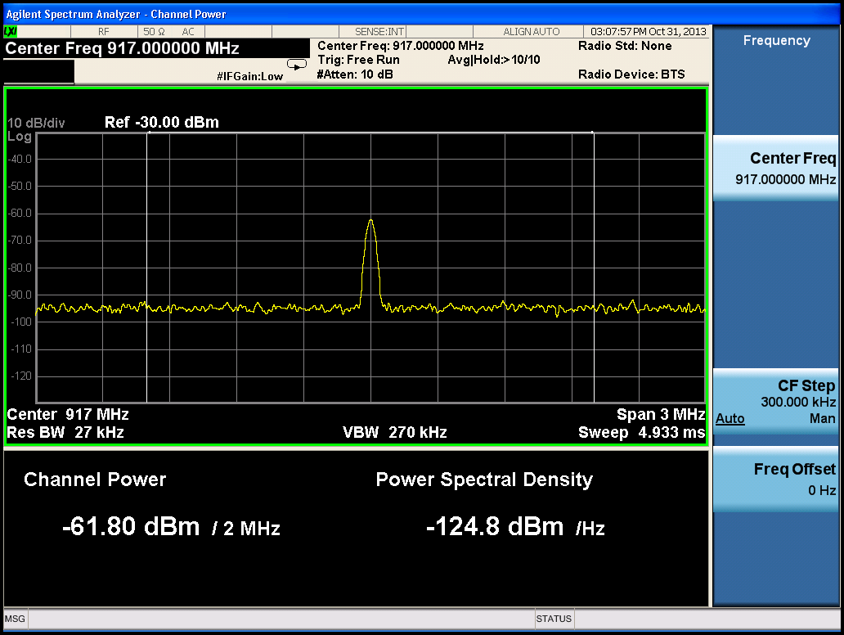

917 MHz 64QAM signal – Occupied Bandwidth

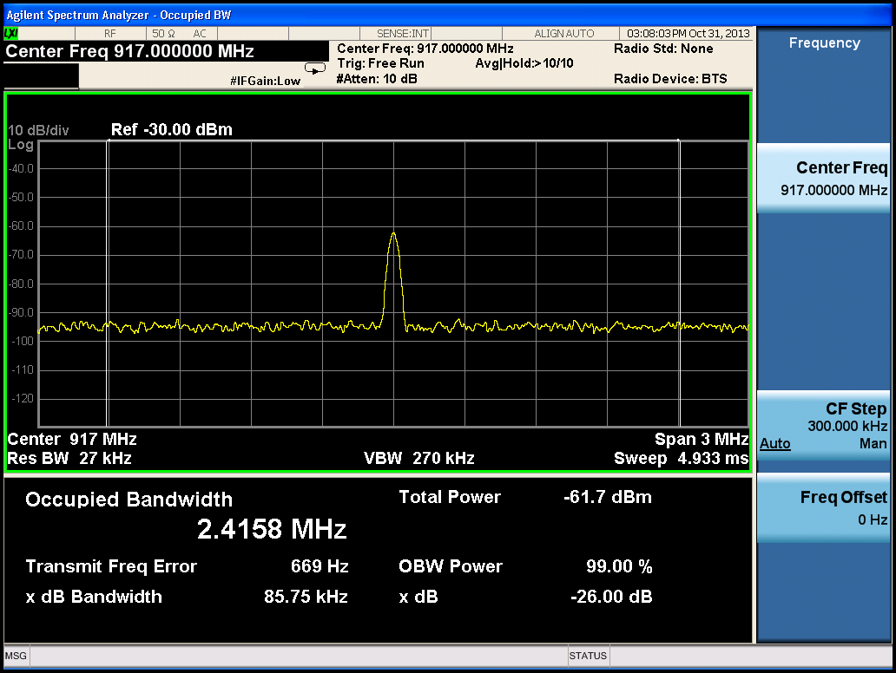

917 MHz 64QAM signal – Spurious Emissions

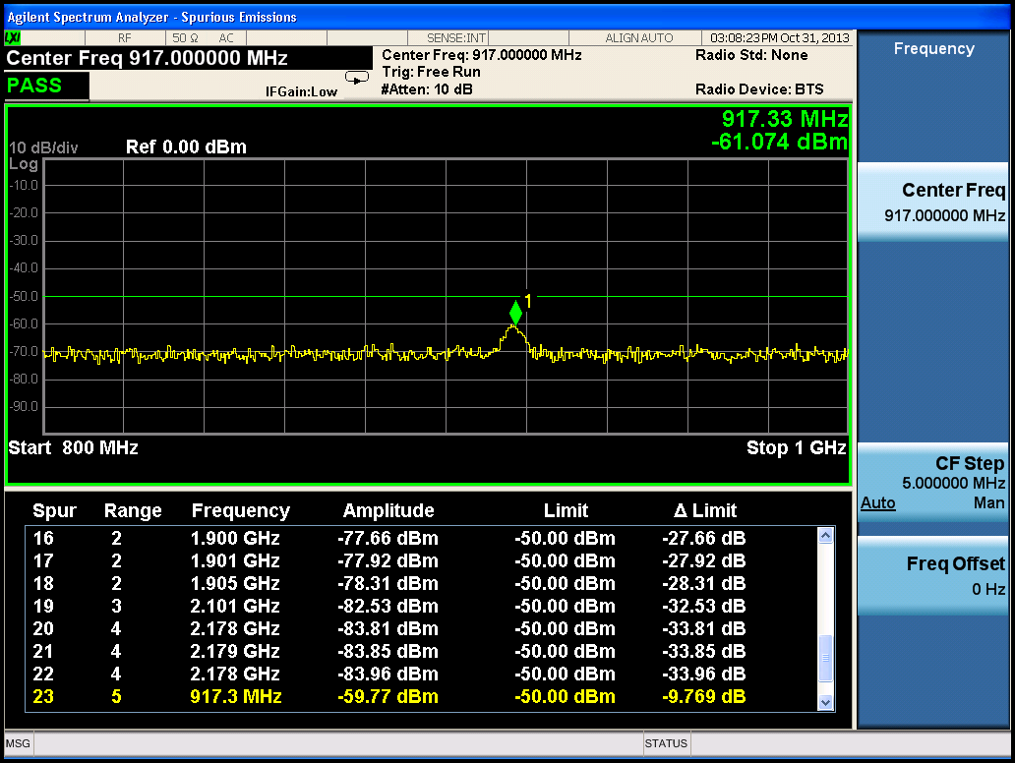

917MHz 64QAM Signal – Complex Spectrum

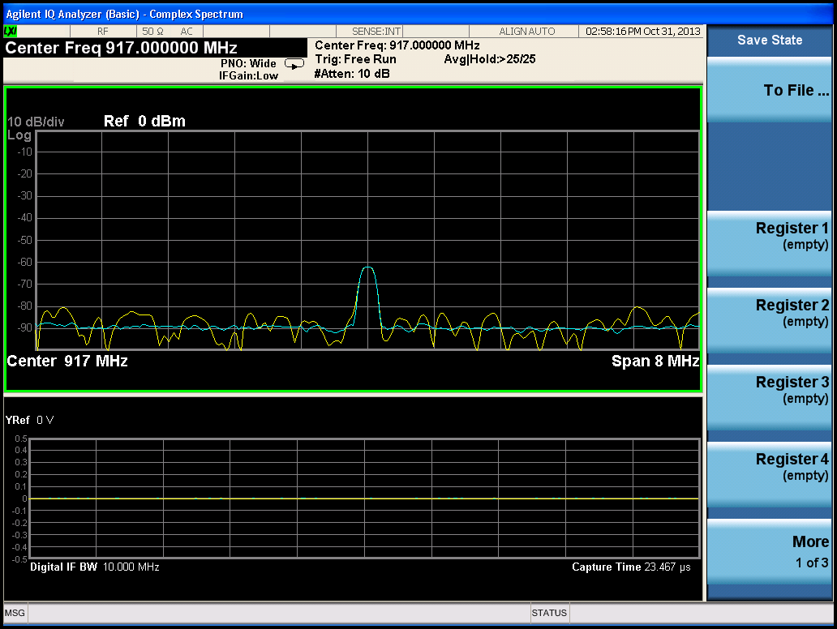

917MHz 64QAM Signal – Swept SA

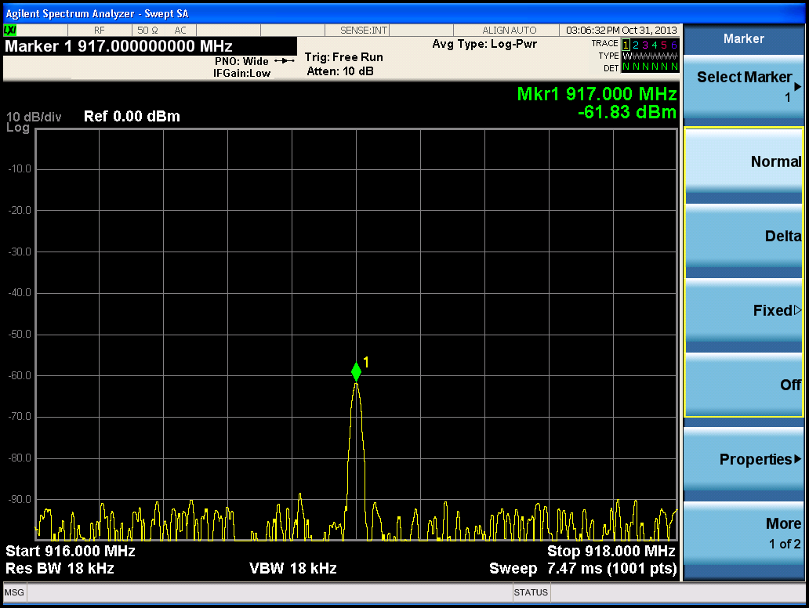

917 MHz 64QAM signal – ACP

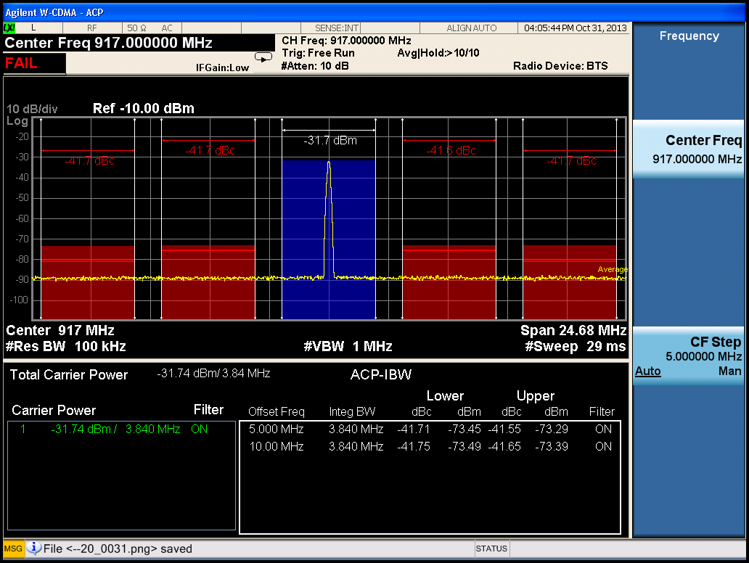

917 MHz 64QAM signal – IQ Constellation Diagram with EVM

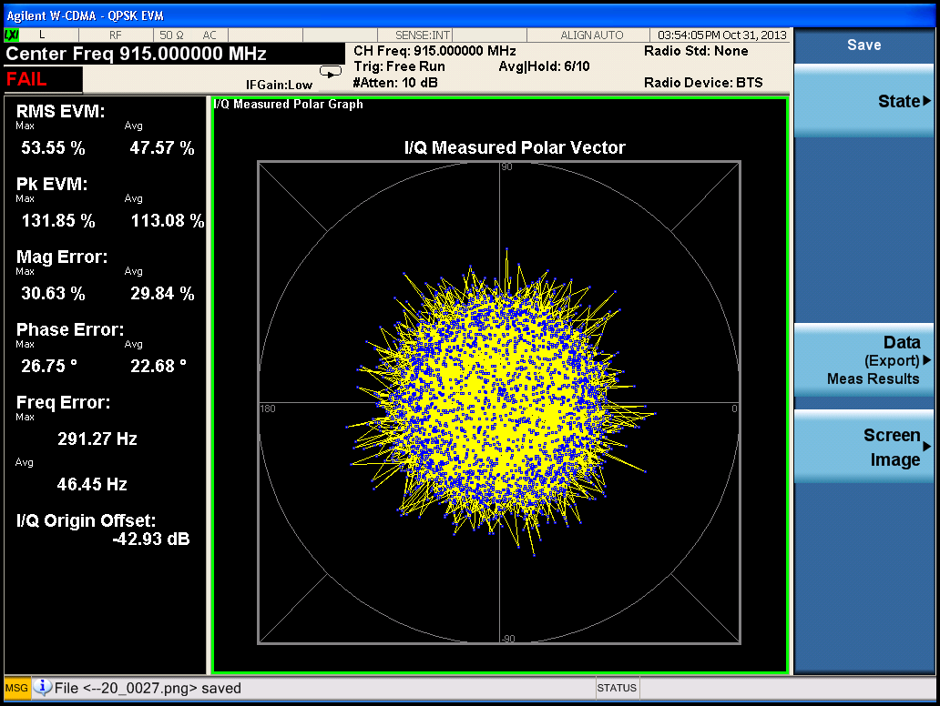

917 MHz 64QAM signal – Power Stat CCDF

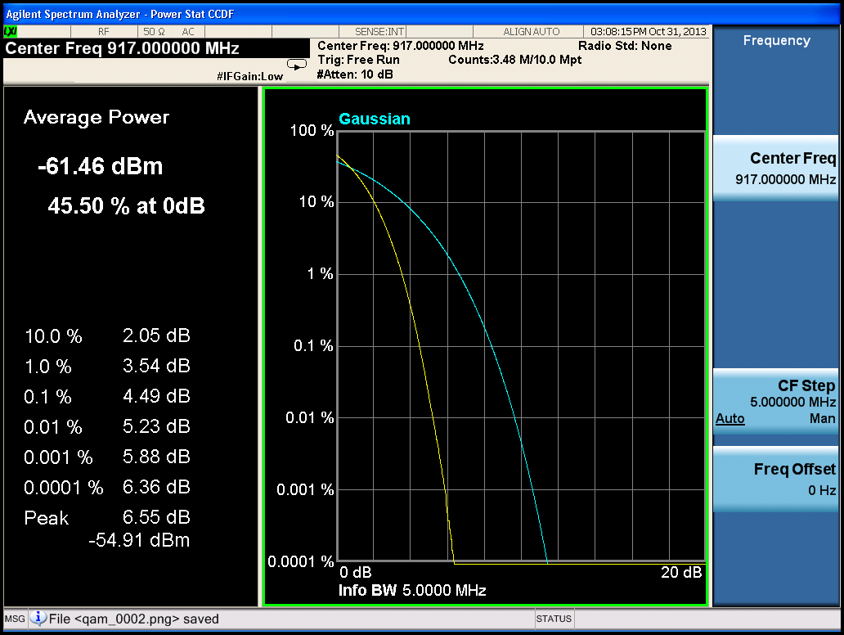

917 MHz 64QAM signal – Spectral Emission Mask

