OOK – Integrate and Dump Stage Output, Input Message Signal

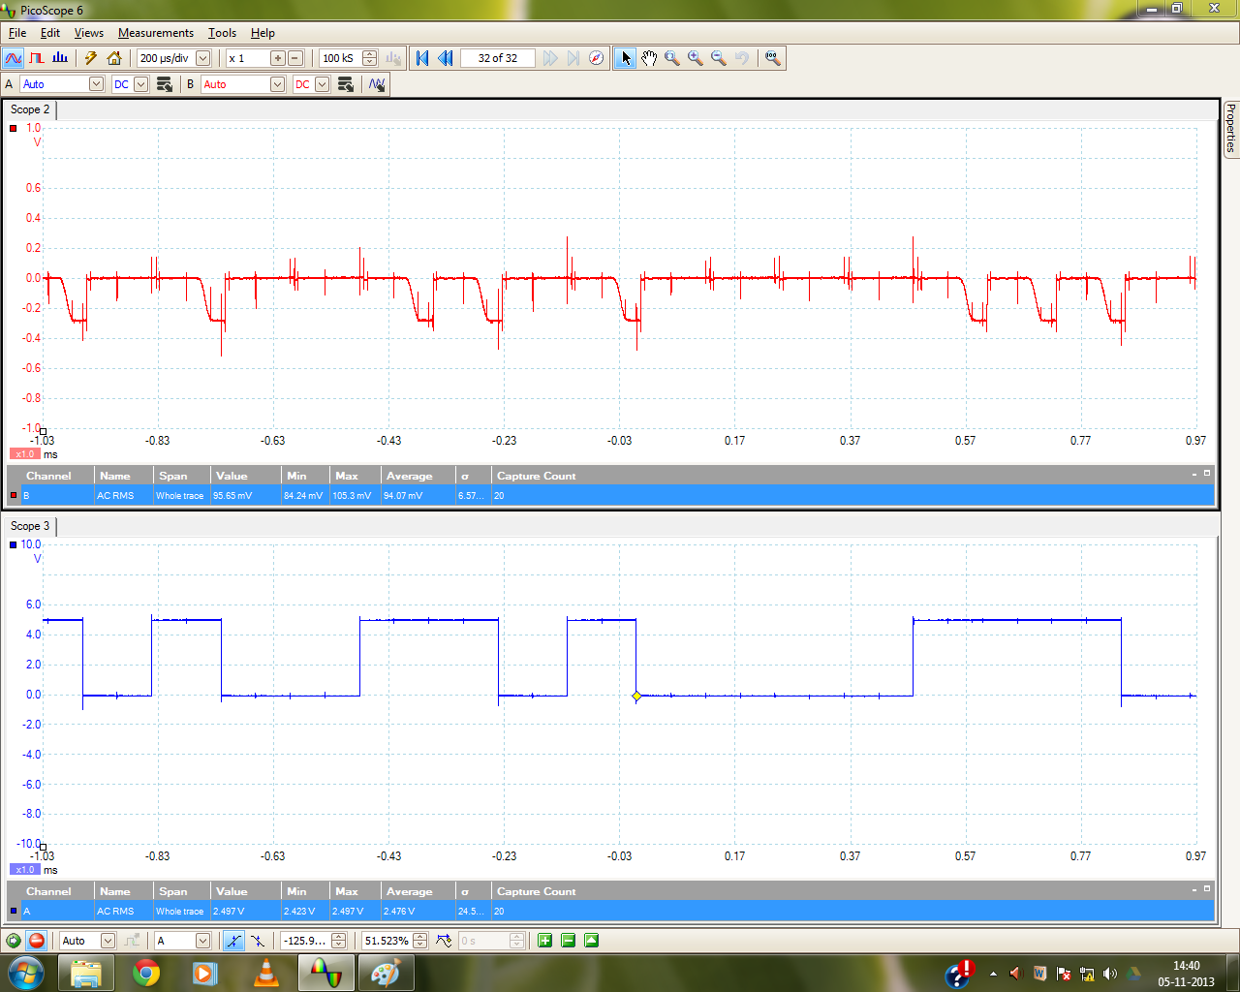

OOK – UWB OOK Modulated Signal, Input Message Signal

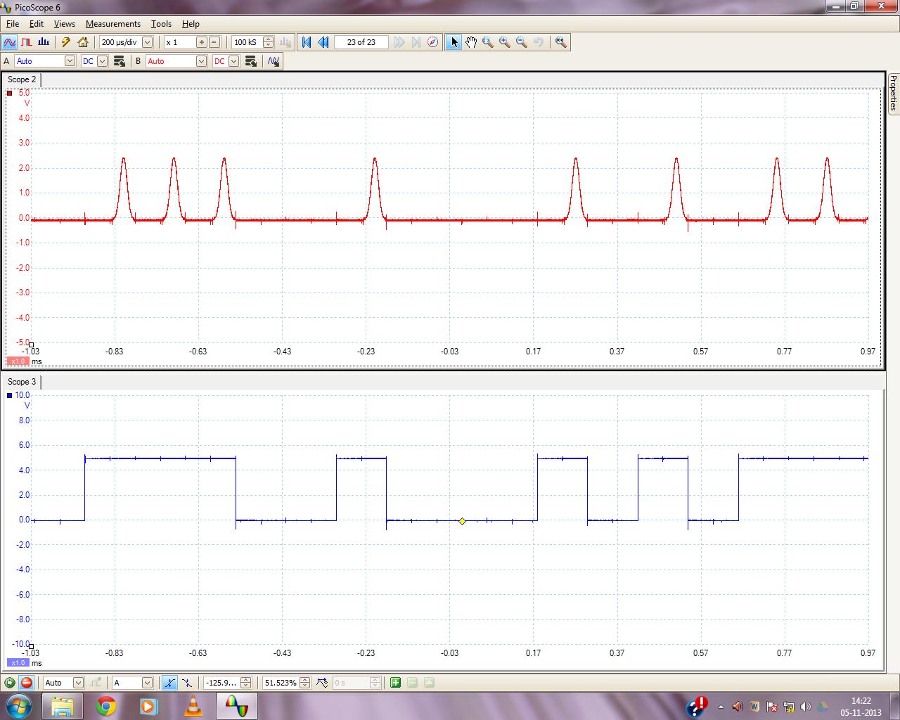

OOK – UWB OOK Demodulated Signal, Input Message Signal

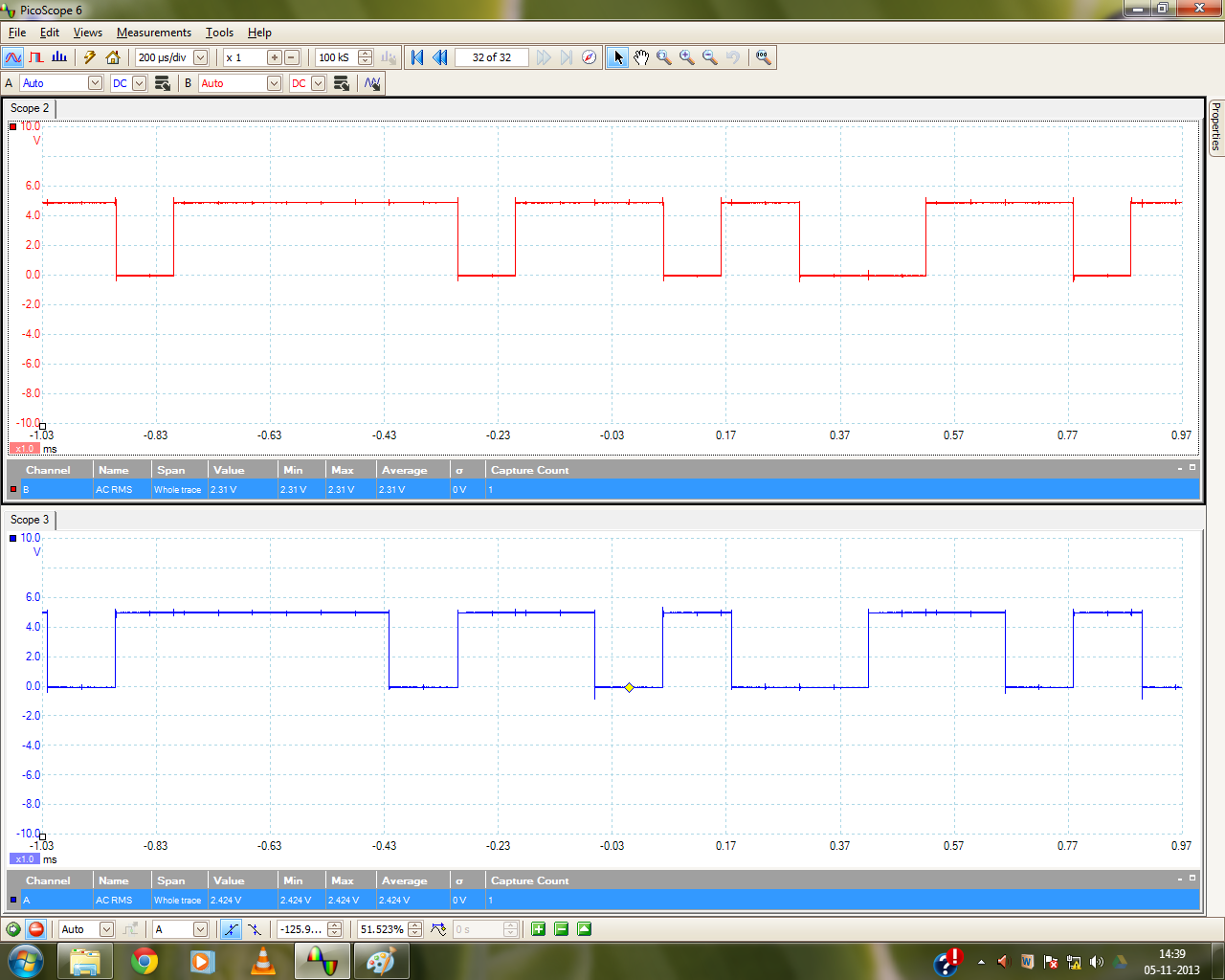

PPM – UWB PPM Modulated Signal, Input Message Signal

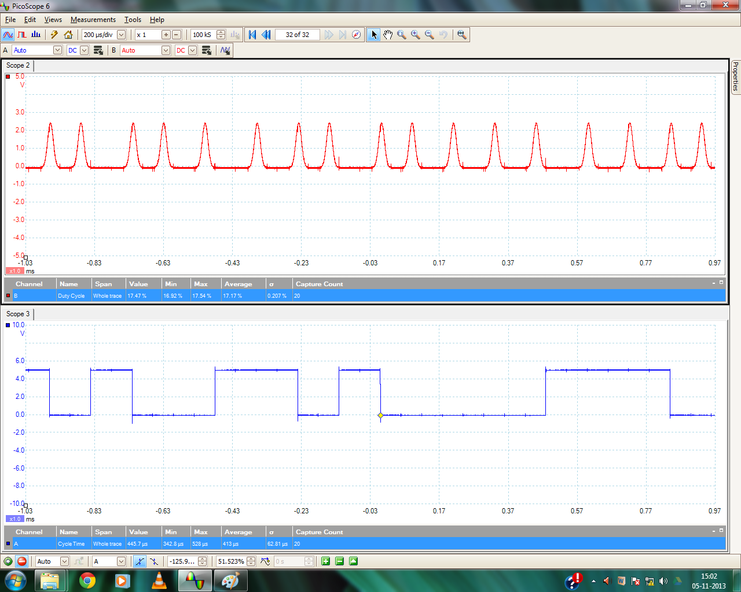

PPM – UWB PPM Demodulated Signal, Input Message Signal

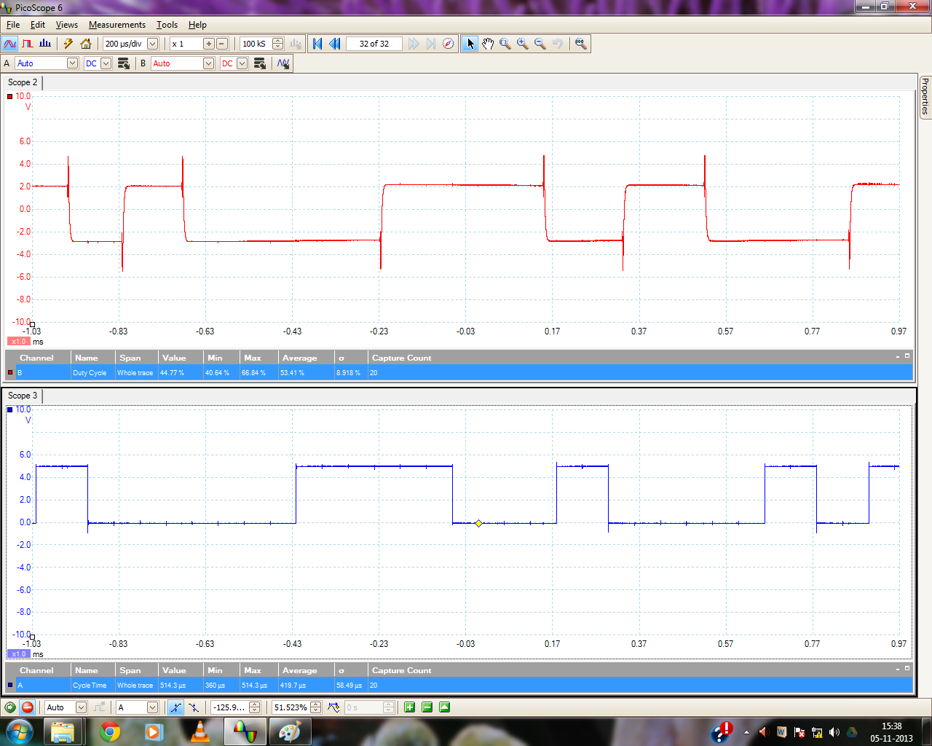

OPM – Integrate and Dump Stage Output, Input Message Signal

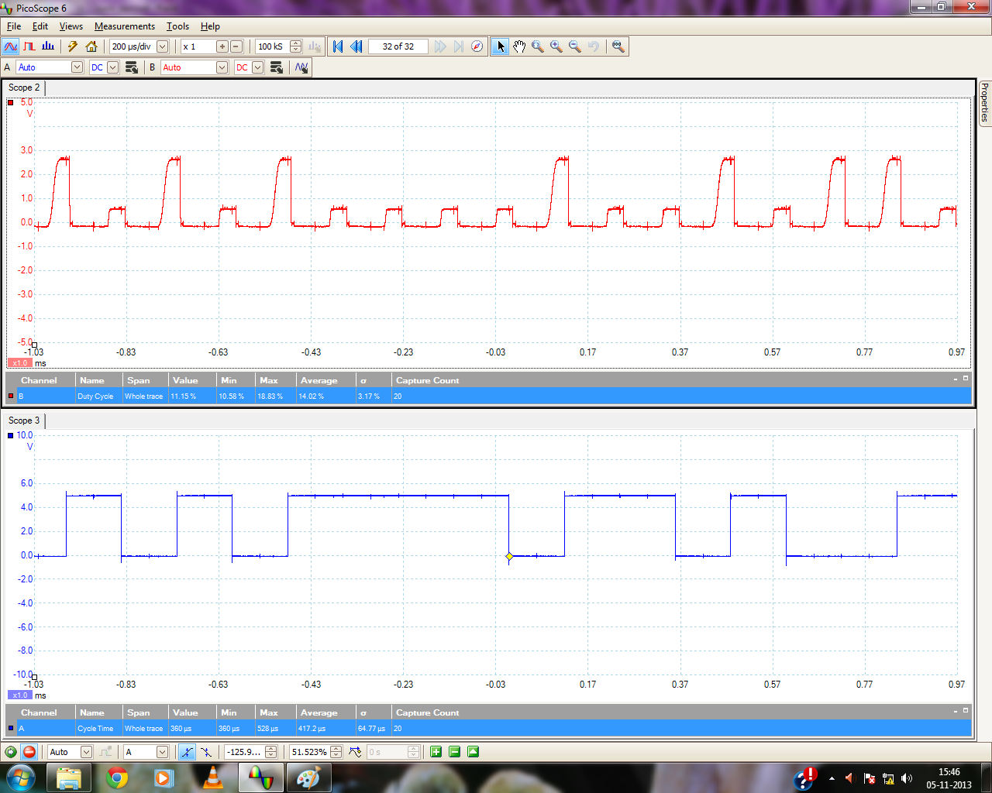

OPM – UWB OPM Modulated Signal, Input Message Signal

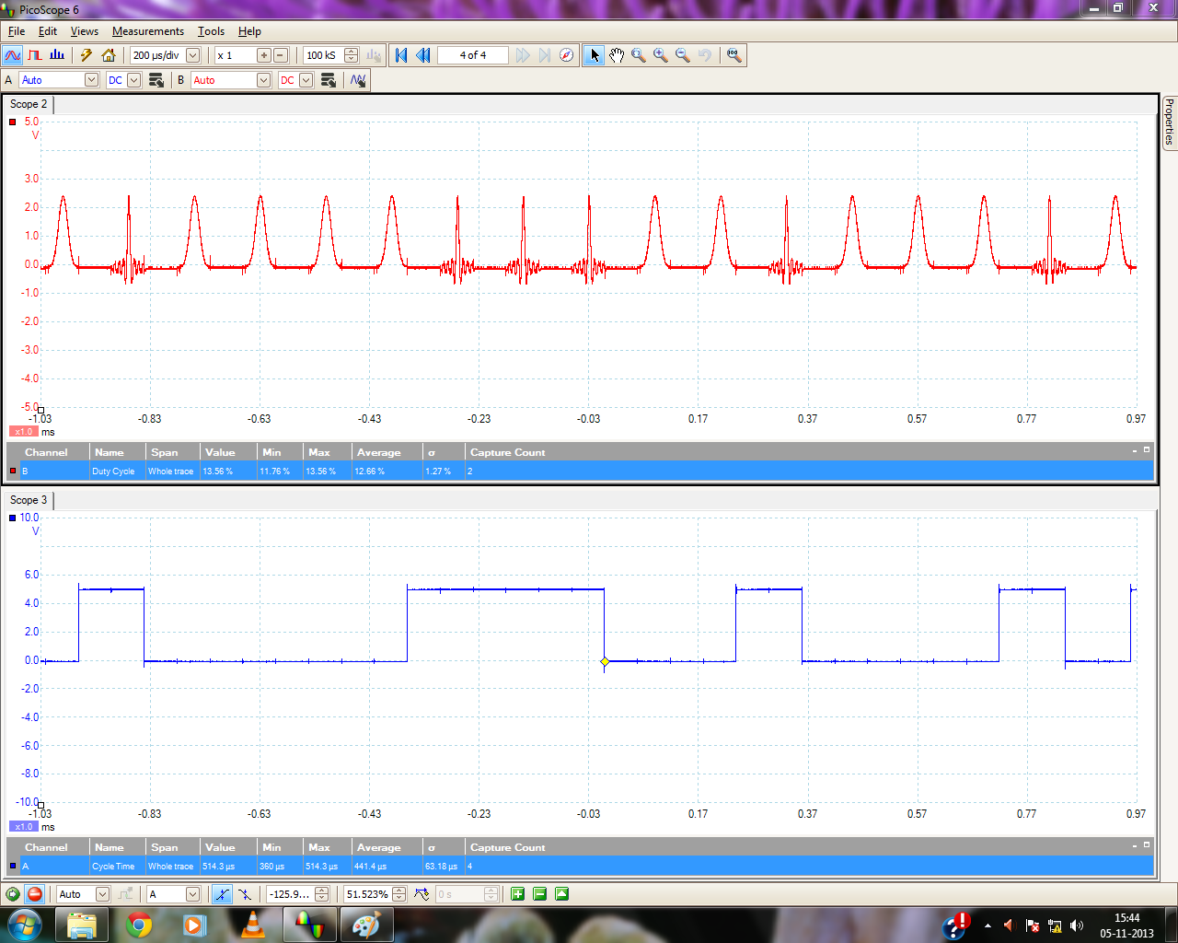

OPM – UWB OPM Demodulated Signal, Input Message Signal

