Image Processing-2

Subhajit Sahu

110EC0181

**Code**

clc;

close all;

im = (imread('tire.tif'));

[m n]=size(im);

im2=zeros(2*m,2*n);

for i=1:m

for j=1:n

im2(i,j)=im2(i,j)+im(i,j);

end

end

[r c]=size(im2);

[X,Y] = meshgrid(-n:n-1,-m:m-1);

Z = 100*sin(2*pi*50*X/(2*m)+2*pi*40*Y/(2*n) )+ 100*sin(2*pi*150*X/(2*m)+2*pi*120*Y/(2*n) );

imn = im2 + Z;

figure,

subplot(2,4,1);

imshow(im,[]);

title('original image');

subplot(2,4,2);

imshow(Z);

title('periodic sinusoidal noise');

subplot(2,4,3);

imshow(im2,[]);

title('padded image');

subplot(2,4,4);

imshow(log(1+abs(fftshift(fft2(im2)))),[]);

title('fft of padded image');

subplot(2,4,5);

imshow(imn,[]);

title('padded noisy image');

Fimn = abs(fftshift(fft2(imn))); %----------fftshift for centralizing the frequency and log for contrast stretching------%

logFimn = log(1+Fimn);

subplot(2,4,6);

imshow(logFimn,[]);

title('fft of the noisy image');

maxval = max(logFimn(:));

[yy,xx] = find(logFimn >= floor(maxval));

% ideal notch filter which allows all frequencies except the selected frequencies

H = ones(2*m,2*n);

for i=1:length(yy)

for j=1:length(xx)

H(yy(i)-1:yy(i)+1,xx(i)-1:xx(i)+1) = 0; %Notch Reject%

H1=1-H; %Notch pass%

end;

end

Fim_restored = H.*fftshift(fft2(imn));

im_restored = abs(ifft2(ifftshift(Fim_restored)));

subplot(2,4,7);

imshow(im_restored,[]);

title('notchpass filter restored image');

subplot(2,4,8);

I=fftshift(fft2(im_restored));

imshow(log(1+abs(I)),[]);

title('fft of the restored image');

m1(:,:)=mean(Z(:));

m2(:,:)=mean(imn(:));

m3(:,:)=mean(imn(:).*Z(:));

m4(:,:)=mean(imn(:).*imn(:));

m5(:,:)=m1.^2;

w(:,:)=(m3-m1*m2)./(m4-m5)

f=imn(:,:)-w.*Z(:,:);

figure;

subplot(2,2,1);

imshow(im2,[])

title('padded image');

subplot(2,2,2);

imshow(Z,[])

title('periodic sinusoidal noise');

subplot(2,2,3);

imshow(imn,[]);

title('noisy image');

subplot(2,2,4);

imshow(f,[]);

title('noisy image after optimum filtering');

figure;

surf(H);

title('notch reject filter in 3D');

figure;

imshow(H);

title('notch reject filter in 2-D');

Output-------‘tire.tif’

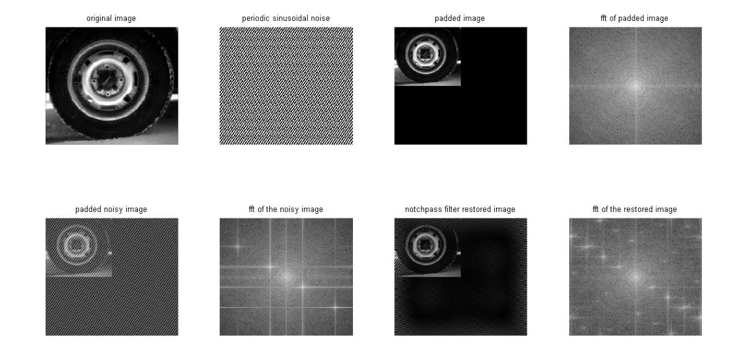

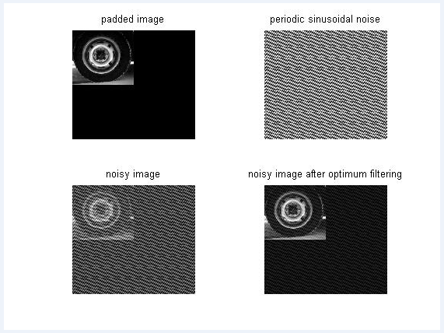

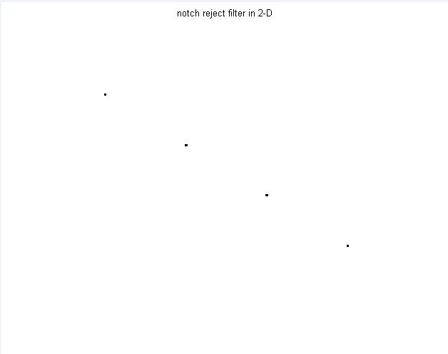

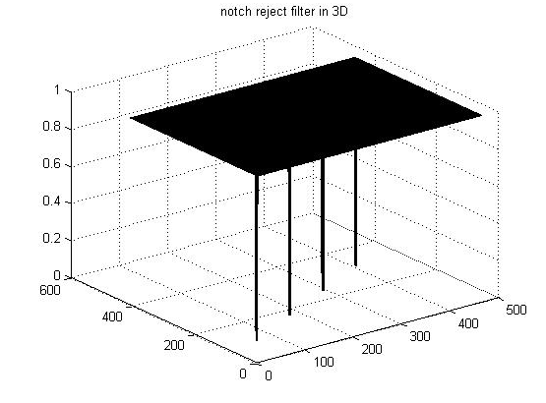

Z = 100*sin(2*pi*50*X/512+2*pi*40*Y/512 )+ 100*sin(2*pi*150*X/512 + 2*pi*120*Y/512)

W=0.8165-------(Optimum Filter)

Discussion

Lets Analyze Different Sinusoids, Optimum Weight and noise expression

Z = 50*sin(2*pi*50*X/512 )

w =0.2181

Z = 100*sin(2*pi*50*X/512 )+100*sin (2*pi*150*Y/512);

w = 0.6894

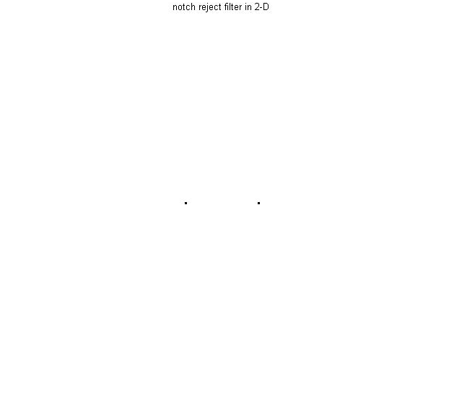

Z= 100*sin(2*pi*50*X/512 )+100*sin (2*pi*150*Y/512)+100*sin(2*pi*250*Y/512);

w =0.7691

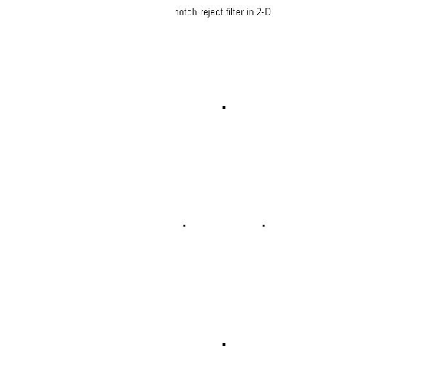

Z = 100*sin(2*pi*50*X/512+2*pi*120*Y/512 );

w = 0.5266

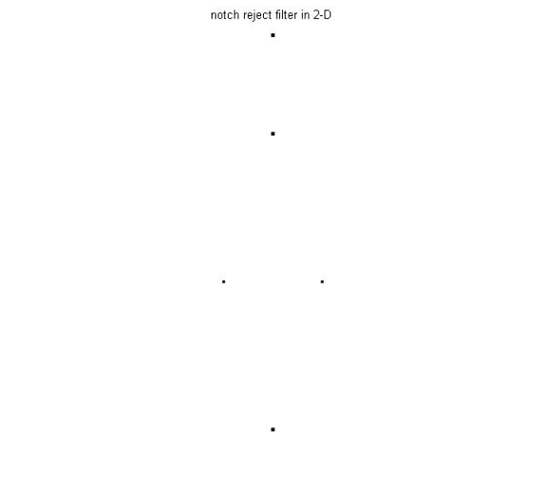

Z = 100*sin(2*pi*50*X/512+2*pi*120*Y/512 )+ 100*sin(2*pi*150*X/512 + 2*pi*80*Y/512);

w = 0.6899

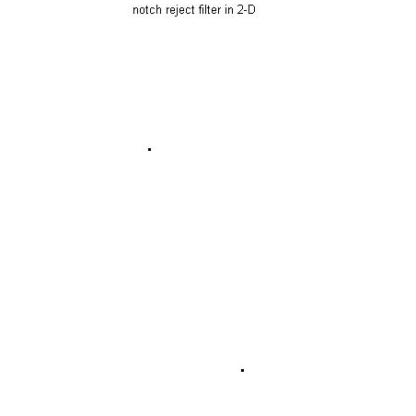

Z = 100*sin(2*pi*50*X/512+2*pi*120*Y/512 )+ 100*sin(2*pi*150*X/512 + 2*pi*80*Y/512)+100*sin(2*pi*250*X/512 + 2*pi*40*Y/512

w =0.7694

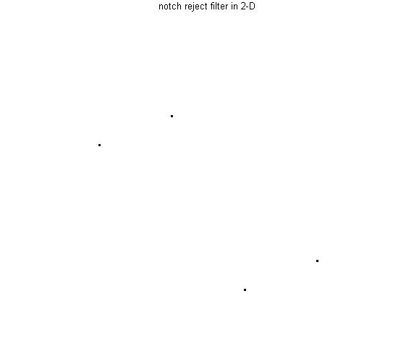

Thank you