§Introduction
Why should we study algorithms?
- Sorting algorithms

11, 7, 14, 1, 5, 9, 10
↓sort
1, 5, 7, 9, 10, 11, 14

Insertion sort
Quick sort

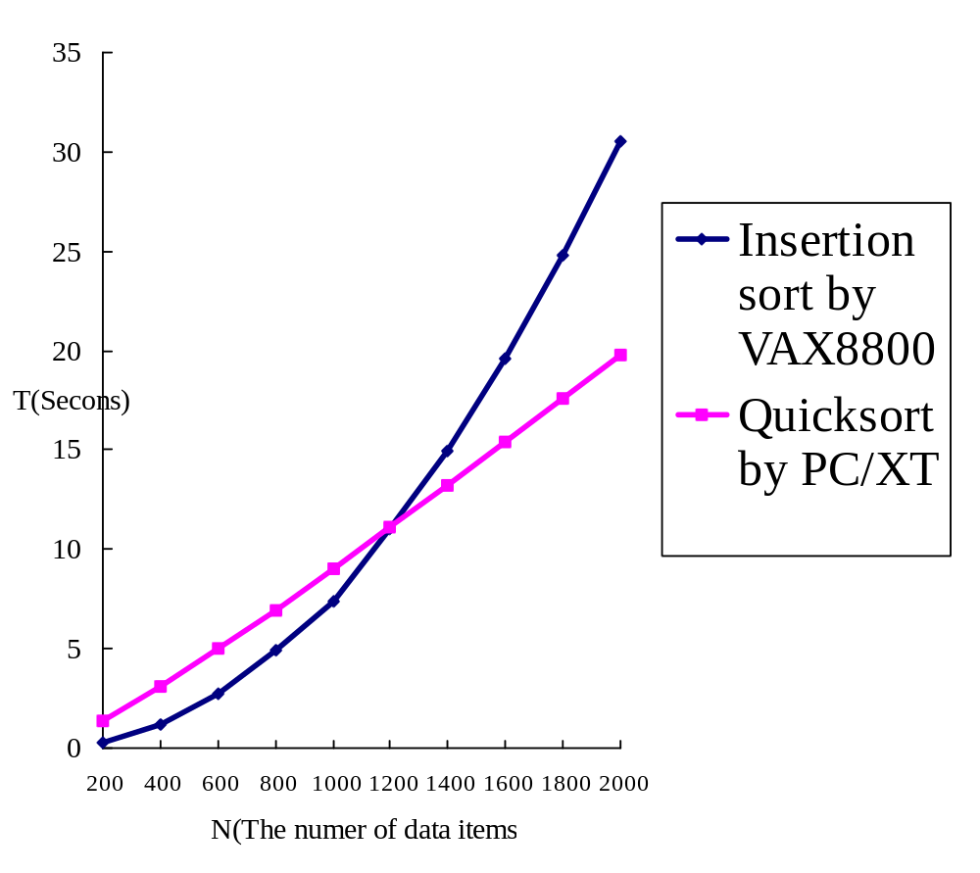
Fig 1-1. Comparison with Two Algorithms Implemented on Two Computers.
- Analysis of algorithms
- Measure the goodness of algorithms efficiency?
asymptotic notations: O(n²)
worst case
average case
amortized
- Measure the difficulty of problems
NP-complete
undecidable
lower bound
- Is the algorithm optimal?

- Knapsack problem

 | P₁ | P₂ | P₃ | P₄ | P₅ | P₆ | P₇ | P₈
Value | 10 | 5 | 1 | 9 | 3 | 4 | 11 | 17
Weight | 7 | 3 | 3 | 10 | 1 | 9 | 22 | 15

M(weight limit)=14
best solution: P₁, P₂, P₃, P₅(optimal)
This problem is NP-complete.

- Traveling salesperson problem
Given: A set of n planar points
Find: A closed tour which includes all points exactly once such that its total length is minimized.
This problem is NP-complete.
- Partition problem
Given: A set of positive integers S
Find: S₁ and S₂ such that S₁∩S₂=∅, S₁∪S₂=S, ∑_{i∈S1}i=∑_{i∈S2}i
(partition into S₁ and S₂ such that the sum of S₁ is equal to S₂)
e.g. S={1, 7, 10, 9, 5, 8, 3, 13}
S₁={1, 10, 9, 8}
S₂={7, 5, 3, 13}
This problem is NP-complete.
- Art gallery problem

- Minimum spanning tree

graph: greedy method
geometry(on a plane): divide-and-conquer
# of possible spanning trees for n points: n^{n-2}
n=10→10⁸, n=100→10¹⁹⁶

- Convex hull

It is not obvious to find a convex hull by examining all possible solutions
divide-and-conquer
- One-center problem

prune-and-search

