§Amortized Analysis

- An example of using potential function
a sequence of operations: OP₁, OP₂, … OP_{m}
OP_{i} : several pops (from the stack) and
one push (into the stack)
t_{i} : time spent by OP_{i}
the average time per operation:
t_{ave} = 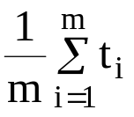

- g. p: pop , u: push

i | 1 | 2 | 3 | 4 | 5 | 6 | 7 | 8
OP_{i} | 1u | 1u | 2p | 1u | 1u | 1u | 2p | 1p
 |  |  | 1u |  |  |  | 1u | 1u
t_{i} | 1 | 1 | 3 | 1 | 1 | 1 | 3 | 2

t_{ave} = (1+1+3+1+1+1+3+2)/8
= 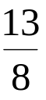
= 1.625

e.g. p: pop , u: push

i | 1 | 2 | 3 | 4 | 5 | 6 | 7 | 8
OP_{i} | 1u | 1p | 1u | 1u | 1u | 1u | 5p | 1u
 |  | 1u |  |  |  |  | 1u
t_{i} | 1 | 2 | 1 | 1 | 1 | 1 | 6 | 1

t_{ave} = (1+2+1+1+1+1+6+1)/8
= 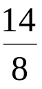
= 1.75

- amortized time and potential function
a_{i} = t_{i} + 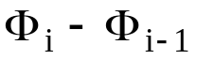
a_{i} : amortized time of OP_{i}
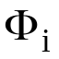: potential function of the stack after OP_{i}
: change of the potential
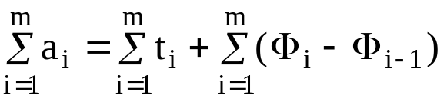
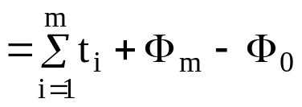

If 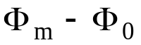 ≥ 0, then 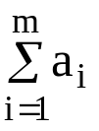 represents an upper bound of 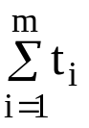

define: : # of elements in the stack.
⇒ 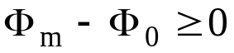
Suppose that before we execute OP_{i}, there are k elements in the stack and OP_{i} consists of n pops and 1 push . Thus,
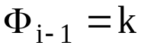
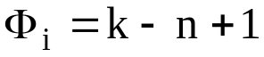
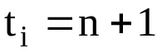
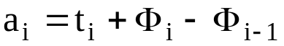
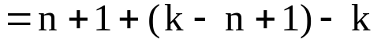
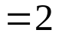
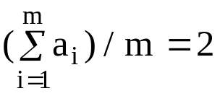
⇒ t_{ave} ≤ 2

By observation, at most m pops and m pushes are executed in m operation, hence t_{ave} ≤ 2.

- An amortized analysis of skew heaps
two skew heaps:
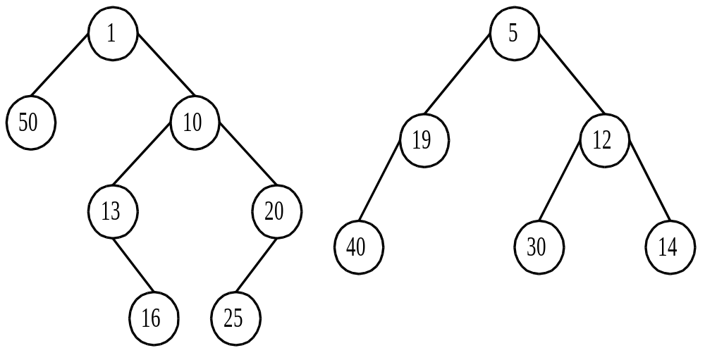
⇓ merge of the right paths
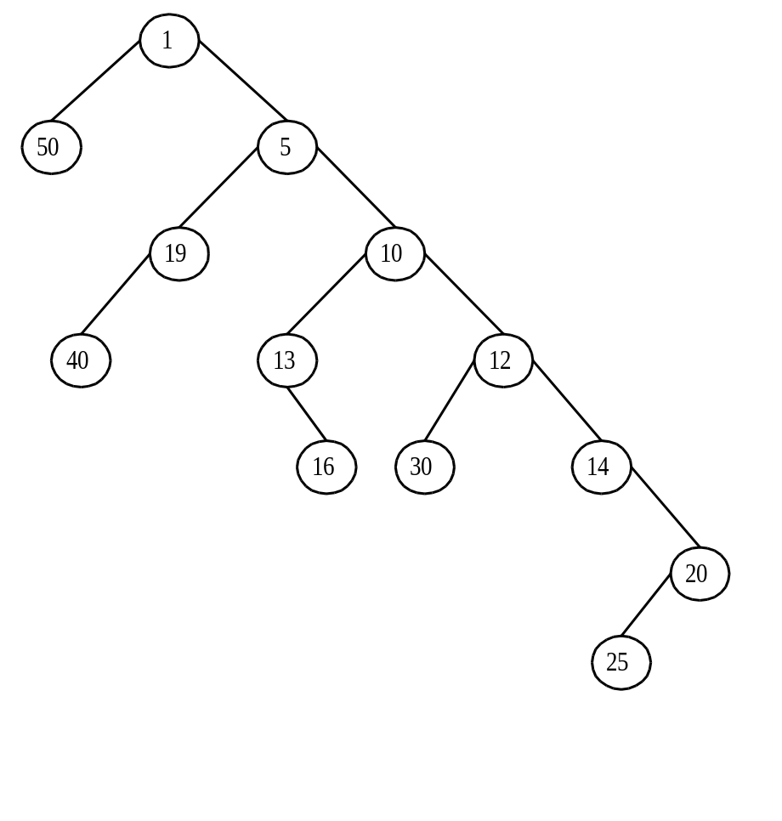
5 right heavy nodes.
⇓ swapping of children along the path formed by the merge.
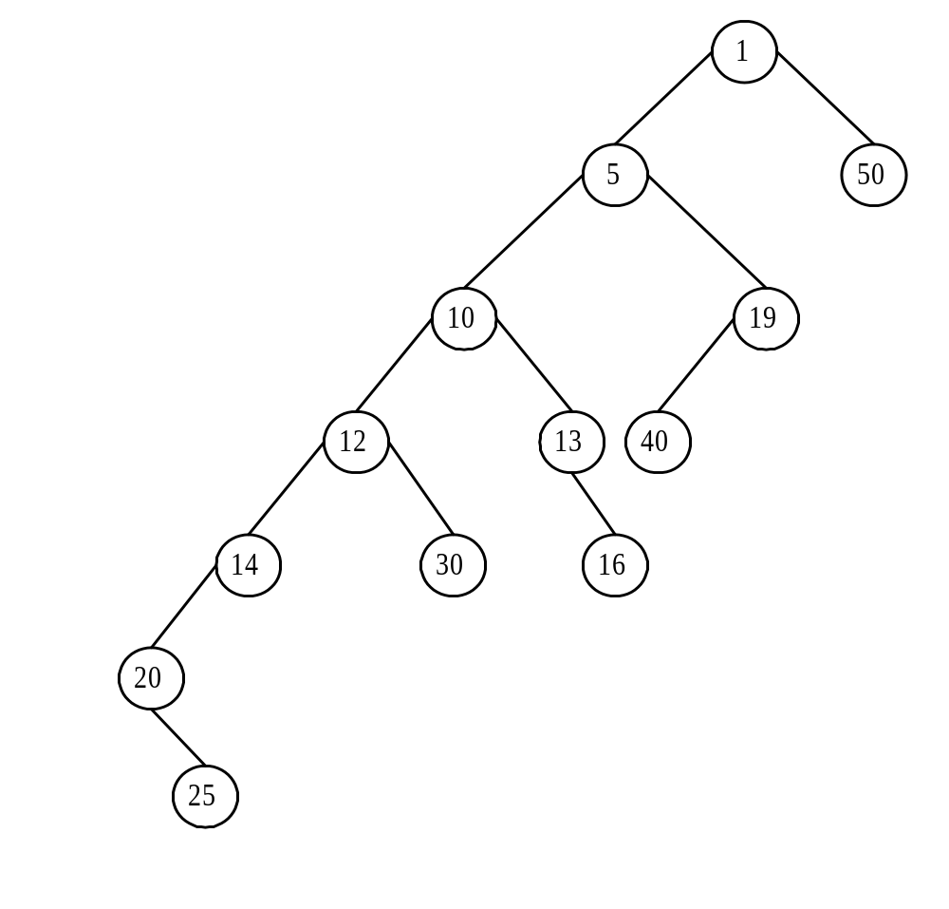
No right heavy node.
meld: merge + swapping
operations on a skew heap:
- find-min(h): find the min of a skew heap h.
- insert(x, h): insert x into a skew heap h.
- delete-min(h): delete the min from a skew heap h.
- meld(h₁, h₂): meld two skew heaps h₁ and h₂.

The first three operations can be implemented by melding.

- potential function
wt(x): # of descendants of node x, including x.
heavy node x: wt(x) > wt(p(x))/2, where
p(x) is the parent node of x.
light node: not a heavy node
potential function Φ_{i}: # of right heavy nodes of the skew heap.

- Any path in an n-node tree contains at most ⎣log₂n⎦ light nodes.

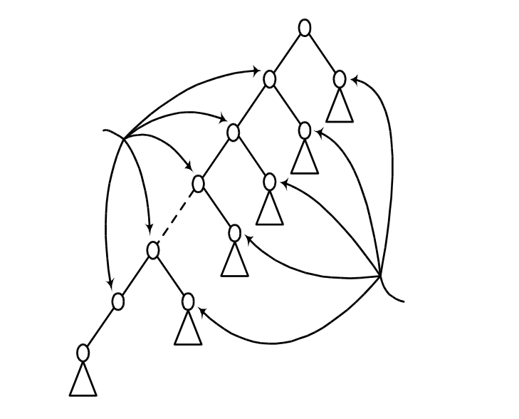
light nodes ≤ ⎣log₂n⎦
# heavy=k₃≤ ⎣log₂n⎦
possible heavy nodes
# of nodes: n

- The number of right heavy nodes attached to the left path is at most ⎣log₂n⎦.

- amortized time
# light ≤ ⎣log₂n₂⎦
# light ≤ ⎣log₂n₁⎦
# heavy = k₂
# heavy = k₁
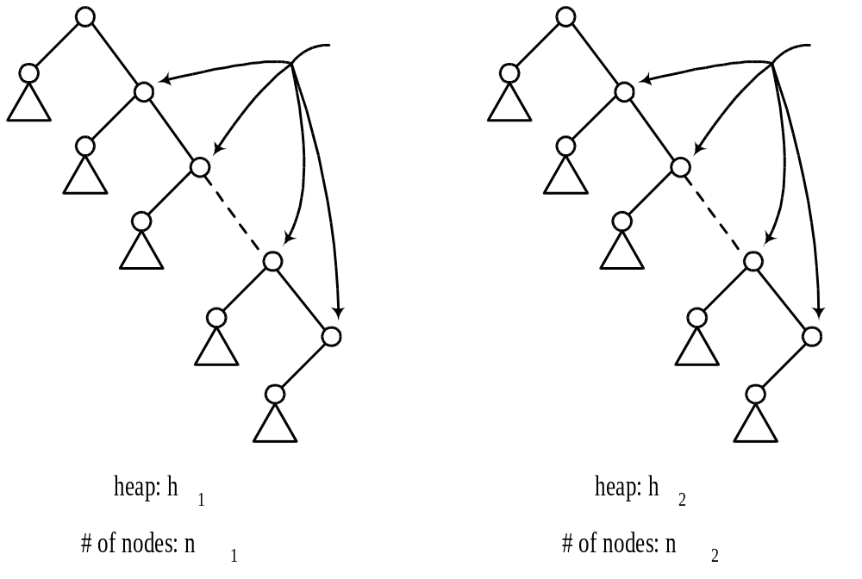

a_{i} = t_{i} + Φ_{i} − Φ_{i-1}
t_{i} : time spent by OP_{i}
t_{i} ≤ 2+⎣log₂n₁⎦+k₁+⎣log₂n₂⎦+k₂
(“2” counts the roots of h₁ and h₂)
≤ 2+2⎣log₂n⎦+k₁+k₂
where n=n₁+n₂
Φ_{i} − Φ_{i-1} = k₃-(k₁+k₂) ≤ ⎣log₂n⎦−k₁−k₂
a_{i} = t_{i} + Φ_{i} − Φ_{i-1}
≤2+2⎣log₂n⎦+k₁+k₂+⎣log₂n⎦−k₁−k₂
=2+3⎣log₂n⎦
⇒ a_{i} = O(log₂n)

- Amortized analysis of AVL-trees
height balance of node v:
hb(v)=height of right subtree - height of left subtree
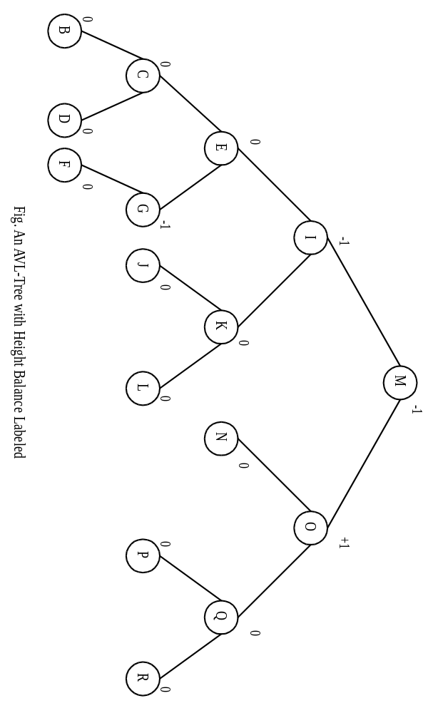
add a new node A:

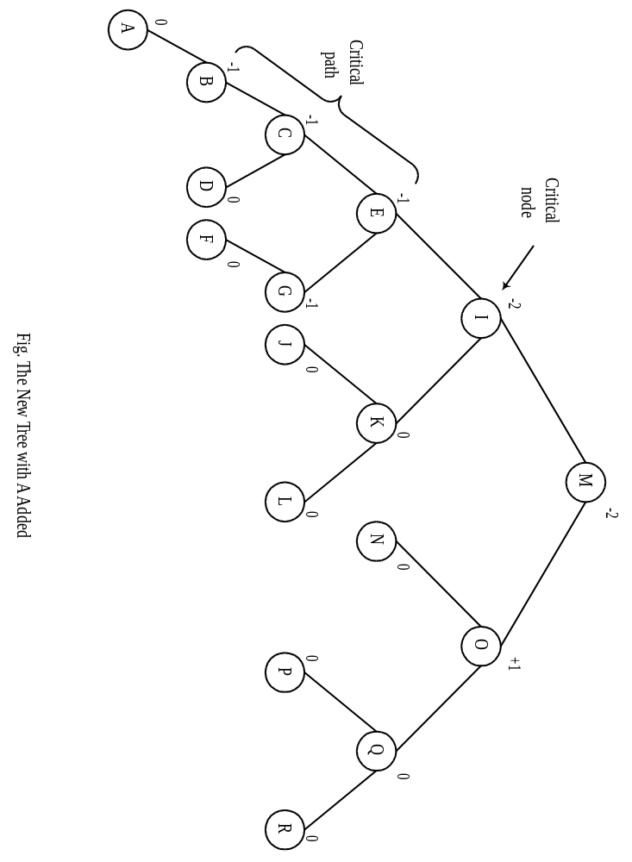
Before insertion, hb(B)=hb(C)=hb(E)=0
hb(I)≠0…the first nonzero from leaves.

Consider a sequence of m insertions on an empty AVL-tree.
T₀: an empty AVL-tree.
T_{i}: the tree after the ith insertion.
L_{i}: the length of the critical path involved in the ith insertion.
X₁: total # of balance factor changing from 0 to +1 or -1 during these m insertions
(rebalancing cost)
X₁=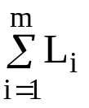 , we want to find X₁.
Val(T): # of unbalanced node in T
(height balance ≠ 0)

Case 1: Absorption (tree height not increased, no need of rebalancing)
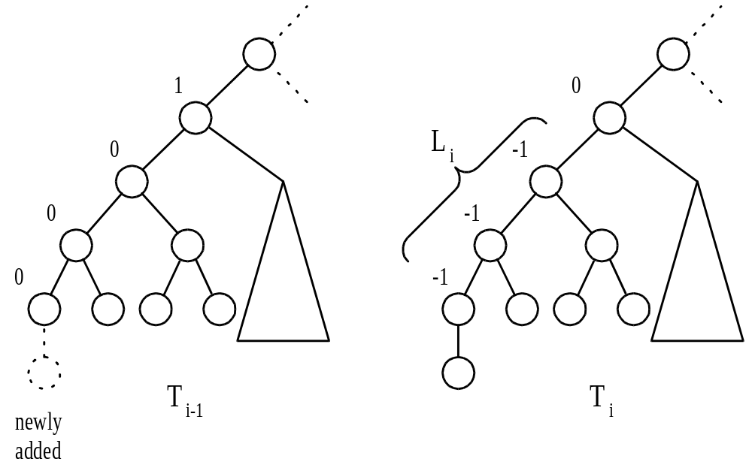
Val(T_{i})=Val(T_{i-1})+(L_{i}−1)
Case 2: Rebalancing the tree.
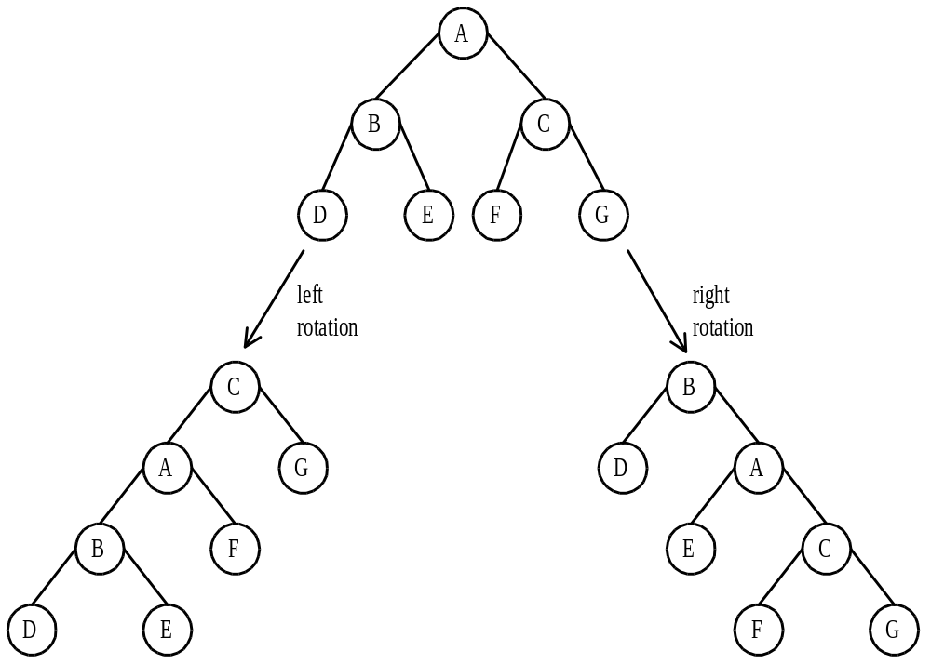

Case 2.1 single rotation
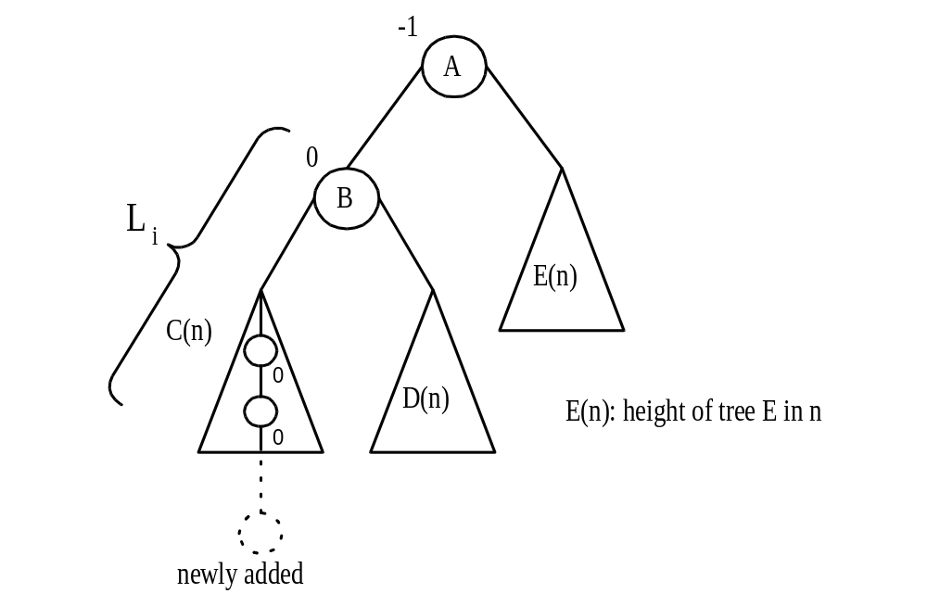
after a right rotation on the subtree rooted at A:
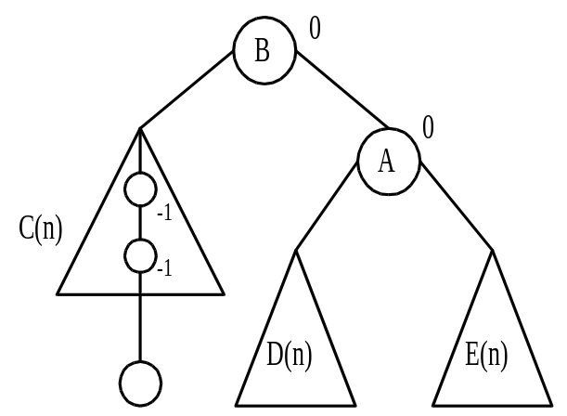
case 2.2 double rotation
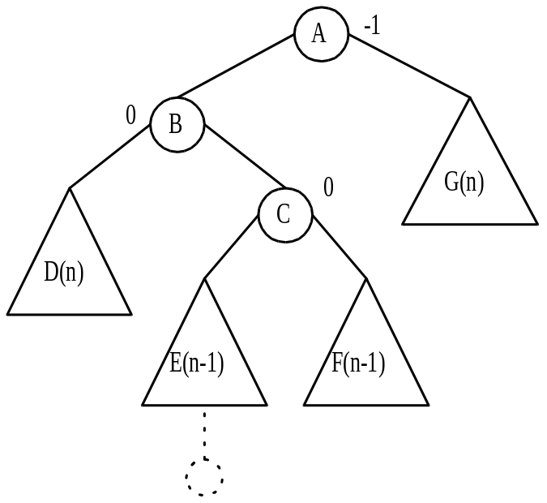
after a left rotation on the subtree rooted at B and a right rotation on the subtree rooted at A
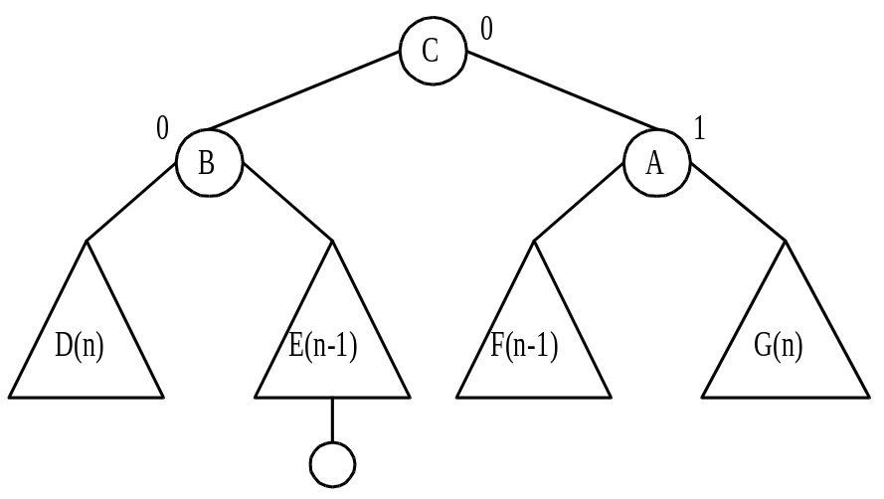
Val(T_{i})=Val(T_{i-1})+(L_{i}-2)
Case 3: Height increase
(L_{i} is the height of the root)
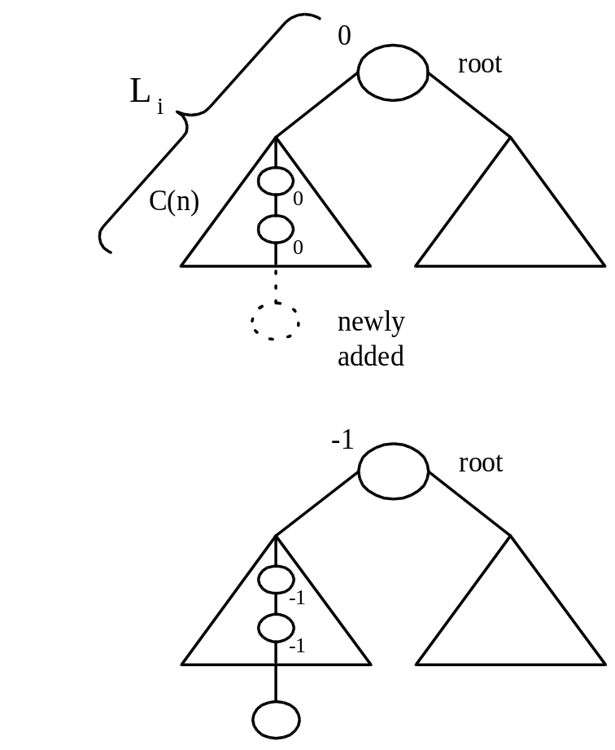
Val(T_{i})=Val(T_{i-1})+L_{i}
X₂: # of absorptions in case 1
X₃: # of single rotations in case 2
X₄: # of double rotations in case 2
X₅: # of height increases in case 3
Val(T_{m}) = Val(T₀)+−X₂−2(X₃+X₄)
=0+X₁−X₂−2(X₃+X₄)
Val(T_{m}) ≤ 0.618m (proved by Knuth)
⇒ X₁ = Val(T_{m})+2(X₂+X₃+X₄)−X₂
≤ 0.618m+2m
= 2.618m
- Amortized analysis of a self-organizing sequential search heuristics
3 methods for enhancing the performance of sequential search:
- Transpose Heuristics:
Query |  | Sequence
B |  | B
D |  | D B
A |  | D A B
D |  | D A B
D |  | D A B
C |  | D A C B
A |  | A D C B

- Move-to-the-Front Heuristics:
Query |  | Sequence
B |  | B
D |  | D B
A |  | A D B
D |  | D A B
D |  | D A B
C |  | C D A B
A |  | A C D B

- Count Heuristics: (decreasing order by the count)
Query |  | Sequence
B |  | B
D |  | B D
A |  | B D A
D |  | D B A
D |  | D B A
A |  | D A B
C |  | D A B C
A |  | D A B C

- analysis of the move to the front heuristics
interword comparison: unsuccessful comparison
intraword comparison: successful comparison
pairwise independent property:
For any sequence S and all pairs P and Q, # of interwod comparisons of P and Q is exactly # of comparisons made for the subsequence of S consisting of only P’s and Q’s.

- g.
Query |  | Sequence |  | (A, B) comparison
C |  | C
A |  | A C
C |  | C A
B |  | B C A |  | √
C |  | C B A
A |  | A C B |  | √
# of comparisons made between A and B: 2

Consider the subsequence consisting of A and B:
Query |  | Sequence |  | (A, B) comparison
A |  | A
B |  | B A |  | √
A |  | A B |  | √
# of comparisons made between A and B: 2

Query | Sequence | C | A | C | B | C | A
 | (A, B) |  | 0 |  | 1 |  | 1
 | (A, C) | 0 | 1 | 1 |  | 0 | 1
 | (B, C) | 0 |  | 0 | 1 | 1
 |  | 0 | 1 | 1 | 2 | 1 | 2

There are 3 distinct interword comparisons:
(A, B), (A, C) and (B, C)
We can consider them separately and then add them up.
the total number of interword comparisons:
0+1+1+2+1+2 = 7

C_{M}(S): # of comparisons of the move to front heuristics
C_{O}(S): # of comparisons of the optimal static ordering

C_{M} ≤ 2C_{O}(S)

Proof:
Inter_{M}(S): # of interword comparisons of the move to the front heuristics
Inter_{O}(S): # of interword comparisons of the optimal static ordering
Let S consist of a A’s and b B’s, a < b.
The optimal static ordering: BA
Inter_{O}(S) = a
⇒ Inter_{M}(S) ≤ 2Inter_{O}(S)
Inter_{M}(S) ≤ 2a
Consider any sequence consisting of more than two items. Because of the pairwise independent property, we have Inter_{M}(S) ≤ 2Inter_{O}(S)

Intra_{M}(S): # of intraword comparisons of the move to the front heuristics
Intra_{O}(S): # of intraword comparisons of the optimal static ordering
Intra_{M}(S) = Intra_{O}(S)

Inter_{M}(S) + Intra_{M}(S) ≤ 2Inter_{O}(S) + Intra_{O}(S)
⇒ C_{M}(S) ≤ 2C_{O}(S)

- The count heuristics has a similar result.
C_{C}(S) ≤ 2C_{O}(S), where C_{C}(S) is the cost of the count heuristics.

- The transposition heuristics does not possess the pairwise independent property
We can not have a similar upper bound for the cost of the transposition heuristics.
- g.
Consider pairs of distinct items independently.
Query | Sequence | C | A | C | B | C | A
 | (A, B) |  | 0 |  | 1 |  | 1
 | (A, C) | 0 | 1 | 1 |  | 0 | 1
 | (B, C) | 0 |  | 0 | 1 | 1
 |  | 0 | 1 | 1 | 2 | 1 | 2

# of interword comparisons: 7 (not correct)
the correct interword comparisons:
Query Sequence | C | A | C | B | C | A
Data Ordering | C | AC | CA | CBA | CBA | CAB
Number of Interword Comparisons    6 | 0 | 1 | 1 | 2 | 0 | 2

- The pairing heap and its amortized analysis
- g. a pairing heap:

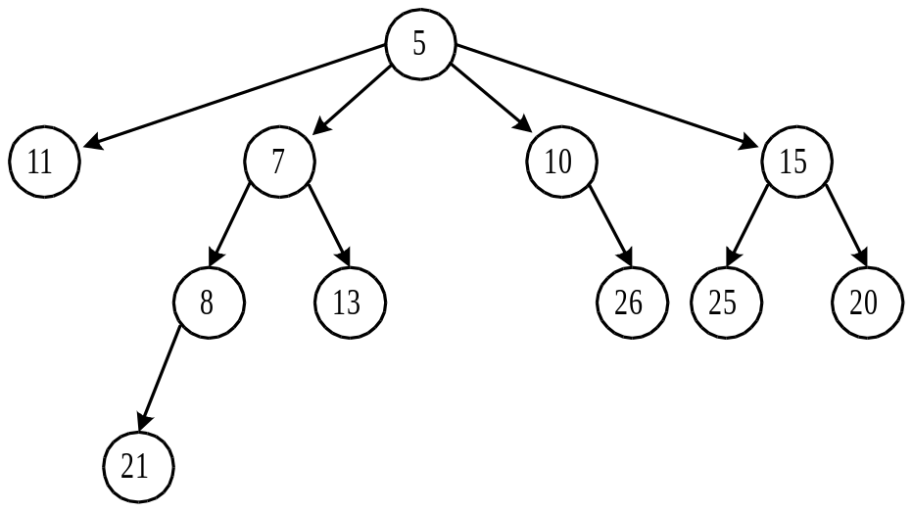

the binary tree representation:

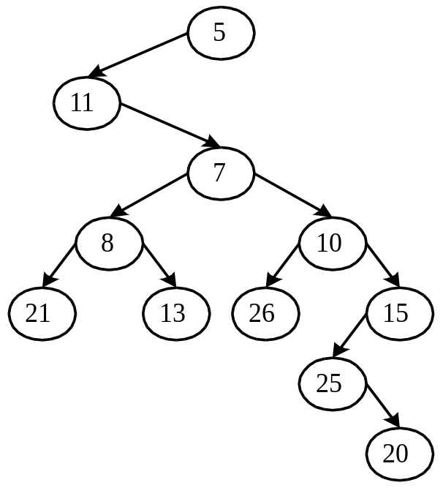

- Basic operations for a pairing heap:
- make heap(h): to create a new empty heap named h.
- find min(h): to find the min. of heap h.
- insert(x, h): to insert an element x into heap h.
- delete min(h): to delete the min. from heap h.
- meld(h₁, h₂): to create a heap by joining two heaps h₁ and h₂.
- decrease key(Δ, x, h): to decrease the element x in heap h by the value Δ.
- delete(x, h): to delete the element x from heap h.

- the internal basic operation:
link(h₁, h₂): to link two heaps into a new heap.

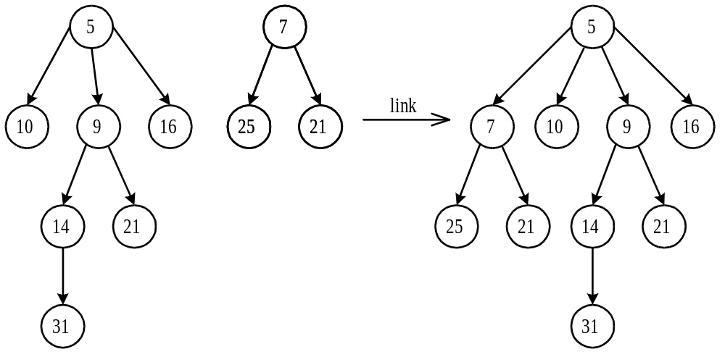

- make heap(h): trivial
- find min(h): trivial
- insert(x, h): apply link(h₁, h₂)
- delete min(h): delete the root, then apply many link(h₁, h₂)’s.
- meld(h₁, h₂): apply link(h₁, h₂)
- decrease(Δ, x, h):
step 1: Subtract Δ from x.
step 2: If x is root, then return.
step 3: Cut the edge joining x and its parent.
Then apply link(h₁, h₂)

- g. decrease(3, 9, h):

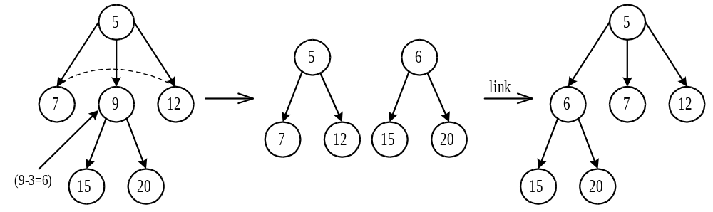

- delete(x, h):
step 1: If x is root, then return (delete min(h)).
step 2: Otherwise,
step 2.1: Cut the edge joining x to its parent.
step 2.2: Perform a delete min(h) on the tree rooted at x.
step 2.3: Link the resulting trees.

- The delete min(h) is critically important to the amortized analysis of the pairing heap.

- How does the delete min(h) work?

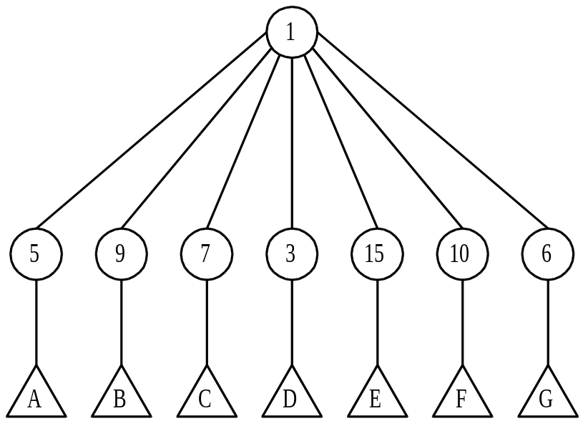

The binary tree representation:
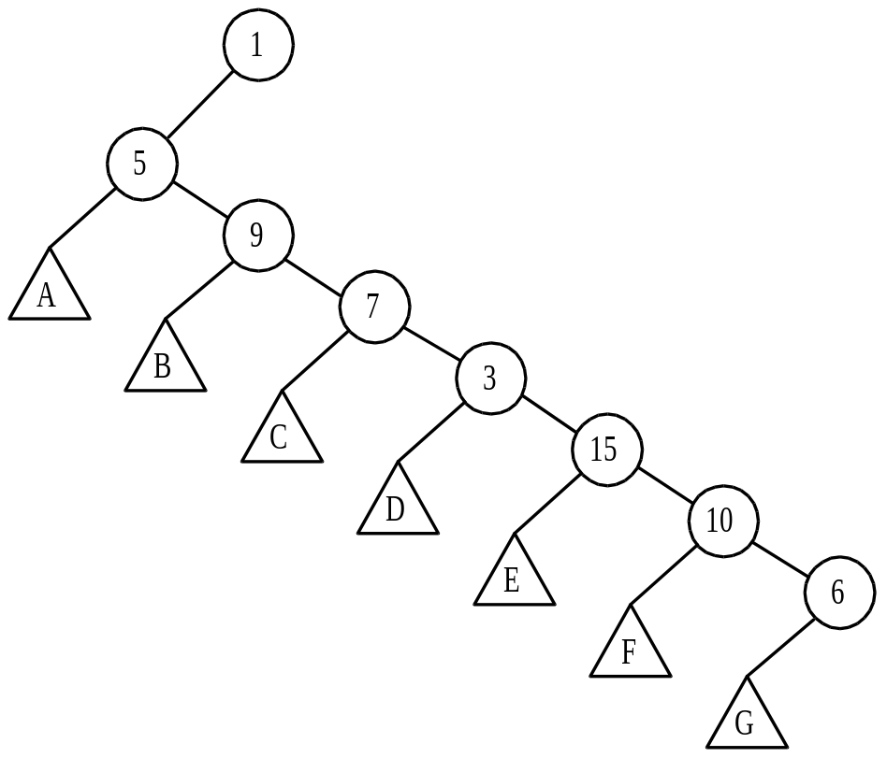

Step 1: delete the root:

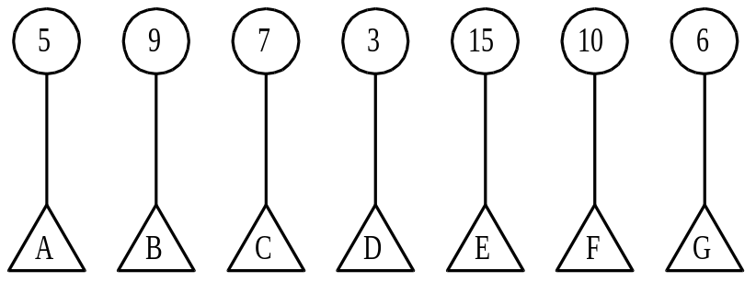

Step 2: pairwise melding:

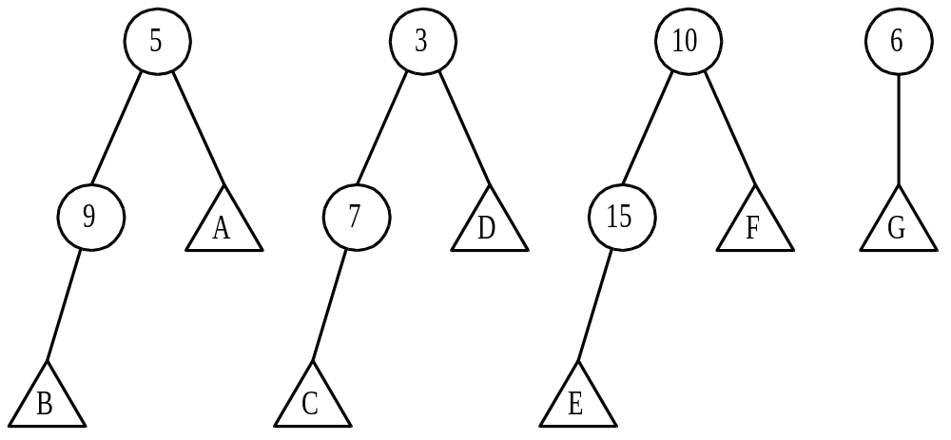

Step 3: melding with the last heap one by one:

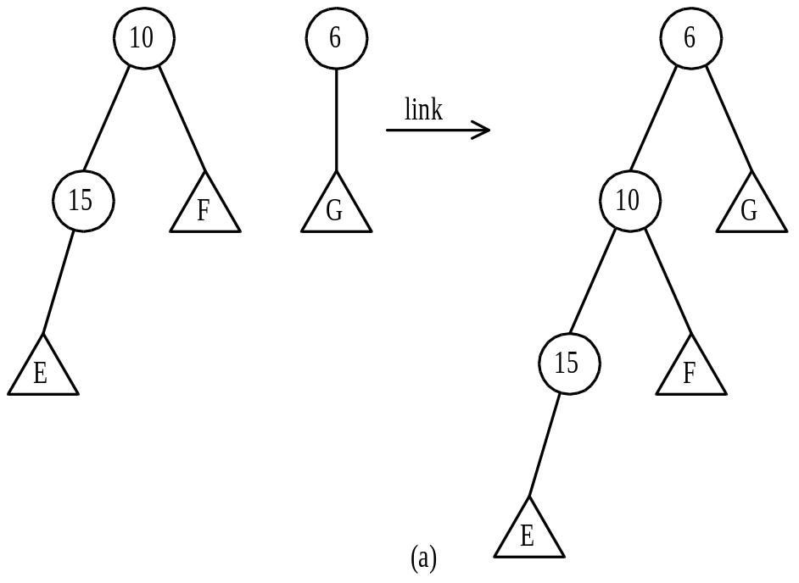

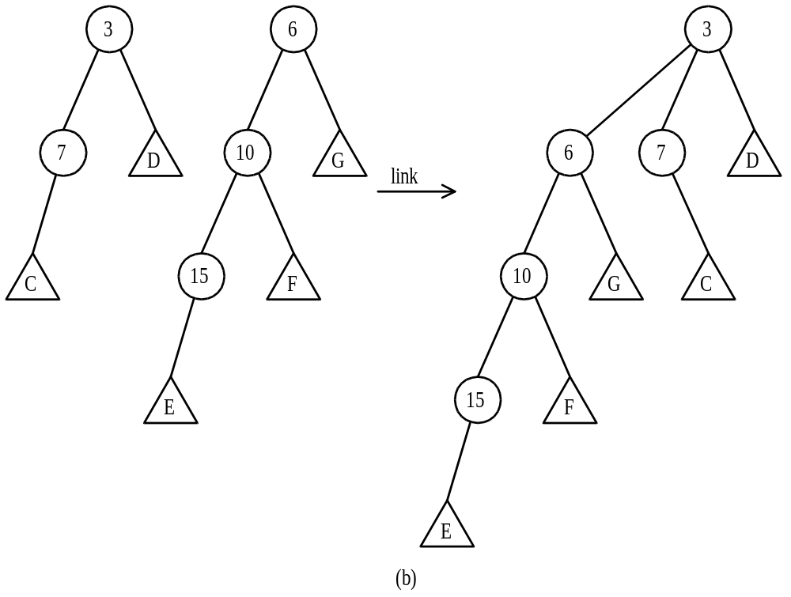

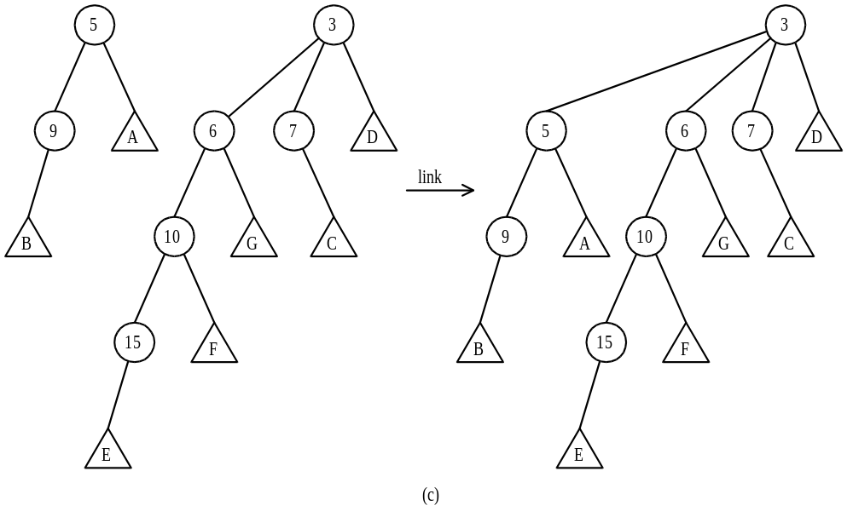
The binary tree representation of the resulting
pairing heap:
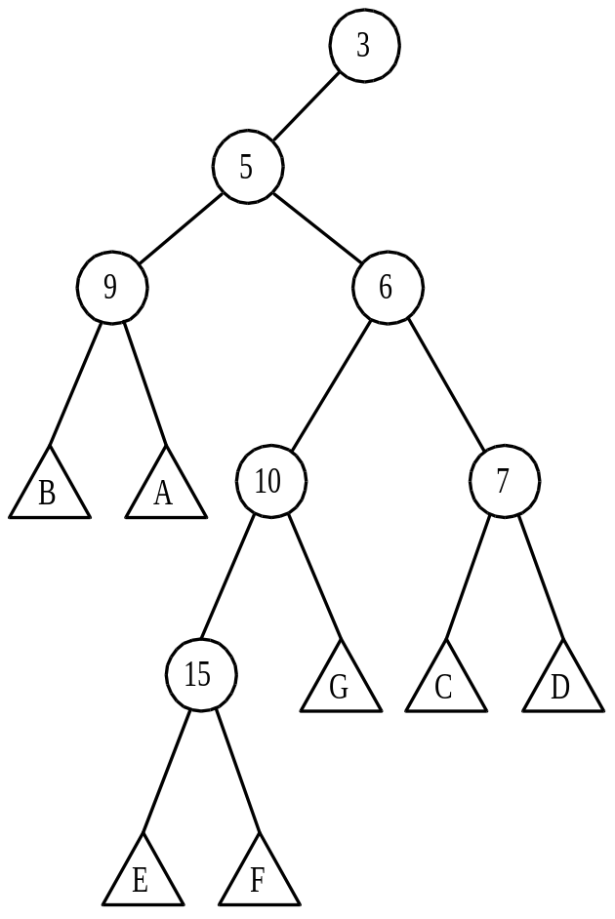

- potential function
s(x): # of nodes in the subtree rooted at x including x in a binary tree.
r(x): rank of x, defind as log(s(x)).
The potential of a binary tree, denoted as Φ, is the sum of the ranks of all nodes.

e.g.

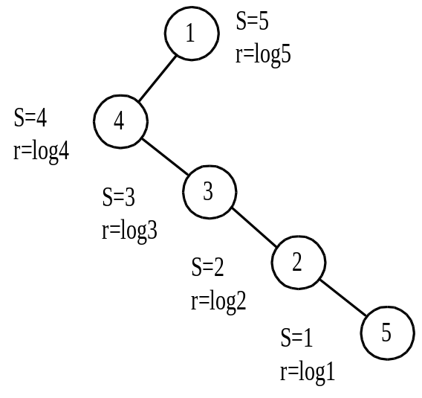
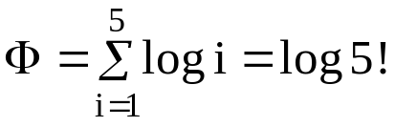

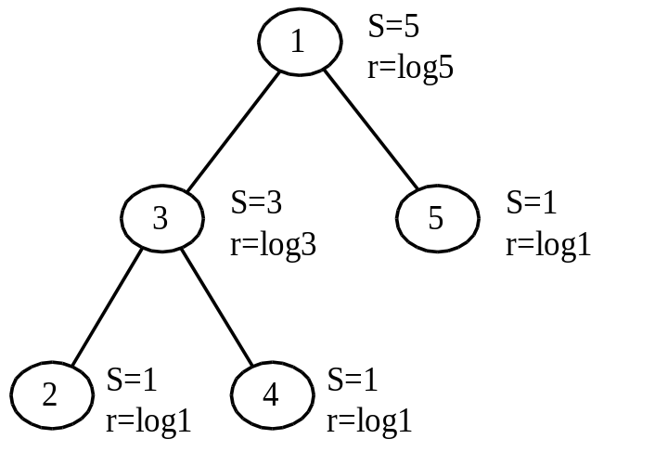
Φ = log5+log3+3log1 = log15

Fig. Potentials of Two Binary Trees

- the change of the potential
a_{i} = t_{i} +
a_{i} : time spent for OP_{i}
: potential after OP_{i}
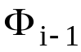: potential before OP_{i}

step 1: deleting the root:
ΔΦ₁ = -log n
step 2: pairwise melding:

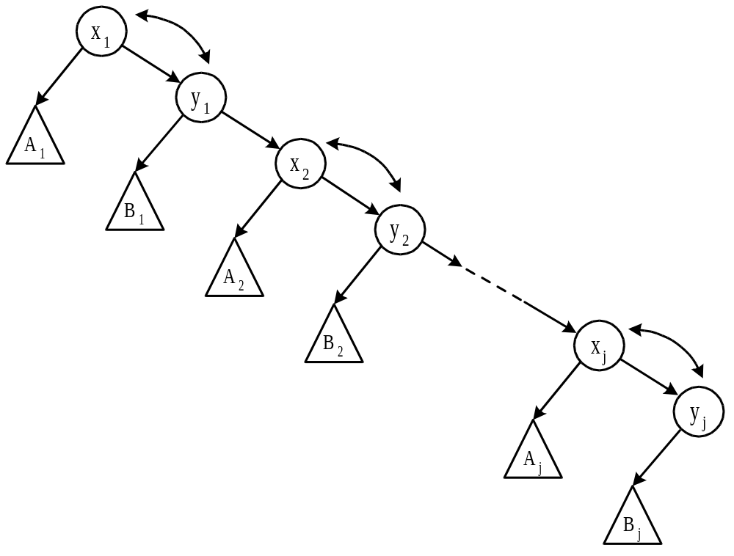

Fig. The Pairing Operations.

the melding of one pair:
pairing heap:
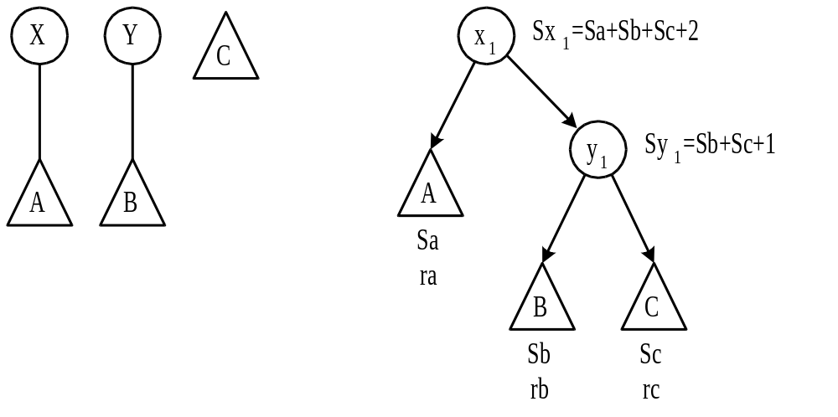
Φ_{before}=ra+rb+rc+
log(Sa+Sb+Sc+2)+
log(Sb+Sc+1)

⇓ meld

case 1: y ≤ x

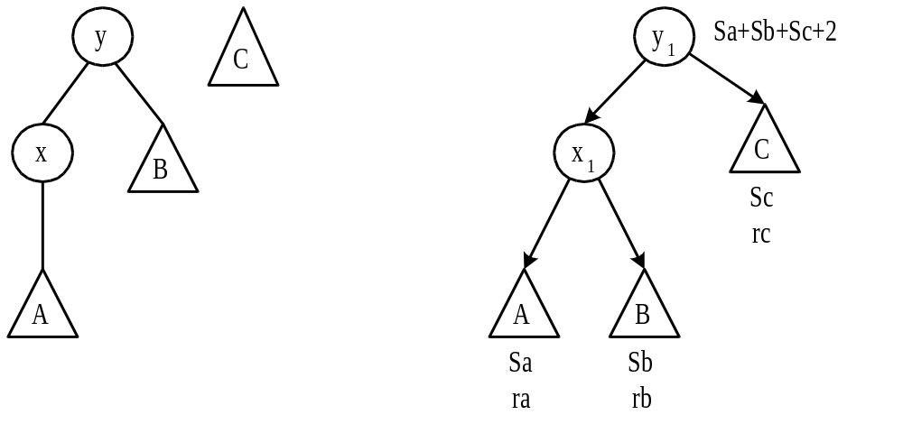

case 2: y > x

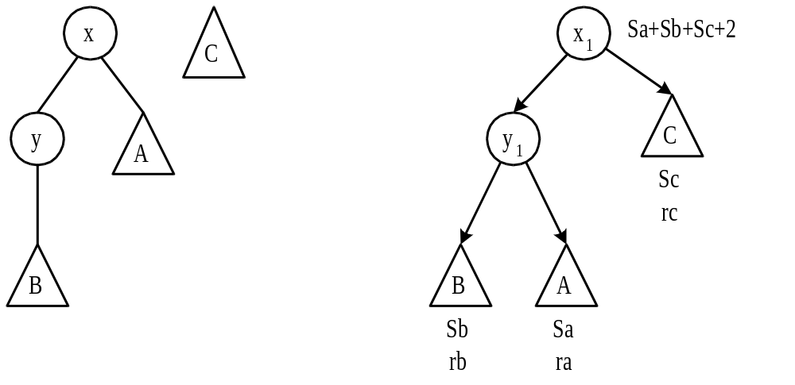

Φ_{after} = ra+rb+rc+log(Sa+Sb+Sc+2)+log(Sa+Sb+1)
ΔΦ_{pair} = Φ_{after} − Φ_{before}
= log(Sa+Sb+1) − log(Sb+Sc+1)
If p, q≥0 and p+q≤1, then logp+logq≤-2

Let 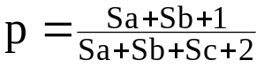 , 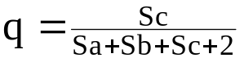
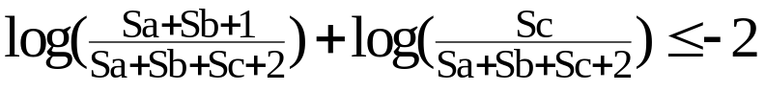
(log(Sc) < log(Sb+Sc+1))
ΔΦ_{pair} ≤ 2log(Sx)−2log(Sc)-2
the last pair, ΔΦ_{pair} ≤ 2log(Sx) ( Sc=0)

ΔΦ_{total pair} 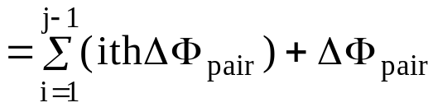 due to the jth pair
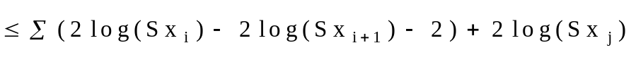
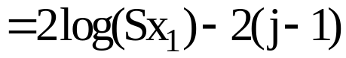
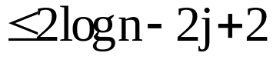

step 3: melding with the last heap one by one:
assume x_{i} < y_{i}
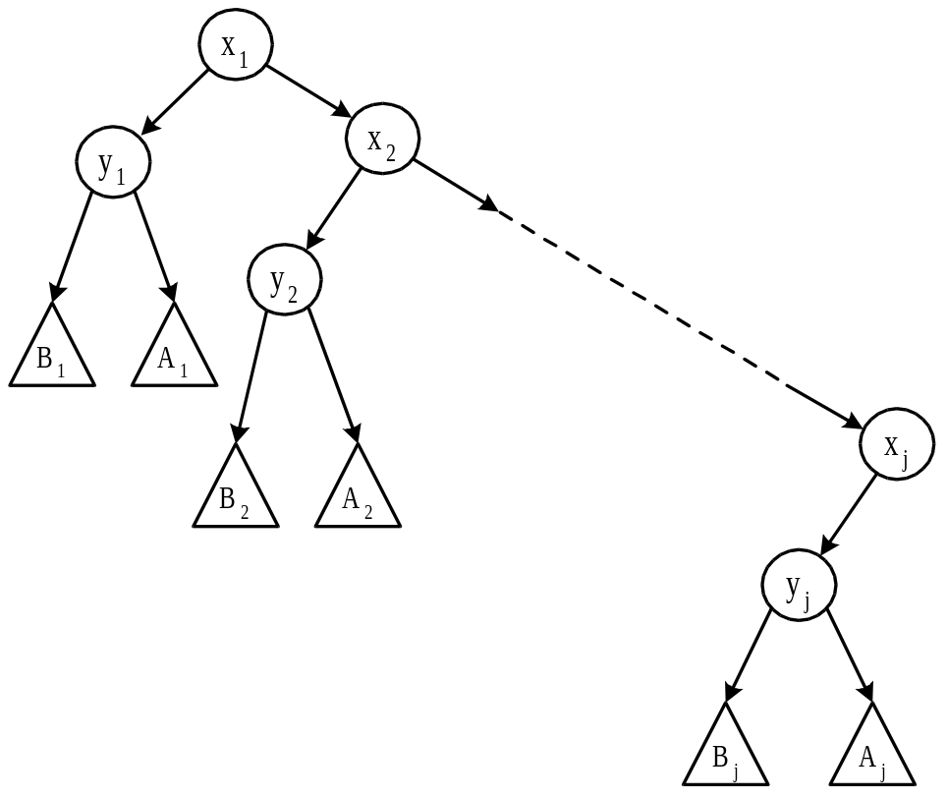

the last pair:

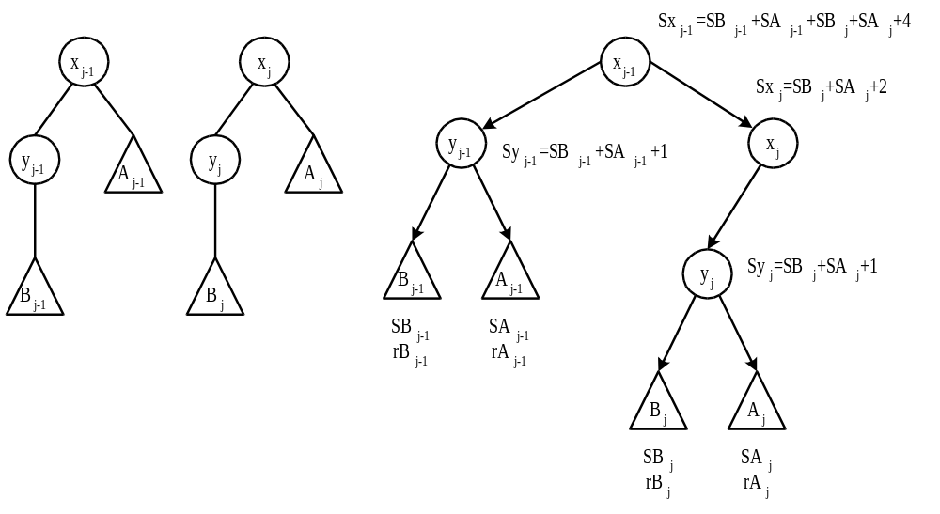

⇓ meld

Case 1: x_{j-1} ≤ x_{j}
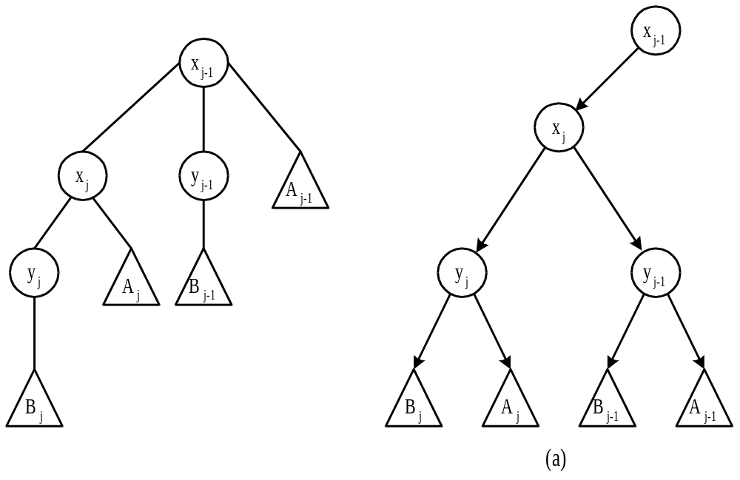
Case 2: x_{j-1} > x_{j}
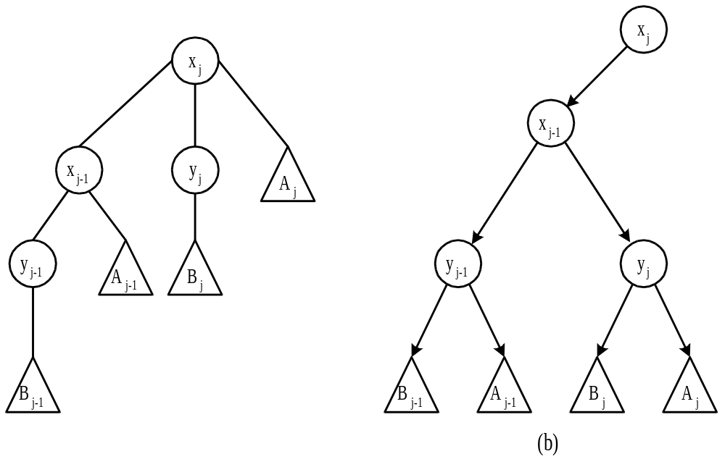

ΔΦ=Φ_{after}−Φ_{before}=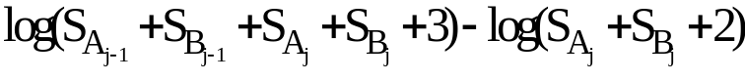
Let n_{i} = # of nodes of tree containing x_{i}, y_{i}, A_{i} and B_{i}
ΔΦ = log(n₁+n₂+☹+n_{j}−1) − log(n₂+n₃+☹+n_{j})
+ log(n₂+n₃+☹+n_{j}−1) − log(n₃+n₄+☹+n_{j})
+ ☹
+ log(n_{j-1}+n_{j}−1) − log(n_{j})
≤ log(n-2) − log(n_{j})
< log(n-1)

a = t+Φ′−Φ
≤ 2j+1−log n+(2log n−2j+2)+log(n-1)
≤ 2logn+3 = O(log n)

