§Randomized Algorithms
In a randomized algorithm (probabilistic algorithm), we make some random choices.

2 types of randomized algorithms:
- for optimization problems, a randomized algorithm gives an optimal solution. The average case time-complexity is more important than the worst case time-complexity.
- For decision problems, a randomized algorithm may make mistakes. The probability of producing wrong solutions is very small.
- A randomized algorithm to solve the closest pair problem
- This problem can be solved by the divide-and-conquer approach in O(nlogn) time.
- The randomized algorithm:
partition the points into several clusters:

X₃ | ● X₅  X₄ 
X₁  X₂ | X₆  X₇

We only calculate distances among points within the same cluster.
Similar to the divide-and-conquer strategy.
There is a dividing process, but no merging process.
Algorithm 11.1 A Randomized Algorithm for Finding a Closest Pair

Input: A set S consisting of n elements x₁, x₂,…, x_{n}, where S R².
Output: The closest pair in S.
Step 1. Randomly choose a set S₁={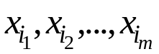} where m=n^{2/3}. Find the closest pair of S₁ and let the distance between this pair of points be denoted as 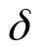.
Step 2. Construct a set of squares T with mesh-size.
Step 3. Construct four sets of squares T₁, T₂, T₃ and T₄ derived from T by doubling the mesh-size to 2.
Step 4. For each T_{i}, find the induced decomposition S=S₁^{(i)} S₂^{(i)}…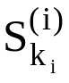, 1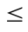i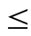4, where S_{j}^{(i)} is a non-empty intersection of S with a square of T_{i}.
Step 5. For each x_{p}, x_{q}∈S_{j}^{(i)}, compute d(x_{p}, x_{q}). Let x_{a} and x_{b} be the pair of points with the shortest distance among these pairs. Return x_{a} and x_{b} as the closest pair.
e.g.

6δ

5δ

4δ
X₃
X₄
X₂
X₅

3δ
X₁
X₉
2δ

X₇
X₆
δ
X₈

6δ
5δ
4δ
3δ
2δ
δ

There are 27 points.
S₁ = {x₁, x₂, …, x₉}, δ = d(x₁, x₂)
T₁:
6δ

5δ
4δ
X₃
X₄

3δ
X₂
X₅

X₉
X₁
2δ
X₇
X₆
δ
X₈
6δ
5δ
4δ
3δ
δ
2δ

T₂:
6δ

5δ
X₃
X₄
4δ
X₂
X₅
3δ
X₉
X₁
2δ
X₇
X₆
δ
X₈
6δ
5δ
4δ
3δ
2δ
δ
T₃:
6δ

5δ
4δ
X₃
X₄
X₂
X₅
3δ
X₉
X₁
2δ
X₇
X₆
δ
X₈

6δ
5δ
4δ
3δ
2δ
δ
T₄:
6δ

5δ
X₃
X₄
4δ
X₂
X₅

3δ
2δ
X₉
X₁
X₇
X₆
δ
X₈

6δ
5δ
4δ
3δ
2δ
δ

- time-complexity : O(n) in average
step 1: O(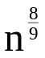) + O(n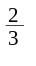) = o(n)
randomly choose (n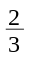)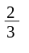 = 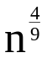 from the n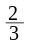points.
Straight forward method for the points: O()
recursively applying the algorithm once: O(n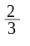)
step 2:
step 3: O(n)
step 4:
step 5: O(n)with probability 1-2e^{-cn}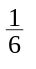

- How many distance computations in step 5?
: mesh-size in step 5
T: partition in step 5
N(T): # of distance computations in partition T
fact: There exists a particular partition T₀, whose mesh-size is δ₀ such that
- N(T₀) c₀n.
- The probability that 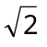δ₀ is 1-2e^{-cn}.
T₁, T₂, …, T₁₆:
mesh-size: 4δ₀

4δ₀

The probability that each square in T falls into at least one square of T_{i} , i = 1, 2, …, 16 is 1-2e^{-cn}.
The probability that
N(T) 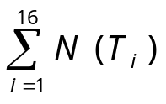
is 1-2e^{-cn}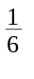.

4δ₀
δ₀
T_{i}:
k

Let the square in T₀ with the largest number of elements among the 16 squares have k elements.

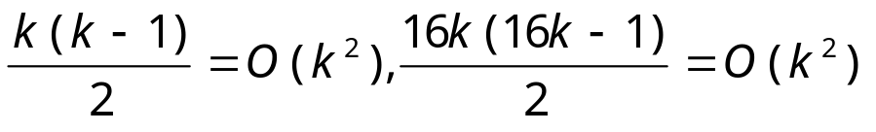
N(T₀) c₀n => N(T_{i}) c_{i}n
N(T) 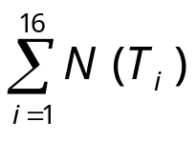= O(n) with probability 1-2e^{-cn}.
- A randomized algorithm to test whether a number is prime.
This problem is very difficult and no polynomial algorithm has been found to solve this problem.

traditional method:
use 2,3,…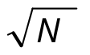 to test whether N is prime.
input size of N : B=log₂N (binary representation)
=2^{B/2}, exponential function of B
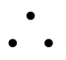 can not be viewed as a polynomial function of the input size.
Algorithm 11.3 A Randomized Prime Number Testing Algorithm

Input: A positive number N, and a parameter m.
Output: Whether N is a prime or not, with probability of being correct 1-ε = 1-2^{-m}.
Step 1. Randomly choose m numbers b₁, b₂, …, b_{m}, 1≤ b₁, b₂, …, b_{m} <N where m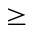log₂(1/ε).
Step 2. For each b_{i}, test whether W(b_{i}) holds where W(b_{i}) is defined as follows:
- b_{i}^{N-1}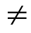1 mod N
or (2) ∃ j [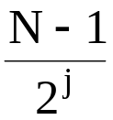 = k is an integer and the greatest common divisor of (b_{i})^{k}-1 and N is not 1 or N.]
If any W(b_{i}) holds, then return N as a composite number, otherwise, return N as a prime.
e.g.1. N = 12
choose 2, 3, 7
2¹²⁻¹ = 2048 ≠ 1 mod 12 ⇒ 12 is a composite number.
e.g.2. N = 11
choose 2, 5, 7
- 2¹¹⁻¹=1024≡1 mod 11
j=1, (N-1)/2^{j}=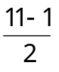=5
GCD(2⁵-1, 11) = 1
W(2) does not hold .
- 5¹¹⁻¹=9765625≡1 mod 11
GCD(5⁵-1, 11) = 11
W(5) does not hold .
- 7¹¹⁻¹=282475249≡1 mod 11
GCD(7⁵-1, 11) = 1
W(7) does not hold .
⇒ 11 is a prime number with the probability of correctness being 1-2⁻³=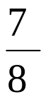.
<Theorem>
- If W(b) holds for any 1 ≤ b < N, then N is a composite number .
- If N is composite, then 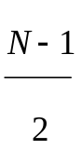 ≤ | { b | 1 ≤ b < N, W(b) holds } |.
- A randomized algorithm for pattern matching pattern string : X length : n
text string : Y length : m , m ≥ n
to find the first occurrence of X as a consecutive
substring of Y .
Assume that X and Y are binary strings.

- g. X = 01001 , Y = 1010100111
X

• straight forward method : O(m n)
• Knuth-Morris-Pratt’s algorithm : O(m)
• the randomized algorithm : O(m k) with a mistake of small probability.
k:# of testings
X = x₁ x₂…x_{n}∈{0,1}
Y = y₁ y₂…y_{m}∈{0,1}
Let Y(i)=y_{i} y_{i+1}….y_{i+n-1}
A match occurs if X=Y(i) for some i .

binary values of X and Y(i):
B(X) = x₁2^{n-1} + x₂2^{n-2} + … + x_{n}
B(Y(i)) = y_{i}2^{n-1}+y_{i+1}2^{n-2}+…+y_{i+n-1} , 1≤i≤m-n+1

Let p be a randomly chosen prime number in {1,2,…,nt²}, where t = m - n + 1.
(x_{i})_{p} = x_{i} mod p

fingerprints of X and Y(i):
B_{p}(x) = ( ( ( (x₁2)_{p}+x₂)_{p}2)_{p}+x₃)_{p}2…
B_{p}(Y(i)) = ( ( ( (y_{i}2)_{p}+y_{i+1})_{p}2+y_{i+2})_{p}2…
⇒ B_{p}(Y(i+1))=( ( ( (B_{p}(Y_{i})-( (2^{n-1})_{p}y_{i})_{p} )_{p} 2)_{p} +y_{i+n})_{p}
= ( (B_{p}(Y_{i})-2^{n-1}y_{i}) 2+Y_{i+n})_{p}
If X=Y(i), then B_{p}(X) = B_{p} (Y(i)), but not vice versa .
e.g. X = 10110 , Y = 110110
n = 5 , m = 6 , t = m - n + 1 = 2
suppose P=3 .
B_{p}(X) = (22)₃ = 1
B_{p}(Y(1)) = (27)₃ = 0
⇒ X≠Y(1)
B_{p}(Y(2)) = ( (0-2⁴) 2+0)₃ = 1 ⇒ X = Y(2)
e.g. X = 10110 , Y = 10011 , P = 3
B_{p}(X) = (22)₃ = 1
B_{p}(Y(1)) = (19)₃ = 1
⇒ X= Y(1) WRONG!

- If B_{p}(X) ≠ B_{p}(Y(i)), then X ≠ Y(i) .
- If B_{p}(X) = B_{p}(Y(i)), we may do a bit by bit checking or compute k different fingerprints by using k different prime numbers in {1,2,…nt²} .
Algorithm 11.4 A Randomized Algorithm for Pattern Matching
Input: A pattern X = x₁ x₂…x_{n}, a text Y = y₁ y₂…y_{m} and a parameter k.
Output: (1)No, there is no consecutive substring in Y which matches with X.
(2)Yes, Y(i) = y_{i} y_{i+1}.…y_{i+n-1} matches with X which is the first occurrence.
If the answer is “No” , there is no mistake.
If the answer is “Yes” , there is some probability that a mistake is made.
Step 1. Randomly choose k prime numbers p₁, p₂, …, p_{k} from {1,2,…,nt²}, where t = m - n + 1.
Step 2. i = 1.
Step 3. j = 1.
Step 4. If B(X)_{Pj} ≠ (B(Y_{i}))_{pj}, then go to step 5.
If j = k, return Y(i) as the answer.
j = j + 1.
Go to step 4.
Step5. If i = t, return “No, there is no consecutive substring in Y which matches with X.”
i = i + 1.
Go to Step 3.
e.g. X = 10110 , Y = 100111 , P₁ = 3 , P₂ = 5
B₃(X) = (22)₃ = 1
?
B₅(X) = (22)₅ = 2
X = Y(2)
B₃(Y(2)) = (7)₃ = 1
B₅(y(2)) = (7)₅ = 2
Choose one more prime number, P₃ = 7
B₇(x) = (22)₇ = 1
B₇(Y(2)) = (7)₇ = 0
⇒X ≠ Y(2)

- How often does a mistake occur?
When a mistake occurs in X and Y(i), B(X) - B(Y(i)) ≠ 0, and p_{j} divides | B(X) - B(Y(i)) | for all p_{j}’s.
Let Q = 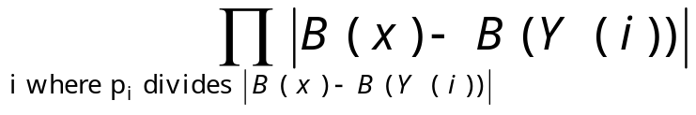
Q < 2^{n(m-n+1)}  B(x)<2^{n} , at most (m-n+1) B(Y(i))’s
2^{n} 2^{n}…2^{n}
m-n-1

<Theorem>
If u≥29 and a<2^{u}, then a has fewer than π(u) diffferent prime number divisors where π(u) is the number of prime numbers smaller than u.
Assume nt ≥ 29 .
Q < 2^{n(m-n+1)} = 2^{nt}
⇒ Q has fewer than π(nt) different prime number divisors.
• If p_{j} is a prime number selected from {1, 2, …, M}, the probability that p_{j} divides Q is less than 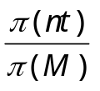
• If k different prime numbers are selected from {1, 2, …nt²} , the probability that a mistake occurs is less than 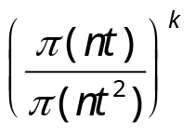 provided nt ≥ 29.
• How do we estimate ?
<Theorem> For all u ≥ 17,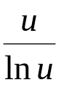 ≤ π(u) ≤1.25506
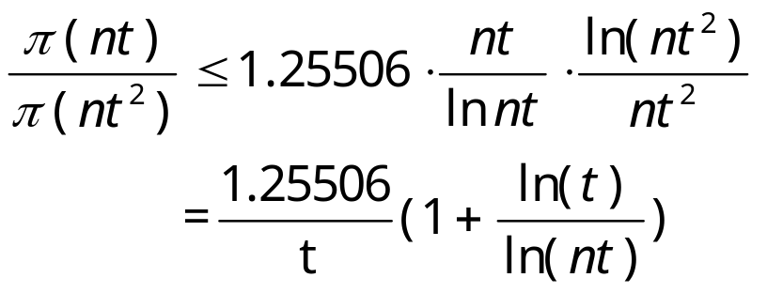
e.g. n = 10 , m = 100 , t = m - n + 1 = 91
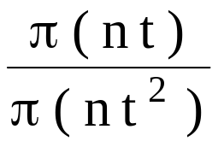 ≤ 0.0229
Let k=4
(0.0229)⁴≈2.75×10⁻⁷
- A randomized algorithm for interactive proofs

two persons:
A: a spy
B: the boss of A
When A wants to talk to B , how does B know that A is the real A, not an enemy imitating A ?
Method I: a trivial method
B may ask the name of A’s mother.
(a private secret)
disadvantage:
The enemy can collect the information ,and imitate A the next time.
Method II:
B may send a Boolean formula to A and ask A to determine its satisfiability. (an NP-complete problem).

It is assumed that A is a smart person and knows how to solve this NP-complete problem.
B can check the answer and know whether A is the real A or not.
disadvantage:
The enemy can study methods of mechanical theorem proving and sooner or later he can imitate A.
In Methods I and II, A and B have revealed too much.

Method III:
B can ask A to solve a quadratic nonresidue problem in which the data can be sent back and forth without revealing much information.

Definition:
(x, y) = 1, y is a quadratic residue mod x if z² ≡ y mod x for some z, 0 < z < x, (x, z) = 1 and y is a quadratic nonresidue mod x if otherwise.
Let
QR = {(x, y) | y is a quadratic residue mod x}
QNR = {(x, y) | y is a quadratic nonresidue mod x}
e.g. x = 9, y = 7
1² ≡ 1 mod 9
2² ≡ 4 mod 9
3² ≡ 0 mod 9
4² ≡ 7 mod 9
5² ≡ 7 mod 9
6² ≡ 0 mod 9
7² ≡ 4 mod 9
8² ≡ 1 mod 9
(9,7) ∈ QR
but (9,5) ∈ QNR
Method:
- A and B know x and keep x confidential .
B knows y.
- Action of B:
- Randomly choose m bits: b₁, b₂, …, b_{m} where m is the length of the binary representation of x.
- Find z₁, z₂, …, z_{m} s.t. (z_{i} , x)=1 for all i .
- Compute w₁, w₂, …, w_{m}:
w_{i} ←z_{i}² mod x if b_{i}=0
w_{i} ← (z_{i}².y) mod x if b_{i}=1
- Send w₁, w₂, …, w_{m} to A.
- Action of A:
- Receive w₁, w₂, …, w_{m} from B.
- Compute c₁, c₂, …, c_{m} :
c_{i} ←0 if (x, w_{i}) ∈ QR
c_{i} ←1 if (x, w_{i}) ∈ QNR
Send c₁, c₂, …, c_{m} to B.
- Action of B:
- Receive c₁, c₂, …, c_{m} from A.
If (x, y) ∈ QNR and b_{i} = c_{i} for all i, then A is the real A ( with probability 1-2^{-m}).

