§The Complexity of Algorithms and the Lower Bounds of Problems

- The goodness of an algorithm
time complexity (more important)
space complexity
for a parallel algorithm :
time-processor product
for a VLSI circuit :
area-time (AT, AT²)

- Measure the goodness of an algorithm
time complexity of an algorithm
worst-case
average-case
amortized

- Measure the difficulty of a problem
NP-complete
undecidable

- Is the algorithm best?
optimal (algorithm)

We can use # of comparisons to measure a sorting algorithm.
- Asymptotic notations
Def: f(n) = O(g(n)) "at most"
∃c, and n₀, ∋ |f(n)| ≤ c|g(n)| ∀ n ≥ n₀
e.g. f(n) = 3n² + 2
g(n) = n²
⇒ n₀=2, c=4
∴f(n) = O(n²)
e.g. f(n) = n³ + n = O(n³)

Def: f(n) = Ω(g(n)) "at least"
"lower bound"
∃ c, and n₀, ∋ |f(n)| ≥ c|g(n)| ∀ n ≥ n₀

Def: f(n) = Θ(g(n))
∃ c₁, c₂, and n₀, ∋ c₁|g(n)| ≤ |f(n)| ≤ c₂|g(n)| ∀ n ≥ n₀

Def: f(n) ∼ o(g(n))
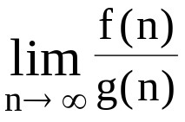 → 1
e.g. f(n) = 3n²+n = o(3n²)
Problem size
 | 10 | 10² | 10³ | 10⁴
log₂n | 3.3 | 6.6 | 10 | 13.3
n | 10 | 10² | 10³ | 10⁴
nlog₂n | 0.33x10² | 0.7x10³ | 10⁴ | 1.3x10⁵
n² | 10² | 10⁴ | 10⁶ | 10⁸
2^{n} | 1024 | 1.3x10³⁰ | >10¹⁰⁰ | >10¹⁰⁰
n! | 3x10⁶ | >10¹⁰⁰ | >10¹⁰⁰ | >10¹⁰⁰
Table 2.1 Time Complexity Functions
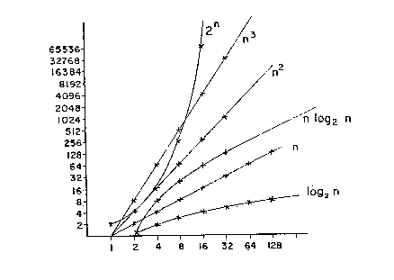
Figure: Rate of growth of common computing time functions
O(1) < O(log n) < O(n) < O(n log n) < O(n²) < O(n³) < O(2^{n}) < O(n!) < O(n^{n})
exponential algorithm: O(2^{n})
polynomial algorithm

Algorithm A: O(n³)
Algorithm B: O(n)
Should Algorithm B run faster than A?
NO!
It is true only when n is large enough!

- Analysis of algorithms
best case: easiest
worst case
average case: hardest
- straight insertion sort
input: 7,5,1,4,3
7,5,1,4,3
5,7,1,4,3
1,5,7,4,3
1,4,5,7,3
1,3,4,5,7

Algorithm 2.1 Straight Insertion Sort
Input: x₁,x₂,...,x_{n}
Output: The sorted sequence of x₁,x₂,...,x_{n}
For j := 2 to n do
Begin
i := j-1
x := x_{j}
While x<x_{i} and i > 0 do
Begin
x_{i+1} := x_{i}
i := i-1
End
x_{i+1} := x
End

- Inversion table
(a₁,a₂,...,a_{n}): a permutation of {1,2,...,n}
(d₁,d₂,...,d_{n}): the inversion table of (a₁,a₂,...a_{n})
d_{j}: the number of elements to the left of j that are greater than j
- g. (7 5 1 4 3 2 6)
2 4 3 2 1 1 0 inversion table
- g. (7 6 5 4 3 2 1)
6 5 4 3 2 1 0 inversion table

- M: # of data movements
M = 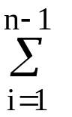(2 + d_{i})
1 5 7 4 3

temporary
d₃=2

best case: already sorted
d_{i} = 0 for 1 ≤ i ≤ n
⇒M = 2(n − 1) = O(n)
worst case: reversely sorted
d₁ = n − 1
d₂ = n − 2
:
d_{i} = n − i
:
d_{n} = 0
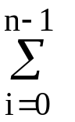d_{i} = 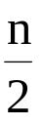(n − 1)
⇒M = (n − 1)+2(n − 1) = O(n²)
average case:
x_{j} is being inserted into the sorted sequence x₁ x₂ ... x_{j-1}
the probability that x_{j} is the largest: 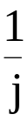
takes 2 data movements
the probability that x_{j} is the second largest:
takes 3 data movements
1 4 7 5
temporary
:
:
# of movements for x_{j} to be inserted:
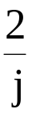 + 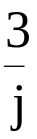 + ... + 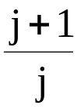 = 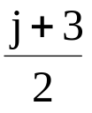
M = 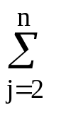 = 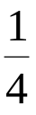(n + 8)(n − 1) = O(n²)

Alternative view (average case)
Only consider # of exchanges.
Method 1
x_{j} is being inserted into the sorted sequence x₁ x₂ .... x_{j-1}
If x_{j} is the kth (1≤k≤j) largest, it takes (k−1)
exchanges.
- g. 1 5 7↔4
1 5↔4 7
1 4 5 7

# of exchanges required for x_{j} to be inserted:
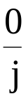 + + + ... + 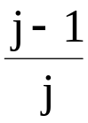 = 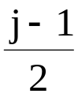
⇒ # of exchanges for sorting:
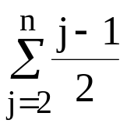
=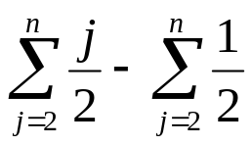
=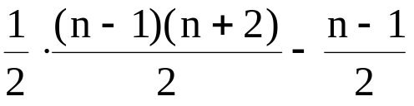
=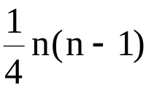
Method 2 (using inversion table) [Knuth 1973]
I_{n}(k): # of permutations which have exactly k
inversions
P_{n}(k): the probability that a given permutation of n numbers has k inversions
P_{n}(k)=I_{n}(k)/n!
average # of inversions(exchanges):
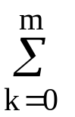k P_{n}(k), where m = 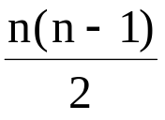
I_{n}(k):
k<n ↑
I_{n-1}(k) largest
I_{n-1}(k−1) 2nd
I_{n-1}(k−2) 3rd
:
I_{n-1}(0) (k+1)th
largest
k≥n ↑
I_{n-1}(k) largest
I_{n-1}(k−1) 2nd
:
I_{n-1}(k−(n−1)) nth largest
(smallest)

⎧I_{n}(k)=I_{n-1}(0)+I_{n-1}(1)+...+I_{n-1}(k), k<n
⎩I_{n}(k)=I_{n-1}(k−n+1)+...+I_{n-1}(k), k≥n
I_{n}(k)=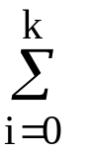I_{n-1}(i), k< n
I_{n}(k)=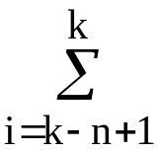I_{n-1}(i−1), k≥n

Prove
k I_{n}(k)= 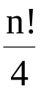n(n−1), where m = 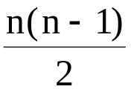
Proof:
by induction
- n=2, m = = 1
I₂(1) = 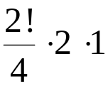 = 1
- Assume that it is true for n.
We shall prove
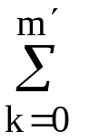k I_{n+1}(k) = 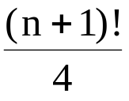n(n+1), m' = 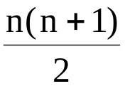
= m + n
k I_{n+1}(k) =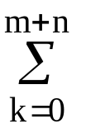 k I_{n+1}(k)
=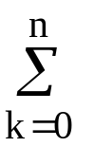kI_{n}(i) + 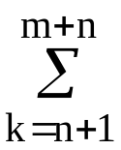k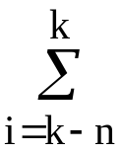I_{n}(i) …………(1)
(∵ I_{n+1}(k) = I_{n}(i), k<n+1
I_{n+1}(k) = I_{n}(i), k≥n+1)
Let (s, t) denote s⋅I_{n}(t)
k
0 | (0,0)
1 | (1,0) | (1,1)
2 | (2,0) | (2,1) | (2,2)
:
n | (n,0) | (n,1) | … |  | (n,n)
n+1 |  | (n+1,1) | (n+1,2) | … | … | (n+1,n+1)
n+2 |  |  | (n+2,2) | … | … | (n+2,n+1) | (n+2,n+2)
:
m |  |  |  |  |  |  |  |  | (m,n-m) | … | (m,m)
:
m+n |  |  |  |  |  |  |  |  |  |  | (m+n,m)
( I_{n}(m+1) = I_{n}(m+2) = … = I_{n}(m+n) = 0 )
(1) can be rewritten as:
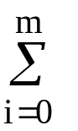I_{n}(i)(i + k)
=(i + k)I_{n}(i)
=i I_{n}(i) + kI_{n}(i)
(i I_{n}(i) = n(n−1), I_{n}(i) = n! )
=n(n−1) + k n!
=n(n−1)(n+1) + n!
=(n+1)(n(n−1)+2n)
=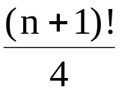n(n+1)

Therefore
k I_{n}(k) = n(n−1), where m =
⇒average # of inversions:
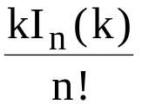 = 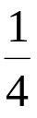n(n−1)
Method 3 (using inversion table and generating function)[Kronsjö 1979]
I_{n}(k)
n\k | 0 | 1 | 2 | 3 | 4 | 5 | 6
1 | 1 | 0 | 0 | 0 | 0 | 0 | 0
2 | 1 | 1 | 0 | 0 | 0 | 0 | 0
3 | 1 | 2 | 2 | 1 | 0 | 0 | 0
4 | 1 | 3 | 5 | 6 | 5 | 3 | 1

Assume we have I₃(k), 0 ≤ k ≤ 3, and a₄>a_{i}, 1≤ i ≤3
✶ a₁ a₂ a₃ a₄  a₁ a₂ a₃ a₄
↑ ↑
largest second largest
G₃(Z) ZG₃(Z)
→ a₁ a₂ a₃ a₄  a₁ a₂ a₃ a₄
↑ ↑
third largest smallest
Z²G₃(Z) Z³G₃(Z)
 | I₄(0) |  | I₄(1) |  | I₄(2) |  | I₄(3) |  | I₄(4) |  | I₄(5) |  | I₄(6)
✶ | I₃(0) | I₃(1) |  | I₃(2) |  | I₃(3)
✴ |  | I₃(0) |  | I₃(1) |  | I₃(2) |  | I₃(3)
→ |  |  |  | I₃(0) |  | I₃(1) |  | I₃(2) |  | I₃(3)
✵ |  |  |  |  |  | I₃(0) |  | I₃(1) |  | I₃(2) |  | I₃(3)

generating function for I_{n}(k)
G_{n}(Z) = I_{n}(k)Z^{k}
for n = 4
G₄(Z) = 1 + 3Z + 5Z² + 6Z³ + 5Z⁴ + 3Z⁵ + Z⁶
= (1 + Z + Z² + Z³)G₃(Z)
in general,
G_{n}(Z) = (1 + Z + Z² + … + Z^{n-1})G_{n-1}(Z)
generating function for P_{n}(k):
g_{n}(Z) =P_{n}(k)Z^{k} = 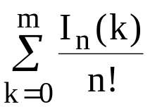Z^{k}
=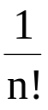G_{n}(Z)
=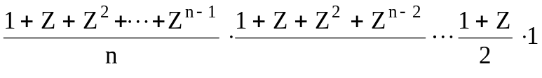
kP_{n}(k) = g_{n}′(1)
=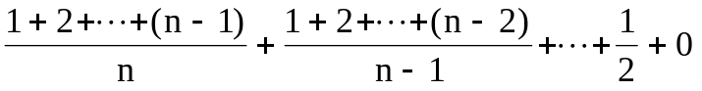
=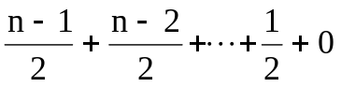
=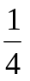n(n−1)
- Binary search
e.g.
sorted sequence: (search 9)
1 4 5 7 9 10 12 15
step 1 ↑
step 2 ↑
step 3 ↑
best case: 1 step = O(1)
worst case: (⎣log₂ n⎦+1) steps = O(log n)
average case: O(log n)
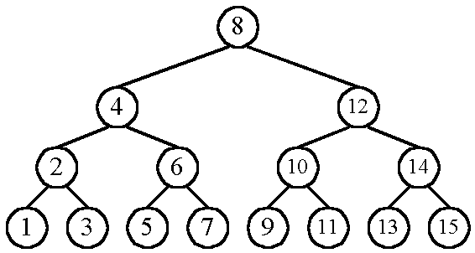
n cases for successful search
n+1 cases for unsuccessful search
the average # of comparisons done in the binary tree:
A(n) = 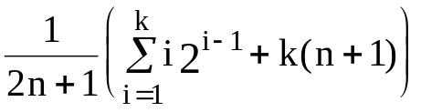, where k = ⎣log n⎦+1
successful unsuccessful
Assume n=2^{k}  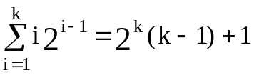 | proved by induction  on k
A(n) = 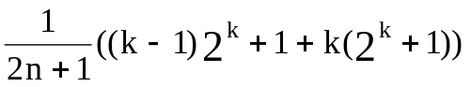
≈ k as n is very large
= log n
= O(log n)

- Straight selection sort
e.g.
7 5 1 4 3
1 5 7 4 3
1 3 7 4 5
1 3 4 7 5
1 3 4 5 7
Only consider # of changes in the flag which is
used for selecting the smallest number in each
iteration.
best case: O(1)
worst case: O(n²)
average case: O(n log n)

- Quick sort
e.g.
11 | 5 | 24 | 2 | 31 | 7 | 8 | 26 | 10 | 15
 |  | ↑ |  |  |  |  |  | ↑
11 | 5 | 10 | 2 | 31 | 7 | 8 | 26 | 24 | 15
 |  |  |  | ↑ |  | ↑
11 | 5 | 10 | 2 | 8 | 7 | 31 | 26 | 24 | 15
△ |  |  |  |  | △
7 | 5 | 10 | 2 | 8 | 11 | 31 | 26 | 24 | 15
|← |  | <11 |  | →| |  | |← | > | 11 | →|
Recursively apply the same procedure.
best case: O(n log n)
A list is split into two sublists with almost equal size.
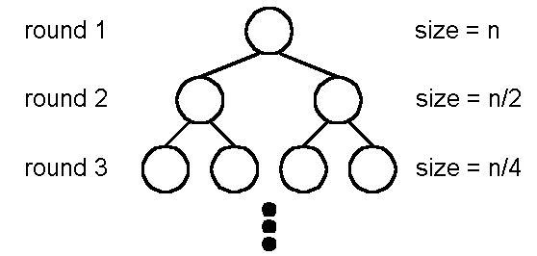
log n rounds are needed.
In each round, n comparisons (ignoring the element used to split) are required.

worst case: O(n²)
In each round, the number used to split is either the smallest or the largest.
n + (n − 1) + … + 1 = = O(n²)
average case: O(n log n)
s n-s
include the splitter

T(n) = 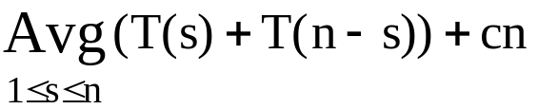
= 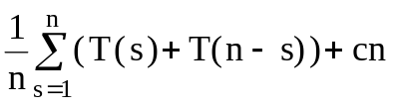
= 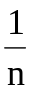(T(1)+T(n−1)+T(2)+T(n−2)+…+T(n)+T(0))+cn, T(0)=0
= (2T(1)+2T(2)+…+2T(n−1)+T(n))+cn
(n−1)T(n) = 2T(1)+2T(2)+…+2T(n−1) + cn²……(1)
(n−2)T(n-1)=2T(1)+2T(2)+…+2T(n−2)+c(n−1)²…(2)
(1) − (2)
(n−1)T(n) −(n−2)T(n−1) = 2T(n−1)+c(2n−1)
(n−1)T(n) −nT(n−1) = c(2n−1)
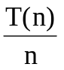=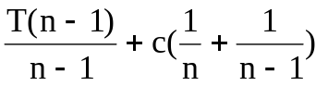
=c(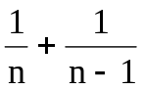)+c(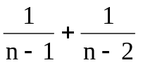)+…+c(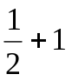)+T(1), T(1) = 0
=c(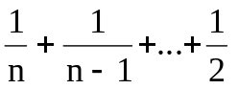)+c(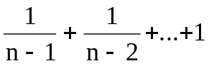)

Harmonic number[Knuth 1986]
H_{n} = 1+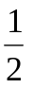+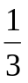+…+
=ln n + γ +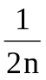−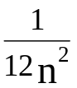+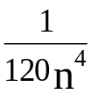−ε, where 0<ε<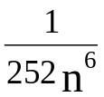
γ = 0.5772156649….
H_{n} = O(log n)
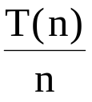 = c(H_{n}−1) + cH_{n-1}
= c(2H_{n}−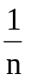−1)
⇒T(n) = 2 c n H_{n} − c(n+1)
=O(n log n)

- 2-D rank finding
Def: A = (a₁,a₂), B = (b₁,b₂)
A dominates B iff a₁> b₁ and a₂ > b₂.
Def: Given a set s of n point, the rank of a point x is the number of points dominated by x.
e.g.

B
A
C
D
E
rank(A) = 0 rank(B) = 1 rank(C) = 1
rank(D) = 3 rank(E) = 0
straightforward algorithm:
compare all pairs of points: O(n²)

more efficient algorithm
step 1: Split the points along the median line L into A and B.

L
1+3=4
A
B
0+1=1
0+2=2
2+3=5
2+4=68
1
1
0
0
step 2: Find ranks of points in A and ranks of points in B, recursively.
step 3: Sort points in A and B according to their y-values. Update the ranks of points in B.
time complexity:
step 1: O(n) (finding median)
step 3: O(n log n) (sorting)
total time complexity
T(n) ≤ 2T(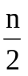) + c₁ n log n + c₂ n
≤ 2T() + c n log n
≤ 4T(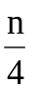) + c n log + c n log n

≤ nT(1) + c(n log n + n log+n log+…+n log 2)
= nT(1) + 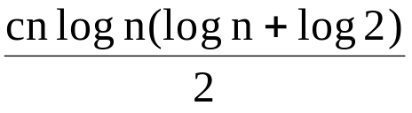
= O(n log²n)

- Lower bound
Def: A lower bound of a problem is the least time complexity required for any algorithm which can be used to solve this problem.
- worst case lower bound
average case lower bound
The lower bound for a problem is not unique.
e.g. Ω(1), Ω(n), Ω(n log n) are all lower bounds for sorting.
(Ω(1), Ω(n) are trivial)

(1)At present, if the highest lower bound of a
problem is Ω(n log n) and the time complexity
of the best algorithm is O(n²).
- We may try to find a higher lower bound.
- We may try to find a better algorithm.
- Both of the lower bound and the algorithm may be improved.
- If the present lower bound is Ω(n log n) and there is an algorithm with time complexity
O(n log n), then the algorithm is optimal.
- The worst case lower bound of sorting
6 permutations for 3 data elements
a₁ a₂ a₃
1 2 3
1 3 2
2 1 3
2 3 1
3 1 2
3 2 1
straight insertion sort:
input data: (2, 3, 1)
- a₁:a₂
- a₂:a₃, a₂↔a₃
- a₁:a₂, a₁↔a₂
input data: (2, 1, 3)
- a₁:a₂, a₁↔a₂
- a₂:a₃
decision tree for straight insertion sort:
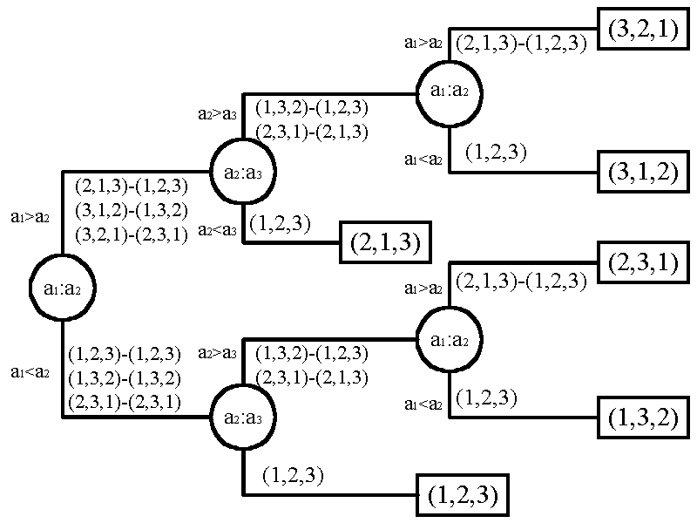
decision tree for bubble sort:
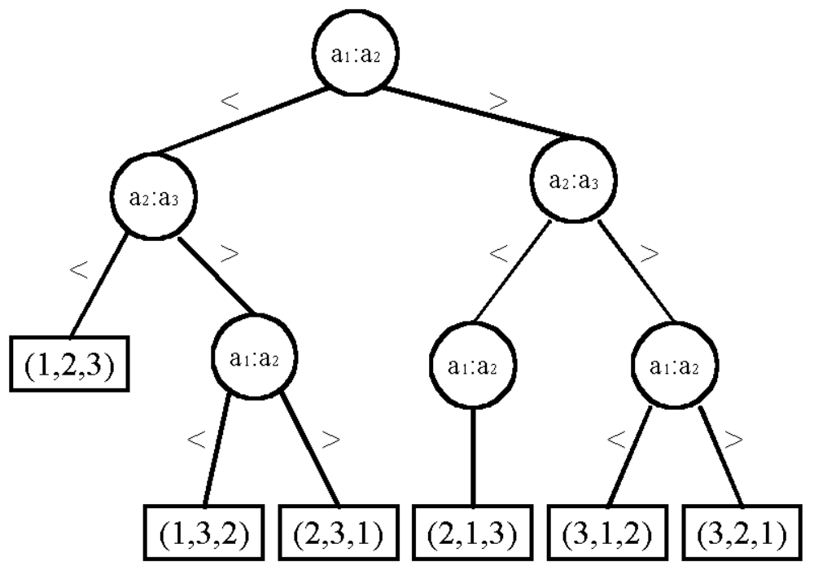
- To find the lower bound, we have to find the smallest depth of a binary tree.
- n! distinct permutations
n! leaf nodes in the binary decision tree.
- balanced tree has the smallest depth:
⎡log(n!)⎤ = Ω(n log n)
lower bound for sorting: Ω(n log n)

Method 1:
log(n!) = log(n(n−1)…1)
= log2 + log3 +…+ log n
> 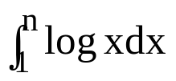
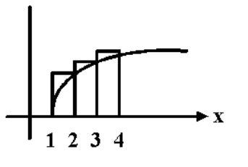
= log e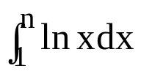
= log e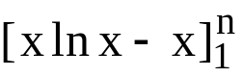
= log e(n ln n − n + 1)
= n log n − n log e + 1.44
≥ n log n − 1.44n
=Ω(n log n)
Method 2:
Stirling approximation:
n! ≈ 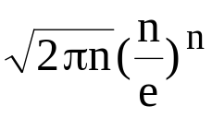
log n! ≈ log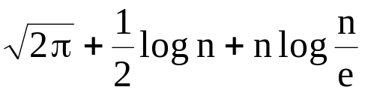
≈ n log n
≈ Ω(n log n)

n | n! | S_{n}
1 | 1 | 0.922
2 | 2 | 1.919
3 | 6 | 5.825
4 | 24 | 23.447
5 | 120 | 118.02
6 | 720 | 707.39
10 | 3,628,800 | 3,598,600
20 | 2.433x10¹⁸ | 2.423x10¹⁸
100 | 9.333x10¹⁵⁷ | 9.328x10¹⁵⁷
- Heapsort—An optimal sorting algorithm
a heap:
parent ≥ son
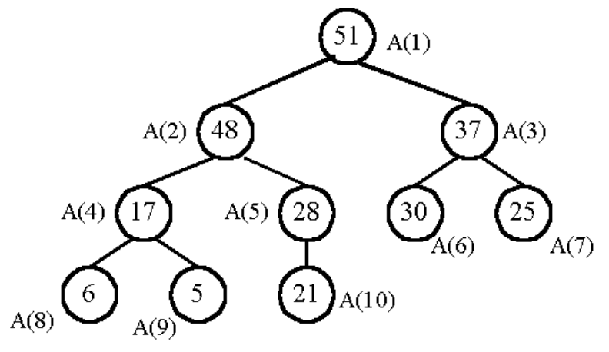
output the maximum and restore:
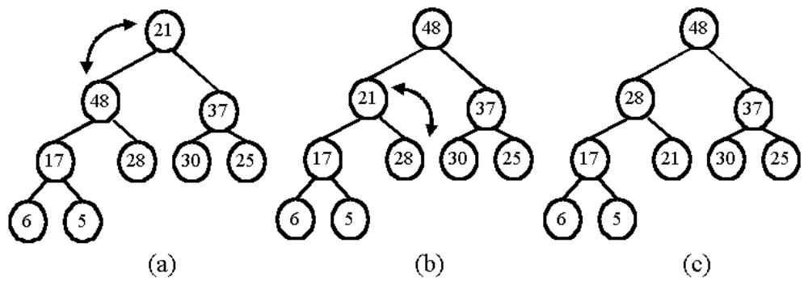
Heapsort: construction
output
Step 1: construction:
input data: 4, 37, 26, 15, 48
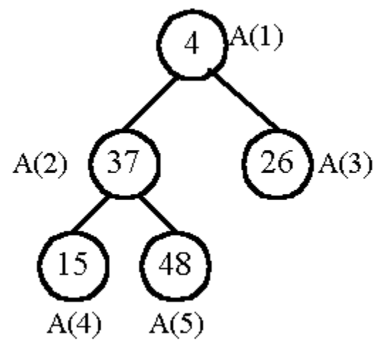
restore the subtree rooted at A(2):
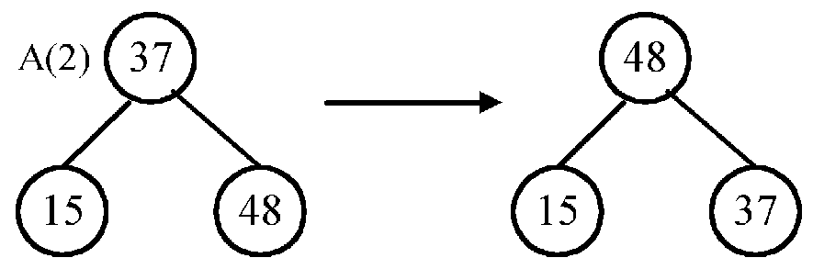
restore the tree rooted at A(1):
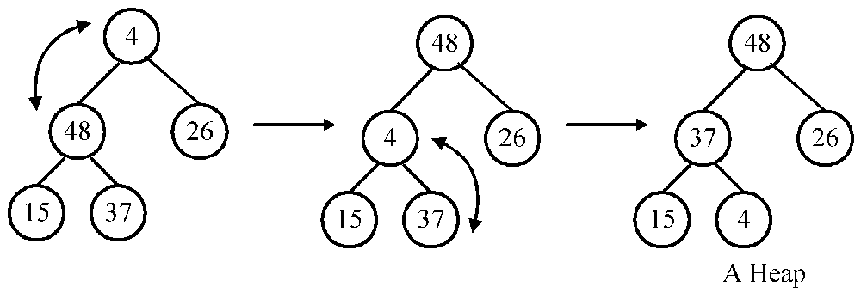
Step 2: output:
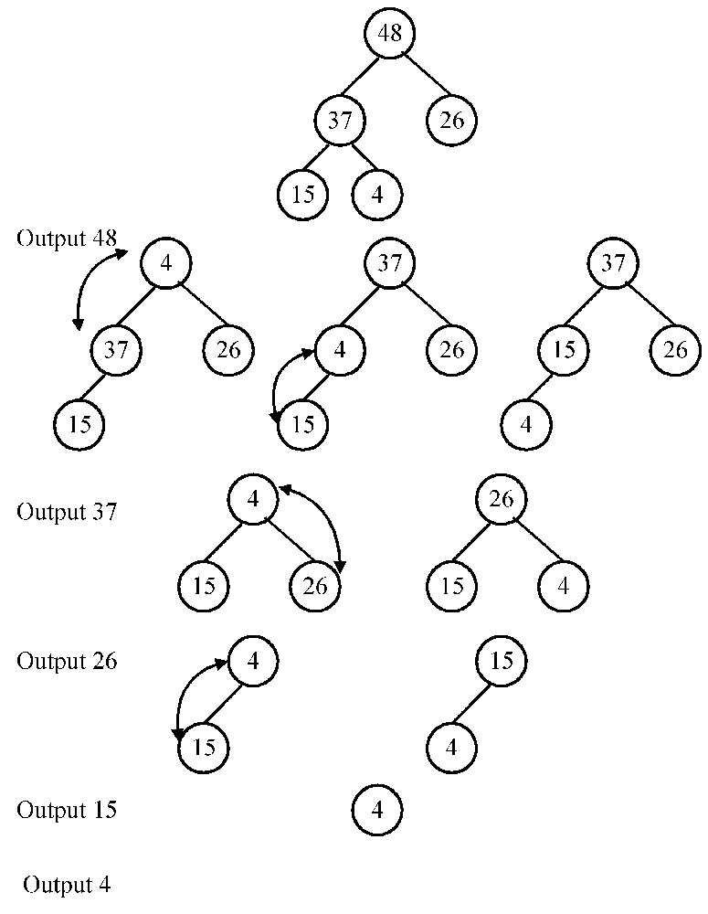
implementation
using a linear array
not a binary tree.
The sons of A(h) are A(2h) and A(2h+1).
time complexity: O(n log n)
Step 1: construction
d = ⎣log n⎦ : depth
# of comparisons is at most:
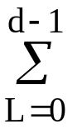2(d−L)2^{L}
=2d2^{L} − 4L2^{L-1}
(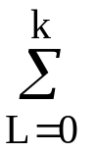L2^{L-1} = 2^{k}(k−1)+1)
=2d(2^{d}−1) − 4(2^{d-1}(d − 1 − 1) + 1)
:
= cn − 2⎣log n⎦ − 4, 2 ≤ c ≤ 4
Step 2: output
2⎣log i⎦
= :
=2n⎣log n⎦ − 4cn + 4, 2 ≤ c ≤ 4
=O(n log n)
- Average case lower bound of sorting
- Binary decision tree
- The average time complexity of a sorting algorithm:
the external path length of the binary tree
n!
- The external path length is minimized if the tree is balanced
(all leaf nodes on level d or level d−1)
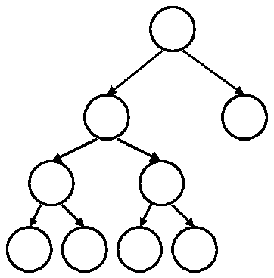
unbalanced
external path length
= 4⋅3 + 1 = 13

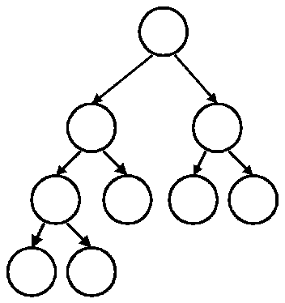
balanced
external path length
= 2⋅3+3⋅2 = 12

- compute the min external path length
- depth of balanced binary tree with c leaf nodes:
d = ⎡log c⎤
Leaf nodes can appear only on level d or d−1.
- x₁ leaf nodes on level d−1
x₂ leaf nodes on level d
x₁ + x₂ = c
x₁ +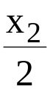 = 2^{d-1}
⇒ x₁ = 2^{d} − c
x₂ = 2(c − 2^{d-1})
- external path length:
M= x₁(d − 1) + x₂d
= (2^{d} − 1)(d − 1) + 2(c − 2^{d-1})d
= c(d − 1) + 2(c − 2^{d-1}), d − 1 = ⎣log c⎦
= c⎣log c⎦ + 2(c − 2^{⎣log c⎦})
- c = n!
M = n!⎣log n!⎦ + 2(n! − 2^{⎣log n!⎦})
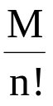 = ⎣log n!⎦ + 2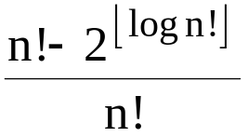
= ⎣log n!⎦ + c, 0 ≤ c ≤ 1
= Ω(n log n)
Average case lower bound of sorting: Ω(n log n)

- Quicksort is optimal in the average case.
( O(n log n) in average )
- (i)worst case time complexity of heapsort is
O(n log n)
- average case lower bound: Ω(n log n)
⇒average case time complexity of heapsort is
O(n log n)
Heapsort is optimal in the average case.

- Improving a lower bound through oracles
problem P: merge two sorted sequences A and B with lengths m and n.
- Binary decision tree:
There are 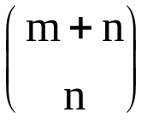 ways
leaf nodes in the binary tree.
The lower bound for merging:
⎡log⎤ ≤ m + n − 1
(conventional merging)
- When m = n
log = log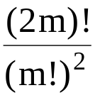 = log((2m)!) − 2log m!
Using Stirling approximation
n! ≈
log ≈ 2m − 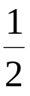log m + O(1)
- Optimal algorithm: 2m − 1 comparisons
log < 2m −1

- oracle:
The oracle tries its best to cause the algorithm to work as hard as it might. (to give a very hard data set)
sorted sequences:
A: a₁ < a₂ < … <a_{m}
B: b₁ < b₂ < … < b_{m}
the very hard case:
a₁ < b₁ < a₂ < b₂ < … < a_{m} < b_{m}
We must compare:
a₁ : b₁
b₁ : a₂
a₂ : b₂
:
b_{m-1} : a_{m-1}
a_{m} : b_{m}
Otherwise, we may get a wrong result for some
input data.
e.g. If b₁ and a₂ are not compared, we can not distinguish
a₁ < b₁ < a₂ < b₂ < … < a_{m} < b_{m} and
a₁ < a₂ < b₁ < b₂ < … < a_{m} < b_{m}
Thus, at least 2m−1 comparisons are required.
The conventional merging algorithm is optimal for m = n.

- Finding lower bound by problem transformation.
Problem A reduces to problem B (A∝B)
iff A can be solved by using any algorithm which solves B.
If A∝B, B is more difficult.
instance  of A |  | transformation  T(tr₁) | → | instance of B  ∣
 |  |  |  | T(B)↓solver of B
answer  of A | ← | transformation  T(tr₂) |  | answer of B
Note: T(tr₁) + T(tr₂) < T(B)
T(A) ≤ T(tr₁) + T(tr₂) + T(B) ∼ O(T(B))
- The lower bound of the convex hull problem
sorting ∝ convex hull
A B
an instance of A: (x₁, x₂,…, x_{n})
↓transformation
an instance of B: {( x₁, x₁²), ( x₂, x₂²),…, ( x_{n}, x_{n}²)}
assume: x₁ < x₂ < …< x_{n}
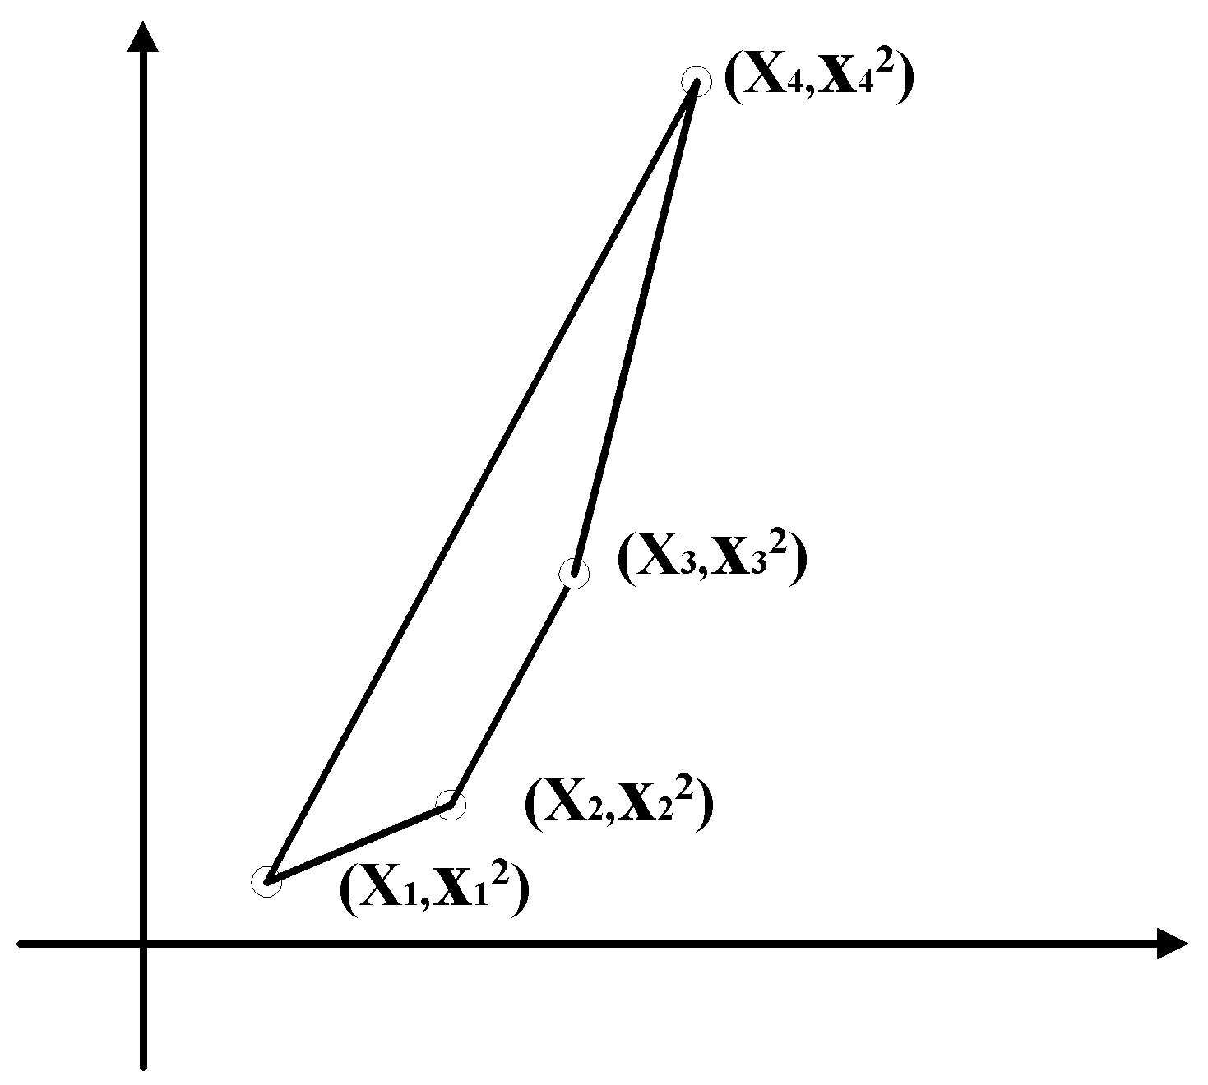
If the convex hull problem can be solved, we can also solve the sorting problem.
The lower bound of sorting: Ω(n log n)
- The lower bound of the convex hull problem:
Ω(n log n)

- The lower bound of the Euclidean minimal spanning tree (MST) probem
sorting ∝ Euclidean MST
A B
an instance of A: (x₁, x₂,…, x_{n})
↓transformation
an instance of B: {( x₁, 0), ( x₂, 0),…, ( x_{n}, 0)}
x₁ < x₂ < x₃ <…< x_{n}
⇔there is an edge between (x_{i}, 0) and (x_{i+1}, 0) in the MST, where 1 ≤ i ≤ n−1

If the Euclidean MST problem can be solved, we can also solve the sorting problem.
The lower bound of sorting: Ω(n log n)
- The lower bound of the Euclidean MST problem: Ω(n log n)

