§The Theory of NP-Completeness
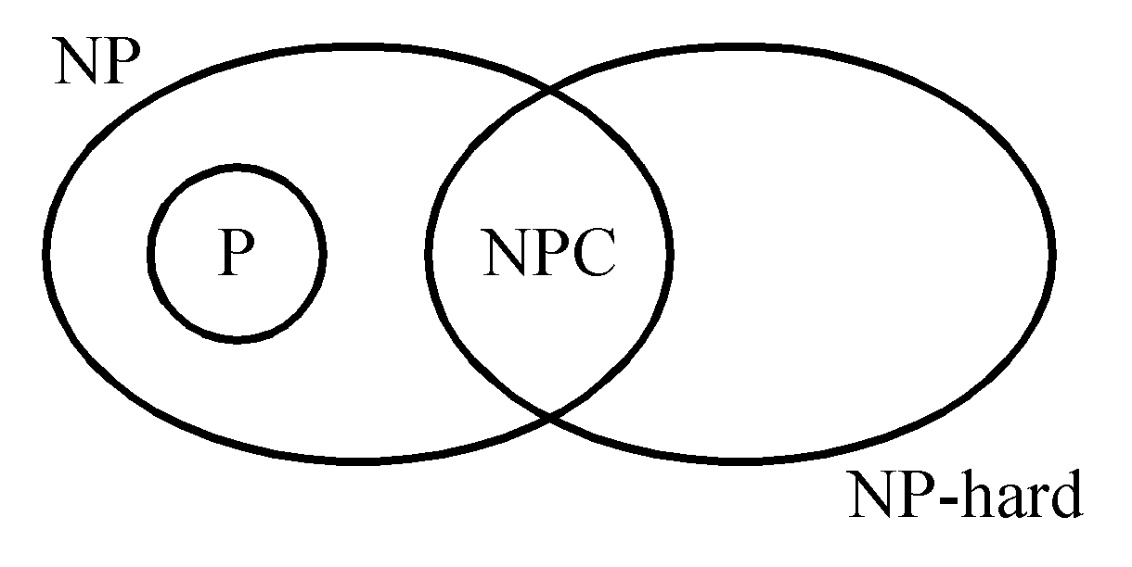

NP: the class of decision problem which can be solved by a non-deterministic polynomial algorithm.
P: the class of problems which can be solved by a deterministic polynomial algorithm.
NP-hard: the class of problems to which every NP problem reduces.
NP-complete: the class of problems which are NP-
(NPC) hard and belong to NP.

Def: Problem A reduces to problem B (A ∝ B) iff A can be solved by a deterministic polynomial time algorithm using a deterministic algorithm that solves B in polynomial time.
- Up to now, none of the NPC problems can be solved by a deterministic polynomial time algorithm in the worst case.
- It does not seem to have any polynomial time algorithm to solve the NPC problems.
- The lower bound of any NPC problem seems to be in the order of an exponential function.

- The theory of NP-completeness always considers the worst case.
- Not all NP problems are difficult. (e.g. the MST problem is a NP problem.)
- If A, B ∈ NPC, then A ∝ B and B ∝ A.

- Theory of NP-completeness

If any NPC problem can be solved in polynomial time, then all NP problems can be solved in polynomial time. (NP = P)

- Decision problems
the solution is simply “Yes” or “No”.
optimization problem: more difficult
decision problem
- g. the traveling salesperson problem
optimization version:
find the shortest tour
decision version:
Is there a tour whose total length is less than or equal to a constant c.

- Solving an optimization problem by a decision algorithm :
give c₁ and test
c₂

c_{n}
The satisfiability problem
the logical formula :
x₁ v x₂ v x₃
& - x₁
& - x₂
the assignment :
x₁ ← F , x₂ ← F , x₃ ← T
will make the above formula true
(-x₁, -x₂ , x₃) represents
x₁ ← F , x₂ ← F , x₃ ← T

- If there is at least one assignment which satisfies a formula, then we say that this formula is satisfiable; otherwise, it is unsatisfiable.
- An unsatisfiable formula :
x₁ v x₂
& x₁ v -x₂
& -x₁ v x₂
& -x₁ v -x₂

- The satisfiability problem: given a Boolean formula, determine whether this formula is satisfiable or not.

- A literal : x_{i} or -x_{i}
- A clause : x₁ v x₂ v -x₃ ≡ c_{i}
- A formula : conjunctive normal form
c₁ & c₂ & … & c_{m}

- resolution principle
c₁ : -x₁ v -x₂ v x₃
c₂ : x₁ v x₄
⇒ c₃ : -x₂ v x₃ v x₄

- if no new clauses can be deduced
⇒ satisfiable

-x₁ v -x₂ v x₃ (1)
x₁ (2)
x₂ (3)
(1) & (2) -x₂ v x₃ (4)
(4) & (3) x₃ (5)
(1) & (3) -x₁ v x₃ (6)

- If an empty clause is deduced
⇒ unsatisfiable
-x₁ v -x₂ v x₃ (1)
x₁ v -x₂ (2)
x₂ (3)
-x₃ (4)

⇓ deduce

(1) & (2) -x₂ v x₃ (5)
(4) & (5) -x₂ (6)
(6) & (3) □ (7)

semantic tree :
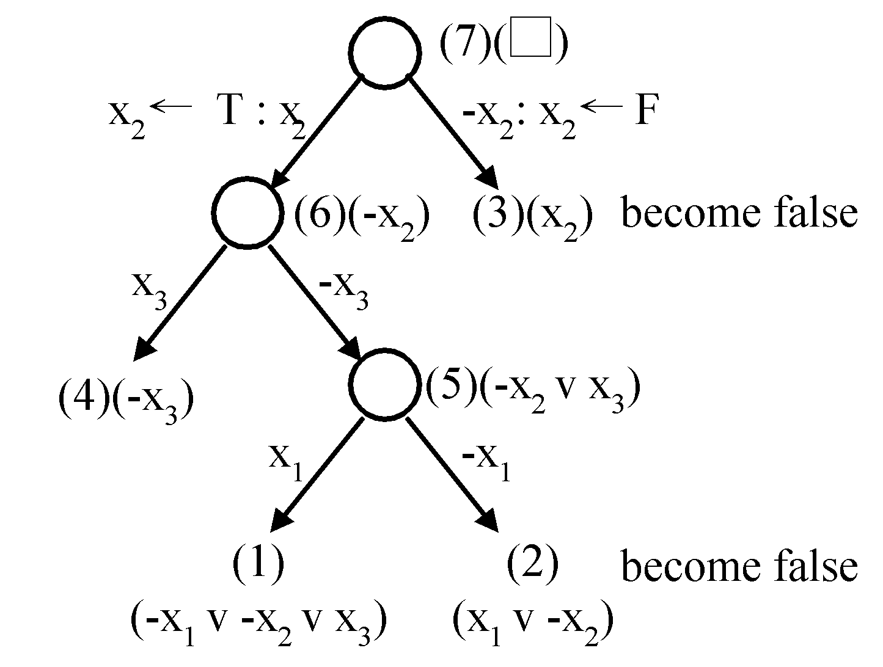

In a semantic tree, each path from the root to a leaf node represents a class of assignments.
If each leaf node is attached with a clause ⇒unsatisfiable.
Nondeterministic algorithms
- guessing
- checking

If the checking stage of a nondeterministic algorithm is of polynomial time-complexity, then this algorithm is called an NP (nondeterministic polynomial) algorithm.
NP problems : (must be decision problems)
e.g. searching, MST
sorting
satisfiability problem (SAT)
traveling salesperson problem (TSP)

- decision version of sorting :
Given a₁, a₂,…, a_{n} and c, is there a permutation of a_{i}′s ( a₁′, a₂′ , … ,a_{n}′ ) such that∣a₂′ – a₁′∣+∣a₃′ – a₂′∣+ … +∣a_{n}′ – a_{n-1}′∣＜c ?

- Not all decision problems are NP problems
e.g. halting problem :
Given a program with a certain input data, will the program terminate or not?
NP-hard
Undecidable

- 〔Horowitz and sahni 1978〕
(i) choice(s): arbitrarily chooses one of the elements in set S
(ii) failure: an unsuccessful completion
(iii) success: a successful completion
nondeterministic searching :
j ← choice(1 : n)
if A(j) = x then success
else failure
- A nondeterministic algorithm terminates unsuccessfully iff there exist no set of choices leading to a success signal.
- The time required for choice(1 : n) is O(1).
- A deterministic interpretation of a non-deterministic algorithm can be made by allowing unbounded parallelism in computation.
- nondeterministic sorting :
B ← 0
for i = 1 to n do
guessing j ← choice(1 : n)
if B[j] ≠ 0 then failure
B[j] = A[i]
for i = 1 to n-1 do
checking if B[i] > B[i+1] then failure
success

- nondeterministic SAT
guessing for i = 1 to n do
x_{i} ← choice( true, false )
if E(x₁, x₂, … ,x_{n}) is true
checking then success
else failure
Cook’s theorem
NP = P iff the satisfiability problem is a P problem.
- SAT is NP-complete.
- Every NP problem reduces to SAT.
- transforming searching to SAT :
Does there exist a number in { x(1), x(2), …, x(n) }, which is equal to 7?
Assume n = 2
i = choice(1, 2)
if x(i) = 7 then SUCCESS
else FAILURE

i=1 v i=2
& i=1 → i≠2
& i=2 → i≠1
& x(1)=7 & i=1 → SUCCESS
& x(2)=7 & i=2 → SUCCESS
& x(1)≠7 & i=1 → FAILURE
& x(2)≠7 & i=2 → FAILURE
& FAILURE → -SUCCESS
& SUCCESS (Guarantees a successful termination)
& x(1)=7 (Input Data)
& x(2)≠7
CNF (conjunctive normal form) :
i=1 v i=2 (1)
i≠1 v i≠2 (2)
x(1)≠7 v i≠1 v SUCCESS (3)
x(2)≠7 v i≠2 v SUCCESS (4)
x(1)=7 v i≠1 v FAILURE (5)
x(2)=7 v i≠2 v FAILURE (6)
-FAILURE v -SUCCESS (7)
SUCCESS (8)
x(1)=7 (9)
x(2)≠7 (10)

satisfiable at the following assignment :
i=1 satisfying (1)
i≠2 satisfying (2), (4) and (6)
SUCCESS satisfying (3), (4) and (8)
−FAILURE satisfying (7)
x(1)=7 satisfying (5) and (9)
x(2)≠7 satisfying (4) and (10)
The semantic tree :
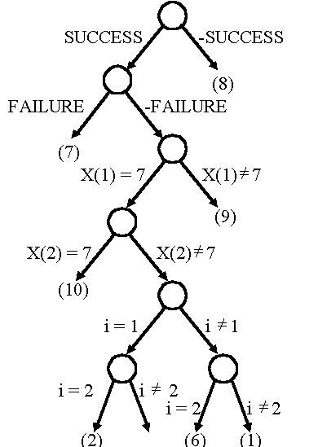

Searching for 7, but x(1)≠7, x(2)≠7
CNF :
i=1 v i=2 (1)
i≠1 v i≠2 (2)
x(1)≠7 v i≠1 v SUCCESS (3)
x(2)≠7 v i≠2 v SUCCESS (4)
x(1)=7 v i≠1 v FAILURE (5)
x(2)=7 v i≠2 v FAILURE (6)
SUCCESS (7)
-SUCCESS v -FAILURE (8)
x(1) ≠ 7 (9)
x(2) ≠ 7 (10)

apply resolution principle :
(9) & (5) i≠1 v FAILURE (11)
(10) & (6) i≠2 v FAILURE (12)
(7) & (8) -FAILURE (13)
(13) & (11) i≠1 (14)
(13) & (12) i≠2 (15)
(14) & (1) i=2 (11)
(15) & (16) □ (17)
We get an empty clause ⇒ unsatisfiable
⇒ 7 does not exit in x(1) or x(2).

Searching for 7, where x(1)=7, x(2)=7
CNF :
i=1 v i=2 (1)
i≠1 v i≠2 (2)
x(1)≠7 v i≠1 v SUCCESS (3)
x(2)≠7 v i≠2 v SUCCESS (4)
x(1)=7 v i≠1 v FAILURE (5)
x(2)=7 v i≠2 v FAILURE (6)
SUCCESS (7)
-SUCCESS v -FAILURE (8)
x(1)=7 (9)
x(2)=7 (10)

The semantic tree :
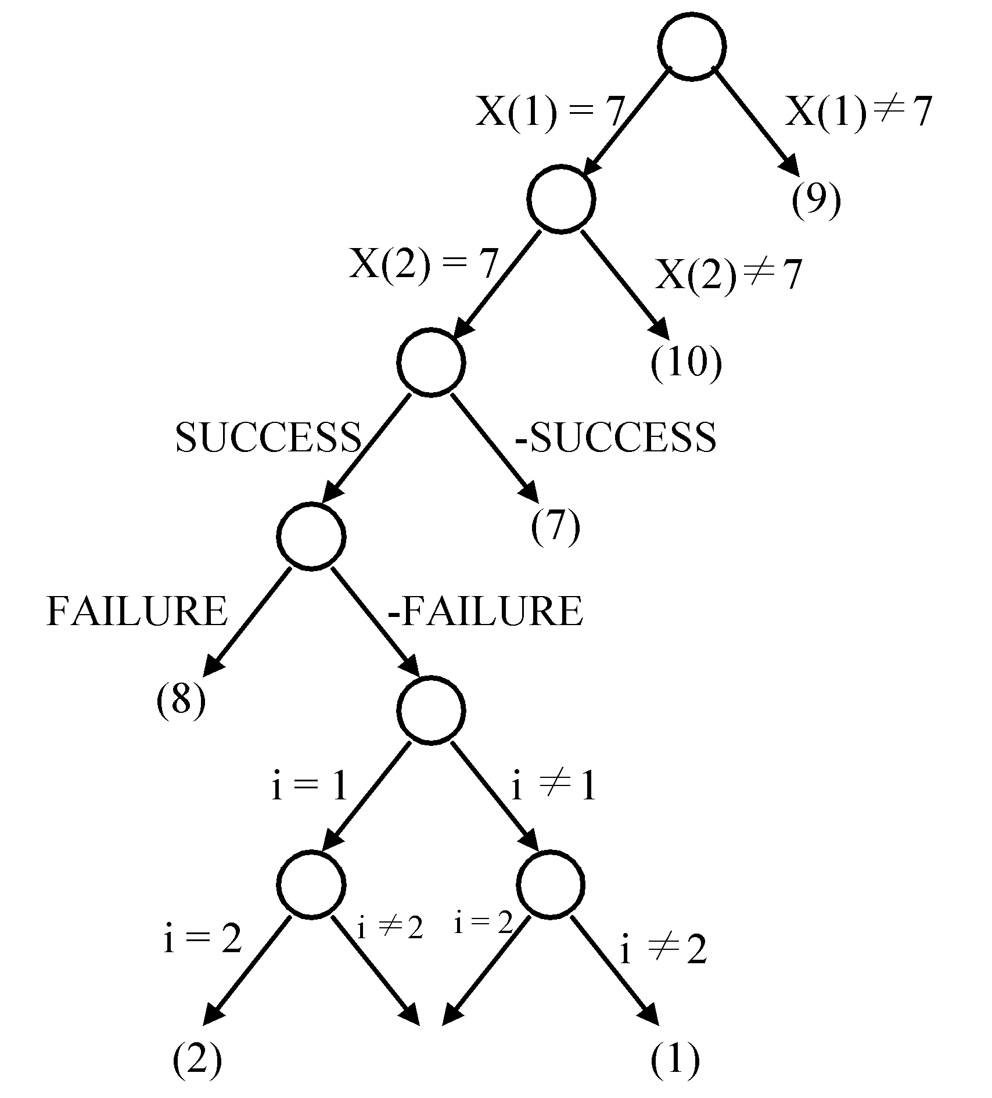
It implies that both assignments (i=1, i=2) satisfy the clauses.
- Transforming the node cover problem to SAT
Def: Given a graph G=(V, E), S is the node cover if S ⊆ V and for every edge (u, v) ∈ E, either u ∈ S or v ∈ S.
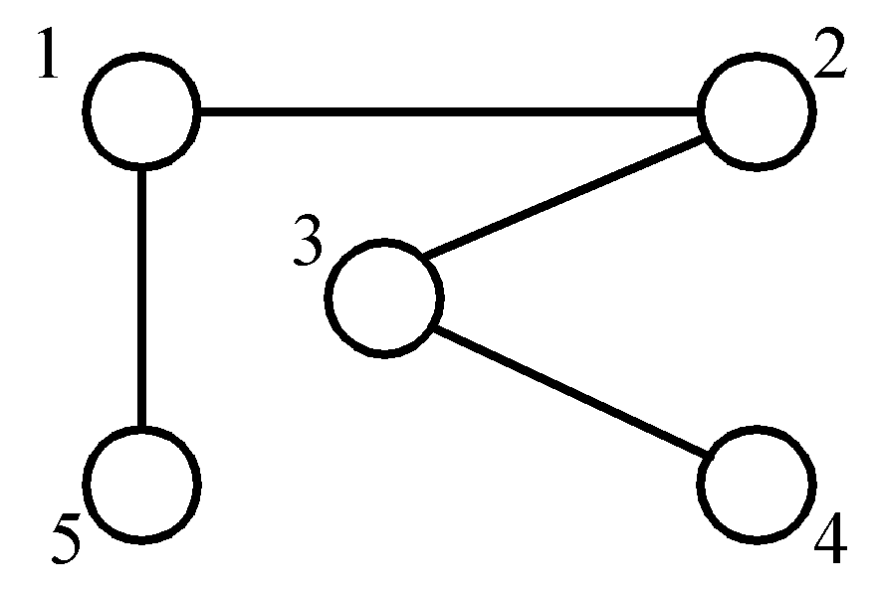
node cover:
{1, 3}
{5, 2, 4}

decision problem : ∃ S ∋ | S | ≤ K ?
BEGIN
i₁ ← choice({1, 2, …, n})
i₂ ← choice({1, 2, …, n} – {i₁})

i_{k} ← choice({1, 2, …, n} – {i₁, i₂, …, i_{k-1}}).
For j=1 to m do
BEGIN
if e_{j} is not incident to one of 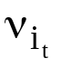(1≤t≤k)
then FAILURE
END
SUCCESS

CNF (conjunctive normal form) :
i₁ = 1 v i₁ = 2… v i₁ = n
(i₁≠1→ i₁＝2 v i₁＝3…v i₁ = n)
i₂ = 1 v i₂ = 2… v i₂ = n

i_{k} = 1 v i_{k} = 2… v i_{k} = n

i₁ ≠ 1 v i₂ ≠ 1 (i₁=1 → i₂≠1 & ... & i_{k}≠1)
i₁ ≠ 1 v i₃ ≠ 1

i_{k-1} ≠ n v i_{k} ≠ n
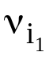∈ e₁ v 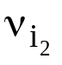 ∈ e₁ v … v 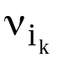∈ e₁ v FAILURE
(∉e₁&∉e₁&…&∉e₁→Failure)
∈ e₂ v ∈ e₂ v … v ∈ e₂ v FAILURE

∈ e_{m} v ∈ e_{m} v … v ∈ e_{m} v FAILURE
SUCCESS
-SUCCESS v -FAILURE
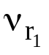∈ e₁
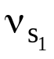 ∈ e₁
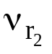 ∈ e₂
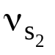 ∈ e₂

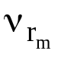 ∈ e_{m}
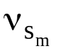 ∈ e_{m}
Proof of NP-Completeness
- prove that A is an NP problem
- prove that ∃ B ∈ NPC, B ∝ A
⇒ A ∈ NPC

- 3-satisfiability problem (3-SAT)
Each clause contains exactly three literals.
- 3-SAT is an NP problem. (obviously)
- SAT ∝ 3-SAT
- one literal L₁ in a clause in SAT :
in 3-SAT :
L₁ v y₁ v y₂
L₁ v -y₁ v y₂
L₁ v y₁ v -y₂
L₁ v -y₁ v -y₂
- two literals L₁, L₂ in a clause in SAT :
in 3-SAT :
L₁ v L₂ v y₁
L₁ v L₂ v -y₁
- three literals in a clause :
remain unchanged
- more than 3 literals L₁, L₂, …, L_{k} in a clause :
in 3-SAT :
L₁ v L₂ v y₁
L₃ v -y₁ v y₂

L_{k-2} v -y_{k-4} v y_{k-3}
L_{k-1} v L_{k} v -y_{k-3}

e.g.
an instance in SAT :
x₁ v x₂
-x₃
x₁ v -x₂ v x₃ v -x₄ v x₅
transform to an instance in 3-SAT :
x₁ v x₂ v y₁
x₁ v x₂ v -y₁
-x₃ v y₂ v y₃
-x₃ v -y₂ v y₃
-x₃ v y₂ v -y₃
-x₃ v -y₂ v -y₃
x₁ v -x₂ v y₄
x₃ v -y₄ v y₅
-x₄ v x₅ v -y₅
SAT ^{transform} 3-SAT
S S′

Proof : S is satisfiable ⇔ S′ is satisfiable
“⇒”
≤ 3 literals in S (trivial)
consider ≥ 4 literals
S : L₁ v L₂ v … v L_{k}
S′: L₁ v L₂ v y₁
L₃ v -y₁ v y₂
L₄ v -y₂ v y₃

L_{k-2} v -y_{k-4} v y_{k-3}
L_{k-1} v L_{k} v -y_{k-3}
S is satisfiable ⇒ at least L_{i} = T
Assume : L_{j} = F ∀ j ≠ i
assign : y_{i-1} = F
y_{j} = T ∀ j < i-1
y_{j} = F ∀ j > i-1
( L_{i} v -y_{i-2} v y_{i-1} )
⇒ S′ is satisfiable.
“⇐”
If S′ is satisfiable, then assignment satisfying
S′ can not contain y_{i}’s only
⇒ at least L_{i} must be true.
(We can also apply the resolution principle).
∴ 3-SAT is NP-complete #

- If a problem is NP-complete, its special cases may or may not be NP-complete.

- chromatic number decision problem
A coloring of a graph G=(V, E) is a function
f : V → { 1, 2, 3,…, k } ∋ if (u, v) ∈ E,
then f(u)≠f(v).
The chromatic number decision problem (CN) :
determine if G has a coloring for k.
e.g.
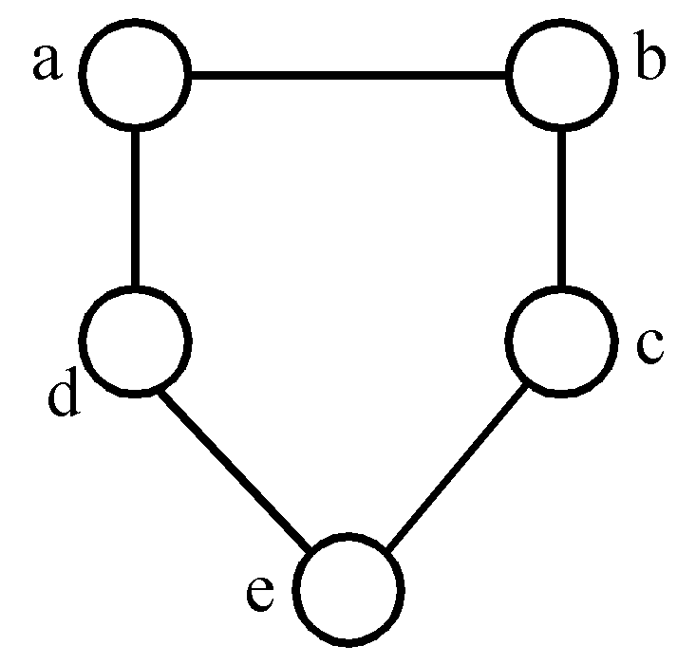
3-colorable
f(a)=1, f(b)=2, f(c)=1
f(d)=2, f(e)=3

<Theorem> Satisfiability with at most 3 literals per clause (SATY) ∝ CN.
Proof :
instance of SATY :
variable : x₁, x₂, …, x_{n} , n ≥ 4
clause : c₁, c₂, …, c_{r}
instance of CN :
G=(V, E)
V={ x₁, x₂, …, x_{n} }∪{ -x₁, -x₂, …, -x_{n} }
∪{ y₁, y₂, …, y_{n} }∪{ c₁, c₂, …, c_{r} }

newly added
E={ (x_{i}, -x_{i}) | 1≤ i ≤ n }∪{ (y_{i}, y_{j}) | i ≠ j }
∪{ (y_{i}, x_{j}) | i ≠ j }∪{ (y_{i}, -x_{j}) | i ≠ j }
∪{ (x_{i}, c_{j}) | x_{i} ∉ c_{j} }∪{ (-x_{i}, c_{j}) | -x_{i} ∉ c_{j} }
e.g.
x₁ v x₂ v x₃ (1)
-x₃ v -x₄ v x₂ (2)
⇓
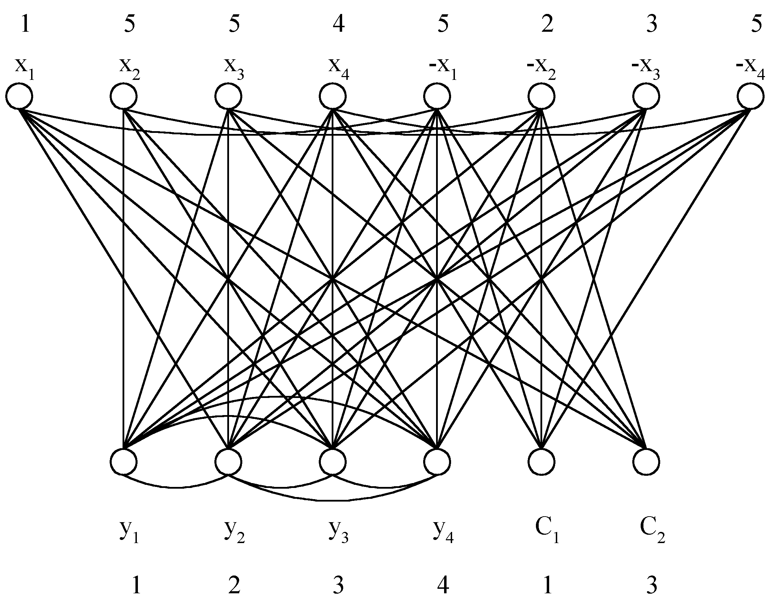
Satisfiable ⇔ n+1 colorable
“⇒”
- f(y_{i}) = i
- if x_{i} = T, then f(x_{i}) = i, f(-x_{i}) = n+1
else f(x_{i}) = n+1, f(-x_{i}) = i
- if x_{i} in c_{j} and x_{i} = T, then f(c_{j}) = f(x_{i})
if -x_{i} in c_{j} and -x_{i} = T, then f(c_{j}) = f(-x_{i})
( at least one such x_{i} )
“⇐”
- y_{i} must be assigned with color i.
- f(x_{i}) ≠ f(-x_{i})
either f(x_{i}) = i and f(-x_{i}) = n+1
or f(x_{i}) = n+1 and f(-x_{i}) = i
- at most 3 literals in c_{j} and n ≥ 4
⇒ at least one x_{i}, ∋ x_{i} and -x_{i} are not in c_{j}
⇒ f(c_{j}) ≠ n+1
- if f(c_{j}) = i = f(x_{i}), assign x_{i} to T
if f(c_{j}) = i = f(-x_{i}), assign -x_{i} to T
- if f(c_{j}) = i = f(x_{i}) ⇒ (c_{j}, x_{i}) ∉ E
⇒ x_{i} in c_{j} ⇒ c_{j} is true
if f(c_{j}) = i = f(-x_{i}) ⇒ similarly #

- set cover decision problem
F = {S_{i}} = { S₁, S₂, …, S_{k} }
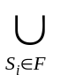S_{i} = { u₁, u₂, …, u_{n} }
T is a set cover of F if T ⊆ F and
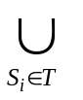S_{i} = 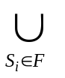S_{i}
The set cover decision problem is to determine if F has a cover T containing no more than c sets.
e.g.
F = {(a₁, a₃), (a₂, a₄), (a₂, a₃), (a₄)}
s₁ s₂ s₃ s₄
T = { s₁, s₃, s₄ } set cover
T = { s₁, s₂ } set cover, exact cover

- exact cover problem
notations same as those in set cover. to determine if F has an exact cover T, which is a cover of F and the sets in T are pairwise disjoint.

<Theorem> CN ∝ exact cover

- sum of subsets problem
a set of positive numbers A = { a₁, a₂, …, a_{n} }
a constant C
determine if ∃ A′ ⊆ A ∋ 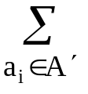 a_{i} = C
e.g. A = { 7, 5, 19, 1, 12, 8, 14 }
- C = 21, A′ = { 7, 14 }
- C = 11, no solution

<Theorem> Exact cover ∝ sum of subsets
Proof :
instance of exact cover :
F = { S₁, S₂, …, S_{k} }
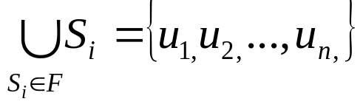
instance of sum of subsets :
A = { a₁, a₂, …, a_{k} } where
a_{j} = ∑ e_{ji}(k+1)^{i} where e_{ji} = 1 if u_{i} ∈ S_{j}
1≤i≤n
e_{ji} = 0 if otherwise.
C = ∑ (k+1)^{i} = (k+1)((k+1)^{n} - 1) / k #
1≤i≤n

why k+1?

- Partition problem
a set of positive numbers A = { a₁, a₂, …, a_{n} }
determine if ∃ a partition P, ∋ ∑a_{i} = ∑a_{i}
i∈p i∉p
e.g. A = {1, 3, 8, 4, 10}
partition : {1, 8, 4} and {3, 10}

<Theorem> sum of subsets ∝ partition
proof :
instance of sum of subsets :
A = { a₁, a₂, …, a_{n} }
C
instance of partition :
B = { b₁, b₂, …, b_{n+2} } where b_{i} = a_{i}, 1≤ i ≤ n
b_{n+1} = C+1
b_{n+2} = ( ∑ a_{i} )+1−C
1≤i≤n
C = ∑a_{i} ⇔ ( ∑a_{i} )+b_{n+2} = ( ∑a_{i} )+b_{n+1}
a_{i}∈S a_{i}∈S a_{i}∉S
⇔ partition : { b_{i} | a_{i}∈S }∪{b_{n+2}}
and { b_{i} | a_{i}∉S }∪{b_{n+1}} #
why b_{n+1} = C+1 ? why not b_{n+1} = C ?
to avoid b_{n+1} and b_{n+2} to be partitioned into
the same subset.
- bin packing problem
n items, each of size c_{i} , c_{i} > 0
bin capacity : c
determine if we can assign the items into
k bins, ∋ ∑c_{i} ≤ c , 1≤j≤k.
i∈bin_{j}
<Theorem> partition ∝ bin packing.

- VLSI discrete layout problem
n rectangles, each with height h_{i} (integer)
width w_{i}
an area A
determine if there is a placement of the n
rectangles within the area A according to
the rules :
- boundaries of rectangles parallel to x axis
or y axis.
- corners of rectangles lie on integer points.
- no two rectangles overlap.
- two rectangles are separated by at least a
unit distance.

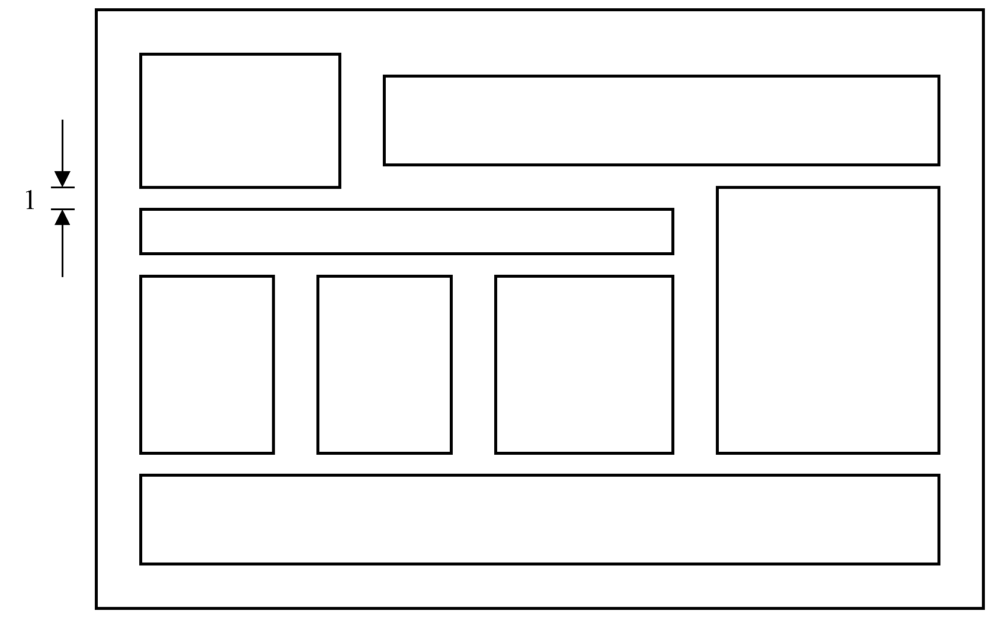
Fig. 3-14 A Successful Placement

<Theorem> bin packing ∝ VLSI discrete layout.

- max clique problem
A maximal complete subgraph of a graph
G=(V, E) is a clique. The max (maximum)
clique problem is to determine the size of a
largest clique in G.
- g.
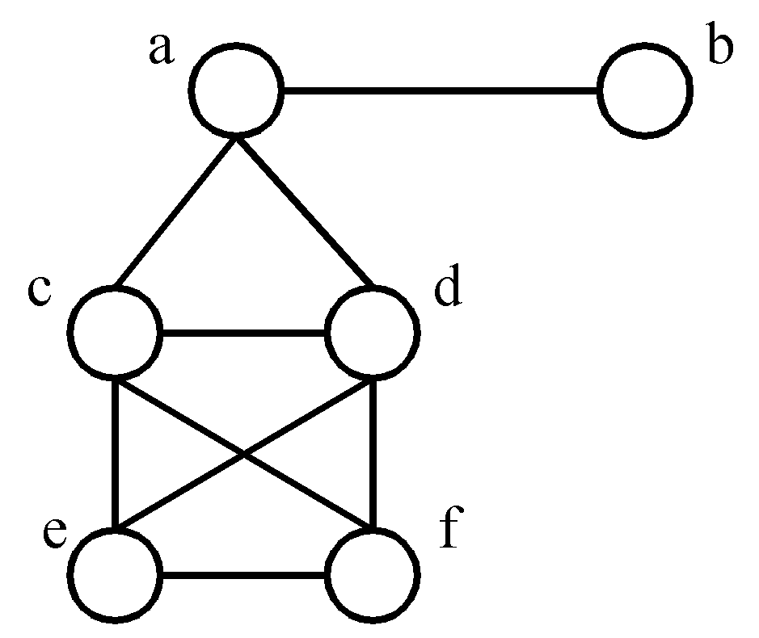
maximal cliques :
{a, b}, {a, c, d}
{c, d, e, f}
maximum clique :
(largest)
{c, d, e, f}

<Theorem> SAT ∝ clique decision problem.

- node cover decision problem
A set S ⊆ V is a node cover for a graph
G = (V, E) iff all edges in E are incident to
at least one vertex in S. ∃ S, ∋ |S| ≤ K ?

<Theorem> clique decision problem ∝ node cover decision problem.

- Hamiltonian cycle problem
A Hamiltonian cycle is a round trip path along n edges of G which visits every vertex once and returns to its starting vertex.
e.g.
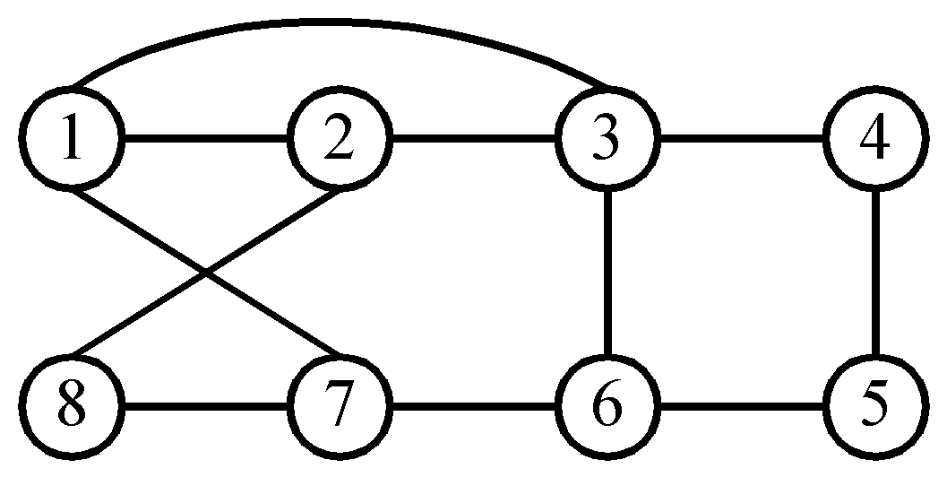

Hamiltonian cycle : 1, 2, 8, 7, 6, 5, 4, 3, 1.

<Theorem> SAT ∝ directed Hamiltonian cycle ( in a directed graph )

- traveling salesperson problem
A tour of a directed graph G=(V, E) is a directed cycle that includes every vertex in V. The problem is to find a tour of minimum cost.

<Theorem> Directed Hamiltonian cycle ∝
traveling salesperson decision
problem.

- 0/1 knapsack problem
n objects, each with a weight w_{i} > 0
a profit p_{i} > 0

capacity of knapsack : M
maximize ∑p_{i}x_{i}
1≤i≤n
subject to ∑w_{i}x_{i} ≤ M
1≤i≤n
x_{i} = 0 or 1, 1≤ i ≤n
decision version :
given K, ∃ ∑p_{i}x_{i} ≥ K ?
1≤i≤n
knapsack problem : 0 ≤ x_{i} ≤ 1, 1≤ i ≤n.

<Theorem> partition ∝ 0/1 knapsack decision
problem.

