§The Divide-and-Conquer Strategy

e.g. find the maximum of a set S of n numbers
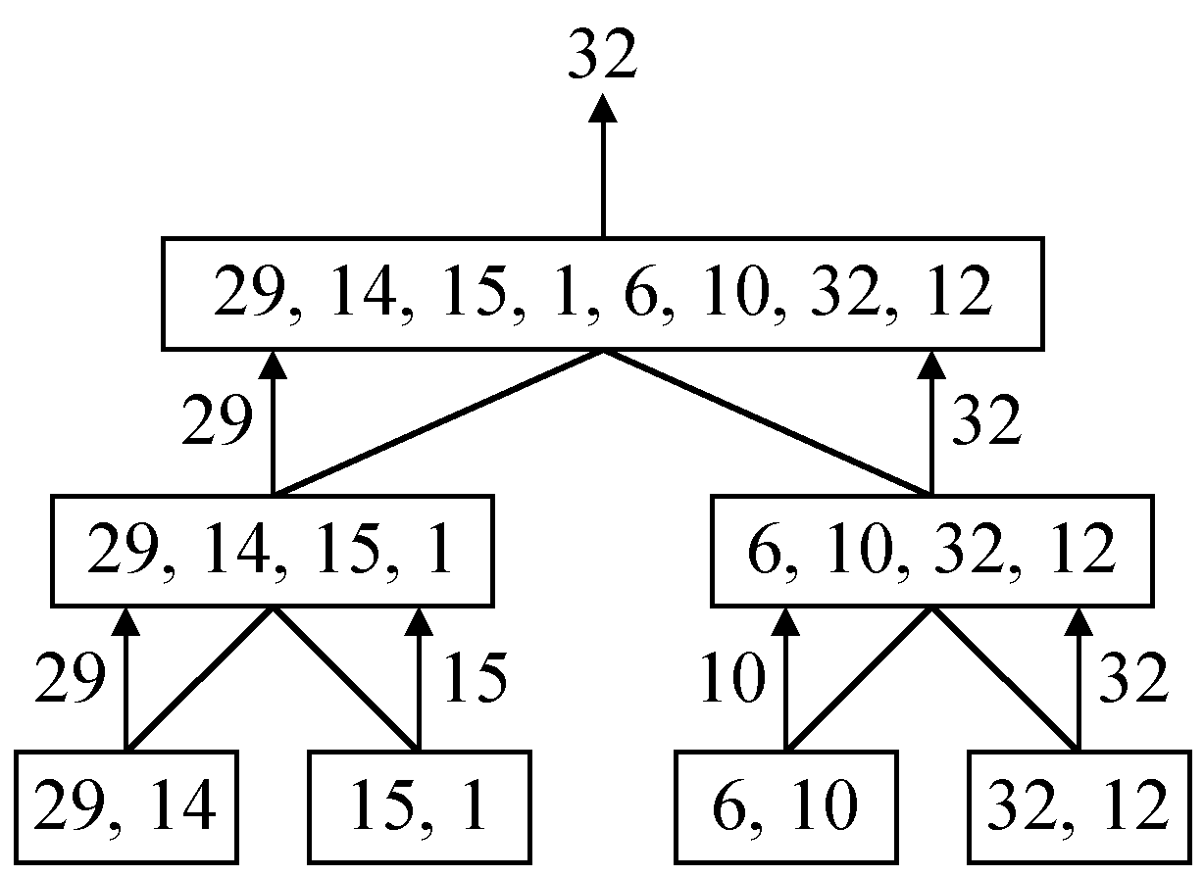

time complexity:
T(n)= | 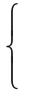 | 2T(n/2)+1  1 | , n>2  , n≤2

assume n = 2^{k}
T(n) = 2T(n/2)+1
= 2(2T(n/4)+1)+1
= 4T(n/4)+2+1
:
=2^{k-1}T(2)+2^{k-2}+…+4+2+1
=2^{k-1}+2^{k-2}+…+4+2+1
=2^{k}-1 = n-1

A general divide-and-conquer algorithm:
Step 1: If the problem size is small, solve this problem directly; otherwise, split the original problem into 2 sub-problems with equal sizes.
Step 2: Recursively solve these 2 sub-problems by applying this algorithm.
Step 3: Merge the solutions of the 2 sub-problems into a solution of the original problem.

time complexity:
T(n)= |  | 2T(n/2)+S(n)+M(n)  b | , n ≥ c  , n < c
where S(n): time for splitting
M(n): time for merging
b: a constant
c: a constant.

e.g. binary search
e.g. quick sort
e.g. merge sort
- 2-D maxima finding problem
Def: A point (x₁, y₁) dominates (x₂, y₂) if x₁ > x₂ and y₁ > y₂. A point is called a maxima if no other point dominates it.
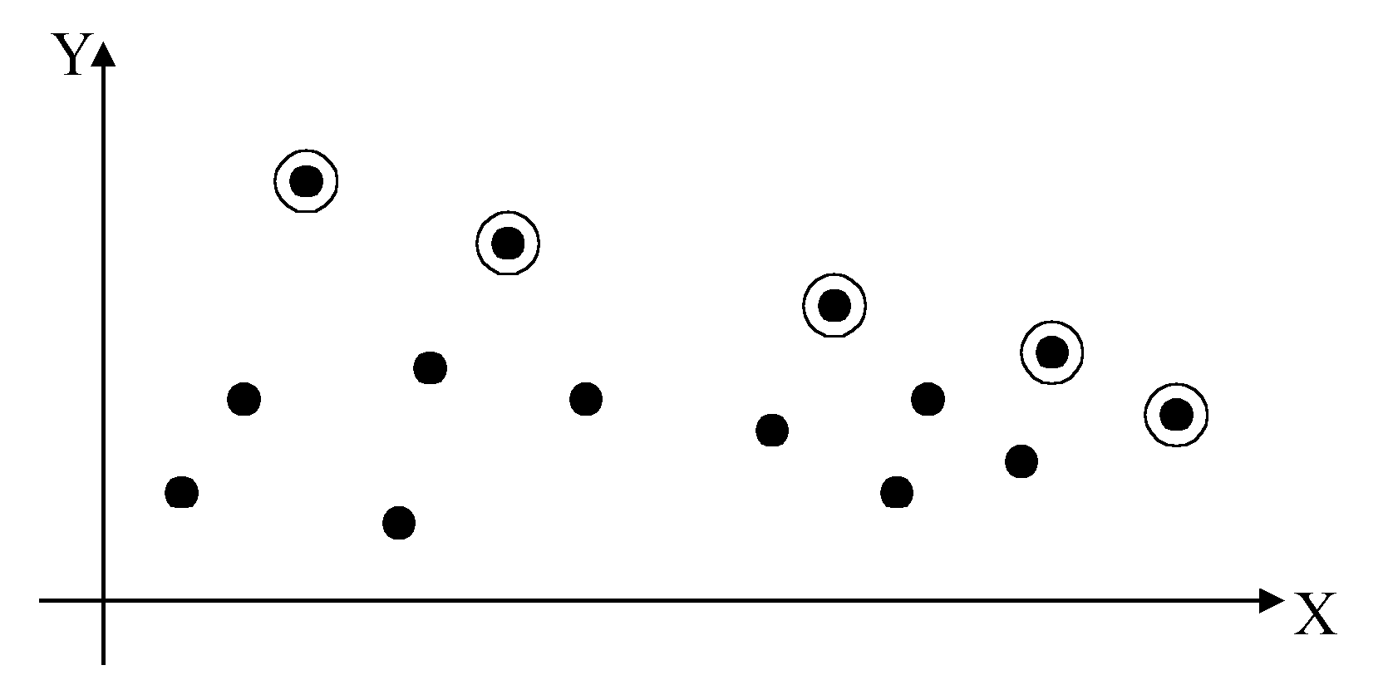

Straightforward method:
compare every pair of points
time complexity: O(n²).

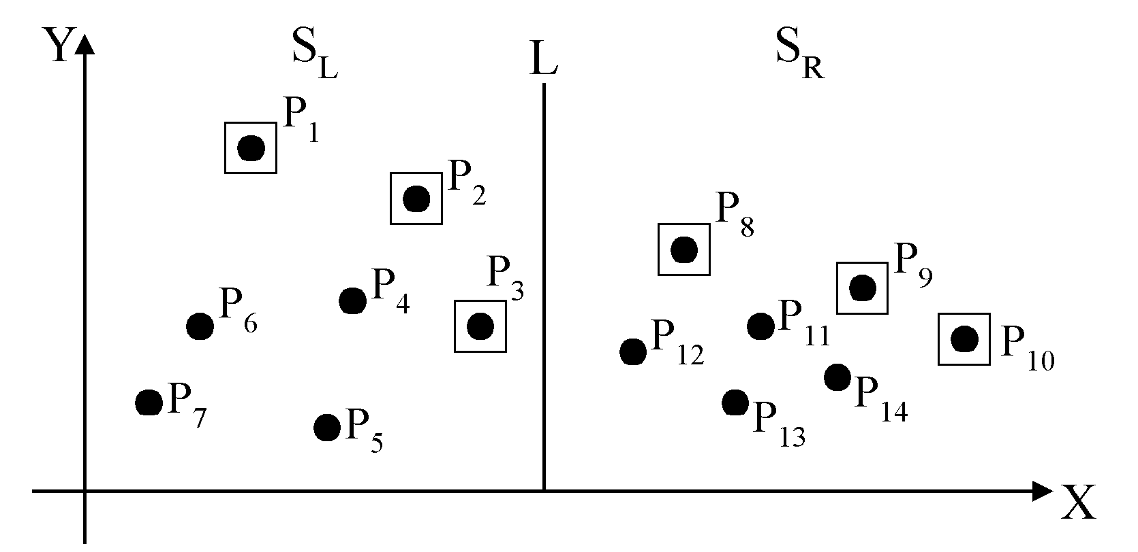
The maximal of S_{L} and S_{R}

Algorithm 5.1 A Divide-and-Conquer Approach to Find Maximal Points in the Plane
Input: A set of n planar points.
Output: The maximal points of S.
Step 1. If S contains only one point, return it as the maxima. Otherwise, find a line L perpendicular to the X-axis which separates the set of points into two subsets S_{L} and S_{R}, each of which consisting of n/2 points.
Step 2. Recursively find the maximal points of S_{L} and S_{R}.
Step 3. Project the maximal points of S_{L} and S_{R} onto L and sort these points according to their y-values. Conduct a linear scan on the projections and discard each of the maximal points of S_{L} if its y-value is less than the y-value of some maximal point of S_{R}.

time complexity:
T(n)= |  | 2T(n/2)+O(n)+O(n log n)  1 | , n > 1  , n = 1
Assume n = 2^{k}
T(n) = O(n log n) + O(n log²n)
= O(n log²n)

Improvement:
(1)Step 3: Find the largest y-value of S_{R}.
time complexity:
T(n)= |  | 2T(n/2)+O(n)+O(n)  1 | , n > 1  , n = 1
⇒T(n) = O(n log n)
(2)The sorting of y-values need be done only once( only one presorting).
No sorting is needed in Step3.
time complexity:
O(n log n) + T(n) = O(n log n)
where
T(n)= |  | 2T(n/2)+O(n)+O(n)  1 | , n > 1  , n = 1

- The closest pair problem
Given a set S of n points, find a pair of points which are closest together.
1-D version:
solved by sorting
time: O(n log n)
2-D version:
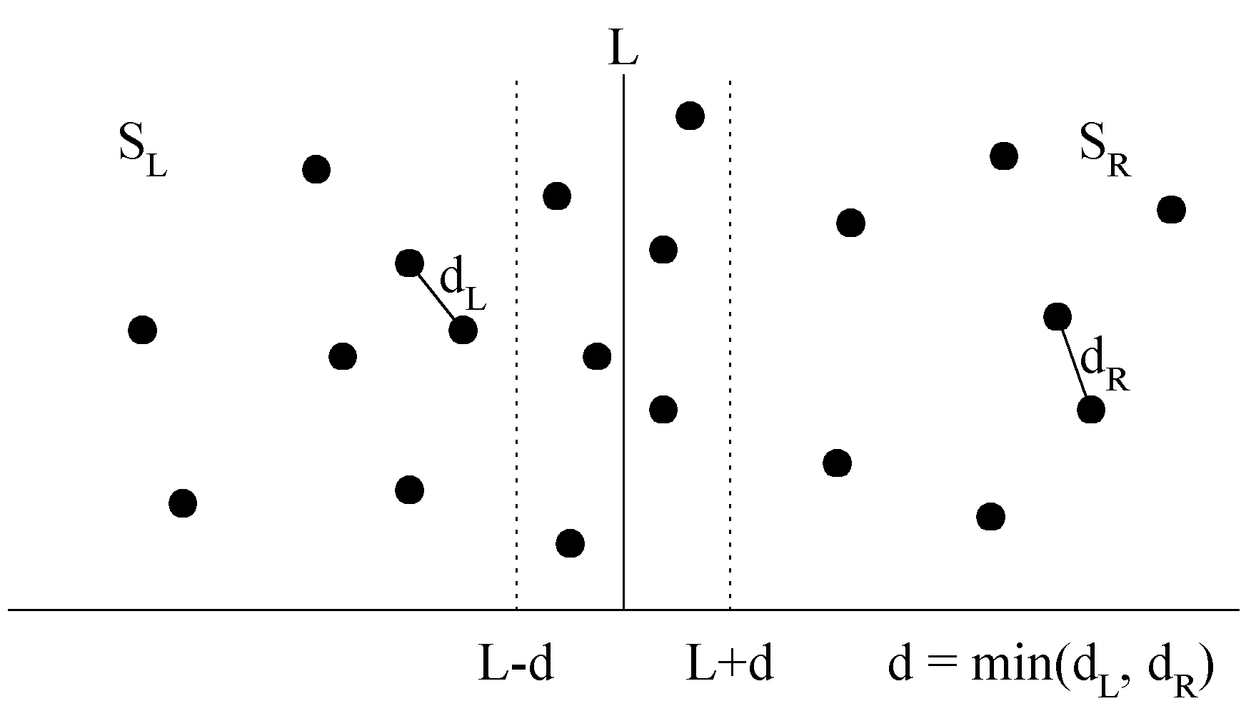
at most 6 points in A:
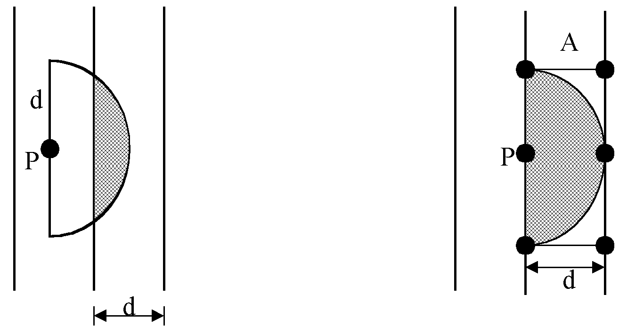
Algorithm 5.2 A Divide-and-Conquer Algorithm to Solve the 2-Dimensional Closest Pair Problem
Input: A set S of n points in the plane.
Output: The distance between two closest points.
Step 1. Sort points in S according to their y-values and x-values.
Step 2. If S contains only one point, return ∞ as its distance.
Step 3. Find a median line L perpendicular to the X-axis to divide S into two subsets, with equal sizes, S_{L} and S_{R}. Every point in S_{L} lies to the left of L and every point in S_{R} lies to the right of L.
Step 4. Recursively apply Step 2 and Step 3 to solve the closest pair problems of S_{L} and S_{R}. Let d_{L}(d_{R}) denote the distance between the closest pair in SL(SR). Let d = min(d_{L}, d_{R}).
Step 5. Project all points within the slab bounded by L-d and L+d onto the line L. For a point P in the half-slab bounded by L-d and L, Let its y-value by denoted as y_{P}. For each such P, find all points in the half-slab bounded by L and L+d whose y-value fall within y_{P}+d and y_{P}-d. If the distance d′ between P and a point in the other half-slab is less than d, let d=d′. The final value of d is the answer.

time complexity: O(n log n)
Step 1: O(n log n)
Steps 2~5:
T(n)= |  | 2T(n/2)+O(n)+O(n)  1 | , n > 1  , n = 1
⇒T(n) = O(n log n)

- The convex hull problem
concave polygon: convex polygon:
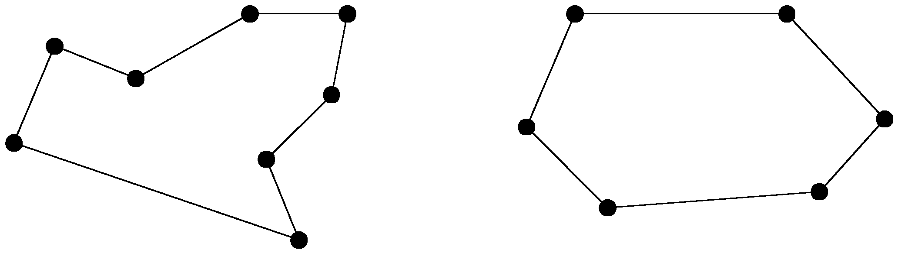
The convex hull of a set of planar points is the smallest convex polygon containing all of the points.
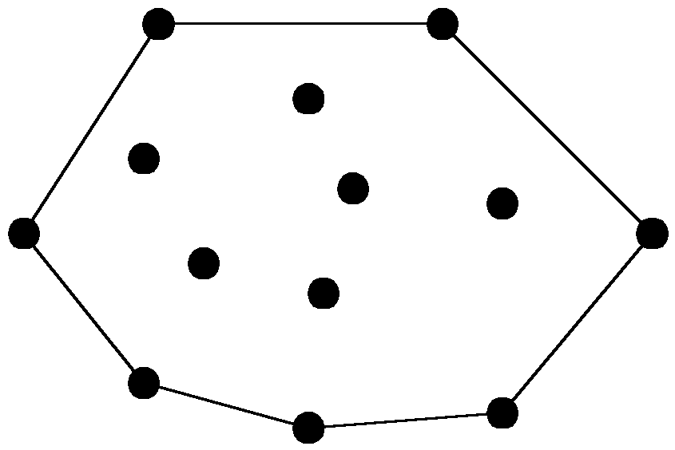
the divide-and-conquer strategy to solve the problem:
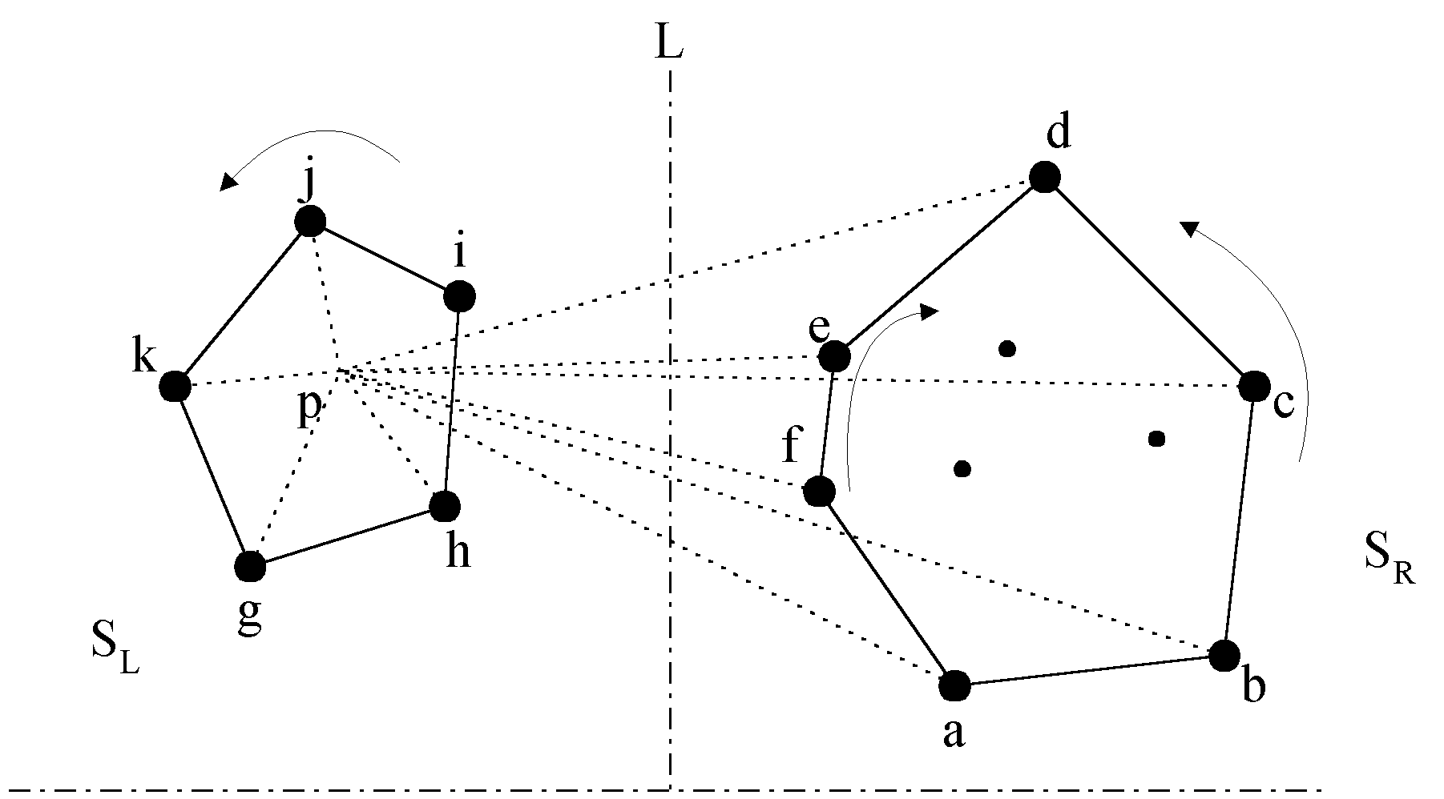
1.Select an interior point p.
2.There are 3 sequences of points which have increasing polar angles with respect to p.
(1) g, h, i, j, k
(2) a, b, c, d
(3) f, e
3.Merge these 3 sequences into 1 sequence:
g, h, a, b, f, c, e, d, i, j, k.
4.Apply Graham scan to examine the points one by one and eliminate the points which cause reflexive angles.
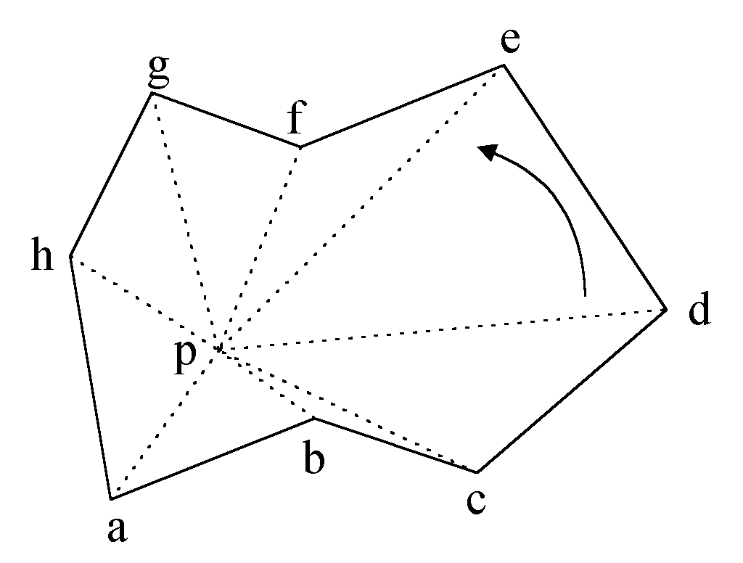e.g. points b and f need to be deleted.

Final result:
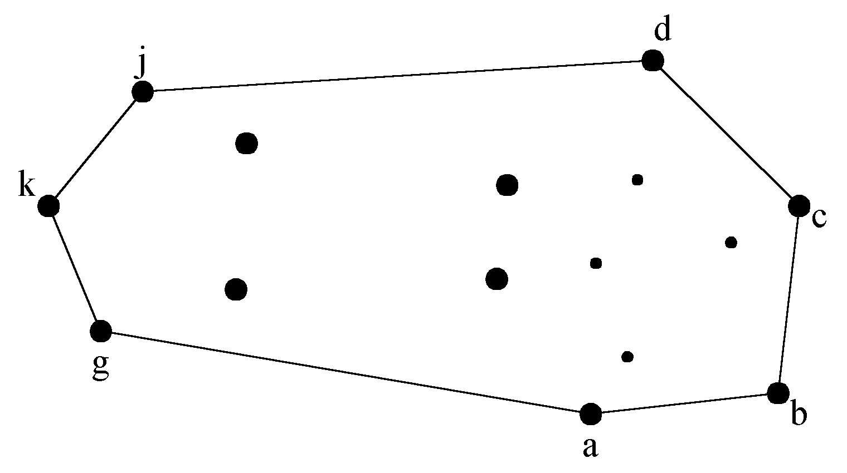
Algorithm 5.3 An Algorithm to Construct a Convex Hull Based Upon the Divide-and-Conquer Strategy
Input: A set S of planar points
Output: A convex hull for S
Step 1. If S contains no more than five points, use exhaustive searching to find the convex hull and return.
Step 2. Find a median line perpendicular to the X-axis which divides S into S_{L} and S_{R}; S_{L} lies to the left of S_{R}.
Step 3. Recursively construct convex hulls for S_{L} and S_{R}. Denote these convex hulls by Hull(S_{L}) and Hull(S_{R}) respectively.
Step 4. Find an interior point P of S_{L}. Find the vertices v₁ and v₂ of Hull(S_{R}) which divide the vertices of Hull(S_{R}) into two sequences of vertices which have increasing polar angles with respect to P. Without loss of generality, let us assume that v₁ has greater y-value than v₂. Then form three sequences as follows:
- Sequence 1: all of the convex hull vertices of Hull(S_{L}) in counterclockwise direction.
- Sequence 2: the convex hull vertices of Hull(S_{R}) from v₂ to v₁ in counter-clockwise direction.
- Sequence 3: the convex hull vertices of Hull(S_{R}) from v₂ to v₁ in clockwise direction.
Merge these three sequences and conduct the Graham scan. Eliminate the points which are reflexive and the remaining points from the convex hull.
time complexity:
T(n) = 2T(n/2) + O(n)
= O(n log n)
- The Voronoi diagram problem
e.g.
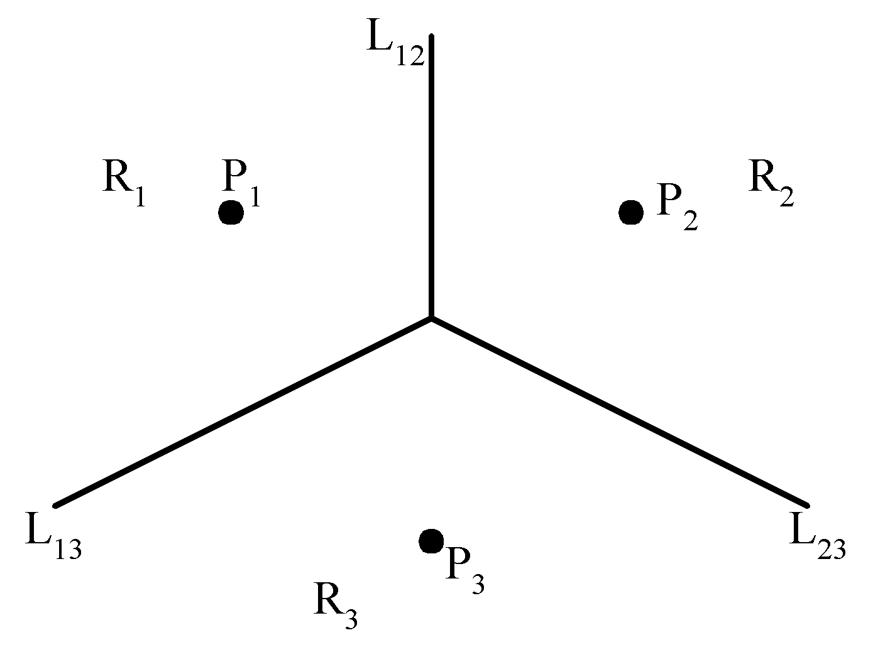
The Voronoi Diagram for Three Points

Each L_{ij} is perpendicular bisector of the line 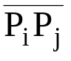.
Def: Given two points P_{i}, P_{j} ∈ S, let H(P_{i}, P_{j}) denote the half plane containing P_{i}. The Voronoi polygon associated with P_{i} is defined as
V(i) = 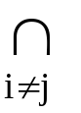 H(P_{i}, P_{j})
e.g.
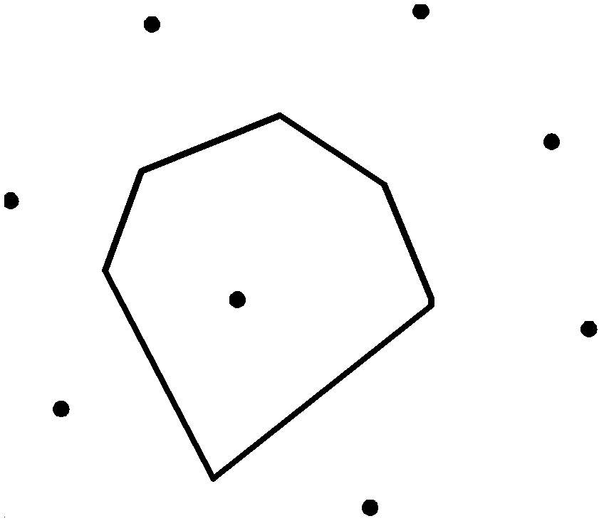
Given a set of n points, the Voronoi diagram consists of all the Voronoi polygons of these points.
e.g. A Voronoi diagram of 6 points:
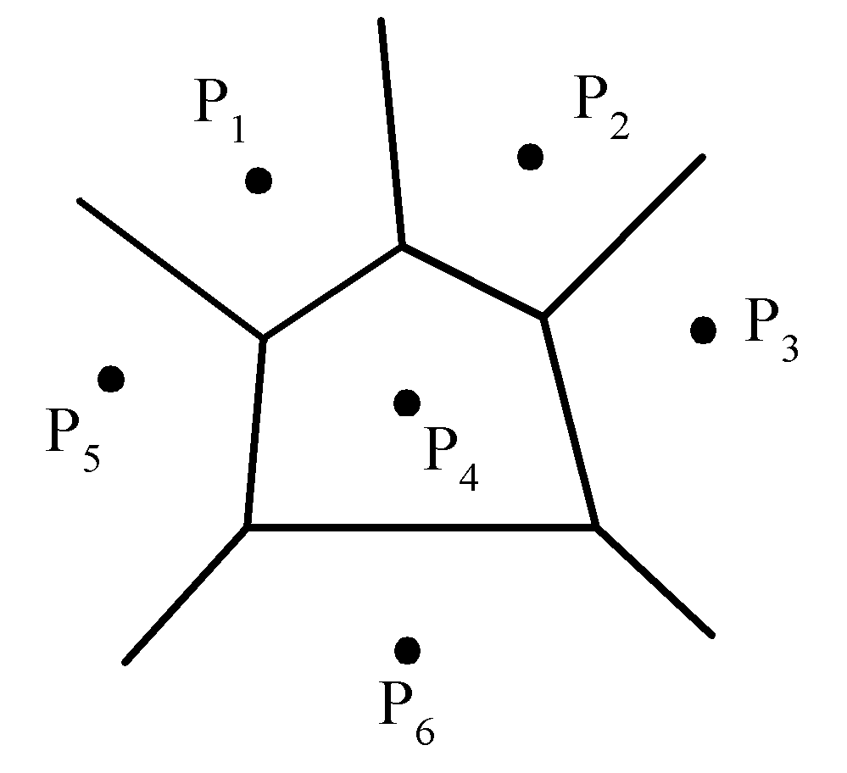
The vertices of the Voronoi diagram are called Voronoi points and its segments are called Voronoi edges.
e.g. A Delaunay triangulation:
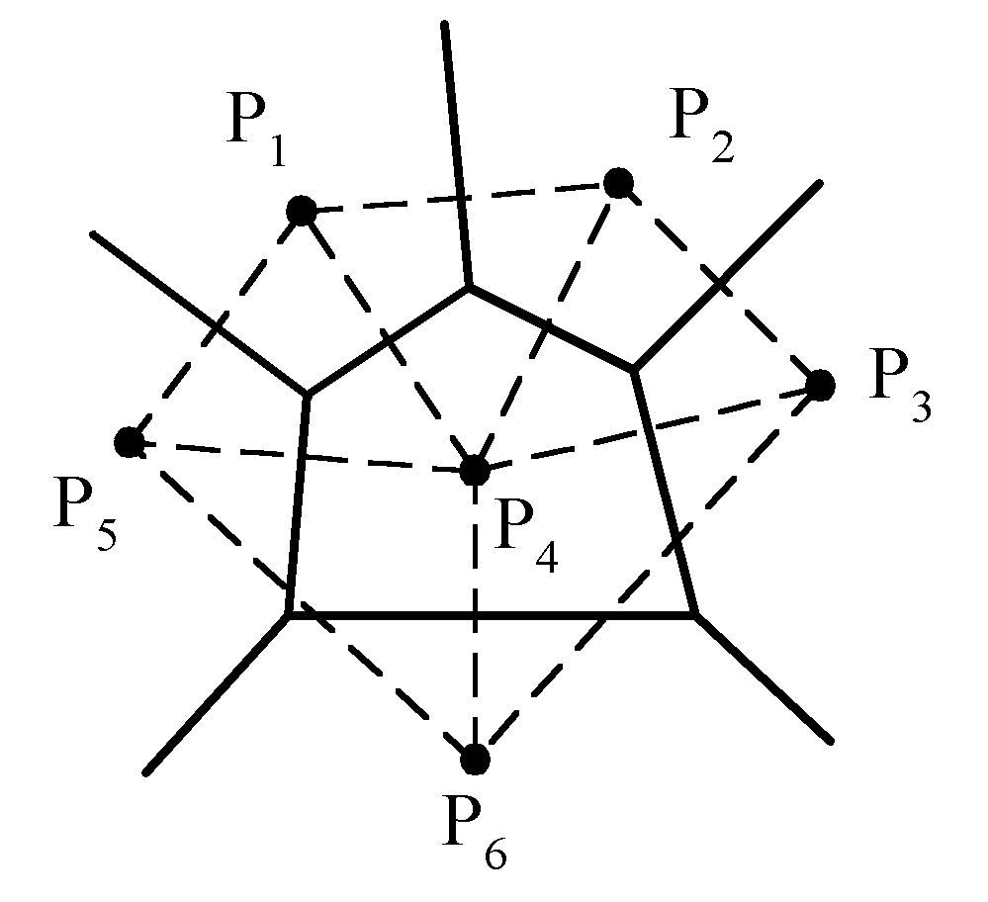
Algorithm 5.4 A Divide-and-Conquer Algorithm to Construct Voronoi Diagrams
Input: A set S of n planar points.
Output: The Voronoi diagram of S.
Step 1. If S contains only one point, return.
Step 2. Find a median line L perpendicular to the X-axis which divides S into S_{L} and S_{R} such that S_{L}(S_{R}) lies to the left(right) of L and the sizes of S_{L} and S_{R} are equal.
Step 3. Construct Voronoi diagrams of S_{L} and S_{R} recursively. Denote these Voronoi diagrams by VD(S_{L}) and VD(S_{R}).
Step 4. Construct a dividing piece-wise linear hyperplane HP which is the locus of points simultaneously closest to a point in S_{L} and a point in S_{R}. Discard all segments of VD(S_{L}) which lie to the right of HP and all segments of VD(S_{R}) that lie to the left of HP. The resulting graph is the Voronoi diagram of S.
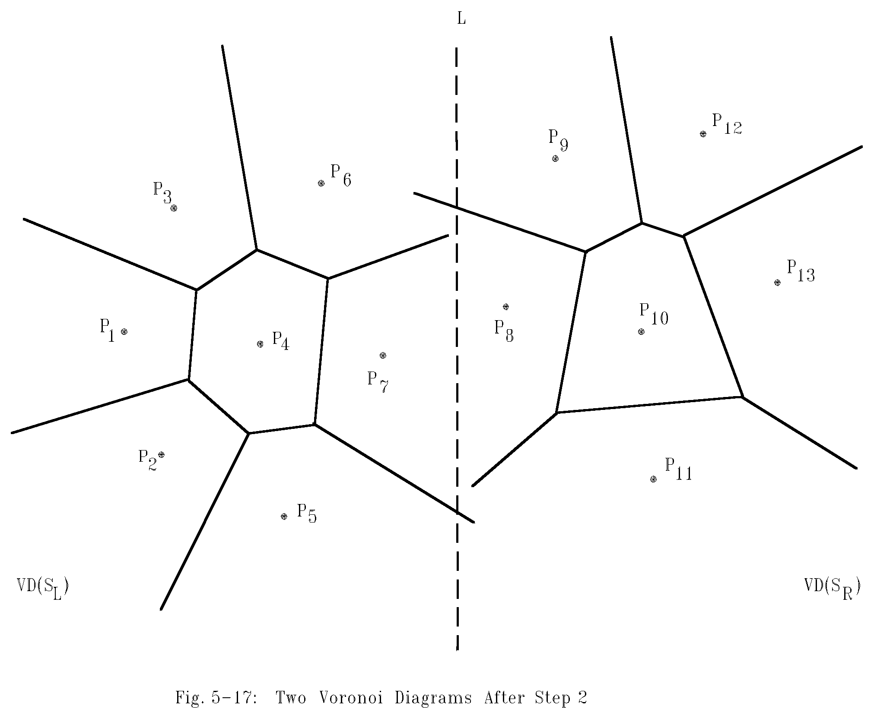
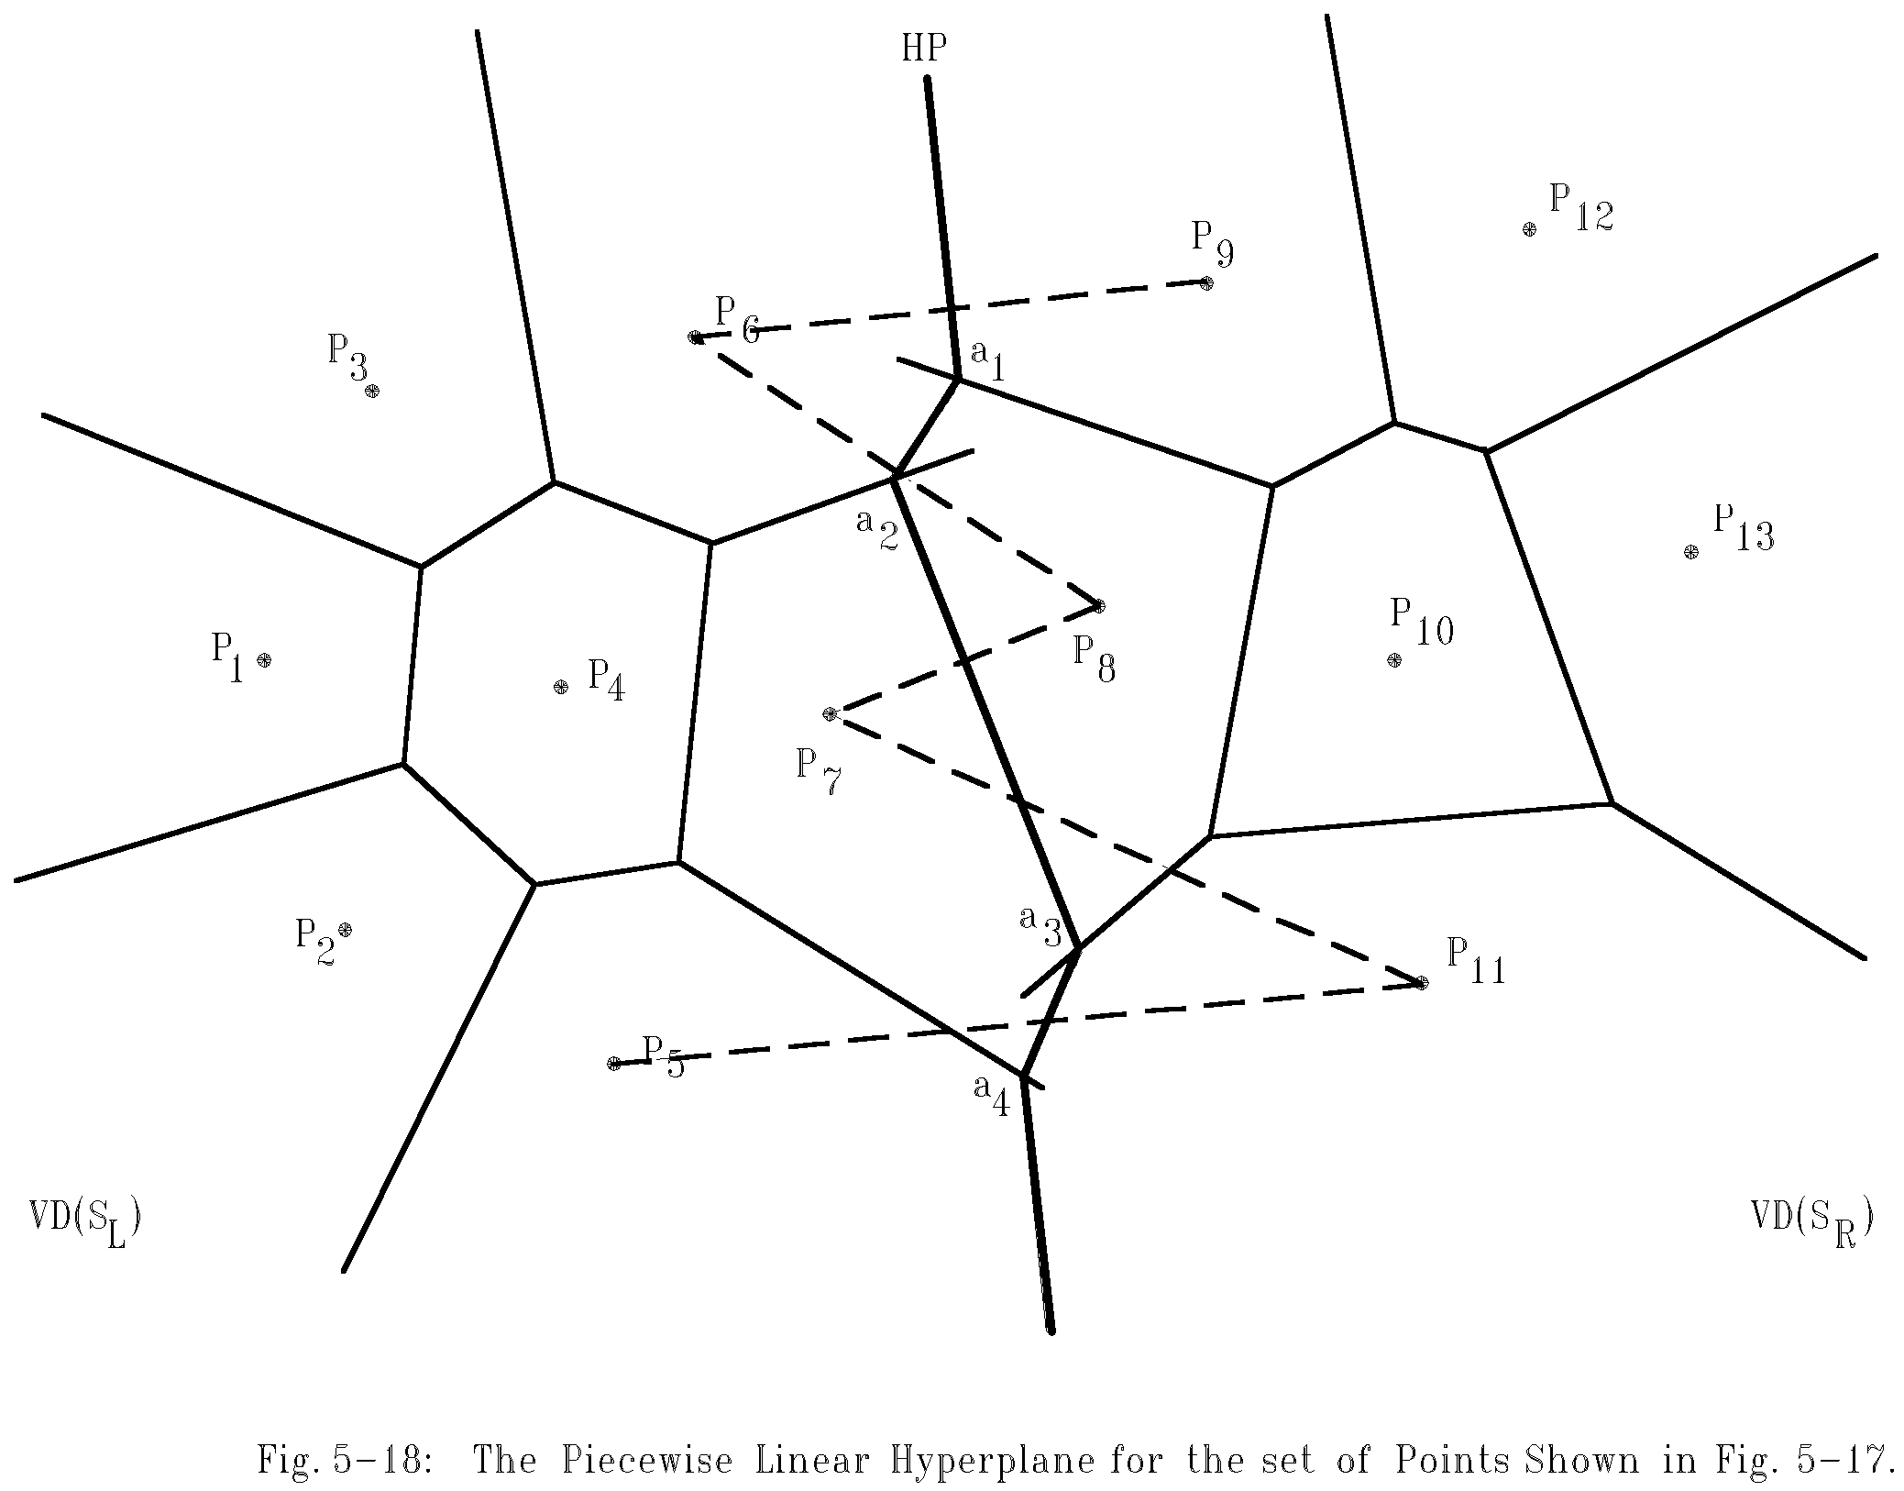
The Final Voronoi diagram:
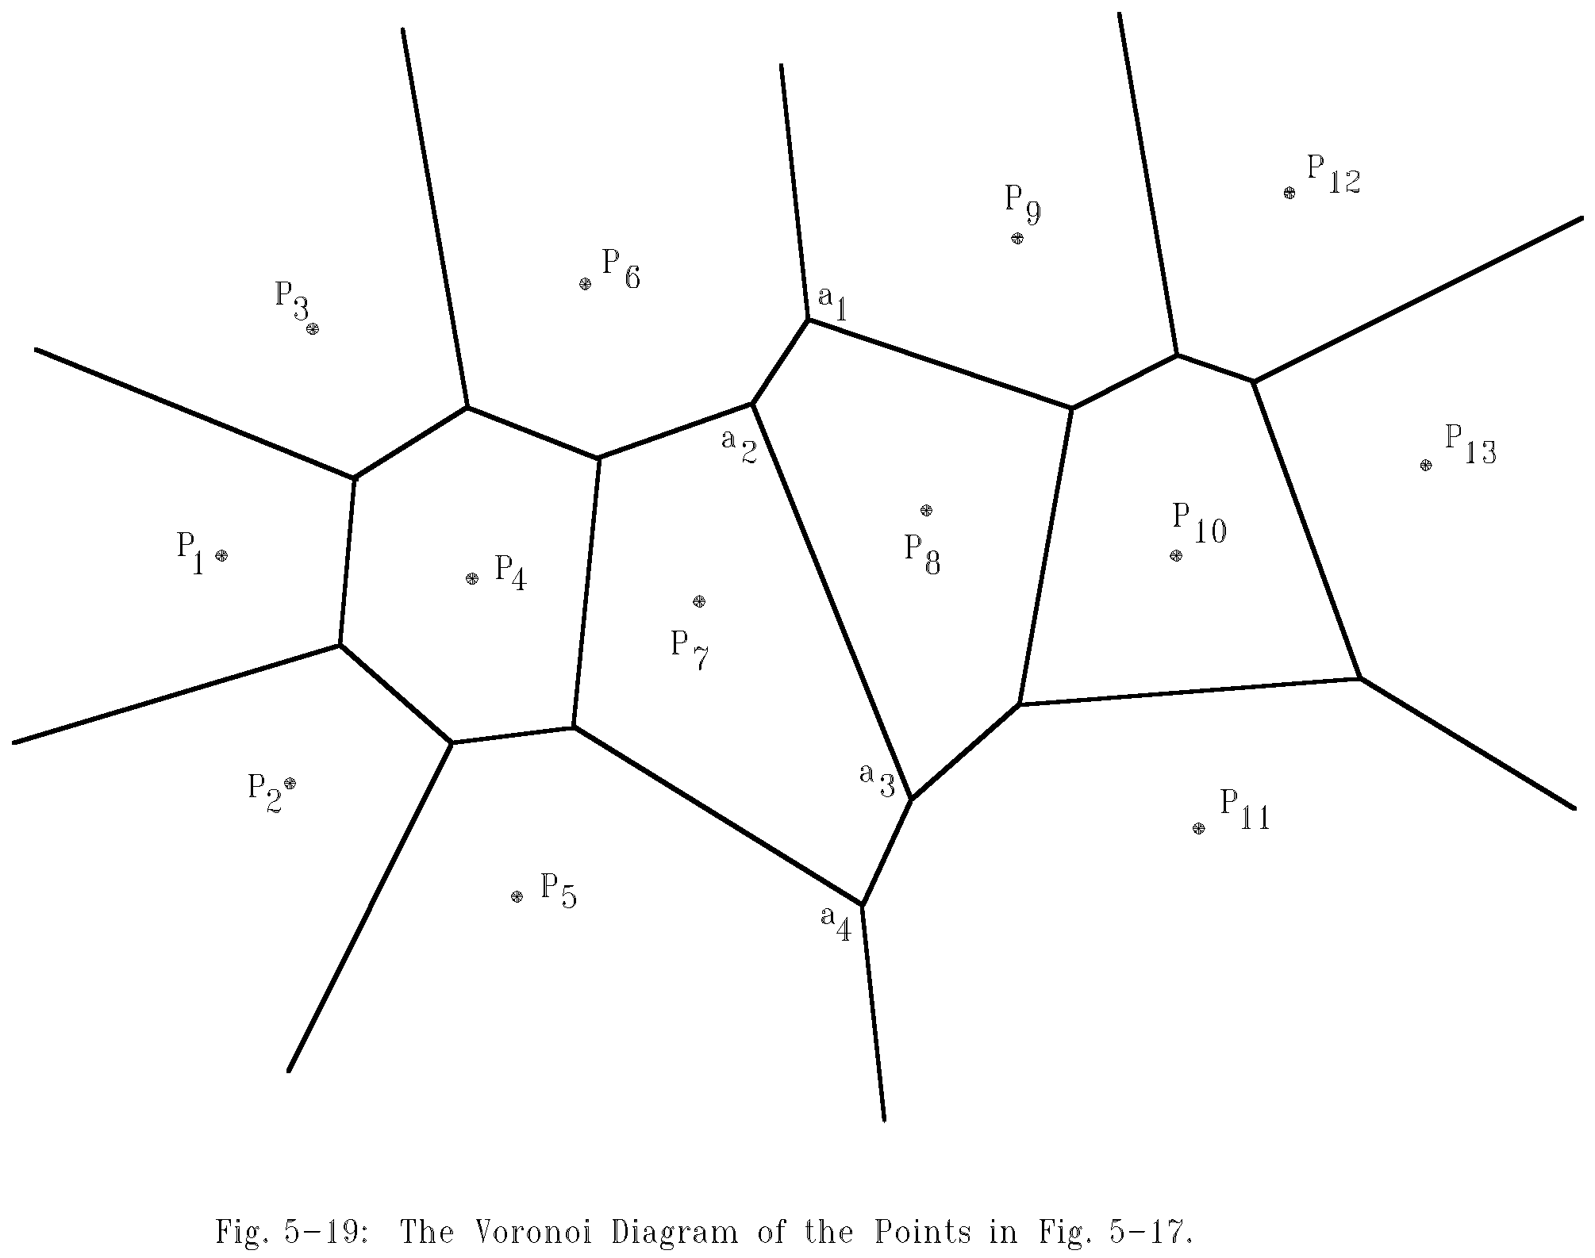
How to merge two Voronoi diagrams?
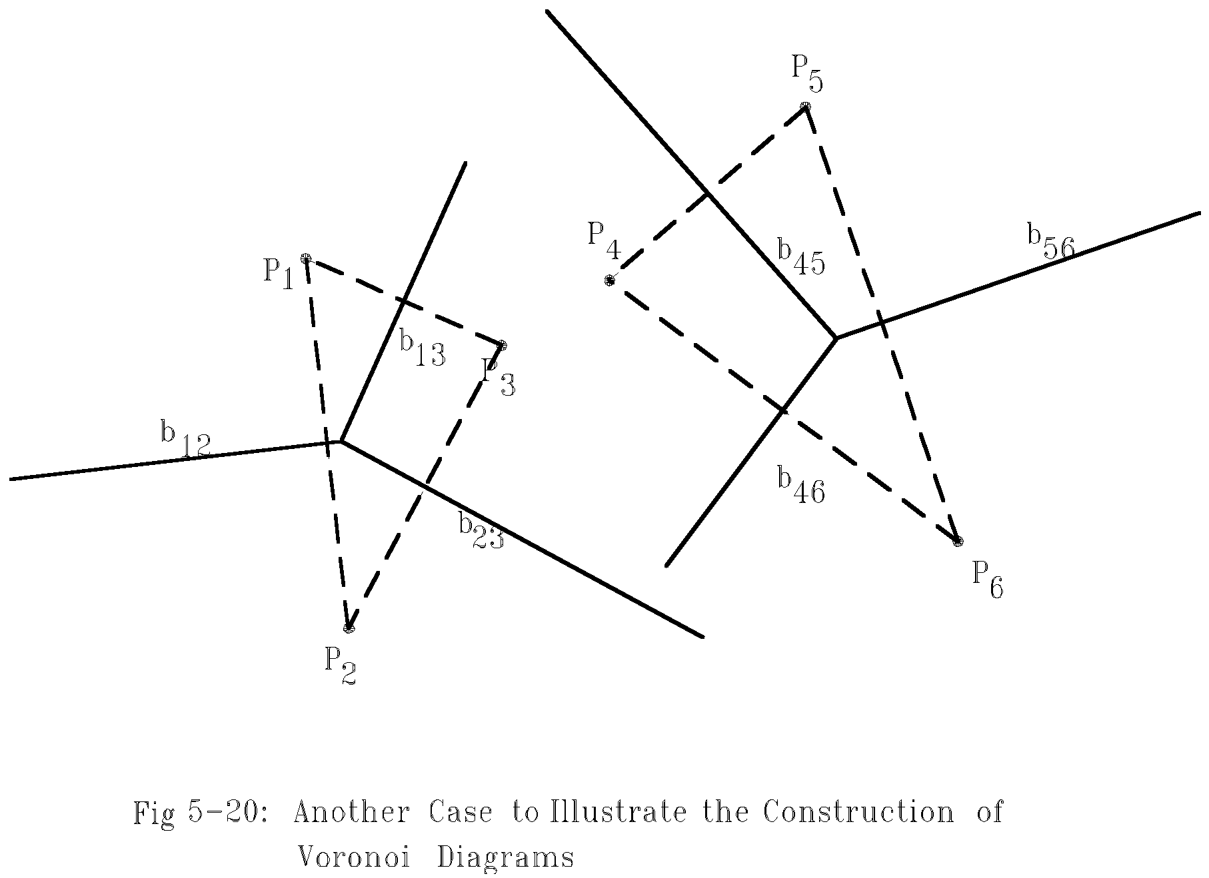
merging:
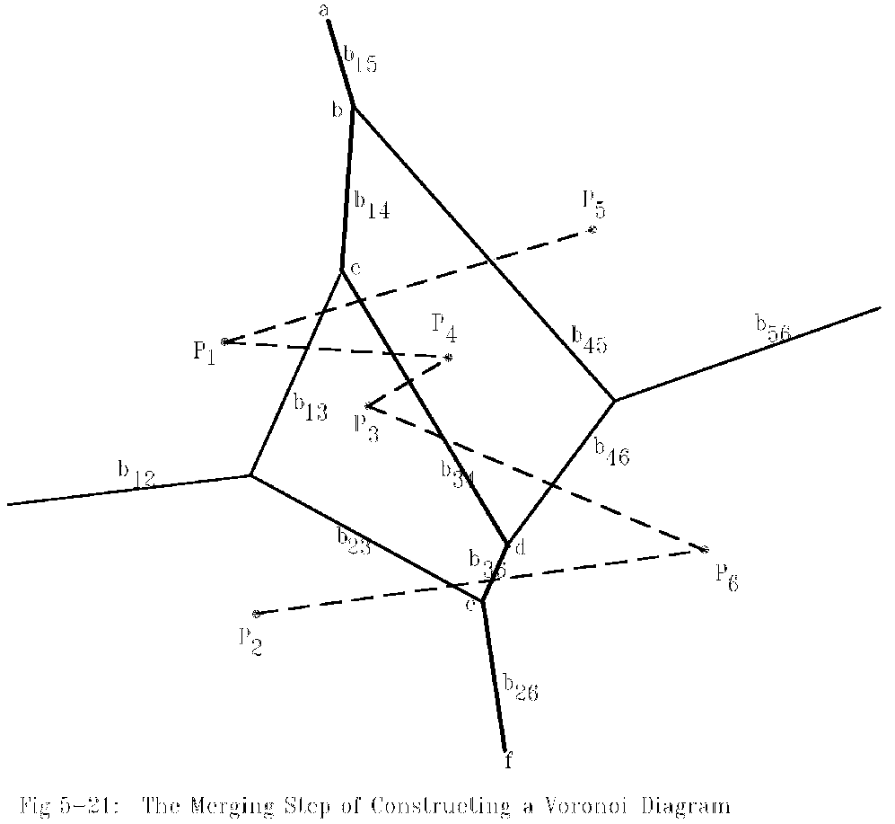
Algorithm 5.5 An Algorithm which Merges Two Voronoi Diagrams into One Voronoi Diagram
Input: (a) S_{L} and S_{R} where S_{L} and S_{R} are divided by a perpendicular line L.
(b) VD(S_{L}) and VD(S_{R}).
Output: VD(S) where S = S_{L}∩S_{R}
Step 1. Find the convex hulls of SL and SR. Let them be denoted as Hull(S_{L}) and Hull(S_{R}) respectively. (A special algorithm for finding a convex hull in this case will by given later.)
Step 2. Find segments 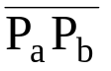 and 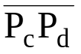 which join HULL(S_{L}) and HULL(S_{R}) into a convex hull (P_{a} and P_{c} belong to S_{L} and P_{b} and P_{d} belong to S_{R}.) Assume that lies above . Let x = a, y = b, SG=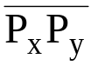 and HP = ∅.
Step 3. Find the perpendicular bisector of SG. Denote it by BS. Let HP = HP∪{BS}. If SG = , go to Step 5; otherwise, go to Step 4.
Step 4. The ray from VD(S_{L}) and VD(S_{R}) which BS first inter sects with must by a perpendicular bisector of either 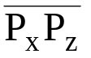 or 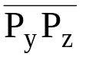 for some z. If this ray is the perpendicular bisector of 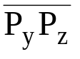, then let SG = 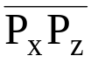; otherwise, let SG =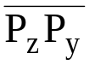. Go to Step 3.
Step 5. Discard the edges of VD(S_{L}) which extend to the right of HP and discard the edges of VD(S_{R}) which extend to the left of HP. The resulting graph is the Voronoi diagram of S = S_{L}∪S_{R}.

Def: Given a point P and a set S of points, the distance between P and S is the distance between P and P_{i} which is the nearest neighbor of P in S.

- The HP obtained from the above algorithm is the locus of points which keep equal distances to S_{L} and S_{R}.
- The HP is monotonic in y.
- # of edges of a Voronoi diagram ≤ 3n - 6, where n is # of points.
reasoning:
- # of edges of a planar graph with n vertices ≤ 3n - 6.
- A Delaunay triangulation is a planar graph.
- edges in Delaunay triangulation
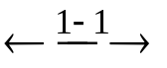edges in Voronoi diagram.
- # of Voronoi vertices ≤ 2n - 4.
reasoning:
- Let F, E and V denote # of face, edges and vertices in a planar graph.
Euler’s relation: F = E - V + 2.
- In a Delaunay triangulation, V = n, E ≤ 3n - 6
⇒ F = E - V + 2 ≤ 3n - 6 - n + 2 = 2n - 4.
- After a Voronoi diagram is constructed, a convex hull can by found in O(n) time.
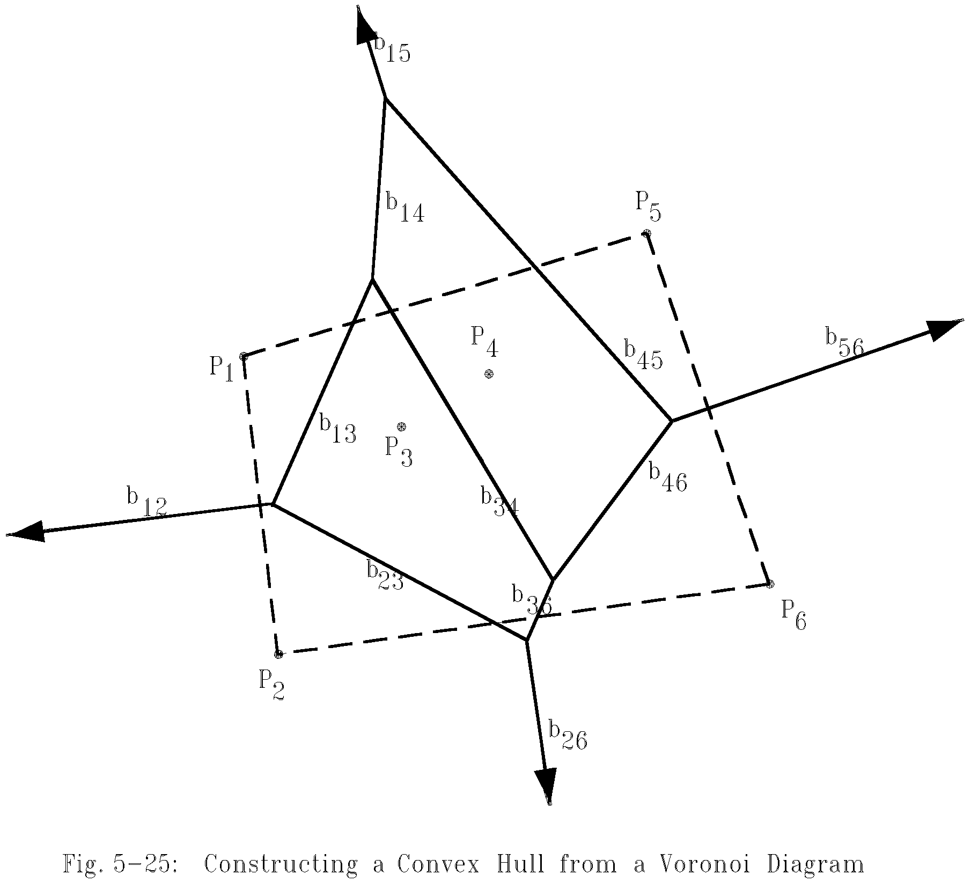

Step 1: Find an infinite ray by examining all Voronoi edges.
Step 2: Let P_{i} be the point to the left of the infinite ray. P_{i} is a convex hull vertex. Examine the Voronoi polygon of P_{i} to find the next infinite ray.
Step 3: Repeat Step 2 until we return to the Starting ray.
- time complexity for merging 2 Voronoi diagrams:
Step 1: O(n)
Step 2: O(n)
Step 3 ~ Step 5: O(n)
(at most 3n - 6 edges in VD(S_{L}) and VD(S_{R}) and at most n segments in HP)
⇒ T(n) = 2T(n/2) + O(n)
=O(n log n)
- The lower bound of the Voronoi diagram problem is Ω(n log n).
∵sorting ∝ Voronoi diagram problem
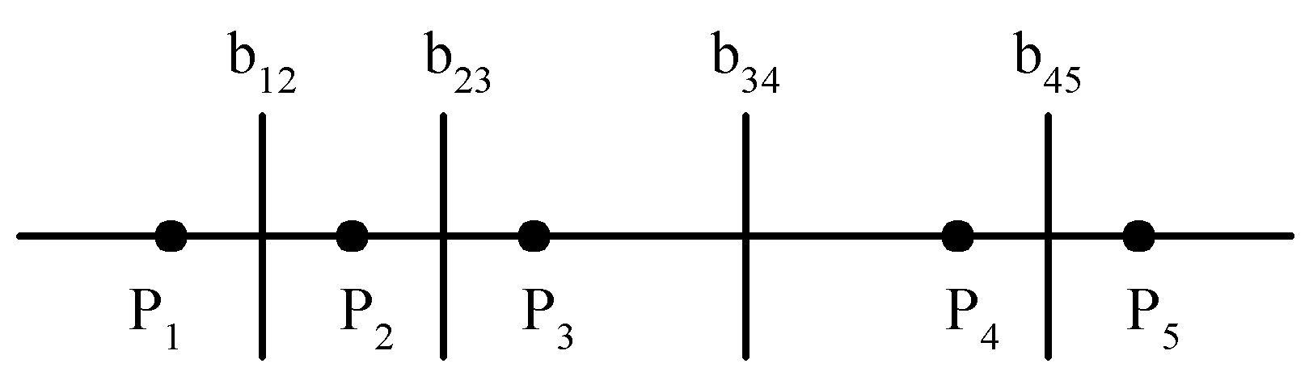
The Voronoi Diagram for a Set of Points on a Straight Line

- Applications of the Voronoi diagrams
- The Euclidean nearest neighbor searching problem.
- The Euclidean all nearest neighbor problem.

- The fast Fourier transform (FFT)
• Fourier transform:
A(f) = 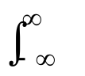a(t)e^{2πift}dt
• inverse Fourier transform:
a(t) = 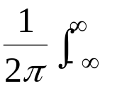A(t)e^{-2πift}df
• discrete Fourier transform(DFT):
given a₀, a₁, …, a_{n-1}
A_{j} = 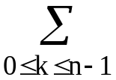a_{k}e^{2πijk/n} ,0 ≤ j ≤ n-1
• inverse DFT:
a_{k} = 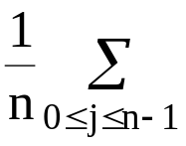A_{j}e^{-2πijk/n} ,0 ≤ k ≤ n-1
• A straightforward method to calculate DFT requires O(n²) time.
• DFT can be solved by the divide-and-conquer strategy.(FFT)
e.g. n =4
A₀ = a₀ + a₁ + a₂ + a₃
A₁ = a₀ + a₁e^{2πi/4} + a₂e^{2πi(2)/4} + a₃e^{2πi(3)/4}
= a₀ + a₁e^{πi/2} + a₂e^{πi} + a₃e^{3πi/2}
A₂ = a₀ + a₁e^{2πi(2)/4} + a₂e^{2πi(2)(2)/4} + a₃e^{2πi(2)(3)/4}
= a₀ + a₁e^{πi} + a₂e^{2πi} + a₃e^{3πi}
A₃ = a₀ + a₁e^{2πi(3)/4} + a₂e^{2πi(3)(2)/4} + a₃e^{2πi(3)(3)/4}
= a₀ + a₁e^{3πi /2} + a₂e^{3πi} + a₃e^{9πi/2}
rewrite as:
A₀ = a₀ + a₁ + a₂ + a₃
A₁ = a₀ + a₁e^{πi/2} + a₂e^{πi} + a₃e^{3πi/2}
A₂ = a₀ + a₁e^{πi} + a₂e^{2πi} + a₃e^{3πi}
A₃ = a₀ + a₁e^{3πi /2} + a₂e^{3πi} + a₃e^{9πi/2}
another from:
A₀ = a₀ + a₂ + (a₁ + a₃)
A₂ = a₀ + a₂e^{2πi} + (a₁e^{πi} + a₃e^{3πi})
= a₀ + a₂ - (a₁ + a₃)
When we calculate A₀, we shall calculate (a₀ + a₂) and (a₁ + a₃). Later, A₂ can be easily found.
Similarly,
A₁ = (a₀ + a₂e^{πi}) + a₁e^{πi/2} + a₃e^{3πi/2}
A₃ = (a₀ + a₂e^{3πi}) + (a₁e^{3πi /2} + a₃e^{9πi/2})
= (a₀ + a₂e^{πi}) - (a₁e^{πi /2} + a₃e^{3πi/2})
e.g. n = 8, let e^{2πi/8}= w = e^{πi/4}
(w⁸ = 1, w⁴ = -1)

A₀ = a₀ + a₁ + a₂ + a₃ + a₄ + a₅ + a₆ + a₇
A₁ = a₀+a₁w+a₂w²+a₃w³+a₄w⁴ +a₅w⁵+a₆w⁶+a₇w⁷
A₂ = a₀+a₁w²+a₂w⁴+a₃w⁶+a₄w⁸+a₅w¹⁰+a₆w¹²+a₇w¹⁴
A₃ = a₀+a₁w³+a₂w⁶+a₃w⁹+a₄w¹²+a₅w¹⁵+a₆w¹⁸+a₇w²¹
⇓
A₀ = (a₀+a₂+a₄+a₆)+(a₁+a₃ +a₅ +a₇)
A₁ = (a₀+a₂w²+a₄w⁴+a₆w⁶)+(a₁w+a₃w³+a₅w⁵+a₇w⁷)
A₂ = (a₀+a₂w⁴+a₄w⁸+a₆w¹²)+(a₁w²+a₃w⁶+a₅w¹⁰+a₇w¹⁴)
A₃ = (a₀+a₂w⁶+a₄w¹²+a₆w¹⁸)+(a₁w³+a₃w⁹+a₅w¹⁵ +a₇w²¹)
Rewrite as:
A₀ = B₀ + C₀ A₄ = B₀ － C₀
A₁ = B₁ + C₁ A₅ = B₁ － C₁
A₂ = B₂ + C₂ A₆ = B₂ － C₂
A₃ = B₃ + C₃ A₇ = B₃ － C₃
We can apply the same method to calculate B_{i}’s and C_{i}’s.
B₀ = a₀+a₂+a₄+a₆
B₂ = a₀+a₂w⁴+a₄w⁸+a₆w¹²
Rewrite as:
B₀ = (a₀+a₄)+(a₂+a₆)
B₂ = (a₀+a₄w⁸)+(a₂w⁴+a₆w¹²)
= (a₀+a₄)-(a₂+a₆)

Similarly,
B₁ = a₀+a₂w²+a₄w⁴+a₆w⁶
= (a₀+a₄w⁴) + (a₂w²+a₆w⁶)
B₃ = a₀+a₂w⁶+a₄w¹²+a₆w¹⁸
= (a₀+a₄w¹²) + (a₂w⁶+a₆w¹⁸)
= (a₀+a₄w⁴) - (a₂w²+a₆w⁶)

In general, let w = e^{2πi/n} (assume n is even)
(w^{n} = 1, w^{n/2} = -1)
A_{j} = a₀+a₁w^{j}+a₂w^{2j}+…+a_{n-1}w^{(n-1)j}
= {a₀+a₂w^{2j}+a₄w^{4j}+…+a_{n-2}w^{(n-2)j}} +
{a₁w^{j}+a₃w^{3j}+…+a_{n-1}w^{(n-1)j} }
= B_{j} + C_{j}
A_{j+n/2} = a₀+a₁w^{j+n/2}+a₂w^{2j+n}+a₃w^{3j+3n/2}+…+
a_{n-1}w^{(n-1)j+(n(n-1)/2)}
= a₀-a₁w^{j}+a₂w^{2j}-a₃w^{3j}+…+a_{n-2}w^{(n-2)j}-a_{n-1}w^{(n-1)j}
= B_{j} - C_{j}
Algorithm 5.6 A Fast Fourier Transform Algorithm Based Upon the Divide-and-Conquer Strategy
Input: a₀, a₁, …, a_{n-1}, n = 2^{k}
Output: A_{j}, j=0, 1, 2, …, n-1
where A_{j} = 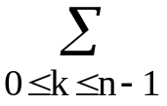a_{k}e^{2πijk/n}
Step 1. If n=2, compute
A₀ = a₀ + a₁,
A₁ = a₀ - a₁, and
return.
Step 2. Divide each A_{j}, 0 ≤ j ≤ n/2 - 1 into two sequences:
O_{j} and E_{j}, where O_{j}(E_{j}), consists of odd-numbered(even-numbered) terms of A_{j}.
Step 3. Recursively calculate the sums of terms in O_{j} and E_{j}. Denote the sum of terms of O_{j} and E_{j} by B_{j} and C_{j} respectively.
Step 4. Compute A_{j} by the following formual:
A_{j} = B_{j} + C_{j} for 0 ≤ j ≤ n/2 - 1
A_{j+n/2} = B_{j} - C_{j} for 0 ≤ j ≤ n/2 - 1.

time complexity:
T(n) = 2T(n/2) + O(n)
= O(n log n)

- Strassen’s matrix multiplicaiton
Let A, B and C by n × n matrices
C = AB
C(i, j) = 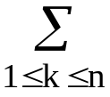A(i, k)B(k, j)
• The straightforward method to perform a matrix multiplication requires O(n³) time.
• The divide-and-conquer strategy:
C = AB
 | C₁₁ | C₁₂ |  | = |  | A₁₁ | A₁₂ |  |  |  | B₁₁ | B₁₂
 | C₂₁ | C₂₂ |  | = |  | A₂₁ | A₂₂ |  |  |  | B₂₁ | B₂₂
C₁₁ = A₁₁B₁₁ + A₁₂B₂₁
C₁₂ = A₁₁B₁₂ + A₁₂B₂₂
C₂₁ = A₂₁B₁₁ + A₂₂B₂₁
C₂₂ = A₂₁B₁₂ + A₂₂B₂₂
time complexity:
T(n) = |  | b  8T(n/2)+cn² | , n ≤ 2  , n > 2
(# of additions: n²)
⇒T(n) = O(n³)
• Strassen’s method:
P = (A₁₁ + A₂₂)(B₁₁ + B₂₂)
Q = (A₂₁ + A₂₂)B₁₁
R = A₁₁(B₁₂ - B₂₂)
S = A₂₂(B₂₁ - B₁₁)
T = (A₁₁ + A₁₂)B₂₂
U = (A₂₁ - A₁₁)(B₁₁ + B₁₂)
V = (A₁₂ - A₂₂)(B₂₁ + B₂₂)

C₁₁ = P + S - T + V
C₁₂ = R + T
C₂₁ = Q + S
C₂₂ = P + R - Q + U

7 multiplications and 18 additions or subtractions.

time complexity:
T(n) = |  | b  7T(n/2)+an² | , n ≤ 2  , n > 2
⇒T(n) = an² + 7T(n/2)
= an² + 7(a(n/2)² + 7T(n/4))
= an² + (7/4)an² + 7²T(n/4)
= …
:
= an²(1 + 7/4 + (7/4)²+…+(7/4)^{k-1}+7^{k}T(1))
≤ cn²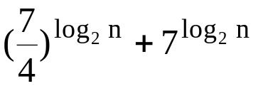, c is a constant
= c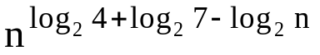 + 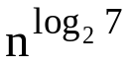
= O()
≅ O(n^{2.81})

