§Approximation Algorithms

Up to now, the best algorithm for solving an NP-complete problem requires exponential time in the worst case. It is too time-consuming.

To reduce the time required for solving a problem, we can relax the problem, and obtain a feasible solution “close” to an optimal solution.

- An approximation algorithm for convex hulls

A convex hull of n points in the plane can be computed in O(nlogn) time in the worst case.

An approximation algorithm:

Step1:Find the leftmost and rightmost points.
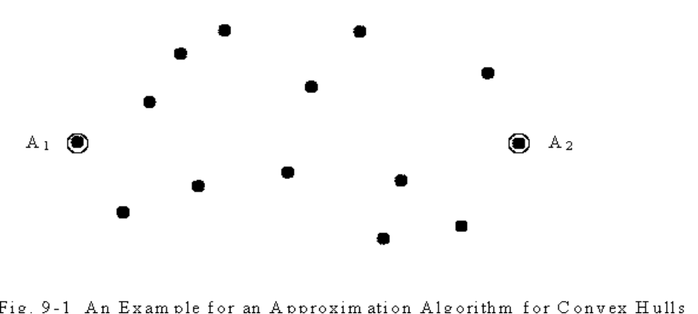
Fig. 9-1 An Example for an Approximation Algorithm for Convex Hulls
Step2:Divide the points into K strips. Find the highest and lowest points in each strip.
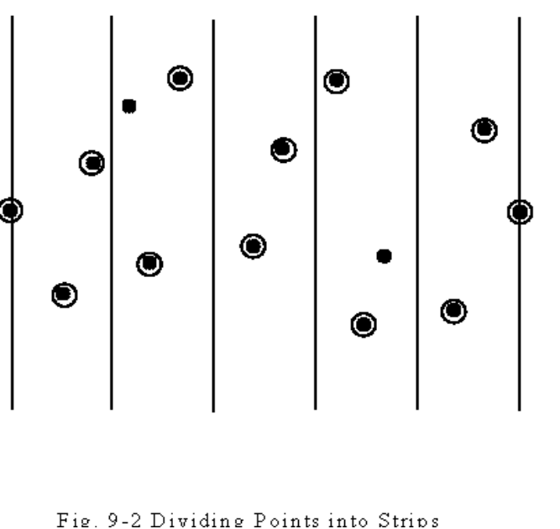
Fig. 9-2 Dividing Points into Strips

Step3:Apply the Graham scan to those highest and lowest points to construct an approximate convex hull. (The highest and lowest points are already sorted by their x-coordinates.)
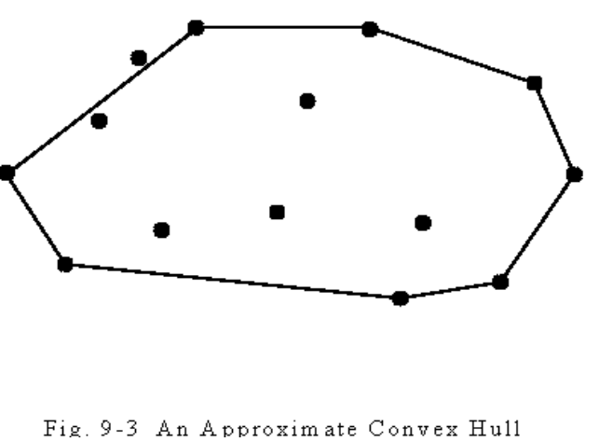
Fig. 9-3 An Approximation Convex Hull
Algorithm 9-1 An approximation Algorithm for Convex Hull.
Input: A set of n points.
Output:An approximate convex hull of S.
Step 1: Find the leftmost and right most points of S, denoted as A₁ and A₂, respectively. (with minimum and maximum x-coordinates respectively).
Step 2: Divide the area bounded by A₁ and A₂ into k equally spaced strips and for each strip, select the points with the minimum and maximum y-coordinates. Denote the set of points selected in this step together with A₁ and A₂ as set P.
Step 3: Construct the convex hull of P and use that as the approximate convex hull of S.

time complexity: O(n+k)
Step 1: O(n)
Step 2: O(n)
Step 3: O(k)

How far away the points outside are from the approximate convex hull? L/K.
L: the distance between the leftmost and rightmost points.
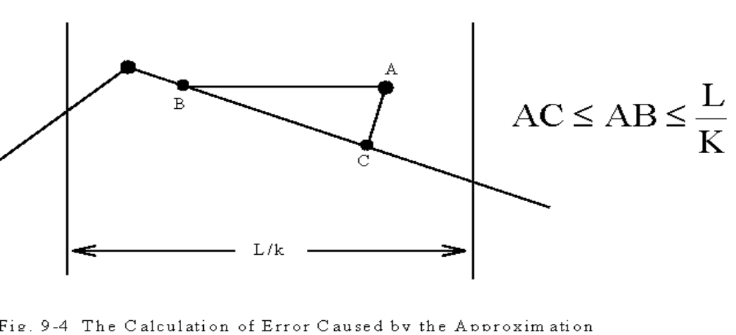
Fig. 9-4 The Calculation of Error Caused by the Approximation
- An approximation algorithm for Euclidean traveling salesperson problem (ETSP).

The ETSP is to find a shortest closed path through a set S of n points in the plane.

The ETSP is NP-hard.

Algorithm 9-2 An Approximation Algorithm for ETSP
Input: A set S of n points in the plane.
Output:An approximate traveling salesperson tour of S.
Step 1: Find a minimal spanning tree T of S.
Step 2: Find a minimal Euclidean weighted matching M on the set of vertices of odd degrees in T. Let G=M∪T.
Step 3: Find an Eulerian cycle of G and then traverse it to find a Hamiltonian cycle as an approximate tour of ETSP by bypassing all previously visited vertices.
- g.
Step1:
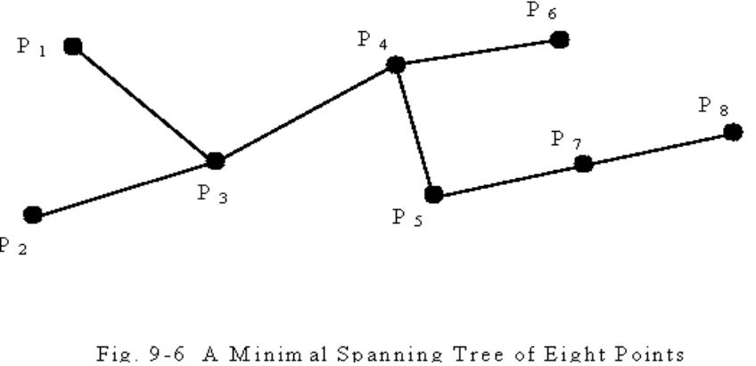
Fig. 9-6 A Minimal Spanning Tree of Eight Points
Step2:The number of points with odd degrees must be even. 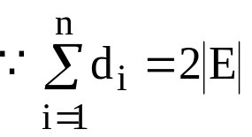 , even
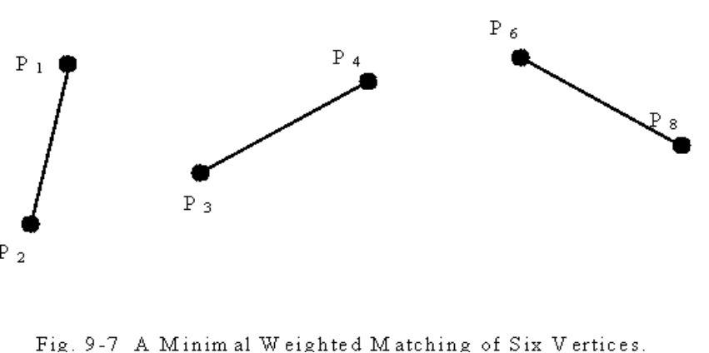
Fig. 9-7 A Minimal Weighted Matching of Six Vertices.

Step3:
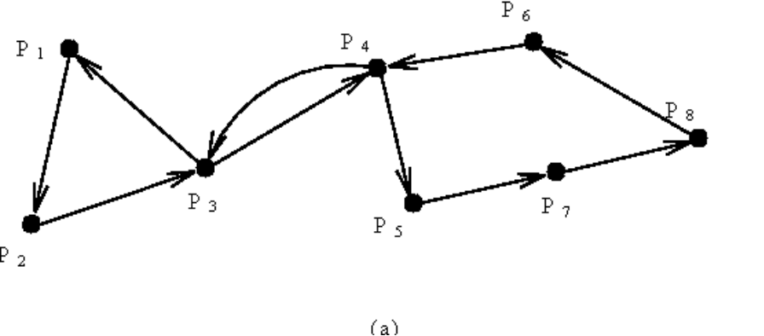
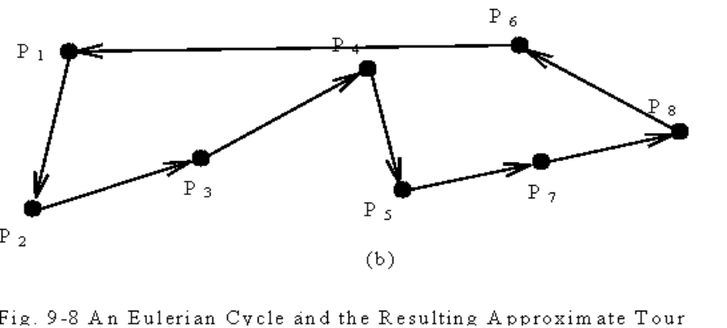
Fig 9-8. An Eulerian Cycle and the Resulting Approximate Tour
time complexity: O(n³)
Step 1: O(nlogn)
Step 2: O(n³)
Step 3: O(n)

How close the approximate solution to an optimal solution?

The approximate tour is within 3/2 of an optimal one.
Reasoning:
L: optimal tour
j₁…i₁j₂…i₂j₃…i_{2m}
{i₁,i₂,…,i_{2m}}: the set of odd degree vertices in T.
2 matchings: M₁={[i₁,i₂],[i₃,i₄],…,[i_{2m-1},i_{2m}]}
M₂={[i₂,i₃],[i₄,i₅],…,[i_{2m},i₁]}
length(L) ≥ length(M₁) + length(M₂)
(triangular inequality)
≥ 2 length(M )
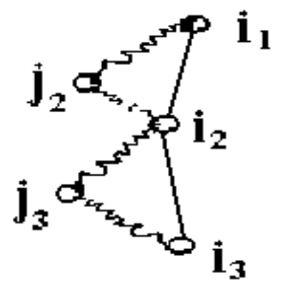
⇒length(M) ≤ 1/2 length(L )
G = T∪M

⇒length(G)=length(T) + length(M)
≤ length(L) + 1/2 length(L)
= 3/2 length(L)
- An approximation algorithm for the bottleneck traveling salesperson problem
- minimize the longest edge of a tour.
- This is a mini-max problem.
- This problem is NP-complete.
- The input data for this problem fulfill the following assumptions:
(i) The graph is a complete graph.
- All edges obey the triangular inequality rule.

- An algorithm for finding an optimal solution:
Step1: Sort all edges in G = (V,E) into a nondecresing sequence |e₁|≤|e₂|≤…≤|e_{m}|. Let G(e_{i}) denote the subgraph obtained from G by deleting all edges longer than e_{i}.
Step2: i←1
Step3: If there exists a Hamiltonian cycle in G(e_{i}), then this cycle is the solution and stop.
Step4: i←i+1 . Go to Step 3.
e.g.
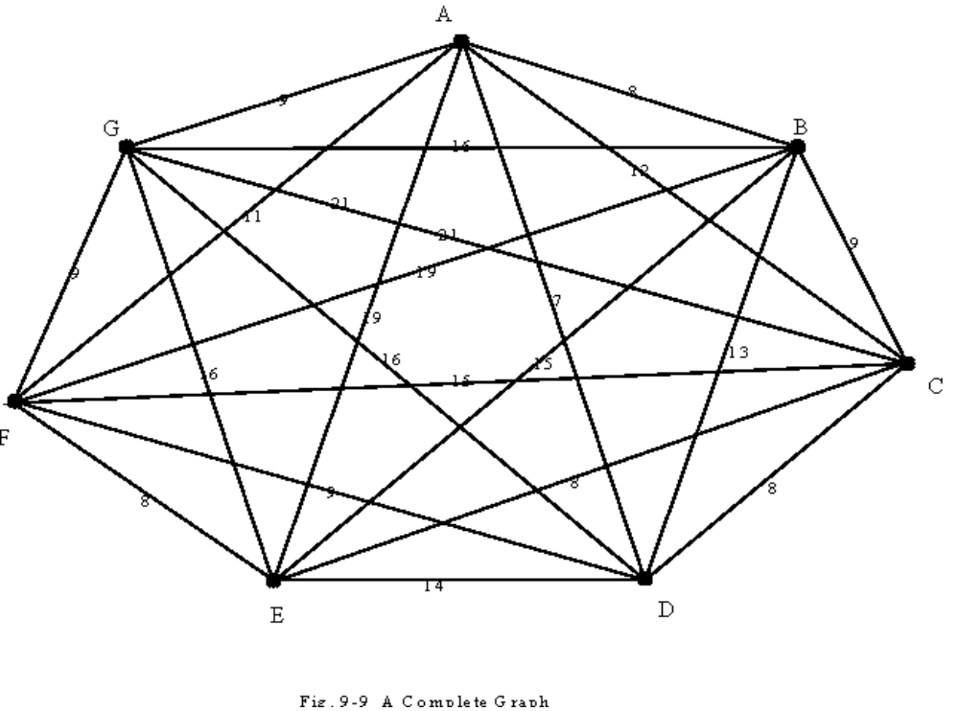
Fig. 9-9 A Complete Graph
e.g.
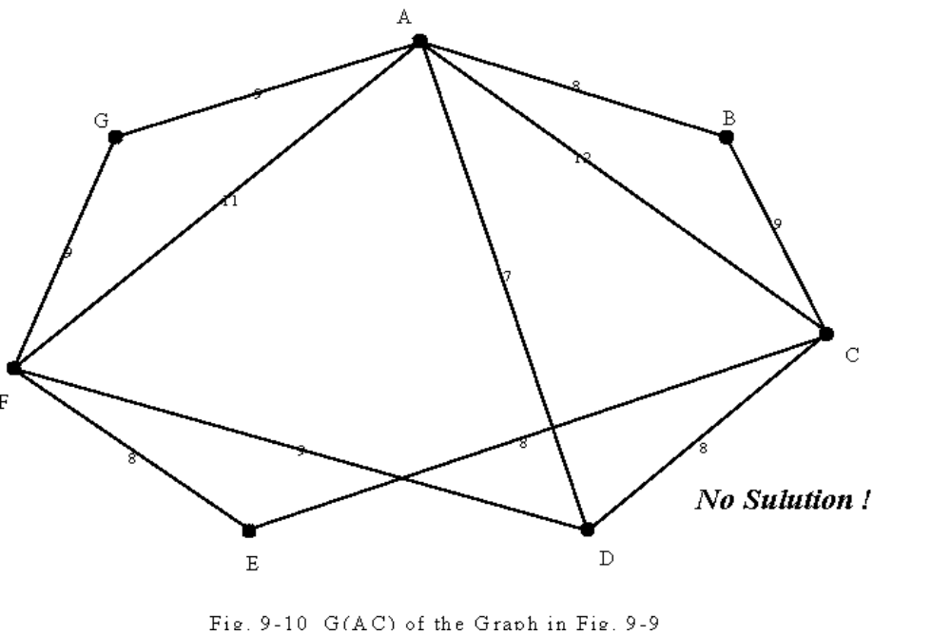
Fig. 9-10 G(AC) of the Graph in Fig 9-9
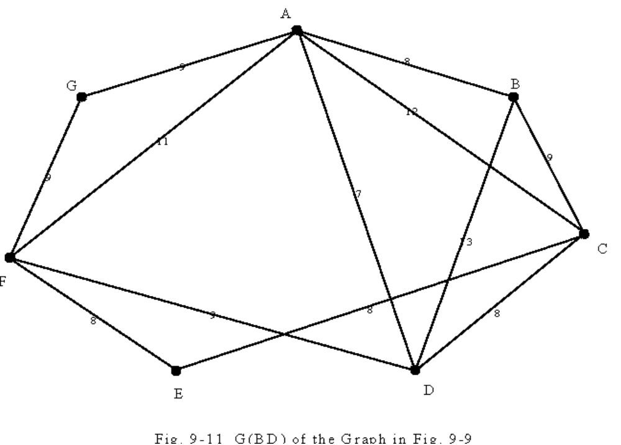
Fig. 9-11 G(BD) of Graph in Fig 9-9
There is a Hamiltonian cycle, A-B-D-C-E-F-G-A, in G(BD).
The optimal solution is 13.
- Def: The t-th power of G=(V,E), denoted as G^{t}=(V,E^{t}), is a graph that an edge (u,v)∈E^{t} if there is a path from u to v with at most t edges in G.
- If a graph G is bi-connected, then G² has a Hamiltonian cycle.
e.g.
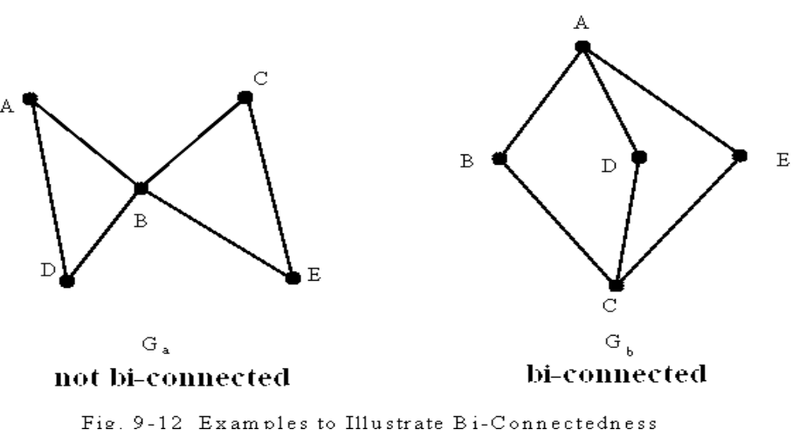
not bi-connected bi-connected
- g.
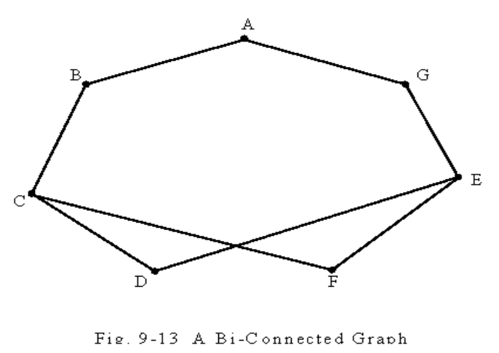
Fig. 9-13 A Bi-Connected Graph
e.g.
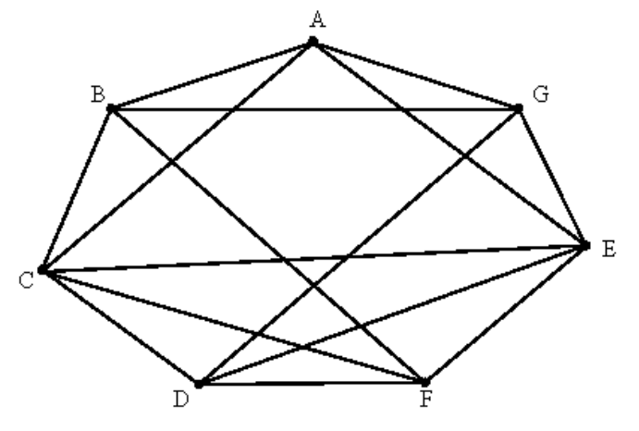
A Hamiltonian cycle

A-B-C-D-E-F-G-A
Fig. 9-14 G² of the Graph in Fig 9-13.

Algorithm 9-3 An Approximation Algorithm to Solve the Special Bottleneck Traveling Salesperson Problem.
Input: A complete graph G=(V,E) where all edges satisfy triangular inequality.
Output:A tour in G whose longest edges is not greater than twice of the value of an optimal solution to the special bottleneck traveling salesperson problem of G.
Step 1: Sort the edges into |e₁|≤|e₂|≤…≤|e_{m}|.
Step 2: i := 1.
Step 3: If G(e_{i}) is bi-connected, construct G(e_{i})², find a Hamiltonian cycle in G(e_{i})² and return this as the output, otherwise, go to Step 4.
Step 4: i := i + 1. Go to Step 3.
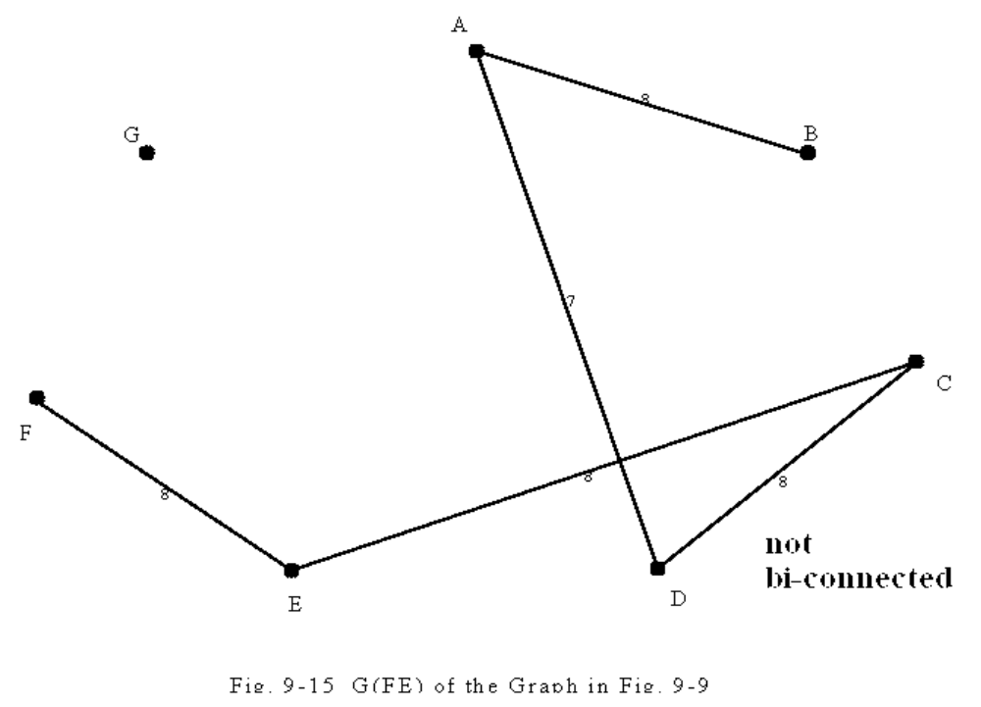
Fig. 9-15 G(FE) of the Graph in Fig 9-9
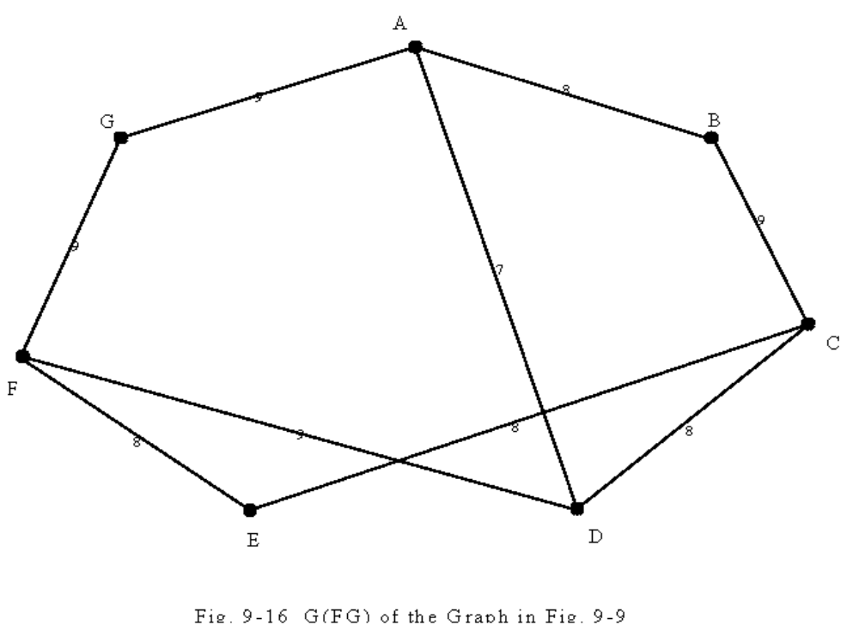
Fig. 9-16 G(FG) of the Graph in Fig 9-9
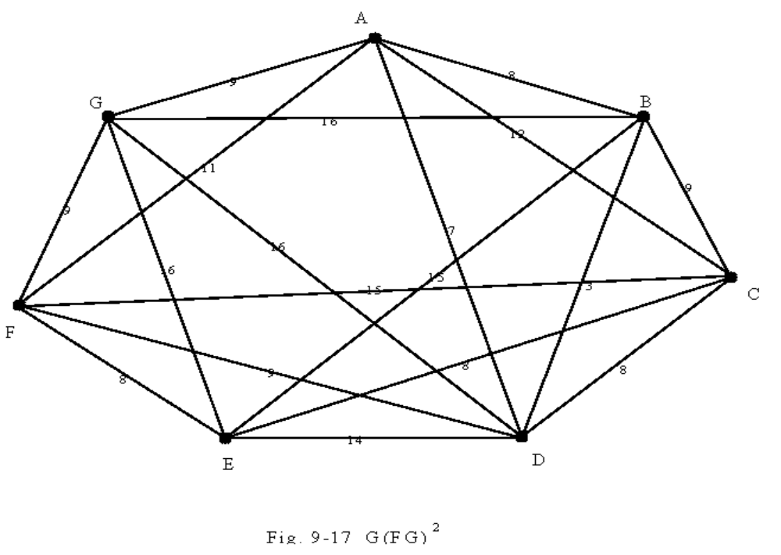
Fig. 9-17 G(FG)²
A Hamiltonian cycle: A-G-F-E-D-C-B-A.
the longest edge: 16

time complexity:
polynomial time

The approximate solution is bounded by two times an optimal solution.

Reasoning:
A Hamiltonian cycle is bi-connected.
e_{op}: the longest edge of an optimal solution
G(e_{i}): the first bi-connected graph
|e_{i}|≤|e_{op}|
The length of the longest edge in G(e_{i})²≤2|e_{i}|
(triangular inequality) ≤2|e_{op}|

If there is a polynomial approximation algorithm which produces a bound less than two, then NP=P.
(The Hamiltonian cycle decision problem reduces to this problem.)
Proof:
For an arbitrary graph G=(V,E), we expand G to a complete G_{c}:
C_{ij} = 1 if (i,j) ∈ E
C_{ij} = 2 if otherwise
(The definition of C_{ij} satisfies the triangular inequality.)
Let V* denote the value of an optimal solution of the bottleneck TSP of G_{c}.
V* = 1 ⇔ G has a Hamiltonian cycle

Because there are only two kinds of edges, 1 and 2 in G_{c}, if we can produce an approximate solution whose value is less than 2V*, then we can also solve the Hamiltonian cycle decision problem.
- An approximation algorithm for the bin packing problem

n items a₁, a₂, …, a_{n}, 0< a_{i} ≤ 1, 1 ≤ i ≤ n
to determine the minimum number of bins of unit capacity to accomodate all n items.

- g. n = 5, {0.3, 0.5, 0.8, 0.2 0.4}
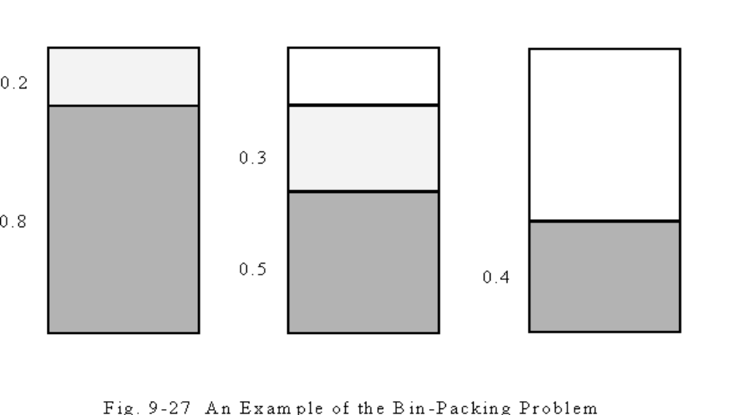
Fig. 9-27 An Example of the Bin-Packing Problem

- The bin packing problem is NP-hard.
An approximation algorithm: (first-fit)
place a_{i} into the lowest-indexed bin which can accommodate a_{i}.

S(a_{i}): the size of a_{i}
OPT(I): the size of an optimal solution of an instance I
FF(I): the size of bins in the first-fit algorithm
C(B_{i}): the sum of the sizes of a_{j}’s packed in bin B_{i} in the first-fit algorithm

OPT(I) ≥ 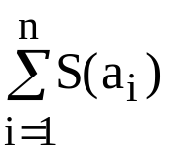
C(B_{i}) + C(B_{i+1}) > 1
m nonempty bins:
C(B₁)+C(B₂)+…+C(B_{m}) > m/2
⇒ FF(I) = m < 2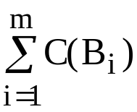 = 2 ≤ 2 OPT(I) FF(I) < 2 OPT(I)
- An approximation algorithm for the rectilinear m-center problem

- The sides of a rectilinear square are parallel or perpendicular to the x-axis of the Euclidean plane.
- The problem is to find m rectilinear squares covering all of the n given points such that the maximum side length of these squares is minimized.
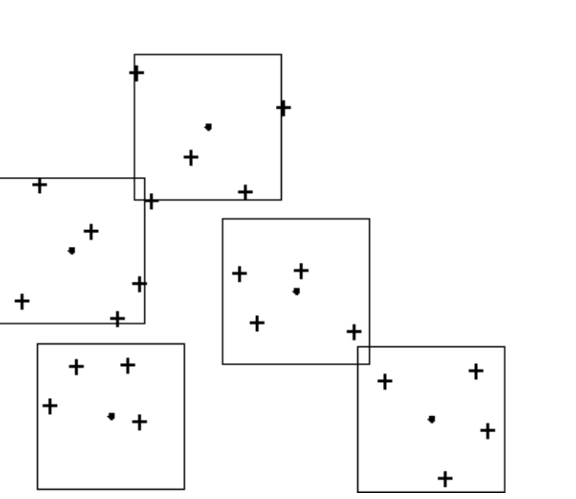
Fig. 9-28 A Rectilinear 5-center Problem Instance

- This problem is NP-complete.
- This problem for the solution with error ratio < 2 is also NP-complete.
input: P={P1, P2, …, Pn}
The size of an an optimal solution must be equal to one of the 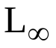(Pi,Pj), 1 ≤ i < j ≤ n, where ((x1,y1),(x2,y2)) = max{|x1-x2|,|y1-y2|}.

Algorithm 9-5 Approximation Algorithm Rectilinear Center
Input: A set P of n points, number of centers: m
Output:SQ[1], …, SQ[m]: A feasible solution of the rectilinear m-center problem with size less than or equal to twice of the size of an optimal solution.
Step 1: Compute rectilinear distances of all pairs of two points and sort them together with 0 into an ascending sequence D[0]=0, D[1], …, D[n(n-1)/2].
Step 2: LEFT := -1, RIGHT := n(n-1)/2.
Step 3: i := ⎡(LEFT + RIGHT)/2⎤.
Step 4: If Test(m, P, D[i]) is not “failure” then
RIGHT := i
else
LEFT := i
Step 5: If RIGHT = LEFT + 1 then
return Test(m, P, D[RIGHT])
else
go to Step 3.
Algorithm 9-6 Algorithm Test(m, P, r):
Input: point set: P, number of centers: m, size: r.
Output: “failure”, or SQ[1], …, SQ[m] m squares of size 2r covering P.
Step 1: PS := P
Step 2: For i := 1 to m do
If PS ≠ ∅ then
p := the point is PS with the smallest x-value
SQ[i] := the square of size 2r with center at p
PS := PS - {points covered by SQ[i]}
else
SQ[i] := SQ[i-1].
Step 3: IF PS = ∅ then
return SQ[1], …, SQ[m]
else
return “failure”.
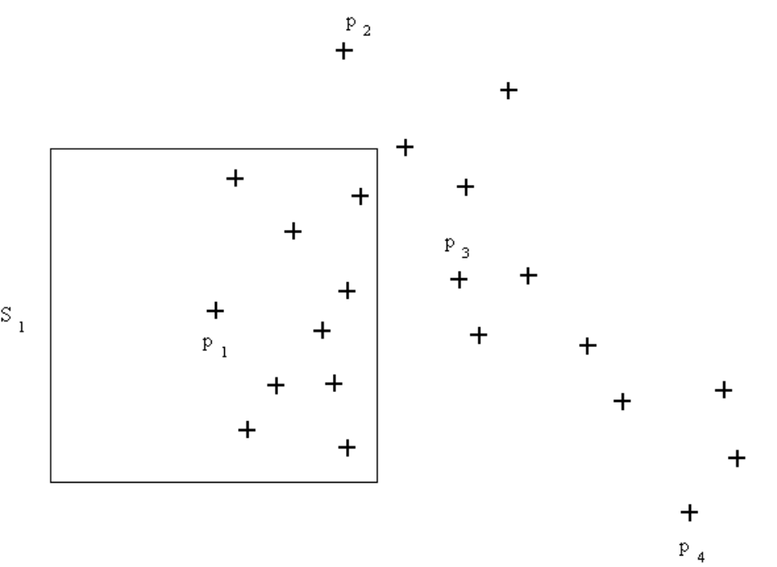
Fig. 9-29 The First Application of the Relaxed Test Subroutine.
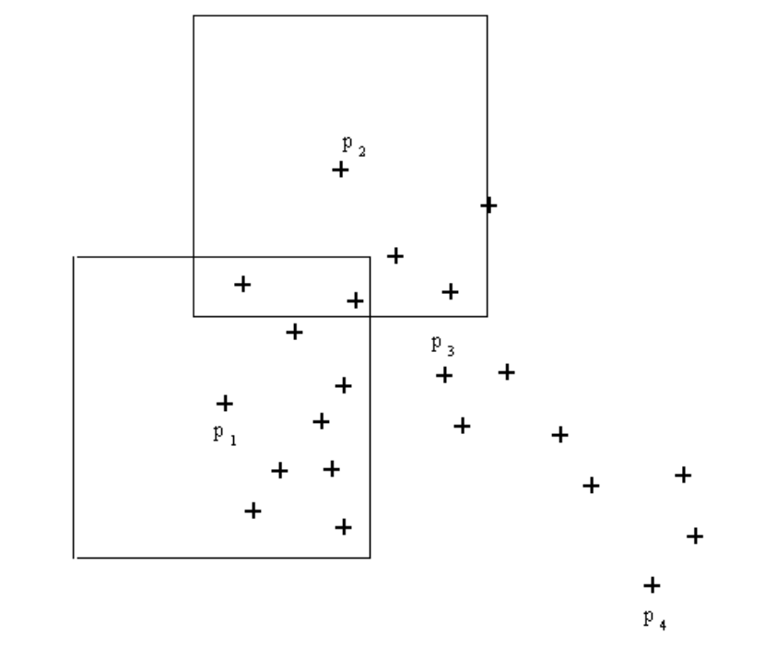
Fig. 9-30 The Second Application of the Test Subroutine.
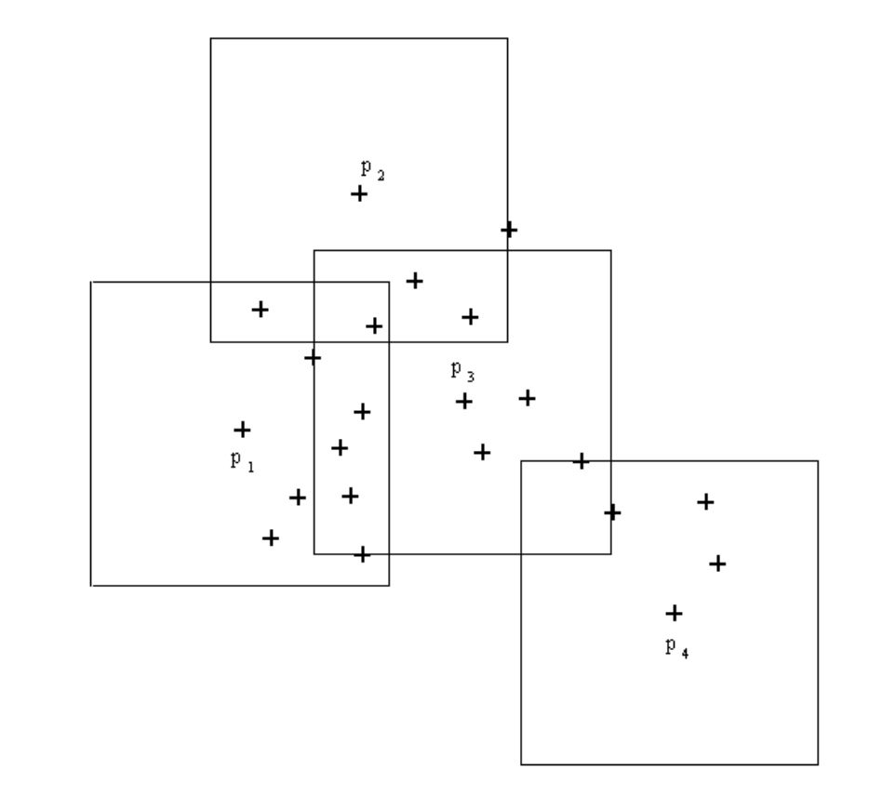
Fig. 9-31 A Feasible Solution of the Rectilinear 5-center Problem
time complexity: O(n²logn)
Step 1: O(n)
Step 2: O(1)
Step 3:
∫ O(logn)* O(mn) = O(n²logn)
Step 5:
The approximation algorithm is of error ratio 2.
If r is feasible, then Test(m, P, r) returns a feasible solution of size 2r.
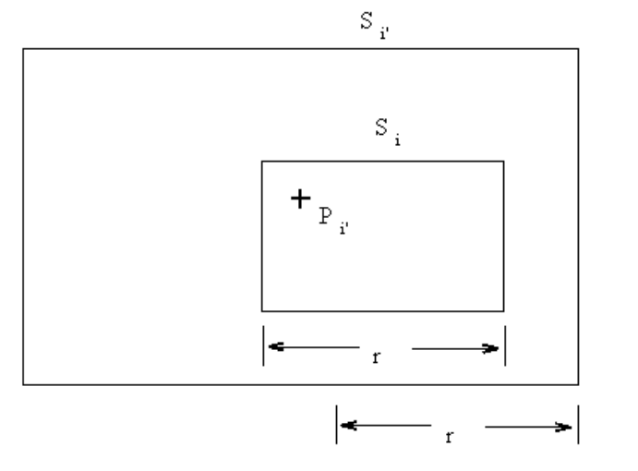
Fig. 9-32 The Explanation of S_{i} ⊂ S_{i}’

