**NITRO Clubs EU**

**IT Robo Olympics**

**Line Following Robot**

**COMPETITION**

**APPENDIX A: COMPETITION FIELD LAYOUT AND SIZING**

**APPENDIX A: COMPETITION FIELD LAYOUT**

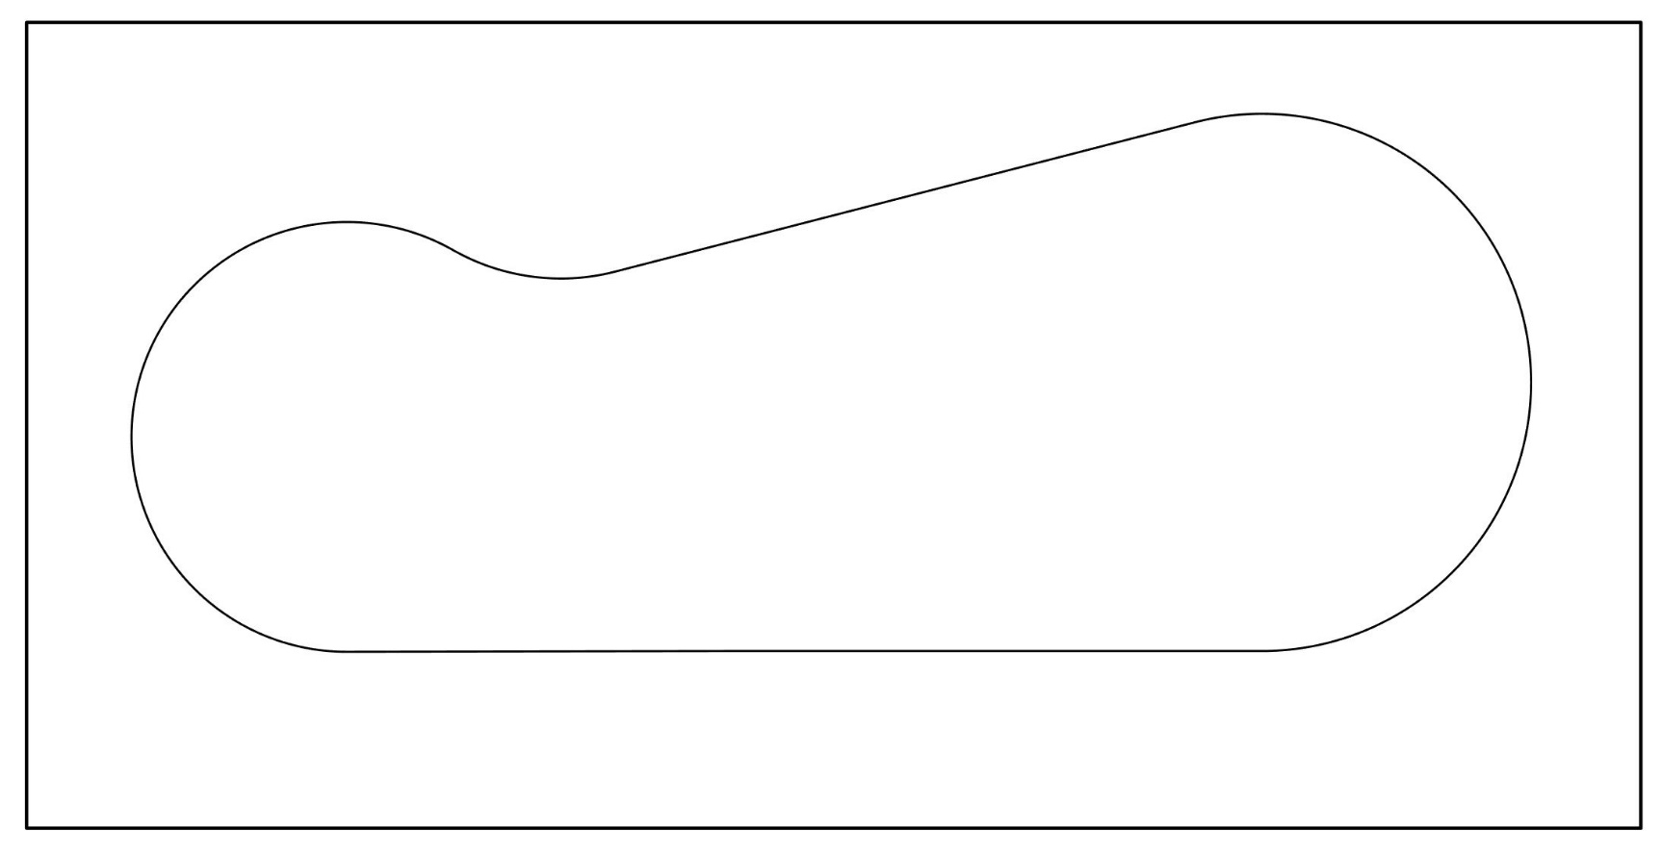

*Fig.1 Line layout*

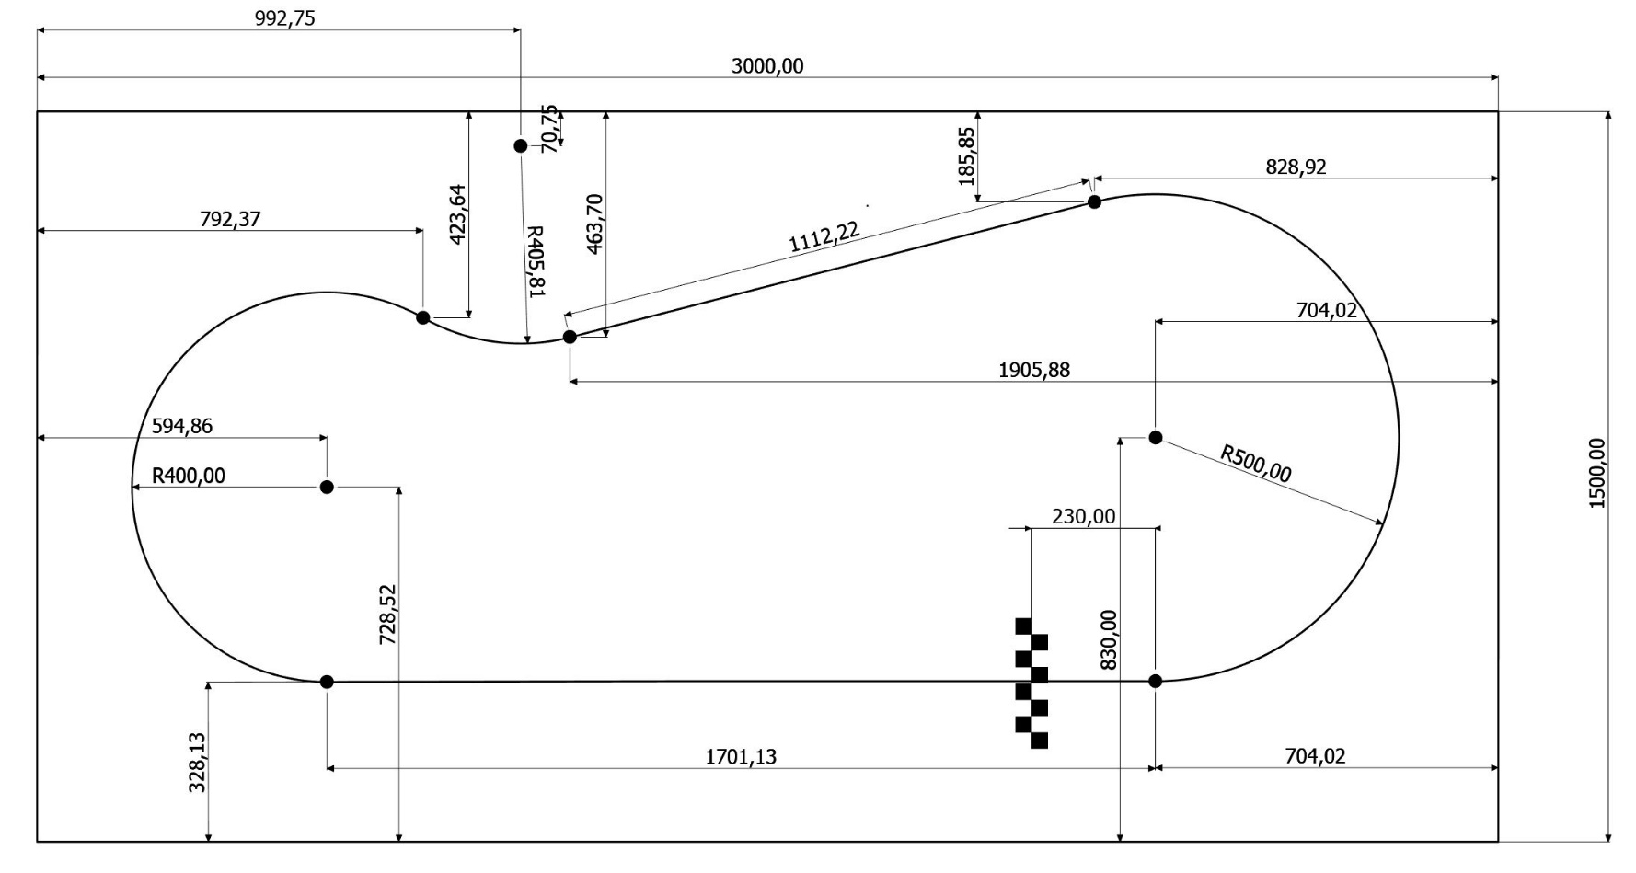

*Fig.2 Line layout dimensions*