**NITRO Clubs EU**

**IT Robo Olympics**

**Maze Solving Robot**

**COMPETITION**

**APPENDIX A: COMPETITION FIELD LAYOUT AND SIZING**

**APPENDIX A: MAZE LAYOUT**

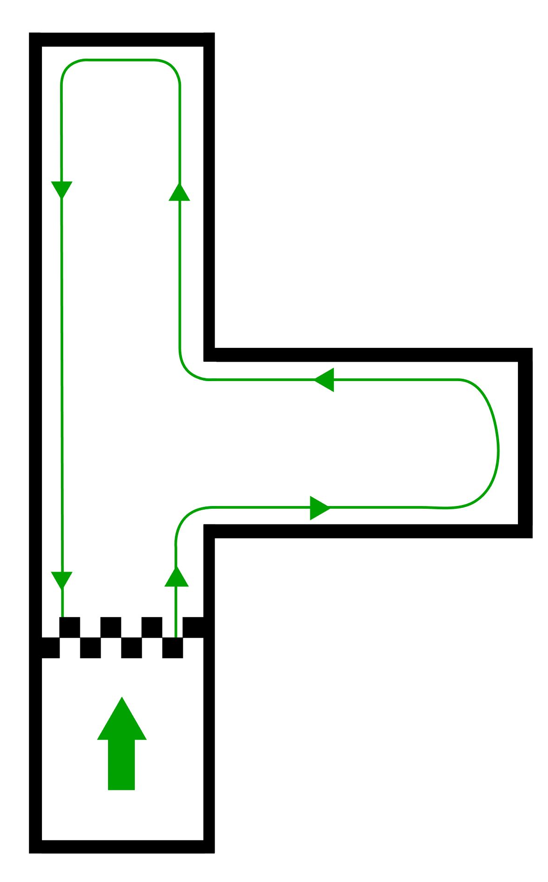

Fig.1 Maze layout

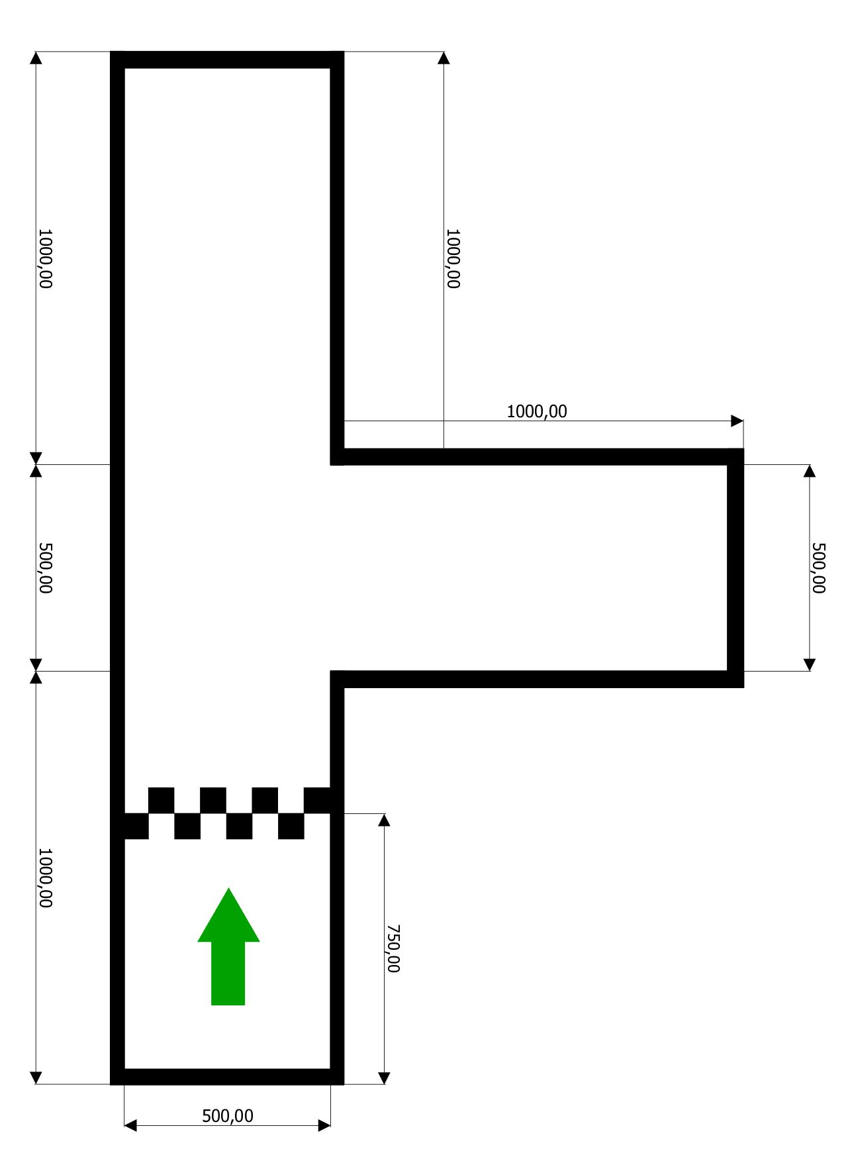

Fig.2 Maze sizing