**NITRO Clubs EU**

**IT Robo Olympics**

**Obstacle Avoiding Line Following Robot**

**COMPETITION**

**APPENDIX A:**

**COMPETITION FIELD LAYOUT AND SIZING**

**APPENDIX A: COMPETITION FIELD LAYOUT**

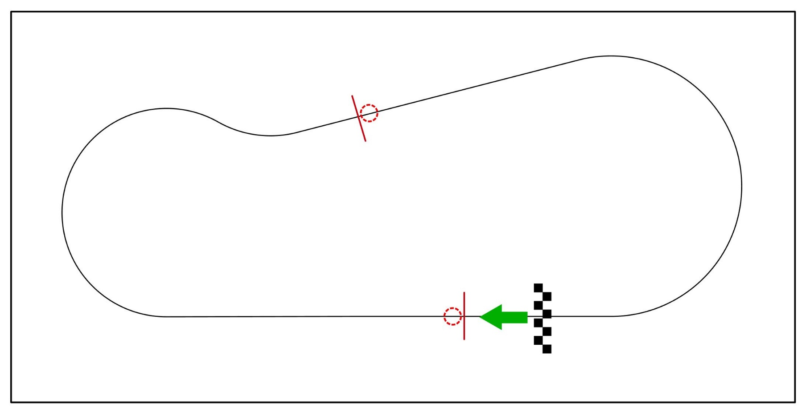

Fig. 1 Line with obstacles layout

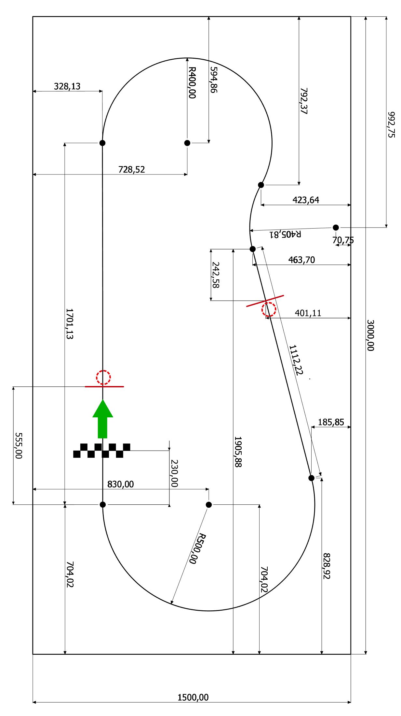

Fig.2 Line with obstacles layout sizing