**NITRO Clubs EU**

**IT Robo Olympics**

**Obstacle Avoiding Line Following Robot**

**COMPETITION**

**RULES & REGULATIONS**

1. **OBJECTIVES**

Participants of the Obstacle Avoiding Line Following Robot competition are required to create and fine tune a program for line following with NITRObot robot, that is able to follow lines from the start line until the finishing line, while avoiding obstacles along the route, returning back to the route/line and continue line following, according to the competition rules. The robot must move autonomously.

Short Description: *The objective of this contest is to complete the course from start to finish in the shortest period of time, while accurately tracking the course line and avoiding obstacles placed on the line.*

1. **CODE OF CONDUCT**
   1. Spirit
      1. It is expected that all participants (students, teachers and mentors alike) respect the aims and ideals of **IT Robo Olympics** as set out in our mission statement.
      2. The volunteers, referees and officials will act within the spirit of the event to ensure the competition is competitive, fair and, most importantly, fun.
      3. It is not whether you win or lose, but how much you learn that counts!
   2. Fair Play
      1. Robots that cause deliberate or repeated damage to the field will be disqualified.
      2. Humans that cause deliberate interference with robots or damage to the field will be disqualified.
      3. I t is expected that the aim of all teams is to participate fairly.
   3. Behavior
      1. Each team is responsible for verifying the latest version of the rules on the **IT Robo Olympics** section of the [**nitroclubs.eu**](https://nitroclubs.eu/)  website, and additional clarifications/corrections on the official forum made by the **IT Robo Olympics** Technical Committee prior to the competition.
      2. Participants should be mindful of other people and their robots when moving around the tournament venue.
      3. Participants are not allowed to enter setup areas of other leagues or other teams, unless explicitly invited to do so by team members.
      4. Teams will be responsible for checking updated information (schedules, meetings, announcements, etc.) during the event. Updated information will be provided on notice boards in the venue, on the local competition website, and/or the **IT Robo Olympics** section of the [**nitroclubs.eu**](https://nitroclubs.eu/)  website.
      5. Participants and their companions who misbehave may be asked to leave the venue and risk being disqualified from the tournament.
      6. These rules will be enforced equally to all participants at the discretion of the referees, officials, tournament organizers and local law enforcement authorities.
      7. Teams are expected to be present at the venue early on the setup day as important activities will occur. These activities include, but are not limited to: registration, participation raffle, interviews, captains and mentor’s meetings, among others.
   4. Mentors
      1. Non-team members (mentors, teachers, parents and other family, chaperones, translators and other adult team members) are not allowed in the student work area.
      2. Mentors are not permitted to be involved in building, repairing, or programming their team’s robots both before and during the competition.
      3. Mentor interference with robots or referee decisions will result in a warning in the first instance. If this behavior recurs, the team could face a possible elimination from the tournament.
      4. Robot programs have to be mainly student’s own work.
   5. Ethics and Integrity
      1. Fraud and misconduct are not condoned. Fraudulent acts may include the following:
         1. Mentors working on the software or hardware of student’s robot(s) during the competition.
         2. More experienced/advanced groups of students may provide advice but should not do the work for other groups. Otherwise, the team risks being disqualified.
      2. **IT Robo Olympics** reserves the right to revoke an award if fraudulent behavior can be proven after the
      3. award ceremony takes place.
      4. If it is evident that a mentor intentionally violates the code of conduct, and repeatedly modifies and works on the student’s robot(s) during the competition, the mentor will be banned from future participation in **IT Robo Olympics** competitions.
      5. Teams that violate the code of conduct can be disqualified from the tournament. It is also possible to disqualify a single team member from further participation in the tournament.
      6. In less severe cases of violations of the code of conduct, a team will be given a warning. In severe or repeated cases of violations of the code of conduct, a team can be disqualified immediately without warning.
   6. Sharing
      1. The spirit of IT Robo Olympics competitions is that any technological and curricular developments should be shared with other participants after the tournament. This furthers the mission of [**NITRO Clubs EU**](https://nitroclubs.eu/) and its **IT Robo Olympics** competitions, as an educational initiative.
      2. Any developments may be published on the **IT Robo Olympics** section of the of [**nitroclubs.eu**](https://nitroclubs.eu/)  website after the event.
      3. Participants are strongly encouraged to ask questions to their fellow competitors to foster a culture of curiosity and exploration in the fields of science and technology.
2. **TEAM**
   1. Each team comprises of two (2) members and one (1) team advisor.
   2. The team members for the Primary School category must be Primary School students or aged 6 to 12 years old.
   3. The team members for Secondary School category must be Secondary School students or aged 12 to 18 years old.
   4. The team advisor must be the teacher or guardian of the team members.
   5. Team members must be ready at the competition field 5 minutes before their every scheduled competition. Failure to do so will result in disqualification.
   6. Team advisors are not permitted to be involved in building, repairing, or programming their team’s robots, both before and during the competition.
   7. Team advisors’ interference with robots or referee decisions will result in a warning in the first instance. If this behavior recurs, the team could face a possible elimination from the tournament.
3. **COMPETITION FIELD AND ROUTE’s AND OBSTACLE SPECIFICATION**
   1. The track consists of a white surface and a 19 mm wide black line (black electrical tape) marking out the route. The route is marked out on PVC light board from FOAMALITE® PVC foamboards (X-press – EU foamed PVC) 3 mm thick (or more) plate or on white laminated HDF plate or just on very light-colored floor (preferably white upon availability).
   2. The shape of the competition route is provided in Appendix A of this document, any changes will be announced on the tournament’s website [**nitroclubs.eu** **NITRO Clubs EU**](https://nitroclubs.eu/)**,** in its **IT Robo Olympics** competitions section.
   3. The beginning of the route is marked by a colored line (other than black) perpendicular to the route. At the starting line, in place where it crosses the route, there is a 100 mm gap in the middle (around the black line).
   4. The position of the placement of the obstacles along the line are marked by a colored lines (other than black) depicting the size of the obstacle. At the crossings of the route, there are 100 mm gaps in the middle (around the black line).
   5. For exact dimensions of the obstacles to be placed on the line/route, refer to Appendix A
   6. The route should not run closer than 300 mm to the edge of the track, measuring from the center of the line marking the route.
   7. Two adjacent lines of the route should not run closer than 500 mm from each other, measuring from the center of the line marking the route.
   8. Maximal angle of the route is 45 degrees.
   9. Minimal turning radius is 250 mm.
   10. The route has no gaps.
   11. Please refer to Appendix A.
4. **ROBOT SPECIFICATIONS**
   1. All robots should be based on the NITRObot base (four wheeled skid steering platform), as specified at [**nitroclubs.eu**](https://nitroclubs.eu/)  the [**NITRO Clubs EU**](https://nitroclubs.eu/) website.
   2. Robot must move autonomously and start with a switch or a push a button. Any wireless/wired remote control is not allowed.
   3. Visible space for pasting approval stickers/tags by organizers of the competition is to be allocated on the robot. This space should be at least 50 mm x 50 mm.
   4. Robot will be inspected before every competition. Robots that are not made in conformity with the rules will not be allowed to participate.
   5. The robot must be fully autonomous after the start. Otherwise, the robot may be disqualified.
5. **COMPETITION RULES**
   1. The time measurement is done automatically, using optical measuring gates or with a stopwatch (depending on availability of the equipment).
   2. The robot must start behind the starting line and must move along the designated track until it touches the finishing line.
   3. When an obstacle is placed on the line, the robot should depart from the line, avoid the obstacle and return back to the line (after the obstacle placement position) and continue following the line.
   4. Two obstacles with the same shape and size will be placed along the line in different positions.
   5. For dimensions of the obstacles and the placement positions on the line, refer to Appendix A.
   6. Each team will be given 2 tries to achieve the team’s fastest time. The fastest time out of the two tries will be taken as the team’s final time.
   7. Team members will be given 1 minute of setting up time before the start of their competition.
   8. After the 1 minute of setting up time, the team is required to start their robot from the starting line and the timer will start.
   9. The robot must reach the finishing line within 3 minutes. The timer will be stopped when the robot touches the finishing line.
   10. Retry is allowed up to three times but the timer will not be stopped. Robot must be placed behind the starting line when retrying. Retry is compulsory every time the robot goes away from the track.
   11. Only the two team members are allowed to enter the competition field.
   12. The team’s robot will be inspected and quarantined 5 minutes before each try.
   13. Reprogramming or modifying of the robot is not allowed after the setting up time.
6. **DISQUALIFICATION**
   1. Team is not present for robot inspection five minutes before the beginning of a match.
   2. Team’s robot does not meet the specifications.
   3. Team member ruins the competition.
   4. Team member displays unsportsmanlike behaviour.
   5. The trial time for the disqualified team will be recorded as 10 minutes.
7. **WINNING THE COMPETITION**
   1. The teams will be ranked based on the team’s final (fastest) time.
   2. In the event of a tie, the team’s next best trial time of the two tries will be referred to.
   3. If there is still a tie, each team will be given 3 new tries, and the winner will be announced based on the best time in the extra rounds.
8. **CONFLICT RESOLUTION**
   1. All decisions during game play are made by the referee or the referee assistant, who are in charge of the field, persons and objects surrounding them.
   2. During game play, the decisions made by the referee and/or the referee assistant are final.
   3. Objections to the decisions of the referees are not accepted.
   4. If a team violates any of the competition rules, unnoticed by the referees, captain or team leader may submit a complaint to the Organizing Committee or personally to the referee before the contest end.
9. **OTHERS**
   1. It is expected that the aim of all teams is to play a fair and clean game. Teams that deliberately cheats or cause interference to others and cause damage to the field and facilities will be disqualified.
   2. All decisions about gameplay and timing are under the digression of the juries.
   3. Juries may announce new rules or decisions pertaining to any issues that are not mentioned in the rules and regulations.
   4. All teams are encouraged to decorate the robots to reflect the culture, aesthetics and styles of their respective educational institute.
   5. All matters not included in the regulations should be adjudicated by the judge of the main competition.
   6. In justified cases, the main judge has a right to make a decision which is contradictory to the regulations of competition.
   7. The organizer reserves the right to amend the Rules & Regulations without giving prior notification or any reasons thereof.

**APPENDIX A: COMPETITION FIELD**

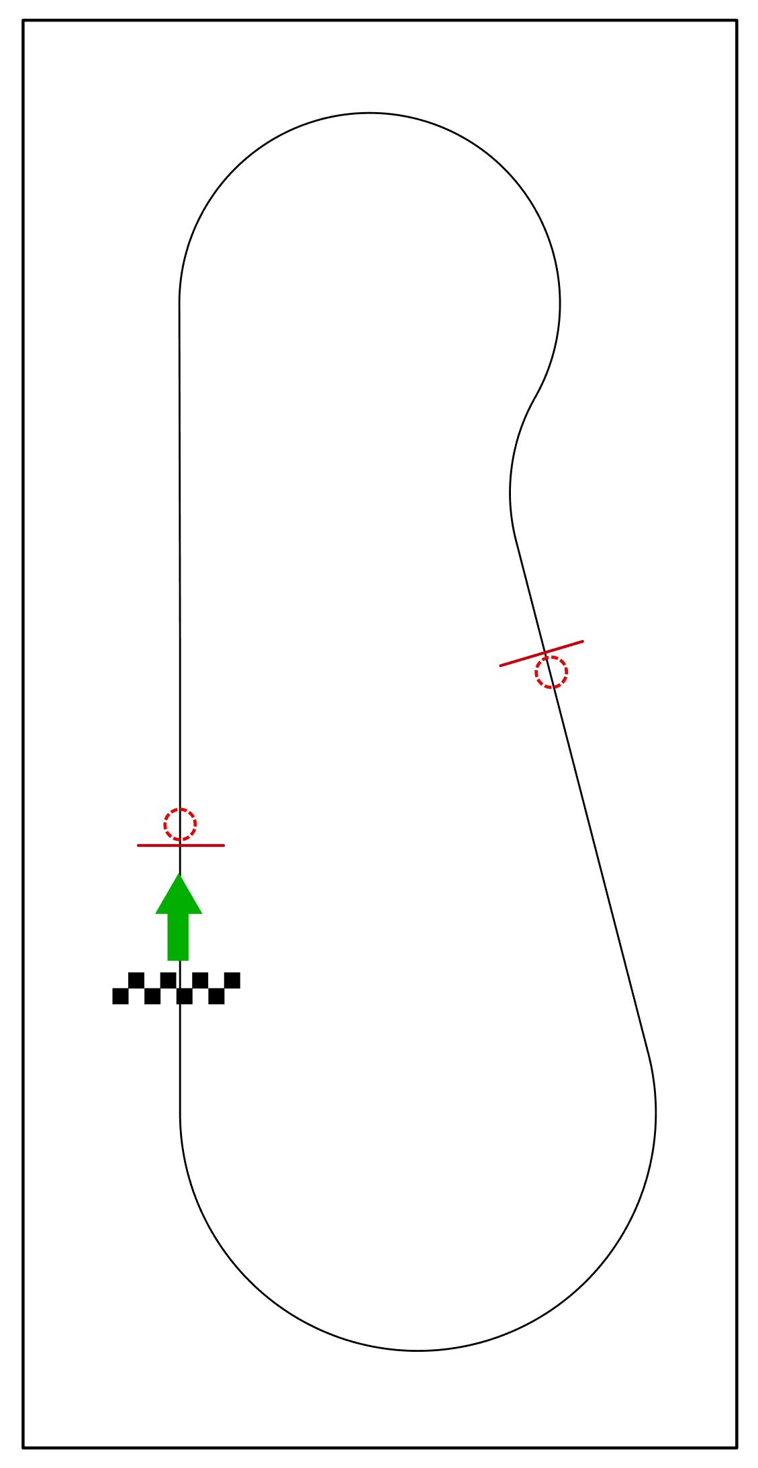

Fig. 1 Line with obstacles

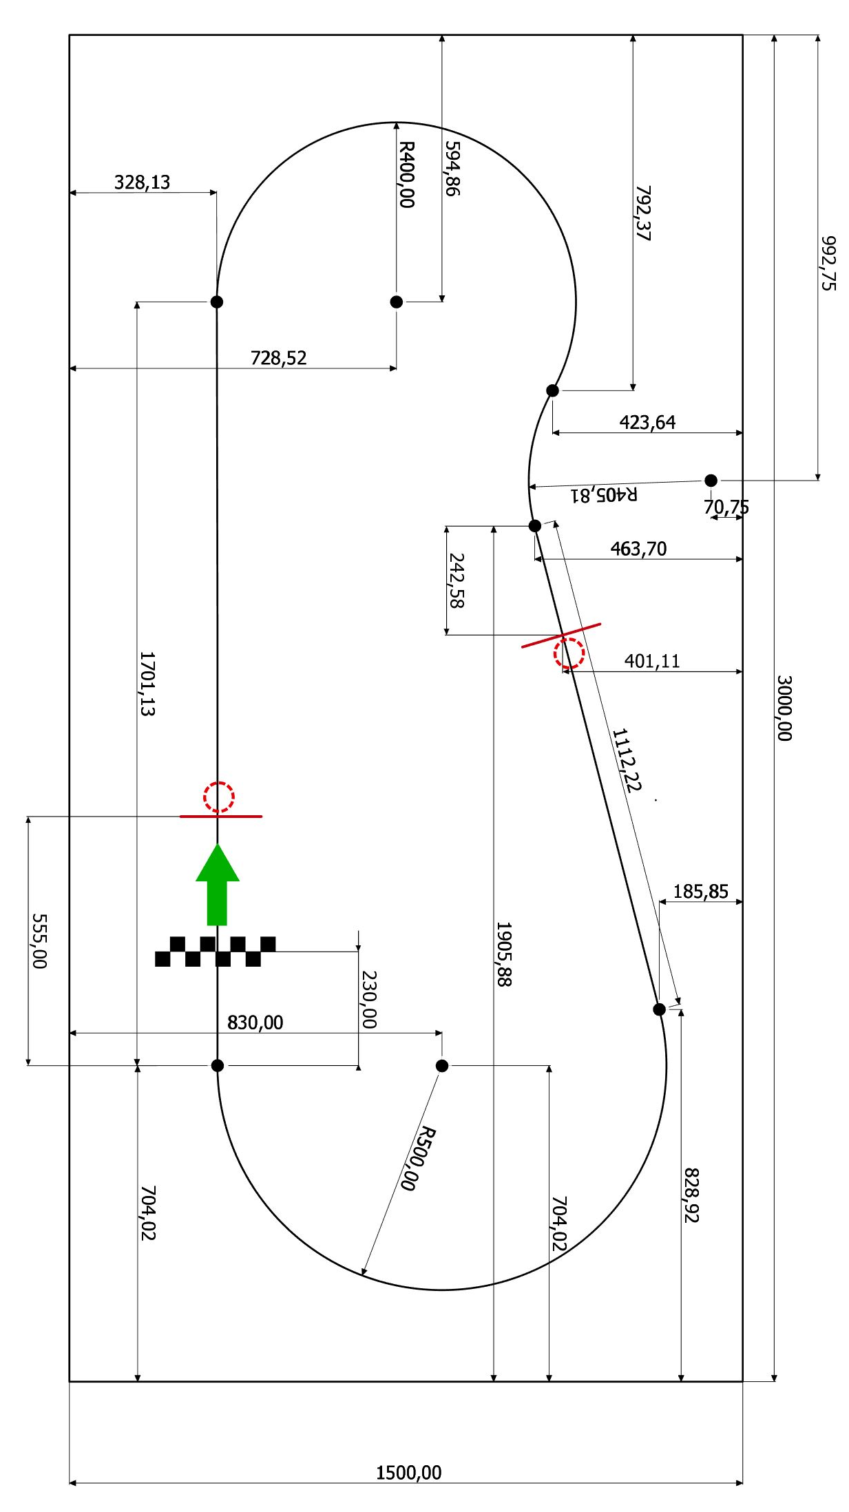

Fig.2 Line with obstacles - sizing