DEVIL MECH
FOR UNITY3D DOCUMENTATION
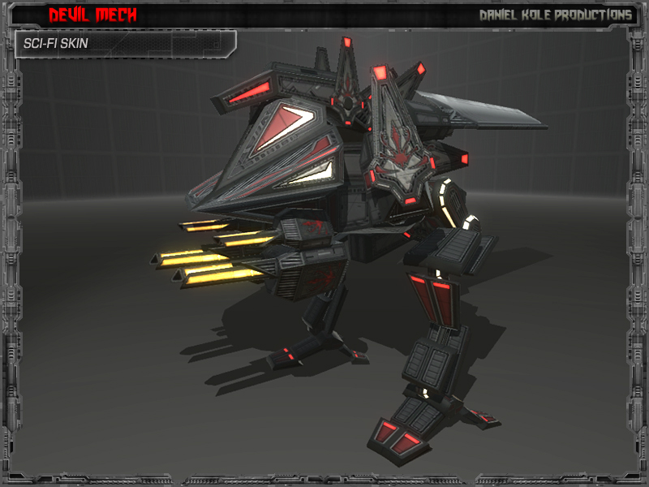
RELEASE VERSION 2.0
CREATED BY: DANIEL KOLE
Copywrite 2014 - Daniel Kole Productions
Devil Mech - Overview:
Requires Unity 5.1.2 or higher.
Devil Mech, is a 2-legged, assault mech. The model has the following animations: idle, strafe right, strafe left, walk forward, walk backward, turn right, turn left, attack, jump, hit from front, hit from back, die backward, die forward, right sword hack, and left sword swing. There are 5 full skins included: Sci-fi, Desert, Green Camo, Snow Camo, and Red Black. A simple movement/animation script is included.
Devil Mech - Usage and Version History:
Usage and Installation:
To use this package:
- Start a new project and import the Devil Mech Asset Package into the project.
- Open the devilMechDemoScene.unity scene located in the DevilMech/Scenes folder. This scene contains a Devil Mech generic prefab with instructions for moving the model. This is the demo setup scene.
Version History:
Version 1.0 -
- First Release Version of Devil Mech.
- Includes a demo scene with a Devil Mech setup with scripts and ready to use.
Version 2.0 -
- Modified and fixed Animations to Add more weight to overall look
- Renamed Mech parts to prevent conflicts with other Daniel Kole Productions models

