TITLE

Human Energy Metabolism (HEM) can be expressed quantitatively:

Energy Intake, EI, is the amount of calories ingested (Hall, 2012). Energy Stored, ES “reflects net changes in the body mass of carbohydrate, protein and fat” (Hall, 2012). Energy Expendture, EE can be subdivided into three parts

Resting Energy Expenditure (REE) is the rate of energy at rest, influenced by body size and composition. Thermic Effect of Food (TEF) represents “digestion and processing of ingested food” (Hall, 2012). Activity Energy Expenditure (AEE), is ‘Energy Expenditure Rate during activity’ (Hall, 2012). Both equations can be combined:

For body weight maintenance EI should be equal to EE. “Any imbalance between the intake and utilization of these macronutrients will lead to an alteration in body composition” (Hall, 2012). Quantitatively we can interpret ES to represent this alteration. We obtain ES > 0 when EI > EE, and ES < 0 when EI < EE. Positive balance for prolonged period of time causes measurable weight gain (Galgani and Revussin, 2008). In this investigation we are going to consider whether positive energy balance results in higher Body Mass Index (BMI), Waist to Hip Ratio (WHR) and/or Body Fat percentage (BF%) in males and/or females. In this experiment TEF was excluded due to limitations in availability of equipment required. As discussed by Reed and Hill (1996) ventilated-hood indirect calorimetry system is needed to calculate the accurate Resting Metabolic Rate in first place, so that the rest of the procedures are valid. For collecting other data cheap, quick, easy and non-invasive methods were used.

Methods

1. Calculation of Energy Intake

Each of the 50 participants involved (48 females and 12 males) kept a food diary for a 48-hour period (Figure 1.1). The average of the total energy content (kcal) form two days was calculated.

1. Energy Expenditure

Each participant kept an activity diary for a 48 hour period (Figure 1.2). The average from two days was calculated. Height of each individual was measured using the stadiometer. Each participant stand bare feet in a natural position and the height was noted. Resting Energy Expenditure (REE) was measured using a spirometer for five minutes placing a mouthpiece removed from a Milton fluid in the mouth and clipping the nose. Each subject was breathing from spirometer for 5 minutes. Each individual was told to relax breath in from the spirometer at the start and exhale into the spirometer at the end of time. Oxygen volume inhaled was subtracted from the initial volume of oxygen present in the spirometer. Then each litre of oxygen inhaled was converted into kcal of energy knowing that each litre produces 4.8 kcal of energy. Therefore by knowing the average number of calories used per minute, results were scaled into the 24 hour period of time to obtain REE. This allowed to calculate the Total Energy Expenditure (TEE) by multiplying REE with daily activity factor.

1. Energy Stored

Weight and BF% were measured using a laboratory scale (Tanita) incorporated with Bioelectric Impedance Analysis. One kilogram was subtracted from the weight for additional clothing. From the data gathered, Body Mass Index (BMI) was calculated (Figure 1.3). Then WHR was measured by noting the narrowest point on the torso and the greatest circumference at the buttocks using a tape-measure. Those two values were then divided respectively.

Results

Table 1 shows an example observation:

|  |  |  |  |  |  |  |  |
| --- | --- | --- | --- | --- | --- | --- | --- |
| Sex | WHR | Height [m] | Weight [kg] | Energy Intake [kcal/day] | Energy Output [kcal/day] | Body Fat % | BMI |
| Female | 0.8 | 1.55 | 57 | 2073 | 2073 | 24.9 | 23.7 |

Table 1

The sample is composed of 50 observations, all of which can be viewed in the appendix D.

Energy Balance (EB) is calculated by subtracting energy output from energy intake for each observation.

Energy Balance is treated as the **independent variable**, because it is a direct cause of body composition change. WHR, BMI and BF% are direct (BF%) and indirect (WHR, BMI) measures of body composition change, and therefore are expected to be influenced by Energy Balance and are treated as **dependent variables**.

Female and male observations are analysed separately, as it is known that the mechanism of fat storage in the adipose tissue is strongly sex-dependent [FIX CITATION: cite nature paper].

The following three assumptions are made about the distribution of independent and dependent variables:

1. The independent variable and the dependent variables are both normally distributed.
2. Observations are independent between units of observation.
3. There is a linear relationship between EB and each of BMI, WHR and BF%

The validity of each of these assumptions is discussed in the appendix A – Data Assumptions.

Only through making these assumptions it becomes valid to employ linear regression to investigate the correlation between each dependent variable and EB (FIX CITATION: https://onlinecourses.science.psu.edu/stat501/node/253). Linear regression is therefore used to produce the best fit line. The slope of the line, its Pearson’s correlation coefficient and the p-value of the corresponding null hypothesis are reported. A detailed explanation of each of these values is given in appendix B – Correlation Measures.

The null hypotheses are that there is no correlation between a dependent variable and the independent variable in females or in males. For example BMI (WHR, BF%) is not correlated to EB in females (males).

A total of 6 graphs are presented (Figures 1 - 6). Table 2 summarises obtained statistical results. (FIX the table)

|  |  |  |  |  |  |  |
| --- | --- | --- | --- | --- | --- | --- |
|  | females | | | males | | |
| BMI | BF% | WHR | BMI | BF% | WHR |
| slope | -0.000394 |  |  |  |  |  |
| Pearson’s | -0.146 |  |  |  |  |  |
| p-value | 0.39 |  |  |  |  |  |

Table 2

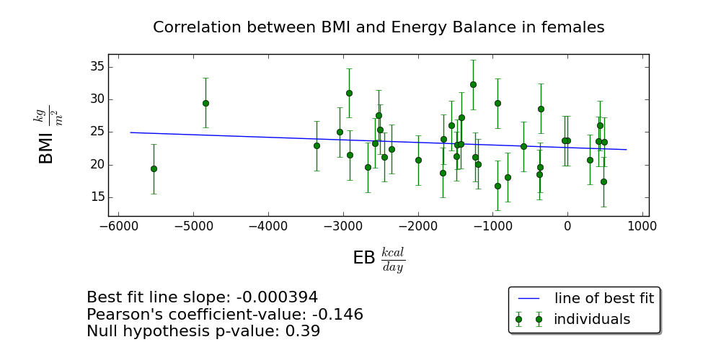

Figure 1

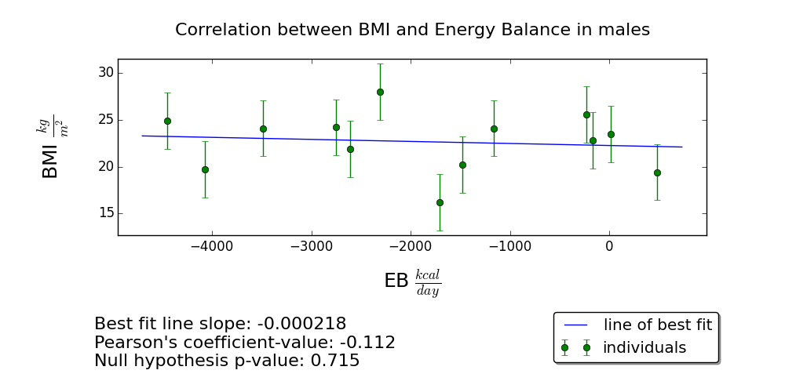

Figure 2

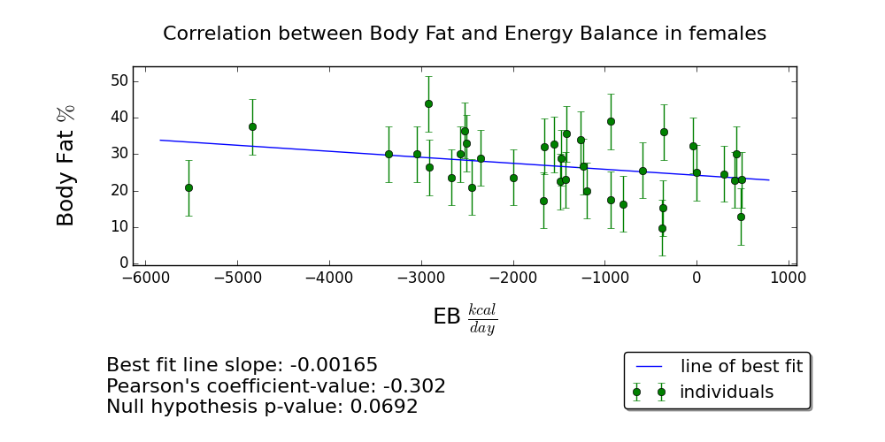

Figure 3

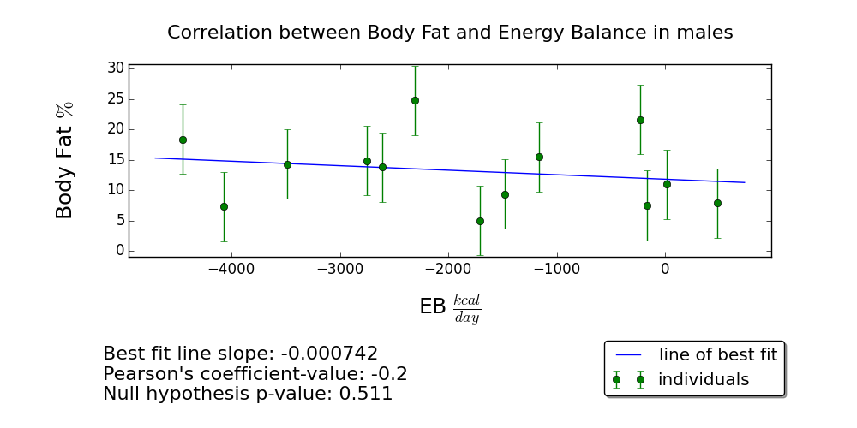

Figure 4

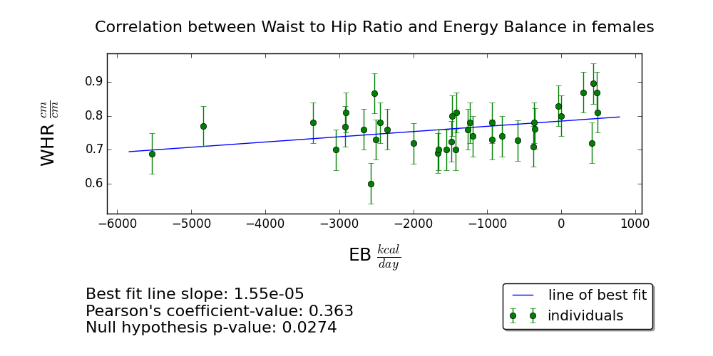 Figure 5

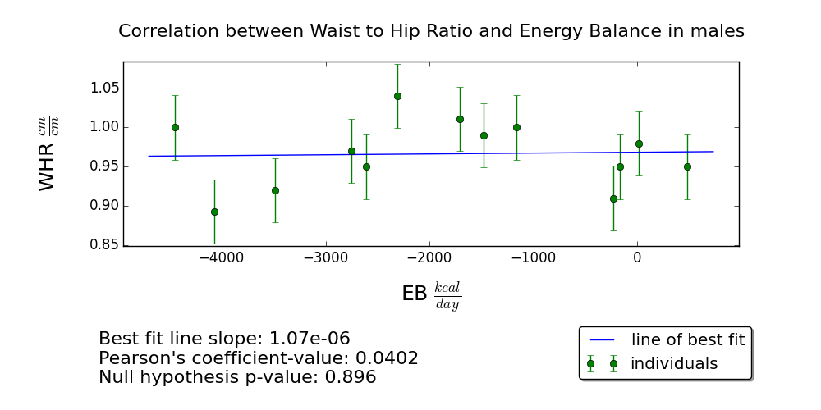

Figure 6

Conclusions:

Negative results:

Unlike expected, not all relationships are positively correlated. Contrary to HEM equation, higher ES results in lower BF% in our sample (Figure 3, 4), manifested by the negative slope of the corresponding best fit lines, both in females and in males. Additionally if we set our p-value cutoff to be 0.15, we have to reject the null hypothesis for females and respect this result as statistically significant and extendable to the population, rendering some of our assumptions, the HEM equation or our experiment invalid, incorrect or flawed. However, assuming a more strict p-value cutoff of 0.5, we cannot reject the null hypothesis for females, and we cannot extend the result to the population. For males the result is inconclusive under both cutoffs, with p-value around 50%.

Inconclusive results:

It cannot be said if BMI is correlated with EB. Pearson’s coefficient is very close to 0 in both females and males, -0.146 and -0.112 respectively, and the null hypothesis is a possible outcome for females and a likely outcome for males, with p-values 0.39 and 0.75. Similar applies to WHR for males, with almost-zero Pearson’s coefficient, and likely null hypothesis (0.89).

Positive results:

The only strong result positively correlates WHR with EB in females. Although the relationship is weak, with Pearson’s coefficient of only 0.36, it generalises well to the population, even under strict 0.05 p-value cutoff.

Summary:

Depending on desired confidence interval, validity of our assumptions, validity of our model and correctness of obtained data we may or may not conclude that use of Bioelectric Impedance Analysis is inaccurate method of measuring percentage of Body Fat in women.

Depending on validity of our assumptions, validity of our model and correctness of obtained data we may conclude that positive Eneregy Balance causes increase in Waist to Hip Ratio in women.

Limitations:

There are certain procedures which may have lead to errors. To make the experiment statistically more valid, higher number of participants should have been used as well as equal number of males and females. A 48 hour period might not be an accurate source of the exact diet and activity of a person. Additionaly, data provided might not have been honest due to the fact that subjects knew in what way their data was being analysed. One of the ways to improve accuracy could be to ask subjects to keep food and activity diaries for a month without any additional information provided about the experiment. One of the biggest errors was the measure of REE, because it was done in a laboratory and for a short period of time. To improve this, each individual could rest for 30 minutes before the test was done, should consume the last meal 2 hours before the test, do the test in a quiet room and should not move their arms and legs during. Body fat percentage and weight of each participant was measured in clothes, which influenced values relying on those. To improve the accuracy for both of those all participants should be naked and on an empty stomach in the morning in case of water and food influence. Equal number of males is needed to increase accuracy for male results (mention graphs) REPETITION?

Appendix A – Data Assumptions

Assumption 1 is based on the fact that phenotypic characteristics, which are influenced by multiple genes and many environmental factors, like amount of adipose tissue [FIX CITATION: cite nature paper] are normally distributed, which is a corollary of the Central Limit Theorem.

Assumption 2 states that a weight (BMI, Energy Balance, etc.) of one student in the class does not influence the weight (BMI, Energy Balance, etc.) of any another student. This is reasonable as the study participants originate from unrelated backgrounds with various eating and exercise habits.

Assumption 3 is based on the HEM equation and the fact that there is a linear correspondence between a unit of mass of adipose tissue and the amount of energy stored.

Appendix B – Correlation Measures

Slope of the regression line is a very simple correlation metric, which can tell us whether a correlation is positive or negative, and can be used to predict the value of the dependent variable given a value of independent variable in the population outside of our sample. However, it doesn’t tell us anything about the quality of the prediction, and how strongly the date fits to the best fit line.

On the other hand Pearson’s coefficient can be used to answer the question about the strength of linear relationship. p-value is the probability for the possibility of there being no correlation.

While Pearson’s coefficient and slope are both statistics for the sample, p-value extends the result from the sample to the population.

scipy.stats.pearsonr function in statistical library scipy is used to compute both Pearson’s coefficient and p-value of the null hypothesis.

From the manual of scipy:

“The Pearson correlation coefficient measures the linear relationship between two datasets. Strictly speaking, Pearson’s correlation requires that each dataset be normally distributed. Like other correlation coefficients, this one varies between -1 and +1 with 0 implying no correlation. Correlations of -1 or +1 imply an exact linear relationship. Positive correlations imply that as x increases, so does y. Negative correlations imply that as x increases, y decreases.

The p-value roughly indicates the probability of an uncorrelated system producing datasets that have a Pearson correlation at least as extreme as the one computed from these datasets. The p-values are not entirely reliable but are probably reasonable for datasets larger than 500 or so.”

[http://docs.scipy.org/doc/scipy-0.14.0/reference/generated/scipy.stats.pearsonr.html]

Any null hypothesis is rejected, if p < 0.05.

Appendix C – Participant Form

|  |  |  |  |  |  |
| --- | --- | --- | --- | --- | --- |
|  | Food/drink consumed | Portion small/medium/large | Amount (g) | Energy Content (kcal/100) | Total Energy Content (kcal) |
| Breakfast |  |  |  |  |  |
| Lunch |  |  |  |  |  |
| Tea |  |  |  |  |  |
| Supper |  |  |  |  |  |
| Extra Snacks |  |  |  |  |  |
| TOTAL FOR 24 HOURS (kcal) | | | | | |

Figure 1.1 Food Diary for a 24 hour period

|  |  |  |  |  |  |
| --- | --- | --- | --- | --- | --- |
| Hours | Time of day | Activity | Duration (hours) | Activity factor | Duration  X  Activity factor |
| 1 |  |  |  |  |  |
| 2 |  |  |  |  |  |
| 3 |  |  |  |  |  |
| 4 |  |  |  |  |  |
| 5 |  |  |  |  |  |
| 6 |  |  |  |  |  |
| 7 |  |  |  |  |  |
| 8 |  |  |  |  |  |
| 9 |  |  |  |  |  |
| 10 |  |  |  |  |  |
| 11 |  |  |  |  |  |
| 12 |  |  |  |  |  |
| 13 |  |  |  |  |  |
| 14 |  |  |  |  |  |
| 15 |  |  |  |  |  |
| 16 |  |  |  |  |  |
| 17 |  |  |  |  |  |
| 18 |  |  |  |  |  |
| 19 |  |  |  |  |  |
| 20 |  |  |  |  |  |
| 21 |  |  |  |  |  |
| 22 |  |  |  |  |  |
| 23 |  |  |  |  |  |
| 24 |  |  |  |  |  |
| TOTAL | | | | |  |
| AVERAGE DAILY ACTIVITY FACTOR (total/24) | | | | |  |

Figure 1.3 Body Mass Index equation.

Appendix D – Raw Data

|  |  |  |  |  |  |  |  |
| --- | --- | --- | --- | --- | --- | --- | --- |
| Sex | WHR | Height [m] | Weight [kg] | Energy Intake [kcal/day] | Energy Output [kcal/day] | Body Fat % | BMI |
| female | 0.8 | 1.55 | 57 | 2073 | 2073 | 24.9 | 23.7 |
| female | 0.6 | 1.67 | 65 | 1432 | 4006 | 30 | 23.3 |
| female | 0.724 | 1.76 | 66 | 2032 | 3516 | 22.5 | 21.3 |
| female | 0.73 | 1.71 | 49 | 2103 | 3041 | 17.5 | 16.8 |
| female | 0.77 | 1.54 | 70 | 1905 | 6746 | 37.6 | 29.5 |
| female | 0.81 | 1.57 | 58 | 1916 | 1431 | 23 | 23.5 |
| female | 0.719 | 1.69 | 59 | 1599 | 3592 | 23.6 | 20.7 |
| female | 0.727 | 1.61 | 59 | 1401 | 1988 | 25.6 | 22.8 |
| female | 0.78 | 1.72 | 87 | 1514 | 2447 | 39 | 29.4 |
| female | 0.73 | 1.66 | 70 | 1947 | 4451 | 33 | 25.4 |
| female | 0.81 | 1.67 | 60 | 1794 | 4703 | 26.4 | 21.5 |
| female | 0.87 | 1.57 | 43 | 1052 | 576.5 | 12.9 | 17.4 |
| female | 0.69 | 1.63 | 50 | 1251 | 2916 | 17.3 | 18.8 |
| female | 0.78 | 1.75 | 70 | 1743 | 5101 | 30 | 22.9 |
| female | 0.83 | 1.72 | 70 | 1752 | 1792 | 32.4 | 23.7 |
| female | 0.76 | 1.45 | 68 | 1680 | 2942 | 34 | 32.3 |
| female | 0.689 | 1.59 | 49 | 1274 | 6811 | 20.8 | 19.4 |
| female | 0.867 | 1.58 | 69 | 941 | 3467 | 36.5 | 27.6 |
| female | 0.7 | 1.65 | 68 | 1988 | 5032 | 30 | 25 |
| female | 0.87 | 1.74 | 63 | 1177 | 881 | 24.6 | 20.8 |
| female | 0.769 | 1.77 | 97 | 1406 | 4330 | 43.86 | 31 |
| female | 0.81 | 1.6 | 70 | 1691 | 3110 | 35.6 | 27.3 |
| female | 0.71 | 1.61 | 48 | 1170 | 1548 | 9.8 | 18.5 |
| female | 0.78 | 1.71 | 62 | 2448 | 4900 | 21 | 21.2 |
| female | 0.8 | 1.64 | 62 | 1203 | 2678 | 29 | 23.1 |
| female | 0.7 | 1.71 | 70 | 643 | 2299 | 32.1 | 23.9 |
| female | 0.7 | 1.64 | 70 | 1213 | 2765 | 32.7 | 26 |
| female | 0.76 | 1.65 | 61 | 1672 | 4022 | 29 | 22.4 |
| female | 0.76 | 1.69 | 56 | 1465 | 4135 | 23.6 | 19.6 |
| female | 0.78 | 1.61 | 55 | 1086 | 2322 | 26.7 | 21.2 |
| female | 0.74 | 1.61 | 52 | 1695 | 2896 | 20 | 20.1 |
| female | 0.78 | 1.58 | 49 | 584.1 | 950.4 | 15.3 | 19.6 |
| female | 0.74 | 1.61 | 47 | 1098 | 1901 | 16.4 | 18.1 |
| female | 0.76194 | 1.63 | 76 | 890 | 1244 | 36.1 | 28.6 |
| female | 0.896 | 1.48 | 57 | 1494 | 1058 | 30 | 26 |
| female | 0.72 | 1.58 | 59 | 2112 | 1699 | 22.9 | 23.6 |
| female | 0.7 | 1.58 | 58 | 890 | 2322 | 23 | 23.2 |
| male | 0.98 | 1.75 | 72 | 1755 | 1741 | 11 | 23.5 |
| male | 0.893 | 1.86 | 68 | 3118 | 7185 | 7.3 | 19.7 |
| male | 1 | 1.73 | 72 | 2857 | 4022 | 15.5 | 24.1 |
| male | 0.95 | 1.76 | 60 | 2612 | 2128 | 7.9 | 19.4 |
| male | 0.92 | 1.81 | 79 | 2294 | 5782 | 14.3 | 24.1 |
| male | 0.95 | 1.85 | 75 | 4247 | 6857 | 13.8 | 21.9 |
| male | 1.011 | 1.79 | 52 | 1906 | 3611 | 5 | 16.2 |
| male | 0.91 | 1.81 | 84 | 4107 | 4335 | 21.6 | 25.6 |
| male | 0.97 | 1.65 | 66 | 2063 | 4816 | 14.9 | 24.2 |
| male | 1.04 | 1.68 | 79 | 2936 | 5241 | 24.8 | 28 |
| male | 0.99 | 1.75 | 62 | 1436 | 2918 | 9.36 | 20.2 |
| male | 0.95 | 1.69 | 65 | 6032 | 6203 | 7.5 | 22.8 |
| male | 1 | 1.77 | 78 | 1649 | 6103 | 18.4 | 24.9 |

References

1. Hall, K. D., Heymsfield, S. B., Kemnitz, J. W., Klein S., Schoeller, D. A. & Speakman, J. R. (2012) Energy balance and its components: implications for body weight regulation. The American Journal of Clinical Nutrition. 95(4). p. 989-994.
2. Galgani, J. & Ravussin, E. (2008) Energy metabolism, fuel selection and body weight regulation. International Journal of Obesity. 32. p. S109–S119.
3. Reed, G. W. & Hill J. O. (1996) Measuring the thermic effect of food. American Journal of Clinical Nutrition 63(2). p. 164-9.
4. FIX add more references from the text (nature paper, etc.)