I recommend that clearly observe the visualizations by downloading the real jpeg file. It is more clearly visible in real image file. The total number of visualizations are 5. My first visualization(1.png) is the basic one which is the analysis of the number of people taken according to age groups.

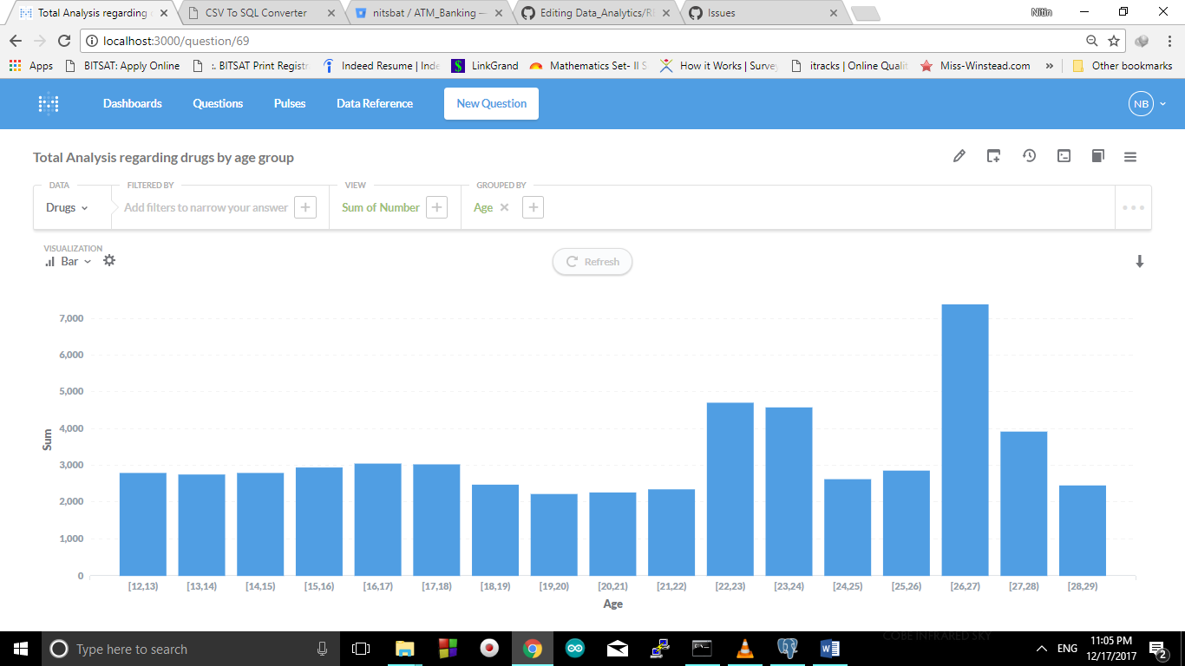

It is clearly visible that people of age group 26-27 have been taken more.

My second visualization is based on the visualization of the people consuming alcohol, marijuana and cocaine(below). The line graph clearly shows that the frequent users of marijuana is more than that of alcohol. Cocaine being costlier and more fatal is the blue line (lower one). We can also observe that after age group 22-23 the alcohol consumption is constant. Hence number of people who started drinking after 22 generally didn’t drink. The older ones are still with their habits. One can clearly see that from age group 26-27 to 27-28 the graph of cocaine suddenly increased. It clearly shows that people under this age are more addicted to cocaine. The reason might be very simple as people in this age group are generally employed and have enough money..

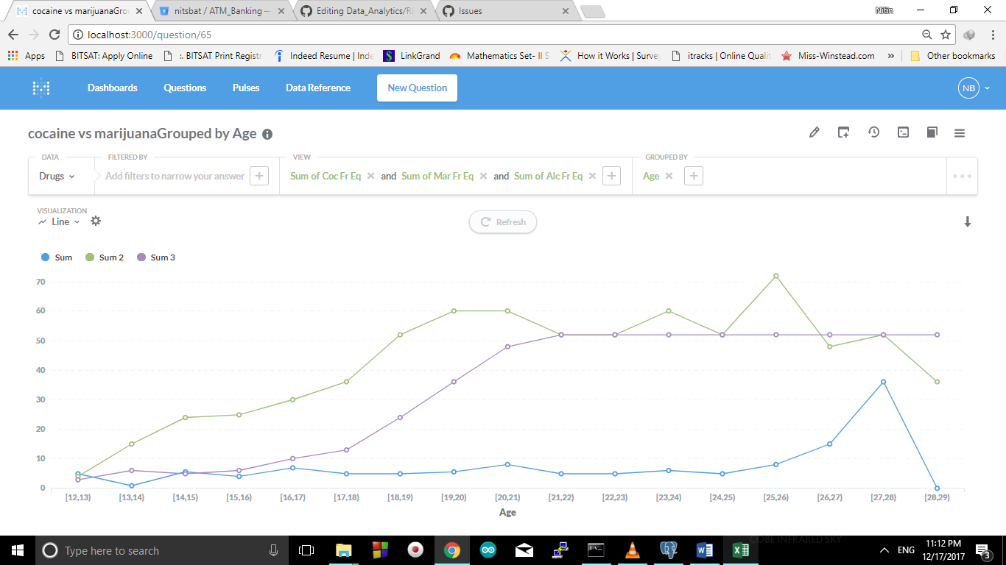

The next visualization is the cumulative sum of consumption of Alcohol. It is interesting to note that the slope is increasing from 15-16 age. Shocked to observe. Then the slope is same and constant till 27-28 age group. It means that number of persons consuming alcohol remains constant. None has developed the habit of stop consuming alcohol.

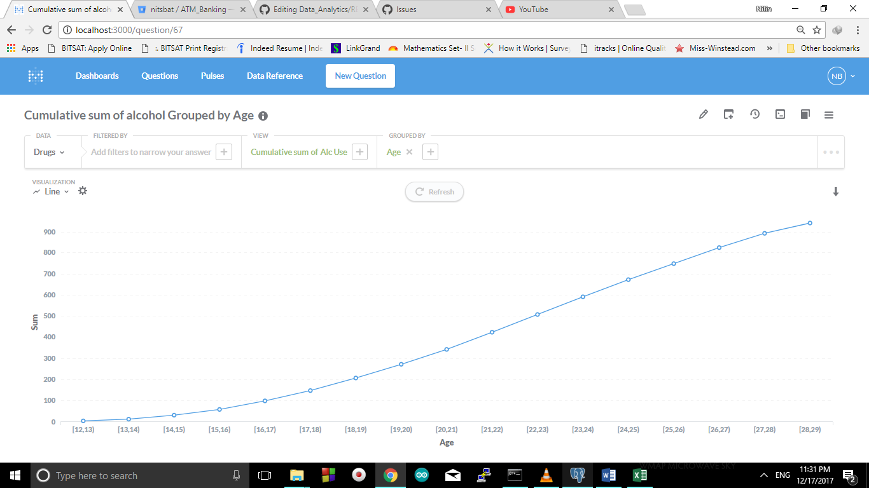

The next visualization is the comparison between the consumer of cocaine frequently use people and cocaine use people. The green line shows that the people at 20-21 are the highest consumption of cocaine. But here the interesting thing is to see that the more frequent users are from the age group 27-28. It is shocked to see that frequent users decreased to a great margin from 27-28 to 28-29. This clearly means that the people are greatly affected or been one of the victim of any diagnosis caused by cocaine. The reason might also include deaths, patient, etc.

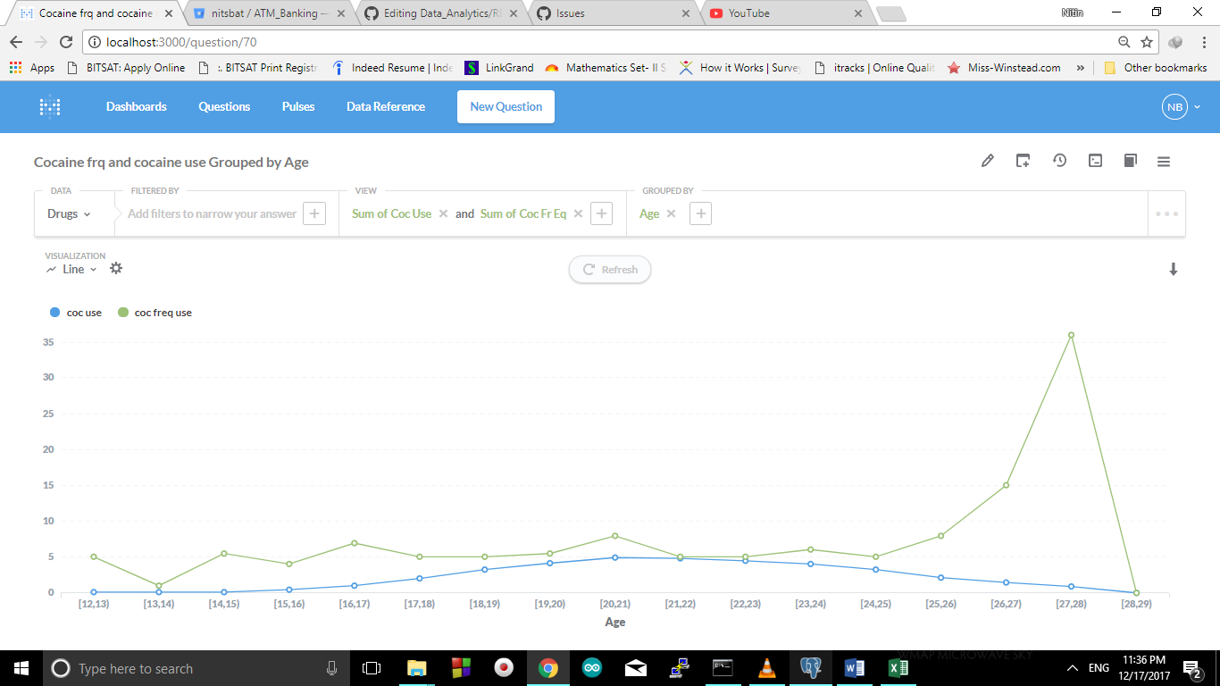

The next visualization is based upon the number of pain releivers consumption by people. Here I have taken pie chart for this purpose. Age groups 20-21 and 22-23 are greatest consumer to pain relievers as these age groups are consuming drugs at a large scale. Even they take various medications to control various stimulations of the body. Please use the real image for viaualisation (5.png)

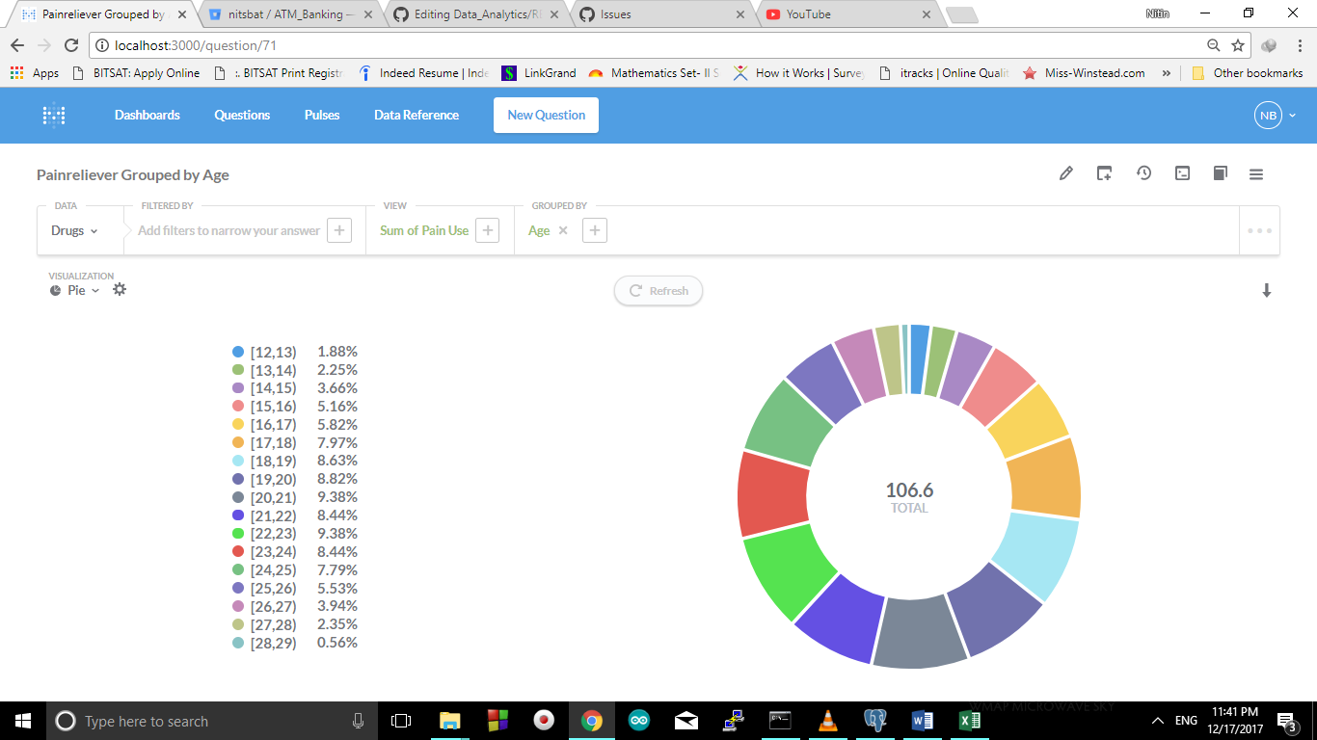

The last image which is Pic6.png is the comparison between cocaine and marijuana and it is shown with the help of bar graphs. What assumptions and results can you convey from this visual.?