Data Exploration Assignment
Lukas Nitsche

Research Question
In this project, we will be exploring Google Trends and College Scorecard data to answer the question: Among colleges that predominantly grant bachelor’s degrees did the release of the Scorecard shift student interest to high-earnings colleges relative to low earnings ones.

Data Loading and Cleaning
Before we can do analysis, we must load the libraries used
library(rio)
Warning: package 'rio' was built under R version 4.4.3
library(dplyr)
Attaching package: 'dplyr'
The following objects are masked from 'package:stats':
filter, lag
The following objects are masked from 'package:base':
intersect, setdiff, setequal, union
library(lubridate)
Warning: package 'lubridate' was built under R version 4.4.3
Attaching package: 'lubridate'
The following objects are masked from 'package:base':
date, intersect, setdiff, union
library(fixest)
Warning: package 'fixest' was built under R version 4.4.3
library(stringr)
library(lubridate)
library(ggplot2)
And now the data as well:
files <- list.files("Lab3_Rawdata", pattern = 'trends_up_to', full.names = TRUE)
gtrends <- import_list(files, rbind = TRUE, fill = TRUE)
scorecard <- import("Most+Recent+Cohorts+(Scorecard+Elements).csv")
However, our data in each of our data files isn’t very usable yet. We must convert the ‘date’ data to a form that we can use.
gtrends$monthorweek <- ymd(str_sub(gtrends$monthorweek, 1, 10))
Also, some of the columns in the ‘gtrends’ variable is irrelevant to what we want to be using, and weekly data makes it too hard to read. Now we use the “group_by()”, “summarize()”, and “mutate()” functions from dplyr to get a monthly average for our data/
gtrends <- gtrends %>% mutate(month = floor_date(as.Date(monthorweek), unit = "month"))
gtrends <- gtrends %>%
group_by(schid, schname, keyword, keynum, month) %>%
summarize(index = mean(index, na.rm = TRUE), .groups = "drop")
The values in the index column also are pretty hard to understand, so we will standardize these values so we know how they compare to other variables.
gtrends <- gtrends %>%
group_by(schname, keyword) %>%
mutate(index_standardized = (index - mean(index, na.rm = TRUE)) / sd(index, na.rm = TRUE))
Our gtrends data is now cleaned, so we must prep the college scorecard data to use. We would like to have it only have one college per entry, so we remove duplicates.
id_name_link_clean <- scorecard %>%
group_by(INSTNM) %>%
mutate(n = n()) %>%
filter(n == 1) %>%
ungroup()
We want our gtrends data to match the scorecard data as well so we change the school names for both to be lowercase
gtrends <- gtrends %>%
mutate(schname = str_to_lower(schname))
id_name_link_clean <- id_name_link_clean %>%
mutate(INSTNM = str_to_lower(INSTNM))
Now that the data matches, we can merge the data
df <- gtrends %>%
inner_join(id_name_link_clean, by = c("schname" = "INSTNM"))
Warning in inner_join(., id_name_link_clean, by = c(schname = "INSTNM")): Detected an unexpected many-to-many relationship between `x` and `y`.
ℹ Row 20432 of `x` matches multiple rows in `y`.
ℹ Row 2251 of `y` matches multiple rows in `x`.
ℹ If a many-to-many relationship is expected, set `relationship =
"many-to-many"` to silence this warning.
final_df <- df %>%
inner_join(scorecard, by = "UNITID")
We now filter by the schools that primarily offer undergraduate degrees
final_df <- final_df %>%
filter(PREDDEG.x == 3)
We can also now shorten our data frame to only include the columns we want for analysis, and rename them to something that makes sense
ana_df <- final_df %>%
select(schname, month, index, index_standardized, 'md_earn_wne_p10-REPORTED-EARNINGS.y')
Adding missing grouping variables: `keyword`
ana_df <- na.omit(ana_df)
ana_df <- ana_df %>%
rename(earnings = 'md_earn_wne_p10-REPORTED-EARNINGS.y')
Also, the ‘earnings’ variable is a character in the data frame, so we want to change this to an integer and remove NA values
ana_df$earnings <- as.integer(ana_df$earnings)
Warning: NAs introduced by coercion
ana_df <- na.omit(ana_df)
We want to split the earnings somehow so we can differ between ‘high’ and ‘low’ earnings.
summary(ana_df$earnings)
Min. 1st Qu. Median Mean 3rd Qu. Max.
17600 36000 41200 43146 47600 166200
From this we have our quartile values and our mean value. We will first split the data into high values, the values greater than the mean and low values, the ones below the mean.
ana_df$high_earnings <- ifelse(ana_df$earnings > 43158, TRUE, FALSE)
We also want to look at the data that occurs after the creation of the College Scorecard since this is what we want to know
ana_df$post_treatment <- ifelse(ana_df$month >= ymd('2015-09-12'), TRUE, FALSE)
Now a feols() using difference in difference can be run on the data. Difference-in-difference will show us the difference between the high and low earnings before and after the creation of the college scorecard.
sc_did <- feols(index ~ high_earnings + post_treatment + high_earnings:post_treatment, data = ana_df)
etable(sc_did)
sc_did
Dependent Var.: index
Constant 47.24*** (0.0685)
high_earningsTRUE 1.635*** (0.1082)
post_treatmentTRUE -3.542*** (0.1691)
high_earningsTRUE x post_treatmentTRUE 0.1337 (0.2670)
______________________________________ __________________
S.E. type IID
Observations 161,762
R2 0.00609
Adj. R2 0.00607
---
Signif. codes: 0 '***' 0.001 '**' 0.01 '*' 0.05 '.' 0.1 ' ' 1
From this table, we see that the high earnings group have more searches on average than low earners before treatment. The overall post-treatment values decrease considerably, however lowering total searches by 3.542, however the difference between low and high value of 0.1337 with a p-value of .2670 is not low enough to say that the scorecard decreased the difference between low-earnings and high-earnings colleges.
We can get a look of this with the following plot:
clean_df <- ana_df %>%
group_by(month, high_earnings) %>%
summarise(avg_standardized_index = mean(index_standardized, na.rm = TRUE))
`summarise()` has grouped output by 'month'. You can override using the
`.groups` argument.
ggplot(clean_df, aes(x = month, y = avg_standardized_index, color = high_earnings)) + geom_line() + geom_vline(xintercept = ymd("2015-09-12"))
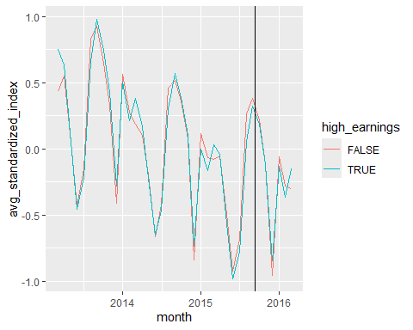
etable(sc_did)
sc_did
Dependent Var.: index
Constant 47.24*** (0.0685)
high_earningsTRUE 1.635*** (0.1082)
post_treatmentTRUE -3.542*** (0.1691)
high_earningsTRUE x post_treatmentTRUE 0.1337 (0.2670)
______________________________________ __________________
S.E. type IID
Observations 161,762
R2 0.00609
Adj. R2 0.00607
---
Signif. codes: 0 '***' 0.001 '**' 0.01 '*' 0.05 '.' 0.1 ' ' 1
I am looking at the average for high earnings and low earnings here since it gives us a good idea of what the general shape is for all of the high and low earnings searches. Over time the total searches match the general trend for searches going down.
If we want to get a better look at the data, we can look at the quartile data again, but instead of splitting at the mean, we will split by quartile. This may give us a better sense of what the difference in searches between the upper quartile earnings colleges and lower quartile earnings colleges.
summary(ana_df$earnings)
Min. 1st Qu. Median Mean 3rd Qu. Max.
17600 36000 41200 43146 47600 166200
qtiles <- quantile(ana_df$earnings, probs = seq(0,1,0.25), na.rm = TRUE)
if(length(unique(qtiles)) == length(qtiles)) {
quartile_df <- ana_df %>%
mutate(earnings_quartile = cut(earnings, breaks = qtiles, include.lowest = TRUE, labels = c(1,2,3,4)))
}
Looking at this, we label the earnings for each school with a 1, 2, 3, or 4 depending on what quartile they fall into. We can now analyze this using a bivariate difference-in-difference using the four pieces of data.
feols(index ~ earnings_quartile + post_treatment + earnings_quartile:post_treatment, data = quartile_df)
OLS estimation, Dep. Var.: index
Observations: 161,762
Standard-errors: IID
Estimate Std. Error t value Pr(>|t|)
(Intercept) 45.684413 0.105309 433.813011 < 2.2e-16
earnings_quartile2 2.369919 0.148813 15.925472 < 2.2e-16
earnings_quartile3 2.862454 0.149988 19.084533 < 2.2e-16
earnings_quartile4 3.671170 0.149624 24.535997 < 2.2e-16
post_treatmentTRUE -3.366087 0.259761 -12.958416 < 2.2e-16
earnings_quartile2:post_treatmentTRUE -0.227565 0.367105 -0.619890 0.53533
earnings_quartile3:post_treatmentTRUE -0.103659 0.370107 -0.280079 0.77942
earnings_quartile4:post_treatmentTRUE -0.153372 0.369244 -0.415367 0.67787
(Intercept) ***
earnings_quartile2 ***
earnings_quartile3 ***
earnings_quartile4 ***
post_treatmentTRUE ***
earnings_quartile2:post_treatmentTRUE
earnings_quartile3:post_treatmentTRUE
earnings_quartile4:post_treatmentTRUE
---
Signif. codes: 0 '***' 0.001 '**' 0.01 '*' 0.05 '.' 0.1 ' ' 1
RMSE: 19.5 Adj. R2: 0.009161
Our results are similar, with the low-earnings (quartile 1) schools earning far less than the other 3. Post treatment, the values overall decrease again for total searches, however the differences between the two also decrease by 0.228, 0.104 and 0.153 for quartiles 2, 3, and 4 respectively. Their p-values of .367, .370 and .370 are not enough to tell us that there is a significant increase in interest for low earnings colleges compared to high earnings ones.
cq_df <- quartile_df %>%
group_by(month, earnings_quartile) %>%
summarise(avg_standardized_index = mean(index_standardized, na.rm = TRUE))
`summarise()` has grouped output by 'month'. You can override using the
`.groups` argument.
ggplot(cq_df, aes(x = month, y = avg_standardized_index, color = earnings_quartile)) + geom_line() + geom_vline(xintercept = ymd("2015-09-12"))
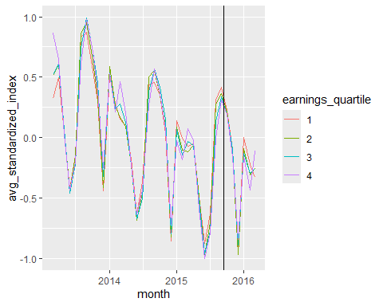
This graph matches what we saw from the feols() with a negative trend in search values after the creation of the google college scorecard.
In conclusion, the impact of the Scorecard was minimal, and we can tell this from the 0.1337 intercept value after the creation of the Scorecard, meaning that there was an increase in the amount of searches for l-earnings schools, but our p-value of .2670 is not low enough to say that our results were meaningful enough to reject our null that the Scorecard did not impact searches for low-earnings colleges.

