**Daffodil International University**

Department of Software Engineering (SWE)

Project/Thesis Committee

May 11, 2023

**NOTICE**

This is to notify that 31st Batch students for final Year Project/Thesis are asked to submit their Project/Thesis proposal by 22/05/2023. In order to submit the Project/Thesis proposal, students are asked to fill up the proposal form. Instruction mentions below,

Before go through the instruction please join google class using Code: **b2izrk7**

**Eligibility for Thesis/Project/Internship**

* Those who are going to complete 130 to 133 credits in this semester (Spring 2023), are eligible to submit the proposal for Final year Project/Thesis.
* **Thesis (General):** Students must have **3.00** CGPA to apply for Thesis. For less CGPA Dept. and Thesis/Project Committee will decide later by their fixed criteria.
* **Project (General):** Any student can take the project but you must be followed **SDLC** to complete the project. We highly discourage the so-called old management system project. Students must have knowledge in both Back end and front-end development for the project.
* **Project (Industry):** Students must have **3.00** CGPA. Students must work for renowned**software companies** for **Industry project** and must work on **SDLC Steps**. **Industry project** time is a minimum of **4 months** and you must submit an **appointment letter** to the Thesis/Project Committee. After filling all the criteria, the Thesis/Project Committee will inform you about the result. If the result is negative then you have to take the project to complete your degree.
* **Thesis (Industry):** Students must have **3.00** CGPA. Students must work on **renowned software companies** for **Industry Thesis**. After filling all the criteria, the Thesis/Project Committee will inform you about the result. If the result is negative then you have to take the project to complete your degree.
* **No group allowed, Individual Task .**

**Please follow the following instructions very carefully.**

1. **Go to website (**[**http://swe.application.daffodilvarsity.edu.bd/final_project/public/register**](http://swe.application.daffodilvarsity.edu.bd/final_project/public/register)**)**
2. **Complete Registration (Fill up Name, Valid email address, Password)**

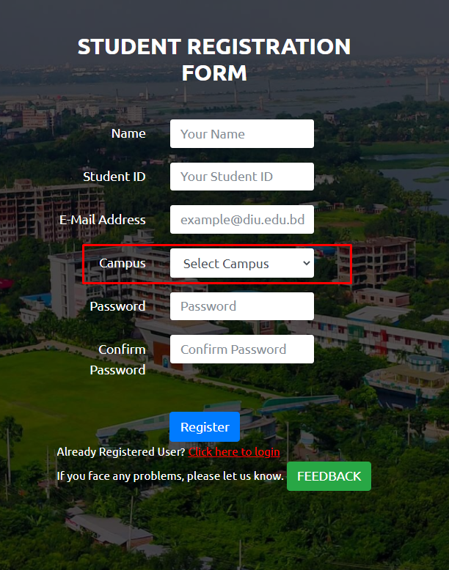

.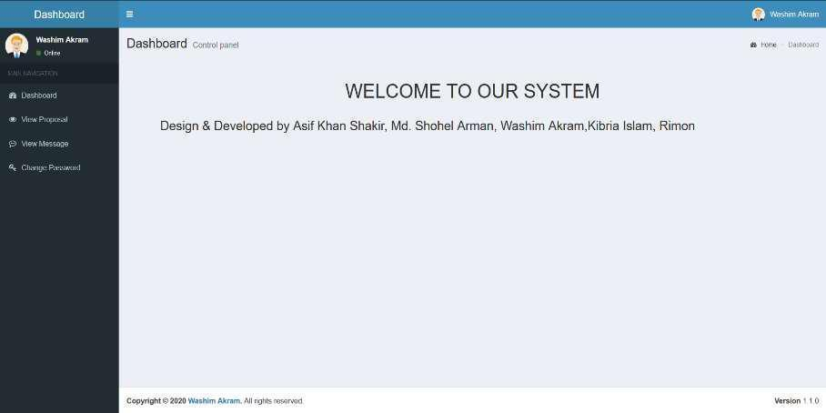

1. **If you are already registered you can be logged in using your student email id and your password.**

**Url:** [**http://swe.application.daffodilvarsity.edu.bd/final_project/public/login**](http://swe.application.daffodilvarsity.edu.bd/final_project/public/login)

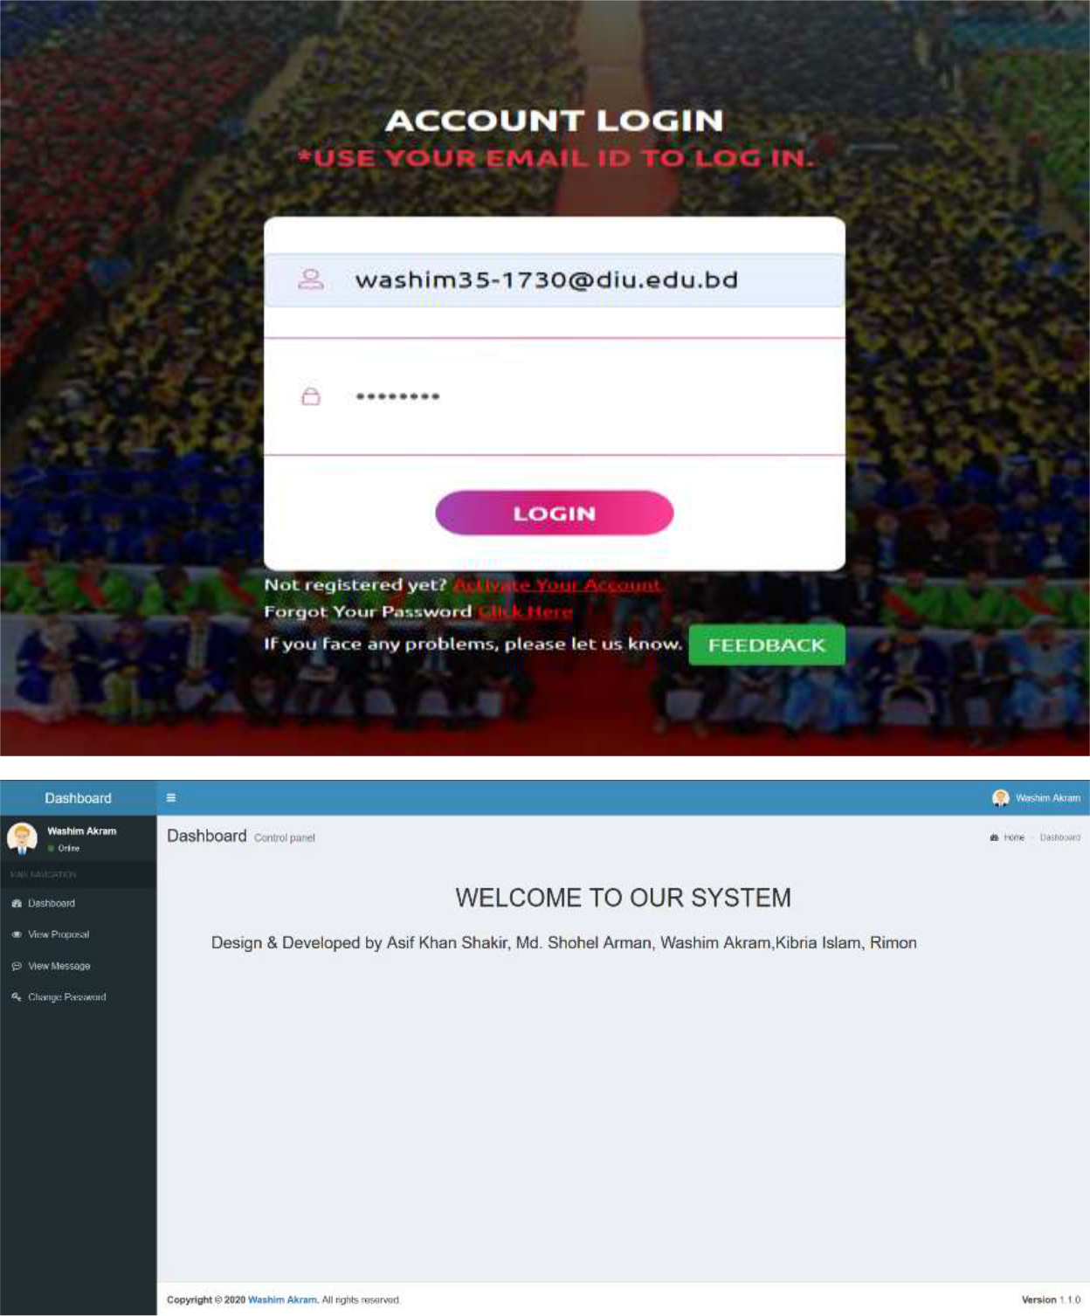

1. **Submit your Proposal Click Here:**

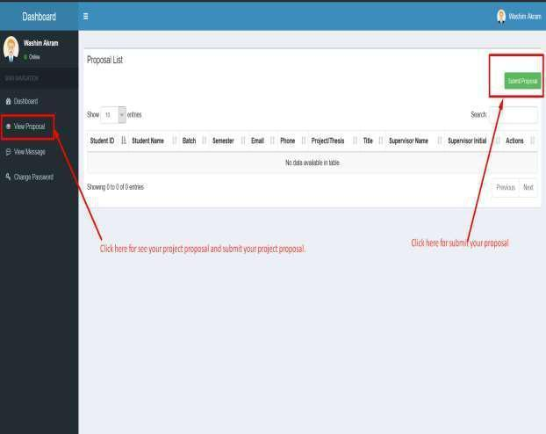

1. **Fill up the proposal form and click submit button. (Fill up Student ID, Batch, Semester, Phone Number, Study, CGPA, Project/Thesis/Internship, Title, Description, * If you want then you can change your name.)**

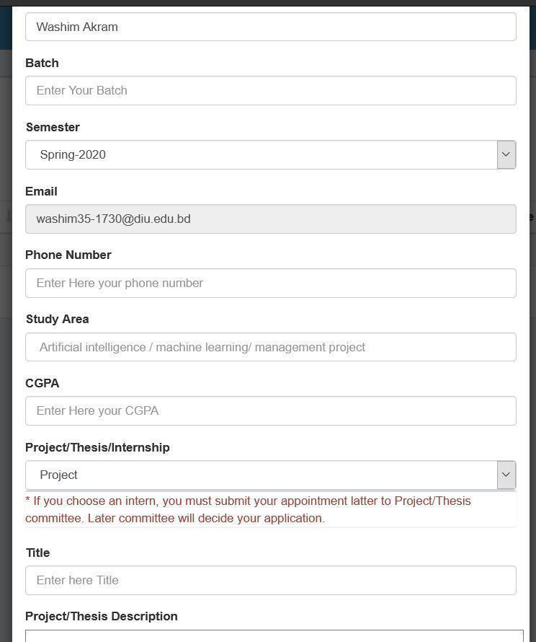

**6. Click View proposal button and see your proposal accepted or pending.**

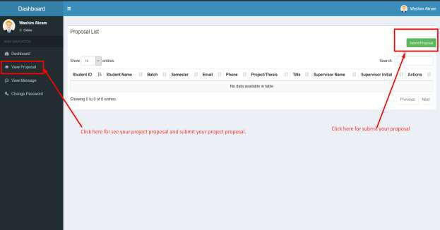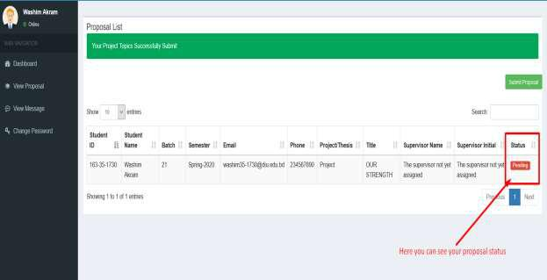

**7. Click view message button and you can see your task.**

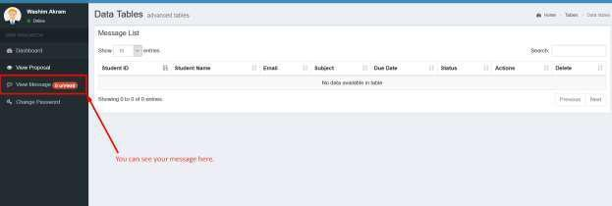

**8. Click view details button then you can see details task.**

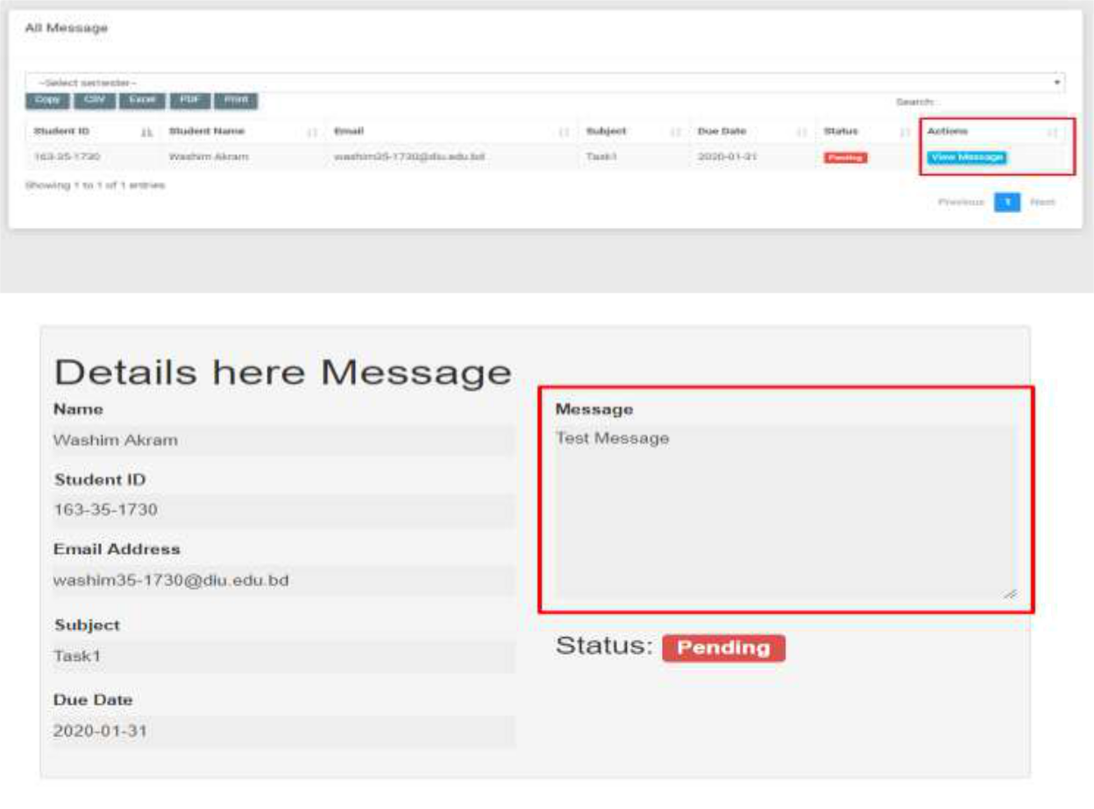

**9. Here you can see notice.**

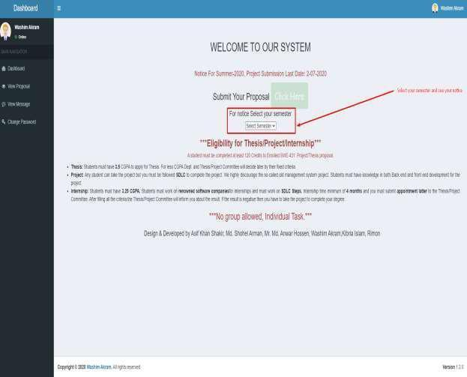

**NB: After 22 May 2023 no proposal will be accepted,

**NB: For further queries contact with this number:

01710404280, 01796679434

Khalid Been Badruzzaman Biplob

Senior Lecturer & Member, Md Rajib Mia-Lecturer & Member Secretary Project/Thesis Committee Department of Software Engineering