Smart Desktop Task Scheduler & Productivity Analyzer
ABSTRACT
The Smart Desktop Task Scheduler & Productivity Analyzer is a Core Java–based desktop application designed to help users efficiently manage their daily tasks and analyze their productivity in an offline environment. In today’s fast-paced world, effective task management and time utilization are critical for both students and professionals. Many existing solutions either rely heavily on internet connectivity or lack advanced features such as intelligent scheduling and productivity analysis. This project addresses these limitations by providing a standalone desktop application that is simple, efficient, and feature-rich.
The system enables users to create, update, delete, and organize tasks through a user-friendly graphical interface developed using Java Swing and AWT. Each task can be assigned attributes such as priority level, deadline, and status, allowing users to systematically plan their activities. The application uses the Java Collections Framework, particularly data structures like PriorityQueue, to implement intelligent task scheduling based on priority and deadlines. This ensures that more important tasks are handled first, improving overall efficiency and time management.
A key feature of the system is its ability to track the time spent on each task using multithreading. This allows the application to run time-tracking processes in the background without affecting the responsiveness of the user interface. By recording the start and end times of tasks, the system calculates accurate time usage, enabling users to monitor how their time is distributed across different activities.
In addition to task management, the system includes a Productivity Analysis module that evaluates user performance based on completed tasks and time spent. It generates structured reports that provide insights into work patterns, helping users identify areas for improvement and optimize their productivity. These reports are stored using Core Java file handling techniques in formats such as TXT and CSV, ensuring data persistence without the need for external databases.
The project emphasizes strong programming fundamentals by implementing Object-Oriented Programming (OOP) concepts such as encapsulation, inheritance, and modular design. It also demonstrates the use of multithreading, file handling, and GUI development within a single integrated application. By avoiding web technologies and databases, the project highlights the capabilities of Core Java in building complete, real-world desktop applications.
Overall, the Smart Desktop Task Scheduler & Productivity Analyzer provides a practical and efficient solution for task management and productivity tracking. It serves as a valuable tool for users seeking to improve their work habits while also showcasing the technical skills and software development capabilities of the developers.

1. INTRODUCTION
1.1 Introduction
Task management and productivity tracking play a crucial role in improving efficiency and maintaining consistency in daily activities, especially for students and professionals who handle multiple responsibilities. In today’s fast-paced environment, many individuals still rely on traditional methods such as handwritten notes or basic digital tools like notepads. While these methods may be simple to use, they often lack advanced features such as proper scheduling, prioritization, automated tracking, and performance analysis. As a result, users may struggle to manage their time effectively, miss deadlines, or fail to evaluate their productivity levels.
To address these limitations, the Smart Desktop Task Scheduler & Productivity Analyzer has been developed as a standalone offline desktop application. The primary objective of this system is to provide an efficient and user-friendly platform for managing tasks while also offering insights into productivity. The application enables users to create, update, delete, and organize tasks based on priorities and deadlines, ensuring better planning and execution of daily activities. By incorporating priority-based scheduling, the system ensures that important tasks are handled first, thereby improving time management.
In addition to task management, the application includes a productivity tracking feature that monitors the time spent on each task. This allows users to understand how their time is distributed across different activities. Based on this data, the system generates productivity reports, which help users analyze their performance, identify inefficiencies, and make informed decisions to improve their workflow.
The application is implemented using Core Java technologies, making it lightweight and platform-independent. The graphical user interface is designed using Swing and AWT, providing an interactive and intuitive user experience. Task scheduling is efficiently handled using Java Collections Framework, particularly data structures like Priority Queue and Comparator. Multithreading is used to enable real-time time tracking without affecting the responsiveness of the application. Additionally, file handling techniques are employed to store and retrieve task data, ensuring persistence even after the application is closed.
Overall, this system serves as a practical solution for effective task management and productivity enhancement, combining simplicity with powerful features in a desktop environment.

1.2 Problem Statement
Traditional task management methods are often inefficient and fail to meet the needs of modern users who handle multiple tasks daily. Many individuals rely on handwritten notes, simple to-do lists, or basic digital tools that lack advanced features such as proper scheduling, prioritization, and automation. As a result, users find it difficult to organize tasks effectively, leading to poor time management and missed deadlines. One of the major limitations is the lack of task prioritization, where tasks cannot be arranged based on importance or urgency. Additionally, these methods do not provide accurate time tracking, making it hard for users to evaluate how their time is being utilized.
Another significant issue is the dependency on internet-based task management tools, which may not always be accessible or reliable in all situations. These tools also often lack structured productivity reports, preventing users from analyzing their performance and identifying areas for improvement. Due to these limitations, there is a need for a simple, efficient, and offline task management system that enables proper scheduling, accurate time tracking, and detailed productivity analysis. Such a system would help users manage tasks effectively while improving overall productivity in a reliable and user-friendly manner.

1.3 Objectives of the Project
The main objectives of this project are to design and develop an efficient task management system that improves productivity and time utilization. The specific objectives are as follows:
- To develop a desktop-based application using Core Java, ensuring platform independence and ease of use without requiring internet connectivity.
- To implement priority-based task scheduling, allowing users to organize tasks according to importance and deadlines for better time management.
- To incorporate multithreading for time tracking, enabling real-time monitoring of time spent on each task without affecting application performance.
- To store and manage task data using file handling techniques, ensuring data persistence and reliability even after the application is closed.
- To apply Object-Oriented Programming (OOP) concepts such as encapsulation, inheritance, and modular design in real-world application development.

1.4 Scope of the Project
The system can be used in colleges, universities, offices, and organizations for effective task management. It provides a simple and user-friendly desktop interface that makes it easy for users to operate. The application helps in organizing tasks and scheduling work efficiently based on priorities and deadlines. It also tracks the time spent on each task, enabling better time management. Additionally, it analyzes productivity and generates reports to help users improve their performance.
2. SYSTEM OVERVIEW
2.1 Existing System
In the current scenario, task management is primarily handled using traditional methods such as handwritten notebooks, spreadsheets, or simple to-do list applications. While these methods are easy to use and widely available, they are not designed to handle complex task scheduling or productivity monitoring.
Most existing tools provide only basic functionalities such as adding, editing, and deleting tasks. They lack intelligent features like automatic prioritization, time tracking, and performance analysis. As a result, users often find it difficult to manage multiple tasks efficiently, especially when dealing with deadlines and workload distribution.
Furthermore, manual systems do not provide real-time insights into how time is spent on tasks. This leads to poor decision-making, reduced productivity, and difficulty in identifying areas for improvement. Hence, there is a need for a more advanced and automated system that can simplify task management and enhance productivity.

2.2 Limitations of Existing System
The existing systems come with several limitations that reduce their effectiveness and usability:
- Manual Errors: Since many systems rely on manual input and tracking, there is a high chance of human errors such as missing tasks, incorrect data entry, or duplication.
- Difficult Data Retrieval: Searching for specific tasks or historical data in notebooks or spreadsheets is time-consuming and inefficient.
- Time-Consuming Process: Managing tasks manually requires continuous effort and attention, which consumes valuable time that could be used more productively.
- No Task Prioritization: Most existing tools do not support advanced prioritization techniques, making it difficult to focus on important or urgent tasks.
- Lack of Productivity Tracking: There is no mechanism to track how much time is spent on tasks or to analyze user performance.
- Limited Automation: Existing systems lack automation features, requiring users to handle all operations manually.
These limitations highlight the need for a system that is more efficient, automated, and capable of providing meaningful insights.

2.3 Proposed System
The proposed system is a desktop application developed using Core Java to automate task management and provide productivity analysis. It features a user-friendly interface built with Swing and AWT, allowing users to create, update, delete, and manage tasks efficiently.
The system includes priority-based scheduling to organize tasks based on importance and urgency, helping users manage time effectively. It also uses multithreading for accurate time tracking, ensuring background monitoring without affecting performance.
Additionally, the system provides productivity analysis with report generation to evaluate performance and identify improvements. Task data is stored using file-based storage, making the application lightweight and easy to deploy.
Overall, the system improves efficiency, reduces manual effort, and offers a structured approach to task management and productivity enhancement.

2.4 Software Requirements
The software requirements for developing and running the proposed system are as follows:
- Java Development Kit (JDK): Version 8 or above is required to develop and execute the application.
- Integrated Development Environment (IDE): Tools such as NetBeans, Eclipse, or Visual Studio Code can be used for coding and debugging.
- Operating System: The application is platform-independent and can run on Windows, Linux, or macOS.
- Java Libraries: Swing and AWT libraries are used for designing the graphical user interface.

2.5 Hardware Requirements
The hardware requirements for the system are minimal and suitable for most modern computers:
- Processor: Intel i3 or higher for smooth performance
- RAM: Minimum 4 GB for efficient multitasking
- Hard Disk: At least 10 GB of free space for storing application files and data
- Input/Output Devices: Standard keyboard and monitor for user interaction

3. TECHNOLOGIES USED
3.1 Java (J2SE)
Java (J2SE) is a widely used object-oriented programming language known for its platform independence, robustness, and security. In this project, Java serves as the core technology for developing the entire application. It is used to implement essential functionalities such as task creation, task management, scheduling algorithms, and productivity analysis. Java also provides strong support for multithreading, which is utilized for tracking time efficiently in the background. Additionally, its built-in libraries enable efficient file handling and data processing, making it suitable for developing a reliable desktop-based application.

3.2 Swing
Java Swing is a powerful GUI (Graphical User Interface) toolkit that is used to design the front-end of the application. It provides a rich set of components such as buttons, labels, text fields, tables, panels, and dialog boxes, which help in building an interactive and user-friendly interface. Swing allows customization of components and supports event-driven programming, enabling smooth interaction between the user and the system. In this project, Swing is used to create screens for task entry, task viewing, scheduling, and displaying productivity reports.

3.3 Java Collections Framework
The Java Collections Framework provides a set of classes and interfaces that help in storing and manipulating data efficiently. In this project, it plays a crucial role in managing tasks dynamically. Data structures such as ArrayList are used to store tasks, while PriorityQueue is used to implement priority-based task scheduling. These structures improve performance by enabling fast data retrieval, insertion, and sorting operations. The use of collections makes the system more flexible, scalable, and efficient in handling multiple tasks.

3.4 File Handling
File handling in Core Java is used to store and retrieve task-related data and productivity reports. Instead of using a database, the system uses text (TXT) and comma-separated values (CSV) files for data storage. This approach simplifies the application and reduces complexity while still ensuring data persistence. File handling operations such as reading, writing, and updating files are implemented to maintain records of tasks and user activities. This makes the system lightweight, easy to deploy, and suitable for environments with limited resources.

4. DATABASE DESIGN
The system uses a file-based storage system instead of a database. Task and productivity information is stored using structured files.
Main Entities
- Task
- Productivity Report

4.1 Task File Structure
Field Name | Data Type | Description | Constraint
task_id | Integer | Unique task ID | Primary Key
task_name | String | Name of the task | Not Null
priority | Integer | Task priority | Not Null
deadline | Date | Task deadline | –
status | String | Task status | –
time_spent | Long | Time spent on task | –

4.2 Productivity Report File Structure
Field Name | Data Type | Description
report_id | Integer | Unique report ID
total_tasks | Integer | Total number of tasks
completed_tasks | Integer | Number of completed tasks
total_time | Long | Total time spent
productivity_score | Double | Productivity score
report_date | Date | Report generation date

4.3 Relationship
One productivity report may contain information about multiple tasks.
Relationship: One-to-Many (1:M)
5. SYSTEM MODULES
1. Task Management Module
The Task Management Module is the core component of the system, responsible for handling all task-related operations. It allows users to create new tasks by entering details such as task name, priority level, deadline, and current status. Users can also update existing tasks, delete completed or unnecessary tasks, and view the list of all tasks in an organized manner. This module ensures that task information is maintained accurately and can be easily accessed whenever required. By providing structured task management, it helps users stay organized and improves overall workflow efficiency.
2. Task Scheduling Module
This module organizes tasks based on priority using the Java Collections Framework, especially PriorityQueue. High-priority tasks are handled first, reducing manual effort and helping users focus on important work.

3. Time Tracking Module
This module tracks the time spent on tasks using multithreading. It records start and stop times without affecting application performance, helping users analyze their time usage effectively.

4. Productivity Analytics Module
This module evaluates user performance based on task completion and time usage. It generates insights and reports that help identify strengths and areas for improvement, enhancing productivity.

5. File Handling & Report Module
This module stores task data and reports in TXT and CSV formats using Java file handling. It ensures data persistence without a database, making the system simple and lightweight.

6. User Interface Module
The User Interface Module provides an interactive and user-friendly graphical interface using Java Swing and AWT. It enables users to easily interact with the system through components such as buttons, text fields, tables, and panels. The interface is designed to be intuitive, allowing users to perform all operations such as managing tasks, scheduling, tracking time, and viewing reports with ease. This enhances the overall user experience and makes the system accessible even to non-technical users.
6. IMPLEMENTATION
6.1 Data Storage
Data storage in the system is implemented using file handling techniques available in Core Java. Instead of relying on complex database systems, the application uses simple text-based storage methods to maintain task and productivity data. Classes such as FileWriter, FileReader, and BufferedReader are used to write, read, and process data efficiently.
Task details, including task name, priority, deadline, and status, are stored in structured text (TXT) or CSV files. This ensures that data is preserved even after the application is closed. The use of file handling makes the system lightweight, easy to deploy, and suitable for environments where database setup is not feasible. Additionally, proper file management techniques are used to update and retrieve data quickly, ensuring smooth application performance.

6.2 Input Validation
Input validation is an important aspect of the system to ensure that only correct and meaningful data is entered by the user. The application checks user inputs at various stages to prevent errors and maintain data integrity. For example, it ensures that required fields are not left empty, numerical values are within valid ranges, and dates are entered in the correct format.
The system also prevents issues such as duplicate task entries or invalid task IDs by applying appropriate validation rules. Error messages and prompts are displayed to guide users in correcting their inputs. This improves the reliability of the system and enhances the overall user experience by reducing the chances of incorrect data entry.

6.3 Exception Handling
Exception handling is implemented to manage unexpected errors that may occur during program execution. The system uses Java’s exception handling mechanisms, such as try-catch blocks, to handle runtime issues effectively. Common exceptions like file access errors, invalid input formats, and missing files are properly managed to prevent the application from crashing.
When an error occurs, the system displays meaningful messages to inform the user about the issue and suggest corrective actions. This ensures that the application remains stable and user-friendly even in error situations. Proper exception handling also helps in debugging and maintaining the system by identifying and managing potential problem areas.

7. OUTPUT SCREENS
Include screenshots of the following windows:
- Login Window:
- The Login Window is the entry point of the Smart Desktop Task Scheduler and Task Manager application.
- It allows users to securely access their personal workspace by entering valid credentials.
- The interface is designed using Java Swing for a simple and user-friendly experience.
- Authentication ensures that only authorized users can manage and track their tasks efficiently.

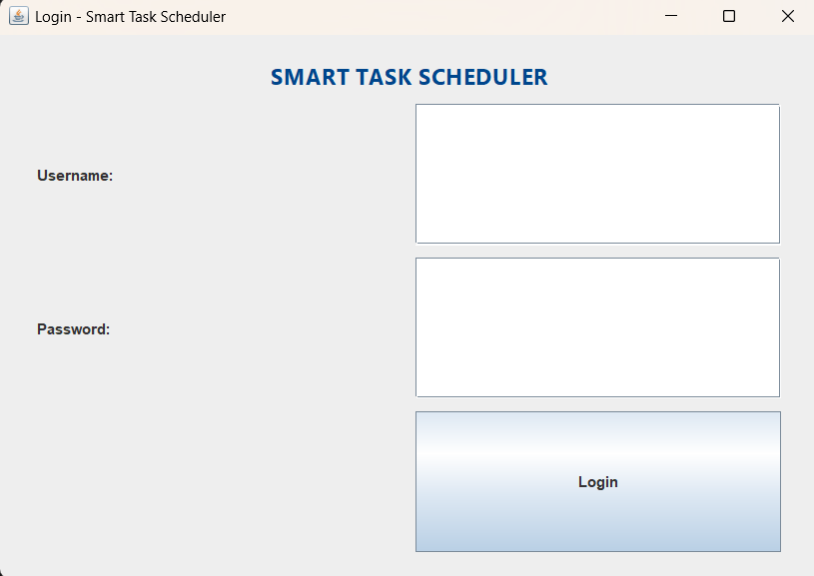

- Main Dashboard:
  - The Main Dashboard serves as the central interface of the Smart Desktop Task Scheduler and Task Manager.
  - It provides an overview of all tasks, including their priority, status, and deadlines.
  - Users can easily add, update, or delete tasks through an interactive Java Swing interface.
  - It also displays productivity insights to help users manage their time more effectively.
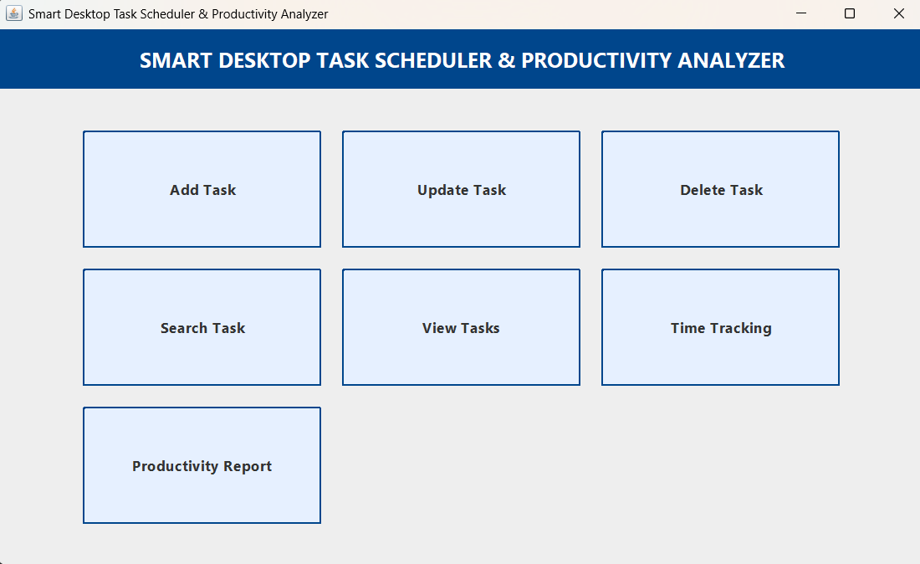

- Add Task Window:
- The Add Task Window allows users to create and schedule new tasks efficiently.
- Users can enter details such as task name, priority level, deadline, and description.
- It is designed using Java Swing to provide a simple and interactive form-based interface.
- This feature helps in organizing tasks systematically and improving overall productivity.

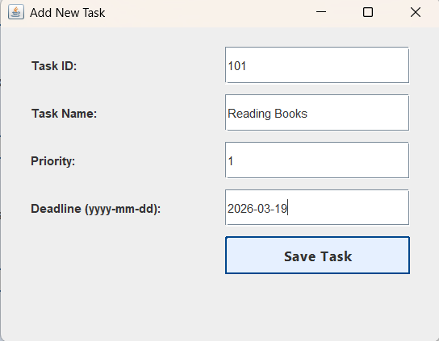

- Update Task Window:
- The Update Task Window allows users to modify existing task details easily.
- Users can edit information such as task name, priority, deadline, and status.
- It provides a user-friendly interface built with Java Swing for smooth interaction.
- This feature ensures tasks remain up-to-date and accurately reflect current progress.

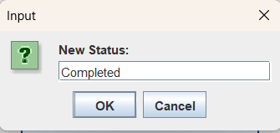

- Search Task Window:
- The Search Task Window enables users to quickly find specific tasks from the task list.
- Users can search based on task name, priority, or deadline for better efficiency.
- It provides a responsive Java Swing interface for fast and accurate results.
- This feature helps save time and improves task management by locating tasks instantly.

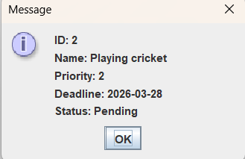

- View Tasks Window:
- The View Tasks Window displays all tasks in a structured and organized format.
- It allows users to see task details such as priority, deadline, and status at a glance.
- The interface is built using Java Swing for clear and user-friendly visualization.
- This feature helps users track progress and manage their tasks efficiently.

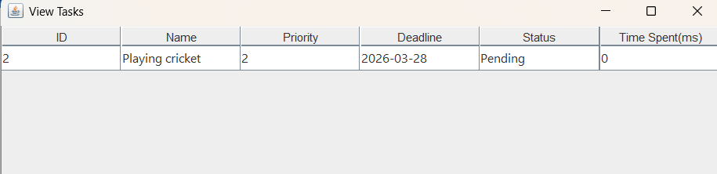

- Delete Task Window:
- The Delete Task Window allows users to remove tasks that are no longer relevant or required.
- Users can select a specific task from the list and confirm deletion to prevent accidental data loss.
- It is designed using a simple and intuitive Java Swing interface for smooth and user-friendly interaction.
- A confirmation prompt ensures safe deletion and enhances data reliability.
- This feature helps maintain a clean, clutter-free task list and improves overall task management efficiency.

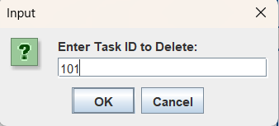

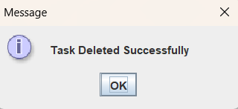

- Productivity Report Window:
- The Productivity Report Window provides detailed insights into the user’s task performance and overall time management.
- It displays key statistics such as completed tasks, pending tasks, overdue tasks, and productivity trends.
- The interface is designed using Java Swing to present data in a clear, structured, and easy-to-understand format.
- Visual summaries help users quickly analyze their efficiency and identify areas for improvement.
- This feature enables better decision-making and helps users enhance their productivity over time.
- This feature helps users analyze their efficiency and improve their work habits.

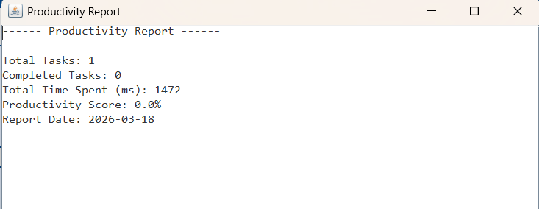

8. CONCLUSION
The Smart Desktop Task Scheduler & Productivity Analyzer successfully provides a simple, efficient, and user-friendly solution for managing daily tasks and analyzing productivity. The system enables users to organize their tasks systematically, assign priorities, and schedule work effectively based on urgency and importance. By incorporating features such as task creation, updating, searching, and deletion, the application ensures complete control over task management. Additionally, the integrated time-tracking mechanism helps users monitor the amount of time spent on each task, allowing them to better understand their work patterns. The generation of productivity reports further assists users in evaluating their performance by providing insights into completed, pending, and overdue tasks.
The application is designed using Java Swing, which offers an interactive and intuitive graphical user interface, making it easy for users to navigate and perform operations smoothly. The use of multithreading enhances the performance of the system by enabling real-time task tracking without affecting the responsiveness of the application. File handling techniques are implemented to store and retrieve task data efficiently, ensuring data persistence even after the application is closed. Moreover, the use of appropriate data structures such as priority queues helps in scheduling tasks based on their importance.
Through the development of this project, students gained valuable hands-on experience in core Java programming concepts, including object-oriented design, GUI development, multithreading, collections, and file handling. They also developed a deeper understanding of software design principles such as modularity, code reusability, and layered architecture. Overall, this project not only demonstrates technical proficiency but also provides a practical tool that can significantly improve personal productivity and time management skills.

9. FUTURE ENHANCEMENTS
Possible improvements for the Smart Desktop Task Scheduler & Productivity Analyzer include several enhancements to increase functionality, usability, and scalability. Adding user authentication and stronger login security mechanisms can help protect user data and ensure that only authorized users can access the system. The graphical user interface can be further improved with modern design elements, better layouts, and enhanced user experience to make the application more visually appealing and intuitive.
Incorporating advanced data visualization features such as charts and graphs can provide clearer insights into productivity patterns, making it easier for users to analyze their performance. Integrating a database system like MySQL or MongoDB can improve data management, allowing efficient storage, retrieval, and handling of large volumes of task data. Additionally, the application can be extended beyond a desktop environment by converting it into a web or mobile application, increasing accessibility and allowing users to manage tasks anytime and anywhere.

10. REFERENCES
- Oracle Java Documentation – https://docs.oracle.com
Official and comprehensive reference for Java programming concepts, APIs, and best practices used in the project.
- Java Programming – Herbert Schildt
A well-known book that provides in-depth knowledge of core Java concepts, object-oriented programming, and practical examples.
- GeeksforGeeks – https://www.geeksforgeeks.org
An online learning platform used for understanding data structures, algorithms, and Java implementation techniques.
- W3Schools Java Tutorials – https://www.w3schools.com/java/
A beginner-friendly resource for learning basic Java syntax, concepts, and quick references during development.

APPENDIX
The appendix section provides supplementary materials that support the implementation and functionality of the Smart Desktop Task Scheduler & Productivity Analyzer. It includes key code snippets, logic explanations, file handling mechanisms, and visual representations of the application.

1. Important Java Code Snippets
This section contains essential parts of the Java implementation that demonstrate the core working of the system.
- Task Class (Model Layer):
Defines the structure of a task, including attributes such as task name, priority, deadline, and status.
- Priority Queue Implementation:
Used to manage tasks based on priority using Comparator for efficient scheduling.
- Multithreading Code:
Demonstrates how multiple tasks are tracked simultaneously using threads.
- GUI Components (Swing/AWT):
Includes code for buttons, panels, text fields, and event listeners used in the user interface.
- Event Handling:
Shows how user actions (like adding or deleting tasks) are handled dynamically.

2. Task Scheduling Logic
The task scheduling mechanism is a core feature of the system and is implemented using efficient data structures and algorithms.
- Tasks are stored in a Priority Queue, where:
  - Higher priority tasks are executed first.
  - If priorities are equal, tasks are scheduled based on deadlines.
- Scheduling Strategy:
  - Priority-based ordering using Comparator
  - Real-time updates when tasks are added/removed
  - Dynamic reordering of tasks
- Execution Flow:
  - User adds a task through GUI
  - Task is inserted into the Priority Queue
  - Scheduler thread continuously monitors tasks
  - Highest priority task is selected for execution
- Advantages:
  - Efficient task management
  - Reduced time complexity for retrieval
  - Real-time responsiveness

3. File Handling Code
The application uses file handling to store and retrieve task data and productivity reports.
- File Operations Used:
  - FileWriter for writing task data
  - BufferedReader for reading stored data
  - PrintWriter for report generation
- Features:
  - Tasks are saved in .txt or .csv format
  - Data persistence ensures tasks are not lost after closing the application
  - Productivity reports can be exported for analysis
- Implementation Details:
  - Saving tasks automatically after each update
  - Loading tasks at application startup
  - Handling exceptions using try-catch blocks

4. Additional Screenshots
This section includes visual representations of the application to provide better understanding.
- Main Dashboard:
Displays all tasks with their priority and status.
- Add Task Window:
Interface for entering task details such as name, deadline, and priority.
- Task Scheduler View:
Shows how tasks are ordered and executed.
- Productivity Analytics Screen:
Graphs or summaries showing user performance.
- Report Output Files:
Screenshots of generated .txt or .csv reports.

5. Conclusion of Appendix
The appendix enhances the overall understanding of the project by providing deeper insights into implementation details, backend logic, and user interface design. It acts as a technical reference for evaluators and developers who wish to understand or extend the system.

