**Lab Cycle Test – II**

**Name Ramratan Sharma Roll Number 205120081**

**2. (A) Write a C program to perform the replacement of requested page(s) based on their requirement in future.**

**Answer-**

#include<stdio.h>

int main()

{

int no_of_frames, no_of_pages, frames[10], pages[30], temp[10];

int flag1, flag2, flag3, i, j, k, pos, max, faults = 0;

printf("Enter number of frames: ");

scanf("%d", &no_of_frames);

printf("Enter number of pages: ");

scanf("%d", &no_of_pages);

printf("Enter page reference string: ");

for(i = 0; i < no_of_pages; ++i)

{

scanf("%d", &pages[i]);

}

for(i = 0; i < no_of_frames; ++i)

{

frames[i] = -1;

}

for(i = 0; i < no_of_pages; ++i)

{

flag1 = flag2 = 0;

for(j = 0; j < no_of_frames; ++j)

{

if(frames[j] == pages[i])

{

flag1 = flag2 = 1;

break;

}

}

if(flag1 == 0)

{

for(j = 0; j < no_of_frames; ++j)

{

if(frames[j] == -1)

{

faults++;

frames[j] = pages[i];

flag2 = 1;

break;

}

}

}

if(flag2 == 0)

{

flag3 =0;

for(j = 0; j < no_of_frames; ++j)

{

temp[j] = -1;

for(k = i + 1; k < no_of_pages; ++k)

{

if(frames[j] == pages[k])

{

temp[j] = k;

break;

}

}

}

for(j = 0; j < no_of_frames; ++j)

{

if(temp[j] == -1)

{

pos = j;

flag3 = 1;

break;

}

}

if(flag3 ==0)

{

max = temp[0];

pos = 0;

for(j = 1; j < no_of_frames; ++j)

{

if(temp[j] > max)

{

max = temp[j];

pos = j;

}

}

}

frames[pos] = pages[i];

faults++;

}

printf("\n");

for(j = 0; j < no_of_frames; ++j)

{

printf("%d\t", frames[j]);

}

}

printf("\n\nTotal Page Faults = %d", faults);

return 0;

}

**OUTPUT**

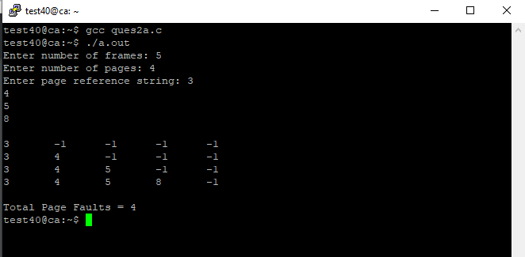

**2 (B) Write a C program to implement a Resource allocation problem for the N processes and M resources**

**Answer-**

#include <stdio.h>

int current[5][5], maximum_claim[5][5], available[5];

int allocation[5] = {0, 0, 0, 0, 0};

int maxres[5], running[5], safe = 0;

int counter = 0, i, j, exec, resources, processes, k = 1;

int main()

{

printf("\nEnter number of processes: ");

scanf("%d", &processes);

for (i = 0; i < processes; i++)

{

running[i] = 1;

counter++;

}

printf("\nEnter number of resources: ");

scanf("%d", &resources);

printf("\nEnter Claim Vector:");

for (i = 0; i < resources; i++)

{

scanf("%d", &maxres[i]);

}

printf("\nEnter Allocated Resource Table:\n");

for (i = 0; i < processes; i++)

{

for(j = 0; j < resources; j++)

{

scanf("%d", &current[i][j]);

}

}

printf("\nEnter Maximum Claim Table:\n");

for (i = 0; i < processes; i++)

{

for(j = 0; j < resources; j++)

{

scanf("%d", &maximum_claim[i][j]);

}

}

printf("\nThe Claim Vector is: ");

for (i = 0; i < resources; i++)

{

printf("\t%d", maxres[i]);

}

printf("\nThe Allocated Resource Table:\n");

for (i = 0; i < processes; i++)

{

for (j = 0; j < resources; j++)

{

printf("\t%d", current[i][j]);

}

printf("\n");

}

printf("\nThe Maximum Claim Table:\n");

for (i = 0; i < processes; i++)

{

for (j = 0; j < resources; j++)

{

printf("\t%d", maximum_claim[i][j]);

}

printf("\n");

}

for (i = 0; i < processes; i++)

{

for (j = 0; j < resources; j++)

{

allocation[j] += current[i][j];

}

}

printf("\nAllocated resources:");

for (i = 0; i < resources; i++)

{

printf("\t%d", allocation[i]);

}

for (i = 0; i < resources; i++)

{

available[i] = maxres[i] - allocation[i];

}

printf("\nAvailable resources:");

for (i = 0; i < resources; i++)

{

printf("\t%d", available[i]);

}

printf("\n");

while (counter != 0)

{

safe = 0;

for (i = 0; i < processes; i++)

{

if (running[i])

{

exec = 1;

for (j = 0; j < resources; j++)

{

if (maximum_claim[i][j] - current[i][j] > available[j])

{

exec = 0;

break;

}

}

if (exec)

{

printf("\nProcess%d is executing\n", i + 1);

running[i] = 0;

counter--;

safe = 1;

for (j = 0; j < resources; j++)

{

available[j] += current[i][j];

}

break;

}

}

}

if (!safe)

{

printf("\nThe processes are in unsafe state.\n");

break;

}

else

{

printf("\nThe process is in safe state");

printf("\nAvailable vector:");

for (i = 0; i < resources; i++)

{

printf("\t%d", available[i]);

}

printf("\n");

}

}

return 0;

}

