**Department of Computer Applications**

**Programme: MCA**

**Course Code : CA704**

**Course Name OPERATING SYSTEMS LAB**

MCA BATCH 2020-23

SEMESTER – 2

**Source Code & Output of Cycle Sheet-I & Cycle Sheet-II**

**Name Ramratan Sharma**

**Roll number 205120081**

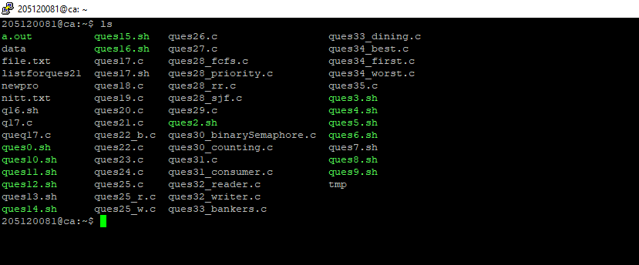

CYCLE SHEET – I

**Question 2 :** Write a shell script to read three numbers from standard input and print the minimum value and maximum.

**Answer**

echo "Enter three nummbers as input "

read a b c

if [ $a -gt $b ] && [ $a -gt $c ]

then

echo "$a is the greatest"

if [ $b -gt $c ]

then

echo "$c is smallest"

else

echo "$b is smallest"

fi

elif [ $b -gt $a ] && [ $b -gt $c ]

then

echo "$b is greatest"

if [ $a -gt $c ]

then

echo "$c is smallest"

else

echo "$a is smallest"

fi

else

echo "$c is greatest"

if [ $a -gt $b ]

then

echo "$b is smallest"

else

echo "$a is smallest"

fi

fi

**Output**

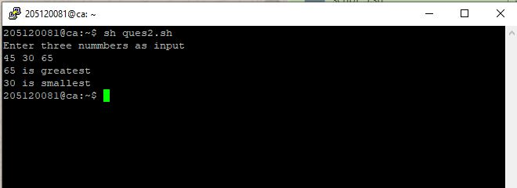

**Question 3 :** Write a shell script to swap two numbers without using 3rd variable

**Answer**

echo "Enter two numbers to swap"

read a b

echo "Before swapping a=$a, b=$b"

a=$((a^b))

b=$((a^b))

a=$((a^b))

echo "After swapping a=$a, b=$b"

**Output**

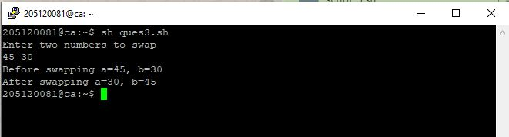

**Question 4 :** Write a shell script to read the marks of a Student and print the grade.

**Answer**

echo "Please Enter the marks for 5 subjects, between 0 and 100"

read a

read b

read c

read d

read e

sum=$((a+b+c+d+e))

echo "Total marks $sum/500 "

echo "Grade Received: "

if [ $sum -gt 200 ]

then

if [ $sum -gt 250 ]

then

if [ $sum -gt 300 ]

then

if [ $sum -gt 350 ]

then

if [ $sum -gt 400 ]

then

if [ $sum -gt 450 ]

then

echo "A"

else

echo "B1"

fi

else

echo "B2"

fi

else

echo "C"

fi

else

echo "D"

fi

else

echo "E"

fi

else

echo "F"

fi

**Output**

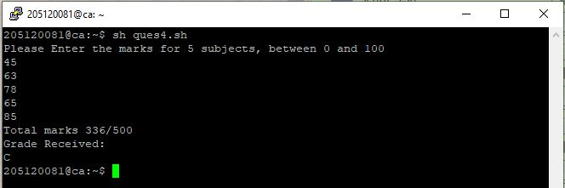

**Question 5 :** Write a shell script to read two integer numbers and perform basic arithmetic operations based on user’s choice (use ‘case’ structure).

**Answer**

# !/bin/bash

# Take user Input

echo "Enter Two numbers : "

read a

read b

# Input type of operation

echo "Enter Choice :"

echo "1. Addition"

echo "2. Subtraction"

echo "3. Multiplication"

echo "4. Division"

echo "Enter Your Choice"

read ch

# Switch Case to perform

# calulator operations

case $ch in

1)res=`echo $a + $b | bc`

;;

2)res=`echo $a - $b | bc`

;;

3)res=`echo $a \* $b | bc`

;;

4)res=`echo "scale=2; $a / $b" | bc`

;;

esac

echo "Result : $res"

**Output**

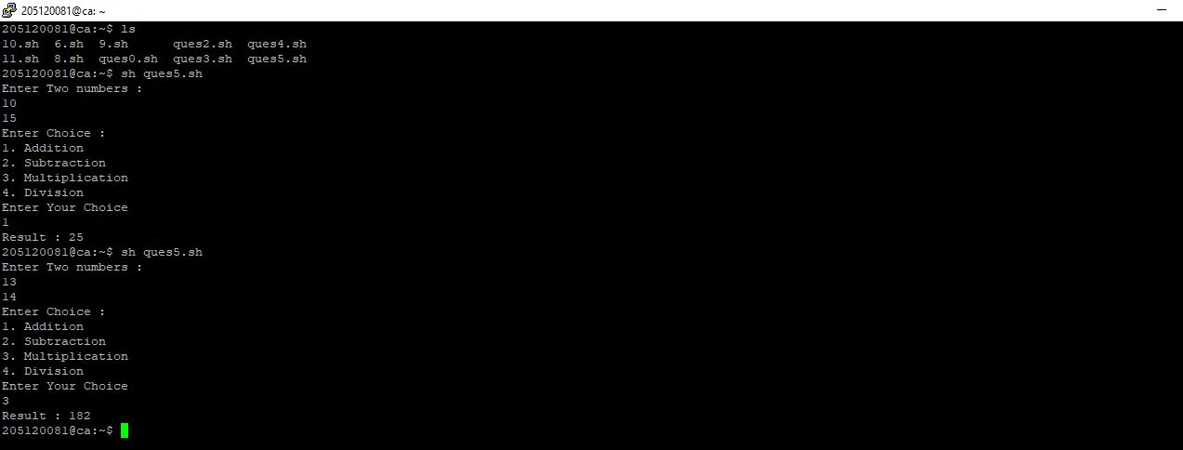

**Question 6 :** Write a shell script to find the sum of first ‘N’ Natural Numbers (use ‘while’ structure)

**Answer**

echo "Enter N :"

read n

i=0

while [ $i -lt $n ]

do

echo -n "Enter Number :"

read val

sum=`expr $sum + $val`

i=`expr $i + 1`

done

echo "Sum of Enter Numbers = $sum"

**Output**

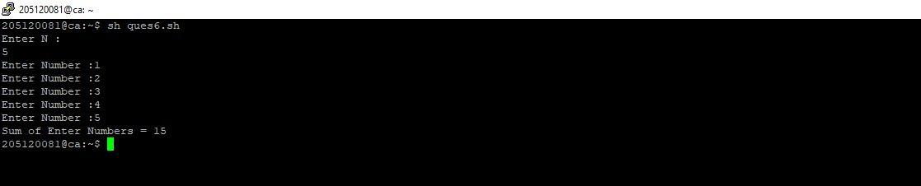

**Question 7 :** Write a shell script to find the sum of first ‘N’ numbers in Fibonacci series (use ‘for’ structure)

**Answer**

echo "Enter Value of n:"

read N

a=0

b=1

sum=0

for (( i=0; i<N; i++ ))

do

echo -n "$sum "

fn=$((a + b))

a=$b

b=$fn

sum=$((sum+a))

done

echo "Sum = $sum"

**Output**

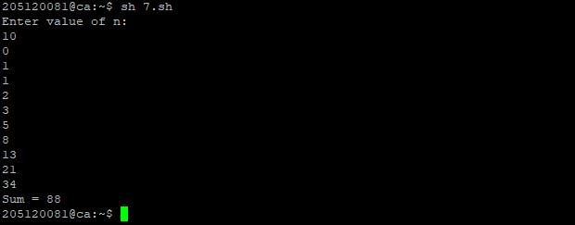

**Question 8 :** Write a shell script to print a given number in reverse order and sum of the individual digits.

**Answer**

echo "Reading a Number, Writing it in reverses order and producing Sum of individual Digits"

read num

rem=0

sm=0

revdig=0

while [ $num -gt 0 ]

do

rem=`expr $num % 10`

echo $rem

sm=$((sm+rem))

num=$((num/10))

revdig=$((revdig*10+rem))

done

echo "Reversed: $revdig, Sum of Digits: $sm"

**Output**

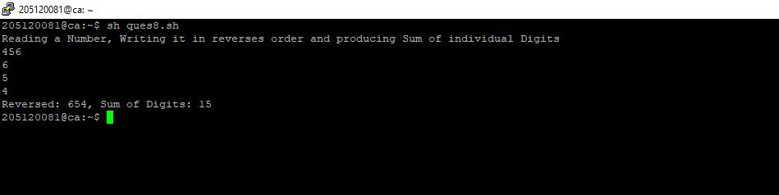

**Question 9 :**  Write a shell script to read two strings and display whether it is equal, not equal, null strings or string with special characters.

**Answer**

#!bin/sh

read -p " enter string 1 : " str1

read -p " enter string 2 : " str2

if [ $str1 = $str2 ]

then echo " strings are equal !"

else

echo " strings are not equal "

fi

if [ -z "$str1" ]

then echo "string 1 is null "

fi

if [ -z "$str2" ]

then echo "string 2 is null "

fi

**Output**

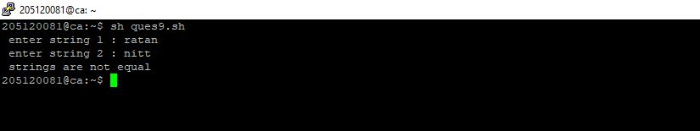

**Question 10 :** Write a shell script to accept one integer argument and print its multiplication table.

**Answer**

#!/bin/bash

echo "Enter Number "

read n

i=1

while [ $i -le 10 ]

do

echo " $n x $i = `expr $n \* $i`"

i=`expr $i + 1`

done

**Output**

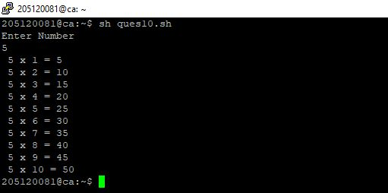

**Question 11 :** Write a shell script, which accepts any number of arguments and prints them in the Reverse order. (For example, if the script is passed A B C as arguments, then execution should produce C B A on the standard output).

**Answer**

a=$#

echo "Number of arguments are" $a

x=$*

c=$a

res=''

while [ 1 -le $c ]

do

c=`expr $c - 1`

shift $c

res=$res' '$1

set $x

done

echo Arguments in reverse order $res

**Output**

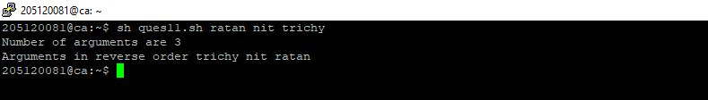

**Question 12 :** Write a Shell Script that makes use of grep to isolate the line in /etc/passwd that contains your login detailsu

username=’whoami’

grep “`whoami`” /etc/passwd

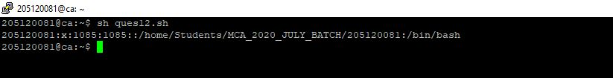

**Question 13:** Write a shell script to display all files in the /home/YourLoginName subdirectory as well as display the type of all files.

**Answer**

for file in *

do

if [ -d $file ]

then echo "$file is a dir "

elif [ -f $file ]

then echo "$file is a file "

elif [ -p $file ]

then echo "$file is a pipe "

else echo "$file is a hyperlink "

fi

done

**Output**

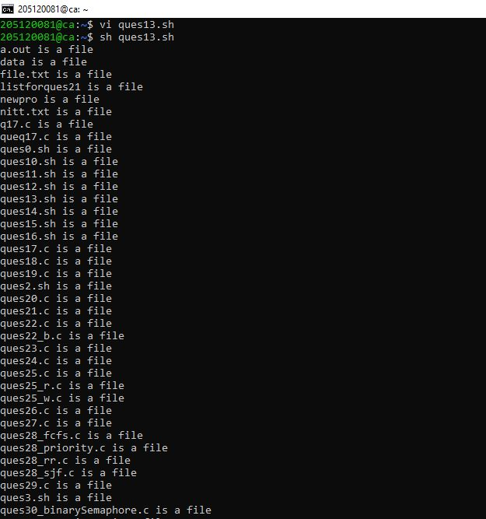

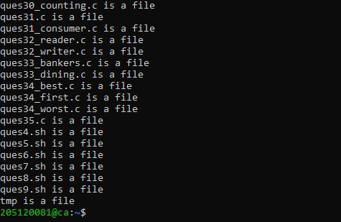

**Question14 :** Using shell script, display the contents of the present working directory. If it is an ordinary file print its permission and change the permissions to r--r--r--.

**Answer**

# !/bin/bash

for item in *

do

if [ -f $item ]

then

echo "----------------$item----------------"

if [ -x $item ]

then

echo "File in Executable mode"

chmod -x $item

echo "Executable permission Removed!"

fi

if [ -w $item ]

then

echo "File in Write mode"

chmod -w $item

echo "Write permission Removed!"

fi

if [ -r $item ]

then

echo "Already in read mode(r--r--r--)"

else

chmod +r $item

echo "Now the read permission granted "

fi

echo "final permission"

ls -al $item

fi

echo

done

**Output**

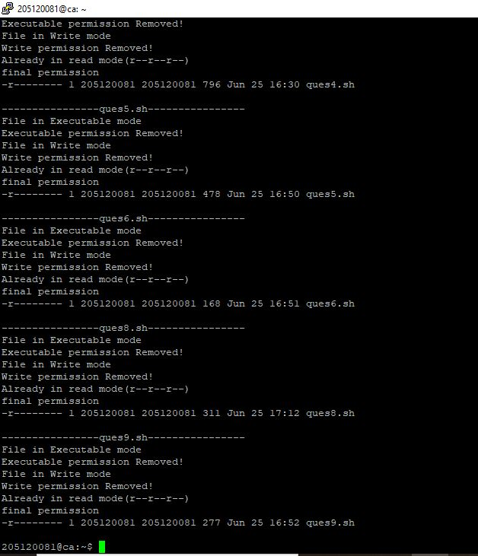

**Question 15:** Use find, grep and sort to display a sorted list of all files in the /home/YourLoginName

subdirectory that contains the word “hello” somewhere inside them.

**Answer** find -type f -print0 | xargs -0 grep -li "hello" | sort

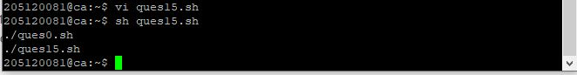

**Question 16:** Write a shell script to produce a list of users and their login shells.

**Answer**

finger $USER | grep 'Shell:*' | cut -f3 -d ":"

16.JPG

**CYCLE SHEET – II**

**Program 17**  Write a C program to kill a process by specifying its name rather than its PID.

**Source Code**

#include<stdio.h>

#include<string.h>

Int main()

{

char cmd[50],cmd1[50],cmd2[50],log[50],pname[50],pid[50];

FILE * fp;

system("rm newpro");

system("rm data");

printf("enter ur login name\n");

fgets(log,sizeof(log),stdin);

strcpy(cmd,"ps -aux | grep ");

strcat(cmd,log);

system(cmd);

printf("enter the name of the process u want to terminate\n");

scanf("%s",pname);

strcpy(cmd1,"ps -a | grep ");

strcat(cmd1,pname);

strcat(cmd1," > newpro");

system(cmd1);

system("cut -f2 -d' ' newpro > data");

fp=fopen("data","r");

fscanf(fp,"%s",pid);

strcpy(cmd2,"kill ");

strcat(cmd2,pid);

system(cmd2);

system(cmd);

printf("the process %s is killed successfully",pname);

}

**Output**

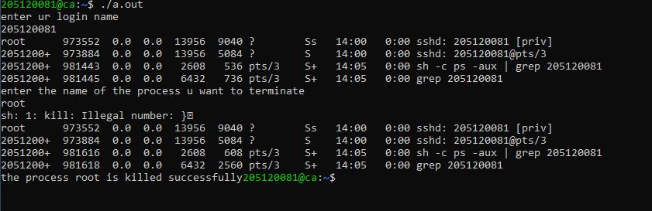

**Program 18 :** Create a file with few lines, Write a C program to read the file and delete the spaces more than one in the file (use UNIX file API’s).

**Source code**

#include<stdio.h>

#include<ctype.h>

int main()

{

FILE * pfile;

int a;

printf("\n Remove the spaces between two words :\n");

printf("-----------------------------------------\n");

// file.txt contain : the quick brown fox jumps over the lazy dog

pfile=fopen ("file.txt","r");

printf(" The content of the file is :\n The quick brown fox jumps over the lazy dog\n\n");

printf(" After removing the spaces the content is : \n");

if (pfile)

{

do {

a = fgetc (pfile);

if ( isgraph(a) ) putchar (a);

} while (a != EOF);

fclose (pfile);

}

printf("\n\n");

return 0;

}

**Output**

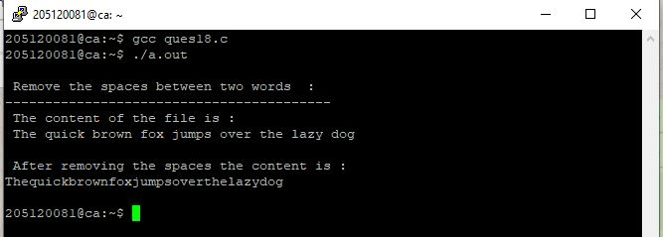

**Program 19 :** Implement a C program to list the users who have logged in more than once.

**Source code**

#include<stdio.h>

#include<sys/utsname.h>

#include<utmp.h>

int main(void)

{

struct utmp *n;

char *a;

int i;

setutent();

n=getutent();

while(n!=NULL)

{

if(n->ut_type==7)

{

printf("%9s",n->ut_user);

printf("%12s",n->ut_line);

printf(" ");

for(i=4;i<16;i++)

printf("%c",a[i]);

printf(" (");

printf("%s10",n->ut_host);

printf(")");

printf("\n");

}

n=getutent();

}

}

**Output**

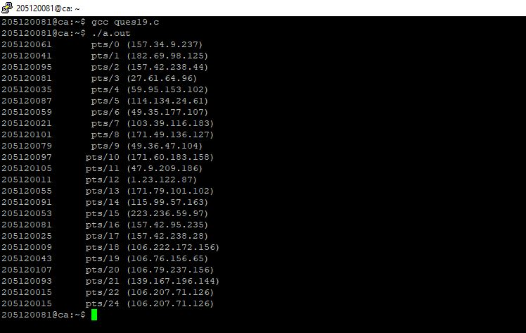

**Program 20 :** Write a C program which renames all .txt files as .text files

**Source code**

#include<stdio.h>

int main()

{

// Old file name

char old_name[] = "ratan.txt";

// Any string

char new_name[] = "nitt.txt";

int value;

// File name is changed here

value = rename(old_name, new_name);

// Print the result

if(!value)

{

printf("%s", "File name changed successfully");

}

else

{

perror("Error");

}

return 0;

}

**Output**

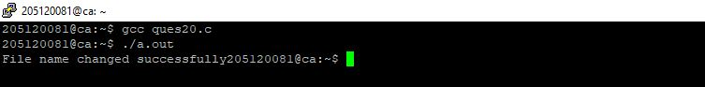

**Program 21 :** Implement a C program that reports the number of file names in the current working directory that consist of exactly five characters.

**Source code**

#include <stdio.h>

#include <string.h>

#include<stdlib.h>

int main()

{

FILE *fp;

int i;

char temp[50], cmd[20];

system("dir > listforques21");

fp = fopen("listforques21", "r");

while (!feof(fp))

{

fscanf(fp, "%s", temp);

if (strlen(temp) == 5)

{

printf(" %s \n", temp);

}

}

return 0;

}

**Output**

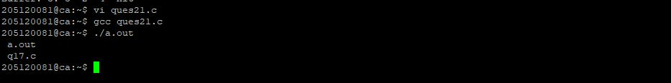

**Program 22 :** Write Programs to

22 a) Report the behaviour of the OS to get the CPU type and model, kernel version.

**Source code**

#include<stdio.h>

#include<stdlib.h>

int main()

{

system("cat /proc/cpuinfo | grep model\\ name");

system("cat /proc/version");

return 0;

}

**Output**

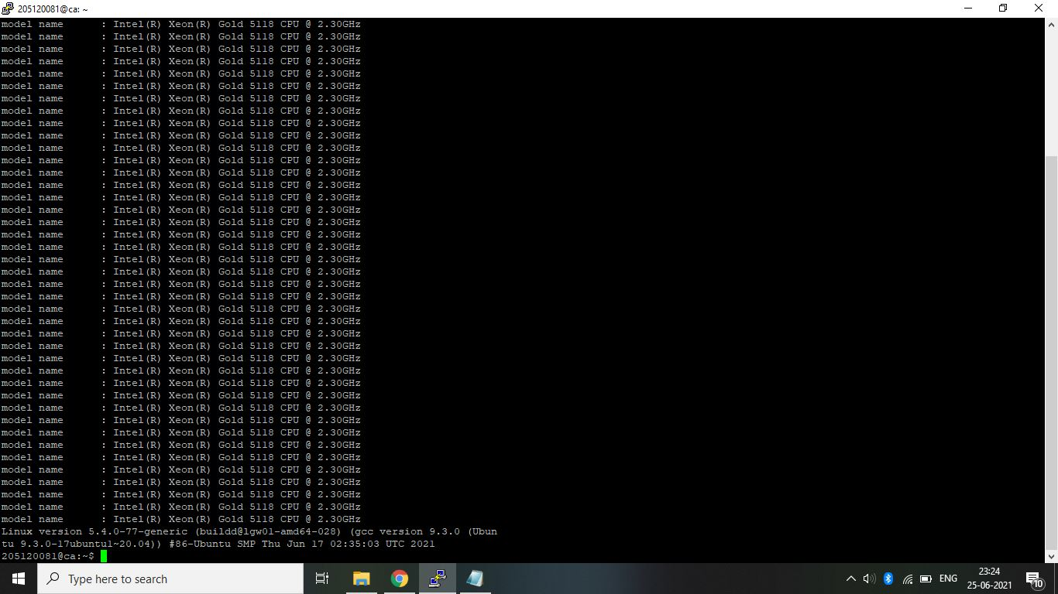

22 b) Get the amount of memory configured into the computer, amount of memory currently available.

**Source code**

#include <stdio.h>

#include <stdlib.h>

int main()

{

system("cat /proc/meminfo | grep Mem");

return 0;

}

**Output**

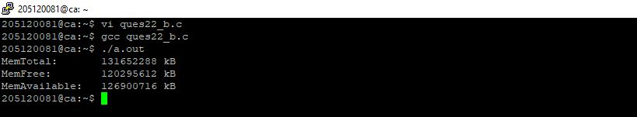

**Program 23** Write a program to a create child process and display the process ID of parent and child processes.

**Source Code**

#include <stdio.h>

#include <sys/types.h>

#include <unistd.h>

int main()

{

int pid = fork();

if(pid)

{

printf("I am the child Process with %d pid\n", getpid());

}

else

{

printf("I am the Parent Process with %d pid\n", getpid());

}

return 0;

}

**Output**

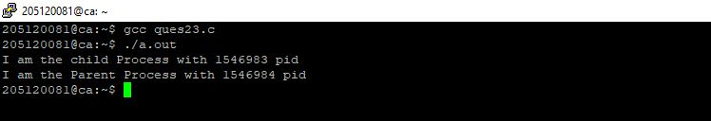

**Program 24** Write a program to demonstrate the implementation of Inter Process Communication (IPC) "who | grep YourLoginName" using pipes.

**Source Code**

#include <stdio.h>

#include <unistd.h>

#include <stdlib.h>

int main()

{

int pid;

int fd[2];

pipe(fd);

pid = fork();

if (pid == -1)

{

perror("fork");

exit(-1);

}

if (pid)

{

close(0);

dup(fd[0]);

close(fd[1]);

execl("/usr/bin/wc", "wc", "-l", (char *)0);

close(fd[0]);

}

else

{

close(1);

dup(fd[1]);

close(fd[0]);

execl("/usr/bin/who", "who", (char *)0);

close(fd[1]);

}

return 0;

}

**Output**

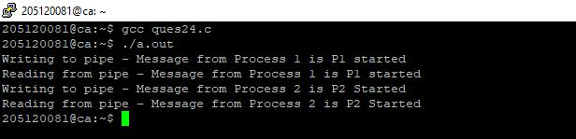

**Program 25** Write a program to demonstrate the implementation of Inter Process Communication (IPC) using Message Queues.

**Source code**

Writer

#include <stdio.h>

#include <sys/ipc.h>

#include <sys/msg.h>

#define MAX 20

struct msg_buffer

{

long msg_type;

char msg_text[100];

} message;

int main()

{

key_t key;

int msgid;

key = ftok("process", 110);

msgid = msgget(key, 0666 | IPC_CREAT);

message.msg_type = 1;

printf("Write Data : ");

fgets(message.msg_text, MAX, stdin);

msgsnd(msgid, &message, sizeof(message), 0);

printf("Message queued : %s \n", message.msg_text);

return 0;

}

**output**

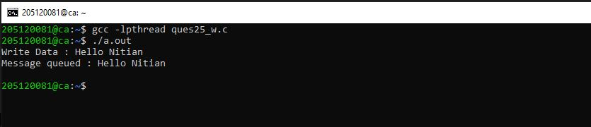

Reader

#include <stdio.h>

#include <sys/ipc.h>

#include <sys/msg.h>

struct msg_buffer

{

long msg_type;

char msg_text[100];

} message;

int main()

{

key_t key;

int msgid;

key = ftok("process", 110);

msgid = msgget(key, 0666 | IPC_CREAT);

msgrcv(msgid, &message, sizeof(message), 1, 0);

printf("Message Received is : %s \n", message.msg_text);

msgctl(msgid, IPC_RMID, NULL);

return 0;

}

**Output**

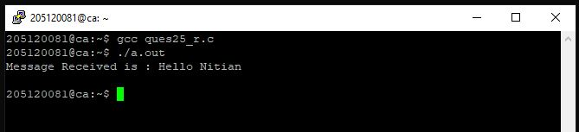

**Output 25**

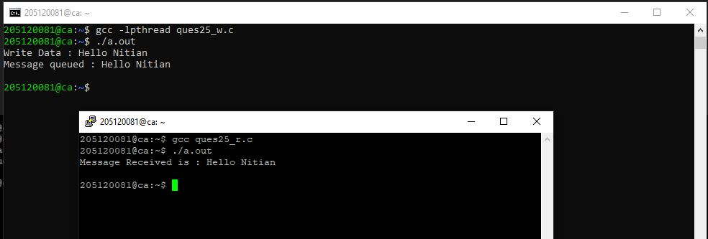

**Program 26 :** Write a program to demonstrate the implementation of Inter Process Communication (IPC) using shared memory.

**Source code**

#include <stdio.h>

#include <stdlib.h>

#include <unistd.h>

#include <string.h>

#include <sys/ipc.h>

#include <sys/shm.h>

#include <sys/types.h>

#define SEGSIZE 100

int main(int argc, char *argv[])

{

int shmid, cntr;

key_t key;

char *segptr;

char buff[] = "poooda......";

key = ftok(".", 's');

if ((shmid = shmget(key, SEGSIZE, IPC_CREAT | IPC_EXCL | 0666)) == -1)

{

if ((shmid = shmget(key, SEGSIZE, 0)) == -1)

{

perror("shmget");

exit(1);

}

}

else

{

printf("Creating a new shared memory seg \n");

printf("SHMID:%d", shmid);

}

system("ipcs –m");

if ((segptr = (char *)shmat(shmid, 0, 0)) == (char *)-1)

{

perror("shmat");

exit(1);

}

printf("Writing data to shared memory...\n");

strcpy(segptr, buff);

printf("DONE\n");

printf("Reading data from shared memory...\n");

printf("DATA:-%s\n", segptr);

printf("DONE\n");

printf("Removing shared memory Segment...\n");

if (shmctl(shmid, IPC_RMID, 0) == -1)

printf("Can‟t Remove Shared memory Segment...\n");

else

printf("Removed Successfully");

}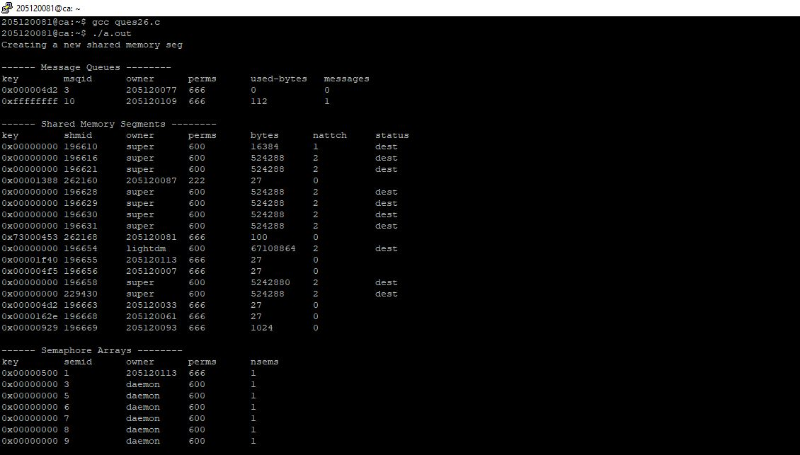

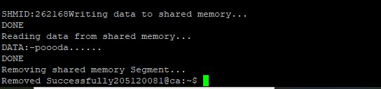

**Program 27 :** Write a program to create a thread and let the thread check whether the given number is prime or not.

**Source Code**

#include<stdio.h>

#include<stdlib.h>

#include<pthread.h>

#include <unistd.h>

#define MAX_THREAD

int n;

void *isPrime(void *vargp)

{

if(n%2)

printf("Odd Number\n");

else

printf("Even Number\n");

int flag = 0;

for(int i=2; i<n; i++)

{

if(n%i==0)

{

flag=1;

break;

}

}

if(flag)

printf("Not Prime\n");

else

printf("Prime\n");

}

int main()

{

printf("Enter the number :");

scanf("%d",&n);

pthread_t thread_id;

printf("Thread Created\n");

pthread_create(&thread_id, NULL, isPrime, NULL);

(void)pthread_join(thread_id, NULL);

printf("Thread Joined\n");

exit(0);

return 0;

}

**Output**

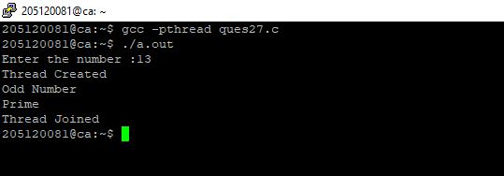

**Program 28** Implement FCFS, SJF, Priority and Round– Robin process scheduling algorithms.

**Source Code**

**FCFS**

#include<stdio.h>

#include<stdlib.h>

int max(int a, int b)

{

if(a<b)

return b;

return a;

}

struct Process {

int arrival;

int burst;

int prioity;

};

int main(){

printf("Simulating First-come First-serve Process Scheduling Algorithm");

printf("\n Enter number of process: ");

int n;

scanf("%d",&n);

struct Process *arr = (struct Process *)malloc(sizeof(struct Process)*n);

for(int i=0; i<n; i++)

{

printf("Enter Arrival time for process #%d: ",i+1);

scanf("%d",&arr[i].arrival);

}

for(int i=0; i<n; i++)

{

printf("Enter Burst time for process #%d: ",i+1);

scanf("%d",&arr[i].burst);

}

for(int i=0; i<n; i++)

{

printf("Enter Priority time for process #%d: ",i+1);

scanf("%d",&arr[i].prioity);

}

/* Waiting Time Caluclation */

int *wt = (int *)malloc(sizeof(int)*n);

wt[0] = 0;

double tot_wt=0;

for(int i=1; i<n; i++)

{

wt[i] = arr[i-1].burst+wt[i-1]-(arr[i].arrival-arr[i-1].arrival);

tot_wt += wt[i];

}

int *tat = (int *)malloc(sizeof(int)*n);

double tot_tat = 0;

for(int i=0; i<n; i++)

{

tat[i] = wt[i]+arr[i].burst;

tot_tat += tat[i];

}

double count = n;

double avg_wt, avg_tat;

avg_wt = tot_wt/count;

avg_tat = tot_tat/count;

printf("\n");

printf("Process\t\tArrival\t\tBurst\t\tPriority\tWait\t\tTat\n");

for (int i = 0; i < n; i++)

{

printf("%d\t\t%d\t\t%d\t\t%d\t\t%d\t\t%d\n",i+1,arr[i].arrival,arr[i].burst,arr[i].prioity,wt[i],tat[i]);

}

printf("\n_______________________________________________________________________________________\n");

printf("\t\t\t\t\t\t\t\t%f\t\t%f\t\n",tot_wt,tot_tat);

printf("Average Waiting Time : %f\n",avg_wt);

printf("Average Turnaround Time : %f\n",avg_tat);

return 0;

}

**Output**

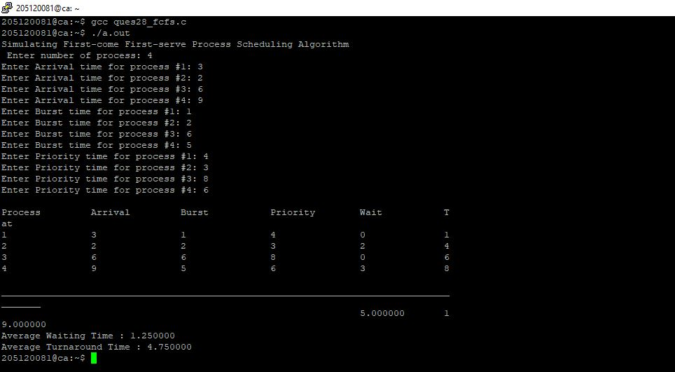

**SJF**

#include<stdio.h>

int main()

{

int bt[20],p[20],wt[20],tat[20],i,j,n,total=0,pos,temp;

float avg_wt,avg_tat;

printf("Enter number of process:");

scanf("%d",&n);

printf("nEnter Burst Time:n");

for(i=0;i<n;i++)

{

printf("p%d:",i+1);

scanf("%d",&bt[i]);

p[i]=i+1;

}

//sorting of burst times

for(i=0;i<n;i++)

{

pos=i;

for(j=i+1;j<n;j++)

{

if(bt[j]<bt[pos])

pos=j;

}

temp=bt[i];

bt[i]=bt[pos];

bt[pos]=temp;

temp=p[i];

p[i]=p[pos];

p[pos]=temp;

}

wt[0]=0;

for(i=1;i<n;i++)

{

wt[i]=0;

for(j=0;j<i;j++)

wt[i]+=bt[j];

total+=wt[i];

}

avg_wt=(float)total/n;

total=0;

printf("nProcesst Burst Time tWaiting TimetTurnaround Time");

for(i=0;i<n;i++)

{

tat[i]=bt[i]+wt[i];

total+=tat[i];

printf("np%dtt %dtt %dttt%d",p[i],bt[i],wt[i],tat[i]);

}

avg_tat=(float)total/n;

printf("nnAverage Waiting Time=%f",avg_wt);

printf("nAverage Turnaround Time=%fn",avg_tat);

}

**Output** 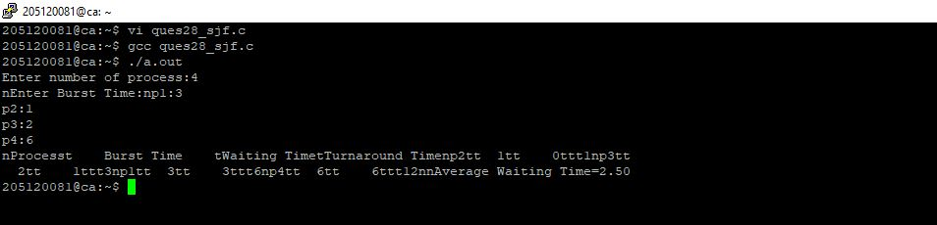

**Priority**

#include <stdio.h>

int main()

{

int bt[20],wt[20],p[20],tat[20],priority[20];

float avwt=0,avtat=0;

int i,j,n,temp,key;

printf("\nEnter the number of the processes: ");

scanf("%d",&n);

for(i=0;i<n;i++)

{

printf("\nEnter the burst time and priority of the process P[%d]: ",i);

scanf("%d",&bt[i]);

scanf("%d",&priority[i]);

p[i]=i;

}

for(i=0;i<n;i++)

{

key=i;

for(j=i+1;j<n;j++)

{

if(priority[j]<priority[key])

{

key=j;

}

}

temp=bt[i];

bt[i]=bt[key];

bt[key]=temp;

temp=priority[i];

priority[i]=priority[key];

priority[key]=temp;

temp=p[i];

p[i]=p[key];

p[key]=temp;

}

wt[0]=0;

tat[0]=bt[0];

avtat=tat[0];

for(i=1;i<n;i++)

{

wt[i]=wt[i-1]+bt[i-1];

tat[i]=tat[i-1]+bt[i];

avwt+=wt[i];

avtat+=tat[i];

}

avwt=avwt/n;

avtat=avtat/n;

printf("\n\nPROCESS\t\twaiting time\tburst time\tTurnaround time\n");

printf("\n");

for(i=0;i<n;i++)

{

printf("P[%d]\t\t%d\t\t%d\t\t%d\n",p[i],wt[i],bt[i],tat[i]);

}

printf("\n\nAverage waiting time: %.2f",avwt);

printf("\n\nAverage Turn around time is: %.2f",avtat);

printf("\n");

return 0;

}

**Output**

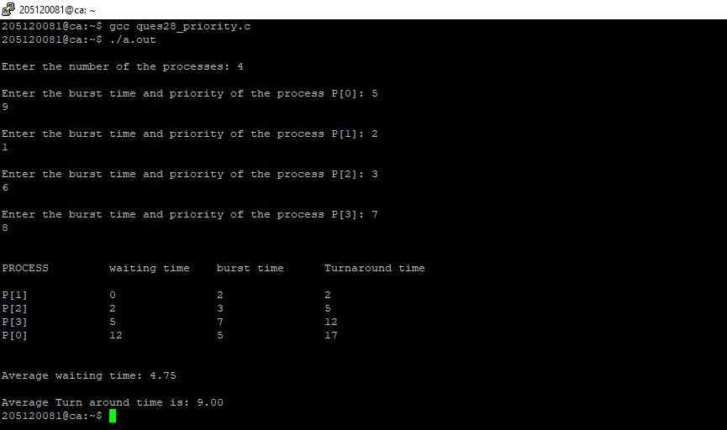

**Round– Robin**

#include<stdio.h>

#include<conio.h>

void main()

{

// initlialize the variable name

int i, NOP, sum=0,count=0, y, quant, wt=0, tat=0, at[10], bt[10], temp[10];

float avg_wt, avg_tat;

printf(" Total number of process in the system: ");

scanf("%d", &NOP);

y = NOP; // Assign the number of process to variable y

// Use for loop to enter the details of the process like Arrival time and the Burst Time

for(i=0; i<NOP; i++)

{

printf("\n Enter the Arrival and Burst time of the Process[%d]\n", i+1);

printf(" Arrival time is: \t"); // Accept arrival time

scanf("%d", &at[i]);

printf(" \nBurst time is: \t"); // Accept the Burst time

scanf("%d", &bt[i]);

temp[i] = bt[i]; // store the burst time in temp array

}

// Accept the Time qunat

printf("Enter the Time Quantum for the process: \t");

scanf("%d", &quant);

// Display the process No, burst time, Turn Around Time and the waiting time

printf("\n Process No \t\t Burst Time \t\t TAT \t\t Waiting Time ");

for(sum=0, i = 0; y!=0; )

{

if(temp[i] <= quant && temp[i] > 0) // define the conditions

{

sum = sum + temp[i];

temp[i] = 0;

count=1;

}

else if(temp[i] > 0)

{

temp[i] = temp[i] - quant;

sum = sum + quant;

}

if(temp[i]==0 && count==1)

{

y--; //decrement the process no.

printf("\nProcess No[%d] \t\t %d\t\t\t\t %d\t\t\t %d", i+1, bt[i], sum-at[i], sum-at[i]-bt[i]);

wt = wt+sum-at[i]-bt[i];

tat = tat+sum-at[i];

count =0;

}

if(i==NOP-1)

{

i=0;

}

else if(at[i+1]<=sum)

{

i++;

}

else

{

i=0;

}

}

// represents the average waiting time and Turn Around time

avg_wt = wt * 1.0/NOP;

avg_tat = tat * 1.0/NOP;

printf("\n Average Turn Around Time: \t%f", avg_wt);

printf("\n Average Waiting Time: \t%f", avg_tat);

getch();

}

**Output**

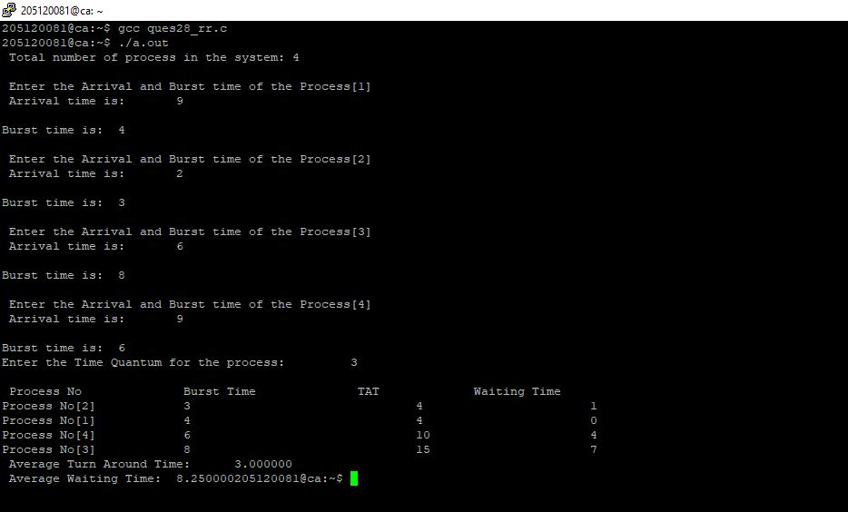

**Program 29** Write a program to perform a tidy exit on receipt of an interrupt signal.

**Source Code**

#include <stdio.h>

#include <stdlib.h>

#include <signal.h>

FILE *temp_file;

void leave(int sig);

int main()

{

(void)signal(SIGINT, leave);

temp_file = fopen("tmp", "w");

for (;;)

{

/*

* Do things....

*/

printf("Ready...\n");

(void)getchar();

}

/* can't get here ... */

exit(EXIT_SUCCESS);

return 0;

}

// SIGHUP 1 Hang up detected on controlling terminal or death of con trolling process

// SIGINT 2 Issued if the user sends an interrupt signal (Ctrl + C)

// SIGQUIT 3 Issued if the user sends a quit signal (Ctrl + D)

// SIGFPE 8 Issued if an illegal mathematical operation is attempted

// SIGKILL 9 If a process gets this signal it must quit immediately a nd will not perform any clean-up operations

// SIGALRM 14 Alarm clock signal (used for timers)

// SIGTERM 15 Software termination signal (sent by kill by default)

// kill -l

void leave(int sig)

{

printf("\nSIGINT Recieved, Exiting");

fprintf(temp_file, "\nInterrupted..\n");

fclose(temp_file);

exit(sig);

}

**Output**

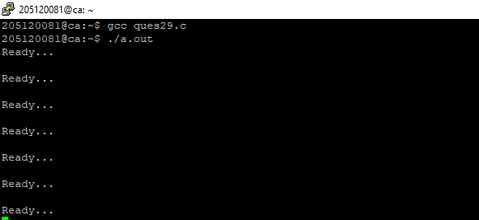

**Program 30** Implement a) Binary Semaphore b) Counting Semaphore

**Source Code** a) Binary Semaphore

#include <stdio.h>

#include <pthread.h>

#include <semaphore.h>

#include <unistd.h>

sem_t mutex;

void* thread(void* arg)

{

//wait

sem_wait(&mutex);

printf("\nEntered..\n");

//critical section

sleep(4);

//signal

printf("\nJust Exiting...\n");

sem_post(&mutex);

}

int main()

{

sem_init(&mutex, 0, 1);

pthread_t t1,t2;

pthread_create(&t1,NULL,thread,NULL);

sleep(2);

pthread_create(&t2,NULL,thread,NULL);

pthread_join(t1,NULL);

pthread_join(t2,NULL);

sem_destroy(&mutex);

return 0;

}

**Output**

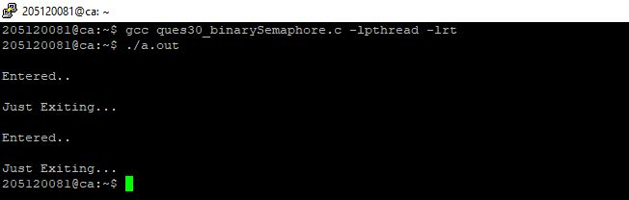

**Program 31 :** Write a program to demonstrate the implementation of Producer and Consumer problem.

**Source Code**

#include <stdio.h>

int main()

{

int buffer[10], bufsize, in, out, produce, consume, choice = 0;

in = 0;

out = 0;

bufsize = 10;

while (choice != 3)

{

printf("\n 1.Produce\t 2.Consume\t 3.Exit");

printf("\nEnter your choice: ");

scanf("%d", &choice);

switch (choice)

{

case 1:

if ((in + 1) % bufsize == out)

printf("\nBuffer is Full");

else

{

printf("\nEnter the value: ");

scanf("%d", &produce);

buffer[in] = produce;

in = (in + 1) % bufsize;

}

break;

case 2:

if (in == out)

printf("\nBuffer is Empty\n");

else

{

consume = buffer[out];

printf("\nThe consumed value is %d\n", consume);

out = (out + 1) % bufsize;

}

break;

}

}

return 0;

}

**Output**

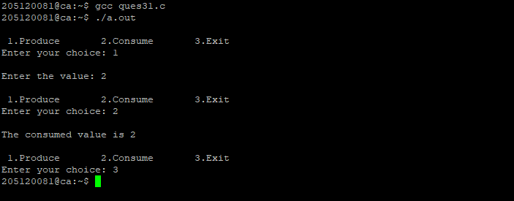

**Program 32 :** Write a program to implement Reader – Writer’s problem

**Source Code**

**ques32_writer.c**

#include <stdio.h>

#include <sys/ipc.h>

#include <sys/msg.h>

// structure for message queue

struct msg_buffer {

long msg_type;

char msg[100];

} message;

int main() {

key_t my_key;

int msg_id;

my_key = ftok("progfile", 65); //create unique key

msg_id = msgget(my_key, 0666 | IPC_CREAT); //create message queue and return id

message.msg_type = 1;

printf("Write Message : ");

fgets(message.msg, 100, stdin);

msgsnd(msg_id, &message, sizeof(message), 0); //send message

printf("Sent message is : %s \n", message.msg);

}

**Output**

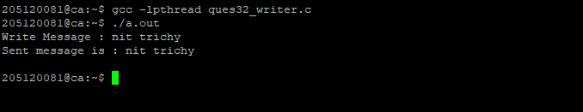

**ques32_reader.c**

#include <stdio.h>

#include <sys/ipc.h>

#include <sys/msg.h>

#include <string.h>

// Define message queue structure

struct msg_buffer {

long msg_type;

char msg[100];

} message;

int main() {

key_t my_key;

int msg_id;

my_key = ftok("progfile", 65); //create unique key

msg_id = msgget(my_key, 0666 | IPC_CREAT); //create message queue and return id

msgrcv(msg_id, &message, sizeof(message), 1, 0); //used to receive message

// display the message

int n=strlen(message.msg);

for(int i=0;i<n;i++)

{

if(message.msg[i]>='A'&&message.msg[i]<='Z')

{

message.msg[i]=message.msg[i]-'A'+'a';

}

else if(message.msg[i]>='a'&&message.msg[i]<='z')

{

message.msg[i]=message.msg[i]-'a'+'A';

}

}

printf("Received Message is : %s \n", message.msg);

msgctl(msg_id, IPC_RMID, NULL); //destroy the message queue

return 0;

}

**Output**

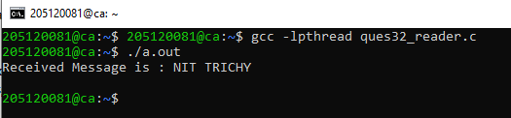

**Output 32**

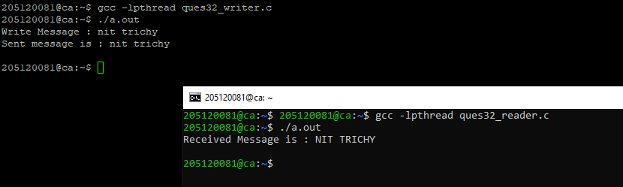

**Program 33** Write a program to implement Dining Philosopher’s problem. Implement Banker’s algorithm.

**ques33_dining.c**

**Source Code**

#include<stdio.h>

#define n 4

int compltedPhilo = 0,i;

struct fork{

int taken;

}ForkAvil[n];

struct philosp{

int left;

int right;

}Philostatus[n];

void goForDinner(int philID){ //same like threads concept here cases implemented

if(Philostatus[philID].left==10 && Philostatus[philID].right==10)

printf("Philosopher %d completed his dinner\n",philID+1);

//if already completed dinner

else if(Philostatus[philID].left==1 && Philostatus[philID].right==1){

//if just taken two forks

printf("Philosopher %d completed his dinner\n",philID+1);

Philostatus[philID].left = Philostatus[philID].right = 10; //remembering that he completed dinner by assigning value 10

int otherFork = philID-1;

if(otherFork== -1)

otherFork=(n-1);

ForkAvil[philID].taken = ForkAvil[otherFork].taken = 0; //releasing forks

printf("Philosopher %d released fork %d and fork %d\n",philID+1,philID+1,otherFork+1);

compltedPhilo++;

}

else if(Philostatus[philID].left==1 && Philostatus[philID].right==0){ //left already taken, trying for right fork

if(philID==(n-1)){

if(ForkAvil[philID].taken==0){ //KEY POINT OF THIS PROBLEM, THAT LAST PHILOSOPHER TRYING IN reverse DIRECTION

ForkAvil[philID].taken = Philostatus[philID].right = 1;

printf("Fork %d taken by philosopher %d\n",philID+1,philID+1);

}else{

printf("Philosopher %d is waiting for fork %d\n",philID+1,philID+1);

}

}else{ //except last philosopher case

int dupphilID = philID;

philID-=1;

if(philID== -1)

philID=(n-1);

if(ForkAvil[philID].taken == 0){

ForkAvil[philID].taken = Philostatus[dupphilID].right = 1;

printf("Fork %d taken by Philosopher %d\n",philID+1,dupphilID+1);

}else{

printf("Philosopher %d is waiting for Fork %d\n",dupphilID+1,philID+1);

}

}

}

else if(Philostatus[philID].left==0){ //nothing taken yet

if(philID==(n-1)){

if(ForkAvil[philID-1].taken==0){ //KEY POINT OF THIS PROBLEM, THAT LAST PHILOSOPHER TRYING IN reverse DIRECTION

ForkAvil[philID-1].taken = Philostatus[philID].left = 1;

printf("Fork %d taken by philosopher %d\n",philID,philID+1);

}else{

printf("Philosopher %d is waiting for fork %d\n",philID+1,philID);

}

}else{ //except last philosopher case

if(ForkAvil[philID].taken == 0){

ForkAvil[philID].taken = Philostatus[philID].left = 1;

printf("Fork %d taken by Philosopher %d\n",philID+1,philID+1);

}else{

printf("Philosopher %d is waiting for Fork %d\n",philID+1,philID+1);

}

}

}else{}

}

int main(){

for(i=0;i<n;i++)

ForkAvil[i].taken=Philostatus[i].left=Philostatus[i].right=0;

while(compltedPhilo<n){

/* Observe here carefully, while loop will run until all philosophers complete dinner

Actually problem of deadlock occur only thy try to take at same time

This for loop will say that they are trying at same time. And remaining status will print by go for dinner function

*/

for(i=0;i<n;i++)

goForDinner(i);

printf("\nTill now num of philosophers completed dinner are %d\n\n",compltedPhilo);

}

return 0;

}

**Output**

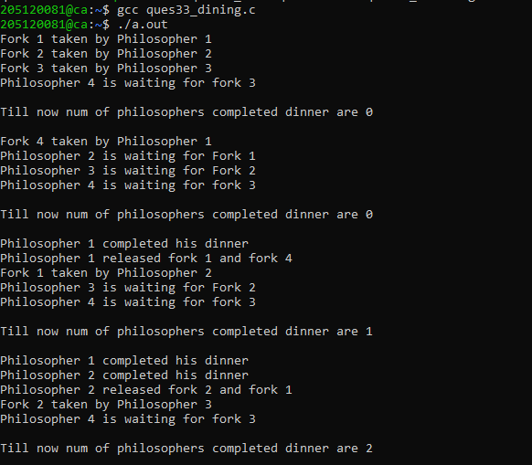

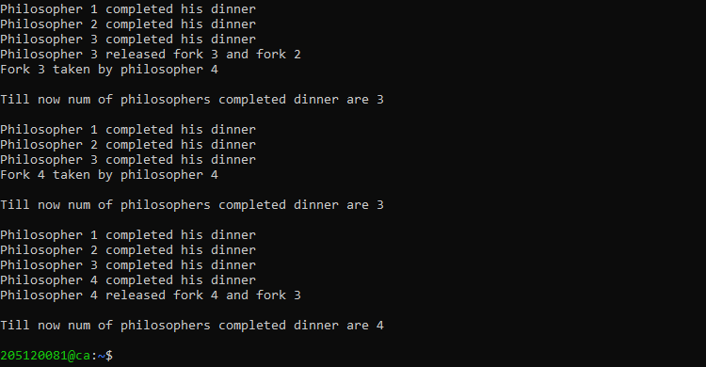

**ques33_bankers.c**

#include <stdio.h>

int current[5][5], maximum_claim[5][5], available[5];

int allocation[5] = {0, 0, 0, 0, 0};

int maxres[5], running[5], safe = 0;

int counter = 0, i, j, exec, resources, processes, k = 1;

int main()

{

printf("\nEnter number of processes: ");

scanf("%d", &processes);

for (i = 0; i < processes; i++)

{

running[i] = 1;

counter++;

}

printf("\nEnter number of resources: ");

scanf("%d", &resources);

printf("\nEnter Claim Vector:");

for (i = 0; i < resources; i++)

{

scanf("%d", &maxres[i]);

}

printf("\nEnter Allocated Resource Table:\n");

for (i = 0; i < processes; i++)

{

for(j = 0; j < resources; j++)

{

scanf("%d", &current[i][j]);

}

}

printf("\nEnter Maximum Claim Table:\n");

for (i = 0; i < processes; i++)

{

for(j = 0; j < resources; j++)

{

scanf("%d", &maximum_claim[i][j]);

}

}

printf("\nThe Claim Vector is: ");

for (i = 0; i < resources; i++)

{

printf("\t%d", maxres[i]);

}

printf("\nThe Allocated Resource Table:\n");

for (i = 0; i < processes; i++)

{

for (j = 0; j < resources; j++)

{

printf("\t%d", current[i][j]);

}

printf("\n");

}

printf("\nThe Maximum Claim Table:\n");

for (i = 0; i < processes; i++)

{

for (j = 0; j < resources; j++)

{

printf("\t%d", maximum_claim[i][j]);

}

printf("\n");

}

for (i = 0; i < processes; i++)

{

for (j = 0; j < resources; j++)

{

allocation[j] += current[i][j];

}

}

printf("\nAllocated resources:");

for (i = 0; i < resources; i++)

{

printf("\t%d", allocation[i]);

}

for (i = 0; i < resources; i++)

{

available[i] = maxres[i] - allocation[i];

}

printf("\nAvailable resources:");

for (i = 0; i < resources; i++)

{

printf("\t%d", available[i]);

}

printf("\n");

while (counter != 0)

{

safe = 0;

for (i = 0; i < processes; i++)

{

if (running[i])

{

exec = 1;

for (j = 0; j < resources; j++)

{

if (maximum_claim[i][j] - current[i][j] > available[j])

{

exec = 0;

break;

}

}

if (exec)

{

printf("\nProcess%d is executing\n", i + 1);

running[i] = 0;

counter--;

safe = 1;

for (j = 0; j < resources; j++)

{

available[j] += current[i][j];

}

break;

}

}

}

if (!safe)

{

printf("\nThe processes are in unsafe state.\n");

break;

}

else

{

printf("\nThe process is in safe state");

printf("\nAvailable vector:");

for (i = 0; i < resources; i++)

{

printf("\t%d", available[i]);

}

printf("\n");

}

}

return 0;

}

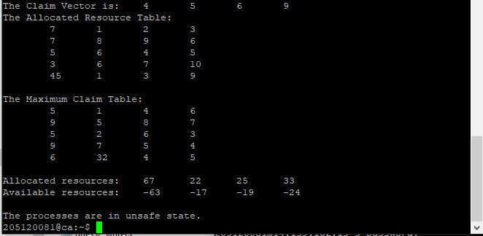

**Program 34** Implement the First Fit, Best Fit and Worst Fit file allocation strategy

**Source Code**

**First fit**

#include <stdio.h>

//#include <conio.h>

#define max 25

void main()

{

int frag[max], b[max], f[max], i, j, nb, nf, temp;

static int bf[max], ff[max];

// clrscr();

printf("\n\tMemory Management Scheme - First Fit");

printf("\nEnter the number of blocks:");

scanf("%d", &nb);

printf("Enter the number of files:");

scanf("%d", &nf);

printf("\nEnter the size of the blocks:-\n");

for (i = 1; i <= nb; i++)

{

printf("Block %d:", i);

scanf("%d", &b[i]);

}

printf("Enter the size of the files :-\n");

for (i = 1; i <= nf; i++)

{

printf("File %d:", i);

scanf("%d", &f[i]);

}

for (i = 1; i <= nf; i++)

{

for (j = 1; j <= nb; j++)

{

if (bf[j] != 1)

{

temp = b[j] - f[i];

if (temp >= 0)

{

ff[i] = j;

break;

}

}

}

frag[i] = temp;

bf[ff[i]] = 1;

}

printf("\nFile_no:\tFile_size :\tBlock_no:\tBlock_size:\tFragement");

for (i = 1; i <= nf; i++)

printf("\n%d\t\t%d\t\t%d\t\t%d\t\t%d", i, f[i], ff[i], b[ff[i]], frag[i]);

// getch();

}

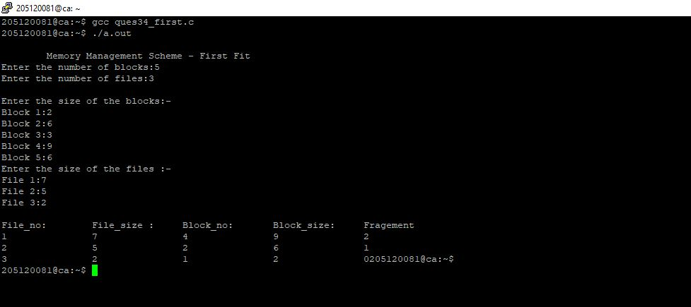

**Best Fit**

#include <stdio.h>

#include <conio.h>

#define max 25

void main()

{

int frag[max], b[max], f[max], i, j, nb, nf, temp, lowest = 10000;

static int bf[max], ff[max];

clrscr();

printf("\nEnter the number of blocks:");

scanf("%d", &nb);

printf("Enter the number of files:");

scanf("%d", &nf);

printf("\nEnter the size of the blocks:-\n");

for (i = 1; i <= nb; i++)

{

printf("Block %d:", i);

scanf("%d", &b[i]);

}

printf("Enter the size of the files :-\n");

for (i = 1; i <= nf; i++)

{

printf("File %d:", i);

scanf("%d", &f[i]);

}

for (i = 1; i <= nf; i++)

{

for (j = 1; j <= nb; j++)

{

if (bf[j] != 1)

{

temp = b[j] - f[i];

if (temp >= 0)

if (lowest > temp)

{

ff[i] = j;

lowest = temp;

}

}

}

frag[i] = lowest;

bf[ff[i]] = 1;

lowest = 10000;

}

printf("\nFile No\tFile Size \tBlock No\tBlock Size\tFragment");

for (i = 1; i <= nf && ff[i] != 0; i++)

printf("\n%d\t\t%d\t\t%d\t\t%d\t\t%d", i, f[i], ff[i], b[ff[i]], frag[i]);

getch();

}

**Output**

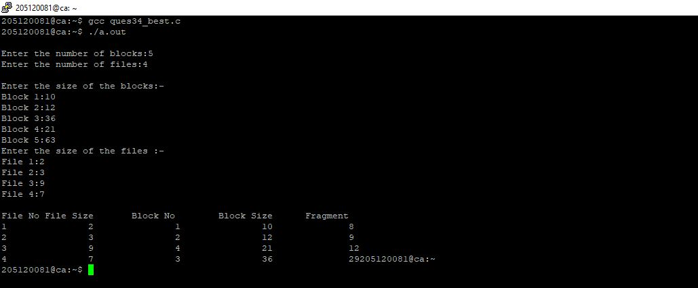

**34 Worst fit**

#include <stdio.h>

#include <conio.h>

#define max 25

void main()

{

int frag[max], b[max], f[max], i, j, nb, nf, temp, highest = 0;

static int bf[max], ff[max];

clrscr();

printf("\n\tMemory Management Scheme - Worst Fit");

printf("\nEnter the number of blocks:");

scanf("%d", &nb);

printf("Enter the number of files:");

scanf("%d", &nf);

printf("\nEnter the size of the blocks:-\n");

for (i = 1; i <= nb; i++)

{

printf("Block %d:", i);

scanf("%d", &b[i]);

}

printf("Enter the size of the files :-\n");

for (i = 1; i <= nf; i++)

{

printf("File %d:", i);

scanf("%d", &f[i]);

}

for (i = 1; i <= nf; i++)

{

for (j = 1; j <= nb; j++)

{

if (bf[j] != 1) //if bf[j] is not allocated

{

temp = b[j] - f[i];

if (temp >= 0)

if (highest < temp)

{

ff[i] = j;

highest = temp;

}

}

}

frag[i] = highest;

bf[ff[i]] = 1;

highest = 0;

}

printf("\nFile_no:\tFile_size :\tBlock_no:\tBlock_size:\tFragement");

for (i = 1; i <= nf; i++)

printf("\n%d\t\t%d\t\t%d\t\t%d\t\t%d", i, f[i], ff[i], b[ff[i]], frag[i]);

getch();

}

**Output**

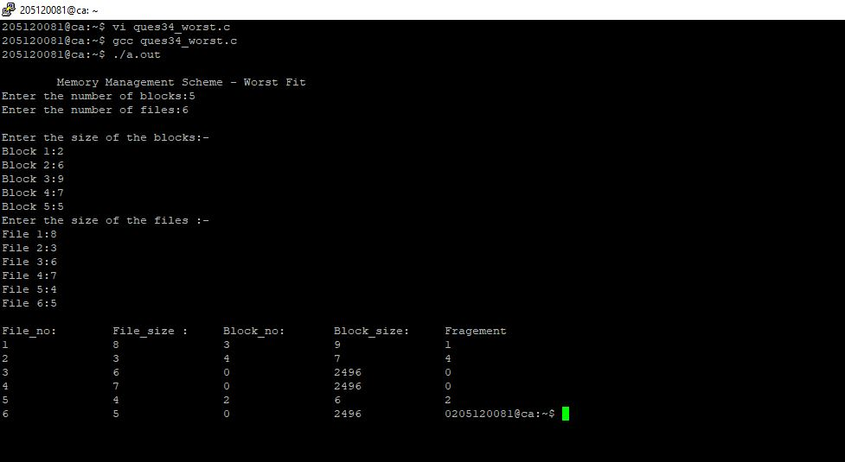

**Program 35.** Implement FIFO, Optimal, LRU and LFU page replacement algorithms.

**Source Code**

#include <stdio.h>

int n, nf;

int in[100];

int p[50];

int hit = 0;

int i, j, k;

int pgfaultcnt = 0;

void getData()

{

printf("\nEnter length of page reference sequence:");

scanf("%d", &n);

printf("\nEnter the page reference sequence:");

for (i = 0; i < n; i++)

{

scanf("%d", &in[i]);

}

printf("\nEnter no of frames:");

scanf("%d", &nf);

}

void initialize()

{

pgfaultcnt = 0;

for (i = 0; i < nf; i++)

p[i] = 9999;

}

int isHit(int data)

{

hit = 0;

for (j = 0; j < nf; j++)

{

if (p[j] == data)

{

hit = 1;

break;

}

}

return hit;

}

int getHitIndex(int data)

{

int hitind;

for (k = 0; k < nf; k++)

{

if (p[k] == data)

{

hitind = k;

break;

}

}

return hitind;

}

void dispPages()

{

for (k = 0; k < nf; k++)

{

if (p[k] != 9999)

printf(" %d", p[k]);

}

}

void dispPgFaultCnt()

{

printf("\nTotal no of page faults:%d", pgfaultcnt);

}

void fifo()

{

initialize();

for (i = 0; i < n; i++)

{

printf("\nFor %d :", in[i]);

if (isHit(in[i]) == 0)

{

for (k = 0; k < nf - 1; k++)

p[k] = p[k + 1];

p[k] = in[i];

pgfaultcnt++;

dispPages();

}

else

printf("No page fault");

}

dispPgFaultCnt();

}

void optimal()

{

initialize();

int near[50];

for (i = 0; i < n; i++)

{

printf("\nFor %d :", in[i]);

if (isHit(in[i]) == 0)

{

for (j = 0; j < nf; j++)

{

int pg = p[j];

int found = 0;

for (k = i; k < n; k++)

{

if (pg == in[k])

{

near[j] = k;

found = 1;

break;

}

else

found = 0;

}

if (!found)

near[j] = 9999;

}

int max = -9999;

int repindex;

for (j = 0; j < nf; j++)

{

if (near[j] > max)

{

max = near[j];

repindex = j;

}

}

p[repindex] = in[i];

pgfaultcnt++;

dispPages();

}

else

printf("No page fault");

}

dispPgFaultCnt();

}

void lru()

{

initialize();

int least[50];

for (i = 0; i < n; i++)

{

printf("\nFor %d :", in[i]);

if (isHit(in[i]) == 0)

{

for (j = 0; j < nf; j++)

{

int pg = p[j];

int found = 0;

for (k = i - 1; k >= 0; k--)

{

if (pg == in[k])

{

least[j] = k;

found = 1;

break;

}

else

found = 0;

}

if (!found)

least[j] = -9999;

}

int min = 9999;

int repindex;

for (j = 0; j < nf; j++)

{

if (least[j] < min)

{

min = least[j];

repindex = j;

}

}

p[repindex] = in[i];

pgfaultcnt++;

dispPages();

}

else

printf("No page fault!");

}

dispPgFaultCnt();

}

void lfu()

{

int usedcnt[100];

int least, repin, sofarcnt = 0, bn;

initialize();

for (i = 0; i < nf; i++)

usedcnt[i] = 0;

for (i = 0; i < n; i++)

{

printf("\n For %d :", in[i]);

if (isHit(in[i]))

{

int hitind = getHitIndex(in[i]);

usedcnt[hitind]++;

printf("No page fault!");

}

else

{

pgfaultcnt++;

if (bn < nf)

{

p[bn] = in[i];

usedcnt[bn] = usedcnt[bn] + 1;

bn++;

}

else

{

least = 9999;

for (k = 0; k < nf; k++)

if (usedcnt[k] < least)

{

least = usedcnt[k];

repin = k;

}

p[repin] = in[i];

sofarcnt = 0;

for (k = 0; k <= i; k++)

if (in[i] == in[k])

sofarcnt = sofarcnt + 1;

usedcnt[repin] = sofarcnt;

}

dispPages();

}

}

dispPgFaultCnt();

}

void secondchance()

{

int usedbit[50];

int victimptr = 0;

initialize();

for (i = 0; i < nf; i++)

usedbit[i] = 0;

for (i = 0; i < n; i++)

{

printf("\nFor %d:", in[i]);

if (isHit(in[i]))

{

printf("No page fault!");

int hitindex = getHitIndex(in[i]);

if (usedbit[hitindex] == 0)

usedbit[hitindex] = 1;

}

else

{

pgfaultcnt++;

if (usedbit[victimptr] == 1)

{

do

{

usedbit[victimptr] = 0;

victimptr++;

if (victimptr == nf)

victimptr = 0;

}

while (usedbit[victimptr] != 0);

}

if (usedbit[victimptr] == 0)

{

p[victimptr] = in[i];

usedbit[victimptr] = 1;

victimptr++;

}

dispPages();

}

if (victimptr == nf)

victimptr = 0;

}

dispPgFaultCnt();

}

int main()

{

int choice;

while (1)

{

printf("\nPage Replacement Algorithms\n1.Enter data\n2.FIFO\n3.Optimal\n4.LRU\n5.LFU\n6.Second Chance\n7.Exit\nEnter your choice:");

scanf("%d", &choice);

switch (choice)

{

case 1 :

getData();

break;

case 2 :

fifo();

break;

case 3 :

optimal();

break;

case 4 :

lru();

break;

case 5 :

lfu();

break;

case 6 :

secondchance();

break;

default :

return 0;

break;

}

}

}

**Output**

