# Metadata Enrichment - Serverless Capstone Project

Metadata Enrichment is a key exercise for Media personals. This capstone project will help news agency/channels to automate metadata enrichment. There are thousands of media assets coming every day to media agencies from different sources like photographers, social media, events and when these assets come to media firms, team managers have to manually categorize, label and position these images in respective locations for easy access.

### Solution:

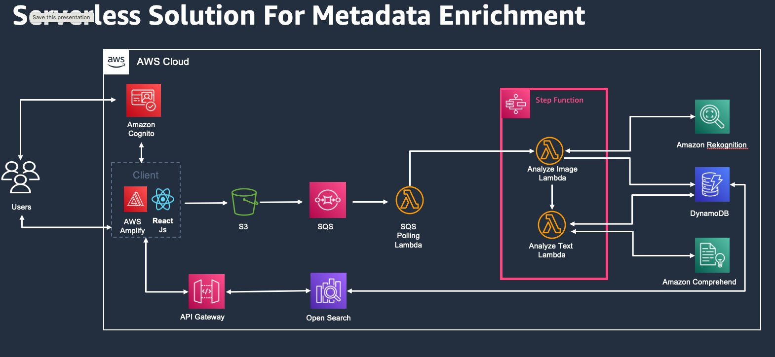

Serverless solution designed to automate the cumbersome process of asset tagging.

This solution consists of three main components :-

1) React Application to upload/view images

    Front end application to upload the assets directly and view the metadata.A react application which uses NodeJs as backend and uses amplify to deploy the application and add storage in S3 for storing media image(s).

2) Workflow that will be triggered whenever an S3 bucket receives an image

     S3 bucket is the landing zone where all the media assets will come initially. Whenever an asset is added to landing zone, it will trigger a notification in SQS. There will be lambda function that will poll SQS and will trigger Step functions workflow to analyze the asset using AI/ML capabilities for below use cases and output will be stored in Dynamo Db

1. Celebrity Face Detection
2. Text Recognition
3. Object Recognition
4. PPE Detection
5. PII Data
6. Sentiment Analysis

3) Search Component

Once the data is identified and stored in Dynamo db, dynamo db streams are configured that will make this data available for search using Amazon Open search service. Open search service is exposed as Rest API using API gateway and can be used in React application to search assets based on Metadata.

Services being used:

* Cognito
* Amplify
* S3
* Lambda
* Step Functions
* SQS
* DynamoDb
* Amazon OpenSearchService
* Amazon Rekognition
* Amazon Comprehend
* Api Gateway

### Assumption & Consideration:

As of now will support only Images with all major formats, processing of images will be asynchronous. Image size is limited to max of 5MB for simplicity.

### Delivery Model:

News Agency can use this out-of-box solution on their account using CDK/ Cloud formation templates.

### Impact:

As manual labelling on a normal image take around 1-2 minute, with our solution we can label images at scale in parallel. A small infra for POC can process 30 document per second. This will save manual efforts of labelling from days to few minutes.There are some existing solutions like Media2Cloud but they are very complex. Solution we are proposing will be an easy solution that can be leveraged by small customers too without any complexity and cost implications.

References :

<https://www.diva-portal.org/smash/get/diva2:1460858/FULLTEXT01.pdf>

<https://docs.aws.amazon.com/rekognition/latest/dg/limits.html>

<https://aws.amazon.com/solutions/implementations/media2cloud/>