Hayes: Safe for Some, Scary for Others
For many residents of London, safety has become a growing concern. Hayes is often seen as a vibrant and diverse area, but opinions on how safe it feels vary widely. While some residents say it feels familiar and comfortable, others describe it as unsettling, particularly after dark. Reporter Nitu Choudhary spoke to residents to see how they felt.

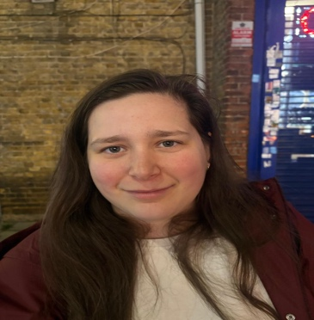
Haley Smith, 26, a receptionist and army veteran who has lived in Hayes for the past six years, said:
“Hayes feels safe during the day, but at night it becomes uncomfortable. Compared to other areas in London, it doesn’t feel as secure. During the daytime, it’s fine, but once it gets dark, we all become more cautious.”


Ceriga Brown, 22, a warehouse worker who has lived in Hayes for more than five years, shared similar concerns:
“If I get the opportunity to leave Hayes, I will do that. The crime rates here are increasing, and it’s not just women who feel unsafe — everyone does. You hear about thefts and fights quite often, and that makes the environment tense.”


Kailash Verma, 25, a student from India, had a more positive view:
“For me, Hayes is safe because I have my people here, and I feel at home. Crime happens everywhere, but here I can roam freely without looking at the time on my watch. That’s how comfortable I feel.”

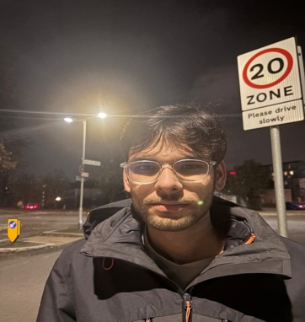
Mukesh Patel, 23, a self-employed resident from Mauritius, said:
“It’s safe during the daytime, but when it gets dark, I feel a bit uneasy, especially when walking alone. Still, I think it’s better than some other areas.”


Niki Thompson, 22, a British hairdresser from Richmond, said:
“It’s uncomfortable because when I walk out at night, I feel eyes following me everywhere. Hayes feels unsafe after dark, and if I ever get the chance to move somewhere else, I’ll take it.”

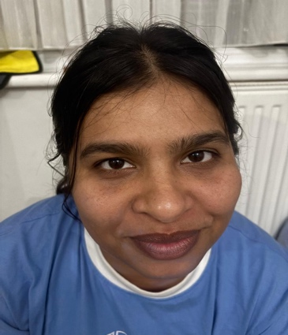
Krupali Prakashbhai Patel, 30, a student from India who works as a barista at Costa Coffee, said:
“It’s not safe at all, during both the day and at night. Some communities dominate the area, and sometimes people are assaulted when they are alone. While opinions differ, most residents agree that Hayes feels safer during the day than at night, and that community connections often shape how secure people feel in their surroundings.”

