1. pipeline {
3. tools {
4. git 'Default'
5. }
6. environment{
7. GIT_CREDENTIALS = credentials('Git')
8. }
9. agent any
10. stages {
11. stage('checkout') {
12. steps {
13. script{
14. checkout([$class : 'GitSCM',
15. branches : [[name: '*/main']],
16. userRemoteConfigs [[url:'https://github.com/nitukumarii/Terraform_EKS_Jenkns.git', credentialsId : 'GIT_CREDENTIALS']]])

19. }
21. }
22. }
23. }
24. }
25. After pipeline need to specify the tool we are going to use that is git here.
26. 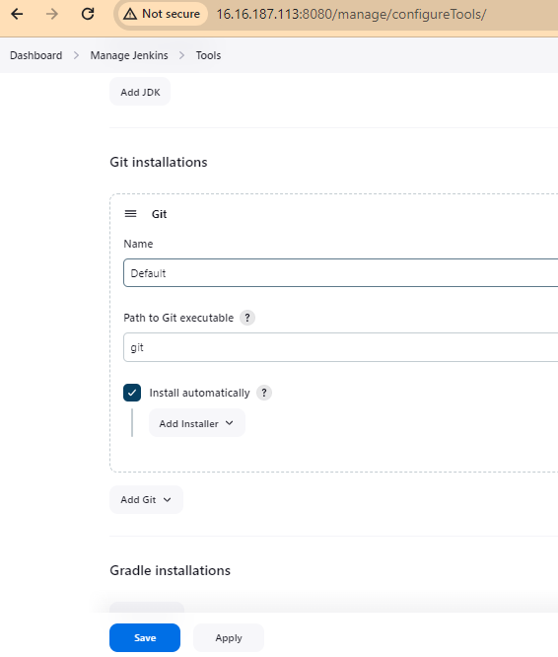
27. Credentials will be defined under environment block
28. GIT_CREDENTIALS = credentials('Git')

The above ‘Git’ is defined on the tool configuration of Jenkins

Jenkins Dashboard > Manage Jenkins > credentials   
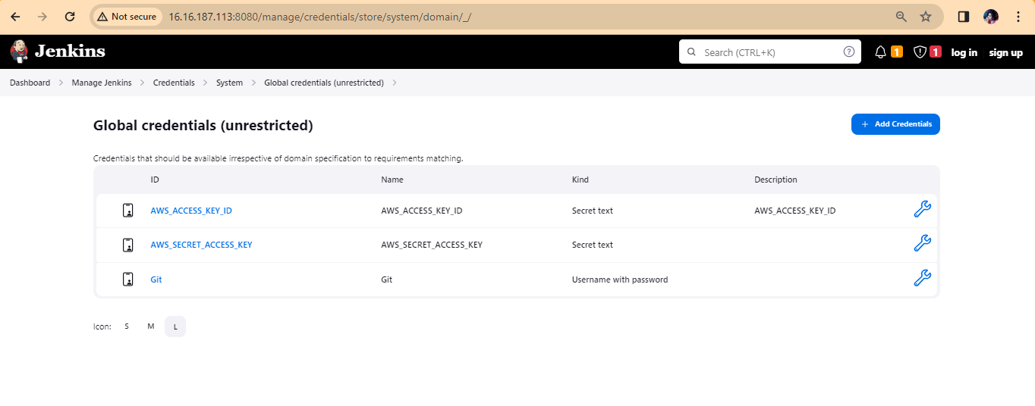

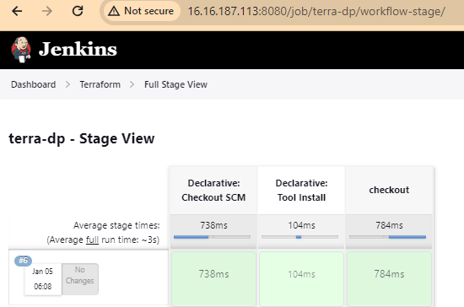

**Terraform init**

Copied terraform, from local machine to ubuntu machine  
>scp -i Jenkins.pem terraform.exe [ubuntu@16.16.187.113:/home/ubuntu/](mailto:ubuntu@16.16.187.113:/home/ubuntu/)

What is its not copying to the server  
  
1. Check if server is running out of space – df -h

2. free -m – check memory , might be possible swap memory is 0  
make space for swap   
  
**sudo fallocate -l 1G /swapfile**

**sudo chmod 600 /swapfile**

**sudo mkswap /swapfile**

**sudo swapon /swapfile**

**3.**check is ssh service is running  
sudo service ssh status  
  
4.check the directory permission and give ownership and permission of write  
  
**ls -ld /home**

**chmod jenkins:jenkins 777 terraform**

**sudo chmod +w /home**

**sudo chown ubuntu:ubuntu /home**

NOTE🡪> no need to specific terraform path,just need to mention .pem file and in same location file should present which we need to copy



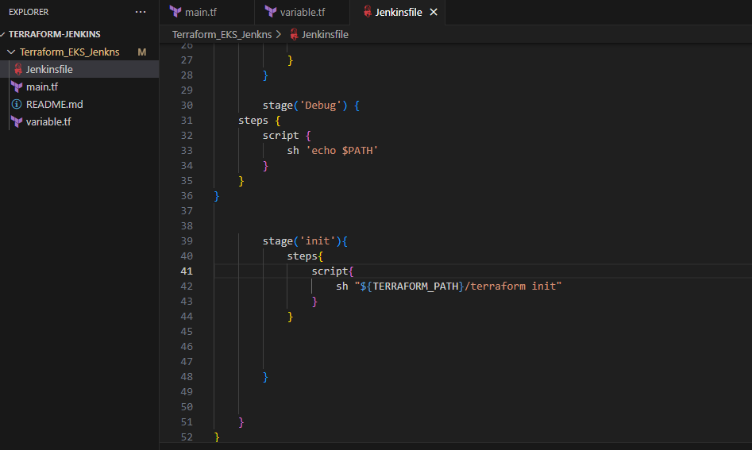

**Note**

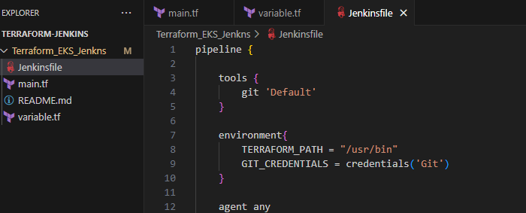

**Terraform path –** It will be the path where of ubuntu server not the local machine terraform.exe file path .  
  
when I was trying with local machine path C:\Users\USER\Downloads\terraform.exe , it was throwing me error or init was getting failed.  
  
After correcting this ….**terraform permission issue** was there

Sudo su - : From ubuntu user to root user   
chown Jenkins:Jenkins terraform : transfer the ownership to Jenkins user   
chmod 777 terraform : gave full permission

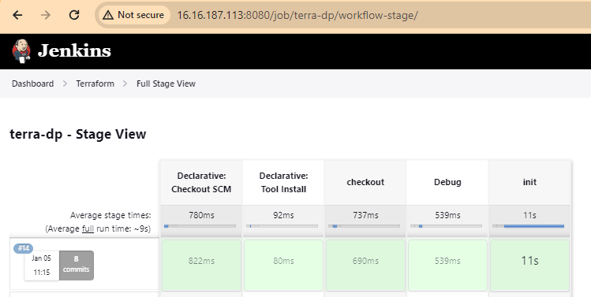

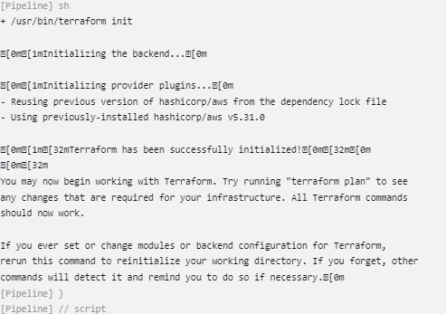

Error.

1. $env:Path -split ';'  
   to check path of terraform – the same should be updated on path variable of system
2. Terraform command not found  
   Reinstalled Terraform  
   set path …best practice C:\System32\terraform.exe (unzip and save at this location) ,restart system
3. Best practice – terraform init -upgarde
4. terraform {
5. required_providers {
6. aws = "~> 3.0.0"
7. terraform = ">= 1.6.6"
8. }
9. }
10. in main.tf file this should be defined
11. 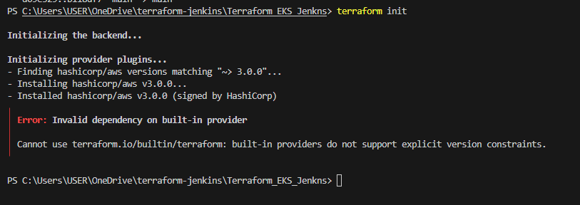

Defining terraform version was throwing error. Hence

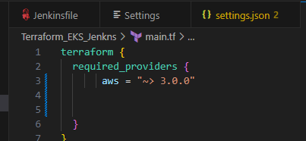

Removed the terraform version from main.tf  
  
  
6. 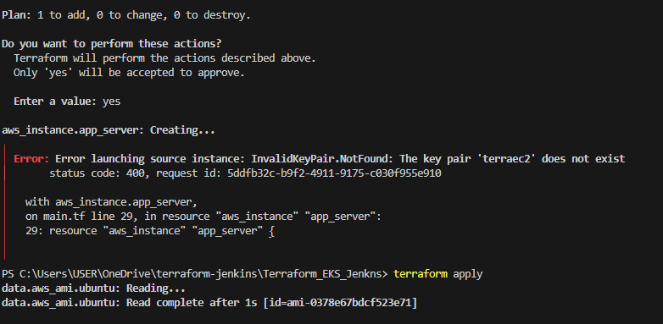

This error arised bcz key pair should be in same region as of ec2 instance

1. 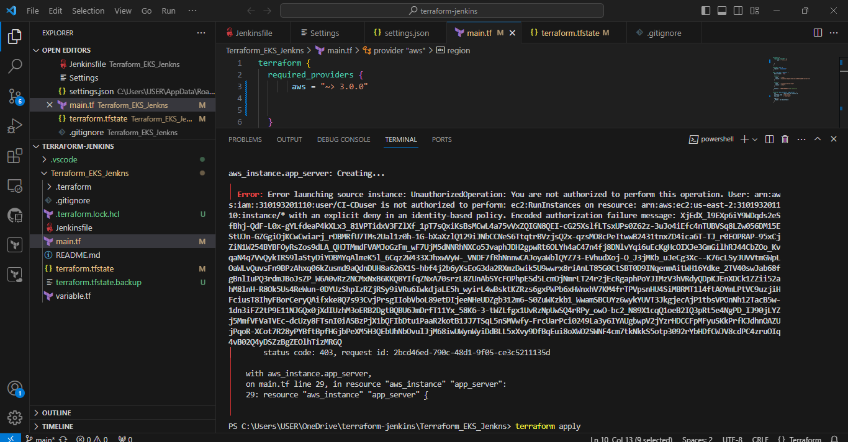

Authorization error   
  
1. Aws configure -configure the awscli

Access key – same as mentioned in main.tf

Secret access key – same as mentioned in main.tf

Aws region – same as main .tf configuration file

Defult format – json  
  
  
2. There was issue with policy I define, so the below policies works fine for terraform   
  
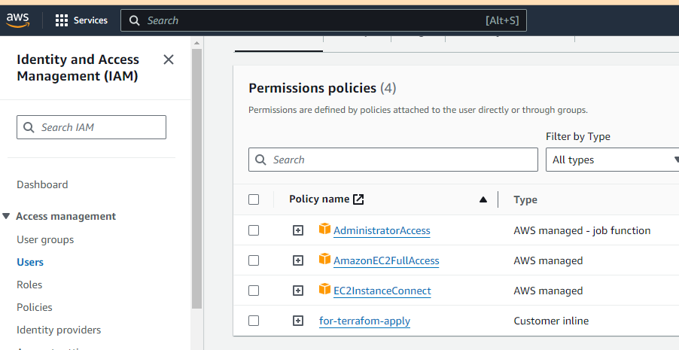

Terraform Plan  
  
Terraform apply  
  
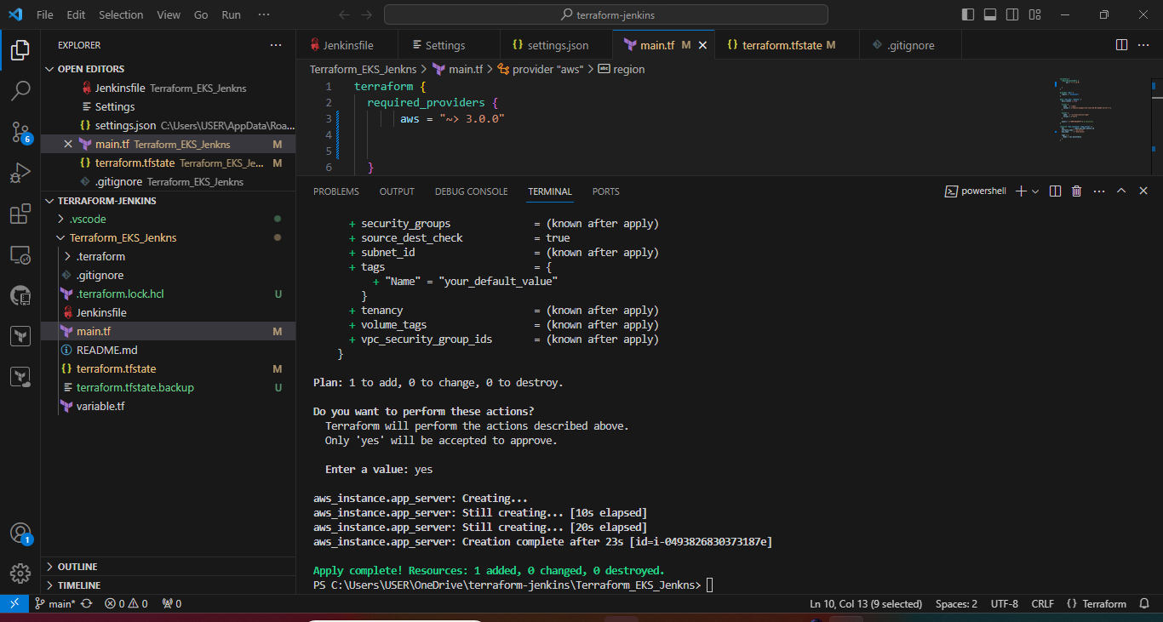

<https://github.com/nitukumarii/Terraform_EKS_Jenkns>

