1.Terraform installation –

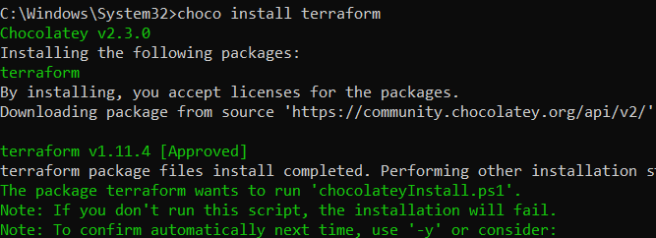

Cmd as administrator and then above command.

2.Github account

3.git installation

4.VSC installation

5.AWS cli installation

<https://docs.aws.amazon.com/cli/latest/userguide/getting-started-install.html>

6.Set up aws profile -> after installating cli -> 1. aws --version

2. aws configure :

* to set up your credentials or to set profile name use flag -profile with aws configure
* aws configure --profile profile name

7.access key - \*\*\*\*\*\*\*\*\*\*\*\*\*\*\*\*\*\*\*\*\*\*\*\*

Secret key - \*\*\*\*\*\*\*\*\*\*\*\*\*\*\*\*\*\*\*\*\*\*\*\*\*

This will create entries in these files: ~/.aws/credentials AND ~/.aws/config

aws configure --profile myproject-dev

8.Verify : aws sts get-caller-identity