**Name of Student**: Nitun Datta

**Name of Project**: AdventureBook

**Project's Purpose or Goal**: *(What will it do for users?)*

Project Purpose: Adventure lovers can share their outdoor activity pictures and stories on my website. So other users can view pictures and learn about places and activities. Users can comment and like the picture.

Advertising partners can post add on their outdoor gears, clothes, bag, tent, etc. with product URL and details. When a user will post a picture, they can tag all the outdoor gears or other stuff in the picture. If other user clicks on those tag items, they will be redirected to the product website. For each click user who posted that picture will earn a commission for flowing traffic to the product site.

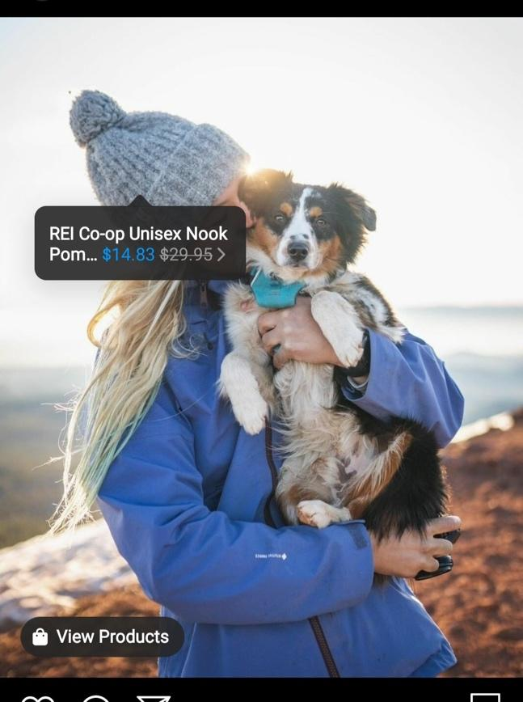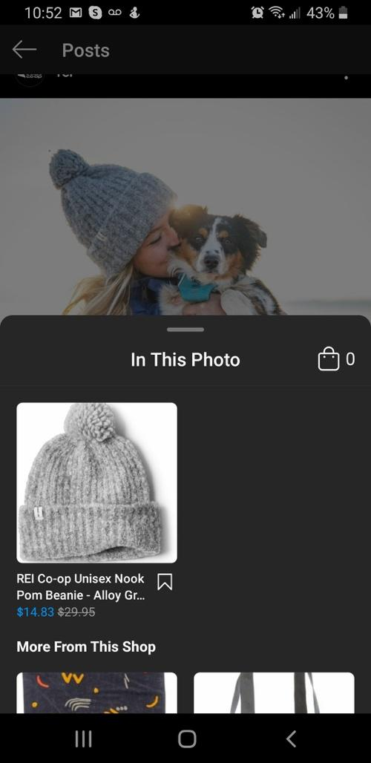

This a great way outdoor adventurers can make money and share stories with others. Also, the product seller can increase their online sell by getting more traffic from my website.

**List the absolute minimum features the project requires to meet this purpose or goal:**

* Users can post pictures and tag items on the picture.
* Advertisers can post add to the website.
* Show earning reports to the user.
* Show traffic flow reports to advertisers.

**What tools, frameworks, libraries, APIs, modules, and/or other resources (whatever is specific to *your* track, and *your* language) will you use to create this MVP? List them all here. Be specific.**

* React, Redux
* C# core, Dot.net MVC
* Mysql

**If you finish developing the** [**minimum viable product (MVP)**](https://www.learnhowtoprogram.com/lessons/the-minimum-viable-product) **with time to spare, what will you work on next? Describe these features here: Be specific.**

* Add some image filtering similar to Instagram.
* Integrate affiliate partner API like [“Avantlink”](https://www.avantlink.com/) for affiliate advertisement.

**What additional tools, frameworks, libraries, APIs, or other resources will these additional features require?**

* C# RESTful service

**Is there anything else you'd like your instructor to know?**