

**From Data to Decisions: A Strategic Modelling on Lead Conversions for World Plus**

|  |  |
| --- | --- |
| ID number | 5533066 |
|  | 5548256 |
|  | 5582564 |
|  | 5559080 |
|  | 5582755 |
|  | 5579997 |

**2023. 12**



# **Masters Programmes: Group Assignment Cover Sheet**

|  |  |
| --- | --- |
| **Student Numbers:** Please list numbers of all group members | **5533066, 5548256, 5582564, 5559080, 5582755, 5579997** |
| **Module Code:** | **IB94Z0** |
| **Module Title:** | **Analytics in Practice** |
| **Submission Deadline:** | **06/12/23** |
| **Date Submitted:** | **05/12/23** |
| **Word Count:** | **1952** |
| **Number of Pages:** | **18** |
| **Question Attempted:**  *(question number/title, or description of assignment)* | **A Strategic Modelling on Lead Conversions for World Plus** |
| **Have you used Artificial Intelligence (AI) in any part of this assignment?** | **No** |
| **Academic Integrity Declaration**  We're part of an academic community at Warwick. Whether studying, teaching, or researching, we’re all taking part in an expert conversation which must meet standards of academic integrity. When we all meet these standards, we can take pride in our own academic achievements, as individuals and as an academic community.  Academic integrity means committing to honesty in academic work, giving credit where we've used others' ideas and being proud of our own achievements.  In submitting my work, I confirm that:   * I have read the guidance on academic integrity provided in the Student Handbook and understand the University regulations in relation to Academic Integrity. I am aware of the potential consequences of Academic Misconduct. * I declare that this work is being submitted on behalf of my group and is all our own, , except where I have stated otherwise. * No substantial part(s) of the work submitted here has also been submitted by me in other credit bearing assessments courses of study (other than in certain cases of a resubmission of a piece of work), and I acknowledge that if this has been done this may lead to an appropriate sanction. * Where a generative Artificial Intelligence such as ChatGPT has been used I confirm I have abided by both the University guidance and specific requirements as set out in the Student Handbook and the Assessment brief. I have clearly acknowledged the use of any generative Artificial Intelligence in my submission, my reasoning for using it and which generative AI (or AIs) I have used. Except where indicated the work is otherwise entirely my own. * I understand that should this piece of work raise concerns requiring investigation in relation to any of points above, it is possible that other work I have submitted for assessment will be checked, even if marks (provisional or confirmed) have been published. * Where a proof-reader, paid or unpaid was used, I confirm that the proof-reader was made aware of and has complied with the University’s proofreading policy.   **Upon electronic submission of your assessment you will be required to agree to the statements above** | |

Table of Contents

**From Data to Decisions: A Strategic Modelling on Lead Conversions for World Plus** 0

**Masters Programmes: Group Assignment Cover Sheet** 1

Abstract 3

1 Introduction 4

2 Data Processing 5

3 Modelling and Literature Review 7

3.1 Decision Tree 7

3.2 Support Vector Machine (SVM) 7

3.3 Random Forest 7

3.4 Logistic Regression 8

3.5 Naïve Bayes 8

4 Evaluation 9

5 Conclusion 11

Bibliography 12

Appendices 13

Abstract

Effectively identifying and actively engaging prospective customers with a high probability of conversion is of utmost importance in optimising marketing expenditures. This research project employs the CRISP-DM methodology to systematically address the challenge. Through comprehensive data and processing, the Support Vector Machine (SVM) model, exhibiting superior accuracy among five constructed models, was chosen to establish a lead prediction system. Our findings indicate that the SVM model demonstrates robust predictive capabilities, showcasing its potential for impactful practical applications in customer acquisition and conversion efforts.

1. Introduction

A critical success factor for banking and financial service companies is the ability to identify and capitalise on prospective customers; therefore, World Plus, a mid-size private bank, plans to implement a lead conversion system for their new term deposit product to minimise their costs with the challenge of accurately predicting leads. This report aims to provide insight and solutions that align with World Plus's objectives to enhance accurately predicting targeted customers through data mining techniques. The Cross-Industry Standard Process for Data Mining (CRISP-DM) methodology will be employed along with this report which each process can be observed in Figure 1. In the first section, the data processing will be discussed, followed by modelling and methods used for prediction including Decision Tree, Support Vector Machine (SVM), Logistic Regression, Random Forest, and Naïve Bayes with brief literature reviews. After modelling, each model will be evaluated using tools such as Confusion Matrix, Receiver Operating Characteristic curve (ROC), or Gain Chart to pinpoint the most effective model for enhancing accurate customer targeting, culminating in a conclusion that summarises insights and proposes actionable plans for World Plus.

Figure 1 CRISP-DM Framework

1. Data Processing

The dataset, consisting of 220,000 records from past product offerings, focused on identifying customer purchases using 15 predictors (see Appendix A for data dictionary). To ensure the accuracy and efficiency of the predictive models, data preparation plays a fundamental role. The very first step is to clean the data by handling data type, missing values and outliers that show in the dataset. Overall, there are diverse ways to solve these problems, however, our approach is to apply A/B testing to test the different methods on the different models to find the best performance measured by confusion matrix that is suitable to our goals. Therefore, the missing values were omitted while the outliers remained because there were no strange or errors with this information. For data type, one hot encoding was used to deal with the nominal variables because SVM and Logistics Regression model, which will be used later, do not work well with this type of categorical variables (see Appendix B.1 for one hot encoding). In the next step, before doing the data partition, the information gain of the predictors on the target variable had been checked so, we could eliminate the attributes that had a low level of importance to the target variable (see Appendix B.2 for Information gain plot). This helps avoid overfitting and improve the performance of the predictive models. After that, stratified sampling with the ratio of 2:1 was used to create the training and test set for modelling because we want to ensure the homogeneity among the groups and avoid information loss from false negative results.

According to the research paper “Credit risk assessment for unbalanced datasets based on data mining, artificial neural network and support vector machines” (Khemakhem et al, 2018), the banks have recently utilised the development of data mining techniques to identify credit risks. However, they lacked attention to the imbalanced dataset problem, which led to the inaccuracy of the predictive models. The insolvent clients, who needed to be considered to minimise risks in practice, were not identified in the models because they fell into the minority class. Therefore, the authors must apply re-sampling techniques as a solution to modify the class distribution of the dataset and measure the performance of these methods on the different predictive modelling. Similar to our dataset, there is a huge gap between the non-target and target customers as can be observed in Figure 2. 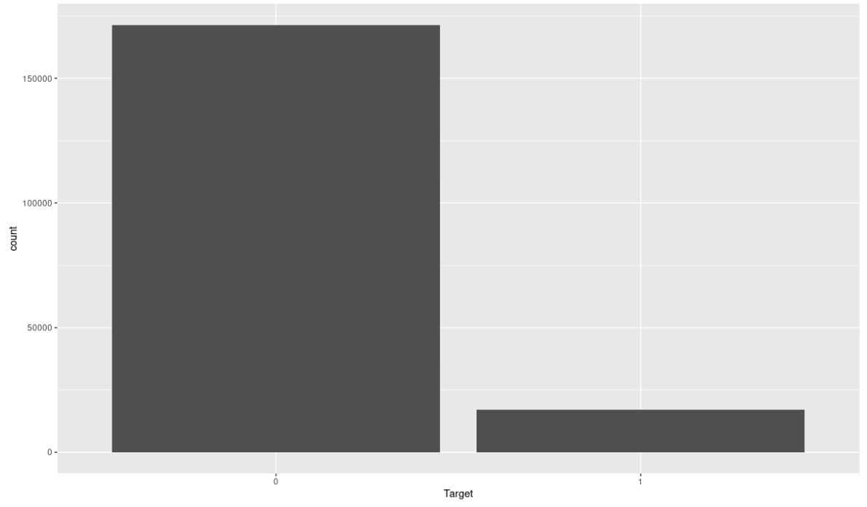

Figure 2 The number of non-targets (0) and targets (1)

Inspired by the method in the research paper, we applied Random Oversampling (ROS), Random Under sampling (RUS) and both, ROS and RUS, at the same time to balance the dataset and compared their performance with the original unbalanced dataset. Logistics Regression and Random Forest models were randomly picked to test on to avoid biased results.

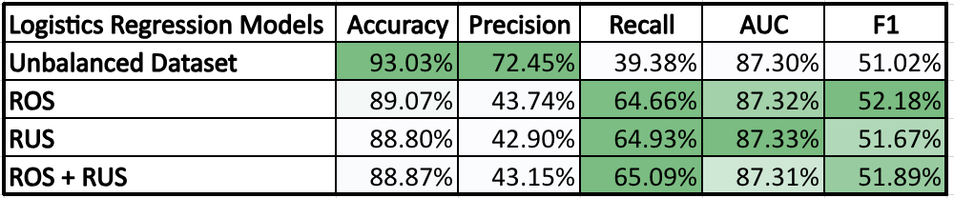

Figure 3 The results of different sampling methods on LR model

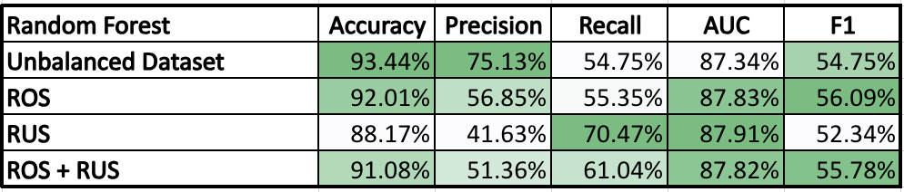

Figure 4 The results of different sampling methods on RF model

According to the results from Figure 3 and 4, ROS + RUS performed quite well in both models and did not overfit compared to the other strategies in models. Therefore, we decided to apply both ROS + RUS at the same time to balance the original dataset.

1. Modelling and Literature Review

To identify the potential target audience for World Plus, we can utilise diverse predictive modelling methods by training on historical customer data. The selection of these models was based on their relevance to identifying target customers in many academic papers and data-driven projects.

* 1. Decision Tree

The appropriateness of Decision Tree Modelling for our project lies in its effectiveness in identifying potential targets and the attributes that influence the target most, especially those likely to convert or leave. Therefore, its usefulness can be found in interpreting and visualising the results of the model. Inspired by "Applying data mining to telecom churn management" (Hung et al, 2006), Decision Tree Modelling has been employed in Telecom Churn Management to identify potential churners to organise targeted marketing strategies and enhance customer retention rates. Our project shares similarities with churn management, emphasising the identification of valid targets to optimise budget and marketing activities. By leveraging Decision Tree Modelling, we aim to understand the distinguishing features of our target audience, utilising Information Gain to reduce ambiguity in target definition.

* 1. Support Vector Machine (SVM)

Support Vector Machines are linear classifiers, that classify data by solving optimisation problems to establish the optimal separation plane between datasets and can also be applied to nonlinear problems by kernel function transformations. The efficiency of SVM is also supported by other research scholars (Xiahou et al, 2022; Buathong et al, 2021), who applied different techniques and parameters to optimise the data classification performance of SVM. Although SVM works effectively for churn prediction, the implementation of all data in this SVM might be delayed.

We used two SVM models with different kernel functions radial and linear and obtained the confusion matrix for both the models. Linear kernel is the simplest kernel function, which represents a linear relationship between data points. It is computationally efficient but limited to linear data separation. Radial basis function (RBF) kernel is based on the Gaussian radial basis function, which assigns higher weights to data points closer to the centre of the kernel.

* 1. Random Forest

The appropriateness of Random Forest for this project is justified based on its ensemble learning nature, feature importance analysis, high accuracy, robust performance, and balanced metrics.

Random Forest employs an ensemble of decision trees, mitigating overfitting and improving generalisation to new data. This approach enhances the model's predictive power by combining multiple weak learners into a strong learner (Breiman, 2001). It also provides a measure of feature importance, allowing for the identification of key attributes influencing the model's predictions. This aligns with the project's objective of understanding the distinguishing features of the target audience (Liaw and Wiener, 2002). The achieved accuracy on the dataset demonstrates the model's effectiveness in correctly classifying instances, making it well-suited for target customer identification. Its robustness and ability to handle large datasets with diverse features makes it suitable for the scale and complexity of the provided dataset.

* 1. Logistic Regression

The Logarithmic Regression model is well-suited for binary classification tasks. One use of logistic regression is to estimate the probability that an event will occur using information or characteristics that are thought to be related to or influence such events. Logistic regression can show which of the numerous factors being assessed has the strongest association with an outcome and provides a measure of the magnitude of the potential influence. It also can “adjust” for confounding factors, i.e., factors that are associated with both other predictor variables and the outcome, so the measure of the influence of the predictor of interest is not distorted by the effect of the confounder (Tolles and Meurer, 2016).

* 1. Naïve Bayes

Naïve Bayes is a simple structure model with the assumption that the attributes are independent. Despite this unrealistic assumption, Festus and Barnabas (2012) stated that the model has surprisingly superior performance over many datasets even though there is a strong attribute dependence compared to other classifiers.

According to A Data Mining-Based Response Model for Target Selection in Direct Marketing (Festus and Barnabas, 2012), Naïve Bayes Classifier was employed to identify customers who are likely to respond to new product offerings in Ebedi Microfinance bank with the results of high accuracy and TPR. The objective of this research is similar to our World Plus's project which aims to predict customers who will convert and purchase their new term deposit product; therefore, we select Naïve Bayes as one of our testing models.

1. Evaluation

We used the data to create five models to predict the lead conversion for World Plus. The results of these models shown in Figure 5 were used to predict the best model for the bank. There is always a trade-off between precision and recall due to their inverse relation illustrated in formulations below. We settle for the results where our models are performing well in terms of identifying and correctly classifying the positive instances.

（4-1）

（4-2）

According to Figure 5, logistic regression exhibits the highest recall in comparison, although it does not achieve the highest precision. The Random Forest (RF) and Support Vector Machine (SVM) models yield comparable results, with slightly elevated accuracy and precision observed in the SVM model, along with a superior Gain Chart outcome considered in Figure 6. The SVM model emerges as the most accurate classification model, achieving 91.31% accuracy, 52.54% precision, 55.54% F-measure, and 58.90% recall (see Appendix C for more detail of results).

Despite the SVM model's superior performance, certain limitations should be acknowledged. These include potential computational intensity when handling large datasets, sensitivity to noise and outliers, and the critical impact of kernel selection on model performance and outcomes. These considerations are crucial in the meticulous construction of the model.

Figure 5 The evaluation of each model

Figure 6 Gain Chart of all models

The ROC in Figure 7 shows the performance of the classification model at all classification thresholds to understand the trade-off between true positive rate and false positive rate which RF, Logistic regression and SVM models achieve high and almost identical Area Under the Curve (AUC) values.

Figure 7 ROC compared the performance of each model and baseline

1. Conclusion

In conclusion, selecting the model with the highest accuracy is crucial for enhancing World Plus's ability to accurately identify leads. Considering the high cost of time and money, we prioritise the model with the highest precision to minimise the cost of false positives in targeting uninterested customers. Additionally, the F-Measure is considered to avoid missing potential customers. To maintain market competitiveness, the bank should make full use of machine learning, specifically the SVM model, for lead prediction. Our evaluation tools include Precision, Recall, accuracy, and area under the ROC curve to identify the best model to develop a lead conversion prediction aiming to target prospective customers through strategic communication channels which SVM proves to be the most efficient model with high precision and accuracy.

Bibliography

Breiman, L. (2001) Random forests. *Machine Learning*, 45 (1): 5–32.

Buathong, W. & Jarupunphol, P. (2021) Dengue fever prediction modelling using data mining techniques. *International Journal of Data Mining and Bioinformatics*, 25 (1/2): 103–127.

Festus Ayetiran, E. & Barnabas Adeyemo, A. (2012) A data mining-based response model for target selection in direct marketing. *International Journal of Information Technology and Computer Science*, 4 (1): 9–18.

Khemakhem, S. & Ben Said, F. & Boujelbene, Y. (2018) Credit risk assessment for unbalanced datasets based on data mining, artificial neural network, and support Vector Machines. *Journal of Modelling in Management*, 13 (4): 932–951.

Liaw, A. & Wiener, M. (2002) Classification and regression by randomForest. *R news*, 2 (3): 18-22.

Shin-Yuan Hung, David C. Yen, Hsiu-Yu Wang. (2006) Applying data mining to telecom churn management. *Expert Systems with Applications*, 31:515-524.

Tolles, J. & Meurer, W.J. (2016) Logistic regression. *JAMA*, 316 (5): 533–534.

Xiahou, X. & Harada, Y. (2022) B2C e-commerce customer churn prediction based on K-means and SVM. *Journal of Theoretical and Applied Electronic Commerce Research*, 17 (2): 458–475.

Appendices

**Appendix A**

Data Dictionary

**Appendix B**

Figure B.1 One hot encoding and removing irrelevant data

Figure B.2 Information Gain

**Appendix C**

The results of each model from Confusion Matrix

Figure C.1 Decision Tree

Figure C.2 SVM

Figure C.3 Random Forest

Figure C.4 Logistic Regression

Figure C.5 Naïve Bayes from Confusion Matrix

