# PRD: Learno

### TL;DR

In today’s digital-first learning environment, YouTube is a go-to platform for self-learners across the globe. With its vast library of free educational videos, it holds the potential to democratize learning at scale. However, the sheer volume of content, lack of structure, and inconsistent quality often leave learners overwhelmed rather than empowered. Unlike structured platforms such as Udemy, Coursera, or LinkedIn Learning, YouTube lacks a guided pathway that ensures progressive skill-building.

***Learno*** aims to bridge this gap by transforming scattered YouTube content into structured, course-like journeys. By leveraging AI, we will curate, sequence, and personalize YouTube videos into coherent learning modules, enriched with interactive features such as summaries, notes, quizzes, and gamified challenges. This solution will empower learners to move from confusion to confidence — learning effectively while staying motivated and engaged.

## Goals

**User Goals**

* Instantly receive a structured, high-quality video-based learning path tailored to their search query and learning style
* Support highly personalized learning by letting users define preferred modalities (visual, auditory, reading/writing, kinesthetic), with the AI adapting content structure and presentation accordingly.
* Build understanding with live-inserted quizzes and checkpoints at relevant moments in the AI-generated syllabus.
* Celebrate progress and encourage completion with adaptive dashboards—progress is tracked per unique learning path, not set curricula.
* Experience continuous, actionable feedback and recommendations, updated in real time as their needs and performance evolve.

**Non-Goals**

* Producing original video content (focus is on real-time intelligent curation, not production).
* Supporting paid or proctored certificates at launch.
* Building a native mobile app (focus on responsive web experience for v1).

## User Personas

## *Persona 1: The Visual Learner*

Name: Ananya Sharma  
Age: 20  
Background: Design student exploring UI/UX on YouTube  
Learning Style: Visual — understands concepts best with diagrams, infographics, and video demonstrations

*Goals:*

* Learn UI/UX tools like Figma and Adobe XD
* See real-world design walkthroughs instead of just theory

*Frustrations:*

* Playlists are cluttered, with no clear sequence from basics to advanced
* Videos often jump around without structured visual progression

*Needs from Product:*

* Video segments focused on design workflows (screen recordings, walkthroughs)
* Auto-generated flowcharts or mind maps summarizing modules
* Curated “visual-first” explanations

## *Persona 2: The Auditory Learner*

Name: Rohan Patel  
Age: 24  
Background: MBA student upskilling in Finance & Economics  
Learning Style: Auditory — prefers listening to explanations, discussions, and lectures

*Goals:*

* Master financial modeling basics before internship
* Absorb concepts by listening while commuting

*Frustrations:*

* Videos have long, filler content, making it hard to find clear explanations
* Struggles when visuals are too text-heavy

*Needs from Product:*

* Clear, narration-driven video recommendations
* Podcast-style audio summaries of key modules
* Transcript-to-audio support for offline listening

## *Persona 3: The Reading/Writing Learner*

Name: Priya Iyer  
Age: 27  
Background: Working professional, preparing for Data Analytics certification  
Learning Style: Reading/Writing — learns best through notes, documentation, and written summaries

*Goals:*

* Build structured knowledge for certification prep
* Create reusable study material from YouTube content

*Frustrations:*

* YouTube lacks consolidated notes or transcripts
* Wastes time pausing videos to take notes manually

*Needs from Product:*

* Auto-generated text notes and summaries for each module
* Ability to highlight, annotate, and export notes
* Flashcards and quick-reference guides built from transcripts

## *Persona 4: The Kinesthetic Learner*

Name: Aditya Verma  
Age: 22  
Background: Engineering student learning Python programming  
Learning Style: Kinesthetic — prefers hands-on practice and “learning by doing”

*Goals:*

* Become proficient in Python to crack coding interviews
* Apply concepts through coding exercises

*Frustrations:*

* Tutorial videos often lack real coding challenges
* Gets demotivated without practice checkpoints

*Needs from Product:*

* Step-by-step coding challenge videos
* Embedded exercises and “try it yourself” tasks after modules
* Quizzes and crosswords to reinforce practice

## Functional Requirements

* **AI-Powered Live Path Generation**
  + Users enter a query or topic; AI instantly constructs a structured learning path mapped against leading syllabi and in-demand skills, customized to parameters like depth, expertise, or time frame.
  + No learning tracks, lessons, or courses are pre-curated or static—each path is built fresh, on demand, for the user’s chosen topic.
* **Real-Time Video Curation & Syllabus Mapping**
  + On each search, AI finds and arranges relevant, high-quality YouTube videos into a logical, pedagogically sequence, dynamically reflecting up-to-date resources and curriculum structures.
* **Interactive Learning Tools**
  + Quizzes and knowledge checks are inserted at strategic points within each AI-generated path.
  + Immediate feedback and explanations are generated and contextualized according to the specific user’s progress in their dynamic path.
  + Track and visualize completion, quiz performance, and time spent on per-path basis

## User Experience

**Landing Page**

* The landing page demonstrates how, with a single search, the platform instantly creates a fresh, structured video learning journey tailored to the user’s topic and style.
* Takes input from the user for the topic they want to learn along with the learning style they would prefer.

**Core Experience**

1. **Search & Path Generation:**
   * User enters a topic or question (e.g., “Linear Regression for Beginners”).
   * AI builds a structured learning path live, drawing from updated syllabus templates, the latest YouTube video resources, and user’s preferences.
   * The generated experience is unique: no pre-defined, one-size-fits-all tracks.
2. **Navigation & Personalization:**
   * Videos are organized live into a logical, personalized sequence.
   * Each step of the path offers video, transcript, and active learning tasks—automatically adjusted to user’s preferred learning modality on the fly.
   * Navigation is adaptive: If the concept is not clear to the user, they can watch the alternative suggested video for the same concept
3. **Interactive Checkpoints:**
   * Contextual quizzes and exercises (created dynamically alongside the video path) reinforce learning, adapting to each user’s performance.
   * Explanations and remediation are delivered instantly as users engage.

## Success Metrics

**User-Centric Metrics**

* 1. **Module Completion Rate:** Percentage of users who complete the dynamically generated learning path per topic.
  2. **Content Satisfaction:** User rating or optional feedback on curated module flows and video selection.
  3. **Session Engagement Time:** Average time spent per learning track/session or per module.
  4. **Repeat Usage:** Percentage of users who return to generate new learning tracks within a 30-day window.

**Business Metrics**

* 1. **New User Activation:** Number and conversion rate of new users completing their first curated module experience.
  2. **User Retention (Day 7/30):** Proportion of users returning to use the platform after 1 week and 1 month.
  3. **Cost per Curated Track:** Average operational/resource cost to generate and deliver a new custom track.

**Technical Metrics**

* 1. **Dynamic Track Generation Latency:** Average time taken by AI to analyze, map, and assemble a new topic path.
  2. **Uptime:** Percentage of time the platform/API remains available and responsive.
  3. **Video Link Reliability:** Rate of broken/missing/inaccessible YouTube links within curated tracks.
  4. **Personalization Accuracy:** Proportion of cases where the module structure matches or closely aligns with major platforms’ syllabi.
  5. **Error & Crash Rate:** Number of failed queries, video loads, or session drops per 1,000 sessions.

## Technical Considerations

**Technical Needs**

* **AI Model:** Capable of interpreting any topic query and generating structured learning paths on demand, aligning with up-to-date syllabi and mapping to available video content.
* **APIs:** Google Search API restricted to YouTube search for live search/embed; OER/curriculum APIs for structure; real-time user preference adapters.
* **Data Models:** Adaptive Quizzes, Real-Time Progress.
* **Front-end:** Responsive, accessibility-first interface; adaptive rendering to support live content assembly and personalization.
* **Back-end:** Real-time AI-driven path assembly, curation algorithms.

**Data Storage & Privacy**

* Compliance with global privacy standards (GDPR, etc.).
* No persistent storage of video media—live linking/referencing only.
* All data structures support rapid generation and deletion per new search.

**Scalability & Performance**

* Infrastructure designed for high-frequency, low-latency AI-driven requests.
* Elastic scaling of path-generation services.
* Resilience to third-party API limits and content churn on YouTube.

**Potential Challenges**

* Ensuring AI maintains curriculum quality and logical sequencing in real time.
* Responding rapidly to shifting or missing video resources.
* Fine-tuning personalization without defaulting to static experiences.
* Intellectual property and compliance in automated curation.

## Milestones & Sequencing

**Product Phases**

**Phase 1: Live Path Generation MVP (Current)**

* Deliver landing page, onboarding, AI-driven learning path generator triggered by user search.
* Integrate YouTube video search/embedbased on learning path generated

**Phase 2: Real-Time Video, Quiz, & Progress (Future enhancements)**

* Dynamic quiz generation, real-time progress.
* Launch user preference intake, adaptive learning modes, accessibility support.
* Gather feedback from the user and real-time update the content on the basis of feedback

## N8N AI Agent Workflow –

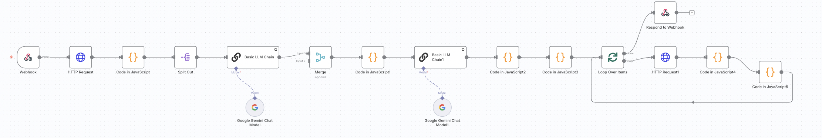

Github link - <https://github.com/nityaagrawa/Learno-website/blob/525266ed7d45d6102930e057b3c6ce6ac7954b62/Learno%201%20masked.json>

## User Interface –

Github Repository - <https://github.com/nityaagrawa/Learno-website>

**Landing Page –**

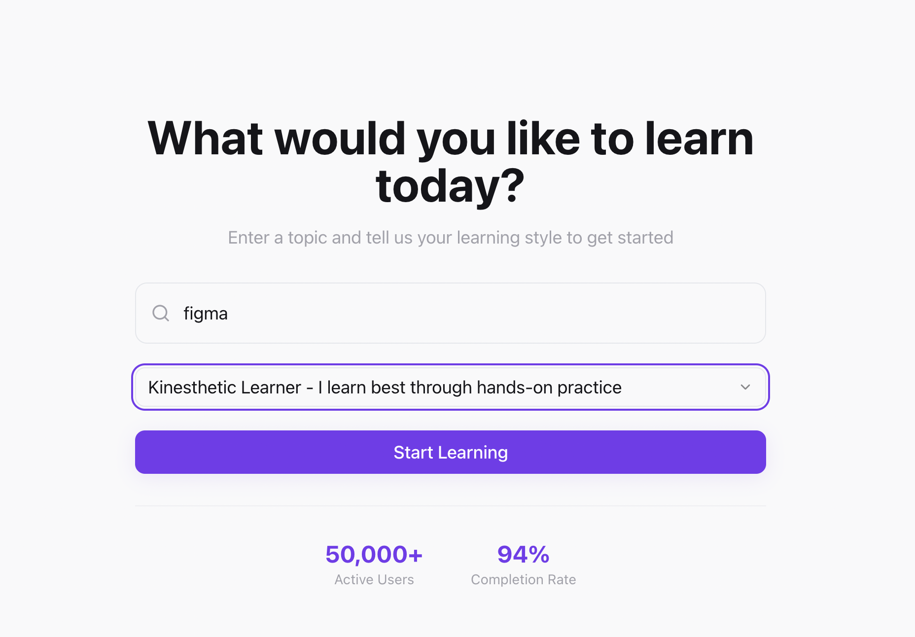

**Processing –**

