Project Title:
Food Ordering Website
Team Name:
Tech Innovators
Team Members:
Nitya Sharma
Course / Subject Name:
Web Development
Guide / Mentor Name:
Naina Devi
Institution Name:
Dr. A. P. J. Abdul Kalam Technical University, Lucknow
Date:
21.02.2026

📌 2. Introduction
Background of the Project
The Online Food Ordering System is a web-based platform that allows users to browse food items and place orders digitally. With the increasing use of the internet, online food services have become very popular.
Why This Topic Was Chosen
- Growing demand for online food delivery services
- To apply HTML, CSS, and JavaScript concepts practically
- To create an interactive and user-friendly interface
Overview of the Problem Domain
Traditional food ordering methods are time-consuming and less efficient. This project provides a digital solution with a simple and interactive interface

📌 3. Problem Statement
Clearly Define the Problem
Users need a simple and interactive platform where they can easily browse food items, select quantities, and place orders without complications.
Existing Challenges
- Complicated user interfaces
- Slow ordering processes
- Poor cart management
- Lack of filtering options
Why Solving This Problem is Important
- Saves time
- Improves user experience
- Simplifies food ordering

📌 4. Objectives
Main Goal
To develop a responsive and interactive 3D Food Ordering Website.
Specific Objectives
- Display multiple food items dynamically
- Provide Veg and Non-Veg filtering options
- Allow quantity selection
- Implement Add to Cart functionality
- Calculate total price automatically
- Simulate payment process

📌 5. Literature Review / Existing System
Current Solutions Available
- Zomato
- Swiggy
- Uber Eats
Limitations of Existing Systems
- Heavy applications requiring installation
- Mandatory login and account creation
- Complex backend systems
- Dependence on continuous internet connection
Research References
- HTML, CSS, and JavaScript Documentation
- MDN Web Docs

📌 6. Proposed System
Overview of the Solution
The proposed system is a frontend-based 3D animated food ordering website that includes a dynamic cart system and filtering functionality.
How It Solves the Problem
- Simple and clean interface
- Fast and smooth interactions
- No login requirement
- Real-time cart updates
Key Improvements
- 3D hover animation effects
- Instant price calculation
- Sliding cart panel
- Responsive grid layout

📌 7. System Architecture / Design
Architecture Overview
User → Web Browser
HTML → Structure
CSS → Styling and 3D Effects
JavaScript → Functional Logic and Cart Management
Modules Description
- User Interface Module
Displays food cards, buttons, and layout design.
- Filter Module
Filters food items based on Veg or Non-Veg categories.
- Cart Module
Handles add-to-cart functionality, quantity management, and total calculation.
- Payment Module
Simulates payment confirmation.
ER Diagram
Food Entity
- Name
- Price
- Type
- Image
Cart Entity
- Food Name
- Quantity
- Total Price

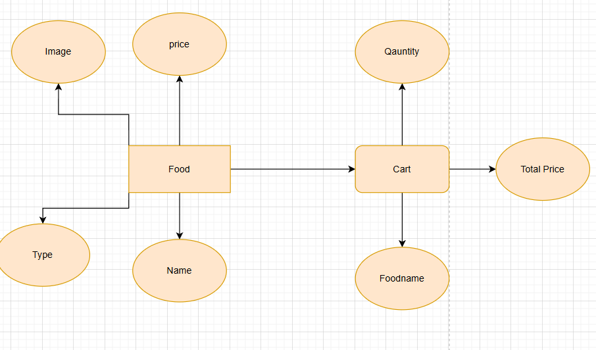

📌 8. Technologies Used
Programming Languages
- HTML
- CSS
- JavaScript
Frameworks
- No external frameworks used
Database
- No database (Frontend-only project)
Tools / Platforms
- Visual Studio Code
- Web Browser (Chrome/Edge)
- Unsplash (for images)

📌 9. Implementation
Development Process
- Designed HTML structure
- Applied CSS styling and 3D effects
- Implemented JavaScript logic for cart and filtering
- Tested all features
Important Features
- Dynamic food item generation
- Random price generation
- Quantity increment/decrement
- Sliding cart panel
- Real-time total calculation
- Payment success simulation
Screenshots
- Home Page
- Filter Section
- Cart Panel
- Payment Success Alert

📌 10. Results & Output
Output Screens
- Food items displayed in grid format
- Cart updates instantly
- Total amount calculated correctly
Performance Results
- Fast loading time
- Smooth 3D animation effects
- No backend delay
Testing Results
- All buttons working correctly
- Accurate total price calculation
- Cart resets after payment
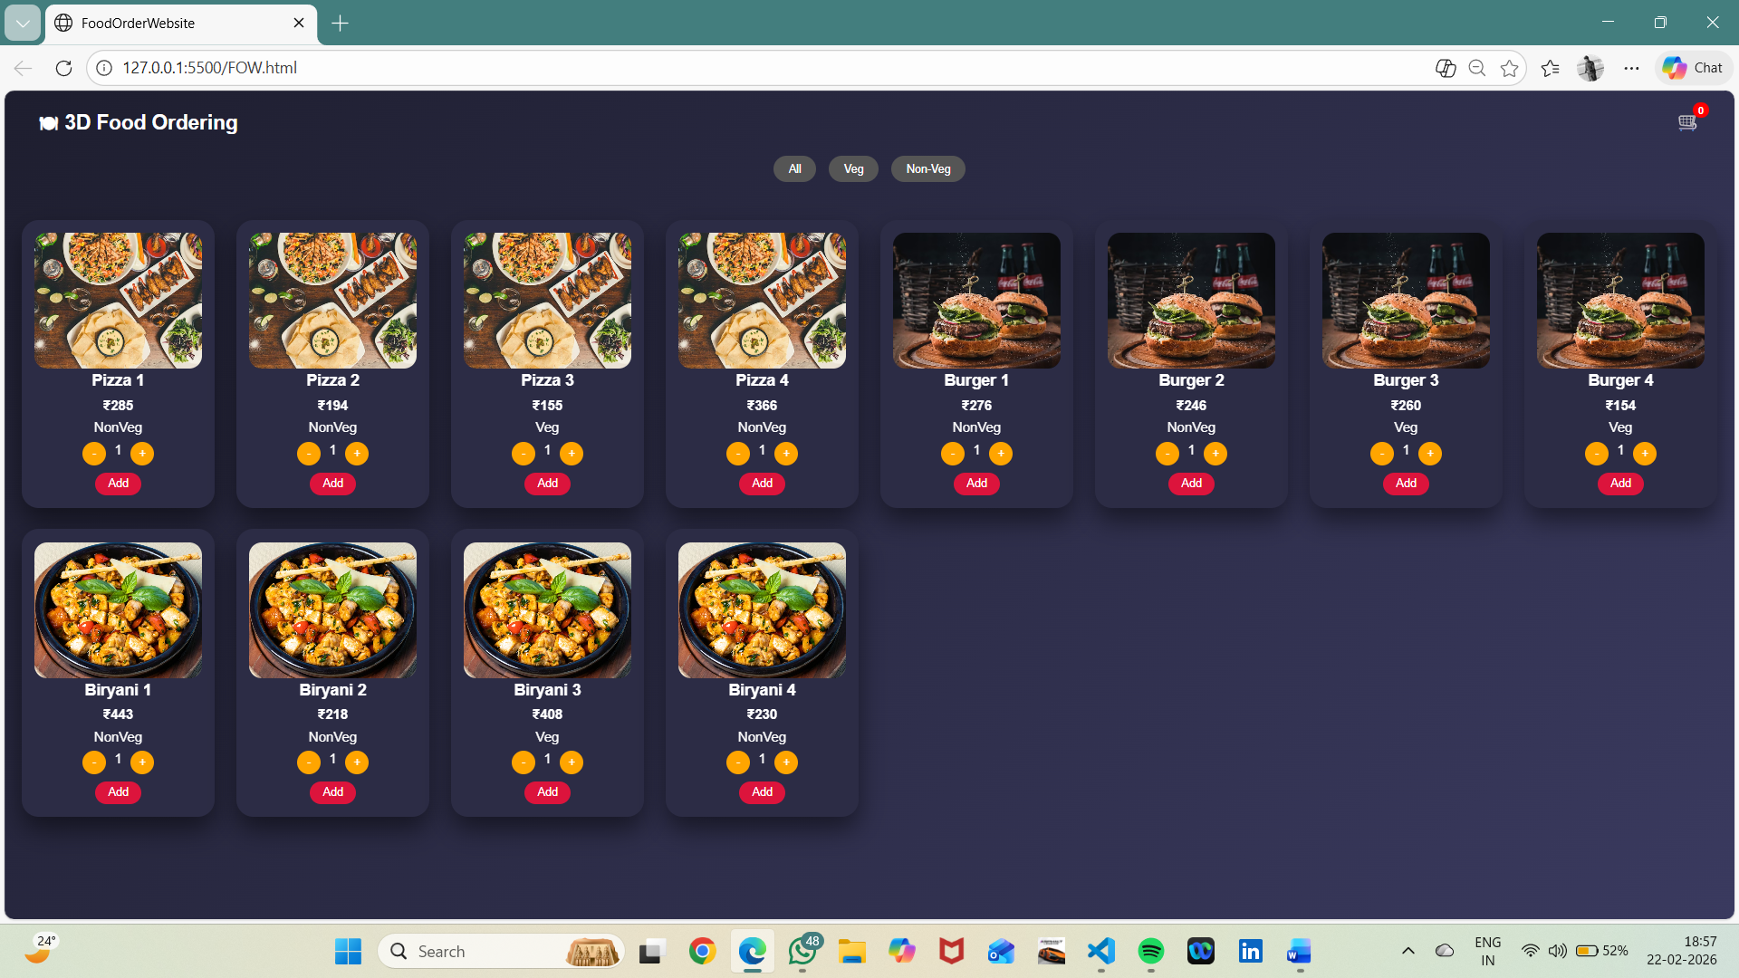

📌 11. Challenges Faced
Technical Difficulties
- Managing dynamic cart updates
- Handling quantity changes
- Filtering items correctly
Team Coordination Issues
- Dividing tasks
- Merging code properly
Solutions
- Debugging using browser console
- Regular testing
- Clear task distribution

12. Future Scope
Possible Enhancements
- Backend integration
- Real payment gateway integration
- User login and authentication
Advanced Features
- Order history
- Dark/Light mode toggle
- Admin dashboard
Scalability
- Integration with MySQL or MongoDB
- Cloud deployment

📌 13. Conclusion
Summary of the Project
The 3D Food Ordering Website is a responsive and interactive web application that provides a simple and smooth food ordering experience.
Key Achievements
- Dynamic user interface
- Functional cart system
- 3D animation effects
Final Outcome
The project was successfully implemented and tested with all core features functioning correctly.

📌 14. References
Books
- HTML & CSS: Design and Build Websites by Jon Duckett
Websites
- https://developer.mozilla.org
- https://www.w3schools.com
Research Papers
- Research papers on Online Food Ordering Systems (Google Scholar)

