Original scientific paper
Received: November 3, 2026.

Dementia Detection Using State-Aware, Age-Normative EEG Classification with a Lightweight Fusion Network

Siddarth Potdar^{1*}, Sanchit Raut¹, Vedant Kannurkar¹
¹ Department of Computer Science and Engineering, Sardar Patel Institute of Technology, Mumbai, India, e-mail: siddarth.potdar23@spit.ac.in, sanchit.raut23@spit.ac.in, vedant.kannurkar24@spit.ac.in

Abstract: Resting-state electroencephalography is an inexpensive, portable candidate for screening mild cognitive impairment and dementia, but published deep learning models are large, mix different recording states and are rarely tested outside their own dataset. This study aimed to build a compact, interpretable classifier of normal cognition, mild cognitive impairment and dementia and to evaluate it rigorously. Using 1,187 clinical recordings from Chung-Ang University Hospital, we first corrected a timing error in the event annotations, reducing the median misalignment in paused recordings from 33 to 3 seconds and making the eyes-closed, eyes-open and light-stimulation state of every second known. We then designed a state-aware, age-normative fusion network with 143,000 parameters that combines state-conditioned signal segments, 48 clinical biomarkers expressed relative to healthy people of the same age, and age, through interpretable gates. An ensemble of three networks reached 72.9% accuracy and an area under the curve of 0.87 on the official test split, above the best published single model (70.2%) at a fraction of its size, and recognised 95.7% of healthy participants. Under repeated five-fold cross-validation the network reached 59.5%, matching logistic regression on the same biomarkers and exceeding two deep learning baselines. Community volunteers were younger and recorded with a different stimulation protocol than patients, which inflates apparent performance, and the model transferred to an independent cohort with an area under the curve of 0.70. We recommend confound-controlled, cross-validated evaluation for such screening tools.
Keywords: electroencephalography, dementia, mild cognitive impairment, deep learning, normative modelling, human–AI interaction.

*Corresponding author: siddarth.potdar23@spit.ac.in
© 2026 by the authors. This article is an open access article distributed under the terms and conditions of the Creative Commons Attribution (CC BY) license (https://creativecommons.org/licenses/by/4.0/).

Introduction

Dementia affects about 57 million people worldwide, a number projected to rise to about 153 million by 2050 (World Health Organization, 2026); in India alone, cases are expected to grow from 5.1 million in 2021 to more than 20 million by 2050. Mild cognitive impairment (MCI) is the main prodromal stage of dementia (Petersen, 2004), and it is the window in which intervention is most useful. Neuropsychological testing, magnetic resonance imaging (MRI), positron emission tomography and cerebrospinal fluid biomarkers are costly, invasive or scarce outside large hospitals. Scalp electroencephalography (EEG), in contrast, is cheap, portable, non-invasive and widely available. Alzheimer's-type dementia produces well-documented EEG changes: slowing of the background rhythm, reduced posterior alpha, increased theta and delta power, and reduced coherence (Jeong, 2004; Dauwels et al., 2010; Babiloni et al., 2020).
The CAUEEG dataset (Kim et al., 2023) is one of the largest public clinical EEG collections with a Normal / MCI / Dementia benchmark. Results on it are, however, hard to interpret for four reasons. First, clinical EEG slowing is read during eyes-closed rest, yet recordings also contain eyes-open periods, photic (flashing-light) stimulation and hyperventilation, and random crops mix these states. Second, per-segment scoring, or splits that share patients, inflate accuracy relative to per-recording, patient-disjoint evaluation (Saeb et al., 2017). Third, a 118-recording test set has a 95% confidence interval of roughly ±9 accuracy points (Varoquaux, 2018). Fourth, deep models are rarely compared with a well-tuned tabular model of established EEG markers under the same protocol, and rarely tested at another site. The published models are also large (11–87 million parameters per model and 254 million for an ensemble), which limits deployment on portable hardware.
Objectives
The objectives of this work are:
1. to analyse the CAUEEG dataset in depth and make its recording-state annotations usable;
2. to design a lightweight, interpretable deep learning model for three-class Normal / MCI / Dementia classification;
3. to compare it with tabular and deep learning baselines trained under exactly the same protocol;
4. to validate the model on independent datasets without retraining.
Contributions
(1) A verified correction of CAUEEG event timing and a per-second state and artifact timeline. (2) SANF-Net, a state-aware, age-normative fusion network of 143k parameters that uses alpha-reactivity and photic-driving biomarkers, which can only be computed with the corrected clock. An ensemble of three SANF-Net models reaches 72.9% accuracy on the official test split. (3) The identification of a photic-stimulation protocol confound between the Normal subgroups, separated from the age confound by age matching. (4) A patient-disjoint, per-recording evaluation with repeated five-fold cross-validation, bootstrap confidence intervals, tabular and deep baselines, ablations, and external testing on two independent MCI cohorts.

Literature Survey

We reviewed seven studies across three modality groups: MRI, EEG and voice (Table 1). MRI studies report very high accuracies but rely on expensive imaging, are often evaluated on 2D slices, and rarely validate across datasets. EEG-based approaches remain underexplored by comparison, and none of the reviewed studies validates on an independent dataset.

Table 1
Literature survey: seven studies across three modality groups
Study | Data | Method | Reported result | Limitation
MRI-based approaches
El-Assy et al. (2024) | ADNI | Dual CNN branches with different filter sizes, concatenated; 3/4/5-class | 99.43%, 99.57%, 99.13% | Possible overfitting; no cross-dataset validation; limited explainability
Odimayo et al. (2024) | ADNI + OASIS | Structure-focused CNN, gamma correction, midsagittal and parasagittal planes | 97–98% | Specific MRI planes only; high computational cost; limited generalisation testing
Mousavi et al. (2025) | ADNI-derived MRI (6,735 images) | Transfer learning (VGG16, VGG19, Xception, InceptionResNetV2), majority-vote ensemble | 98.52% | Derived dataset may lack clinical diversity; mostly 2D slice-based
EEG-based approaches
Kim et al. (2023) | CAUEEG | CEEDNet: end-to-end 1D/2D CNN and transformer family on raw EEG with age | 70.2% single, 74.7% ensemble (three-class, per recording) | Single dataset; large models (11–87M parameters); limited interpretability
Miltiadous et al. (2023) | AD, FTD and healthy EEG | Dataset publication | Not a model paper | No benchmark model; limited size
Jungrungrueang et al. (2025) | Resting-state EEG | Dynamic EEG connectivity features with CNN classification | 93.6% (multi-class) | EEG only; no MRI integration
Other modalities
Xue et al. (2021) | Framingham Heart Study voice recordings | CNN + LSTM on audio, minimal feature engineering | Binary classification | No MRI comparison; restricted clinical data
ADNI: Alzheimer's Disease Neuroimaging Initiative; OASIS: Open Access Series of Imaging Studies; CNN: convolutional neural network; LSTM: long short-term memory; AD: Alzheimer's disease; FTD: frontotemporal dementia.

EEG markers of cognitive decline. Spectral slowing (theta/alpha and delta/alpha ratios), lower alpha peak frequency, reduced alpha reactivity to eye opening and loss of inter-regional coherence are consistently reported in Alzheimer's disease and, more weakly, in MCI (Jeong, 2004; Dauwels et al., 2010; Babiloni et al., 2020).
Machine learning on CAUEEG. Kim et al. (2023) released CAUEEG together with CEEDNet, trained on random 10 s crops with age as an input. CEFA-Net (Sobahi et al., 2026) combines a three-scale CNN with a branch of clinical EEG ratios and a focal loss, reporting 81.0% with per-segment evaluation and 73.8% on a patient-disjoint test. A microstate-based support vector machine reports 89% (Hasan et al., 2025). These numbers use different evaluation units and splits and are not directly comparable. Mishra et al. (2025) contrasted CAUEEG with GENEEG, a general-practice cohort, and found poor transfer between the two and strongly overlapping MCI and control feature distributions. Compact architectures such as EEGNet (Lawhern et al., 2018) are common baselines for small clinical datasets.
Normative modelling and shortcut learning. Normative models describe each subject as a deviation from a reference population conditioned on covariates such as age (Marquand et al., 2016), which separates normal ageing from pathology. Classifiers frequently exploit acquisition artifacts instead of the target signal (Geirhos et al., 2020); in medical imaging, scanner or protocol differences between cohorts are a well-known source (Roberts et al., 2021; Varoquaux & Cheplygina, 2022).
Research gap. No reviewed work combines (i) a lightweight EEG model that uses recording-state information, (ii) a comparison with strong baselines under an identical, patient-disjoint protocol, and (iii) validation on independent datasets. This work addresses all three.

Materials and Methods

Data Collection
CAUEEG-Dementia. CAUEEG (Kim et al., 2023) contains clinical 19-channel scalp EEG (international 10–20 system) recorded at 200 Hz at Chung-Ang University Hospital, Korea, with event annotations for eyes open/closed, photic stimulation, hyperventilation, artifacts and recording pauses. The dementia task has 1,187 recordings (459 Normal, 417 MCI, 311 Dementia) in an official split of 950 training, 119 validation and 118 test recordings. The official no-overlap test subset (90 recordings) excludes patients who also have recordings in the training split. Using the dataset's symptom codes, the Normal class divides into community-recruited volunteers, patients with subjective memory impairment (SMI) whose testing was normal, and 13 recordings with neither code (Table 2).

Table 2
CAUEEG-Dementia subgroups (all 1,187 recordings)
Group | n | Age (years) | Photic (%) | EO (%) | Length (min) | EC (min) | Photic (min)
Normal: community | 260 | 61.7±8.3 | 12 | 63 | 10.2 | 5.7 | 0.1
Normal: SMI | 186 | 69.6±9.3 | 90 | 84 | 13.8 | 5.6 | 0.7
Normal: other | 13 | 68.4±7.2 | 69 | 85 | 13.2 | 5.5 | 0.6
MCI | 417 | 73.8±7.8 | 92 | 87 | 13.8 | 5.8 | 0.8
Dementia | 311 | 76.6±8.1 | 92 | 80 | 14.0 | 6.6 | 0.8
Photic / EO: share of recordings with usable photic-stimulation / eyes-open data. EC: eyes closed. Durations are clean minutes after artifact masking.

External cohorts. For testing without retraining we use two public MCI datasets. Isfahan (Kashefpoor et al., 2016; Kashefpoor et al., 2019) has two releases of 19-channel, 256 Hz eyes-closed resting EEG (2016: 16 normal / 11 MCI; 2019: 16 normal / 18 MCI). GENEEG (Mishra et al., 2025) has general-practice recordings (35 control / 28 MCI) at 250 Hz during an eyes-closed P300 protocol, with the T5 and T6 channels unavailable (interpolated). Neither provides state annotations or per-subject ages, so all segments are treated as one state and a fixed age is imputed, which removes age as a source of information.
Preprocessing
Signals are band-pass filtered (0.5–45 Hz, fourth-order zero-phase Butterworth), clipped at ±3000 μV and resampled to 100 Hz. The first 10 s are discarded for electrode settling. External recordings are re-referenced to the common average, as in CAUEEG.
Event-clock correction. Each CAUEEG event is a sample index at 200 Hz with a text label. These indices count wall-clock time including paused periods, whereas the EDF signal contains only the recorded portions joined end-to-end. Event i therefore maps to signal position
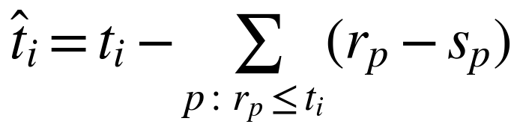 (1)
where s_{p} and r_{p} are the Paused and Recording resumed indices of pause p. Every recording ends with a Paused event, which should coincide with the end of the signal and so checks the alignment. Of the 1,187 recordings, 293 contain a pause. In these, the raw final event lies a median of 33 s (maximum 678 s) from the signal end; after correction the median is 3 s, and 1,184 of 1,186 recordings align within 6 s (Figure 1).
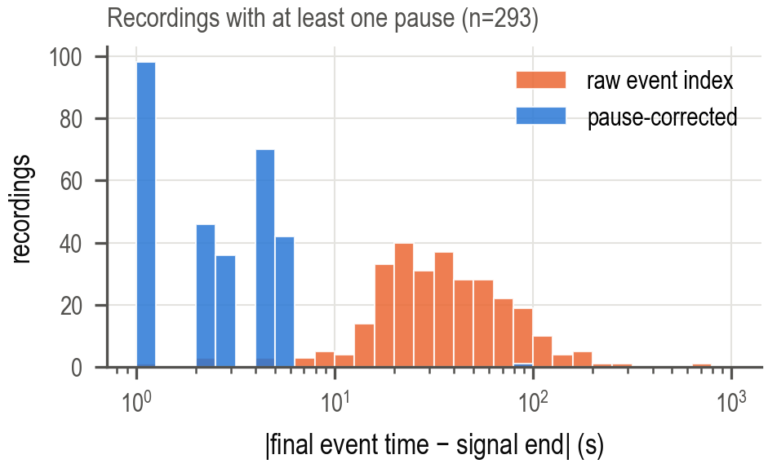
Figure 1. Offset between the final Paused event and the end of the signal for recordings with pauses, before (orange) and after (blue) the correction.

State timeline and clean mask. From the corrected events we label every second as eyes-closed, eyes-open, photic, hyperventilation or unknown. A clean mask removes 1 s before and 3 s after every state change, 3 s around pause joins, 2 s before to 3 s after point artifacts (movement, coughing, swallowing, talking) and 30 s after drowsiness or sleep annotations. Hyperventilation, which slows the EEG of healthy subjects, is excluded from both segments and biomarkers.
Age-Normative Clinical Biomarkers
For each recording we compute 48 biomarkers from Welch spectra of 4 s windows (2 s step):
– Eyes-closed (39): log relative δ, θ, α and β power in five regions; theta/alpha, delta/alpha and slow/fast ratios; fronto-posterior alpha ratio; alpha and beta hemispheric asymmetry; posterior alpha centre of gravity and peak frequency; spectral entropy; median frequency; total power; Hjorth mobility and complexity; inter-hemispheric and fronto-posterior coherence.
– Eyes-open (5): global relative band powers and posterior alpha centre of gravity.
– Reactivity and driving (2): posterior alpha reactivity, log(P_{α}^{EC}/P_{α}^{EO}), and occipital photic-driving signal-to-noise ratio at the flash frequency.
– Availability (2): indicators for the presence of eyes-open and photic data.
Because EEG slows with healthy ageing, a raw biomarker mixes age with impairment. For every biomarker x_{j} we fit a linear age model on the training Normal recordings only and replace x_{j} with its robust deviation
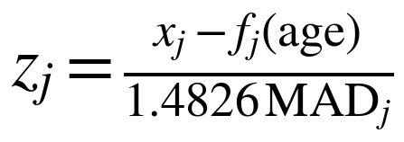 (2)
where MAD_{j} is the median absolute deviation of the normal residuals; values are clipped to ±6. In cross-validation the normative model is refitted within each fold.
Evaluation Protocol
All metrics are per recording and all splits are patient-disjoint. We report two complementary protocols. (i) Official split, the benchmark protocol of Kim et al. (2023): models are trained on the 950 training recordings and scored on the 118 test recordings and the 90-recording no-overlap subset. (ii) Repeated five-fold cross-validation over the pooled 1,069 training and validation recordings, with the normative model and age scaling refitted in each fold, giving one out-of-fold prediction per recording; the main models are run with several fold assignments. Metrics are accuracy, balanced accuracy, macro F1, macro one-vs-rest area under the ROC curve (AUC), per-class recall and pairwise AUCs, with 95% bootstrap confidence intervals (1,000 resamples); model differences use a paired bootstrap on the same recordings.

Baseline Models and Results

Baseline Models
All baselines use exactly the same folds, per-fold normative refitting and per-recording scoring as the proposed model.
Tabular models. Age alone; the 48 biomarkers, raw or normative; and normative biomarkers plus age. Each uses L₂-regularised, class-balanced logistic regression (LR), with the regularisation strength tuned by an inner five-fold cross-validation. The last set is also modelled with histogram gradient boosting (HGB).
Deep models on raw EEG. EEGNet-8,2 (Lawhern et al., 2018) and a CEEDNet-style 1D-ResNet (four stages of two residual blocks on the raw 19 channels, age concatenated before the classifier, 2.3M parameters) (Kim et al., 2023), both trained on random 10 s crops. Both share the proposed model's data pipeline, loss, schedule, augmentation and weight averaging, and average segment logits per recording, so only the architecture differs. The 1D-ResNet follows CEEDNet's design but is not the authors' code or training recipe.
Baseline Results
Table 3 lists the baselines. The tabular models are strong: age alone already reaches 51.1% (AUC 0.709), and logistic regression on normative biomarkers plus age reaches 59.3±0.7% (AUC 0.778±0.004). The deep models that see only raw EEG are weaker: EEGNet reaches 52.9% (AUC 0.707) and the 1D-ResNet 57.7% (AUC 0.752). On the official test split the 1D-ResNet scores 61.0%, below the published 70.2% for CEEDNet, which used larger models, longer training and test-time augmentation.

Table 3
Baseline results (per recording). Cross-validation: five-fold out-of-fold, n = 1069 (mean ± s.d. over five fold assignments where marked *). Test: official test split, n = 118, mean of the five fold models
 | Cross-validation |  |  | Official test
Model | Acc | BAcc | AUC | Acc | BAcc | AUC
Age (LR)* | 51.1±0.2 | 51.6±0.2 | .709±.002 | 55.1 | 54.6 | .739
Biomarkers, raw (LR) | 56.0 | 56.0 | .761 | 63.6 | 63.5 | .815
Biomarkers, normative (LR) | 58.1 | 58.1 | .761 | 62.7 | 63.2 | .809
Normative biomarkers + age (LR)* | 59.3±0.7 | 59.3±0.7 | .778±.004 | 66.1 | 65.9 | .839
Normative biomarkers + age (HGB) | 59.2 | 58.9 | .779 | 61.0 | 60.2 | .813
EEGNet | 52.9 | 51.5 | .707 | 60.2 | 58.0 | .773
1D-ResNet (CEEDNet-style) | 57.7 | 57.1 | .752 | 61.0 | 60.0 | .810
Acc: accuracy (%); BAcc: balanced accuracy (%); AUC: macro one-vs-rest area under the ROC curve; LR: logistic regression; HGB: histogram gradient boosting.

Proposed Model: SANF-Net

SANF-Net (State-Aware, age-Normative Fusion Network) has three input branches combined by modality-gated fusion (Figure 2). It has 143k parameters.
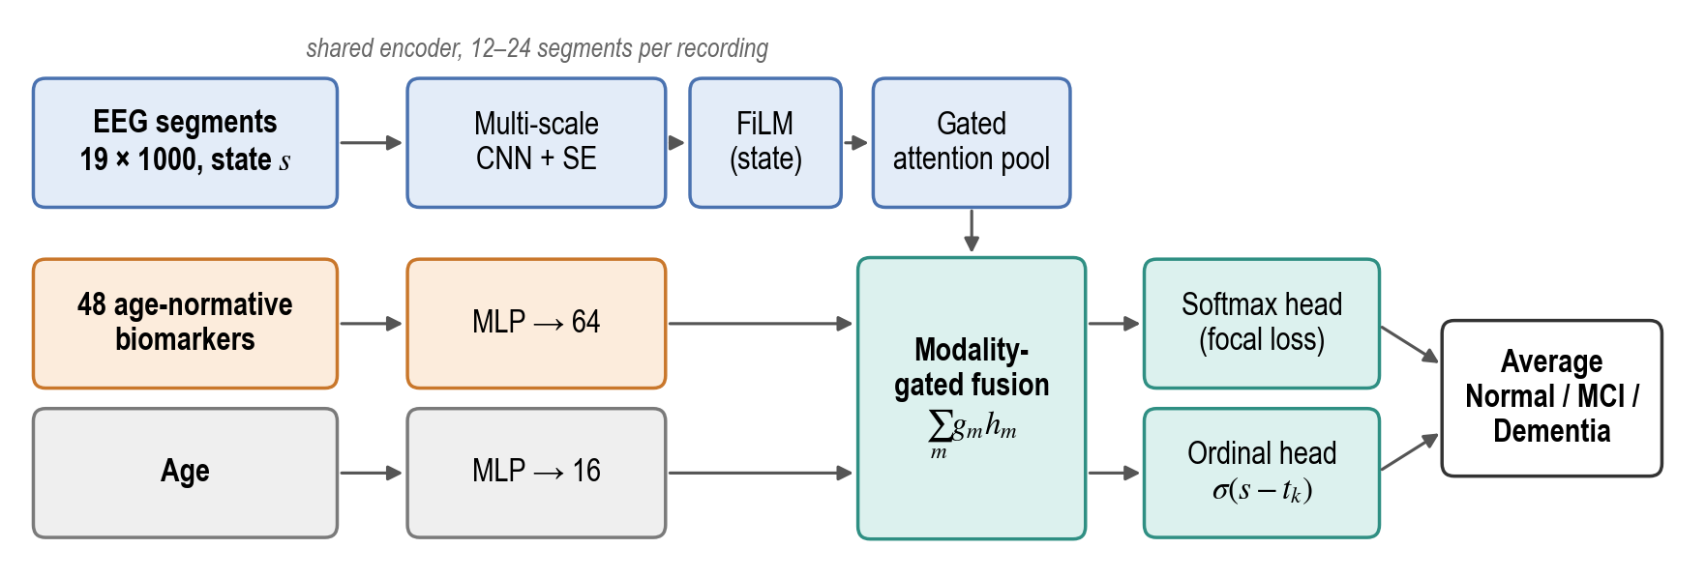
Figure 2. SANF-Net. State-tagged EEG segments, age-normative biomarkers and age are encoded separately and combined by modality-gated fusion feeding a softmax and an ordinal head.

Architecture
EEG branch. A recording is a bag of 10 s segments (19 × 1000 samples) drawn from clean seconds by state: 60% eyes-closed, 25% eyes-open and 15% photic (12 segments per recording in training, 24 at evaluation). A shared encoder applies three parallel temporal convolutions (0.11, 0.25 and 0.51 s kernels, matching beta, alpha and delta–theta time scales), a depthwise spatial convolution over the 19 channels, a separable convolution with squeeze-and-excitation (SE), a temporal convolution with a second SE block, and mean and standard-deviation pooling to a 128-dimensional embedding h. Each embedding is modulated by its state s with feature-wise linear modulation (FiLM) (Perez et al., 2018), h' = h⊙(1+γ_{s})+β_{s}, and gated attention pooling (Ilse et al., 2018) combines the segments of a recording.
Biomarker and age branches. The 48 normative z-scores pass through a two-layer perceptron (64-dimensional output) and standardised age through a small perceptron (16-dimensional). Age is an explicit input so that its contribution can be measured and ablated.
Modality-gated fusion. Each branch is projected to 128 dimensions; a linear layer over the concatenated projections yields softmax gates g over the three modalities, and the fused vector is Σ_{m} g_{m} h_{m}. The gates show how much each prediction relied on EEG, biomarkers or age. During training each modality is dropped with probability 0.15 (never all at once), so that no single input, particularly age, carries the model.
Two output heads. Normal < MCI < Dementia is an ordered scale. Besides a softmax head, an ordinal cumulative-link head (McCullagh, 1980) predicts a severity score s_{sev} and two ordered thresholds t₁ < t₂, with P(y > k) = σ(s_{sev}-t_{k}). The class probabilities of the two heads are averaged.
Training
The loss is a class-weighted focal cross-entropy (Lin et al., 2017) (γ = 1.5; weights 1.0 / 1.4 / 1.2 for Normal / MCI / Dementia; label smoothing 0.05) plus 0.5 times the cumulative binary cross-entropy of the ordinal head. We train for 35 epochs with AdamW (learning rate 10⁻³, weight decay 0.05, three-epoch warm-up and cosine decay), 16 recordings per batch, mixed precision, gradient clipping at 2.0 and an exponential moving average (EMA) of the weights (decay 0.995). Augmentation comprises amplitude scaling (0.9–1.1), Gaussian noise, channel dropout (0.1), biomarker noise and same-class bag mixing: with probability 0.3, 25–50% of a recording's segments are replaced by segments of another training recording with the same label. We evaluate the final EMA weights rather than selecting a checkpoint on the small validation set, whose 119 recordings make checkpoint selection noisy. One model trains in about 6 minutes on a laptop RTX 4050 GPU. Table 4 summarises the configuration.

Table 4
SANF-Net configuration
Setting | Value | Setting | Value
Sampling rate | 100 Hz | Parameters | 143k
Band-pass | 0.5–45 Hz | Epochs | 35
Segment length | 10 s (19×1000) | Batch | 16 recordings
Segments (train / eval) | 12 / 24 | Optimiser | AdamW, lr 10⁻³, wd 0.05
State mix (EC / EO / photic) | 60 / 25 / 15% | Loss | focal (γ 1.5) + 0.5 ordinal
Biomarkers | 48, age-normative | Class weights | 1.0 / 1.4 / 1.2
Temporal kernels | 0.11 / 0.25 / 0.51 s | Dropout / modality dropout | 0.3 / 0.15
Embedding / fusion size | 128 / 128 | Weight averaging | EMA, decay 0.995

Ensemble and Results

Final Ensemble
The final model is an ensemble of three SANF-Net instances trained on the official training split with different random seeds and identical settings. For each recording the class probabilities of the three models are averaged and the most probable class is predicted. The ensemble has 429k parameters in total.
Official Test Results
Table 5 compares SANF-Net with the published CEEDNet results on the official test split. The ensemble reaches 72.9% accuracy, 72.3% balanced accuracy, a macro F1 of 0.709 and a macro AUC of 0.870. A single SANF-Net reaches 68.4±2.8% (individual seeds 64.4%, 70.3% and 70.3%). The ensemble is above CEEDNet's best single model (70.2%) and within 1.8 points of its nine-model ensemble (74.7%), with about 590 times fewer parameters. On the no-overlap subset, which excludes every patient seen in training, the ensemble reaches 72.2% (AUC 0.863), close to its full-test score, which indicates no leakage through repeated patients. CEEDNet's ensemble reports 76.7% on this subset. With 118 test recordings, the 95% confidence interval of any single test accuracy is about ±8 points.

Table 5
Three-class results on the official CAUEEG split (per recording). Single SANF-Net: mean ± s.d. over three seeds
 |  | Test (n = 118) |  |  |  | No-overlap (n = 90)
Model | Params | Acc | BAcc | F1 | AUC | Acc | AUC
CEEDNet, best single model† | 11M+ | 70.2 | – | – | – | – | –
CEEDNet, 9-model ensemble† | 253.8M | 74.7 | – | – | – | 76.7 | –
SANF-Net, single | 143k | 68.4±2.8 | 67.3±3.6 | .666±.035 | .849±.014 | 67.4±1.4 | .844±.011
SANF-Net, 3-model ensemble | 429k | 72.9 | 72.3 | .709 | .870 | 72.2 | .863
†As published by Kim et al. (2023), with their own training recipe and test-time augmentation. Params: parameters; F1: macro F1.

Per-class performance. Table 6 gives the ensemble's confusion matrix and per-class metrics. The model recognises 95.7% of healthy participants and labels none of them as demented, and detects 77.4% of dementia patients. MCI is the hardest class: its recall is 43.9%, with errors split between the two neighbouring classes, but its precision is the highest of all classes (75.0%), so an MCI prediction is usually correct. Severe errors (Normal predicted as Dementia or the reverse) are rare.

Table 6
Confusion matrix (row percentages, counts in brackets) and per-class metrics of the SANF-Net ensemble on the official test split
True ↓ / Predicted → | Normal | MCI | Dementia | Precision | Recall | F1
Normal (n = 46) | 95.7 (44) | 4.3 (2) | 0.0 (0) | 72.1 | 95.7 | .822
MCI (n = 41) | 34.1 (14) | 43.9 (18) | 22.0 (9) | 75.0 | 43.9 | .554
Dementia (n = 31) | 9.7 (3) | 12.9 (4) | 77.4 (24) | 72.7 | 77.4 | .750

What the model uses. The mean modality gates on the test set differ by true class. For Normal recordings the EEG branch has the largest weight (EEG 0.39, biomarkers 0.29, age 0.32); for MCI the biomarker and age branches dominate (0.37 and 0.38, EEG 0.25); for Dementia the three are balanced (0.34, 0.35, 0.31).
Cross-Validated Results
Because a 118-recording test set is small and the official test split turns out to be easier than the pooled data (the same models score 59.9±1.0% on validation but 68.4±2.8% on test), we also evaluate under repeated five-fold cross-validation. SANF-Net reaches 59.5±0.3% accuracy and a macro AUC of 0.778±0.006 over four fold assignments (first assignment: 59.8%, 95% CI 56.7–62.8%), which is very stable across repeats. Under the identical protocol it is significantly better than EEGNet (+6.8 points, CI 3.4–10.1) and better than the 1D-ResNet in AUC (+0.028, CI 0.003–0.050), and it is statistically indistinguishable from logistic regression on the same normative biomarkers plus age (paired difference -0.1±0.5 points). Out-of-fold recall is 76.8% for Normal, 62.9% for Dementia and 38.8% for MCI (Figure 3). For MCI versus Normal the AUC is 0.787, detecting 63% of MCI at 80% specificity.
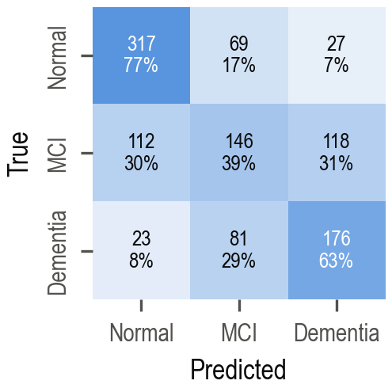
Figure 3. SANF-Net out-of-fold confusion matrix under five-fold cross-validation (n = 1069, counts and row percentages).

Ablation Study
Table 7 removes one component at a time under the same cross-validation protocol. Removing both non-EEG branches clearly hurts: the EEG-only network loses 4.5 accuracy points (CI 1.4–8.0) and 0.049 macro AUC, and its MCI recall falls to 24.5%. State-aware sampling gives a small but significant AUC gain (+0.013, CI 0.002–0.025), and normative scoring and the biomarker branch each add about 0.02 MCI-versus-Normal AUC. Removing the ordinal head leaves accuracy and AUC unchanged but raises MCI recall from 38.8% to 58.8%, at the cost of Normal and Dementia recall; this gives a screening-oriented operating point.

Table 7
Ablations (five-fold cross-validation, out-of-fold, n = 1069)
Variant | Acc | AUC | AUC Normal vs MCI | MCI recall
SANF-Net (full) | 59.8 | .780 | .787 | 38.8
random crops, no state | 58.6 | .767 | .781 | 36.2
no FiLM state conditioning | 58.9 | .777 | .784 | 41.8
mean instead of attention pooling | 58.5 | .782 | .783 | 35.9
plain standardisation (no normative) | 57.6 | .768 | .768 | 36.4
no biomarkers | 57.3 | .772 | .767 | 34.8
no age | 58.5 | .783 | .788 | 37.0
EEG only | 55.3 | .731 | .719 | 24.5
no ordinal head | 59.5 | .777 | .785 | 58.8

Protocol and Age Confounds
Community-recruited normals differ from every other group in ways unrelated to cognition (Table 2, Figure 4): they are younger (61.7 versus 69.6–76.6 years), only 12% of their recordings include photic stimulation (versus 90–92% of every other group), and their recordings are shorter. A model can therefore recognise many community normals from the protocol alone.
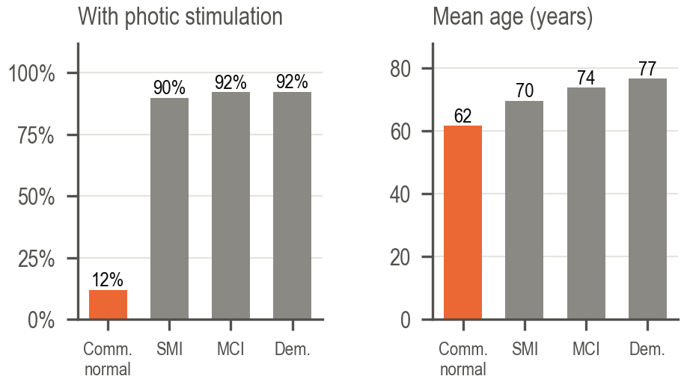
Figure 4. Share of recordings with photic stimulation and mean age per subgroup. Community normals differ from all clinical groups in both, independently of cognition.

We therefore trained protocol-blind variants: (A) SANF-Net with photic segments and the three protocol features removed, and (B) SANF-Net on eyes-closed segments only (Table 8). Removing protocol information costs SANF-Net 2.7 accuracy points and the linear model 2.5 points, almost entirely on the community-versus-MCI comparison, whereas SMI-versus-MCI stays at 0.65–0.66 for every model. SANF-Net relies less on the shortcut than the linear model, as its much higher SMI recall shows (57.9% versus 35.7%). After 1:1 age matching, SMI versus MCI falls to 0.54–0.57 for every model, and the 24 community normals recorded with photic stimulation are not distinguished from age-matched MCI by any model (AUC 0.50–0.59).

Table 8
Protocol confound (five-fold cross-validation, out-of-fold). Comm.: community-recruited normals (n = 229); SMI: subjective memory impairment (n = 171)
 |  |  | AUC vs MCI
Model | Acc | AUC | Comm. | SMI | SMI recall
Age (LR) | 51.1 | .709 | .858 | .618 | 42.7
Normative biomarkers + age (LR) | 59.3 | .778 | .951 | .655 | 35.7
without protocol features | 56.8 | .747 | .863 | .660 | 50.6
SANF-Net | 59.8 | .780 | .891 | .653 | 57.9
(A) no photic information | 57.1 | .764 | .852 | .649 | 63.7
(B) eyes-closed only | 58.5 | .756 | .842 | .650 | 63.7

External Validation
Table 9 reports MCI-versus-normal performance on the external cohorts without retraining, using the five cross-validation fold models (predictions averaged); MCI is scored with 1-P(Normal). Since age is uninformative there, these results reflect EEG and biomarkers only. We also apply a label-free site calibration: channel amplitudes are rescaled to the cohort's median and the normative z-scores are re-centred on the cohort's own normals in a leave-one-out manner. On the pooled Isfahan cohorts the AUC is 0.67, rising to 0.70 with site calibration (0.76 on Isfahan 2016); on GENEEG, whose montage and protocol differ more, it is 0.58. Across the external cohorts 81–91% of healthy participants are correctly classified as Normal. With 61–63 subjects per cohort all intervals are wide.

Table 9
External MCI versus normal without retraining. AUC with 95% bootstrap confidence interval
Cohort | n (MCI) | No calibration | Site calibration
Isfahan 2016 | 27 (11) | .73 (.51–.91) | .76 (.57–.92)
Isfahan 2019 | 34 (18) | .64 (.45–.84) | .63 (.44–.81)
Isfahan pooled | 61 (29) | .67 (.53–.80) | .70 (.56–.83)
GENEEG | 63 (28) | .58 (.44–.72) | .58 (.42–.74)

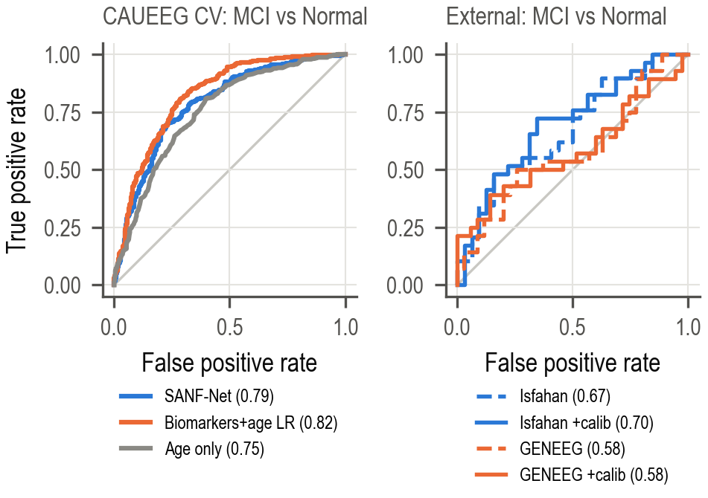
Figure 5. MCI versus normal ROC curves. Left: CAUEEG out-of-fold predictions. Right: external cohorts without retraining, with and without site calibration.

Discussions

A compact model at benchmark level. The SANF-Net ensemble reaches 72.9% accuracy and an AUC of 0.87 on the official test split with 429k parameters, above CEEDNet's best single model and close to its nine-model ensemble, which is about 590 times larger. A model of this size trains in minutes on a laptop GPU and is suitable for portable or primary-care hardware, which is where an EEG-based screen is most useful. Its clinical error profile is favourable for screening: almost all healthy participants are recognised, no healthy participant is labelled as demented, and when MCI is predicted it is usually correct.
The recording state matters. Correcting the event clock was a prerequisite for state-aware sampling, for the alpha-reactivity and photic-driving biomarkers, and for detecting the protocol confound. State-aware sampling gives a significant AUC gain over random crops, and the gates make each prediction's reliance on EEG, biomarkers and age visible.
Architecture versus features. Under cross-validation SANF-Net matches, but does not beat, logistic regression on the same normative biomarkers, and it beats the EEG-only deep baselines mainly because it also sees the biomarkers and age: its own EEG-only ablation lies between EEGNet and the 1D-ResNet. Gains on this benchmark should therefore always be compared against a strong tabular model of established markers under the same protocol. SANF-Net's advantage over the linear model is that it relies far less on the protocol shortcut.
Much of the MCI signal is age and protocol. The MCI-versus-Normal AUCs on CAUEEG mix age, recording protocol and EEG physiology. After age matching, distinguishing a patient with memory complaints who does or does not have MCI reaches only 0.54–0.57, consistent with the overlapping feature distributions reported by Mishra et al. (2025). Results on this dataset should be reported per Normal subgroup and with age-matched comparisons.
Single splits mislead. The official test split is about 8 points easier than the pooled data, and a 118-recording test set carries an interval of about ±8 points. Cross-validated results with repeated fold assignments should accompany any official-test number.
Transfer. Without retraining or age information, the model keeps useful MCI discrimination on Isfahan (AUC 0.67–0.76) and recognises most healthy participants at new sites, but transfers little to GENEEG, whose montage and protocol differ more. Re-centring normative references on a site's own normals is cheap and label-free.
Limitations. Training data come from a single hospital. The model design was developed on the official split and the official test set was consulted during development, which is one reason cross-validated results are reported alongside it. Subgroup labels rely on the dataset's symptom codes, and the community-with-photic subgroup is small. The external cohorts are small, lack ages and state annotations, and were not recorded with the CAUEEG protocol. Diagnoses are clinical, without biomarker confirmation.

Conclusions

CAUEEG event annotations need a pause correction before they can be used. Once corrected, they enable state-aware, age-normative modelling of MCI and dementia. SANF-Net, a 143k-parameter fusion network built on these ideas, reaches 72.9% accuracy and an AUC of 0.87 on the official test split as a three-model ensemble, comparable to published models hundreds of times larger, with interpretable modality gates. Under repeated cross-validation it reaches 59.5%, outperforms deep EEG-only baselines, matches a strong linear model while relying less on the protocol shortcut, and transfers to an independent cohort with an AUC of 0.70. The analysis also shows that community-recruited normals in CAUEEG are distinguishable by recording protocol and age alone, so confound-controlled, cross-validated evaluation should be standard for EEG-based cognitive screening. Future work includes improving MCI sensitivity, multi-site training, adding cognitive test scores, and deploying the model through a clinician-facing dashboard.

Acknowledgements
We thank our guide, Dr. Sujata Kulkarni, for her guidance throughout the project, and the creators of the CAUEEG, Isfahan MCI and GENEEG datasets for making their data available.

Funding
This research did not receive any specific grant from funding agencies in the public, commercial, or not-for-profit sectors.

Conflict of Interests
The authors declare no conflict of interest.

Data Availability Statement
The data that support the findings of this study are available from their original providers. These data were derived from the following resources: the CAUEEG dataset (Kim et al., 2023), the Isfahan MCI datasets (Kashefpoor et al., 2016; Kashefpoor et al., 2019) and the GENEEG dataset (Mishra et al., 2025), under the access conditions of each provider. The code, event-alignment correction, trained-model results and evaluation protocol are available at https://github.com/nityaashetty/SidMajor.

Institutional Review Board Statement
Not applicable. This study is a secondary analysis of publicly available, de-identified datasets; no new data were collected from human participants.

Author Contributions
All authors contributed equally to conceptualization, methodology, software, formal analysis, and writing (original draft preparation, review and editing). All authors have read and agreed to the final version of the manuscript.

References

Babiloni, C., et al. (2020). What electrophysiology tells us about Alzheimer's disease: a window into the synchronization and connectivity of brain neurons. Neurobiology of Aging, 85, 58–73.
Dauwels, J., Vialatte, F., & Cichocki, A. (2010). Diagnosis of Alzheimer's disease from EEG signals: Where are we standing? Current Alzheimer Research, 7(6), 487–505.
El-Assy, A. M., Amer, H. M., Ibrahim, H. M., & Mohamed, M. A. (2024). A novel CNN architecture for accurate early detection and classification of Alzheimer's disease using MRI data. Scientific Reports, 14, 3463.
Geirhos, R., Jacobsen, J.-H., Michaelis, C., Zemel, R., Brendel, W., Bethge, M., & Wichmann, F. A. (2020). Shortcut learning in deep neural networks. Nature Machine Intelligence, 2(11), 665–673.
Hasan, M. M., Lind, P. G., Ombao, H., Yazidi, A., & Khadka, R. (2025). EEG-MSAF: An interpretable microstate framework uncovers default-mode decoherence in early neurodegeneration. arXiv:2509.02568.
Ilse, M., Tomczak, J. M., & Welling, M. (2018). Attention-based deep multiple instance learning. In Proceedings of the 35th International Conference on Machine Learning (ICML) (pp. 2127–2136).
Jeong, J. (2004). EEG dynamics in patients with Alzheimer's disease. Clinical Neurophysiology, 115(7), 1490–1505.
Jungrungrueang, T., Chairat, S., Rasitanon, K., Limsakul, P., & Charupanit, K. (2025). Translational approach for dementia subtype classification using convolutional neural network based on EEG connectome dynamics. Scientific Reports, 15, 17331.
Kashefpoor, M., Rabbani, H., & Barekatain, M. (2016). Automatic diagnosis of mild cognitive impairment using electroencephalogram spectral features. Journal of Medical Signals and Sensors, 6(1), 25–32.
Kashefpoor, M., Rabbani, H., & Barekatain, M. (2019). Supervised dictionary learning of EEG signals for mild cognitive impairment diagnosis. Biomedical Signal Processing and Control, 53, 101559.
Kim, M.-J., Youn, Y. C., & Paik, J. (2023). Deep learning-based EEG analysis to classify normal, mild cognitive impairment, and dementia: Algorithms and dataset. NeuroImage, 272, 120054.
Lawhern, V. J., Solon, A. J., Waytowich, N. R., Gordon, S. M., Hung, C. P., & Lance, B. J. (2018). EEGNet: a compact convolutional neural network for EEG-based brain–computer interfaces. Journal of Neural Engineering, 15(5), 056013.
Lin, T.-Y., Goyal, P., Girshick, R., He, K., & Dollár, P. (2017). Focal loss for dense object detection. In Proceedings of the IEEE International Conference on Computer Vision (ICCV) (pp. 2980–2988).
Marquand, A. F., Rezek, I., Buitelaar, J., & Beckmann, C. F. (2016). Understanding heterogeneity in clinical cohorts using normative models: Beyond case-control studies. Biological Psychiatry, 80(7), 552–561.
McCullagh, P. (1980). Regression models for ordinal data. Journal of the Royal Statistical Society: Series B (Methodological), 42(2), 109–127.
Miltiadous, A., Tzimourta, K. D., Afrantou, T., Ioannidis, P., Grigoriadis, N., Tsalikakis, D. G., Angelidis, P., Tsipouras, M. G., Glavas, E., Giannakeas, N., & Tzallas, A. T. (2023). A dataset of scalp EEG recordings of Alzheimer's disease, frontotemporal dementia and healthy subjects from routine EEG. Data, 8(6), 95.
Mishra, A., Joffe, D., Telidevara, S. S., Oakley, D. S., & Liu, A. (2025). On the challenges of detecting MCI using EEG in the wild. arXiv:2501.17871.
Mousavi, S. M., Moulaei, K., & Ahmadian, L. (2025). Classifying and diagnosing Alzheimer's disease with deep learning using 6735 brain MRI images. Scientific Reports, 15, 22721.
Odimayo, S., Olisah, C. C., & Mohammed, K. (2024). Structure focused neurodegeneration convolutional neural network for modelling and classification of Alzheimer's disease. Scientific Reports, 14, 15270.
Perez, E., Strub, F., de Vries, H., Dumoulin, V., & Courville, A. (2018). FiLM: Visual reasoning with a general conditioning layer. In Proceedings of the AAAI Conference on Artificial Intelligence.
Petersen, R. C. (2004). Mild cognitive impairment as a diagnostic entity. Journal of Internal Medicine, 256(3), 183–194.
Roberts, M., et al. (2021). Common pitfalls and recommendations for using machine learning to detect and prognosticate for COVID-19 using chest radiographs and CT scans. Nature Machine Intelligence, 3(3), 199–217.
Saeb, S., Lonini, L., Jayaraman, A., Mohr, D. C., & Kording, K. P. (2017). The need to approximate the use-case in clinical machine learning. GigaScience, 6(5), gix019.
Sobahi, N., Özçelik, S. T. A., Şengür, A., & Güldemir, H. (2026). Knowledge-Guided Deep Learning with Clinical EEG Biomarkers for Automated Dementia Detection and Staging. Diagnostics, 16(18), 2912.
Varoquaux, G. (2018). Cross-validation failure: Small sample sizes lead to large error bars. NeuroImage, 180, 68–77.
Varoquaux, G., & Cheplygina, V. (2022). Machine learning for medical imaging: methodological failures and recommendations for the future. npj Digital Medicine, 5, 48.
World Health Organization (2026). Dementia: Fact sheet. https://www.who.int/news-room/fact-sheets/detail/dementia.
Xue, C., Karjadi, C., Paschalidis, I. C., Au, R., & Kolachalama, V. B. (2021). Detection of dementia on voice recordings using deep learning: A Framingham Heart Study. Alzheimer's Research & Therapy, 13, 146.

