1)
a) – c count
Stops after sending count ECHO_REQUEST packets. With the deadline option, ping waits for count ECHO_REPLY packets, until the timeout expires.

b) – i interval
Wait interval seconds between sending each packet. The deafult is to wait for one second between each packet normally, or not to wait in flood mode. Only super-user can set values less than 0.2 seconds.

c) – l preload
If preload is specified, ping send that many packets without waiting for reply. Normal user can set value of less than and eqaul to 3.

d) – s packetsize
specifies the number of bytes to be sent. If the packet size is set to 64 bytes, then the total packet size is 72 bytes. (8 bytes of ICMP header data)

2)
a) www.google.com (172.217.10.110)
Avg. RTT : 5.106 ms
Packet loss : 0%
Avg. RTT : 92.00 ms
Packet loss : 0%
loaction : Jupiter, Florida, US

b) www.amazon.in (52.95.120.67)
Avg. RTT : 95.540 ms
Packet loss : 0%
Avg. RTT : 28.000 ms
Packet loss : 0%
location : Dublin, Leinster, Ireland, Europe

c) www.udacity.com (52.85.101.135, ISP : amazon.com)
Avg. RTT : 6.488 ms
Packet loss : 0%
Avg. RTT : 14.000 ms
Packet loss : 0%
location : Seattle, Washington, US

d) www.pornhub.com (31.192.120.36)
Avg. RTT : 97.501 ms
Packet loss : 0%
Avg. RTT : 14.000 ms
Packet loss : 0%
location : Netherlands

e) www.iitg.ac.in (14.139.196.22, ISP : National informatics Center)
Avg. RTT : 269.271 ms
Packet loss : 0%
Avg. RTT : 181.000 ms
Packet loss : 10%
location : Guwahati, Assam, India

Location of www.spfld.com : US (first one)
Location of ping.online-domain-tools.com : Mezoun, Beroun District, Czechia, Europe. (second one)

RTTs are strongly correlated with the geographical distacne of the hosts as packets have to travel larger distance and propagation delay is significant.

In case of www.iitg.ac.in (with ping.online-domian-tools.com) packet loss is 10% (no. of packet send is 20)

Host : www.google.com

RTTs doesn’t change with packet size (in byte) much.

Although, time of affect the RTT as traffic on the links is different in different time of the day leading to different kind of delays (major one is queuing delay)

4)
a) ifconfig
Display the currently active connections.

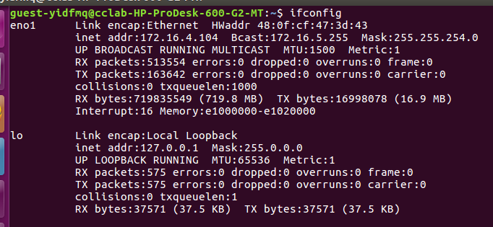
Here, eno1 is the ethernet connection and lo is the loopback interface. lo is a special network interface that the system uses to communicate with itself.

Link encap :
Name of the network interface connection.

HWaddr :
Hardware address or MAC address.

inet :
IP Address. The address assigned by ISP.

Bcast :
Broadcast Address associated with that particular interface. Some Protocols such as ARP will do a broadcast to all devices on the local network using this address.

Mask :
It is bit mask that shows how much of the address is routable, which determines whether the computer can connect directly to a device on the LAN or whether it need to send the packet to a router.

UP :
It is flag. This flag indicate that the kernel module related to network interface has been loaded.

BROADCAST :
Denotes that the network device suppourts broadcasting. A neccessary thing to obtain IP address via DHCP server.
RUNNING :
The interface is ready to accept data.

MULTICAST :
This indicate that network interface suppourt multicast. Multicast allows a source to send packets to multiple machines as long as the machines are looking for that packets.

MTU :
Maximum Transmission Unit is the size of the each packet received by the netwrok interface. Its default value for Ethernet connections is 1500. Setting this to a higher value could cause hazard packet fragmentation or buffer overflow. Loopback will have higher MTU value that Ethernet

Metric :
This option can take values like 0, 1, 2, 3, ... with lower the value the more leverage it has. The value of this option decides the priority of the device. This metric value is used by the routing information protocol (RIP) to build routing table for network. The default value is 0.

RX :
‘packets’ received by connection. ‘error’, how many error occurred. ‘dropped’, how many packets are dropped. ‘overrun’, how many packets were lost because of overrun. Reciever overrun happen
when packets come faster than the kernel can service the last interrupt.

TX :
‘packets’ transmitted by connection. ‘error’, how many error occurred. ‘dropped’, how many packets are dropped. ‘overrun’, how many packets were lost because of overrun.

collisions :
If it has a value greater than 0, it could mean that packets are colliding while traversing your network – a sure sign of netwrok congestion.

RX bytes :
Amount of data received through that network interface.

TX bytes :
Amount of data transmitted through that network interface.

Interrupt :
This is usually set by system. It is basically the interrupt number used by the CPU. This number is the IRQ number used by the CPU and NIC to communicate across the bus. An interrupt request (IRQ) is a hardware signal sent to processor that tenporarily stops the current running process and runs the interrupt handler routine. Hardware interrupts are used to handle events such as recieving data from a modem or network card, key press etc.

Memory :
indicate a segment of memory in use.

txqueuelen :
Size of the buffer that is managed by the network scheduler. Measured in number of Ethernet frames.

b) ifcongif – a
It shows all network connections (even that are inactive).

c) ifconfig network_interface_name
To see the configuration of a specific network interface.
In the below example, network_interface_name is eno1.
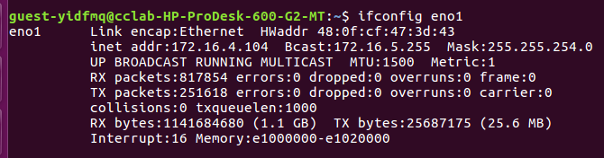
d) sudo ifconfig network_interface_name up/down
up is used for enabling a disabled network interafce. It require super-user mode. down used for disabling a enabled network interface.
e) sudo ifconfig network_interface_name static_IP_address
It used for assigning static IP address to network interface.
Ex : sudo ifconfig eno1 172.16.8.24

f) sudo ifconfig network_interface_name netmask mask_value
It is used to set the network mask of netwrok interface.
Ex : sudo ifconfig eno1 netmask 255.255.255.0

g) sudo ifconfig network_interface_name broadcast broadcast_value
It is used to set the broadcast address of the network interface.
Ex : sudo ifconfig eno1 broadcast 172.16.5.254

This configuration can be combined in a single command.
Ex : sudo ifconfig eno1 172.16.8.24 netmask 255.255.255.0 broadcast 172.16.5.254

h) sudo ifconfig network_interface_name [-]arp
Enable (or, disable, if the “-” prefixe is specified) the use of ARP protocol on this interface.

i) sudo ifconfig netywork_interface_name [-]promisc
Enable (or disable, if specified the “-” prefixe) the promiscuous mode of the interface. If promiscuous is enabled, all packets on the network will be received by the interface.

