**CS207_PROJECT**

**A Smartphone controlled car**

# The point of making this repository is to explain how we made a smartphone controlled car using arduino, which difficulties we faced and how we solved them. We made this smartphone controlled car as our final project for CS 207.

# Our group had a common interest in making something smartphone-controlled. But as rc cars are too common so we all decided to pick up something different and came up with an idea of making an arduino smartphone controlled car. It seemed easy at first but later on we found it challenging and interesting.

**Requirements and Materials**

* Arduino Uno R3 Board
* Chassis 4WD with DC Motor and Wheel x4
* Motor Driver L298N
* Bluetooth module HC-06
* 9 volts battery
* Soldering iron
* Duct tape
* Glue
* Bunch of jumper wire

**Build Instructions**

Here is where you can find specific instructions about how the smartphone controlled car is built. Also, I have included some schematics for the H bridge, USB shield and arduino:

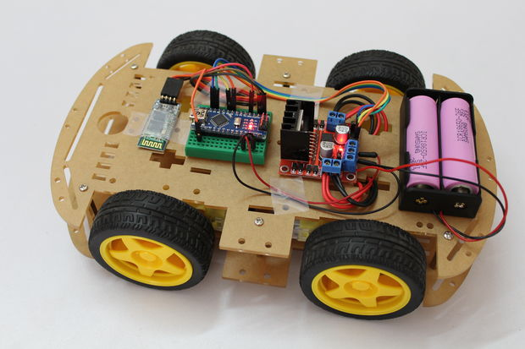

Schematic is given below:

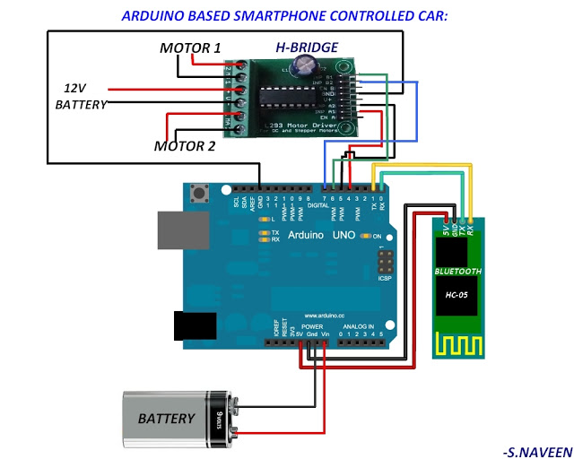

**Usage**

This is where you will find out how the car and the application actually works! You can connect it to either external power or to laptop to run the code. If you are connecting it to external power supply make sure to upload the code to the arduino first. The process is as follows:

* Upload the code given to the arduino.
* Attach the batteries and motors to it.
* Turn the Bluetooth on in your smartphone and connect it to the Bluetooth module.
* The code is set up to perform the functions according to smartphone application.

**Team**

The build team consists of:

Nityang Patel -> I did coding, GitHub repository, etc.  Providing the space for our so-called laboratory.

Preyansh Patel -> Designing, writeups, electronic expert. He helped in financing.

**Credits**

* YOUTUBE and INSTRUCTIBLES

**Useful links**

* Our video: https://www.youtube.com/watch?v=kewza7RyKMQ&t=90s
* Arduino IDE: <https://www.arduino.cc/en/Main/Software>
* Fritzing (For schematics): http://www.kitkatgadgets.com/2016/11/smartphone-controlled-car-using-arduino_25.html
* DAD: <https://www.google.ca/>