**Menu**

* About Gari Khane Campaign
  + What is Gari Khane Campaign?

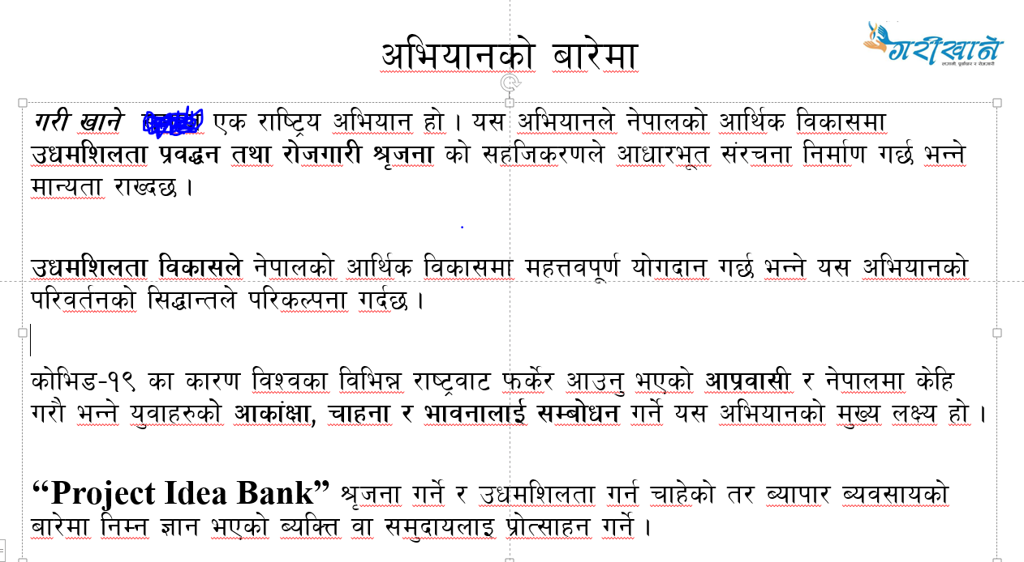

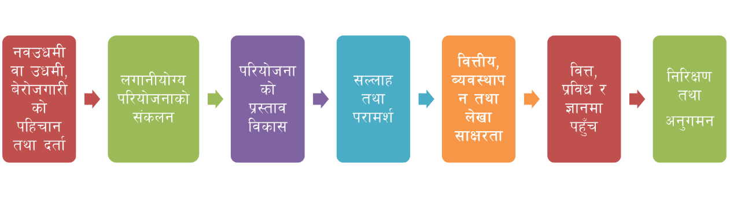

* + Messages - is it just display static messages?
    - Yes, messages and case studies
  + Partners
  + Our stories of Gari Khane entrepreneurs
  + Our network (map) - did we need to integrate Google map with pin places?
* Gari Khane Projects/ Initiatives
  + Under Implementation
  + Under Study
* Project Idea Bank
  + Province-wise / Sector-wise / Documents - what kind of data we add on this section?
    - We will provide data when we receive and have it, data on each projects will be put under the following heading
      * Name of project
      * Sector (type)
      * Project location
      * Project description
      * Project components/ technology
      * Market opportunity
      * Successful examples (if any)
      * Development/ investment modality (inc. development period)
      * Total project cost
      * IRR (estimate)
      * References
* Job Board
  + Listings - jobs - did we post job from this and also user apply from this?
    - Yes, we post the jobs but there needs to be a mechanism where we receive messages/ requests to list jobs
    - Rather than full-fledged application, perhaps they can click ‘I am interested’
* Access to Investment and Finance
  + Information related to banks and loans
* What’s on?
  + Events / Webinars (Date: Calendar) - only display on app and post from Web?
    - Yes, both
* Join the Movement/ Get Involved
  + Become a mentor (form) - provide required fields
    - Has been provided
  + Become a Garikhane Entrepreneur (form)- required fields
    - Has been provided