**Cognizant - DN 4.0 Deep Skilling Stage**

**Mandatory Hands-On Week 1 Solutions**

1. **Design Patterns And Principles**

Exercise 1: Implementing Singleton Pattern

**CODE:**

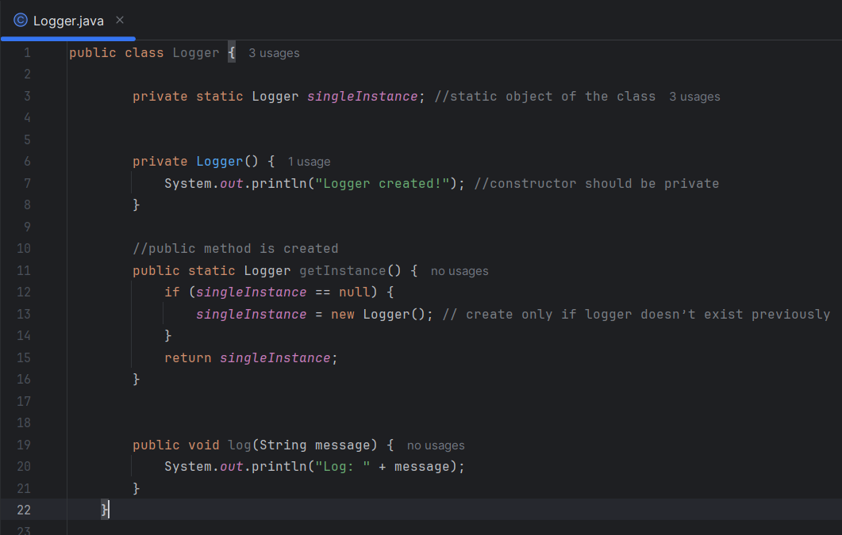

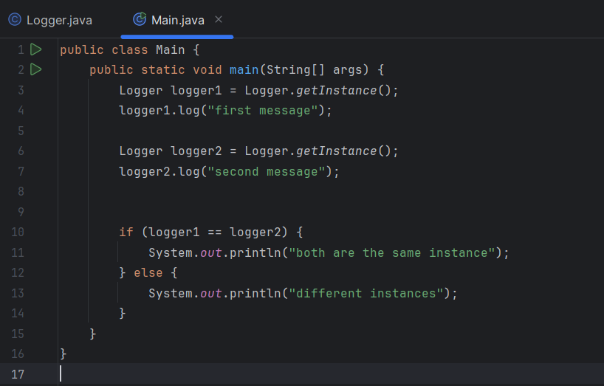

**Output:**

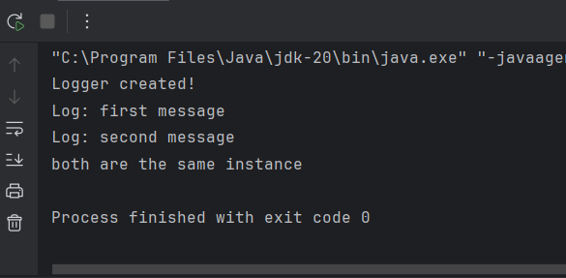

Exercise 2: Implementing the Factory Method Pattern

**CODE:**

**Hierarchy:**

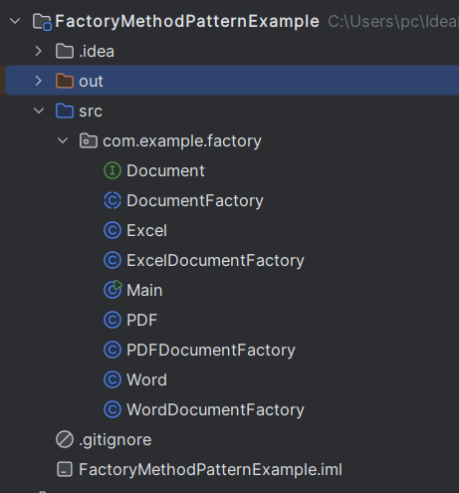

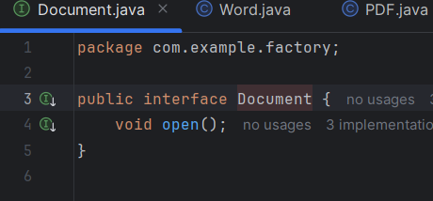

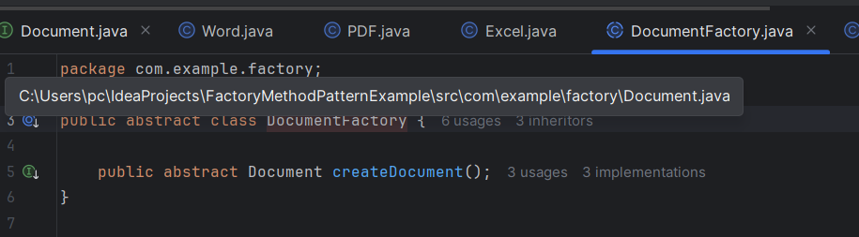

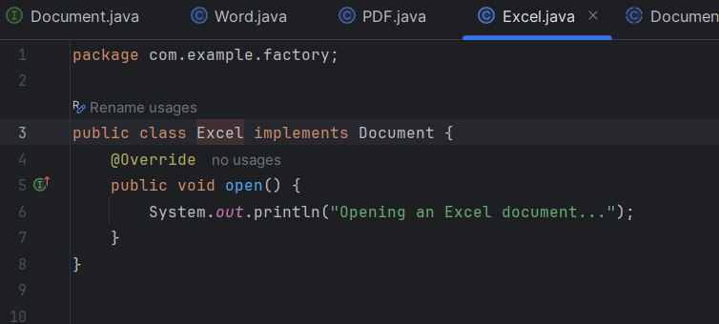

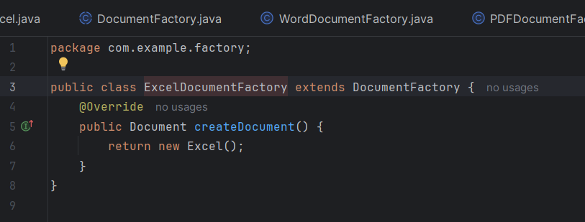

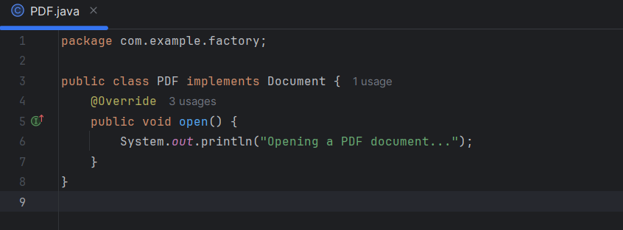

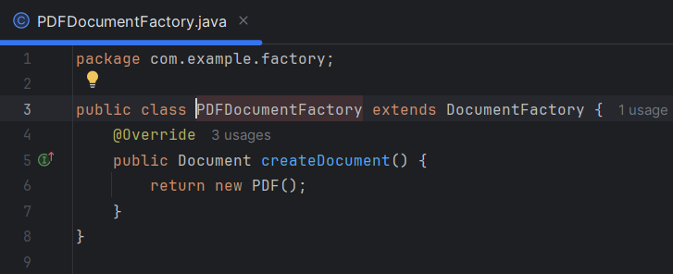

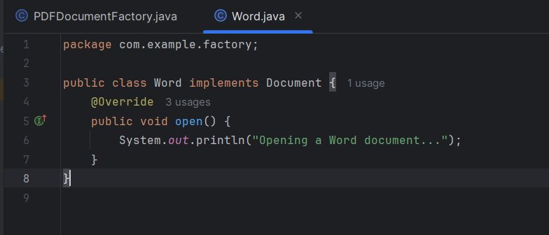

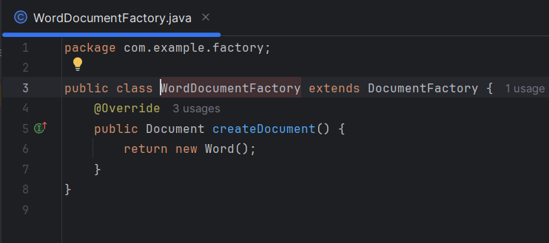

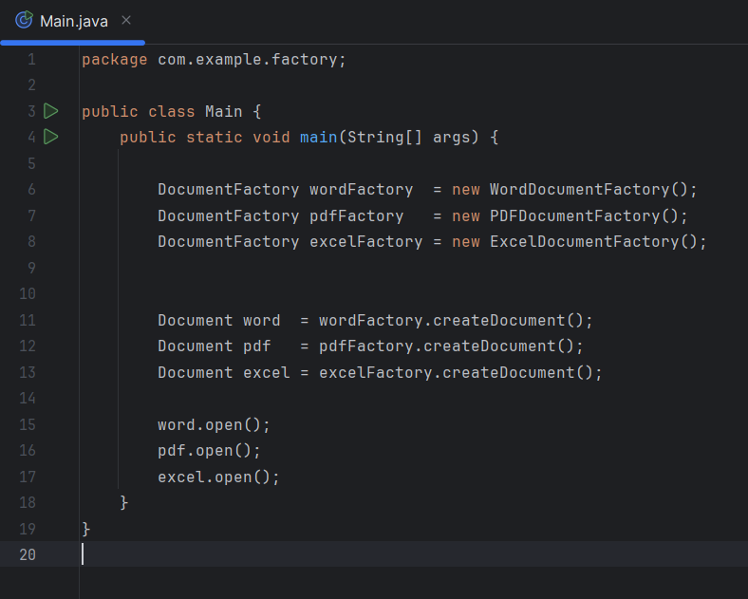

**OUTPUT:**

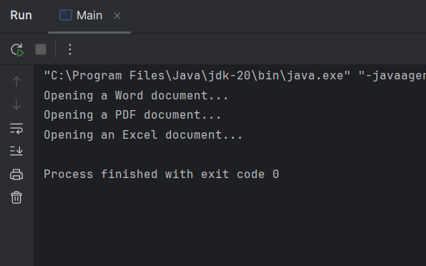

1. **Data structures and Algorithms**

Exercise 1: E-commerce Platform Search Function

**Big O notation** describes how the performance of an algorithm scales with input size n. It helps developers choose faster, more efficient algorithms.

**Code:**

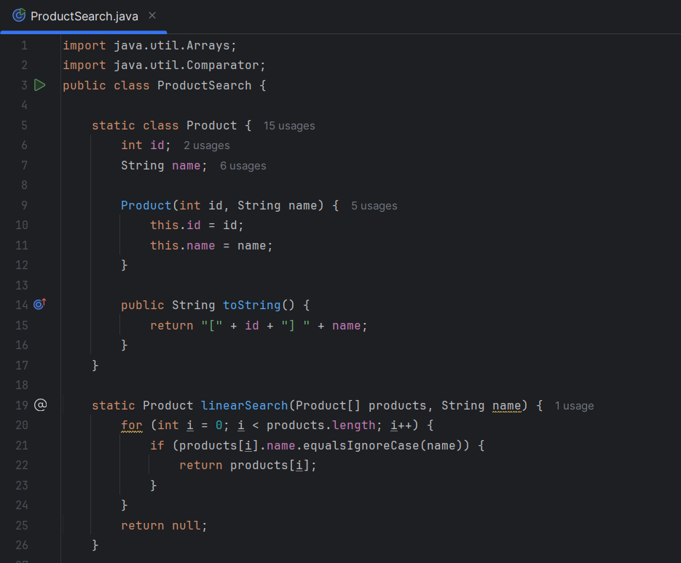

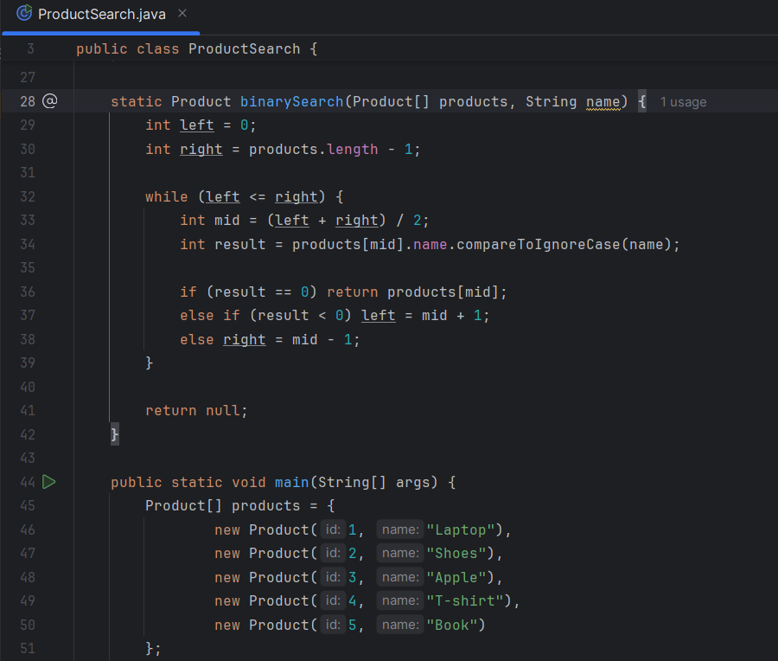

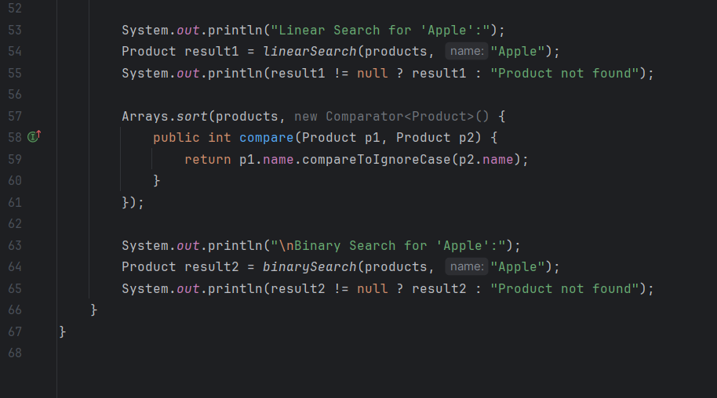

**Output:**

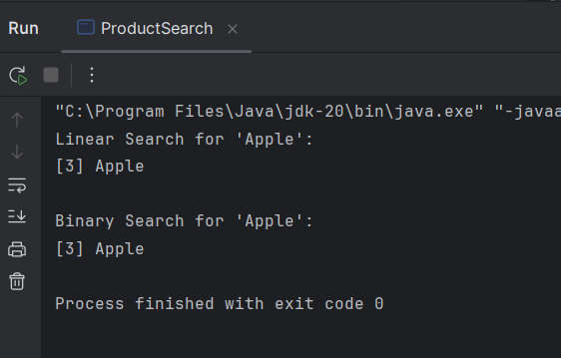

Exercise 2: Financial Forecasting

**Recursion** is when a method calls **itself** to solve smaller versions of the same problem.

Predicting Future Value Recursively

1.Use an initial amount ( ₹1000)  
2.Apply a growth rate (10% or 0.10)  
3. Predict how much it grows over n years

**Code:**

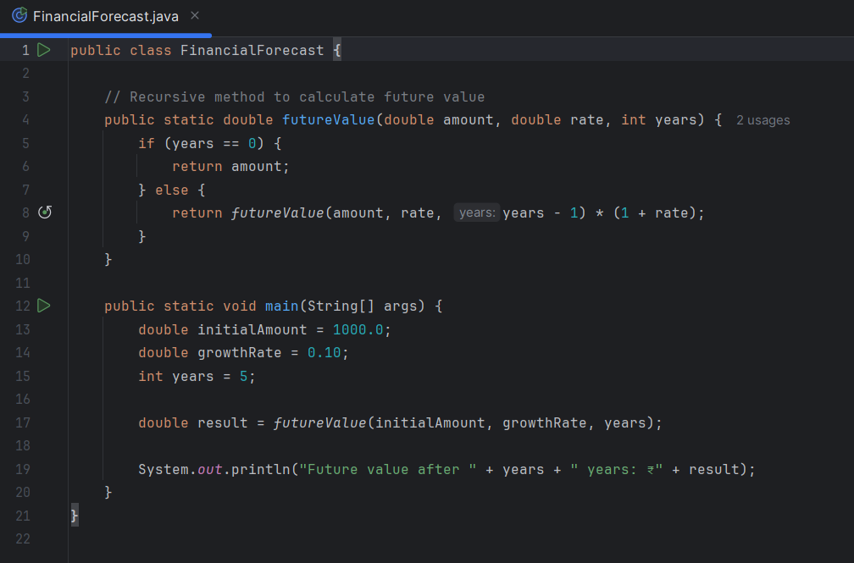

**Output:**

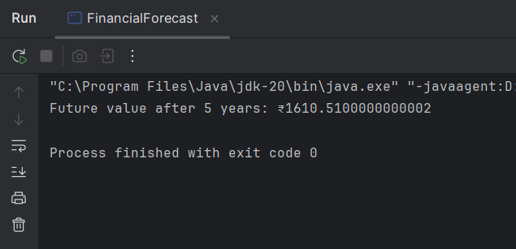

## Time Complexity

Recursive calls = n (one call per year)  
Time Complexity: O(n)  
Space Complexity: O(n) due to call stack

**Can be optimized using iteration. (uses less space)**