**Cognizant - DN 4.0 Deep Skilling Stage**

**Mandatory Hands-On Week 4 Solutions**

1. **Spring REST Using Spring Boot**

**Exercise 1: Create a Spring Web Project using Maven**

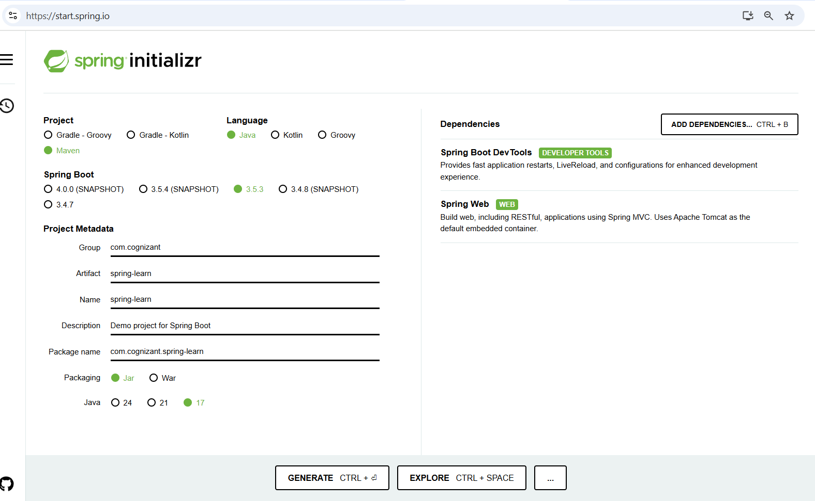

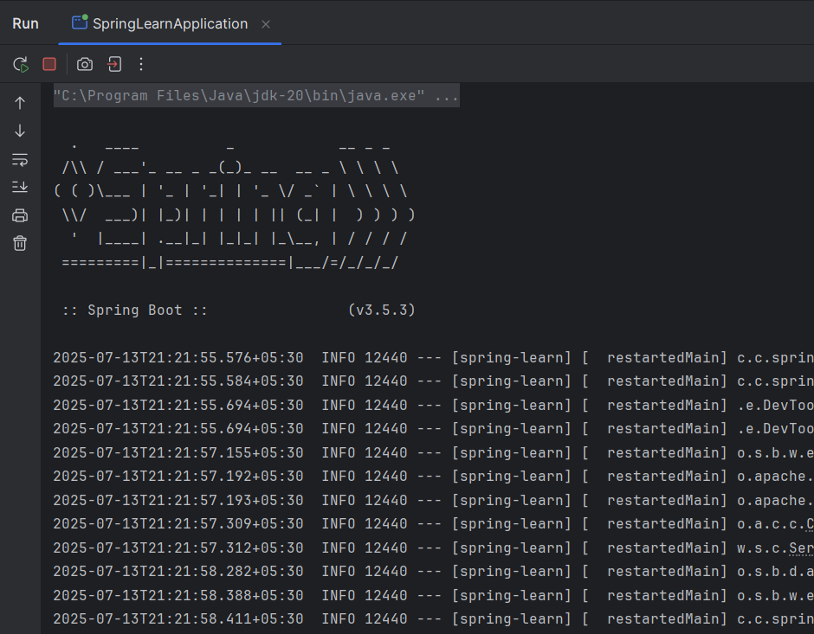

**pom.xml**

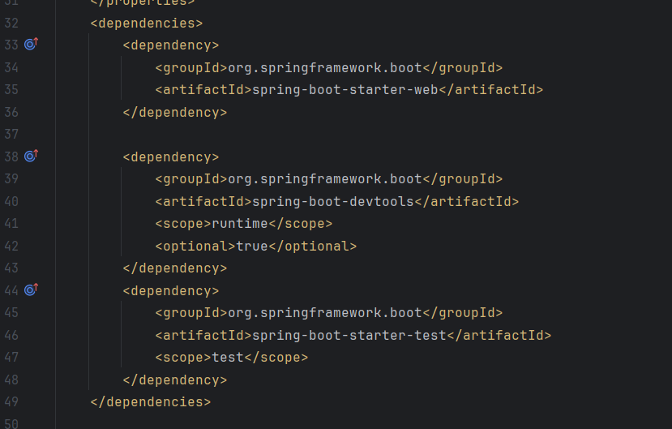

**Exercise 2: Spring Core – Load Country from Spring Configuration XML**

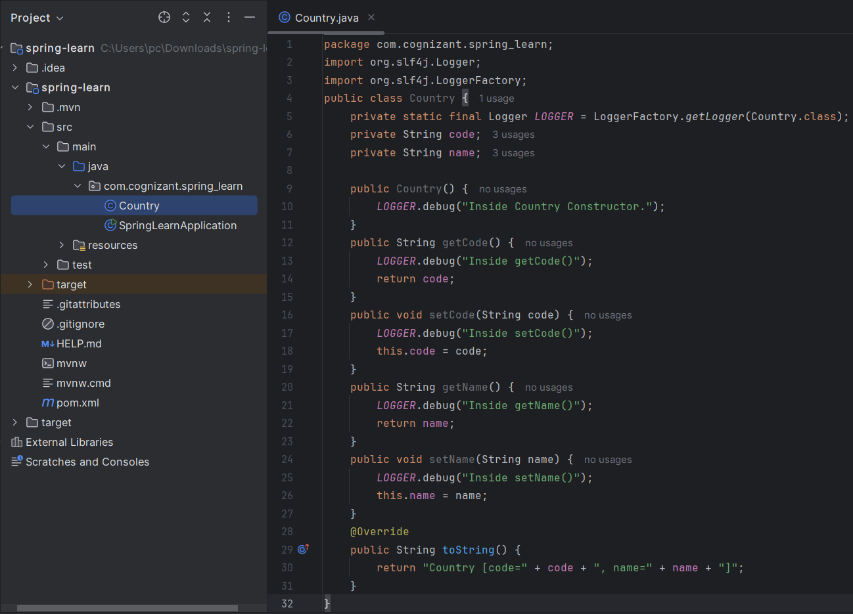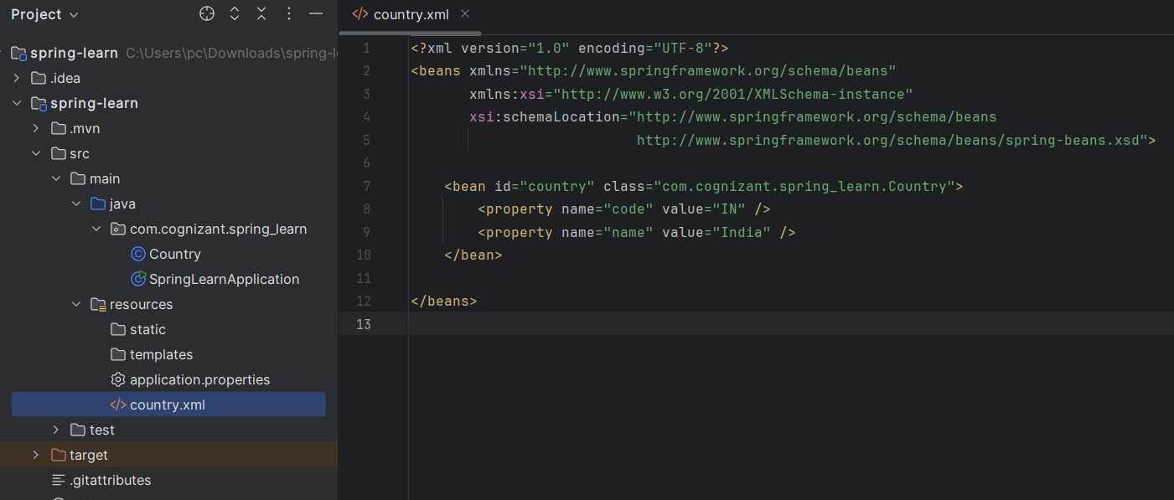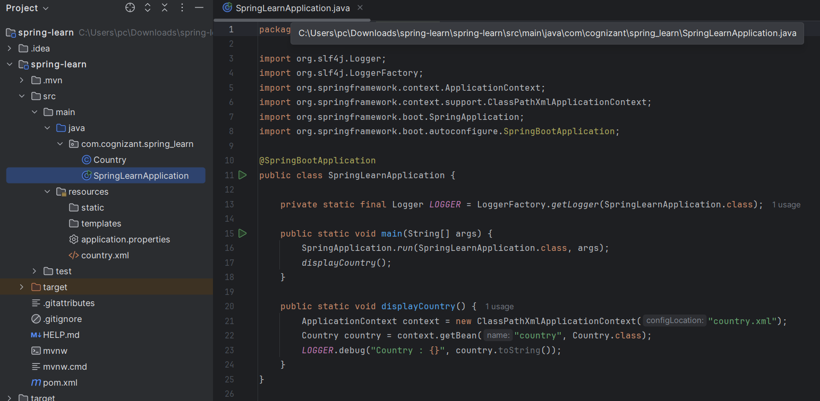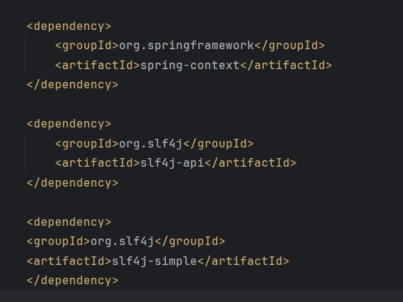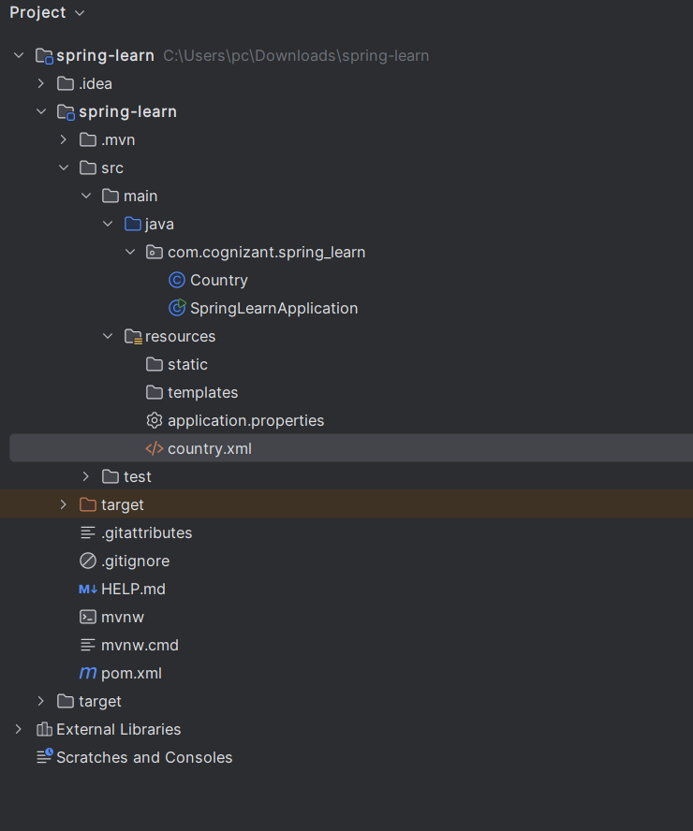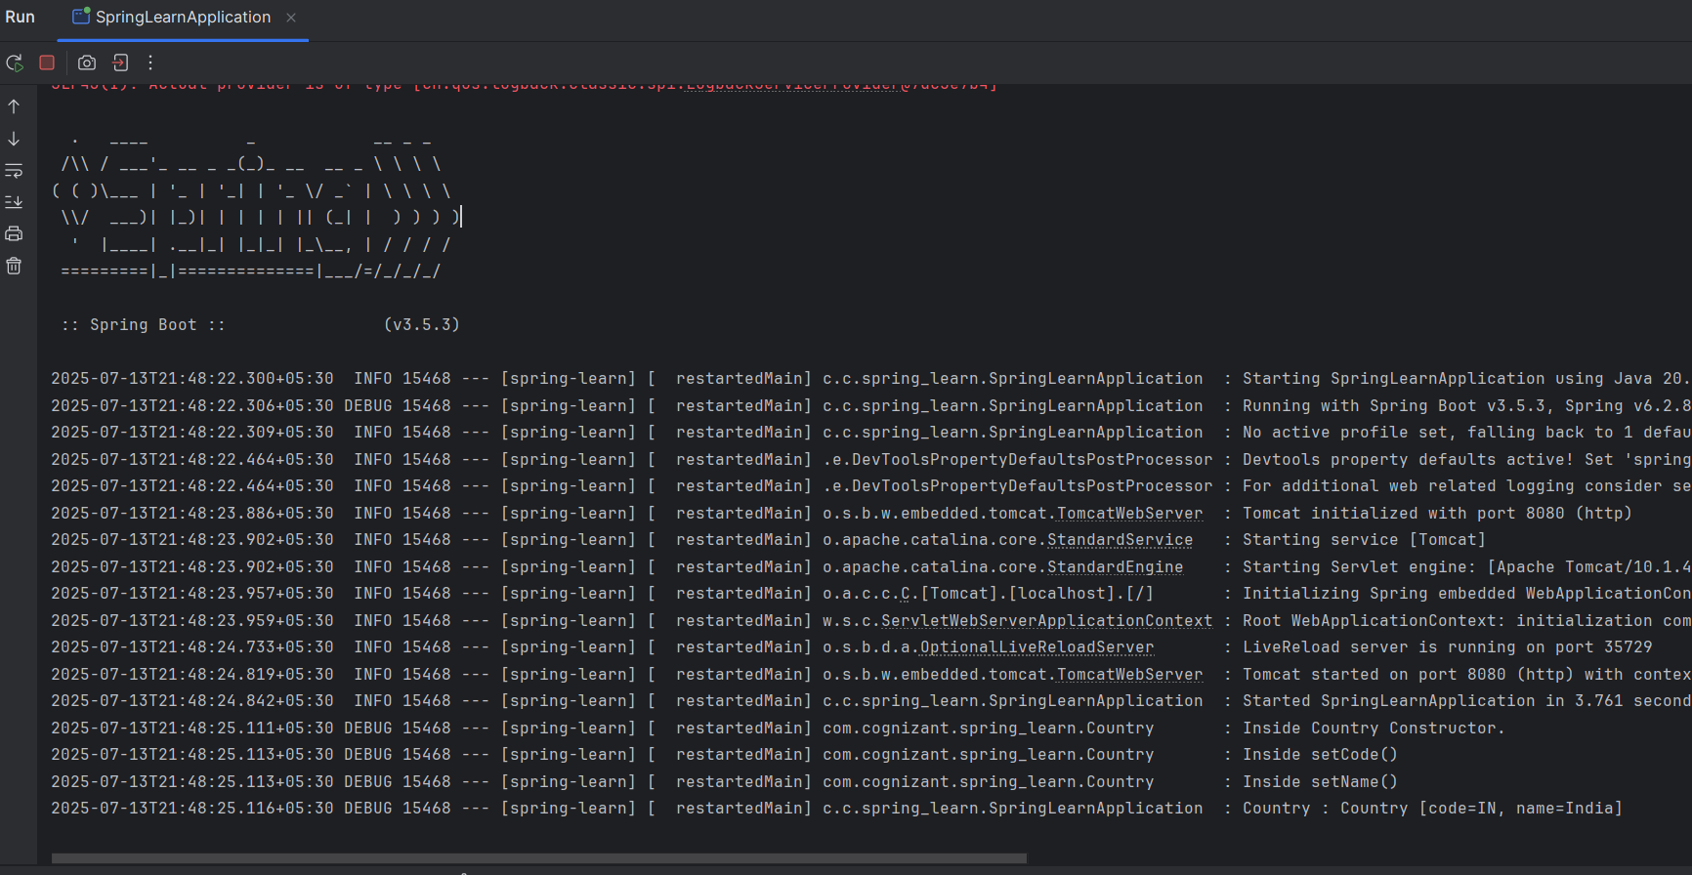

**Exercise 3: Spring Core – Load Country from Spring Configuration XML**

**application.properties**

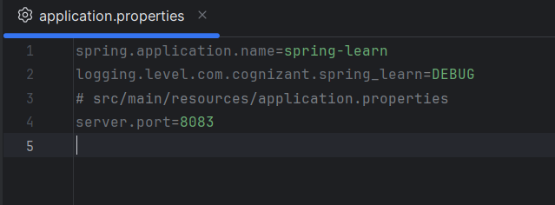

**src/main/java/com/cognizant/spring_learn/controller/HelloController.java**

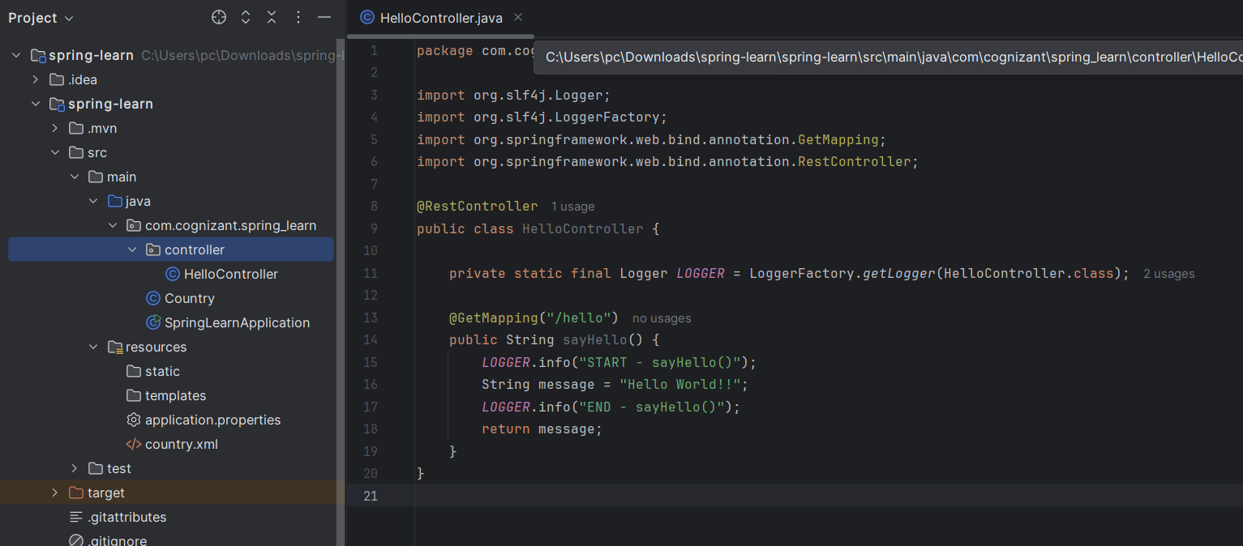

**Output:**

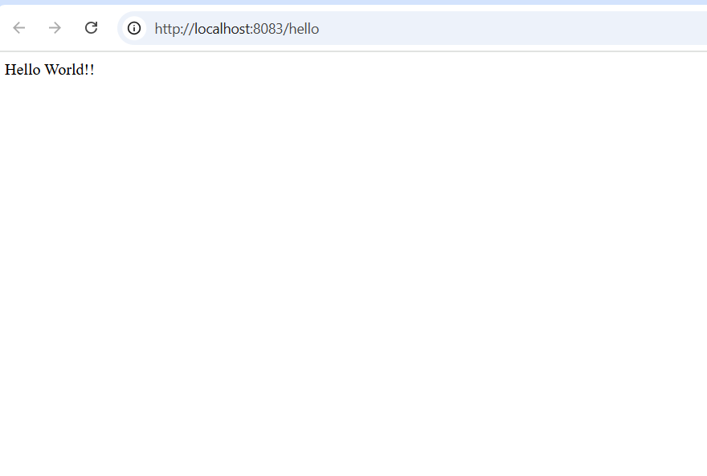

**Exercise 4: REST - Country Web Service**

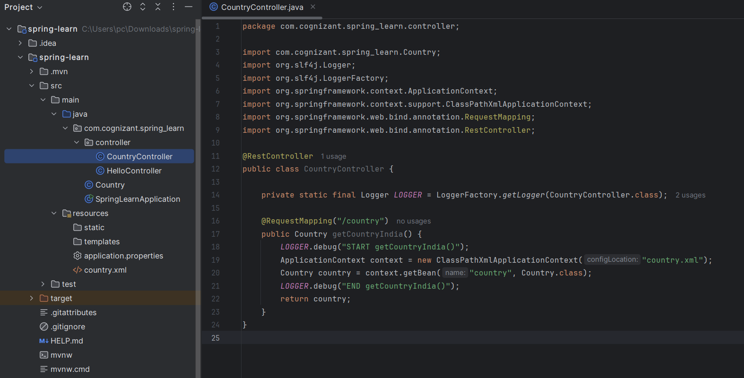

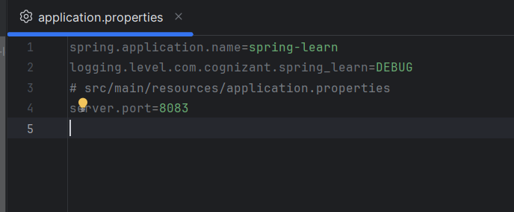

**Output:**

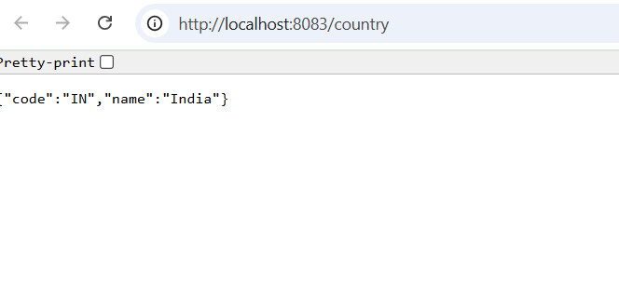

### SME Explanation Points

* What happens in the controller method?  
   Spring calls getCountryIndia(), loads country.xml, fetches the "country" bean, and returns it.
* How is the bean converted to JSON?  
   Spring Boot uses Jackson (from spring-boot-starter-web) to auto-convert the Java object to JSON because @RestController + returning a POJO = JSON by default.
* Where to see HTTP headers?  
  + In Chrome → Right-click → Inspect → Network tab → click the /country request → check Headers tab.
  + In Postman → Send request to /country → click Headers tab to view response headers.

**Exercise 5: REST - Get country based on country code**

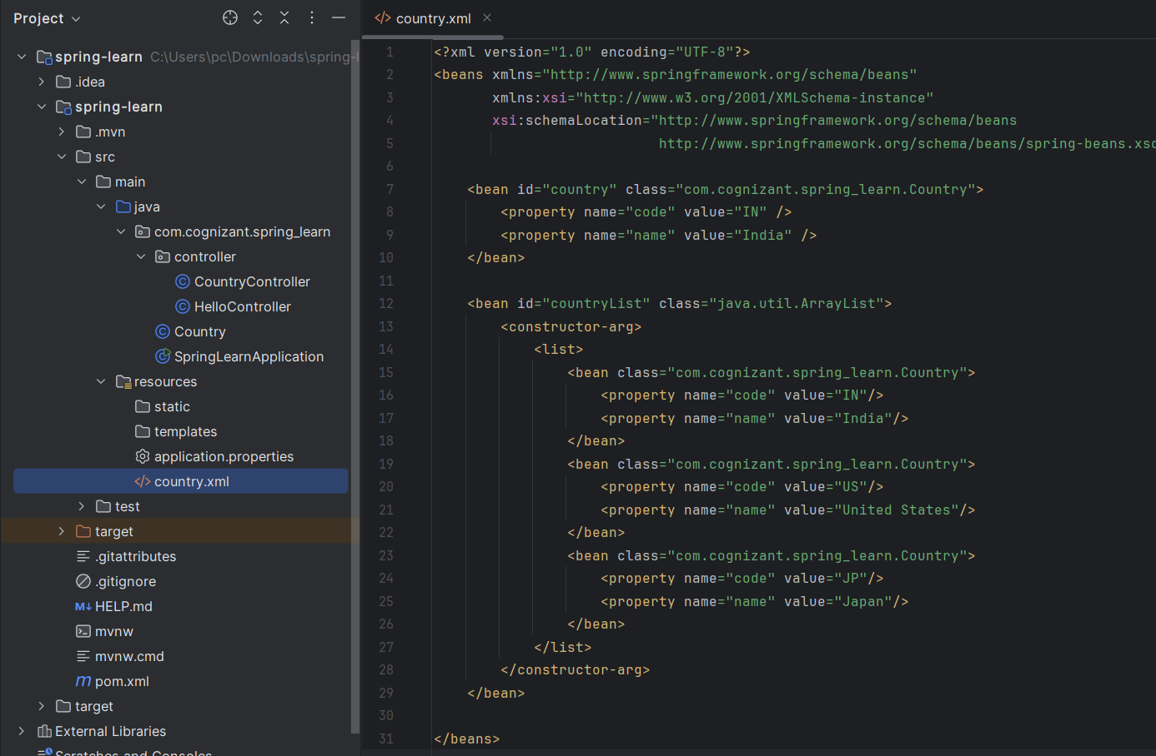

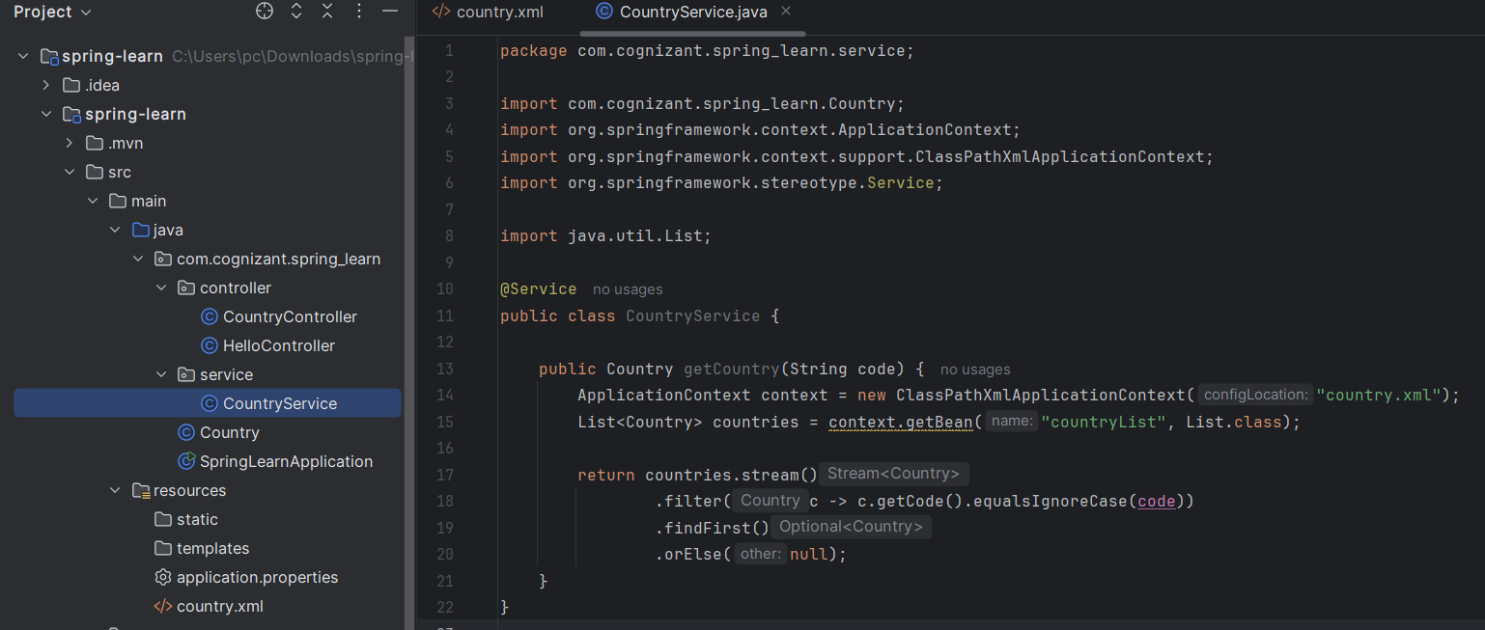

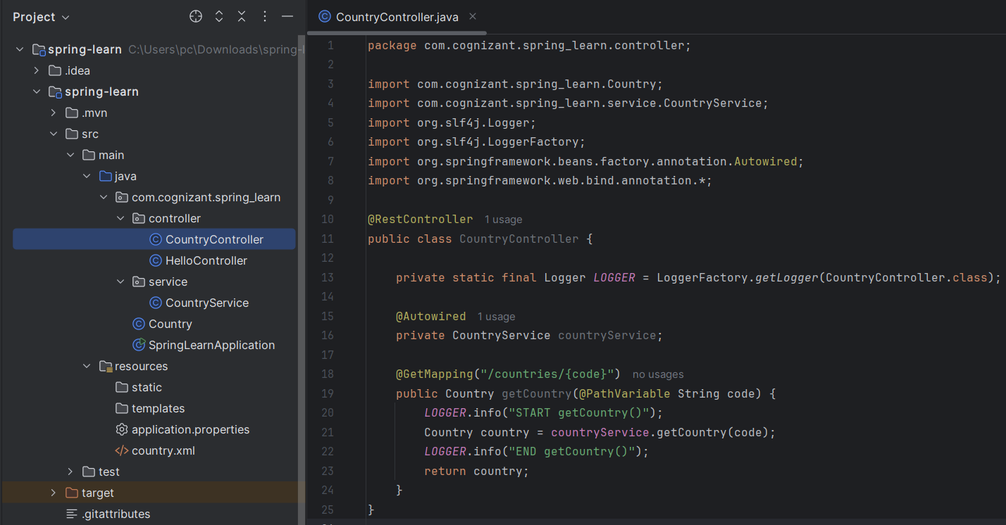

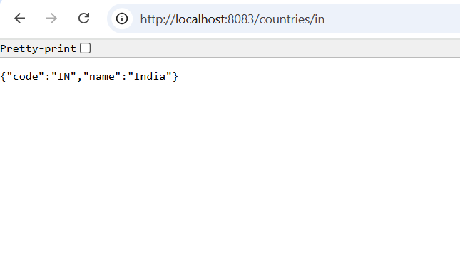

**Exercise 6: REST - Create authentication service that returns JWT**

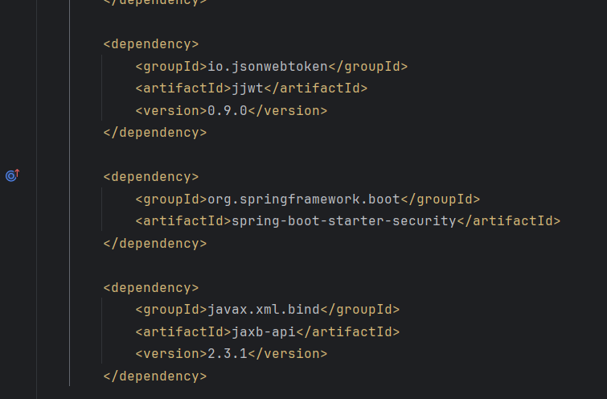

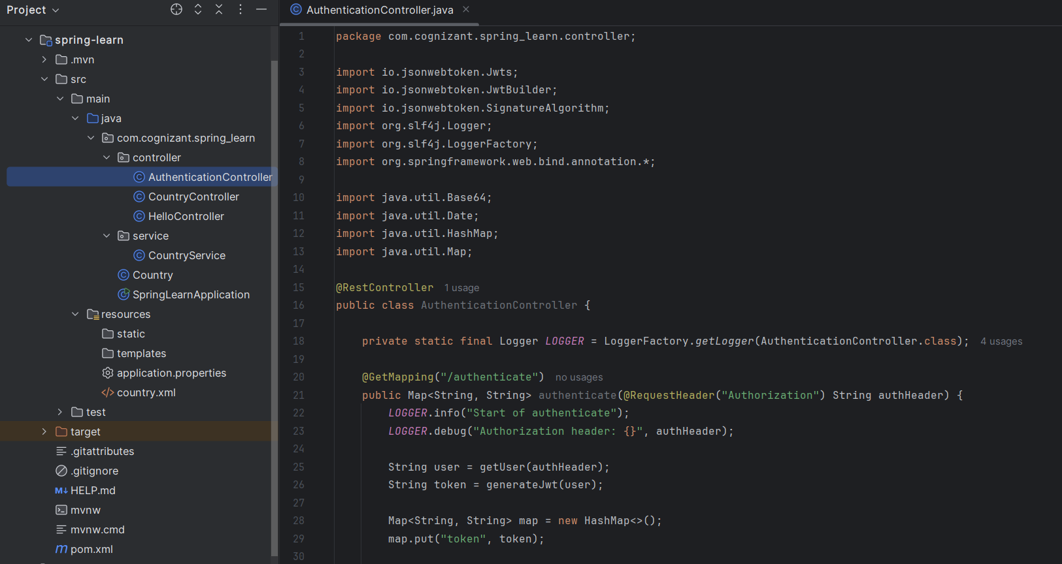

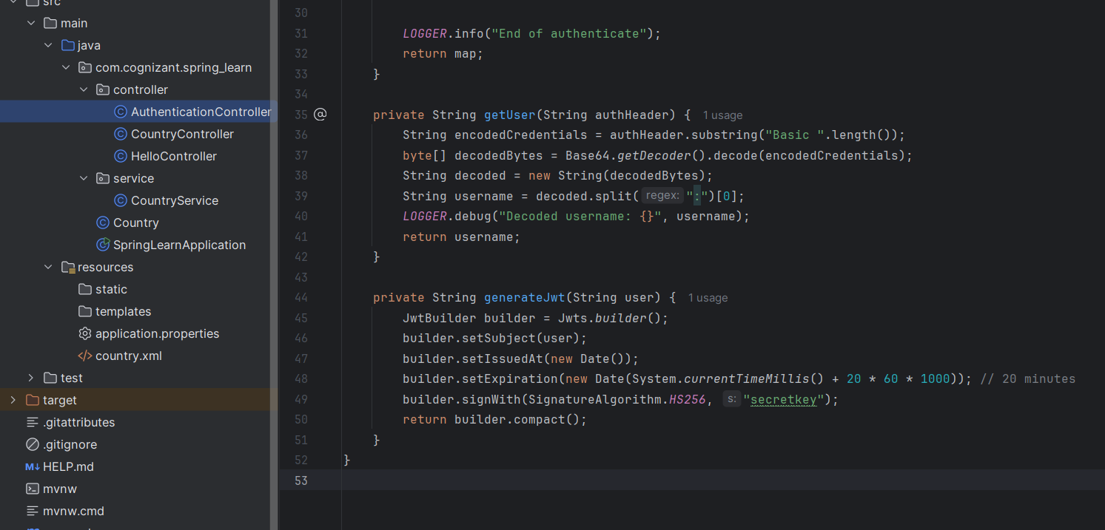

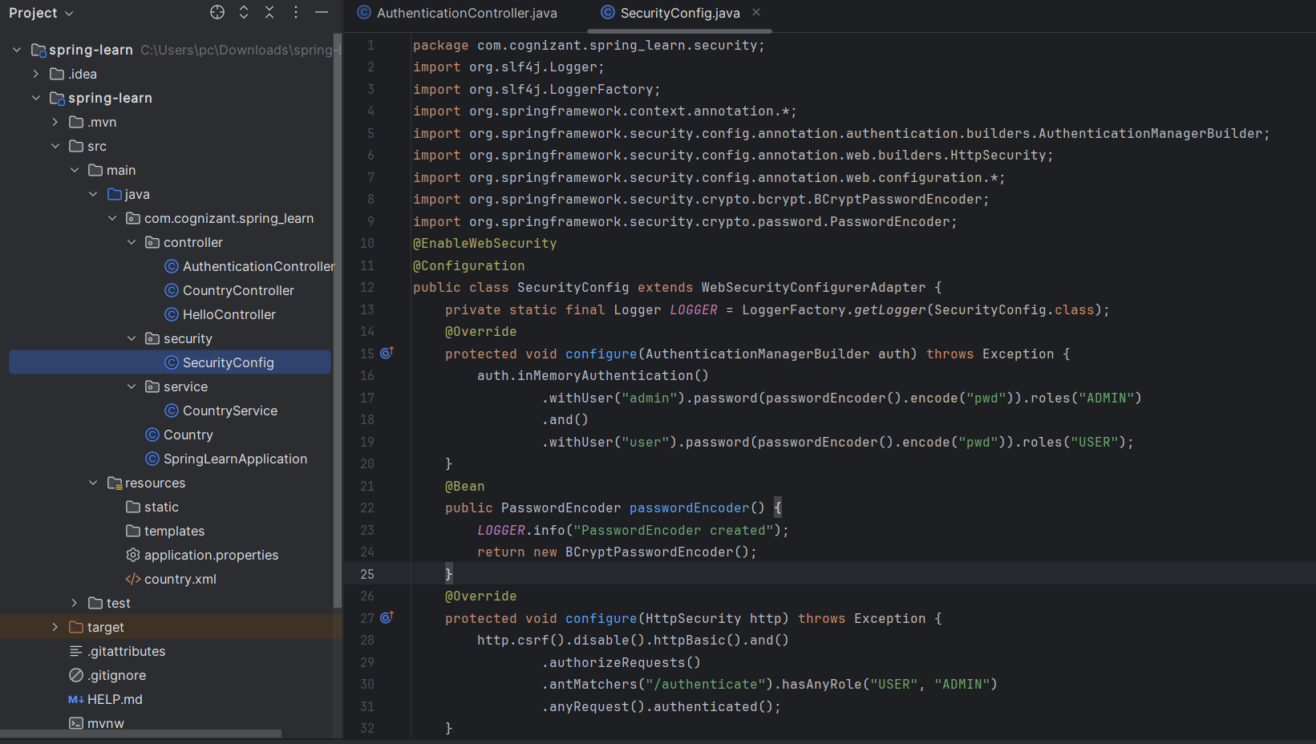

**In Terminal:**

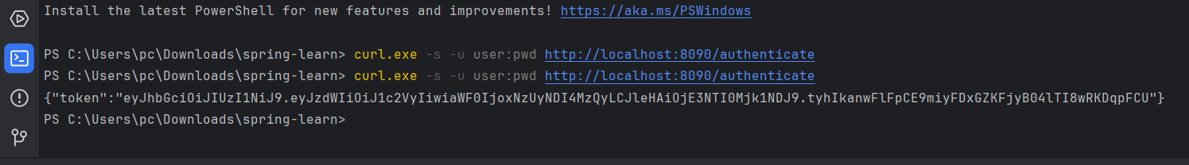

**Output** [**http://localhost:8090/authenticate**](http://localhost:8090/authenticate)

