**Cognizant - DN 4.0 Deep Skilling Stage**

**Mandatory Hands-On Week 5 Solutions**

**Microservices with Spring Boot 3 and Spring Cloud**

**Exercise 1: Creating Microservices for account and loan**

**For ACCOUNT:**

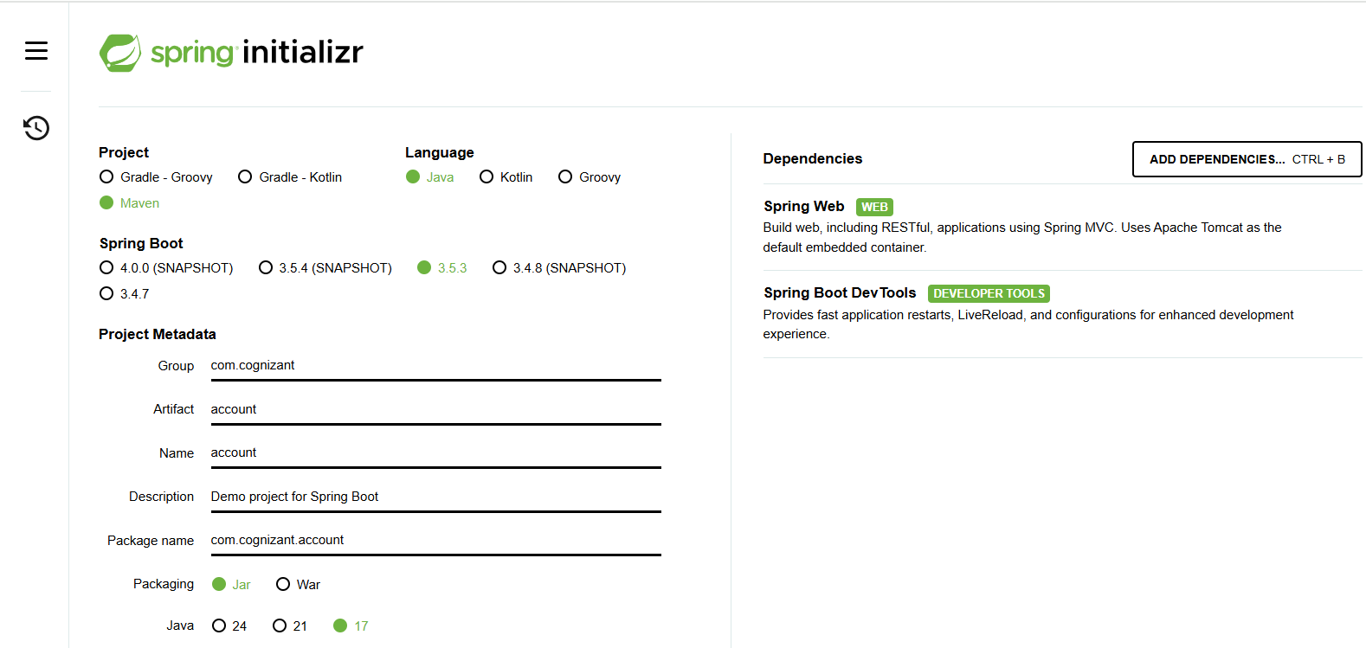

**Controller:**

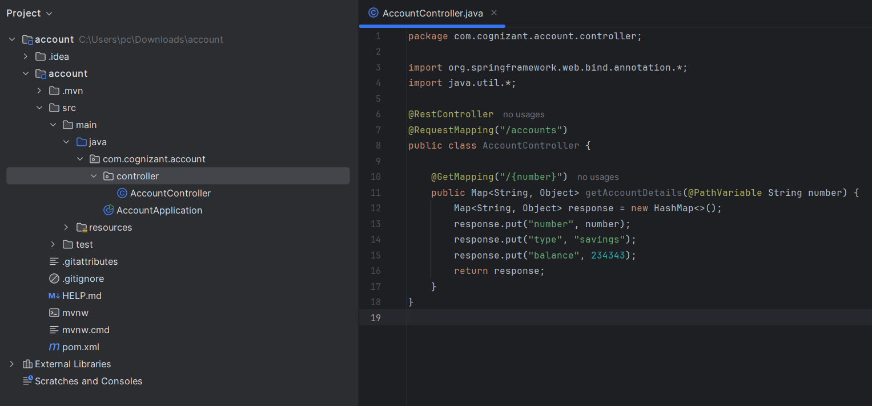

**Output:**

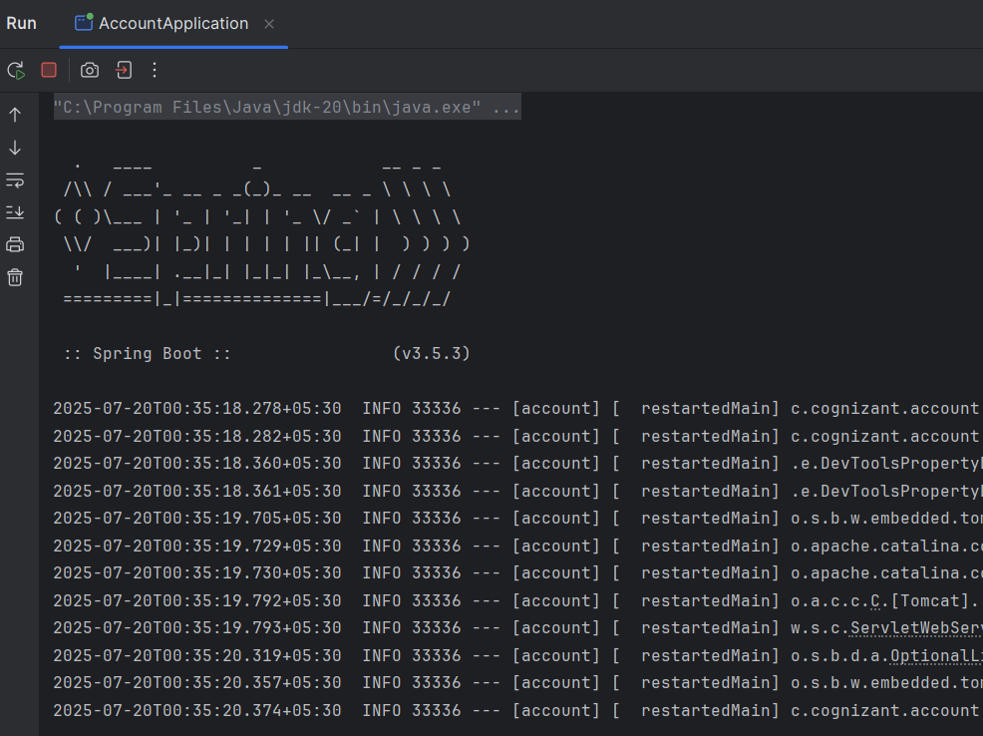

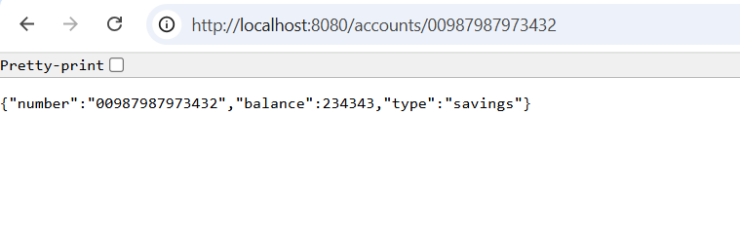

**For Loan**

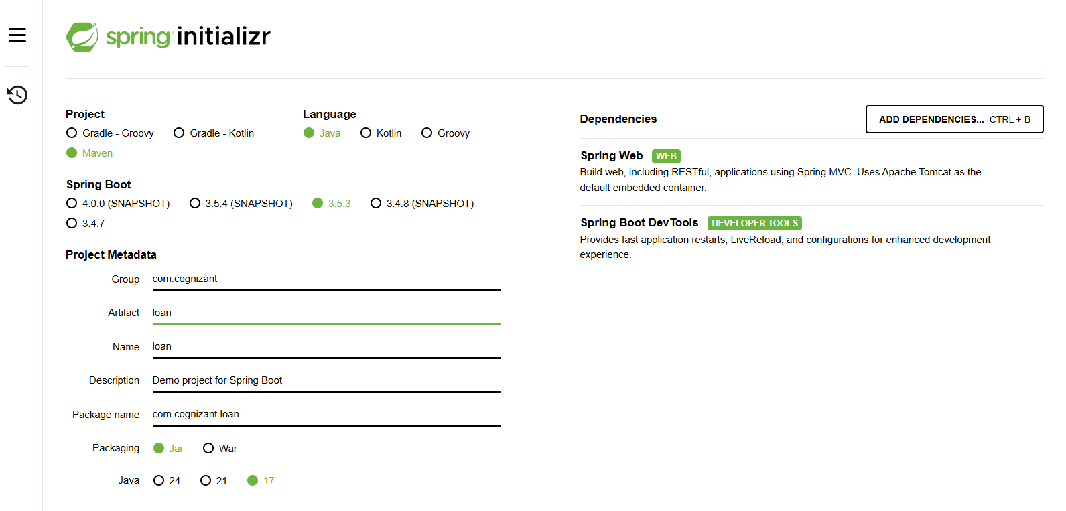

**Controller:**

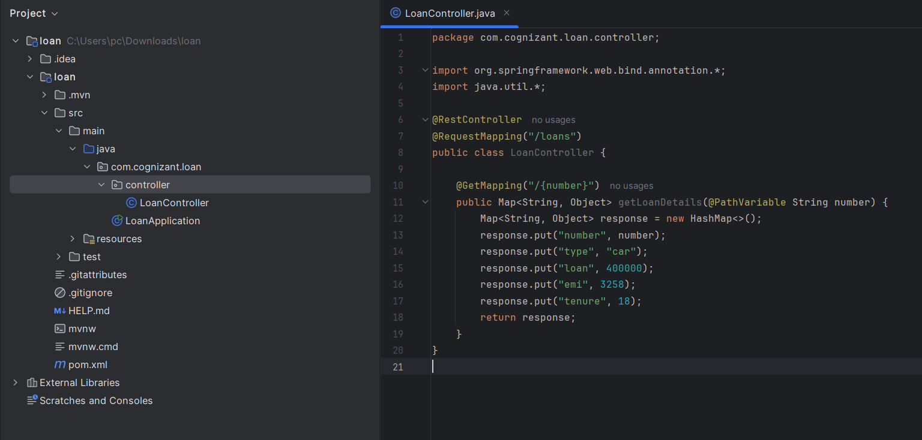

**Change port number:**

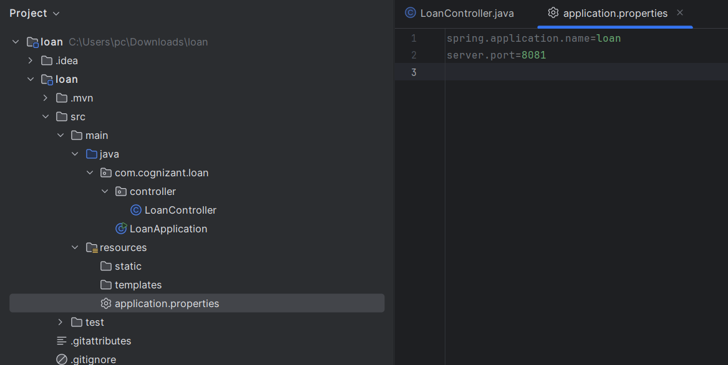

**Output:**

