**Cognizant - DN 4.0 Deep Skilling Stage**

**Mandatory Hands-On Week 6 Solutions**

1. **ReactJS-HOL**

Exercise 1

* install Create React App globally:  
   npm install -g create-react-app
* Next, create the React application by running:  
   npx create-react-app myfirstreact
* navigate into the project folder by typing:  
   cd myfirstreact
* open the file named App.js located in the src folder. replace it with the following code:

function App() {

return (

<div>

<h1>welcome to the first session of React</h1>

</div>

);

}

export default App;

* To run the React application  
   npm start
* go to http://localhost:3000  
   **"welcome to the first session of React"**

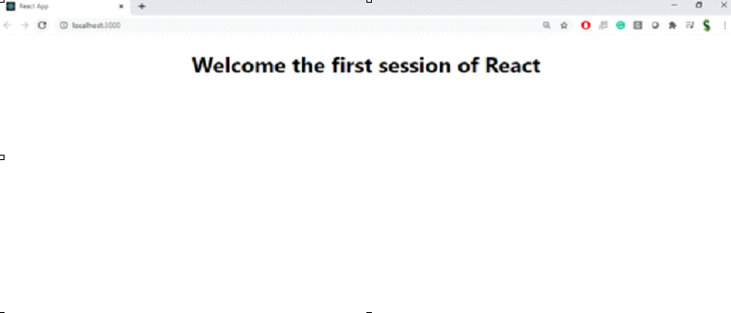

Exercise 2:

* **Create React App** npx create-react-app StudentApp
* **Navigate into project folder** cd StudentApp
* **Create “Components” folder** under src

**Create Home.js** inside src/Components  
  
 function Home() {

return (

<div>

<h2>Welcome to the Home page of Student Management Portal</h2>

</div>

);

}

export default Home;

* **Create About.js** inside src/Components  
    
   function About() {

return (

<div>

<h2>Welcome to the About page of the Student Management Portal</h2>

</div>

);

}

export default About;

* **Create Contact.js** inside src/Components  
    
   function Contact() {

return (

<div>

<h2>Welcome to the Contact page of the Student Management Portal</h2>

</div>

);

}

export default Contact;

* **Edit App.js** in src folder  
   Replace content with:  
    
   import Home from './Components/Home';

import About from './Components/About';

import Contact from './Components/Contact';

function App() {

return (

<div>

<Home />

<About />

<Contact />

</div>

);

}

export default App;

* **Start the app** npm start
* **Open browser** Go to http://localhost:3000

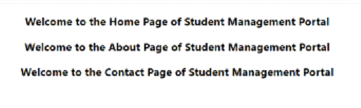

Exercise 3:

* **Create React App** npx create-react-app scorecalculatorapp
* **Navigate into project folder** cd scorecalculatorapp
* **Create Components folder** under src

**Create CalculateScore.js** inside src/Components  
  
 import './Stylesheets/mystyle.css';

function CalculateScore(props) {

const average = props.total / props.goal;

return (

<div className="score-box">

<h2>Student Score Calculator</h2>

<p><strong>Name:</strong> {props.name}</p>

<p><strong>School:</strong> {props.school}</p>

<p><strong>Total Marks:</strong> {props.total}</p>

<p><strong>Number of Subjects:</strong> {props.goal}</p>

<p><strong>Average Score:</strong> {average}</p>

</div>

);

}

export default CalculateScore;

* **Create Stylesheets folder** under src

**Create mystyle.css** inside src/Stylesheets  
  
 .score-box {

border: 2px solid #007bff;

padding: 20px;

margin: 30px;

border-radius: 10px;

background-color: #f2f2f2;

font-family: Arial, sans-serif;

}

.score-box h2 {

color: #007bff;

}

* **Edit App.js** in src folder  
   Replace content with:  
    
   import CalculateScore from './Components/CalculateScore';

function App() {

return (

<div>

<CalculateScore name="Rahul Sharma" school="Greenfield High" total={450} goal={5} />

</div>

);

}

export default App;

* **Start the app** npm start
* **Open browser** Go to <http://localhost:3000>

Exercise 4:

### **Student Management Portal – scorecalculatorapp**

* **Create React App** npx create-react-app scorecalculatorapp
* **Navigate into project folder** cd scorecalculatorapp
* **Create Components folder** under src

**Create CalculateScore.js** inside src/Components  
  
 import './Stylesheets/mystyle.css';

function CalculateScore(props) {

const average = props.total / props.goal;

return (

<div className="score-box">

<h2>Student Score Calculator</h2>

<p><strong>Name:</strong> {props.name}</p>

<p><strong>School:</strong> {props.school}</p>

<p><strong>Total Marks:</strong> {props.total}</p>

<p><strong>Number of Subjects:</strong> {props.goal}</p>

<p><strong>Average Score:</strong> {average}</p>

</div>

);

}

export default CalculateScore;

* **Create Stylesheets folder** under src

**Create mystyle.css** inside src/Stylesheets  
  
 .score-box {

border: 2px solid #007bff;

padding: 20px;

margin: 30px;

border-radius: 10px;

background-color: #f2f2f2;

font-family: Arial, sans-serif;

}

.score-box h2 {

color: #007bff;

}

* **Edit App.js** in src folder  
    
   import CalculateScore from './Components/CalculateScore';

function App() {

return (

<div>

<CalculateScore name="Rahul Sharma" school="Greenfield High" total={450} goal={5} />

</div>

);

}

export default App;

* **Run the app** npm start
* **Open in browser** Go to http://localhost:3000

Exercise 5:

### **BlogApp using Lifecycle Hooks**

* **Create React App** npx create-react-app blogapp
* **Navigate to project folder** cd blogapp
* **Open in VS Code** code .

**Create Post.js** in src  
  
 function Post({ title, body }) {

return (

<div>

<h3>{title}</h3>

<p>{body}</p>

</div>

);

}

export default Post;

* **Create Posts.js** as a class component in src  
    
   import React, { Component } from 'react';

import Post from './Post';

class Posts extends Component {

constructor() {

super();

this.state = {

posts: [],

};

}

loadPosts = () => {

fetch('https://jsonplaceholder.typicode.com/posts')

.then(response => response.json())

.then(data => this.setState({ posts: data }))

.catch(error => console.error('Error fetching posts:', error));

};

componentDidMount() {

this.loadPosts();

}

componentDidCatch(error, info) {

alert('An error occurred: ' + error);

}

render() {

return (

<div>

<h2>Blog Posts</h2>

{this.state.posts.map(post => (

<Post key={post.id} title={post.title} body={post.body} />

))}

</div>

);

}

}

export default Posts;

* **Edit App.js** to include Posts component  
    
   import Posts from './Posts';

function App() {

return (

<div>

<Posts />

</div>

);

}

export default App;

* **Run the app** npm start
* **Open in browser** Go to http://localhost:3000