Cognizant - DN 4.0 Deep Skilling Stage

Mandatory Hands-On Week 7 Solutions

React-9

Cricketapp

terminal:
npx create-react-app cricketapp
cd cricketapp

src/Components/ListofPlayers.js
import React from "react";

const ListofPlayers = () => {
const players = [
{ name: "Virat Kohli", score: 85 },
{ name: "Rohit Sharma", score: 95 },
{ name: "Shubman Gill", score: 60 },
{ name: "Hardik Pandya", score: 45 },
{ name: "Rishabh Pant", score: 78 },
{ name: "KL Rahul", score: 88 },
{ name: "Jasprit Bumrah", score: 40 },
{ name: "Shami", score: 50 },
{ name: "Jadeja", score: 72 },
{ name: "Kuldeep Yadav", score: 65 },
{ name: "Axar Patel", score: 90 }
];

const filteredPlayers = players.filter(player => player.score < 70);

return (
<div>
<h2>All Players</h2>
<ul>
{players.map((player, index) => (
<li key={index}>{player.name} - {player.score}</li>
))}
</ul>

<h3>Players with score below 70</h3>
<ul>
{filteredPlayers.map((player, index) => (
<li key={index}>{player.name} - {player.score}</li>
))}
</ul>
</div>
);
};

export default ListofPlayers;

src/Components/IndianPlayers.js
import React from "react";

const IndianPlayers = () => {
const oddTeam = ["Kohli", "Pant", "Hardik", "Shami", "Gill"];
const evenTeam = ["Rohit", "Rahul", "Bumrah", "Jadeja", "Kuldeep"];

const [p1, p2, p3, p4, p5] = oddTeam;
const [q1, q2, q3, q4, q5] = evenTeam;

const T20players = ["Surya", "Ishan", "Samson"];
const RanjiTrophyPlayers = ["Shreyas", "Ruturaj", "Rahane"];

const mergedPlayers = [...T20players, ...RanjiTrophyPlayers];

return (
<div>
<h2>Odd Team Players</h2>
<ul>
<li>{p1}</li>
<li>{p2}</li>
<li>{p3}</li>
<li>{p4}</li>
<li>{p5}</li>
</ul>

<h2>Even Team Players</h2>
<ul>
<li>{q1}</li>
<li>{q2}</li>
<li>{q3}</li>
<li>{q4}</li>
<li>{q5}</li>
</ul>

<h2>Merged T20 + Ranji Trophy Players</h2>
<ul>
{mergedPlayers.map((player, index) => (
<li key={index}>{player}</li>
))}
</ul>
</div>
);
};

export default IndianPlayers;

src/App.js
import React from "react";
import ListofPlayers from "./Components/ListofPlayers";
import IndianPlayers from "./Components/IndianPlayers";

function App() {
const flag = true; // Change to false to display IndianPlayers

return (
<div className="App">
<h1>Welcome to Cricket App</h1>
{flag ? <ListofPlayers /> : <IndianPlayers />}
</div>
);
}

export default App;

src/index.js
Leave it as generated:
import React from 'react';
import ReactDOM from 'react-dom/client';
import './index.css';
import App from './App';

const root = ReactDOM.createRoot(document.getElementById('root'));
root.render(
<React.StrictMode>
<App />
</React.StrictMode>
);

Run: npm start
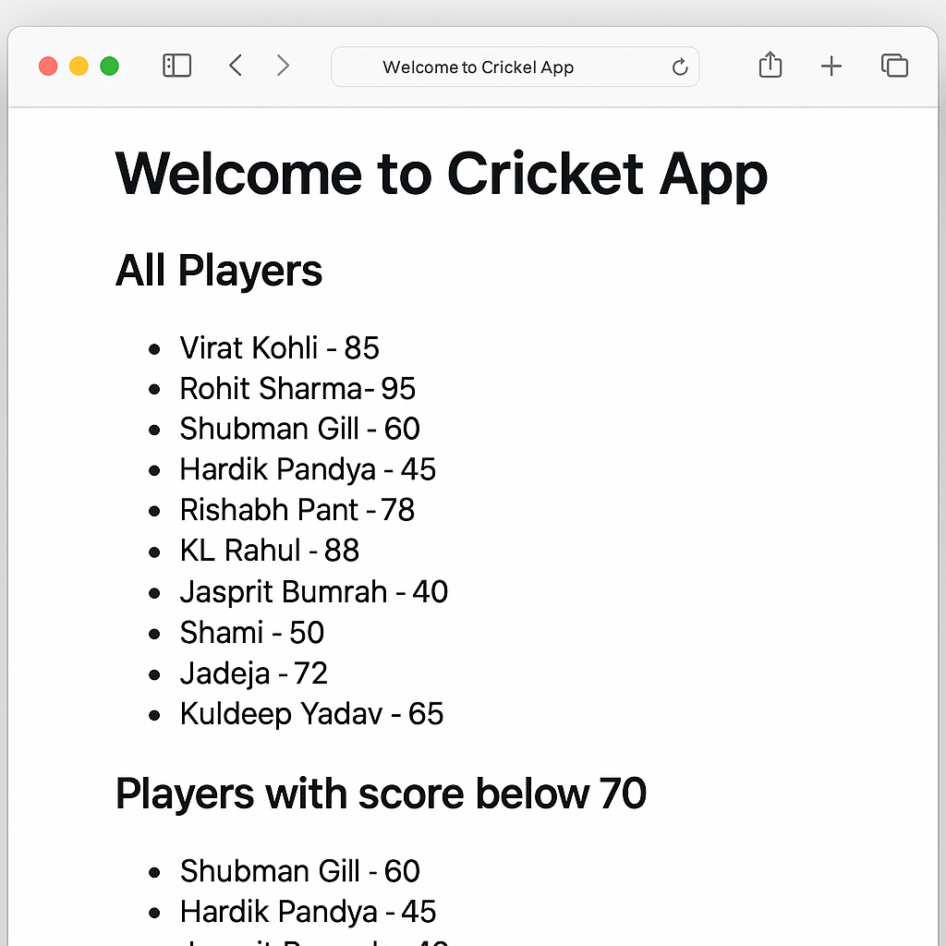

React-9

Officespacerentalapp

terminal:
npx create-react-app officespacerentalapp
cd officespacerentalapp

src/App.js

import React from "react";

function App() {
const heading = <h1 style={{ textAlign: "center", color: "navy" }}>Office Space Rentals</h1>;

const officeImage =
"https://images.unsplash.com/photo-1581375276005-72d646d7a49c?auto=format&fit=crop&w=800&q=60";

const officeDetails = {
name: "Urban Hive Co-Working",
rent: 75000,
address: "4th Floor, Omega Building, MG Road, Bangalore"
};

const officeList = [
{ name: "Startup Bay", rent: 50000, address: "Koramangala, Bangalore" },
{ name: "GrowthHub Spaces", rent: 85000, address: "Powai, Mumbai" },
{ name: "WorkDen", rent: 40000, address: "Aundh, Pune" },
{ name: "HiveWork", rent: 62000, address: "Salt Lake, Kolkata" }
];

const rentStyle = (rent) => ({
color: rent < 60000 ? "red" : "green",
fontWeight: "bold"
});

return (
<div style={{ padding: "20px", fontFamily: "Arial" }}>
{heading}

<img
src={officeImage}
alt="Office space"
style={{ width: "100%", maxHeight: "400px", objectFit: "cover", borderRadius: "8px", marginBottom: "20px" }}
/>

<h2>Featured Office</h2>
<p><strong>Name:</strong> {officeDetails.name}</p>
<p><strong>Rent:</strong> <span style={rentStyle(officeDetails.rent)}>{officeDetails.rent}</span></p>
<p><strong>Address:</strong> {officeDetails.address}</p>

<h2>Available Spaces</h2>
<ul>
{officeList.map((office, index) => (
<li key={index} style={{ marginBottom: "10px" }}>
<p><strong>Name:</strong> {office.name}</p>
<p><strong>Rent:</strong> <span style={rentStyle(office.rent)}>{office.rent}</span></p>
<p><strong>Address:</strong> {office.address}</p>
</li>
))}
</ul>
</div>
);
}

export default App;

src/index.js (default)

No changes needed. It stays as generated:
import React from 'react';
import ReactDOM from 'react-dom/client';
import './index.css';
import App from './App';

const root = ReactDOM.createRoot(document.getElementById('root'));
root.render(
<React.StrictMode>
<App />
</React.StrictMode>
);

Run:
npm start

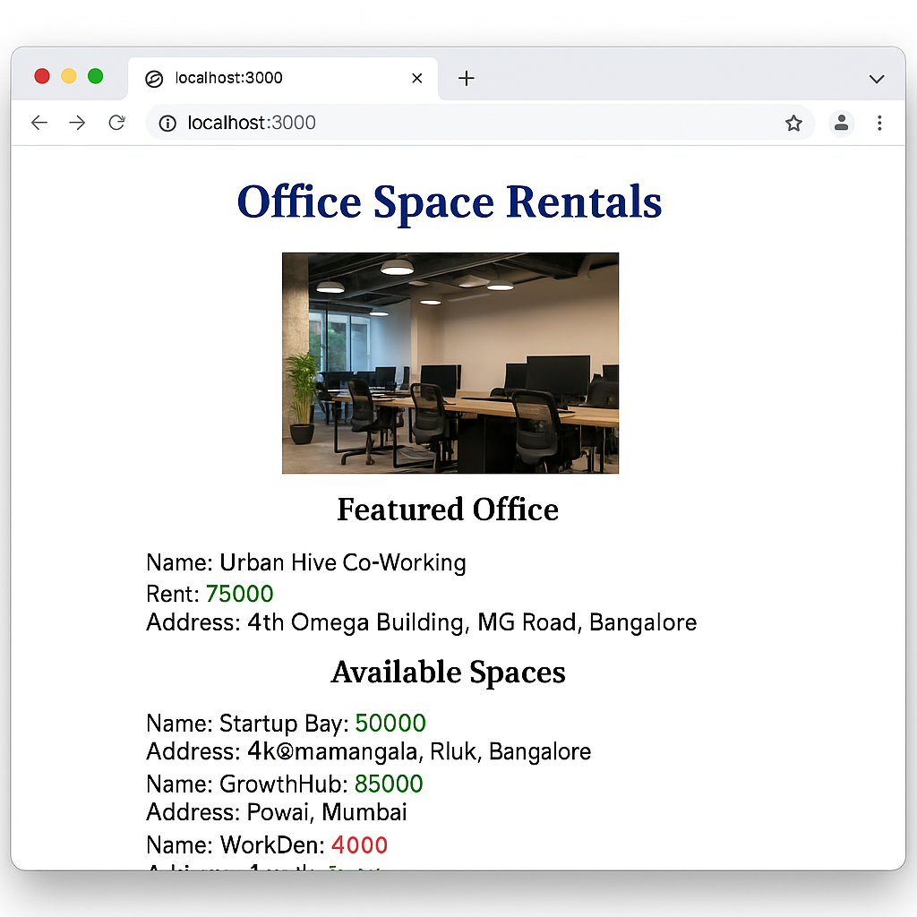

React-11

Eventexamplesapp

Create React App

npx create-react-app eventexamplesapp
cd eventexamplesapp

src/Components/Counter.js

import React, { Component } from "react";

class Counter extends Component {
constructor(props) {
super(props);
this.state = {
count: 0
};
}

increment = () => {
this.setState({ count: this.state.count + 1 });
this.sayHello();
};

decrement = () => {
this.setState({ count: this.state.count - 1 });
};

sayHello = () => {
alert("Hello! Value incremented.");
};

render() {
return (
<div>
<h2>Counter: {this.state.count}</h2>
<button onClick={this.increment}>Increment</button>
<button onClick={this.decrement}>Decrement</button>
</div>
);
}
}

export default Counter;

src/Components/WelcomeButton.js

import React from "react";

function WelcomeButton() {
const sayWelcome = (message) => {
alert(`You clicked: ${message}`);
};

return (
<div>
<button onClick={() => sayWelcome("welcome")}>Say Welcome</button>
</div>
);
}

export default WelcomeButton;

src/Components/SyntheticEventButton.js

import React from "react";

function SyntheticEventButton() {
const handleClick = (e) => {
e.preventDefault();
alert("I was clicked");
};

return (
<div>
<button onClick={handleClick}>OnPress</button>
</div>
);
}

export default SyntheticEventButton;

src/Components/CurrencyConvertor.js

import React, { useState } from "react";

function CurrencyConvertor() {
const [rupees, setRupees] = useState("");
const [euros, setEuros] = useState("");

const handleConvert = (e) => {
e.preventDefault();
const conversionRate = 0.011; // Approximate rate
setEuros((rupees * conversionRate).toFixed(2));
};

return (
<div>
<h3>Currency Convertor</h3>
<input
type="number"
placeholder="Enter amount in ₹"
value={rupees}
onChange={(e) => setRupees(e.target.value)}
/>
<button onClick={handleConvert}>Convert</button>
{euros && <p>Equivalent in Euro: €{euros}</p>}
</div>
);
}

export default CurrencyConvertor;

src/App.js

import React from "react";
import Counter from "./Components/Counter";
import WelcomeButton from "./Components/WelcomeButton";
import SyntheticEventButton from "./Components/SyntheticEventButton";
import CurrencyConvertor from "./Components/CurrencyConvertor";

function App() {
return (
<div className="App" style={{ padding: "20px", fontFamily: "Arial" }}>
<h1>React Event Examples</h1>
<Counter />
<hr />
<WelcomeButton />
<hr />
<SyntheticEventButton />
<hr />
<CurrencyConvertor />
</div>
);
}

export default App;

src/index.js (default)

import React from "react";
import ReactDOM from "react-dom/client";
import App from "./App";

const root = ReactDOM.createRoot(document.getElementById("root"));
root.render(
<React.StrictMode>
<App />
</React.StrictMode>
);

Run:
npm start
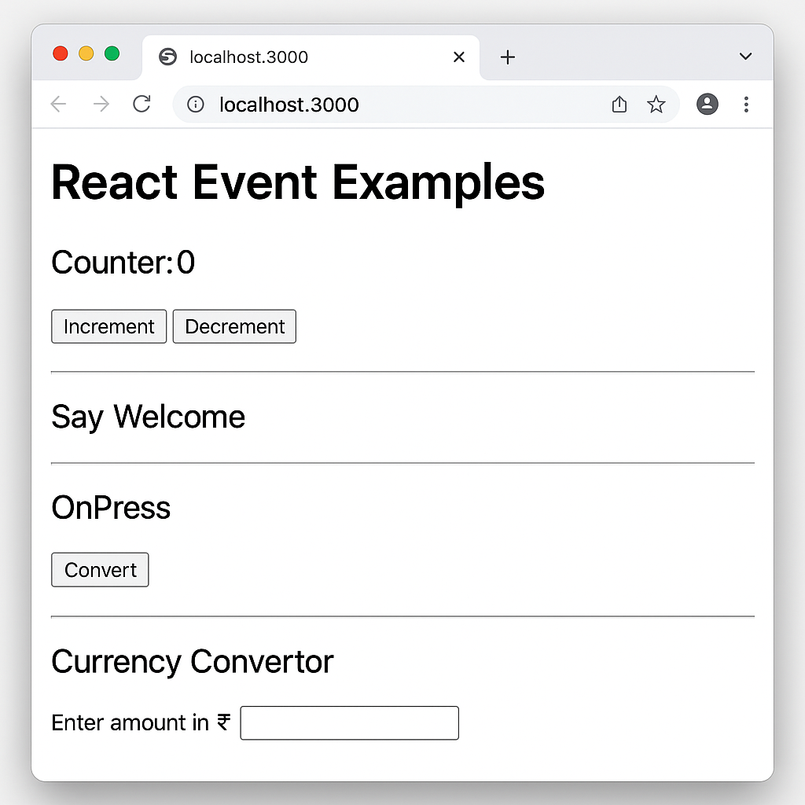

React-12

Ticketbookingapp

Step 1: Create React App
npx create-react-app ticketbookingapp
cd ticketbookingapp

src/Components/GuestPage.js
import React from "react";

const GuestPage = () => {
return (
<div>
<h2>Welcome, Guest!</h2>
<p>You can browse flights but need to log in to book tickets.</p>
<ul>
<li>Indigo - 10:00 AM - Delhi to Mumbai</li>
<li>SpiceJet - 1:30 PM - Bangalore to Pune</li>
<li>Air India - 4:00 PM - Hyderabad to Goa</li>
</ul>
</div>
);
};

export default GuestPage;

src/Components/UserPage.js
import React from "react";

const UserPage = () => {
return (
<div>
<h2>Welcome, User!</h2>
<p>You can now book your flight tickets:</p>
<ul>
<li> Indigo - <button>Book Now</button></li>
<li> SpiceJet - <button>Book Now</button></li>
<li> Air India - <button>Book Now</button></li>
</ul>
</div>
);
};

export default UserPage;

src/App.js

import React, { useState } from "react";
import GuestPage from "./Components/GuestPage";
import UserPage from "./Components/UserPage";

function App() {
const [isLoggedIn, setIsLoggedIn] = useState(false);

const handleLogin = () => setIsLoggedIn(true);
const handleLogout = () => setIsLoggedIn(false);

let page;

if (isLoggedIn) {
page = <UserPage />;
} else {
page = <GuestPage />;
}

return (
<div style={{ padding: "20px", fontFamily: "Arial" }}>
<h1>Flight Ticket Booking App</h1>
<div style={{ marginBottom: "15px" }}>
{isLoggedIn ? (
<button onClick={handleLogout}>Logout</button>
) : (
<button onClick={handleLogin}>Login</button>
)}
</div>
{page}
</div>
);
}

export default App;

src/index.js (leave as default)

import React from "react";
import ReactDOM from "react-dom/client";
import App from "./App";

const root = ReactDOM.createRoot(document.getElementById("root"));
root.render(
<React.StrictMode>
<App />
</React.StrictMode>
);

Run:
npm start

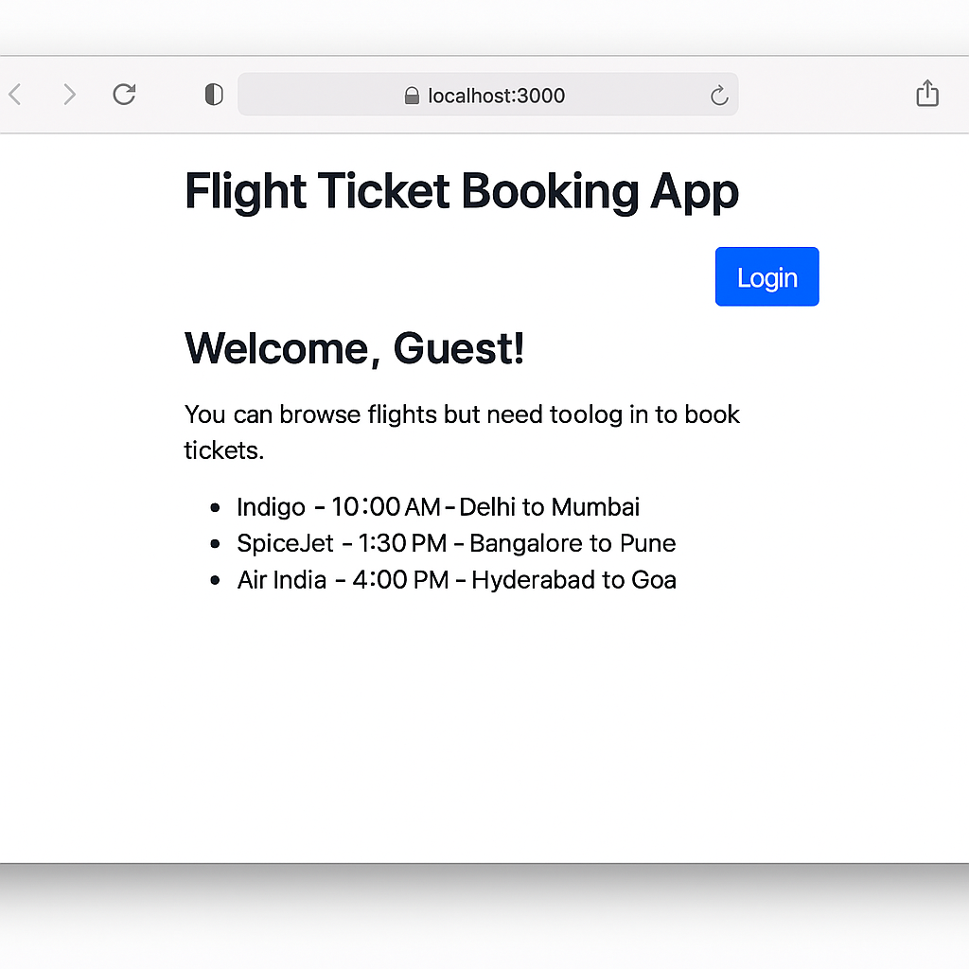

React-13

Bloggerapp

Create React App
npx create-react-app bloggerapp
cd bloggerapp

src/Components/BookDetails.js
import React from "react";

const BookDetails = () => {
return (
<div>
<h2> Book Details</h2>
<ul>
<li>Title: React in Action</li>
<li>Author: Mark Tielens Thomas</li>
<li>Publisher: Manning</li>
</ul>
</div>
);
};

export default BookDetails;

src/Components/BlogDetails.js
import React from "react";

const BlogDetails = () => {
return (
<div>
<h2> Blog Details</h2>
<ul>
<li>Title: Learning React Basics</li>
<li>Author: Dev Blogger</li>
<li>Date: August 2025</li>
</ul>
</div>
);
};

export default BlogDetails;

src/Components/CourseDetails.js
import React from "react";

const CourseDetails = () => {
return (
<div>
<h2> Course Details</h2>
<ul>
<li>Name: Full Stack React</li>
<li>Platform: Coursera</li>
<li>Duration: 8 weeks</li>
</ul>
</div>
);
};

export default CourseDetails;

src/App.js
import React, { useState } from "react";
import BookDetails from "./Components/BookDetails";
import BlogDetails from "./Components/BlogDetails";
import CourseDetails from "./Components/CourseDetails";

function App() {
const [section, setSection] = useState("book");

const renderComponent = () => {
// Method 1: if-else
if (section === "book") {
return <BookDetails />;
} else if (section === "blog") {
return <BlogDetails />;
} else {
return <CourseDetails />;
}
};

return (
<div style={{ padding: "20px", fontFamily: "Arial" }}>
<h1>Blogger App</h1>

<div style={{ marginBottom: "20px" }}>
<button onClick={() => setSection("book")}>Show Book</button>
<button onClick={() => setSection("blog")}>Show Blog</button>
<button onClick={() => setSection("course")}>Show Course</button>
</div>

{/* Method 2: Ternary Operator */}
{section === "book" ? <BookDetails /> : null}

{/* Method 3: Logical && */}
{section === "blog" && <BlogDetails />}

{/* Method 4: Switch-like method */}
{renderComponent()}
</div>
);
}

export default App;

src/index.js
Leave it unchanged:
import React from "react";
import ReactDOM from "react-dom/client";
import App from "./App";

const root = ReactDOM.createRoot(document.getElementById("root"));
root.render(
<React.StrictMode>
<App />
</React.StrictMode>
);

Run Your App
npm start

