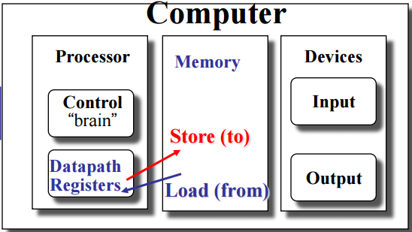

***Specifications***

**OS memory:**

**Instruction memory:**

**Data memory:**

**Registers:**

Size: 32 bit

Number: 8 registers

**Storage operation:**

Instruction format:

Explanation: Following Little Endian, shift operation.

**Loading operation:**

**Instruction format:**

**Explanation:**

**Screen Shots:**