**Assignment 6 “Echo Client/Server”**

**Group - SS05**

**Output Screenshots:**

* Cleaning old output files from directory using “make clean” command.
* And compiling “client.c” and “server.c” programs using “make” command.

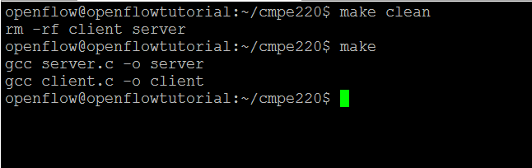

* Run Server executable file with “./server” command.
* Run Client executable file with “./client” command in separate terminal.

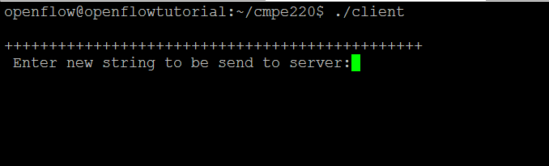

* After sending string to server,
  + Example-1:
    - Client side

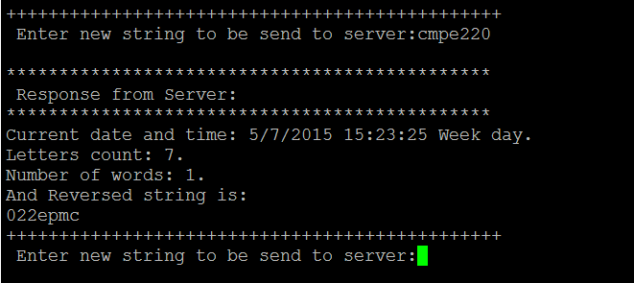

* + - Server side

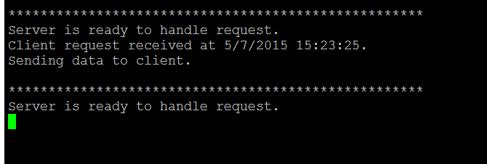

* + Example-2:
    - Client side

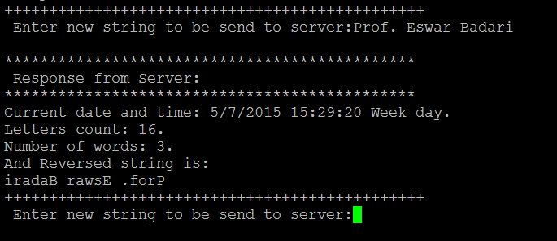

* + - Server side

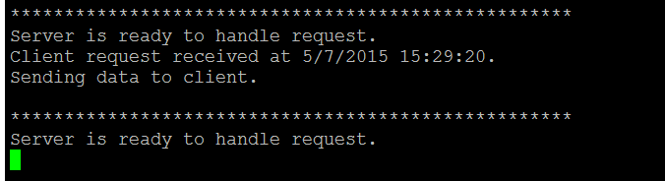

* + Example-3
    - Client side

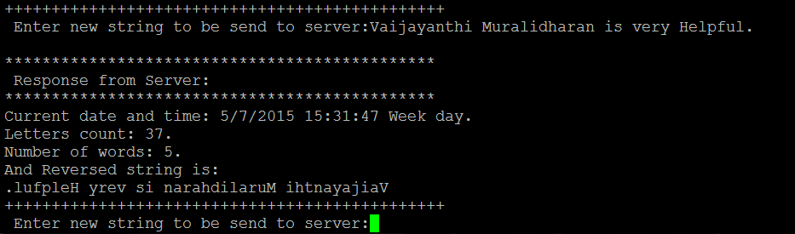

* + - Server side

