***BODHI-LIBRARY MANAGEMENT SYSTEM***

***ABSTRACT***

Bodhi is a library management system, which is designed to assist the librarians and administrative staff to manage and monitor library related functionalities and transactions. It is an automated system with two users, primarily the desk staff and administrator. It is designed to operate across a library with multiple branches. The system can keep track of library related data and permits adding new members, new books, and updating borrower information, searching books and members and facility to borrow and return books, fine computation etc. to name a few.

***User Manual:***

Bodhi is designed for the librarians to automate library management. It provides authenticated access to administrators and desk staff. The login credentials for the 2 users are as follows:

<http://localhost:8080/bodhi/admin/home>

User id : Bodhi_mgr/abcd1234, Bodhi_user/abcd1234

It provides the following facilities:

* **Search**: There are 2 functionalities embedded here:

1. **Search for Books**: This can be carried out with the details pertaining to the book like ISBN code, Author name or book title. It also retrieves book details even when the complete details like full Book Id or full name of the author etc. are unknown that is it helps in retrieving book details on a relative basis. This also provides details regarding the available number of copies and branch at which it is available.

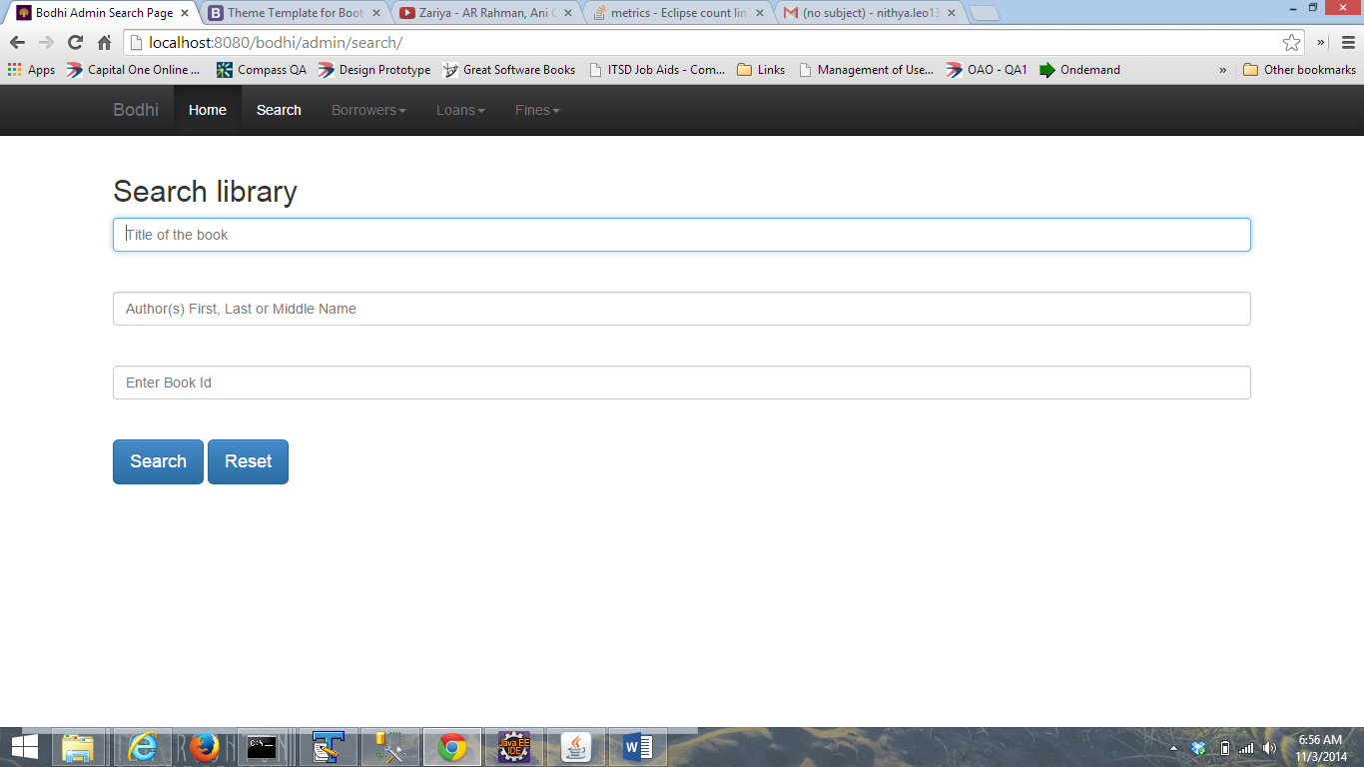

1. **Search for Borrower**: It searches for and retrieves details regarding the borrowers based on their name or card number.

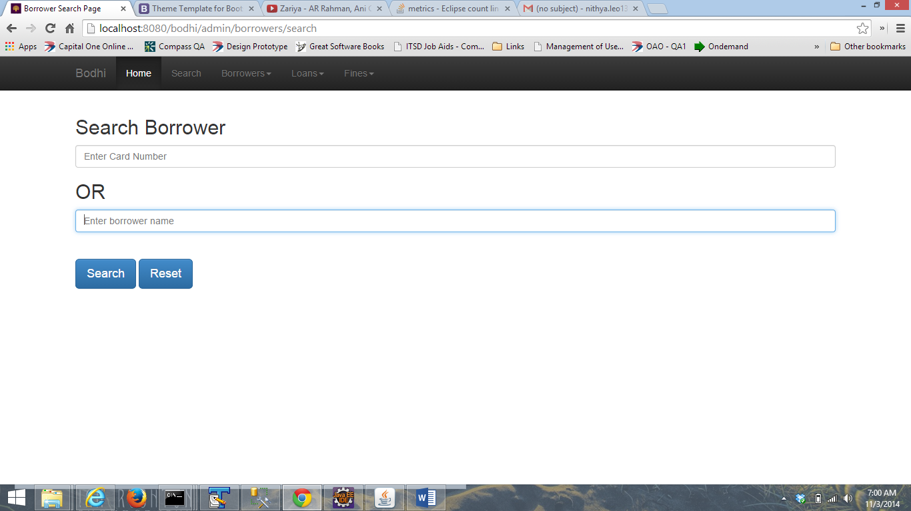

* **Borrower Management**: It permits the user to add new borrowers and also ensures that multiple cards are not issued for the same person. It also handles updating the borrower details. New member’s card number are generated automatically

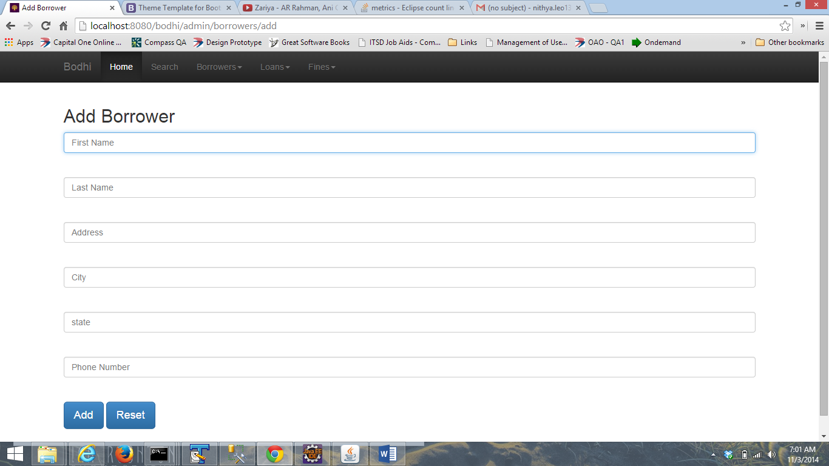

* **Transactions**: They basically include:

1. **Check In**: Facilitates the returns management i.e. when the books are returned the return entry can be made here. It returns the borrower details for a book based on the book id or borrower name or his/her card number. It also permits search based on partial information also.

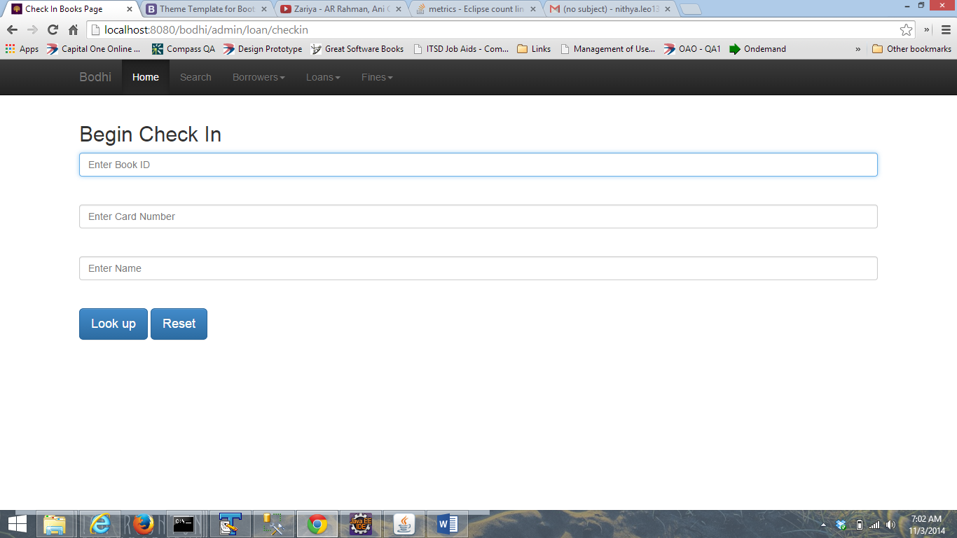

1. **Check Out**: It is used to keep track of the books borrowed by the Borrower. It permits maximum of 3 books per borrower and also it checks the availability of copies in the branch.

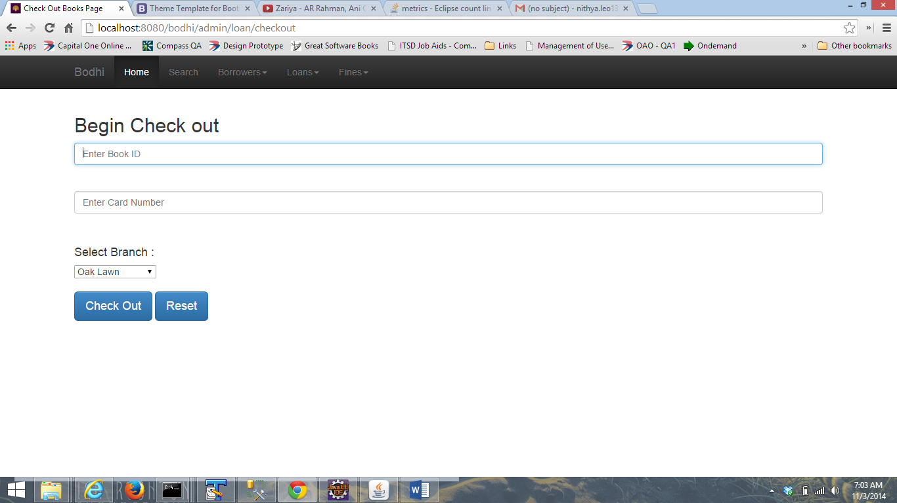

* **Fine Management**: For Overdue books fines are estimated and managed by this module. Fine amount is computes 25 cents per day. When the book is returned it will provide details regarding the fine accumulated till this day and also it will calculate fine estimates for the books not yet returned. When payments are made it removes the outstanding amount and also clears the prohibition on the borrower from accessing books. It provides fine history of the borrower and total fine accumulated for the borrower. It also encompasses a very simple partial fine payment scheme.

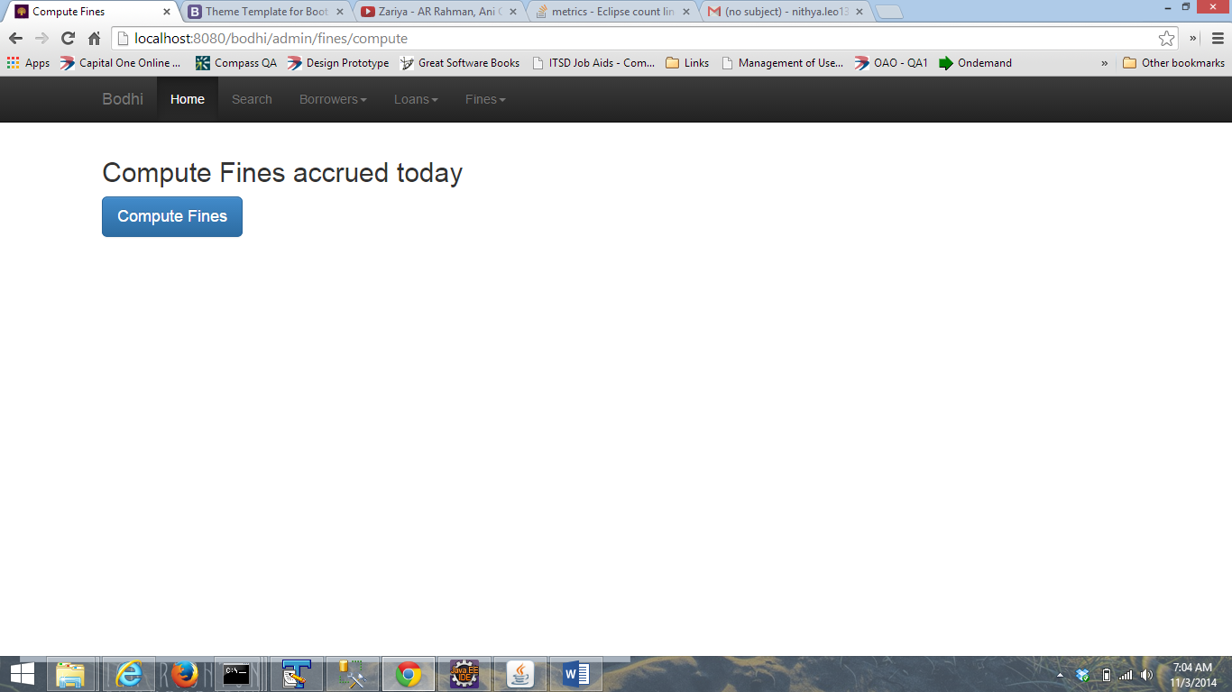

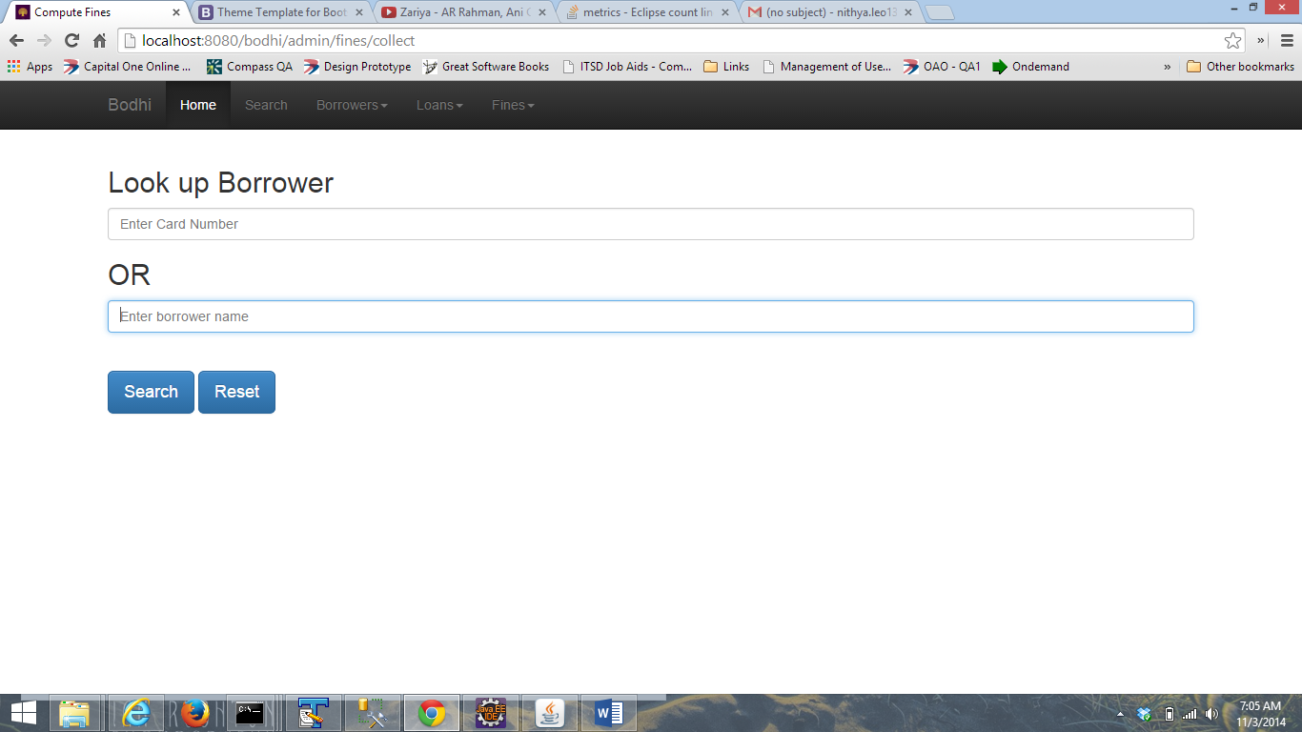

|  |  |  |
| --- | --- | --- |
|  | **Technology/Tools Used** | **Version** |
| 1 | Java | 8 |
| 2 | Spring | 3.1.1 |
| 3 | Bootstrap | 3.3.0 |
| 4 | JSTL | 1.2 |
| 5 | log4j | 1.4 |
| 6 | apache-commons | 3.1 |
| 7 | javax-servlet api | 3.0.1 |
| 8 | Apache Tomcat | 8.0.12 |
| 9 | Eclipse IDE | Juno Service Release 2 |
| 10 | MS SQL Server | 11.0.2100.60 |

***System Design:***

The system is built on MVC architecture using spring model view controller pattern. The JSP represents the view and controller is the business logic implemented in java and model is represented by the database.

When request from the client’s browser hits the application, the application invokes the controller responsible for serving the request. The controller invokes the business interface which internally access the DAO (data access object) for CRUD operations. The business logic gets applied on the response from the DAO layer and is relayed back to the view as a model object. This model object represents the data that gets displayed on the view.

***Additional Features Included***:

1. Responsive Design
2. Borrower Deletion, which is permitted if and only if borrower does not have any outstanding loan.
3. Renewal of the books: Extending the deadline of the books
4. Authentication
5. Partial fines