**Egf Intrument Service Testing Evidence**

**Instrument Create**

curl --location 'localhost:8480/egf-instrument/instruments/_create' \

--header 'Content-Type: application/json' \

--data '{

"requestInfo":{

"resMsgId":"placeholder",

"status":"200",

"apiId":null,

"ver":null,

"ts":1483212661000,

"key":null,

"authToken":"",

"userInfo":{

"id":1

}

},

"instruments":[

{

"id":"hello",

"transactionNumber":"transactionNumber",

"transactionDate":"23-08-2017",

"amount":100,

"payee":"payee",

"transactionType":"Credit",

"bank":{

"id":10,

"code":"10",

"name":"nameupdate",

"description":"descriptionupdate",

"active":true,

"type":"typeupdate",

"tenantId":"default"

},

"bankAccount":{

"id":"1",

"bankBranch":{

"id":"1",

"bank":{

"id":10000,

"code":"10",

"name":"neameupdate",

"description":"descriptionupdate",

"active":true,

"type":"typeupdate",

"tenantId":"default"

},

"code":"Rajesh",

"name":"Rajesh",

"active":true,

"micr":"Rajesh",

"tenantId":"default"

},

"chartOfAccount":{

"id":"1223",

"tenantId":"default"

},

"fund":{

"id":"1",

"tenantId":"default"

},

"accountNumber":"000000000001",

"accountType":"OTHER SCHEDULED BANKS",

"active":true,

"type":"RECEIPTS_PAYMENTS",

"tenantId":"default"

},

"instrumentType":{

"id":"f3ae954c-74b0-47d9-9c17-088362c31e35",

"name":"Online",

"active":"true",

"tenantId":"default"

},

"serialNo":"serialNo",

"tenantId":"default"

}

]

}'  
  
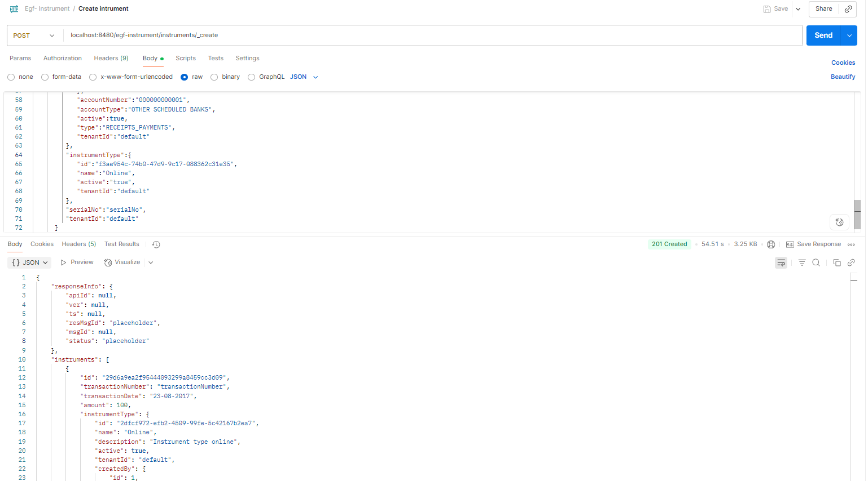

**Instrument search**

curl -X POST \

'http://localhost:8480/egf-instrument/instruments/_search?tenantId=default&pageSize=10&offset=0' \

-H 'Content-Type: application/json' \

-d '{

"RequestInfo": {

"apiId": "Rainmaker",

"ver": ".01",

"ts": "01-01-2017 12:00:00",

"action": "_search",

"did": "1",

"key": "",

"msgId": "20170310130900|en_IN",

"authToken": "your-auth-token-here",

"userInfo": {

"id": 1,

"userName": "admin",

"name": "Administrator",

"type": "EMPLOYEE",

"mobileNumber": "9999999999",

"emailId": "admin@egovernments.org",

"roles": [

{

"name": "Employee",

"code": "EMPLOYEE",

"tenantId": "default"

}

],

"tenantId": "default",

"uuid": "string"

}

}

}'

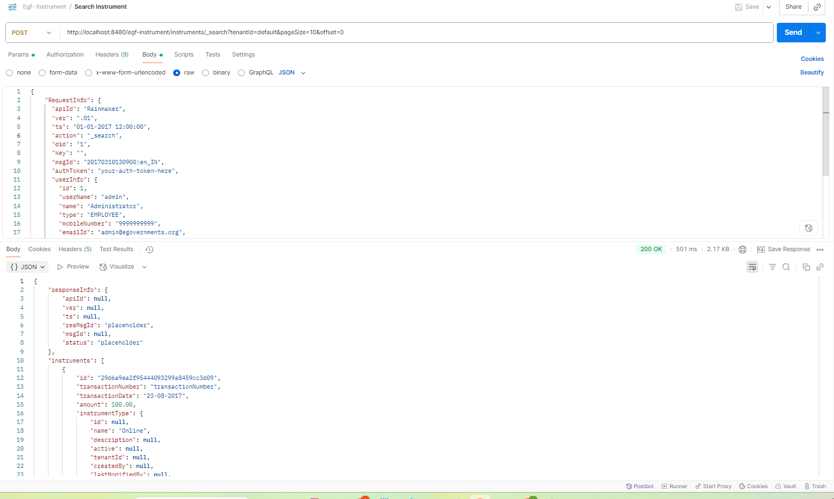

**Instrument delete:**  
  
curl -X POST \

http://localhost:8480/egf-instrument/instruments/_delete \

-H 'Content-Type: application/json' \

-d '{

"RequestInfo": {

"apiId": "Rainmaker",

"ver": ".01",

"ts": "01-01-2017 12:00:00",

"action": "_delete",

"did": "1",

"key": "",

"msgId": "20170310130900|en_IN",

"authToken": "your-auth-token-here",

"userInfo": {

"id": 1,

"userName": "admin",

"name": "Administrator",

"type": "EMPLOYEE",

"mobileNumber": "9999999999",

"emailId": "admin@egovernments.org",

"roles": [

{

"name": "Employee",

"code": "EMPLOYEE",

"tenantId": "default"

}

],

"tenantId": "default",

"uuid": "string"

}

},

"instruments": [

{

"id": "29d6a9ea2f95444093299a8459cc3d09",

"tenantId": "default"

}

]

}'  
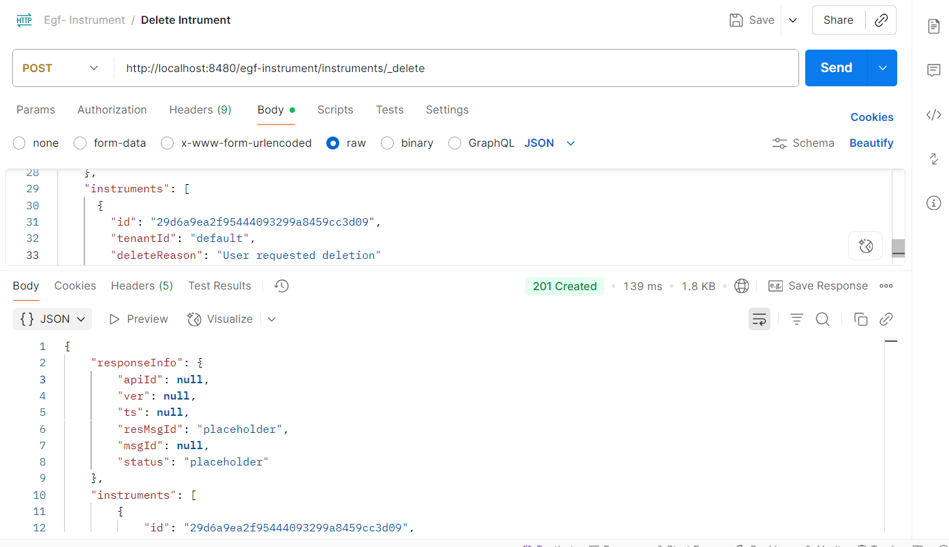

**Instrument update:**  
curl --location 'http://localhost:8480/egf-instrument/instruments/_update' \

--header 'Content-Type: application/json' \

--data-raw '{

"RequestInfo": {

"apiId": "Rainmaker",

"ver": ".01",

"ts": "01-01-2017 12:00:00",

"action": "_update",

"did": "1",

"key": "",

"msgId": "20170310130900|en_IN",

"authToken": "your-auth-token-here",

"userInfo": {

"id": 1,

"userName": "admin",

"name": "Administrator",

"type": "EMPLOYEE",

"mobileNumber": "9999999999",

"emailId": "admin@egovernments.org",

"roles": [

{

"name": "Employee",

"code": "EMPLOYEE",

"tenantId": "default"

}

],

"tenantId": "default",

"uuid": "string"

}

},

"instruments": [

{

"id": "d6043e33bebf43e9bca8577638dbb0d4",

"transactionNumber": "updatedTransactionNumber",

"transactionDate": "25-08-2017",

"amount": 769,

"instrumentType": {

"id": "2dfcf972-efb2-4509-99fe-5c42167b2ea7",

"name": "Online",

"description": "Instrument type online",

"active": true,

"tenantId": "default"

},

"bank": {

"id": "10",

"code": "10",

"name": "nameupdate",

"description": "descriptionupdate",

"active": true,

"type": "typeupdate",

"tenantId": "default"

},

"branchName": "Updated Branch",

"bankAccount": {

"id": "1",

"bankBranch": {

"id": "1",

"bank": {

"id": "10000",

"code": "10",

"name": "neameupdate",

"description": "descriptionupdate",

"active": true,

"type": "typeupdate",

"tenantId": "default"

},

"code": "Rajesh",

"name": "Rajesh",

"address": null,

"address2": null,

"city": null,

"state": null,

"pincode": null,

"phone": null,

"fax": null,

"contactPerson": null,

"active": true,

"description": null,

"micr": "Rajesh",

"tenantId": "default"

},

"chartOfAccount": {

"id": "1223",

"glcode": null,

"name": null,

"accountCodePurpose": null,

"description": null,

"isActiveForPosting": null,

"parentId": null,

"type": null,

"classification": null,

"functionRequired": null,

"budgetCheckRequired": null,

"majorCode": null,

"isSubLedger": null,

"tenantId": "default"

},

"fund": {

"tenantId": "default",

"id": "1",

"name": null,

"code": null,

"identifier": null,

"level": null,

"parent": null,

"active": null

},

"accountNumber": "000000000001",

"accountType": "OTHER SCHEDULED BANKS",

"description": null,

"active": true,

"payTo": null,

"type": "RECEIPTS_PAYMENTS",

"tenantId": "default"

},

"financialStatus": null,

"remittanceVoucherId": null,

"transactionType": "Credit",

"payee": "Updated Payee",

"drawer": "Updated Drawer",

"serialNo": "updatedSerialNo",

"instrumentVouchers": [],

"tenantId": "default"

}

]

}'  
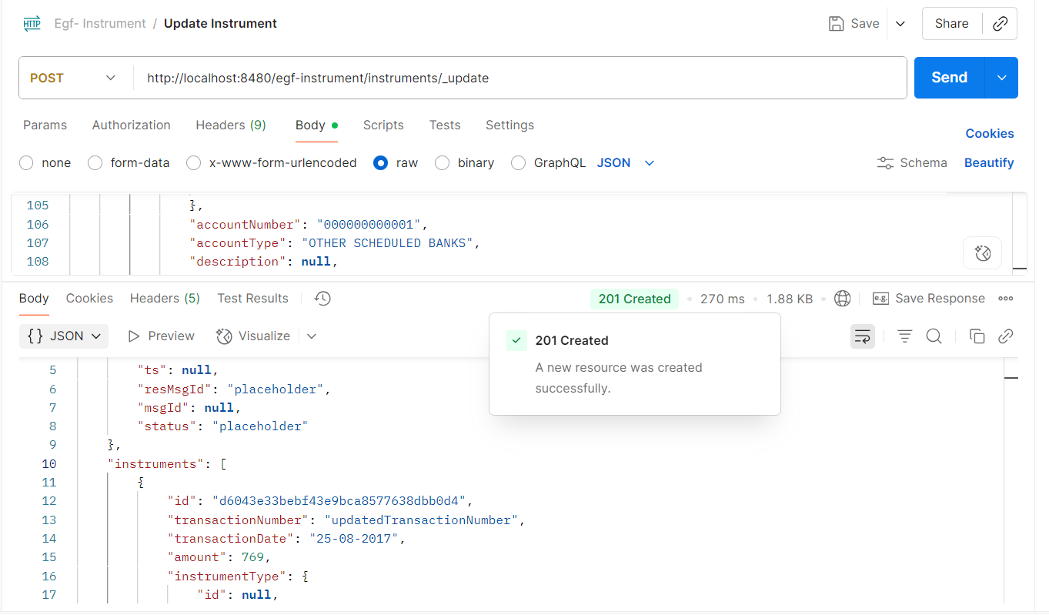

**Deposit Instrument**:  
  
curl --location 'http://localhost:8480/egf-instrument/instruments/_deposit' \

--header 'Content-Type: application/json' \

--data-raw '{

"RequestInfo": {

"apiId": "Rainmaker",

"ver": ".01",

"ts": "01-01-2017 12:00:00",

"action": "_deposit",

"did": "1",

"key": "",

"msgId": "20170310130900|en_IN",

"authToken": "your-auth-token-here",

"userInfo": {

"id": 1,

"userName": "admin",

"name": "Administrator",

"type": "EMPLOYEE",

"mobileNumber": "9999999999",

"emailId": "admin@egovernments.org",

"roles": [

{

"name": "Employee",

"code": "EMPLOYEE",

"tenantId": "default"

}

],

"tenantId": "default",

"uuid": "string"

}

},

"instruments": [

{

"id": "d6043e33bebf43e9bca8577638dbb0d4",

"remittanceVoucherId": "REM001",

"tenantId": "default"

}

]

}'  
  
  
  
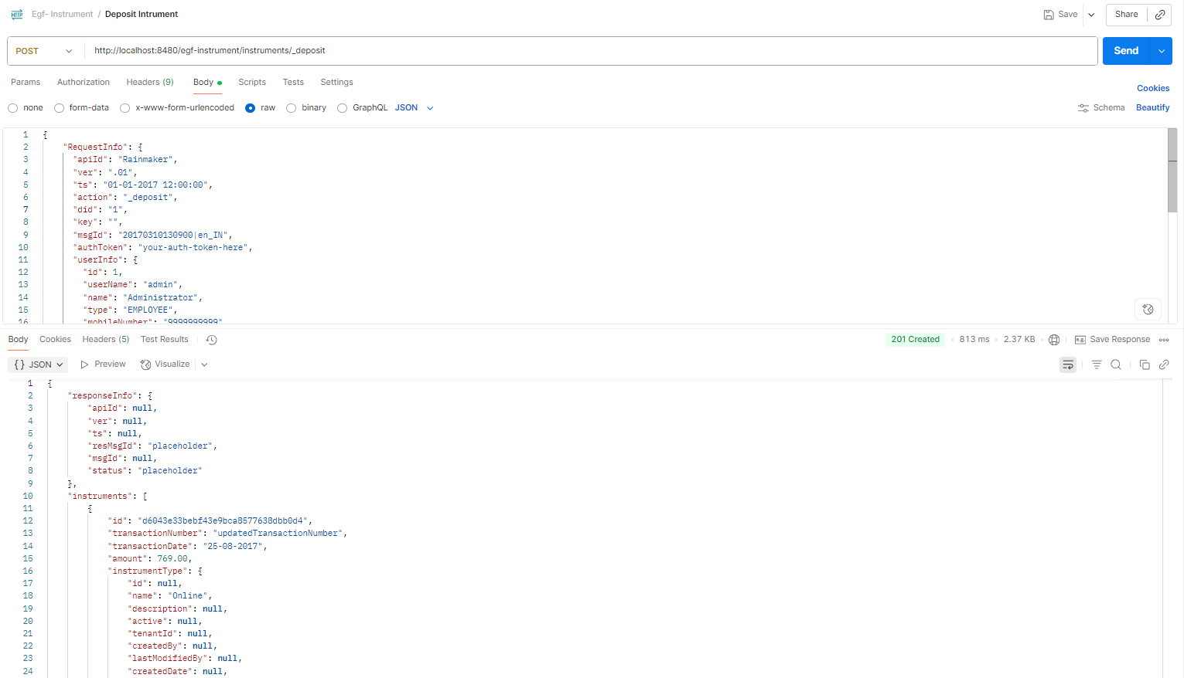

Dishonor instrument

curl --location 'http://localhost:8480/egf-instrument/instruments/_dishonor' \

--header 'Content-Type: application/json' \

--data-raw '{

"RequestInfo": {

"apiId": "Rainmaker",

"ver": ".01",

"ts": "01-01-2017 12:00:00",

"action": "_dishonor",

"did": "1",

"key": "",

"msgId": "20170310130900|en_IN",

"authToken": "your-auth-token-here",

"userInfo": {

"id": 1,

"userName": "admin",

"name": "Administrator",

"type": "EMPLOYEE",

"mobileNumber": "9999999999",

"emailId": "admin@egovernments.org",

"roles": [

{

"name": "Employee",

"code": "EMPLOYEE",

"tenantId": "default"

}

],

"tenantId": "default",

"uuid": "string"

}

},

"instruments": [

{

"id": "d6043e33bebf43e9bca8577638dbb0d4",

"tenantId": "default"

}

]

}'  
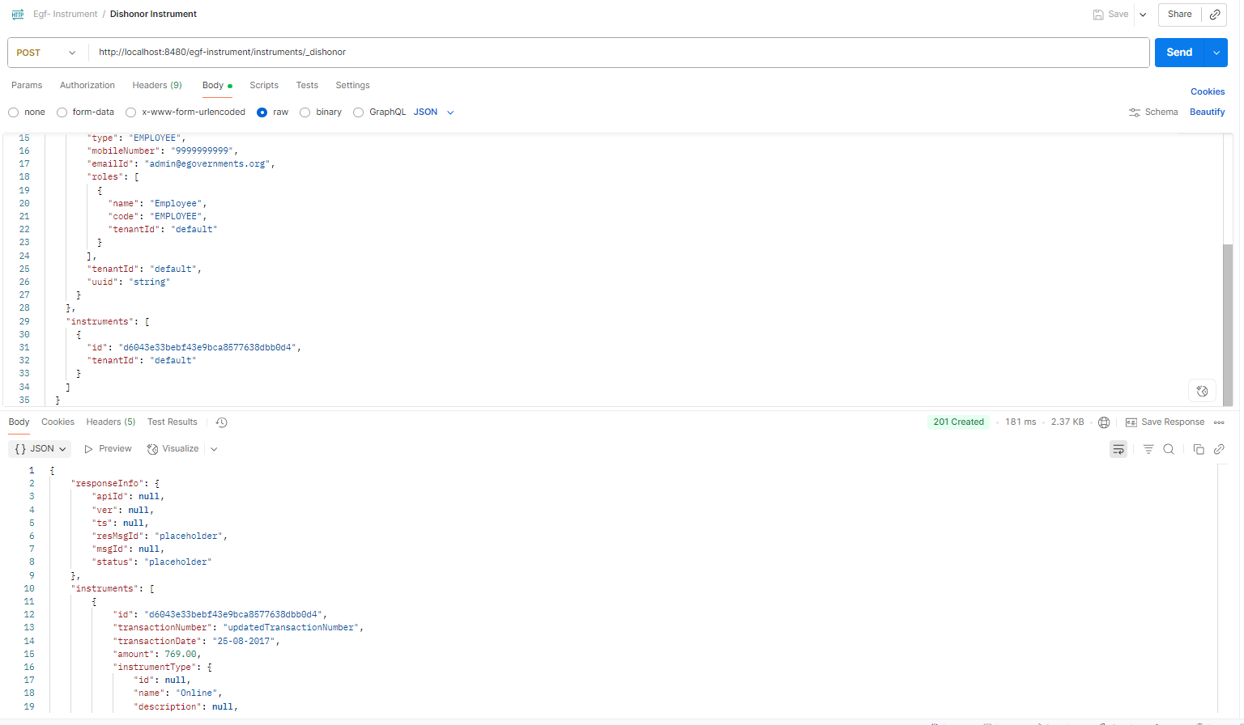

CreateInstrumentType

curl --location 'http://localhost:8480/egf-instrument/instrumenttypes/_create' \

--header 'Content-Type: application/json' \

--data-raw '{

"RequestInfo": {

"apiId": "Rainmaker",

"ver": ".01",

"ts": "01-01-2017 12:00:00",

"action": "_create",

"did": "1",

"key": "",

"msgId": "20170310130900|en_IN",

"authToken": "your-auth-token-here",

"userInfo": {

"id": 1,

"userName": "admin",

"name": "Administrator",

"type": "EMPLOYEE",

"mobileNumber": "9999999999",

"emailId": "admin@egovernments.org",

"roles": [

{

"name": "Employee",

"code": "EMPLOYEE",

"tenantId": "default"

}

],

"tenantId": "default",

"uuid": "string"

}

},

"instrumentTypes": [

{

"name": "UPI",

"description": "Unified Payments Interface",

"active": true,

"tenantId": "default"

}

]

}'

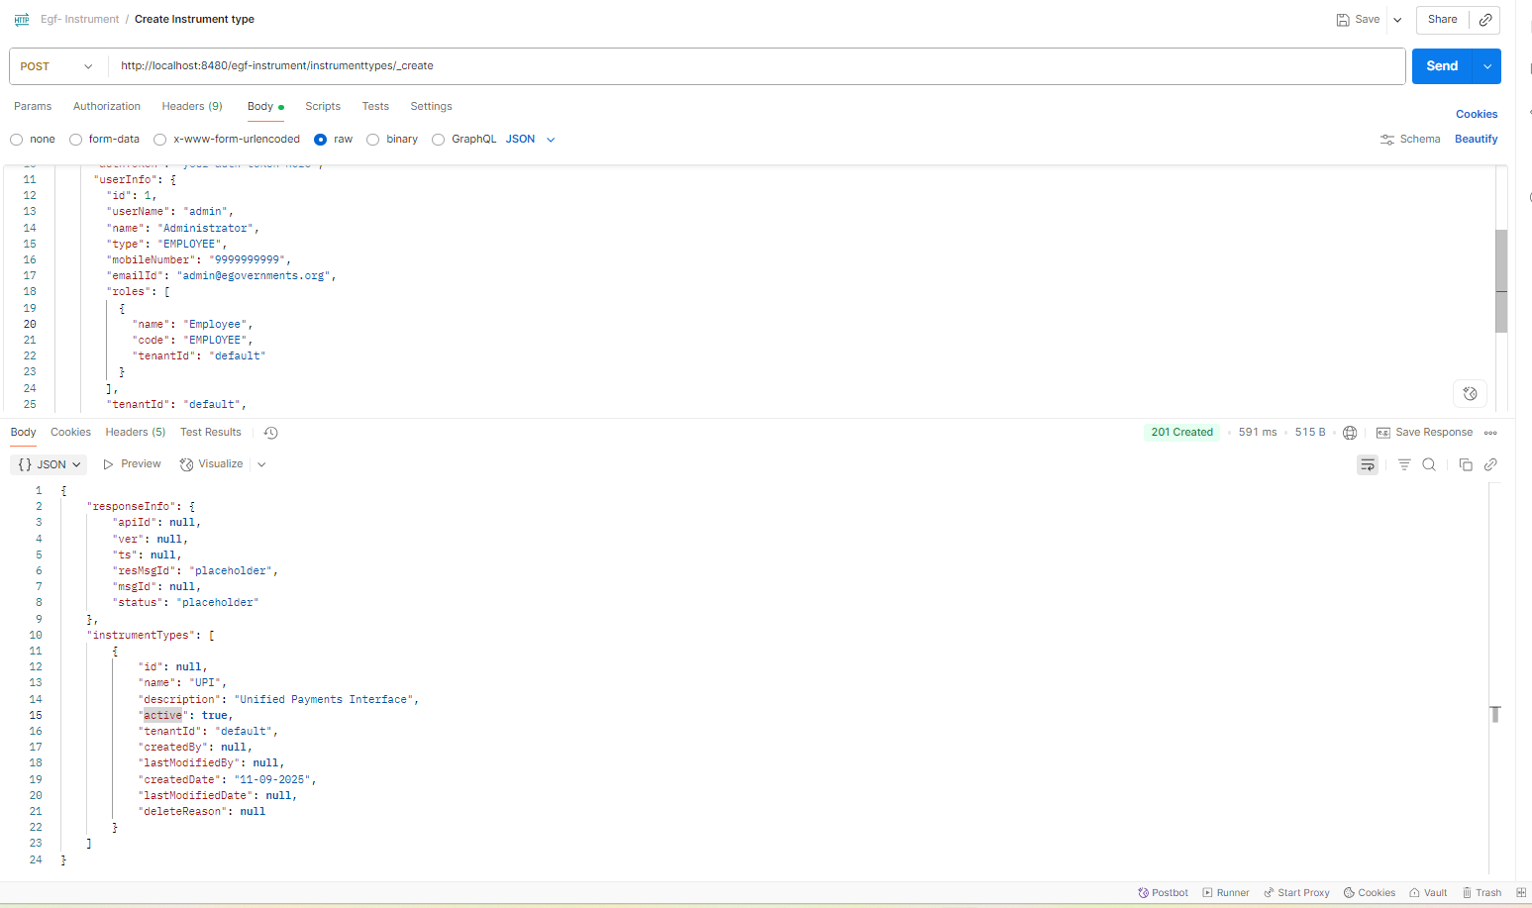

UpdateInstrumentType

curl --location 'http://localhost:8480/egf-instrument/instrumenttypes/_update' \

--header 'Content-Type: application/json' \

--data-raw '{

"RequestInfo": {

"apiId": "Rainmaker",

"ver": ".01",

"ts": "01-01-2017 12:00:00",

"action": "_update",

"did": "1",

"key": "",

"msgId": "20170310130900|en_IN",

"authToken": "your-auth-token-here",

"userInfo": {

"id": 1,

"userName": "admin",

"name": "Administrator",

"type": "EMPLOYEE",

"mobileNumber": "9999999999",

"emailId": "admin@egovernments.org",

"roles": [

{

"name": "Employee",

"code": "EMPLOYEE",

"tenantId": "default"

}

],

"tenantId": "default",

"uuid": "string"

}

},

"instrumentTypes": [

{

"id": "2dfcf972-efb2-4509-99fe-5c42167b2ea7",

"name": "UPI_Updated",

"description": "Updated Unified Payments Interface",

"active": true,

"tenantId": "default"

}

]

}'  
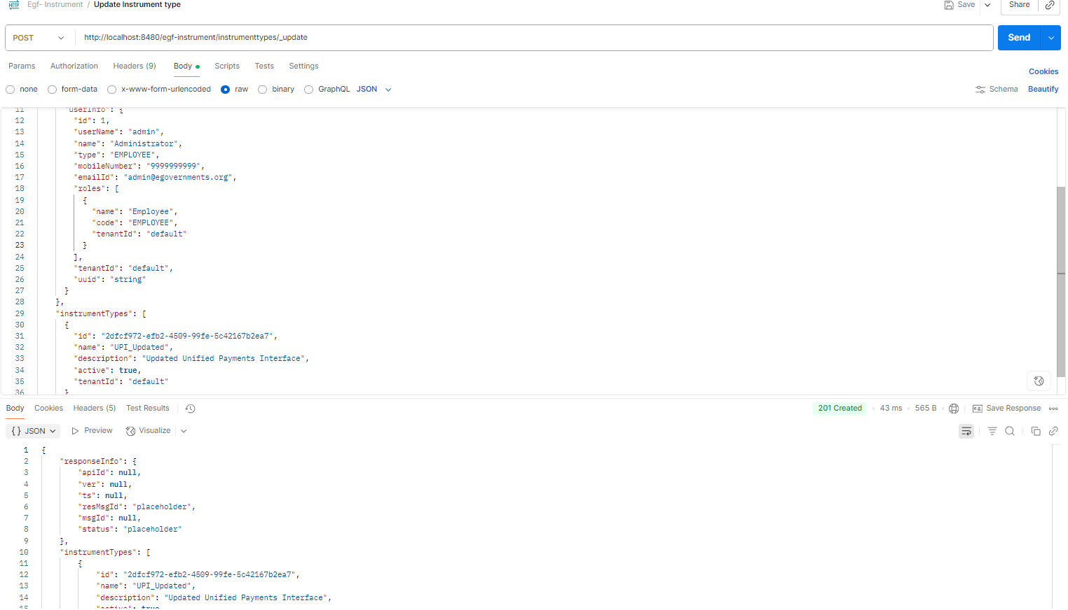

SearchInstrumentType:  
  
curl --location 'http://localhost:8480/egf-instrument/instrumenttypes/_search?tenantId=default&pageSize=10&offset=0' \

--header 'Content-Type: application/json' \

--data-raw '{

"RequestInfo": {

"apiId": "Rainmaker",

"ver": ".01",

"ts": "01-01-2017 12:00:00",

"action": "_search",

"did": "1",

"key": "",

"msgId": "20170310130900|en_IN",

"authToken": "your-auth-token-here",

"userInfo": {

"id": 1,

"userName": "admin",

"name": "Administrator",

"type": "EMPLOYEE",

"mobileNumber": "9999999999",

"emailId": "admin@egovernments.org",

"roles": [

{

"name": "Employee",

"code": "EMPLOYEE",

"tenantId": "default"

}

],

"tenantId": "default",

"uuid": "string"

}

}

}'

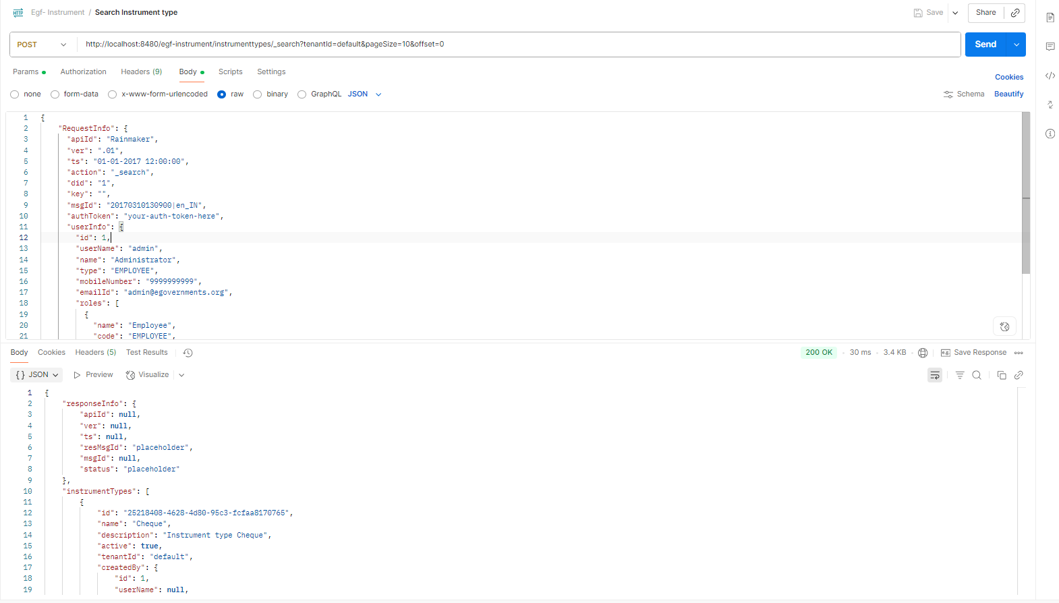

**DeleteInstrumentType**

curl --location 'http://localhost:8480/egf-instrument/instrumenttypes/_delete' \

--header 'Content-Type: application/json' \

--data-raw '{

"RequestInfo": {

"apiId": "Rainmaker",

"ver": ".01",

"ts": "01-01-2017 12:00:00",

"action": "_delete",

"did": "1",

"key": "",

"msgId": "20170310130900|en_IN",

"authToken": "your-auth-token-here",

"userInfo": {

"id": 1,

"userName": "admin",

"name": "Administrator",

"type": "EMPLOYEE",

"mobileNumber": "9999999999",

"emailId": "admin@egovernments.org",

"roles": [

{

"name": "Employee",

"code": "EMPLOYEE",

"tenantId": "default"

}

],

"tenantId": "default",

"uuid": "string"

}

},

"instrumentTypes": [

{

"id": "331703eaa04548b7984f237c94049cac",

"tenantId": "default"

}

]

}'

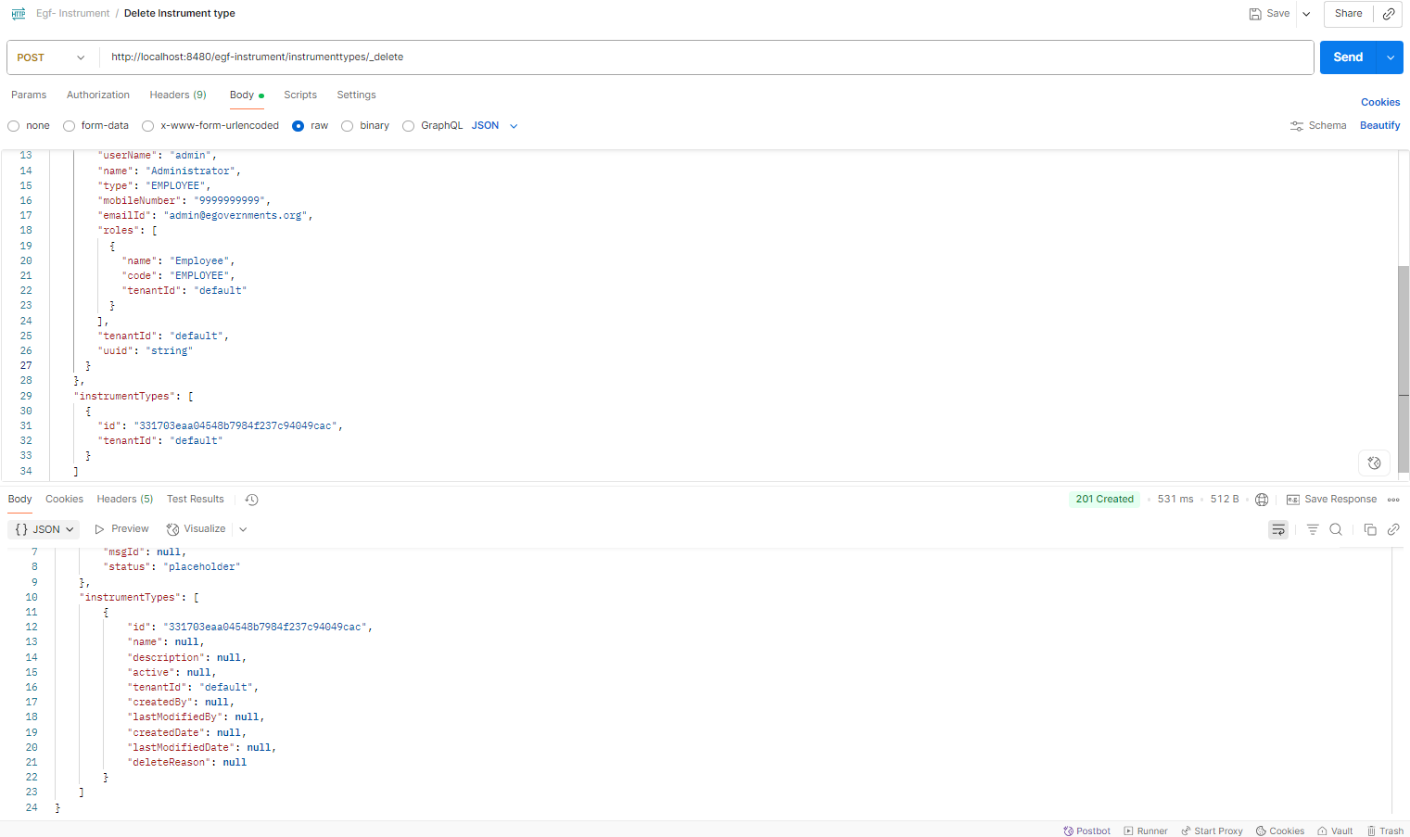

**Create Instrument Account Code**

curl --location 'http://localhost:8480/egf-instrument/instrumentaccountcodes/_create' \

--header 'Content-Type: application/json' \

--data-raw '{

"RequestInfo": {

"apiId": "Rainmaker",

"ver": ".01",

"ts": "01-01-2017 12:00:00",

"action": "_create",

"did": "1",

"key": "",

"msgId": "20170310130900|en_IN",

"authToken": "your-auth-token-here",

"userInfo": {

"id": 1,

"userName": "admin",

"name": "Administrator",

"type": "EMPLOYEE",

"mobileNumber": "9999999999",

"emailId": "admin@egovernments.org",

"roles": [

{

"name": "Employee",

"code": "EMPLOYEE",

"tenantId": "default"

}

],

"tenantId": "default",

"uuid": "string"

}

},

"instrumentAccountCodes": [

{

"instrumentType": {

"name": "DD"

},

"accountCode": {

"glcode": "11001"

},

"tenantId": "default"

}

]

}'

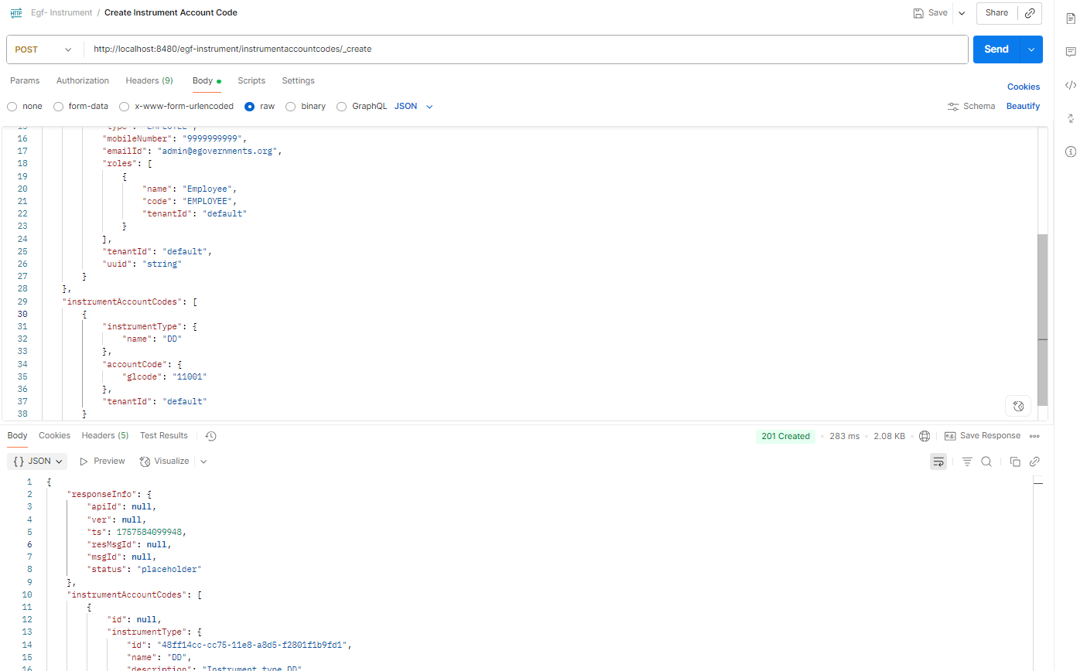

**Update Instrument Account Code**

**curl --location 'http://localhost:8480/egf-instrument/instrumentaccountcodes/_update' \**

**--header 'Content-Type: application/json' \**

**--data-raw '{**

**"RequestInfo": {**

**"apiId": "Rainmaker",**

**"ver": ".01",**

**"ts": "01-01-2017 12:00:00",**

**"action": "_update",**

**"did": "1",**

**"key": "",**

**"msgId": "20170310130900|en_IN",**

**"authToken": "your-auth-token-here",**

**"userInfo": {**

**"id": 1,**

**"userName": "admin",**

**"name": "Administrator",**

**"type": "EMPLOYEE",**

**"mobileNumber": "9999999999",**

**"emailId": "admin@egovernments.org",**

**"roles": [**

**{**

**"name": "Employee",**

**"code": "EMPLOYEE",**

**"tenantId": "default"**

**}**

**],**

**"tenantId": "default",**

**"uuid": "string"**

**}**

**},**

**"instrumentAccountCodes": [**

**{**

**"id": "ef8e5365c10348659151405e3c4ad510",**

**"instrumentType": {**

**"id": "48ff14cc-cc75-11e8-a8d5-f2801f1b9fd1",**

**"name": "DD"**

**},**

**"accountCode": {**

**"glcode": "11001"**

**},**

**"tenantId": "default"**

**}**

**]**

**}'**

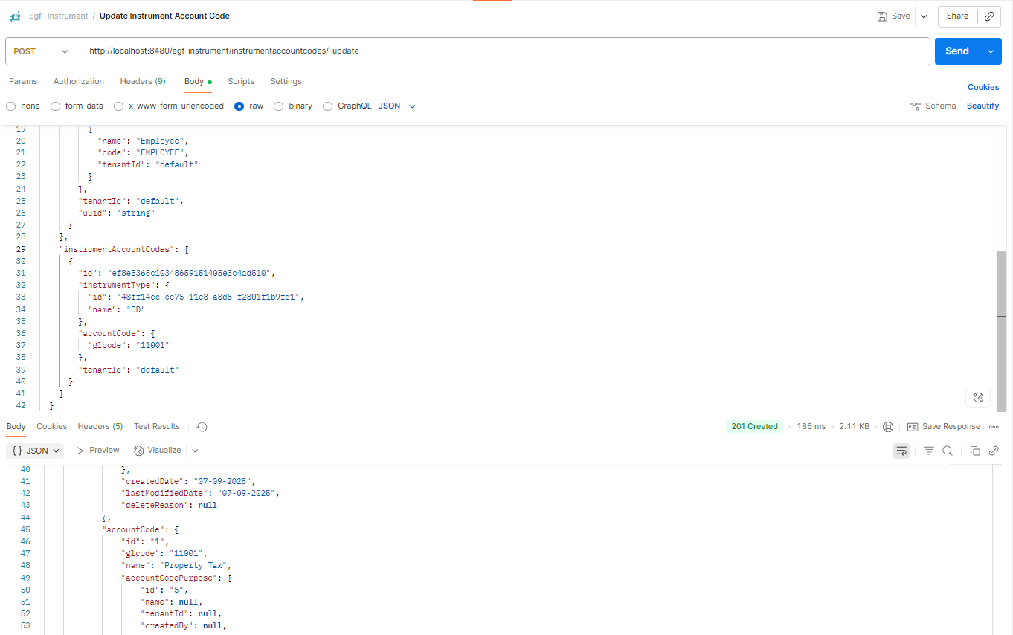

**Search Instrument Account Code**

curl --location 'http://localhost:8480/egf-instrument/instrumentaccountcodes/_search?tenantId=default' \

--header 'Content-Type: application/json' \

--data-raw '{

"RequestInfo": {

"apiId": "Rainmaker",

"ver": ".01",

"ts": "01-01-2017 12:00:00",

"action": "_search",

"did": "1",

"key": "",

"msgId": "20170310130900|en_IN",

"authToken": "your-auth-token-here",

"userInfo": {

"id": 1,

"userName": "admin",

"name": "Administrator",

"type": "EMPLOYEE",

"mobileNumber": "9999999999",

"emailId": "admin@egovernments.org",

"roles": [

{

"name": "Employee",

"code": "EMPLOYEE",

"tenantId": "default"

}

],

"tenantId": "default",

"uuid": "string"

}

}

}'

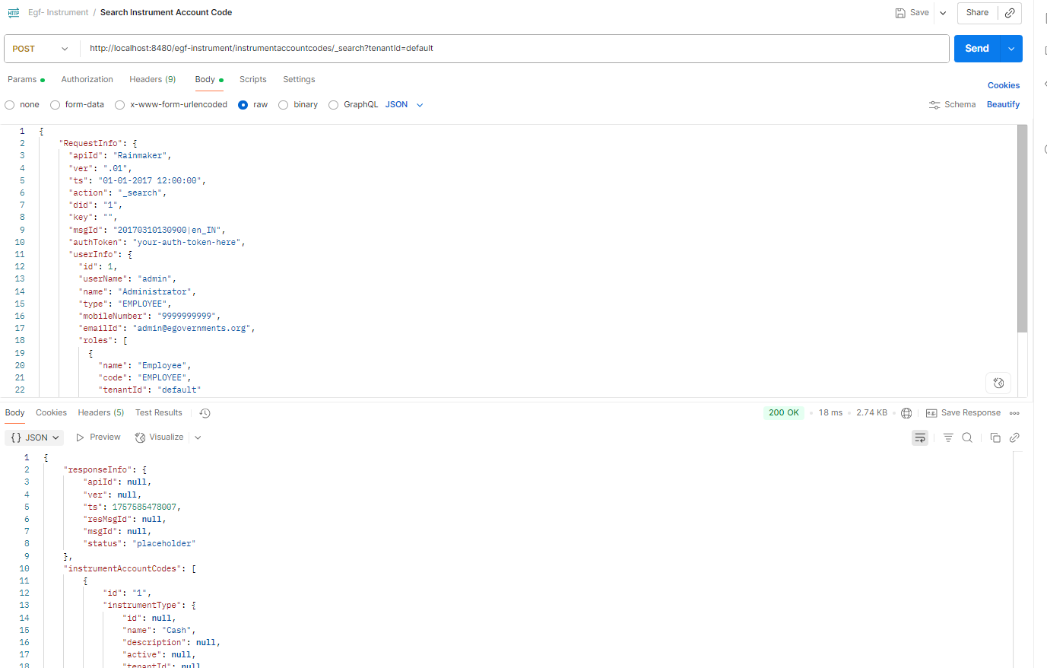

**Delete Instrument Account Code**

curl --location 'http://localhost:8480/egf-instrument/instrumentaccountcodes/_delete' \

--header 'Content-Type: application/json' \

--data-raw '{

"RequestInfo": {

"apiId": "Rainmaker",

"ver": ".01",

"ts": "01-01-2017 12:00:00",

"action": "_delete",

"did": "1",

"key": "",

"msgId": "20170310130900|en_IN",

"authToken": "your-auth-token-here",

"userInfo": {

"id": 1,

"userName": "admin",

"name": "Administrator",

"type": "EMPLOYEE",

"mobileNumber": "9999999999",

"emailId": "admin@egovernments.org",

"roles": [

{

"name": "Employee",

"code": "EMPLOYEE",

"tenantId": "default"

}

],

"tenantId": "default",

"uuid": "string"

}

},

"instrumentAccountCodes": [

{

"id": "ef8e5365c10348659151405e3c4ad510",

"instrumentType": {

"id": "48ff14cc-cc75-11e8-a8d5-f2801f1b9fd1",

"name": "DD"

},

"accountCode": {

"glcode": "11001"

},

"tenantId": "default"

}

]

}'

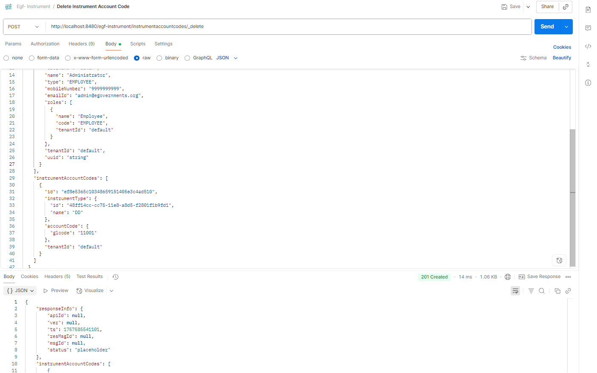

**Create Surrender Reasons**  
  
curl --location 'http://localhost:8480/egf-instrument/surrenderreasons/_create' \

--header 'Content-Type: application/json' \

--data-raw '{

"RequestInfo": {

"apiId": "Rainmaker",

"ver": ".01",

"ts": "01-01-2017 12:00:00",

"action": "_create",

"did": "1",

"key": "",

"msgId": "20170310130900|en_IN",

"authToken": "your-auth-token-here",

"userInfo": {

"id": 1,

"userName": "admin",

"name": "Administrator",

"type": "EMPLOYEE",

"mobileNumber": "9999999999",

"emailId": "admin@egovernments.org",

"roles": [

{

"name": "Employee",

"code": "EMPLOYEE",

"tenantId": "default"

}

],

"tenantId": "default",

"uuid": "string"

}

},

"surrenderReasons": [

{

"name": "Damaged Cheque",

"description": "Cheque is physically damaged and cannot be processed",

"tenantId": "default"

}

]

}'  
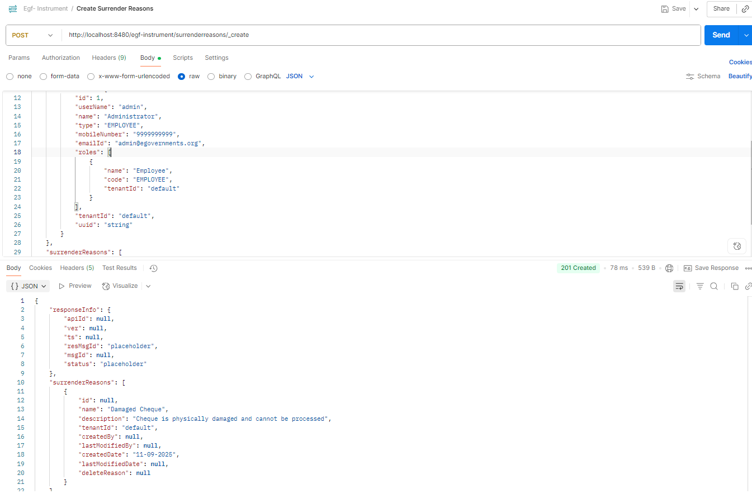

**Update Surrender Reasons**

curl --location 'http://localhost:8480/egf-instrument/surrenderreasons/_update' \

--header 'Content-Type: application/json' \

--data-raw '{

"RequestInfo": {

"apiId": "Rainmaker",

"ver": ".01",

"ts": "01-01-2017 12:00:00",

"action": "_update",

"did": "1",

"key": "",

"msgId": "20170310130900|en_IN",

"authToken": "your-auth-token-here",

"userInfo": {

"id": 1,

"userName": "admin",

"name": "Administrator",

"type": "EMPLOYEE",

"mobileNumber": "9999999999",

"emailId": "admin@egovernments.org",

"roles": [

{

"name": "Employee",

"code": "EMPLOYEE",

"tenantId": "default"

}

],

"tenantId": "default",

"uuid": "string"

}

},

"surrenderReasons": [

{

"id": "cf7651e5d15a4e6e9fa02e78551647d1",

"name": "Damaged Cheque Updated",

"description": "Updated description for damaged cheque that cannot be processed",

"tenantId": "default"

}

]

}'

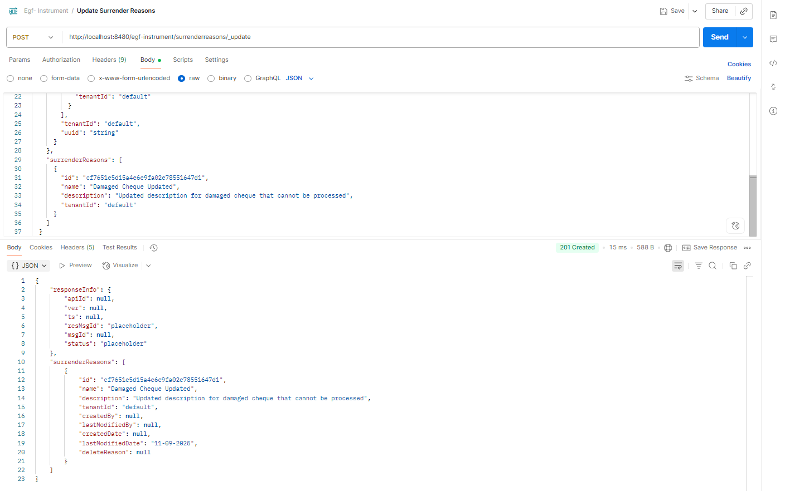

**Search Surrender Reasons**

curl --location 'http://localhost:8480/egf-instrument/surrenderreasons/_search?tenantId=default&pageSize=10&offset=0' \

--header 'Content-Type: application/json' \

--data-raw '{

"RequestInfo": {

"apiId": "Rainmaker",

"ver": ".01",

"ts": "01-01-2017 12:00:00",

"action": "_search",

"did": "1",

"key": "",

"msgId": "20170310130900|en_IN",

"authToken": "your-auth-token-here",

"userInfo": {

"id": 1,

"userName": "admin",

"name": "Administrator",

"type": "EMPLOYEE",

"mobileNumber": "9999999999",

"emailId": "admin@egovernments.org",

"roles": [

{

"name": "Employee",

"code": "EMPLOYEE",

"tenantId": "default"

}

],

"tenantId": "default",

"uuid": "string"

}

}

}'

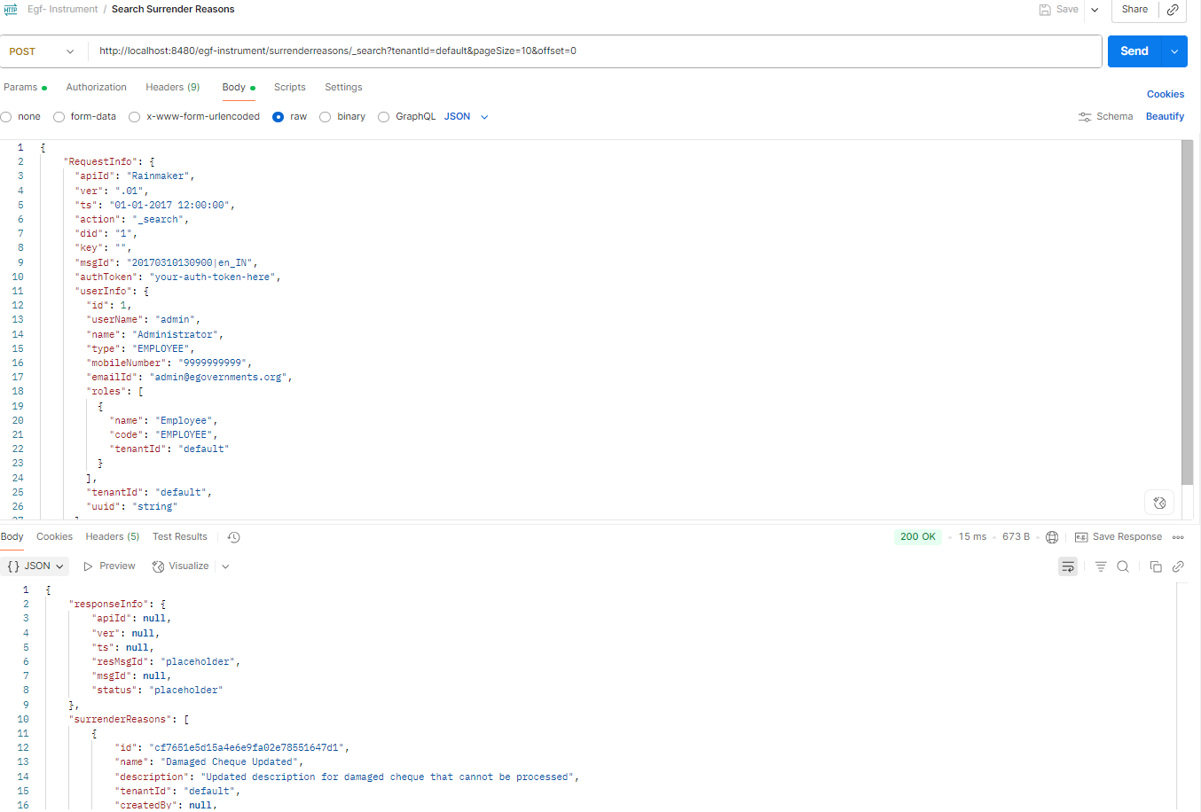

**Delete Surrender Reasons**

curl --location 'http://localhost:8480/egf-instrument/surrenderreasons/_delete' \

--header 'Content-Type: application/json' \

--data-raw '{

"RequestInfo": {

"apiId": "Rainmaker",

"ver": ".01",

"ts": "01-01-2017 12:00:00",

"action": "_delete",

"did": "1",

"key": "",

"msgId": "20170310130900|en_IN",

"authToken": "your-auth-token-here",

"userInfo": {

"id": 1,

"userName": "admin",

"name": "Administrator",

"type": "EMPLOYEE",

"mobileNumber": "9999999999",

"emailId": "admin@egovernments.org",

"roles": [

{

"name": "Employee",

"code": "EMPLOYEE",

"tenantId": "default"

}

],

"tenantId": "default",

"uuid": "string"

}

},

"surrenderReasons": [

{

"id": "cf7651e5d15a4e6e9fa02e78551647d1",

"tenantId": "default"

}

]

}'

